Blow them UP!!!

----Save the world with bombs in your hand.

1. Background Introduction

AI robots revolt against humans. Use the bomb to destroy them and save the world!

1. Game Introduction

A game contains one or two players and one or two robot players. Each player has infinite bomb to plant but have a 1.5s CD. The bomb will block the way and each bomb will release cross shape laser after 1.5s bomb have been planted. The players has 3 initial HP and minus 1 when being hit. After being shotten by laser, the player will get 2s dodging all lasers and the player’s icon start flicking. If HP downs below 0, the player will be removed from the map. The game will last 3 min to determine winner with highest score. If there is only last player, game will end immediately, and that player become survivor. However, if the game last for full 3 min, all players last will be survivor. **Because of system difference, we strongly recommend you play on windows system. The unroot Linux(ed) version support 1 player playing with bots, if you insist to play on unroot Linux, the experience will be awful. Also, movement in unroot Linux will have delay.**

2. Game Menu

Main Menu

The game start menu contains three choices (start, setting and quit). Player can use WASD to select, and use Enter or ‘e’ to confirm.

Setting Menu

Setting is for player to change player number and robot number, also changing map and self-defining map function is included in setting. We used a config file to store the changes to the setting, so players don’t need to set again the next time they play.

Player Setting

You can switch on or off players or robots here, which means you can play both PVP and PVE in this game.

Map Setting

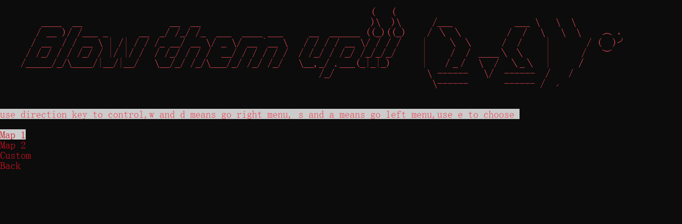

You can change the map here.

Map 1

Map2

You can even create and use your own map ( 11 x 11 ). Just change the numbers in yourmap.txt following the rules below:

0 : Empty block 1 : obstacle with 1 HP 2 : obstacle with 2 HP 3 : obstacle with 3 HP 4:Unbreakable wall

(A little egg: something interesting will happen if you press ‘↑ ↑ ↓ ↓ ← → ← → b a’ and try to change the difficulty level in setting menu )

3. Gameplay

**Player1: W,A,S,D to control direction, use space to plant bombs.**

**Player2: Use direction keys to control direction, use ‘0’ to plant bombs.**

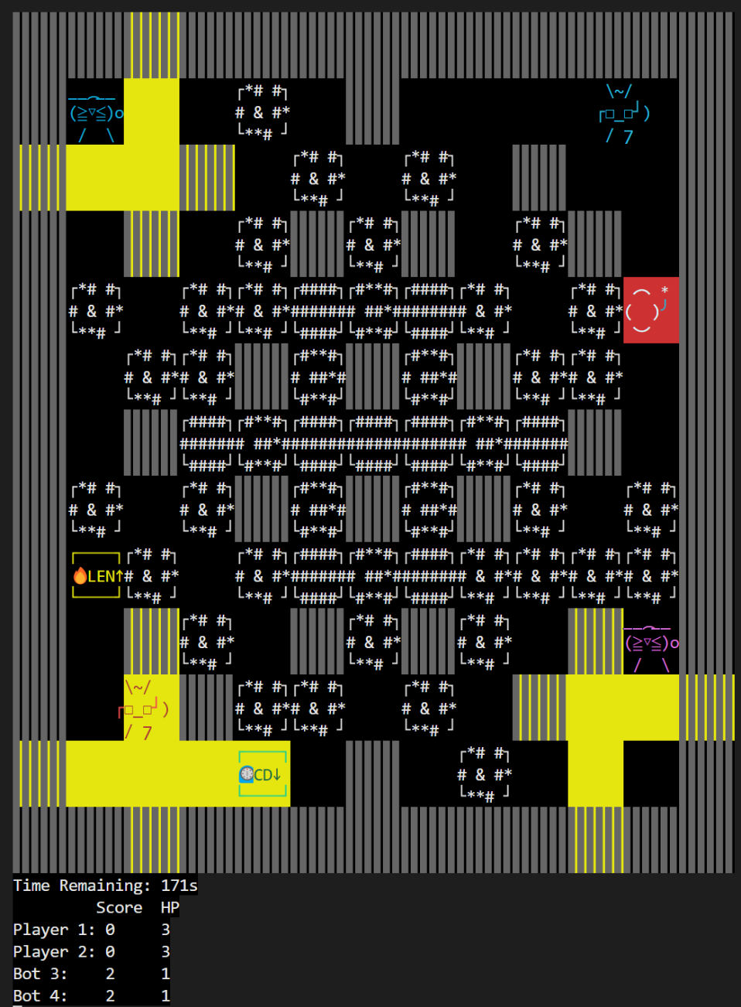

In the game, we use different colors and shapes to distinguish players and robots.

Player 1

Player 2

Robot 3

Robot 4

Though the placement of obstacles may seem random, the map is well designed for players. Every player/robot need approximately same number of bombs to get to the center of the battlefield.

4. rules for getting score

Removing obstacles can produce 1 point, weather what level the obstacle is. Use laser to kill other players can get 10 points. But if player’s bomb kill itself, the score will minus 10 points. Therefore, this game mechanic encourages players to kill others, but it also offers another choice for players to avoid battling

5. Obstacles & Items

We use different types of obstacles to provide diversified gaming experience.

┌####┐

######

└####┘ represents obstacles with 3 HP. (Need 3 damage to remove it)

┌#**#┐

# ##*#

└#**#┘ represents obstacles with 2 HP. (Need 2 damage to remove it)

┌*# #┐

# * #*

└**# ┘ represents obstacles with 1 HP. (Need 1 damage to remove it)

图表

低可信度描述已自动生成 represents unbreakable wall

represents unbreakable wall

The laser can be stopped by obstacles and boundaries but will lower HP of obstacles (initial 1 or 2 or 3, -1 when be shotted), once HP of an obstacle below 0, it will be removed and randomly leave items (shown below).

Increase speed (light blue) 🡪

徽标

Increase damage (yellow) 🡪

手表

中度可信度描述已自动生成Lower CD of bomb (light green) 🡪

图标

Increase laser length 🡪

Lower explode time (light yellow)🡪

文本

低可信度描述已自动生成Increase HP (light red)🡪

6.Game End Menu

When game ends, we’ll show players’ scores and survivors. Here you can start a new game, or you can back to the menu, do some settings and come back to game.