Chapter 1:

By: James Makovics

1. Bit – a piece of information that is either a 1 or a 0

1

1. Byte – 8 bits

00101

1. CPU – the brain of a computer that handles all program instructions

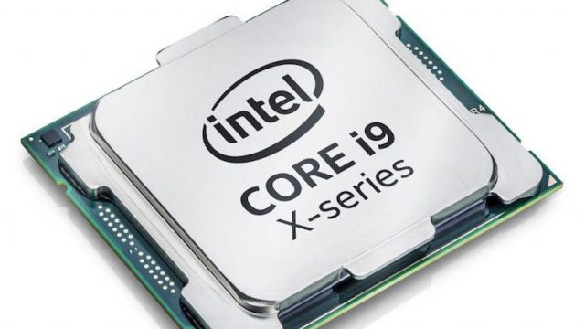

1. Computer Instruction – a set of code that tells the CPU to execute a command

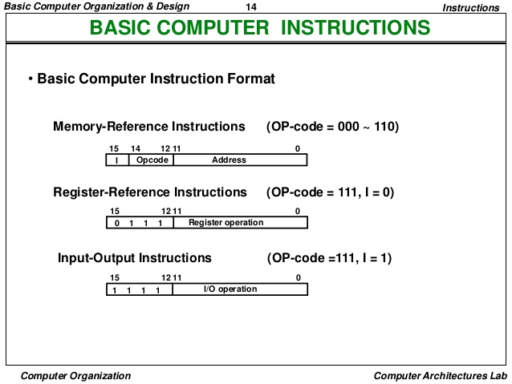

1. Computer memory – a piece of hardware that stores programs and data

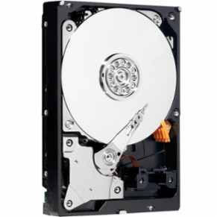

1. Computer program – a set of instructions that can instruct a CPU to execute multiple commands

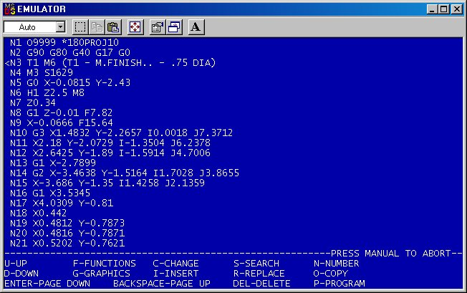

1. Application – a compiled program that can be run without an interpreter



1. Machine language – a rudimentary language that uses 1’s and 0’s

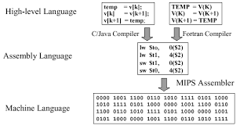

1. Compiler – compiles code to be checked for syntax errors

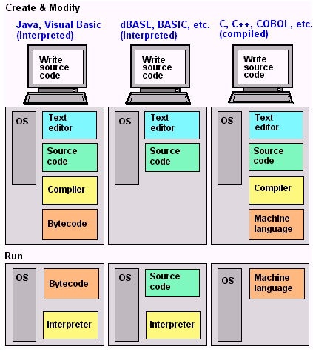

1. High level languages – a programming language that uses plain English rather than machine code



1. Virtual machine – a computer that is emulated/simulated by another physical computer



1. RAM – a temporary storage location for programs that need to be accessed quickly

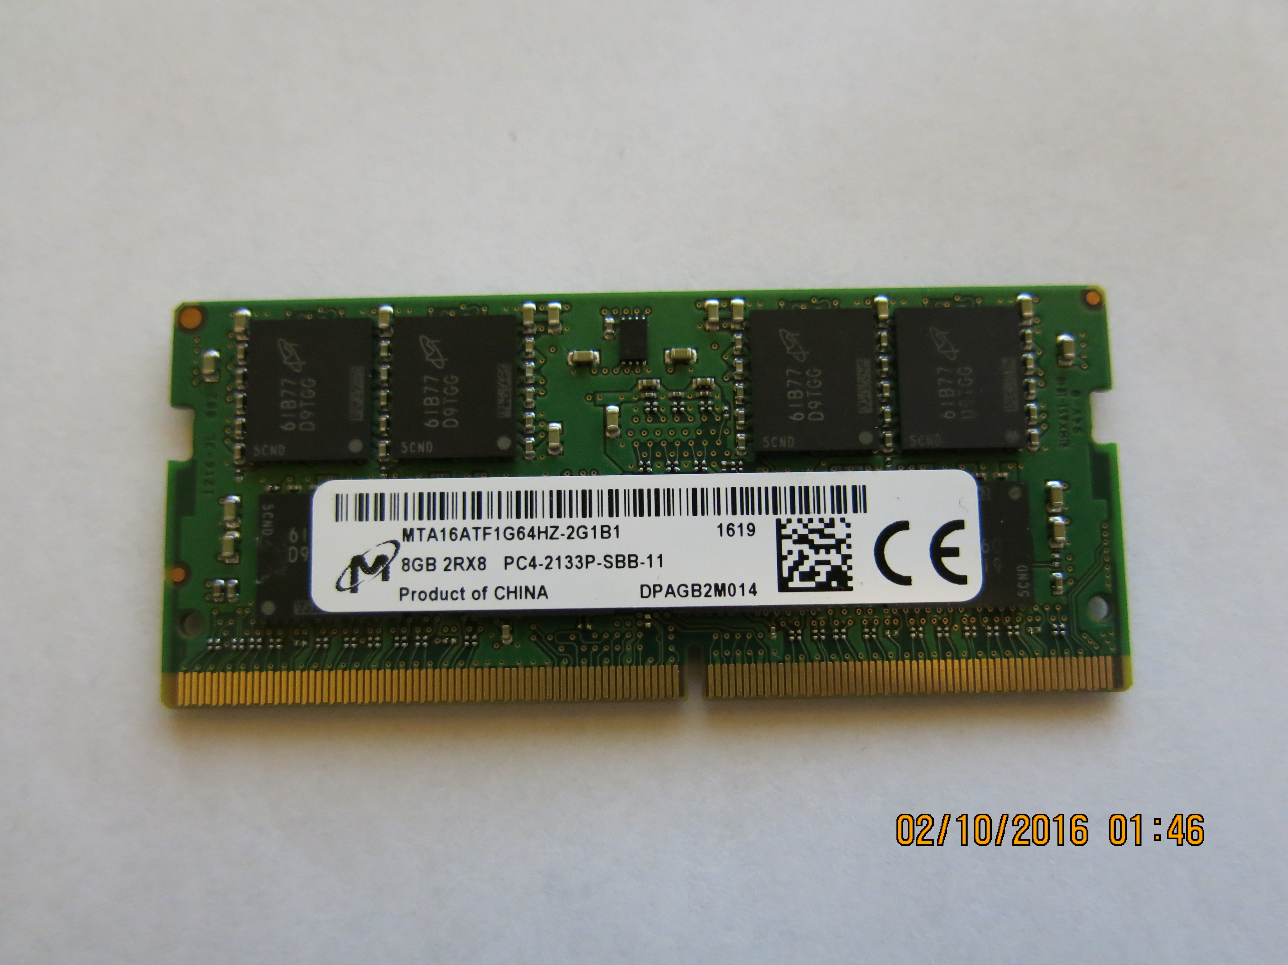

1. Cache – a temporary storage location for program data that can be accessed very quickly

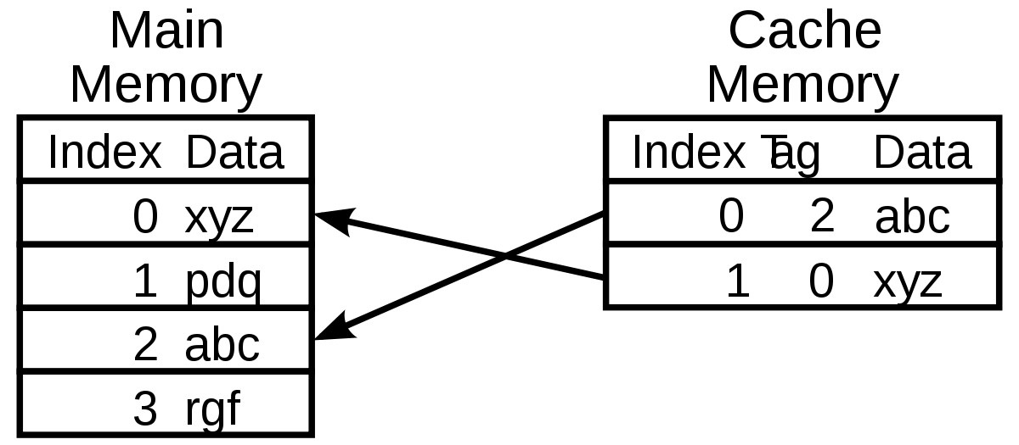

1. Transistor – a semi-conductor that changes electrical signals

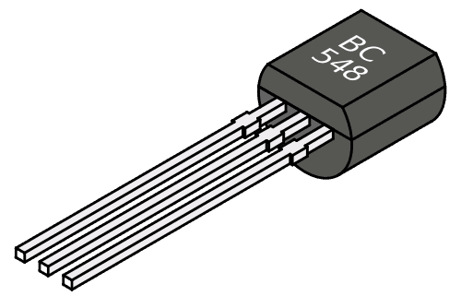

1. Script – A set of instructions that are followed by a computer

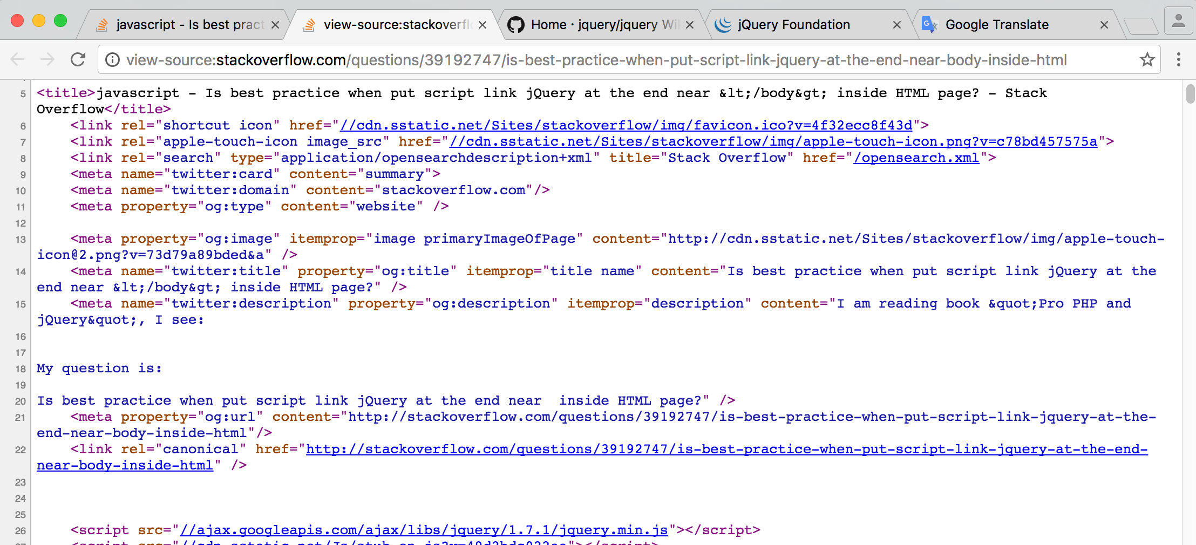

1. Interpreter – runs the code and determines how the code should be executed

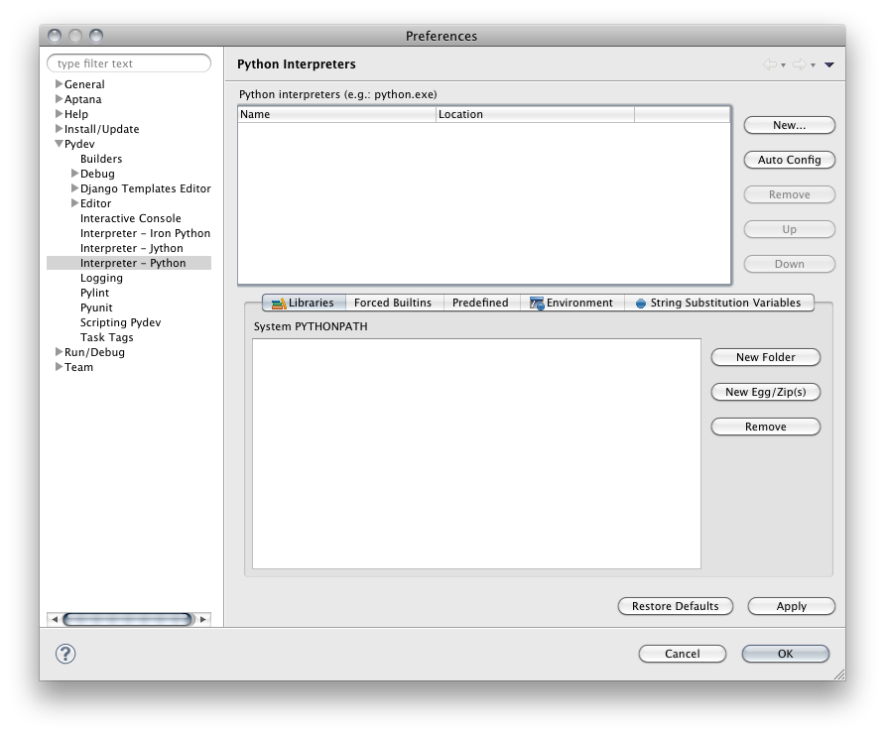

1. Open Source – a library or program that is free to use as well as having free access to the source



1. Code – a set of reserved words or variables that can be arranged to give an output

|  |  |  |  |  |
| --- | --- | --- | --- | --- |
| and | assert | break | class | continue |
| def | Del | elif | else | except |
| exec | finally | for | from | global |
| if | import | in | is | lambda |
| not | Or | pass | print | raise |
| return | Try | while |  |  |

1. IDE – an Intergraded Development Environment that a programmer uses to make programs

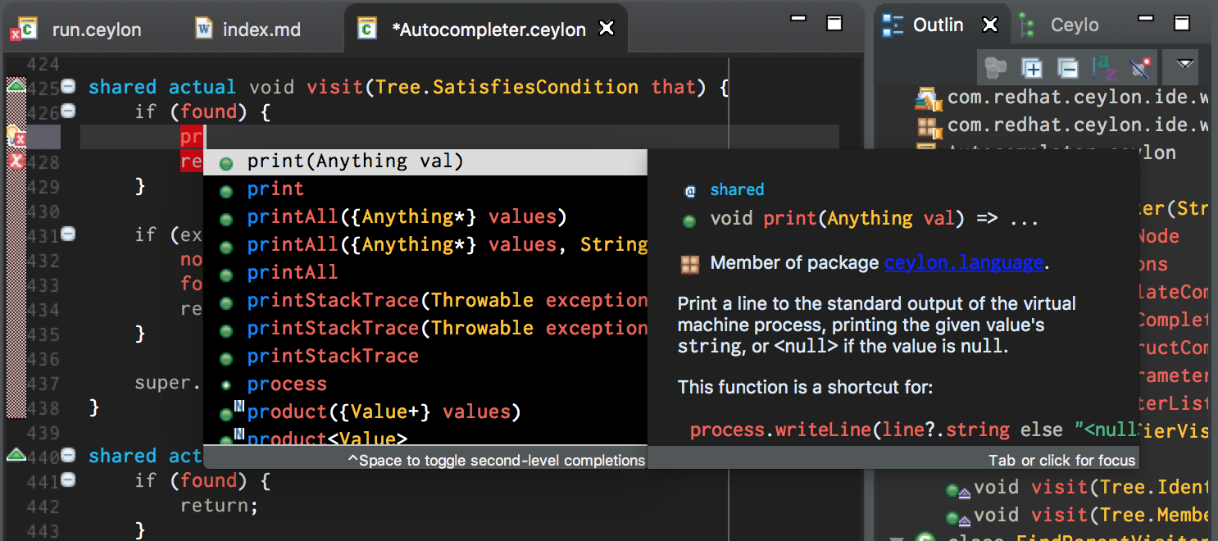

1. Binary – is a base 10 number system that has a maximum value of 255

