Chapter 2:

By: James Makovics

1. print() – prints a statement to the console

print("The total of the item is: $%0.2f" % (total))

1. * - multiplication operator

total_tax = shirt * sales_tax

1. / - division operator

drive_half_speed = drive_speed / 2

1. + - addition operator

add = 3 + 5

1. – - subtraction operator

subtract = 3 - 5

1. variable – is an object that stores a value

str = str(“HelloWord”)

1. end=’ ‘ – allows for print statements to be printed without creating a new line

str = str(“HelloWord”), end=’Goodbye’

1. string literal – a set of characters within “ ”

str = “HelloWorld”

1. input() – takes an input from a user

user_input = float(input(“please enter a number: ”))

1. int() – casts a variable to an integer

x = int(x)

1. type() – checks the format that the variable is stored as

x = 15

>>>type(x)

<type 'int'>

1. str() – casts a variable to an String

str = str(“Hello”)

1. casting – assigns a variable to data type

x = 15

int = int(x)

1. syntax error – an error in formatting

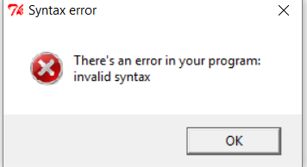

1. float – a data type that stores decimals

>>> x = float(15)

>>> x

15.0

1. object – a class or multiple classes that come together to create a specific function

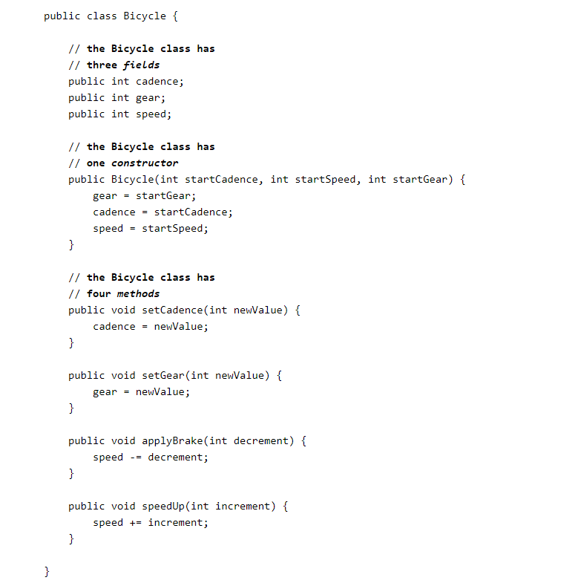

1. Assignment – sets a variable to a number, string, boolean, or float

x = 15

1. reserved words – a list of words that are used for logic

|  |
| --- |
|  |
| and | assert | break | class | continue |
| def | Del | elif | else | except |
| exec | finally | for | from | global |
| if | import | in | is | lambda |
| not | Or | pass | print | raise |
| return | Try | while |  |  |

1. camel case – a naming scheme that uses proper formatting of classes and variables

thisIsCamelCase

1. % symbol in Python – a remainder operator

>>> 15 % 3

0

1. // - the fractional part of the remainder is removed and uses the lowest number

>>> 15 // 3

3

1. PEMDAS – the order of operations which are: parenthesis, exponents, multiplication, division, addition, and subtraction

()

^2

*

/

+

-