|  |
| --- |
|  |
|  |
| CMP2089M |
| Group Project |
| Stephen Smith |

The following table shows the agreed allocation of workload against this assignment submission. The table has been checked and all members in our group as identified in the Group List presented on Moodle, are shown correctly in this table. The percentage values provided have been agreed and total 100%. (**Remove example names**)

|  |  |  |  |
| --- | --- | --- | --- |
| Enrolment Number | Surname | Forename | Agreed Percentage Workload |
| 222931 | Chaloner | Karl | 20% |
| 303330 | Green | Joshua | 20% |
| 308614 | Kuranda | Lukas | 20% |
| 014096 | Lewis | Martin | 20% |
| 285674 | McArthur | James | 20% |

**28/03/2017**

Y



CMP2089M GROUP PROJECT

Assessment Item 2: (75%)

**Corridor Display System**

Project Report

GROUP ALDRIN

Karl Chaloner, 222931

Joshua Green, 303330

Lukas Kuranda, 308614

Martin Lewis, 014096

James McArthur, 285674

HNC/HND Computer Science

Contents

March 28, 2017

Lincoln College

Bishops Building, Monk’s Road, Lincoln LN2 5HQ



Introduction 3

Critical Reflection……………………………………………………………………………………………………………….…4

Objectives Analysis…………………………………………………………………………………………………………………….4

Development Progress……………………………………………………………………………………………………………..15

Applications…………………………………………………………………………………………………………………………..23

Corridor Display System…………………………….……………………………………………………………………….32

Database/API…………………….

JSON Data………………………………….

Jobs Page……………………………

Warnings Page………………………………..

Facts Page

Countdown Page…………………………………..

Welcome Page……………………………

Future Improvements………………………

Teamwork analysis

Karl……………………………………………

Joshua……………………………………….

Lukas…………………………………………..

Martin……………………………………………

James……………………………………………..

Impact on Project…………………………

Mark Allocation………………………….

References

Appendices

Introduction

The aim of the assignment was to plan and develop, as a group, a Corridor Display System for Lincoln College, with an emphasis on working as a team to achieve the aims and objectives outlined in the project proposal. The goal of successfully developing a web-based Corridor Display System required effective and consistent collaboration between each member of the team and enabled everyone to utilise the skills developed in other areas of the course.

*“One of the attractions as an individual to work in a team is that it allows us to expand our knowledge, ability and experience.”* (Adair & Thomas, 2004)

The system was designed with the primary intention of drawing its main source of information from an external database and presenting that information on-screen where appropriate on a given date. The criteria established to accomplish this was previously defined in the project proposal, which provided a useful means of measuring the assignment’s progress.

Each member of the team was given a series of tasks necessary to achieve this, utilising their skills in areas they felt they were best suited, whilst ensuring the task challenged their knowledge and skills in those areas.

This report is intended to highlight and analyse the various objectives that were undertaken by the group in accordance with the criteria established in the project proposal, including any changes to the original plan, as well as provide some insight into the various team activities that took place in partial fulfilment of this task.

Critical Reflection

Developing the Corridor Display System (CDS) required the team to divide the project up into a series of smaller objectives, thereby enabling the group to establish a timeframe for completing each aspect of the system’s design and tangibly measure the progress being made, including a likely completion date. This also made the process of designing the various components of the CDS more manageable.

The following analysis intends to explore the criteria laid out for the group during the project proposal and to what extent the objectives were successfully completed, including any changes that were made to ensure they were accomplished on time and per the initial specification.

This section also looks at the development progress of the Corridor Display System and the applications used to support this, including relevant justifications for using a particular tool/software.

Objectives Analysis

Part One: *To research, identify and implement appropriate design formats for the CDS website, with a focus on the readability and structural layout of each web page to be displayed on the college monitor.*

The basic layouts using HTML were developed relatively early in the project as it enabled the team to focus their efforts on the components necessary for the CDS to work as expected, such as the countdown and QR. Lukas was responsible for developing the layout used in the QR code page, with the QR code designed to sit between two layers of text when presented on the screen. This required the width and height of this generated QR code to conform with the dimensions of the page to ensure it displayed properly. The image below demonstrates the basic layout used for displaying the page, with the image beneath showing the concepts for the original design.

**Final Layout** **Prototype Layout**

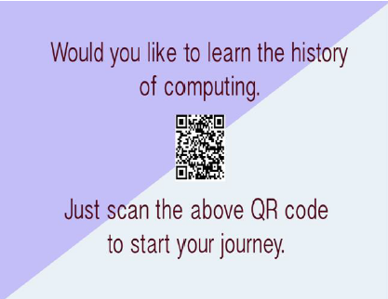

Additionally, Lukas was also responsible for the layout of the warning page, which much like the QR page, needed to conform to design standards established by the team (to fit on the 1080p screen correctly).

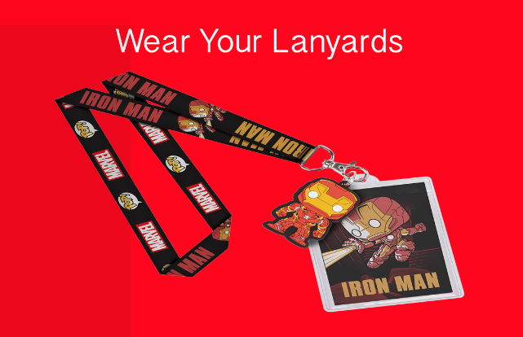

Josh oversaw the design for the facts page layout which, as demonstrated below, differs from the concept design. During the process of designing the CSS used in the layout, Josh had difficulties in getting the layout to work properly so the design was adjusted.

**Final Layout** **Prototype Layout**

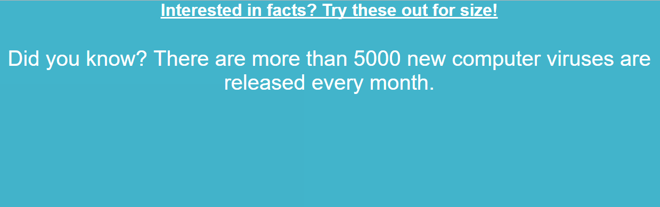

Lastly, James was responsible for the layout design used in the countdown page, which was adapted from the original prototype concepts to meet the requirements of the client. The original version functioned more like a general clock in terms of its presentation, however, the client requested a style that was more like the preferred design. **Prototype Design**

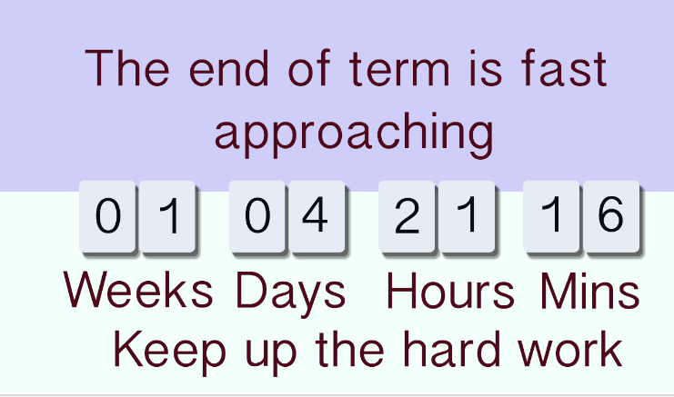

**Final Design Client Design**

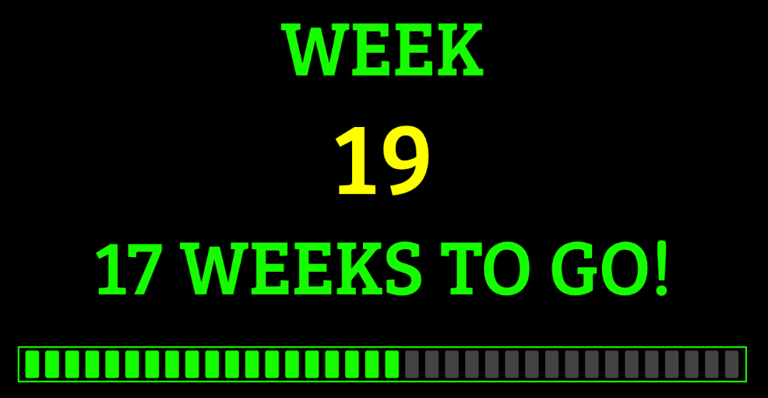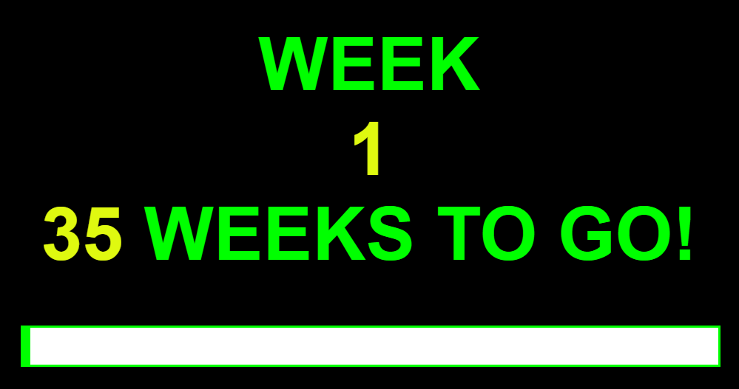

The prototype designs were used as a basic guide in designing each of these web pages, although the results in most cases were altered to meet the updated requirements, as members of the group came to understand the features they were trying to implement better.

The layout criteria for the web pages was largely determined at everyone’s discretion, but all members were required to ensure the conventions identified in the data dictionary were followed correctly and that the dimensions of the page were a match for the 1920 x 1080 display they were to be presented on. However, colours, fonts, border sizes etc. were dependant on each group member’s personal preference, as long as these design choices did not make the page unreadable and/or unprofessional in appearance.

Since small adjustments to the layouts were made over the course of the project, there was little need to review the prototype designs once the main task of designing the various CDS functions was underway.

Part Two: *To retrieve, process and display externally-stored data, such as room numbers, lesson times and important notifications on the newly-created CDS website, where applicable.*

The primary feature of the CDS is its ability to retrieve external data from a database and display the relevant information on-screen. This involves a jQuery call to the college database with the URLs containing the data, including information such as lesson times, start dates, week numbers and all other data relevant to our project. Communication with the database is done via an API (written in PHP). which acts as the intermediary between the system and the database. The first attempts to retrieve the data involved a standard getJSON call which was a useful method for accessing and displaying the data that was needed since the syntax was relatively simple and required minimal coding to perform as intended.

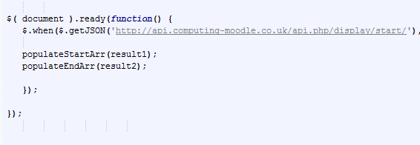

However, after further discussion about accessing the data, Martin recommended a switch to using ajax calls instead, since getJSON is more generalised. Ajax allowed the group to specify the data being fed into it and has a more specific syntax for passing data from the API, as well as better error checking compared with getJSON.

In this case, the data is retrieved from one of several URLs by the *getData* function. This function contains the ajax call that specifies the information to retrieve i.e. the key-value pairs contained in the JSON array. If this call is successful, the data is then sent to one of several *storeData* functions designed to store, in a set of variables, all the relevant values we need.

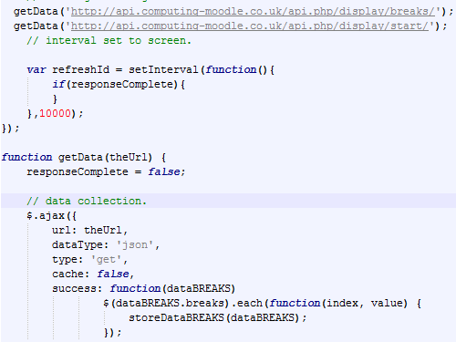

Essentially, using jQuery and ajax made it easier to create ajax requests and then process the data returned by the API, in JSON format. (Duckett, 2014).

The JSON data is returned by the ajax request as a string of text, which is then converted into DOM objects by the browser. This process allows the team to refer to each value in the object array by its name and index number. The data obtained from the key/value pairs can then be manipulated by various JavaScript functions in the code, such as the *displayLessons* function used below.

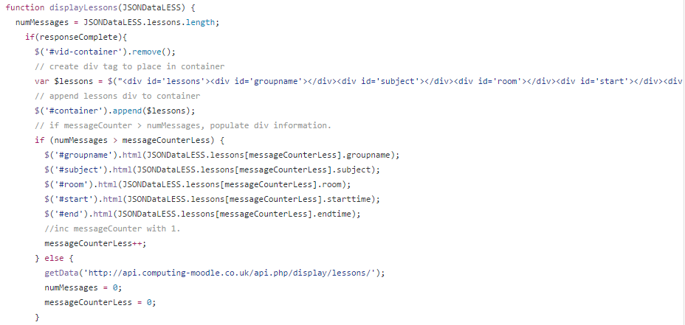

Both Martin and James were responsible for implementing this data correctly, having worked on the backbone functions used for displaying the data. For example, the *startCollege* function is designed to check the date and populate the *weekDATA* array based on whether the current academic year has started and presenting the correct, updated information every following week until the end of the current academic year.

Part Three: *To scan and read a URL from a newly-generated QR code that will open a secondary web page on the user’s mobile phone / tablet, containing fun and informative facts related to computer science.*

The main container for the QR code used in the CDS was created by Lukas, with the intention that users can scan the QR on-screen, with any QR reader, and this would provide a URL to a website with useful information related to Computer Science. The exact URL is determined by information provided by the API and is generated in the form of a QR code for convenience. This way users can scan the code and be directed to a useful website automatically.



The primary value of these codes is to transport users from a physical place (in this case, the CDS), to a digital destination, such as a YouTube video, a computing article, or any news that is relevant to their study modules. This feature alleviates the need to manually enter a URL and has become a widely-adopted feature in both business and digital marketing. It is of relevance in this project, since the CDS is not interactive, which means users are unable to find links by simply clicking on them.

Lukas had the initial idea of producing the QR codes in the web page’s code, however, Martin pointed out that this wasn’t necessary since the QR codes are generated by the API and will show up when a request is made by the system.

Part Four: *To co-ordinate all group work and ensure that deadlines are met in accordance with the most recent Gant Chart model, thereby ensuring successful completion of the project.*

Co-ordinating the group’s assignments required the team to store all their work in a single repository, accessible by everyone. From the earliest stages of the project, the team was advised to use GitHub to house their HTML, CSS and JavaScript documentation, regardless of whether the work would be used in the final product. This process ensured the whole team could track the individual progress of each member and provided some insight into the history of each component’s development. It offered the additional benefit of allowing everyone to share and edit each other’s work, including any literature useful for development tasks or research we were assigned each week.

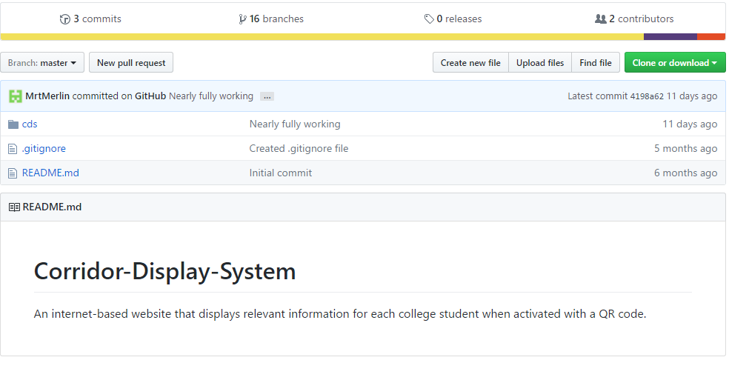

The GitHub repository used by the group, called Corridor-Display-System, was hosted by James, with the rest of the group members acting as contributors. Each person was given a specific branch to work on where they could upload, edit or delete any web documentation they were working on.

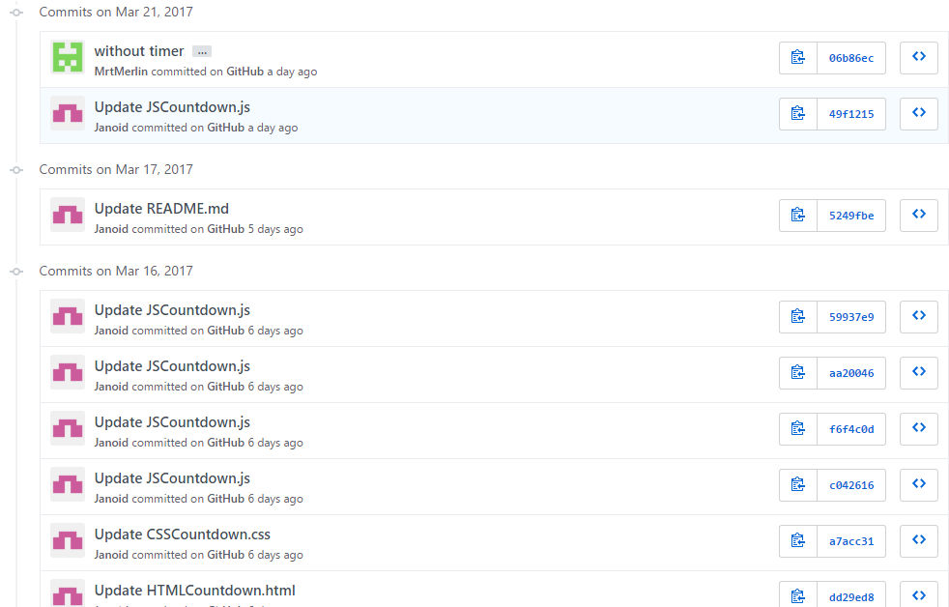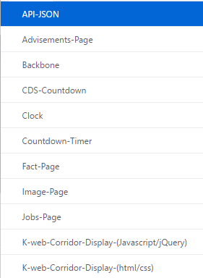

This aspect of the repository provided a useful means of observing our project’s development from beginning to end, performing like a timeline, and showcases evidence of the project’s history. In addition, the repository provided a form of version control for all the group’s work, recording changes made to each file, where each record would be stored in the repository in case they needed to be referred to later, such as for unstable builds.

The Gannt chart used in the project shows the amount of work that was undertaken in between starting the group project, and the date of its eventual completion. The model used in the assignment was created relatively early in the design process, just prior to the start of the CDS project, with amendments made to its design on a semi-regular basis; usually during, or shortly after, a group meeting.

This model enabled the group to accurately assess the allotted time devoted to an individual task and clearly predict the length of time necessary to complete it.

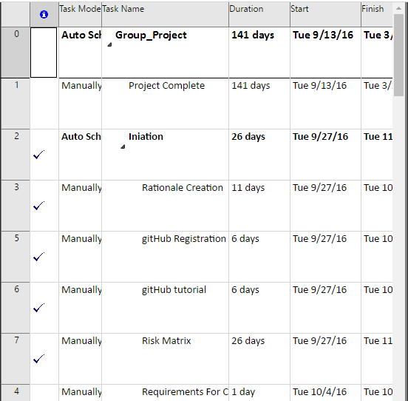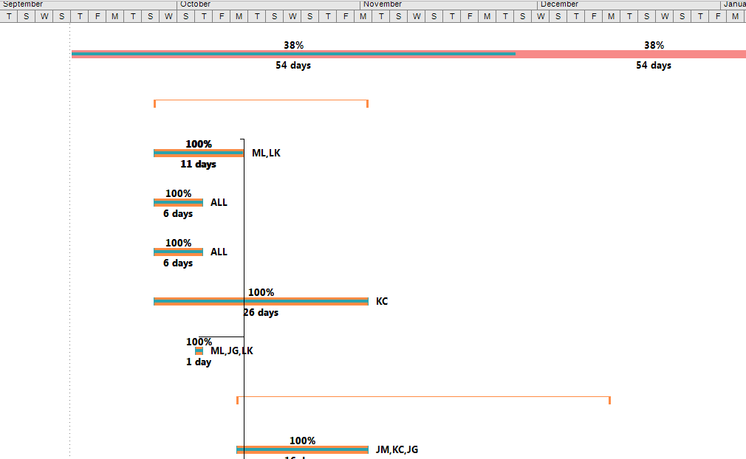

Karl was placed in charge of making sure the Gannt chart remained up to date, including any overdue tasks. Each one of these tasks was allocated a time slot within the CDS schedule, with each member of the group assigned a place to one or more, indicating how much time they had to accomplish it. The Gannt chart model used for the CDS was created using Microsoft Project and was accessible to the entire group via a shared folder on Google Drive.

In regards to group meetings, each person in the group took turns in recording minutes, which were a basic account of conversation topics that took place during each group meeting and was normally hosted by another member, often on a rotational basis, each week. A more detailed description of these meetings will be discussed in the next section of the review and all the recorded minutes associated with the project can be found in the appendices.

Development Progress

Gannt Chart

As mentioned in the previous section, the Gannt chart was used to illustrate the start/finish dates for each objective in the project, as well as the final project itself. Each updated version of the Gannt chart was uploaded as a distinct file, accessible on the group’s shared folder, called Group Project, on Google Drive. Most of the team had access to Google Drive accounts which is why it was deemed the best option for sharing content outside of the GitHub repository. Karl was given responsibility for the task of updating and uploading each new iteration of the Gannt chart, but unfortunately this was only achieved semi-regularly, resulting in aspects of the Gannt charts progression being omitted from the folder.

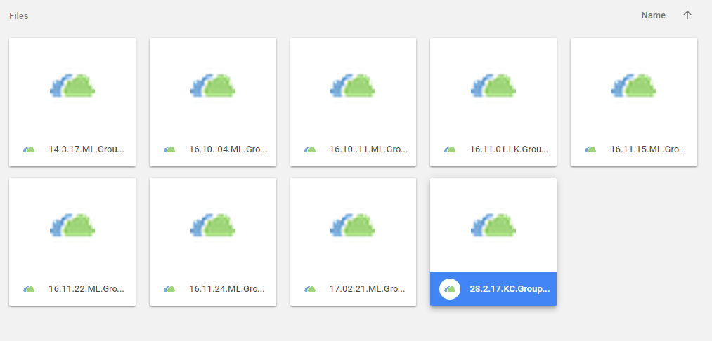

The CDS Gannt chart demonstrates the relationship between various tasks. For example, the testing activities are directly linked to the completion of each page, such as the advisements, warning, facts and countdown pages. This list of tasks offers a detailed breakdown of how progress in one aspect of the project has a direct correlation with the entire schedule status.

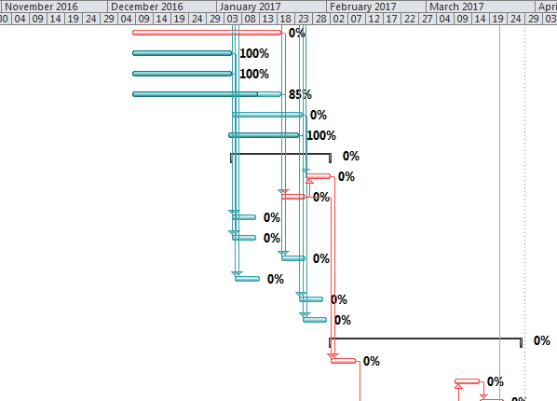

The duration of time allotted can range from optimistic, pessimistic and a more frequent, but conservative, ‘middle’ range. With hindsight, many of the tasks that were scheduled early in the project were often provided with time allotments in the optimistic range. Subsequently, these durations were frequently amended per each group member’s understanding of the task(s) being performed, such as the countdown timer, which required much more time to implement properly than was originally allocated.

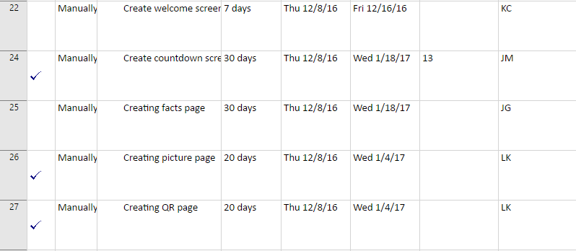

Project critical paths, such as the countdown and other backbone features were colour-coded in red on the Gannt Chart to denote their essential status in finishing the CDS, whilst important (but not crucial) features were coloured in blue. Anything that could be implemented given a surplus of time was coloured with a black line. Features were often grouped together as a visual aide to indicate they were elements of a larger task, such as the web pages.

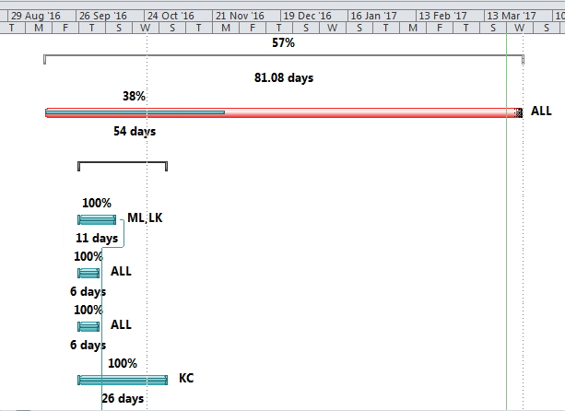

Although a moderate attempt was made to utilise the project planning features available in scheduling software, the execution was not followed to a sufficient degree, resulting in many aspects of its design falling short of expected standards.

Aside from the fact that updates of the Gannt chart were infrequent and incomplete, many additional design features available in MS Project that would have provided a more comprehensive look at the groups planning processes were not implemented. This includes, but is not necessarily limited to, what constitutes an assignment working day, nor how much time should be allocated to the task every working day. Neither does it allocate sufficient time in the event an assignment task, both essential and non-essential, is overdue. Additional evidence of the Gannt chart model can be found in the appendices.

Meetings

An account of each group meeting would begin with an acknowledgement of group attendance. This attendance record was maintained as an Excel document on Google Drive, with registrations normally recorded by the meeting’s chair.



The positions of responsibility (such as the chair, timekeeper, and notetaker) were determined by the team rota that was originally established in the group’s first official meeting, with each role in the meeting alternating between different group members to guarantee everyone got to participate in each role at least once.

The chairman was responsible for planning the agenda topics each week, with executive decision-making regarding the structure of these meetings. Topics of discussion were usually pre-prepared and uploaded to the team’s Google Drive folder so that other group members could contribute suggestions for topics prior to the meeting.

These topics covered areas such as the project’s status, plans for upcoming tasks, weekly assignments, and any potential changes to the project.

The process of taking minutes was done by the designated notetaker for the week who, like the chairman, was determined by the current rota. These minutes were organised into interesting and/or important markers of conversation with a time attributed to each significant point of discussion. These normally highlighted anything useful that had been discussed by the group and were a useful way for the team to reflect on the main points of the meeting. The example below illustrates the standard design used in most of these meetings.

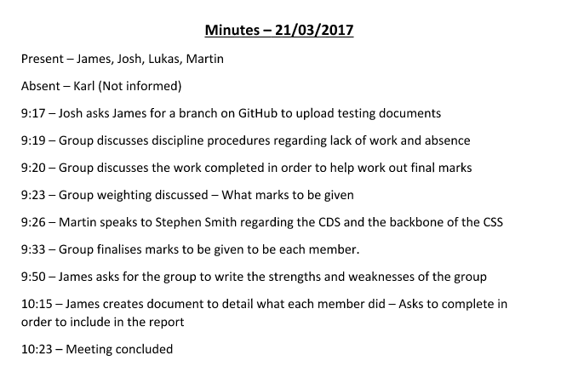

The alternative method used to document meetings was through use of individual planners. These planners served a similar function to diary entries, with individual members using them to note any particularly useful information relating to their appointed tasks.

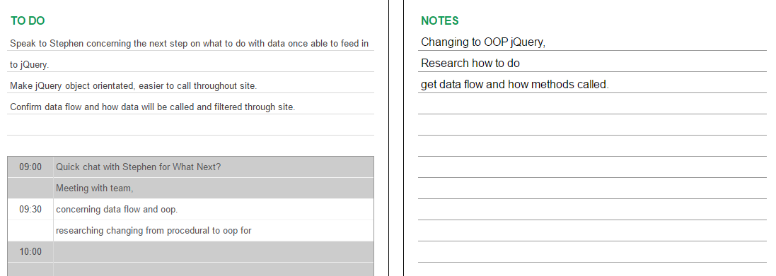

All individuals were encouraged to use these planners to document the work they needed to do for the following week, as well as providing useful reminders of anything that remained unfinished. These planners were used sparingly during the latter stages of the project, with many in the group occasionally forgetting to write out their personal plan for the week. The result of this is that there are fewer individual documents with evidence of each group member’s contribution to the assignment.

Tasks were both voluntary contributions and work requested by the presiding chair of the meeting. Appropriate delegation of these tasks was based on each member’s personal knowledge, skills and experience, combined with their previous track record of completing tasks effectively and per the time constraints.

The image below, taken from the disciplinary procedures document produced during the project proposal writeup details the measures involved in the event of unfinished tasks.

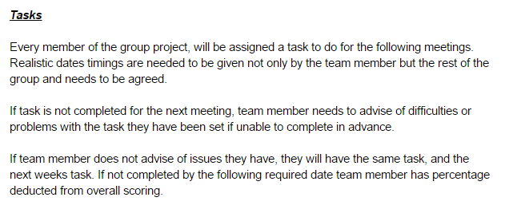

Failure to carry out a task without sufficient explanation to justify its incompleteness and failing to notify other group members in advance of the next meeting could result in further responsibility for the affected individual, and, for repeat offenders, the potential to lose a percentage of their total marks. A full list of these disciplinary measures can be found in the appendices

Setting tasks properly had the potential to effectively motivate group members into action, however, many tasks were not designated as frequently and clearly as they could have been. This is likely due to a less formal structure adopted in group meetings. The project would have substantially benefitted from more frequent, in-depth meetings between all members and a regular account of each attendee’s current progress, in agreement with the timeframe laid out in the Gannt chart.

Communication

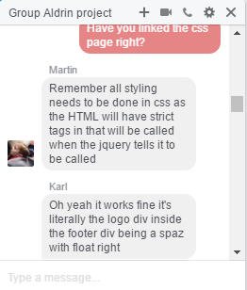

The group’s predominant means of communicating remotely i.e. outside of meetings, was through use of Facebook’s chat feature. This was a largely informal way for the team to discuss topics concerning the project and provided a convenient and readily accessible way of exchanging thoughts and ideas over long distance. These exchanges were not generally organised in advance; instead acting as way to communicate in between group meetings.

Although this method was sufficient for informal discussions between various members, it did not allow the group to maintain an accurate, formal archive of communication that could be referred to in the final project report.

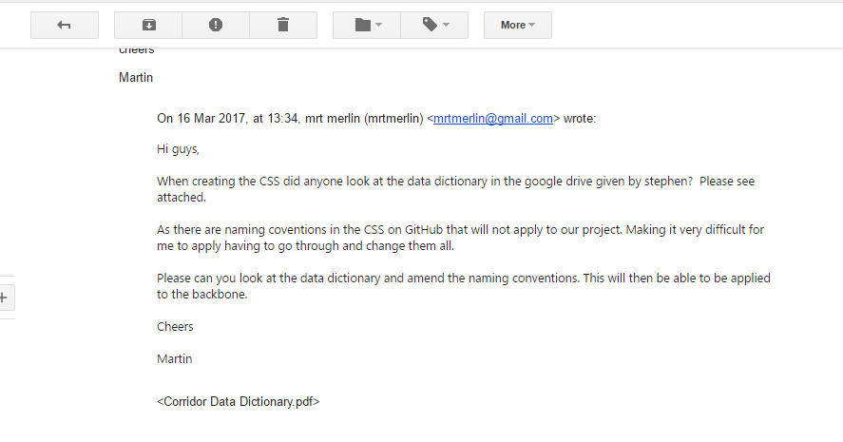

It was during the final two months of the project’s development that the team agreed to continue most project-related communication through a combination of informal Facebook chat and more comprehensive notifications via email. Using emails made it easier to keep a log of the groups discussion when they needed to be reviewed later.

Applications

Atom

The main application used for writing and editing HTML, CSS and JavaScript was the free, downloadable text editor, Atom. This particular piece of software was chosen due to its user-friendly IDE, and its extensible user interface, which can be personalised with a variety of free packages/themes that have been shared by its supporting community.

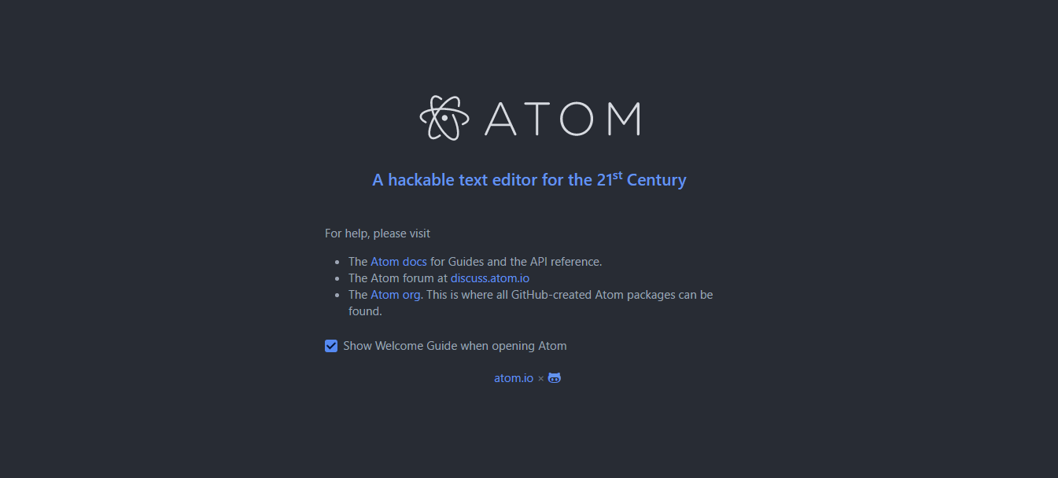

Its layout and features were viewed as highly suited to web programming languages, particularly JavaScript, which was used in several areas for the CDS. This meant the application could be used by everyone in the group, regardless of their individual skill level.

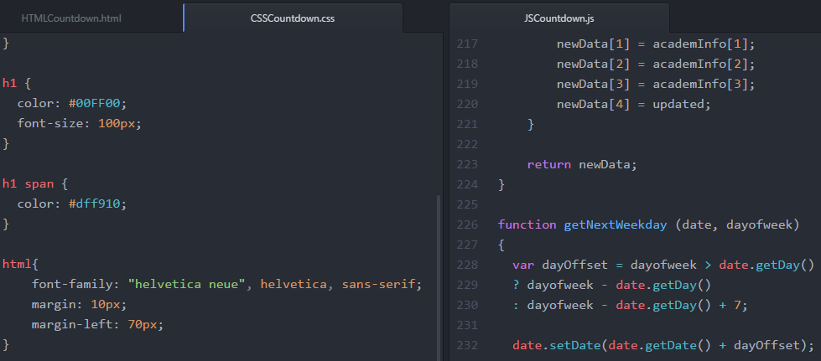

The downside of using Atom, however, is the performance can occasionally be slow compared with similar text editor tools, such as Sublime. Additionally, the application does not come with much supporting documentation to help initiate new users or improve their understanding of Atom’s library of features, instead having to rely on information provided by the community.

Notepad++ was briefly discuss as an alternative to Atom and Sublime, but was dismissed early in the process since its IDE was seen as too minimalist and it lacked many of the features present in both applications, such as plugins, and its user interface was also seen as too basic by comparison.

Web browsers

The web browsers used to test various aspects of the CDS include, Google Chrome, Mozilla Firefox, Apple Safari, and the Raspberry Pi’s kweb suite. These represented most web browsing tools used by everyone in the group and offered a way to test the system on a variety of different web browsers to make sure it was displaying features correctly.



Microsoft Project

Microsoft Project was the application used to design and update the CDS Gannt chart; acting as both a task scheduler and calendar. These displayed a history and digital map of the projects current progress. Using this software enabled the group to assign members to certain tasks, develop a plan/timeline, and predict a likely completion date for each component.

Once work on the project proposal was completed, the team could assign development tasks to the Gannt chart, such as a facts page, advisements page, countdown page etc. and estimate a likely completion date for each of these individually. This schedule is visualised as a chain of project-related events that form parts of a critical path.

The success of this structure was reliant on each member of the group fulfilling the criteria and time constraints assigned to a given task, with the intention of providing the project calendar with regular updates.

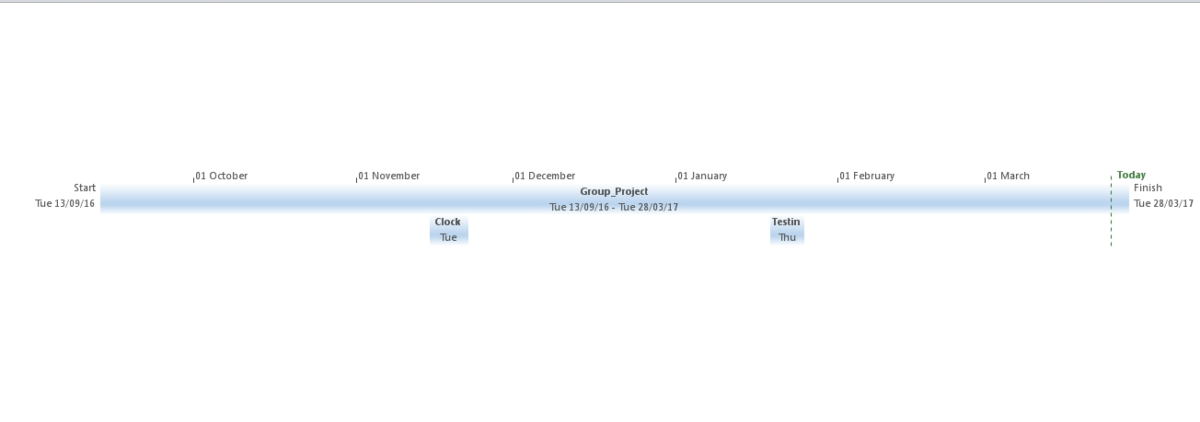

Unfortunately, as mentioned in the Objective Analysis section, this aspect of the project was not fully utilised since the group had failed to maintain updates of this schedule at regular intervals. This resulted in amendments being attempted after tasks were already registered as completed in the Gannt chart.

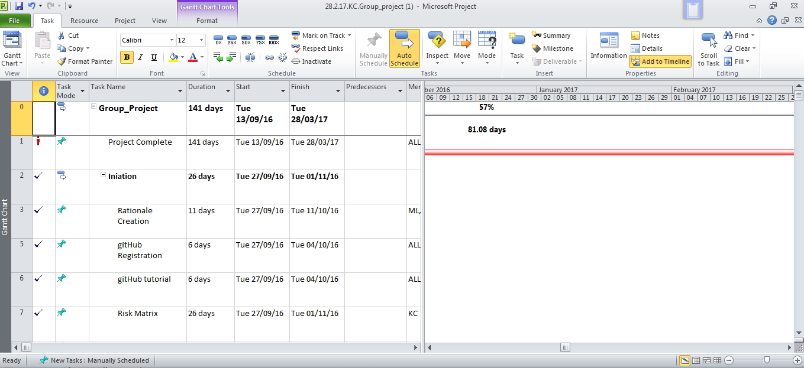

Microsoft Project was the most readily accessible, and comprehensive, project management tool available to the group at the project’s outset, which is the main reason why it was used in this assignment. However, the group was largely unfamiliar with MS Project’s feature set and using it effectively required training and experience that the group was unable or unwilling to commit to, especially if learning how to use it properly took time away from project development.

Google Drive

Google’s free file-hosting service, Google Drive, was used as an additional repository for various project documentation because this tool was accessible to everyone in the group and individuals could easily upload and share files without permission from another party. Using Google Drive enabled the entire team to collaborate on a variety of documents, including the ability to write and edit weekly activity records, research pertaining to a given task (e.g. Raspberry Pi), tests on numerous CDS features, and was also used to store the group’s Gannt chart.

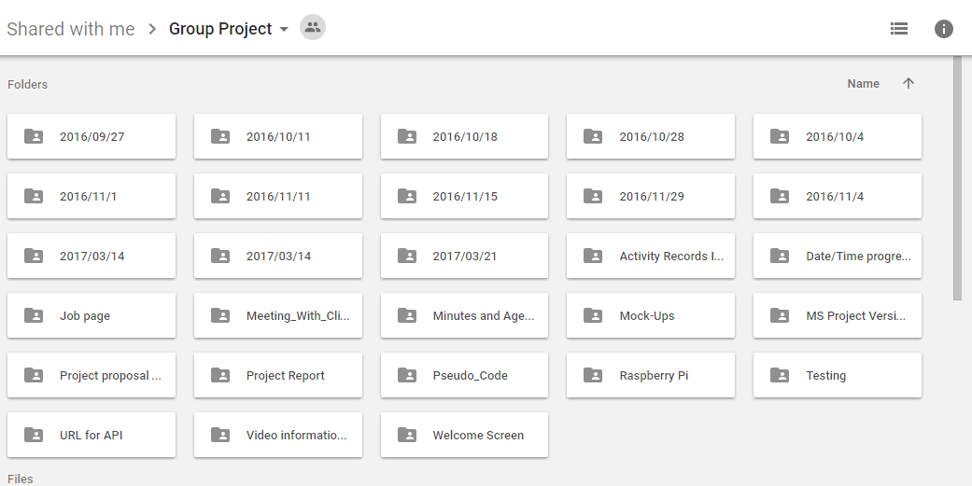

Important documents, such as project proposal files, were predominantly given separate folders to make finding them easier, with miscellaneous files stored in the projects default folder. Sharing these files/folders meant the group could view and edit one another’s documents - useful for certain tasks such as the proposal, review, Gannt chart and activity sheets. Additionally, group contact information and attendance records were stored here.

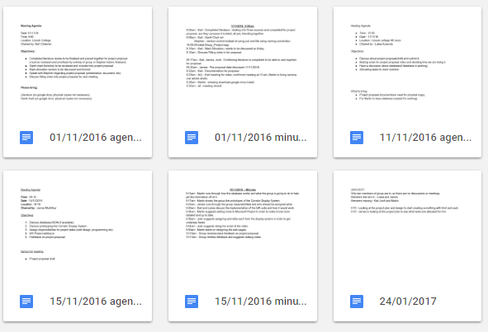

This system of storing files was used primarily because it was easy to create and amend certain documents compared with other services such as GitHub, and the group found its user interface simpler to navigate on a variety of platforms, including mobile and tablet devices. In addition, most members in the group already had access to Google accounts which made sharing documents in Google Drive much simpler and logical.

An alternative method of storing the documents was the git repository service – GitHub – which, although used more in the later stages of the project for storing these files, was initially for version control and storing the final edits of crucial documents, such as the project proposal and review.

One of the main disadvantages involved with Google Drive was that the folder became increasingly cluttered over time, making it harder to navigate easily as work progressed. This was compounded by members of the group uploading files in a variety of different areas, resulting in unnecessary copies of several documents.

GitHub

Versioning control system and online repository, GitHub, was used as the main tool for archiving and updating our project records having been recommended to the group during the project proposal stage. GitHub is a free and useful tool for providing backups of the group project and was used to document the history of each page used in the Corridor Display System, from beginning to end.

The main repository used in this assignment, called Corridor-Display-System, was created and administrated by James, with Karl, Lukas, Josh and Martin acting as collaborators in the repository. Each member of the group was responsible for a distinct branch, usually created from the master branch, and, once completed, would commit their work to this master branch.

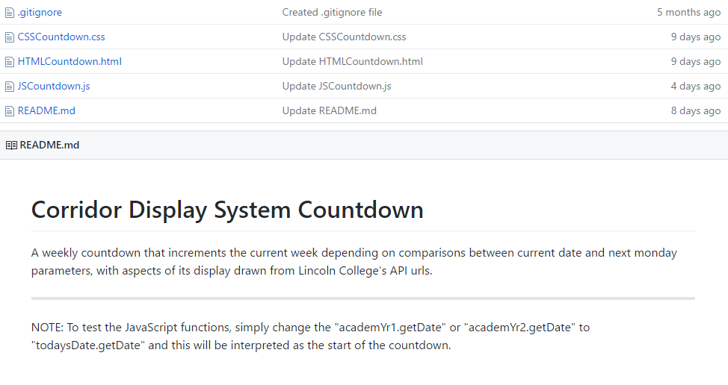

The repository was designed such that individual team members would work on their assigned task independently, e.g. page layouts, and then be free to upload the current version of their work into the appropriate branch. Every time one of these documents was altered or reuploaded, the repository would track the development changes made to that file, highlighting its history in red (removed content) and green (added content).

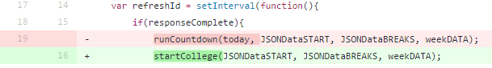

Most files that were added to the repository consisted largely of HTML, CSS and JavaScript, as well as additional documents that were crucial to the final project, such as the proposal and the report. Since GitHub supports a drag and drop feature for uploading files, the system would attempt to add files that were not useful or relevant to the core project, including a few extraneous files related to the HTML, CSS and JavaScript code. For this reason, a gitignore file was added to the master branch, including all successive branches, that would remove this content from the repository automatically.

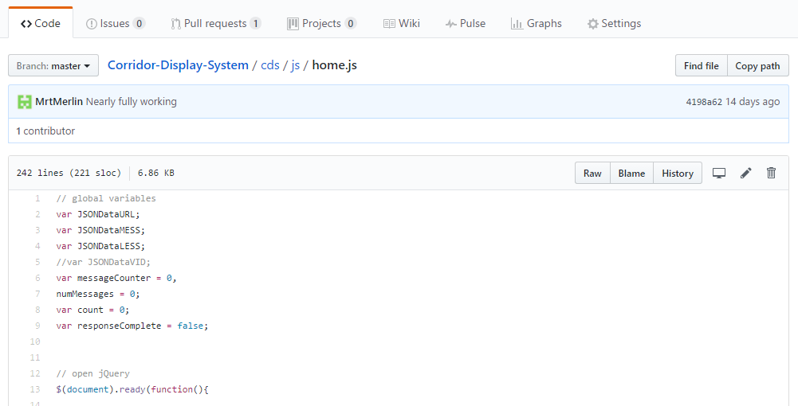

GitHub can be accessed via web browser or through a downloadable app that can be linked to the repository, but was mainly operated using the browser because many in the group found the app did not always work correctly and was found to be generally difficult to use properly.

One of the key features that made GitHub so useful was the ability to implement versioning control on all our documents. The version control enabled the group to work on various iterations of the same file, without affecting another member’s instance of the file, before committing the new version to the correct branch. This helped to avoid potential errors or unnecessary changes creeping into the code, but also provided an opportunity to revert to previous builds of the file, in the event something went wrong. The URL below links to the main GitHub repository used by Group Aldrin in this assignment.

https://github.com/Janoid/Corridor-Display-System

Corridor Display System Design

Welcome page

Facts Page

Countdown Page

Future Improvements

Testing

Raspberry Pi

Teamwork Analysis

Karl

Josh

Martin

Martin’s role in the group was to develop and implement the backbone of the Corridor Display System, including the JavaScript and jQuery functions necessary to call the JSON data for our web pages and was a central figure in making sure that all aspects of the assignment came together in the final product.

He was responsible for ensuring that all members of the group adhered to the design standards set out in the client brief and would frequently remind other group members to refer to the data dictionary during the development of each page.

In addition, he was one of the most punctual group members and would always come prepared to every group meeting, being keen to make sure that everyone was aware of the various tasks assigned to them that week. Although he could occasionally be distracted during meetings, it rarely had an adverse impact on his performance or the tasks he needed to finish that day or when deadlines for a feature were imminent.

Since Martin possessed more experience in web programming than the other group members, he was an important factor in determining the progress being made and oversaw the various design and jquery aspects of the system’s design, including the decision to implement ajax in place of the previous getJSON calls.

Lukas

Lukas was responsible for the design of the warning page, advice page and the QR code features, and was a highly effective team player  who worked hard in all the areas where he was given plenty of responsibility.  He was a consistently punctual individual throughout the duration of the project and demonstrated a strong degree of initiative when faced with unfamiliar tasks, conveying a willingness to learn in areas where he admitted to have little or no experience.

Although his attitude to work was of a high standard, Lukas was, like other members, prone to distraction during group meetings and tended to joke around during discussions regarding the current status of the project and what was needed to progress.

Despite this, he was successful in his approach to the tasks presented to him and could complete all of the design work he was tasked with, including the warning and advisement pages, as well as the code to implement the QR code generated by the API.

James

Impact on Project

Mark Allocation

Martin - 30

Lukas - 20

Joshua - 20

Karl - 5 :(

James - 25

Marks have been allocated based on individual performance throughout the project, with the final allocations determined by the group during the final week of the project. Both Joshua and Lukas agreed to a 20 point allocation based on the level of their contribution and the difficulty of the work done while Martin was allocated the highest percentage of the marks because of the high difficulty involved i implementing the backbone of the system. James was awarded 25 marks , whilst the team decided to give Karl 5 due to his low level of contribution to the task.

References

Appendices

Teamwork Analysis

How did you get to know each other as a group and establish ways of working together?

What roles did you adopt within your group?

How did you organise group meetings?

How did you allocate tasks?

What other strategies did you use for dividing up the worload (e.g. working in pairs)?

How did you improve the effectiveness of your group?

What challenges and issues did you experience as a group?

What process did you use to write your group report and/or develop your presentation?

What were your strengths and weaknesses as a group?

What were your personal strengths and weaknesses as a member of the group?

How would you personally do things differently if you were to work with the same group?

How has this experience helped you to understand the role of groups in the workplace?

What else have you learnt about working in groups?