|  |
| --- |
| JM Development |
| Advanced Web Programming: Project 1 |
| **Portfolio Website Mobile** |
| Version #0.9  All work Copyright © 2013 by JM Development.  All rights reserved. |
| **James McColl** |
|  |



|  |
| --- |
| February 1st, 2013 |

**Table of Contents**

1. Title Page
2. Table of Contents
3. Description and Navigation bar explanation
4. Colours Used
5. Typography Section and Wireframes
6. Branding

Description

This site is a simple portfolio website that I can use to showcase various jobs and projects I have completed to a prospective customer. As the semester progresses, this site will be updated further and become something I put on my resumé. I have also created a mobile version of the site that is easier to read and navigate when viewed from a phone browser.

Navigation Bar

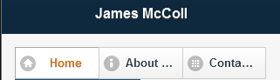

The picture above is my navigation bar that allows users to explore my website.

The active page is given an orange font colour and a lighter shade for the background to highlight it is the current active page.

When pressed, the link will change to a darker blue to give feedback on what button is being pressed.

Colours

The colours used in my site are as follows:

Hex Code: #102D43 // RGB: 15-45-67

Hex Code: #245372 // RGB: 36-83-114

Hex Code: #F6F6F6 // RGB: 246-246-246

Hex Code: #E2800F // RGB: 219-109-15

Also included: White

Hex Code: #FFFFFF // RGB: 255-255-255

Typography

I used Arial and Helvetica on my website as it allows my users to comfortably read any text on the screen without causing kerning.

Wireframes

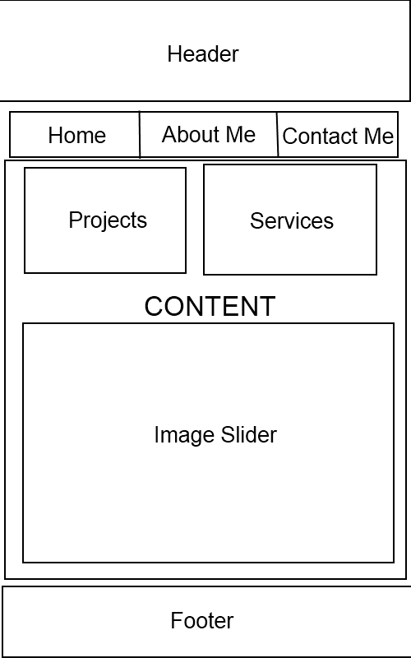

This is the default format for my mobile site. The header, footer, and navigation bar are consistently located in their positions illustrated above. The ‘Content’ area where the slider, projects button, and services button change depending on what page of the site is open. For this example, since the Home page is being shown, the displayed content is visible.