I have noticed from this lab that it’s going to be easier to test invalid input before the valid. So from now on I will start by testing invalid inputs then valid to make this a little easier to do. Also, I read the part about the happy paths from the last lab, I completely forgot to do the other paths as our whole house hold has been sick for about 2 weeks.(started with stomach flu then got the flu). Now that my flu brain is gone and I can think clearly, I should have covered all the paths.

|  |  |  |  |  |
| --- | --- | --- | --- | --- |
| Test Case | Input | Expected Output | Output | Pass/Fail |
| 1.Phone number validation with correct input | 1234567890 | Should ask for zipcode | As expected | pass |
| 2.Phone number validation with incorrect input | 12345 abcdefghij | Should prompt for valid input from user | As expected | pass |
| 3.Zipcode validation with correct input | 12345  12345-6789 | Should ask for matrix input | As expected | pass |
| 4.Zipcode validation with incorrect input | 1234  12345-67  Abcde  Abcde-fghi | Should prompt for valid zipcode | As expected | pass |
| 5.Matrix input with valid response | 1 2 3  4 5 6  7 8 9 | Should prompt for second matrix | As expected | pass |
| 6.Matrix input with invalid response | 1 2  1 2 x | Should prompt to enter valid response for row(x) | As expected | pass |
| 7.Matrix Addition | Valid matrix1(1-9) and matrix2(1-9)  1 | Result of matrix addition | As expected | pass |
| 8.Matrix subtraction | Valid matrix1(1-9) and matrix2(1-9)  2 | Result of matrix subtraction | As expected | pass |
| 9.Matrix multiplication | Valid matrix1(1-9) and matrix2(1-9)  3 | Result of matrix multiplication | As expected | pass |
| 10.Element-wise multiplication | Valid matrix1(1-9) and matrix2(1-9)  4 | Results of element-wise multiplication | As expected | pass |
| 11.Exits program | 5 | Exits program and displays message | As expected | Pass |
| 12.Invalid menu selection | 6 | Displays error message, prompts user for valid response | As expected | pass |
| 13.Transpose matrix | 1 2 3  4 5 6  7 8 9  1 for addition  This input is for both matrix | 2 8 14  4 10 16  6 12 18 | As expected | pass |
| 14.Row mean calc. | 1 2 3  4 5 6  7 8 9  1 for addition  This input is for both matrix | 4 10 16 | As expected | pass |
| 15.Column mean calc. | 1 2 3  4 5 6  7 8 9  1 for addition  This input is for both matrix | 8 10 12 | As expected | pass |

1.

2.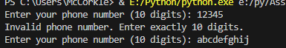

3.

3.

4.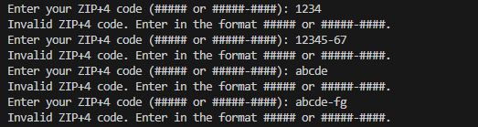

5.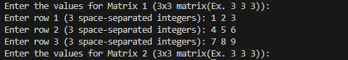

6.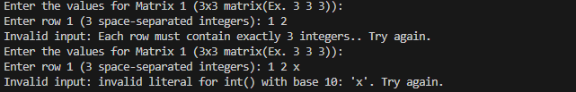

Input for both matrix 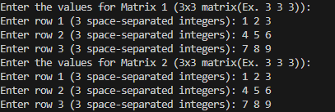

7.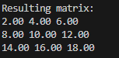

8.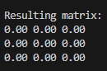

9.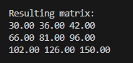

10.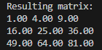

11.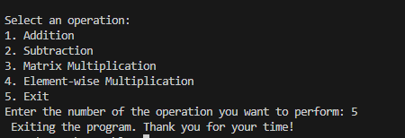I removed the space.

12.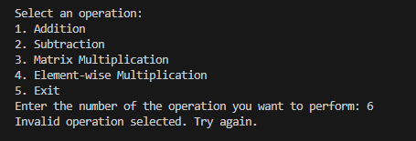

13.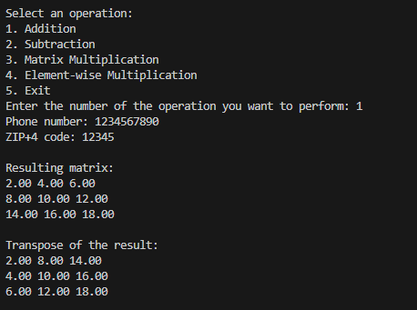

14.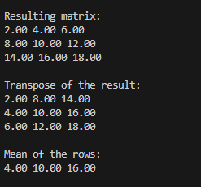

15.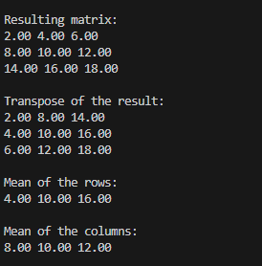

16.Pylint: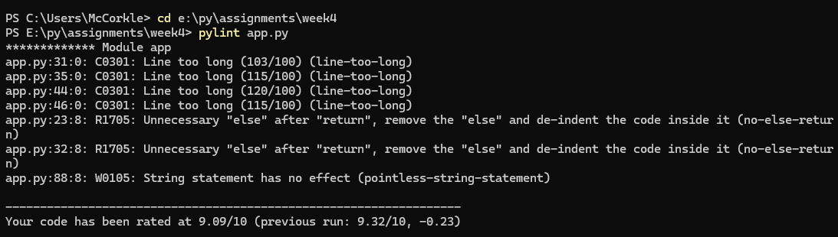

|  |  |  |  |
| --- | --- | --- | --- |
| Test number | Password | Hash output | Cracked?Y/N |
| 1 | PI3.14156 | 26832171c1cb4ecb12dba893123c87af  E994eab377065b53f615d79c2b75a76568b66d5996d7c80f209cb5787963e07a  beebd7b4fe43e8d6f8eb2f50b4920d2aea5e306e5e8f26ef3d4c48a576c96580a5aeac288000964e355784de5983d4641ab918164cdd1730a2f6f197f566945e | N |
| 2 | Password | Dc647eb65e6711e155375218212b3964  e7cf3ef4f17c3999a94f2c6f612e8a888e5b1026878e4e19398b23bd38ec221a  e6c83b282aeb2e022844595721cc00bbda47cb24537c1779f9bb84f04039e1676e6ba8573e588da1052510e3aa0a32a9e55879ae22b0c2d62136fc0a3e85f8bb | Y |
| 3 | 1!2@3#4$5% | 6301f9010508ba0aa0bbb5727a211521  e458fa44f126ab2c97a7b61bad25a3165368ef188ece750b1ba46f70dcd8dceb  d540444096eaac5ceacad782928b049d4587526e9bea0ba3c8e62894da8fd8c5a8d2bb7abaf99ee193cb72a69a027a0cf9ef8d0f00e5cc5e9616c03d2d2335d0 | Y |
| 4 | Johnathan | 71322ee56c0b438a46b6468158c35554  db2b5f7ac9c15aba48d57c074a8048197dd96b935f5449247abf51f26bde675b  563e3af0117fce0d2616aeafe6ab2d8317ff8d6044ae973490d3bc9cc185ea240a1a0ccc9e4785412e200073236f0a75e8cf13a38ee098239b127474d1e200ae | Y |
| 5 | RandomPassword | E4fe9d55eca109d740cc379312857fc1  7f7211a236c4eb16565befd8709bba1c002442fe285467a1ecbd0f7ec839949e  dde17d96a2e8ad9b4b65b2666fa363ddd0157d7f521460bc149c46f95caa3ebe252537497cbea0621b0837bc54ff83587f7ea1bd992d838bb6e2c567f423997b | N |
| 6 | PythonIsFun! | C92af4dbf0c3797109b48f7b8d4ee22d  a012d0e86caa5c7a363eb7b4a264c8279f6f37c8215ea3f673651abfbad20d9b  2243e56133c2a0a4c8513c8b0059fb50857851304845a32c84cab005dfb15c4592e11d36b44411aeeeeeccb2cb2ea939c6a53fc3490ea8b9b4c995f5d891f5e5 | N |
| 7 | 03-27-1990 | A8074854debfa70e44bc19087f9182e4  8e3882a0179a0e6a9a7ae88bf1c9ee587277030b153f60eeb88de394f09c2793  b024f9446f54fa4f66d8190d4e18a1895f3f157bcf531b58dcab03f680530693144bd369b7c021468915c86876f2fe70f9a9b13a4cb0685c4246bc7d4b51764e | Y |
| 8 | JamesMcCorkle | 64c6ed21495d5572a2fff5ec2c953c6b  49b957e35a28359c071daec6d99718792659e747d8635b0537431c9abe460d7f  9e9c55c9d7180db6a10e22efa3f92a98a44c8713c5658c06fb910800cd17663a949017da2a66b7dc3d48f40c9a175dafb3d560d1d1847cdcb3d910dc5f20717e | N |
| 9 | PaigeMcCorkle | 5a40ffc4f2308cd335d03c7ee0fbd71e  6a84051f30937c671650a68f4eadd97b89931c73fc52432caa5a50f1dff3373c  ea4cbacd8d73c5c35473d87eef66208408ac8c0f118e583f35b36f8a592fb8390741eff34a24450f885299a67203a3d7f331a3163f81e8d0eb169986483a30c0 | N |
| 10 | PatrickMcCorkle | Cac98a70c2db592652e29aeaafa541e3  91d8f8715139c50b16745422e677ae348c1e09cfa9eaaebf651571178c00dba5  5fe51c1fece2eba4cd709c6c007fa839ad74939c71e642fbbb52bb8316f81fb9d2482975161a92715d98aec1ec546beb9f07b7f9b1f149e9fa4a59f02daceb7b | N |