|  |  |  |  |  |
| --- | --- | --- | --- | --- |
| Test Case | Input | Expected Outcome | Outcome | Pass/Fail |
| 1. Displays states in alphabetical order | 1 | Displays states in alphabetical order | As expected | Pass |
| 1. Search for state and display: State name, population, and state flower | 2, Tennessee | Displays all state info in a readable format | As expected | Pass |
| 1. Displays bar graph with top 5 populated states | 3 | Displays top 5 states with highest population on a bar graph | As expected | Pass |
| 1. Update a population for a state | 4, Tennessee, increase population by 1 person | Updates pop | As expected | Pass |
| 1. Exit program | 5 | Exits program and displays a thank you message | As expected | Pass |

1. 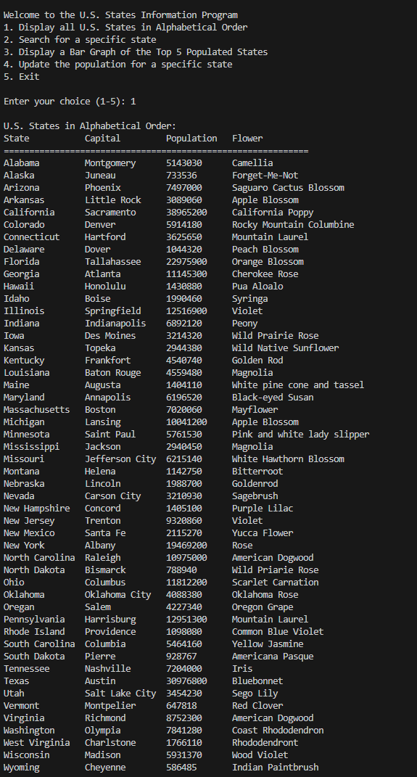
2. 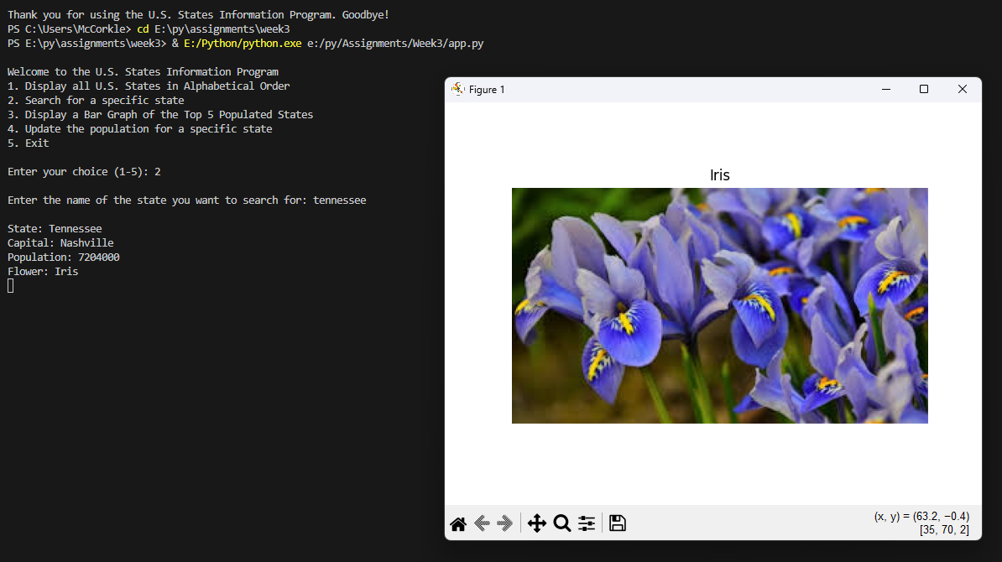
3. 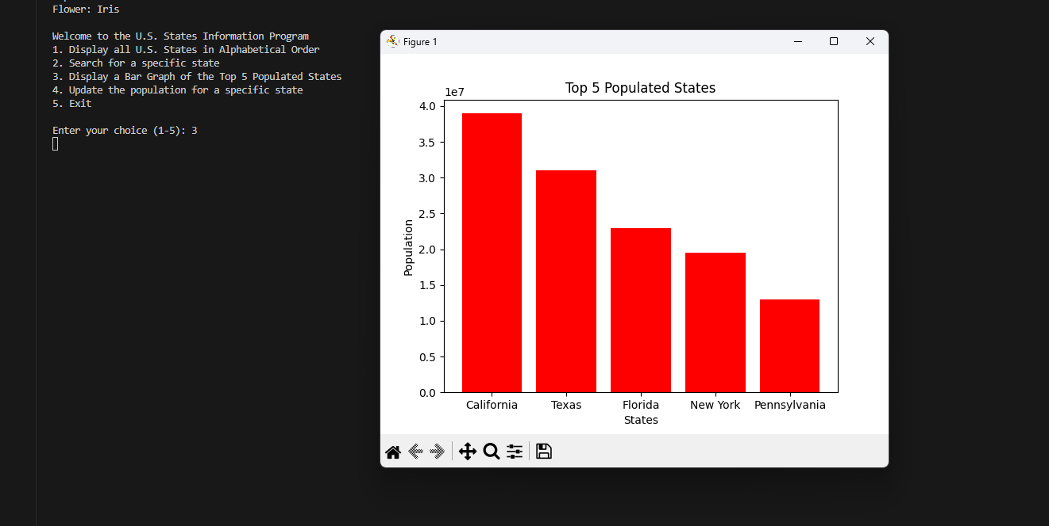
4. 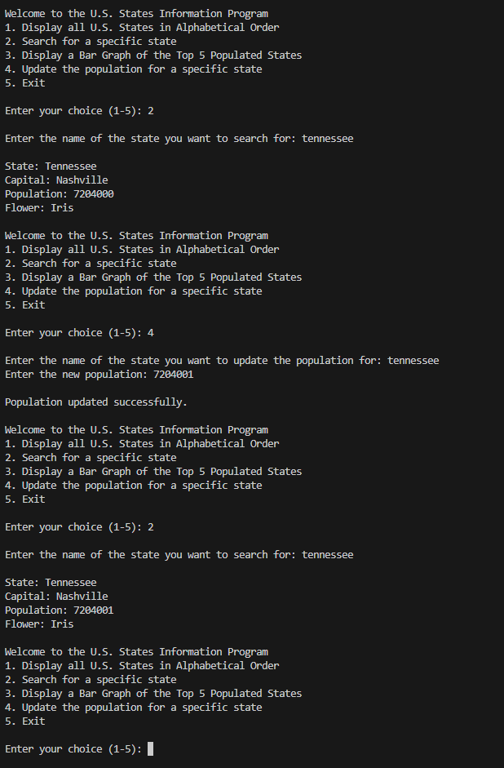Included previous pop, and updated pop to show that the program is working. However, after exiting the program the data reverts back to what it was before updating.