Meneses, James Joash F.

2ECE-D

Programming Assignment: Data Wrangling

**Problem 1**

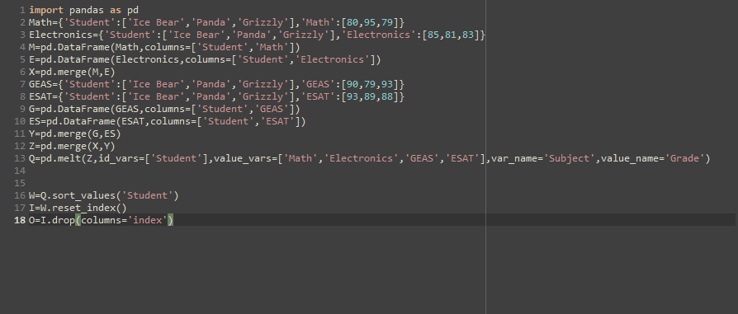

Python Code for Problem 1

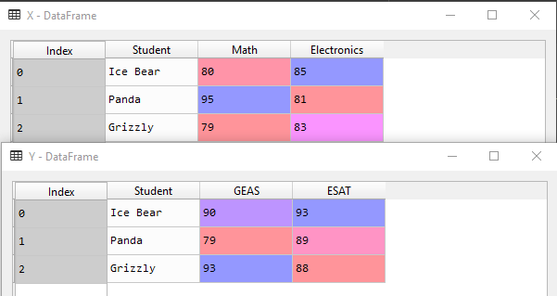

Initial Data Frames

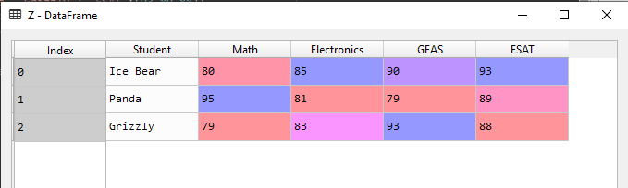

Merged Data Frames

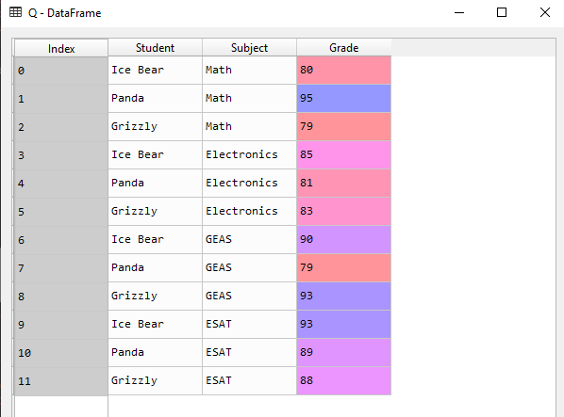

‘Melted’ Data Frame wherein the columns Math, Electronics, GEAS, and ESAT are stored in the column ‘Subject’ and their values are stored in the column ‘Grade’, adjacent to the respective subject and student.

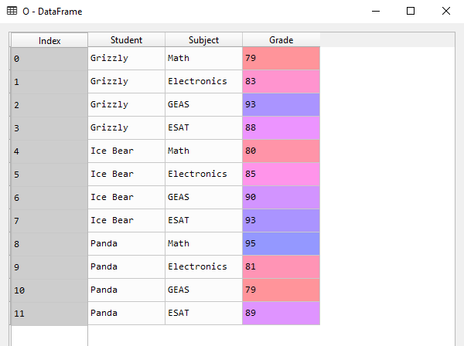

Additionally, the students can be arranged by their names in descending order (A-Z)

**Problem 2**

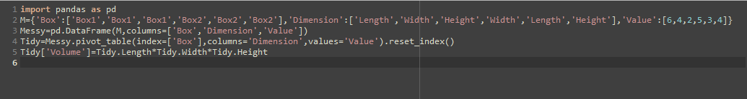

Python Code for Problem 2

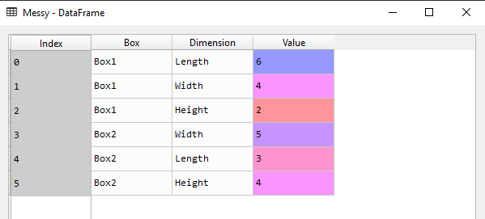

‘Messy’ Data Frame of Problem 2

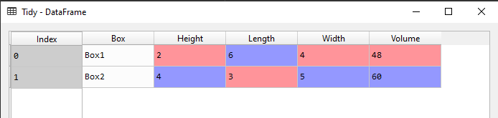

‘Tidy’ Data Frame of Problem 2 where the Height, Length, and Width are given their own columns with their respective values adjacent to its respective box. The column ‘Volume’ is also added and its values are determined by multiplying the Height, Length, and Width of the Box and storing it within the column ‘Volume’ adjacent to its respective Box