Meneses, James Joash F.

2ECE-D

Programming Assignment Pandas

Problem 1

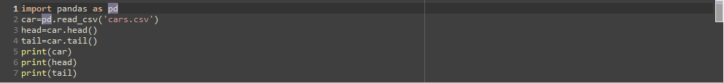

Script file

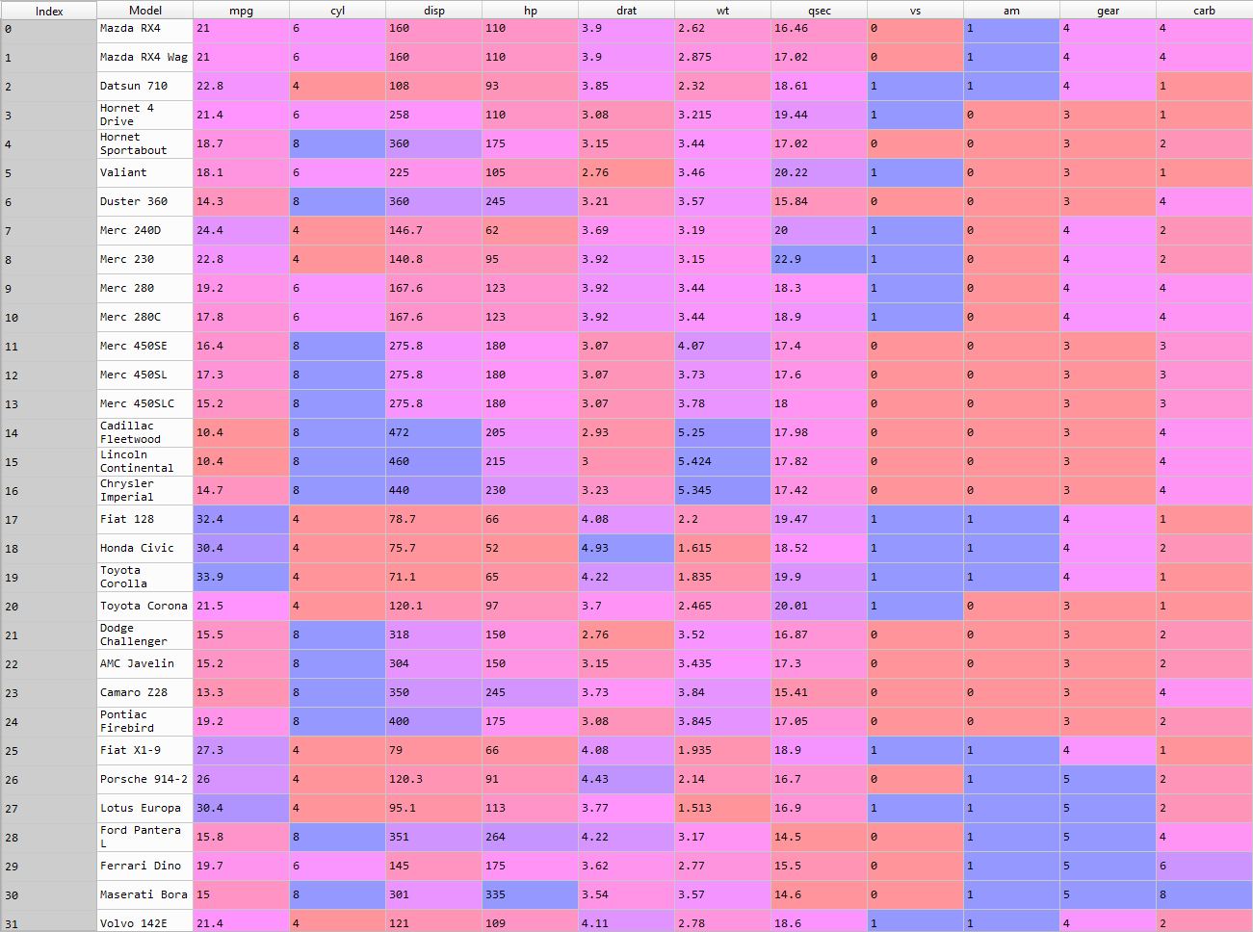

Data frame of cars.csv

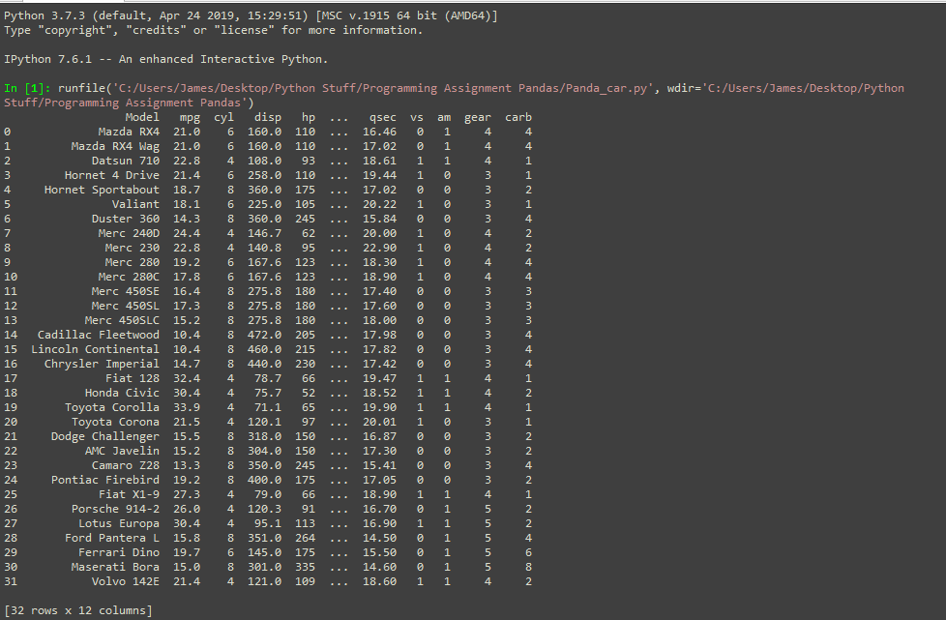

Data frame of cars.csv in IPython console

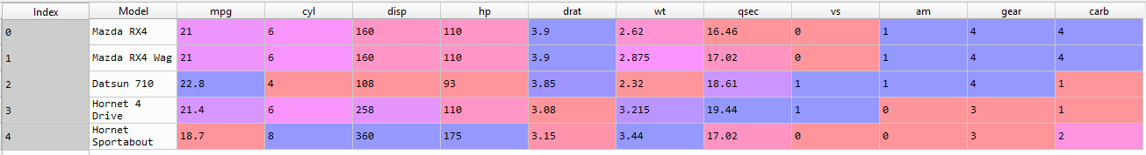

1st 5 rows (head) of cars.csv

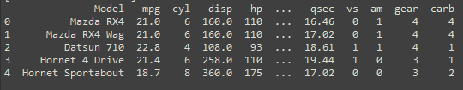

1st 5 rows (head) of cars.csv in IPython Console

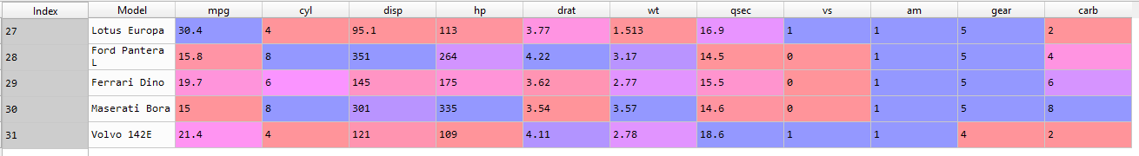

Last 5 rows (tail) of cars.csv

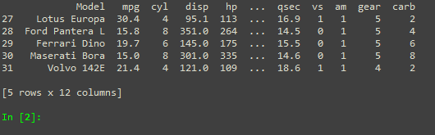

Last 5 rows (tail) of cars.csv in IPython Console

Problem 2

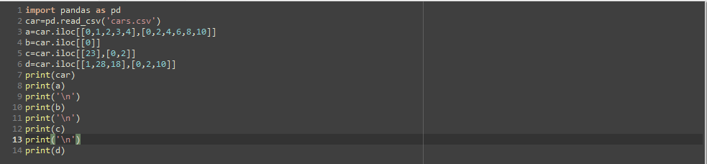

Script file

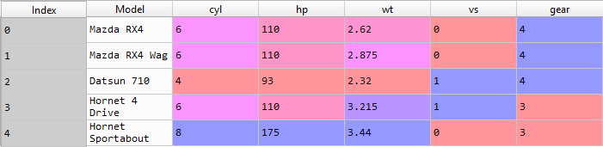

The 1st five rows with odd-numbered columns

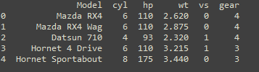

The 1st five rows with odd-numbered columns in IPython Console



The row that contains the “Mazda RX4”



The row that contains the “Mazda RX4’ in IPython Console



The number of cylinders the “Camaro Z28” has



The number of cylinders the “Camaro Z28” has in IPython Console

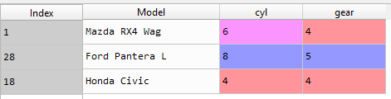

The car models “Mazda RX4 Wag”, “Ford Pantera L”, and “Honda Civic” and the number of cylinders and gear type they have

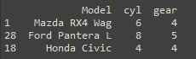

The car models “Mazda RX4 Wag”, “Ford Pantera L”, and “Honda Civic” and the number of cylinders and gear type they have in IPython Console