**VIETNAM NATIONAL UNIVERSITY HCMC**

**INTERNATIONAL UNIVERSITY**



 School of Computer Science and Engineering

**PROJECT REPORT**

### Principles of Database Management

**BAKERY ORDER MANAGEMENT**

|  |  |  |  |
| --- | --- | --- | --- |
| **No.** | **Full Name** | **Student ID** | **Evaluation (%)** |
| 1 | Nguyễn Minh Việt | ITDSIU21130 | 50% |
| 2 | Nguyễn Quốc Huy | ITDSIU21067 | 50% |

**COURSE:** Principles of Database Management_S1_24G1L2-Tue-Afternoon

**INSTRUCTOR:** N. Q. Phú

Table of Contents

**I. INTRODUCTION3**

**II. IDEA BRAINSTORMING AND PROCEDURES3**

1. Elements in the database3

2. ER model4

3. View in database4

4. Conversion from ER model to relational model5

5. SQL Server Management Studio6

6. Random data generation8

7. Java coding14

8. Outcome application17

**III. CONCLUSION19**

**IV. REFERENCE19**

1. **INTRODUCTION**

Cake has become an integral part of many joyous celebrations, delighting taste buds and marking milestones with its sugary embrace. As indulgent as it may seem, the demand for cake knows no bounds. From birthdays to anniversaries, people place orders for cakes on a daily basis, creating a desired market for bakeries to flourish.

Recognizing the need to efficiently manage these cake orders, this project emerges, harnessing the power of Java, SQL, and Python to create and validate a cohesive and comprehensive database, and GUI to log in a management account that allows plug-in queries to access the data.

This report runs through the procedure of identifying the entities for the ERD and relational database, generating random data for the database, creating a new query, importing all the data, and implementing the Java code for accessing the database through GUI.

1. **IDEA BRAINSTORMING AND PROCEDURES**
2. **Elements in the database:**

The list of entities contains within the bakery management system:

* ‘baker’: the assigned staff to complete the order.
* ‘cake’: the requested cake and related information.
* ‘bakery’: Leila bakery branch sites that take customer's orders and assign a baker to follow the requested order.
* ‘buyerdata’: the customer information.

Required attributes have been assigned to each entity, including selecting the primary keys.

The relationship between each entity is as follows:

* One-to-many: Each type of cake can have many customers placing orders.
* One-to-many: Each baker can be assigned to complete multiple cakes.
* Many-to-many: Different bakery sites can put a lot of types of cake up for sale.
* All participations are set to mandatory.

1. **ER model:**

An Entity Relationship Diagram, also known as an ERD or ER Model, is a flowchart type that illustrates how entities relate to each other within a system. ER Models depict the interconnectedness of entities, relationships, and their attributes by employing a defined set of symbols such as rectangles, diamonds, ovals, and connecting lines.

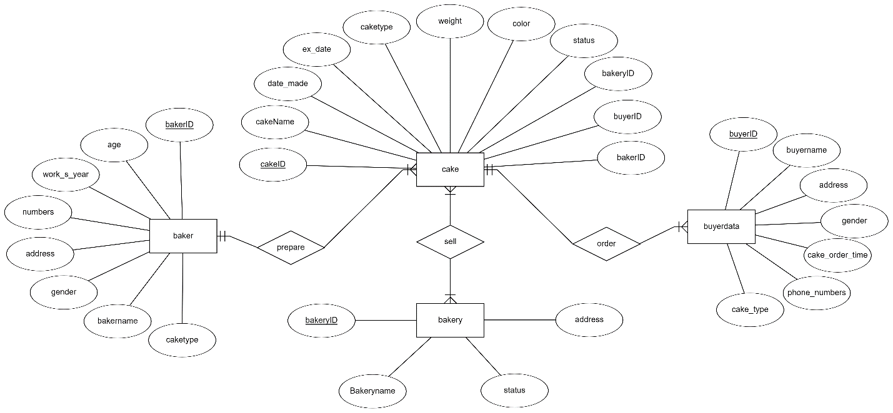

**Figure 1:** ERD of the bakery order management, based on the listed elements in the database

On the grounds of the previous listing of elements in the database, this project defines the four entities, their attributes, and participation to assist in the visualization of the data as shown in Figure 1.

1. **View in database:**

After visualizing the data by using the ERD, the implementation of a relational database is demanded to organize the data efficiently and identify relationships between key data points.

A relational database is a collection of information that is organized in predefined relationships, where data is stored in one or more tables of columns and rows, allowing one to comprehend and gain insights about the relationship between various data points.

This project database demonstrates as following:

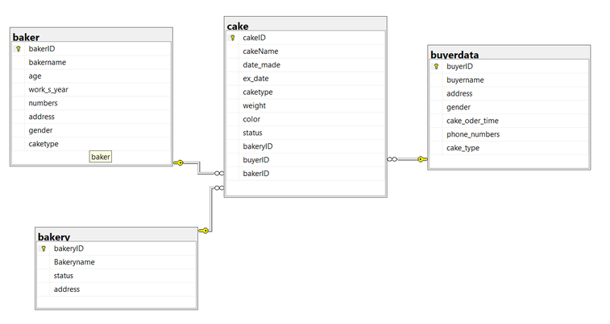

**Figure 2:** The relational database of the bakery management

1. **Conversion from ER model to relational model:**

A relational model is an abstract model used to organize data within a database. In order to control access to a database, write data, run queries, or perform any other tasks related to database management, a database management system must have an underlying model that defines how the data within it are organized.

Based on the ER model, the relationships between elements are depicted.

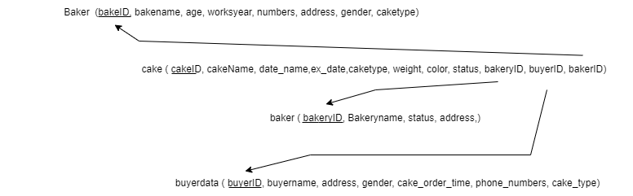

**Figure 3:** The relational model of the bakery management

1. **SQL Server Management Studio:**

According to Microsoft, SQL Server Management Studio (SSMS) is an integrated environment for managing any SQL infrastructure, from SQL Server to Azure SQL Database. SSMS provides tools to configure, monitor, and administer instances of SQL Server and databases. Use SSMS to deploy, monitor, and upgrade the data-tier components used by your applications and build queries and scripts.

**Figure 2:** SSMS

SSMS is used as the building platform of the database:

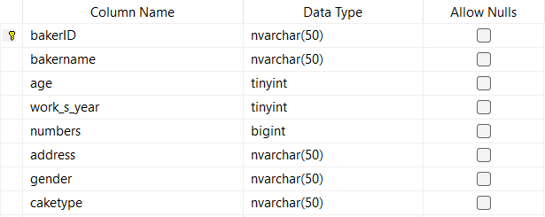

**Figure 4:** baker table attributes

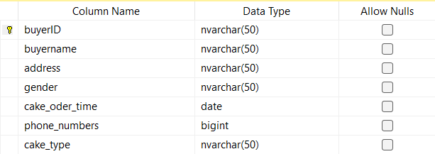

**Figure 5:** buyerdata table attributes

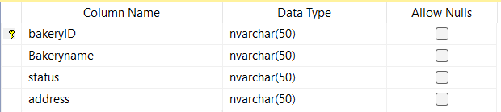

**Figure 6:** bakery table attributes

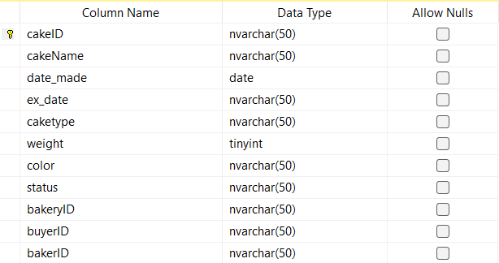

**Figure 7:** cake table attributes

All four tables have been defined with sets of attributes, their data type, and the primary keys.

1. **Random data generation:**

To simulate the scenario, this project data is arbitrarily generated to produce a substantial sample amount via Python. After generating the sample data, they are imported into an Excel spreadsheet and then converted to a CSV file. The data is manually organized to prevent null cells. After reorganization, the data is imported onto SSMS.

Data generation:

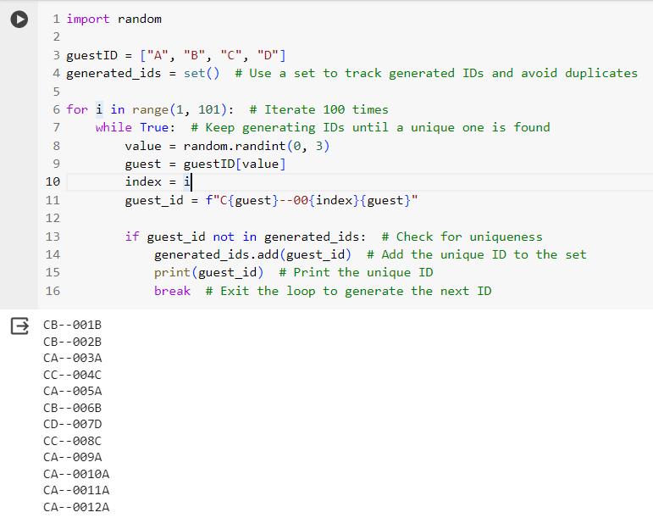

**Figure 8:** IDs generation functions

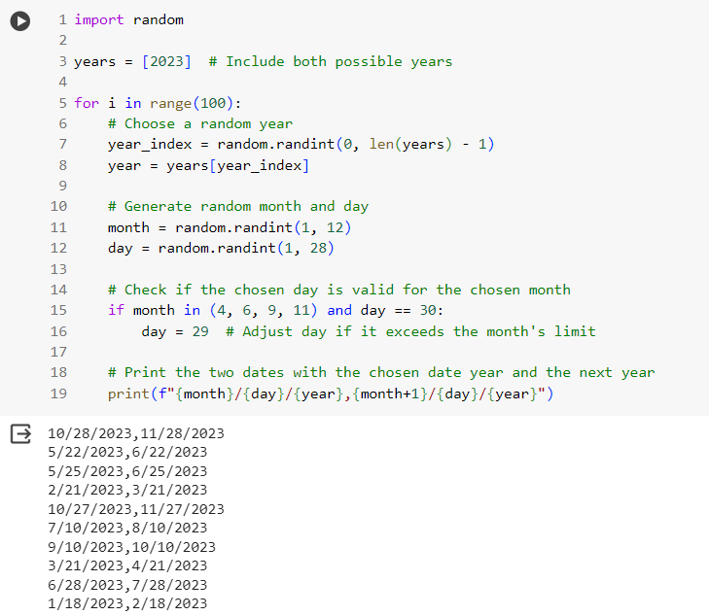

**Figure 9:** dates generation functions

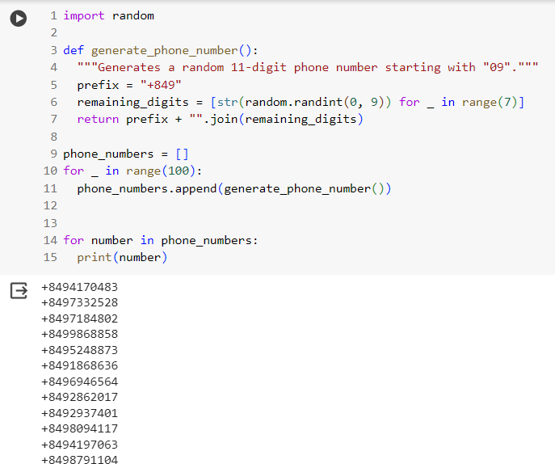

**Figure 10:** phone numbers generation functions

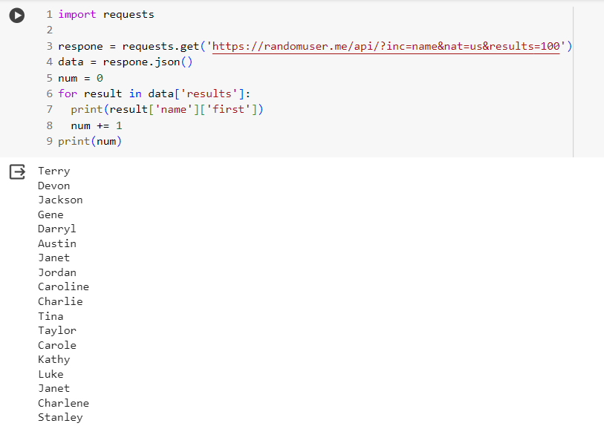

**Figure 11:** names generation functions

Excel import:

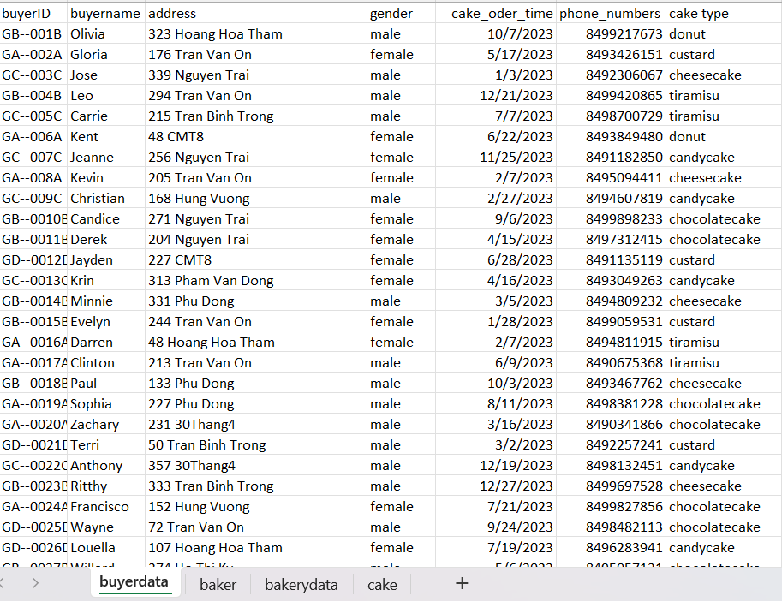

**Figure 12:** buyerdata data

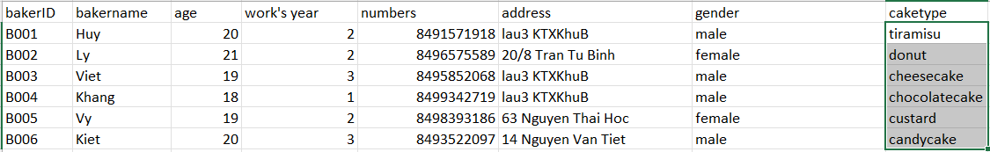

**Figure 13:** baker data

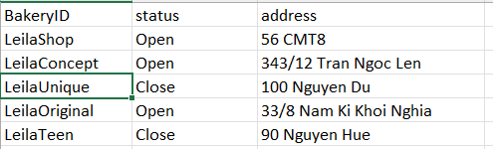

**Figure 14:** bakery data

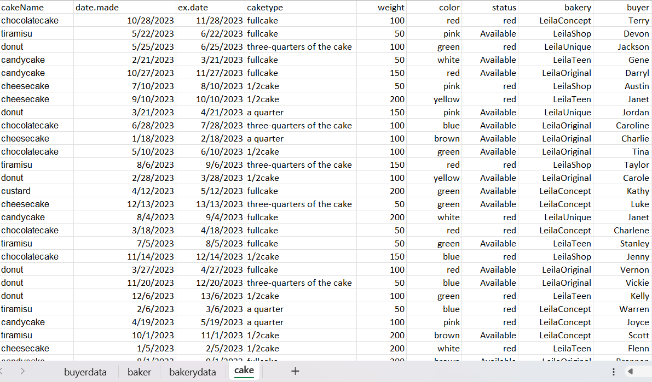

**Figure 15:** cake data

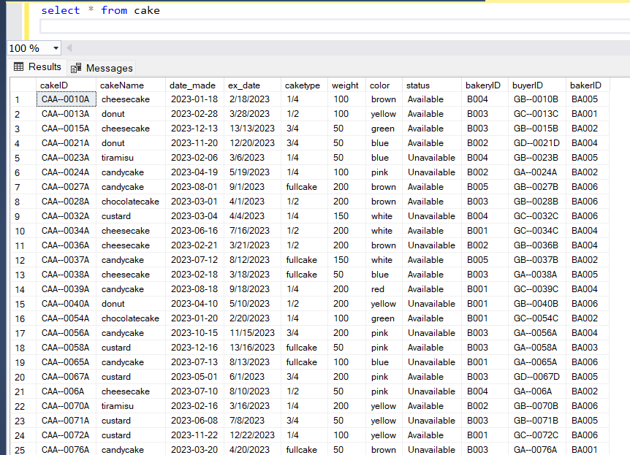

**Figure 16:** Data entry

After importing sample data to SQL, the database is finally prepared and qualified to be used and called from the JDBC.

1. **Java coding:**

JDBC stands for Java Database Connectivity. JDBC is a standard Java API used to write programs required to access databases and connect and execute the query with the database.

**Figure 17:** Database application design with Java

JDBC API is an approach to handling databases that can perform the following activities:

* Connect to the database.
* Execute queries and update statements to the database.
* Retrieve the results received from the database.

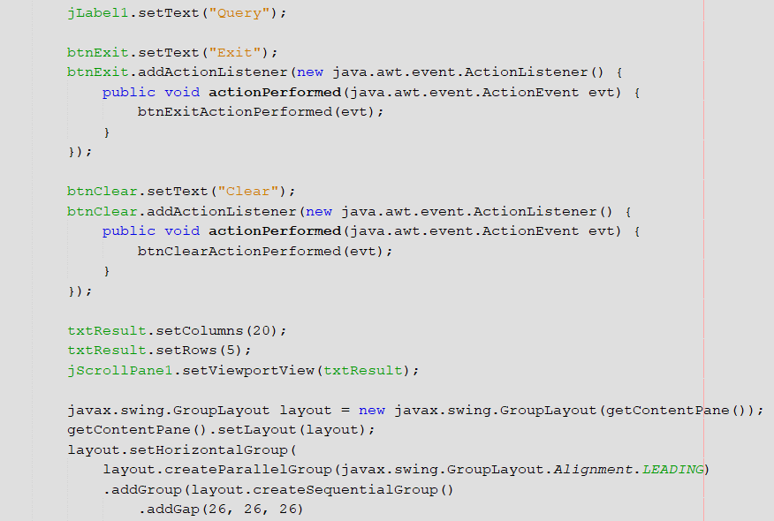

**Figure 18:** Login GUI

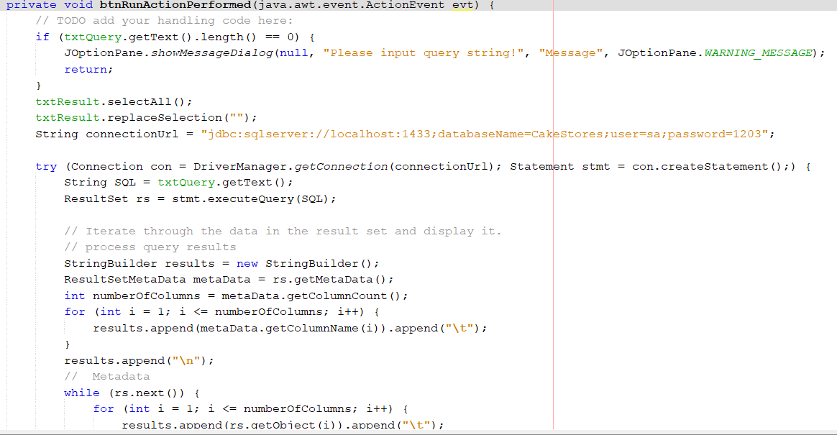

**Figure 19:** Login GUI

The GUI is implemented subsequently to form the login and management interfaces with ancillary box messages and functions.

1. **Outcome application:**

The project should be fundamentally complete at this point and the outcome is shown below:

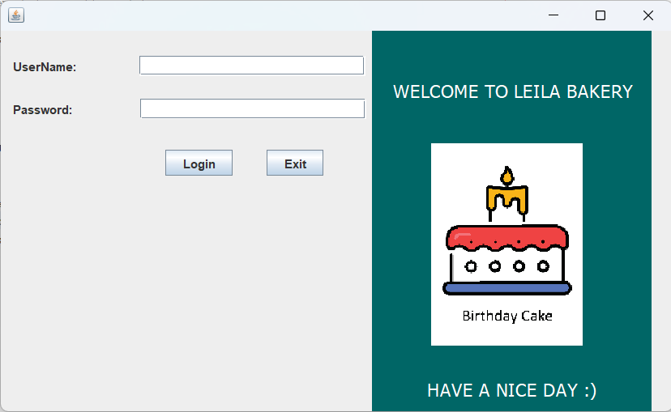

**Figure 20:** Login interface

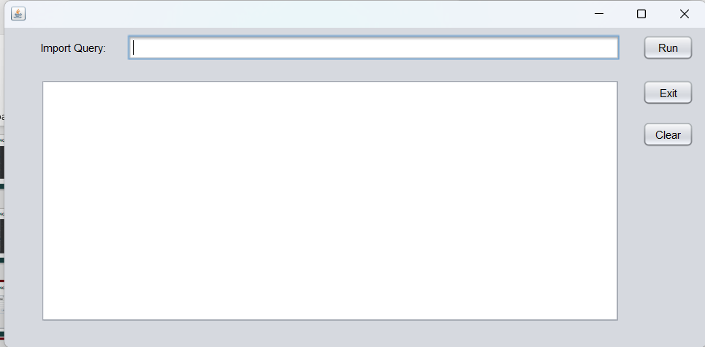

**Figure 21:** Management interface with a text box to input desired queries

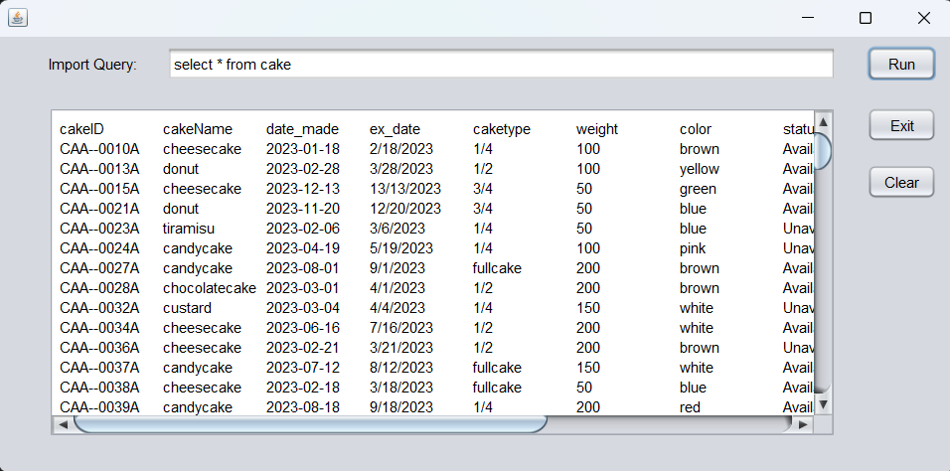

**Figure 22:** cake database

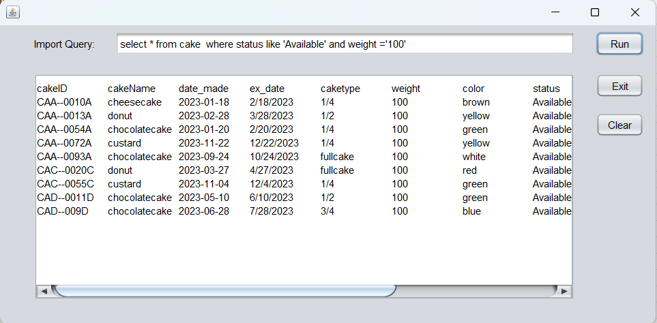

**Figure 23:** Filter cake database where they are “Available” and weight “100”

In the instance when the staff requests to check if there are any available cakes with a weight of 100, a SELECT statement can be used to choose the ‘cake’ database, stating WHERE to select columns ‘status’ and ‘weight’ with desired values as shown in Figure 23.

*select * from cake where status like ‘Available’ and weight=’100’*

1. **CONCLUSION**

In the instance when the staff requests to check if there are any available cakes with a weight of 100, a SELECT statement can be used to choose the ‘cake’ database, stating WHERE to select columns ‘status’ and ‘weight’ with desired values as shown in Figure 23.

The project is simple but runnable applying fundamental knowledge and related skills in the field. Therefore, there is potential room for growth. For instance, the database can be improved to be more efficient, applying data normalization (e.g. 1NF, 2NF, 3NF, BCNF), and additional tables for more detailed data. About the login screen, this project simulates the scenario where the system is used by a staff member. For improvement, it may have the feature to allow additional accounts for the staves and managers, bakers, and customers.

Link to GitHub of the project:

<https://github.com/JamesN883/PDM_BakeryManagement/tree/main>

Link to recorded presentation:

<https://www.youtube.com/watch?v=ZG_ravyEXdg&ab_channel=HuyNguy%E1%BB%85n>

1. **REFERENCE**

**[1]** **Adding Functionality to Buttons: A Beginners Guide**

<https://www.netbeans.info/kb/articles/gui-functionality.html>

**[2]** **Cách chuyển đổi Excel sang file CSV và xuất các tệp Excel sang định dạng CSV UTF-8**

<https://blog.hocexcel.online/cach-chuyen-doi-excel-sang-csv-va-xuat-cac-tep-excel-sang-dinh-dang-csv-utf-8.html>

**[3] Data Normalization: Definition, Importance, and Advantages**

https://coresignal.com/blog/data-normalization/

**[4] Description of the database normalization basics**

https://learn.microsoft.com/en-us/office/troubleshoot/access/database-normalization-description

**[5] Download SQL Server Management Studio (SSMS)**

<https://learn.microsoft.com/en-us/sql/ssms/download-sql-server-management-studio-ssms?view=sql-server-ver16>

**[6]** **How to Connect to Microsoft SQL Server in NetBeans IDE**

<https://www.youtube.com/watch?v=a1WCD6Pdjt4&ab_channel=CodeJava>

**[7] Java JDBC Tutorial**

https://www.javatpoint.com/java-jdbc

**[8]** **JAVA - How To Design Login And Register Form In Java Netbeans**

<https://www.youtube.com/watch?v=jHSBrX8lLWk>

**[9]** **Kết nối Java với SQL Server**

<https://viettuts.vn/java-jdbc/ket-noi-java-voi-sqlserver>

**[10]** **Kết nối Netbeans với SQL Server**

<https://www.youtube.com/watch?v=j7ByKpXxsdE&ab_channel=th%C3%A2ntri%E1%BB%87u>

**[11]** **Login Form Java**

<https://www.javatpoint.com/login-form-java>