DriverPass System Design Document

Prepared by James Sinnott-Nadasky for DriverPass. This document builds on the business requirements document from Project One and gives the development team the UML models and technical requirements needed to build the DriverPass system.

UML Diagrams

UML Use Case Diagram

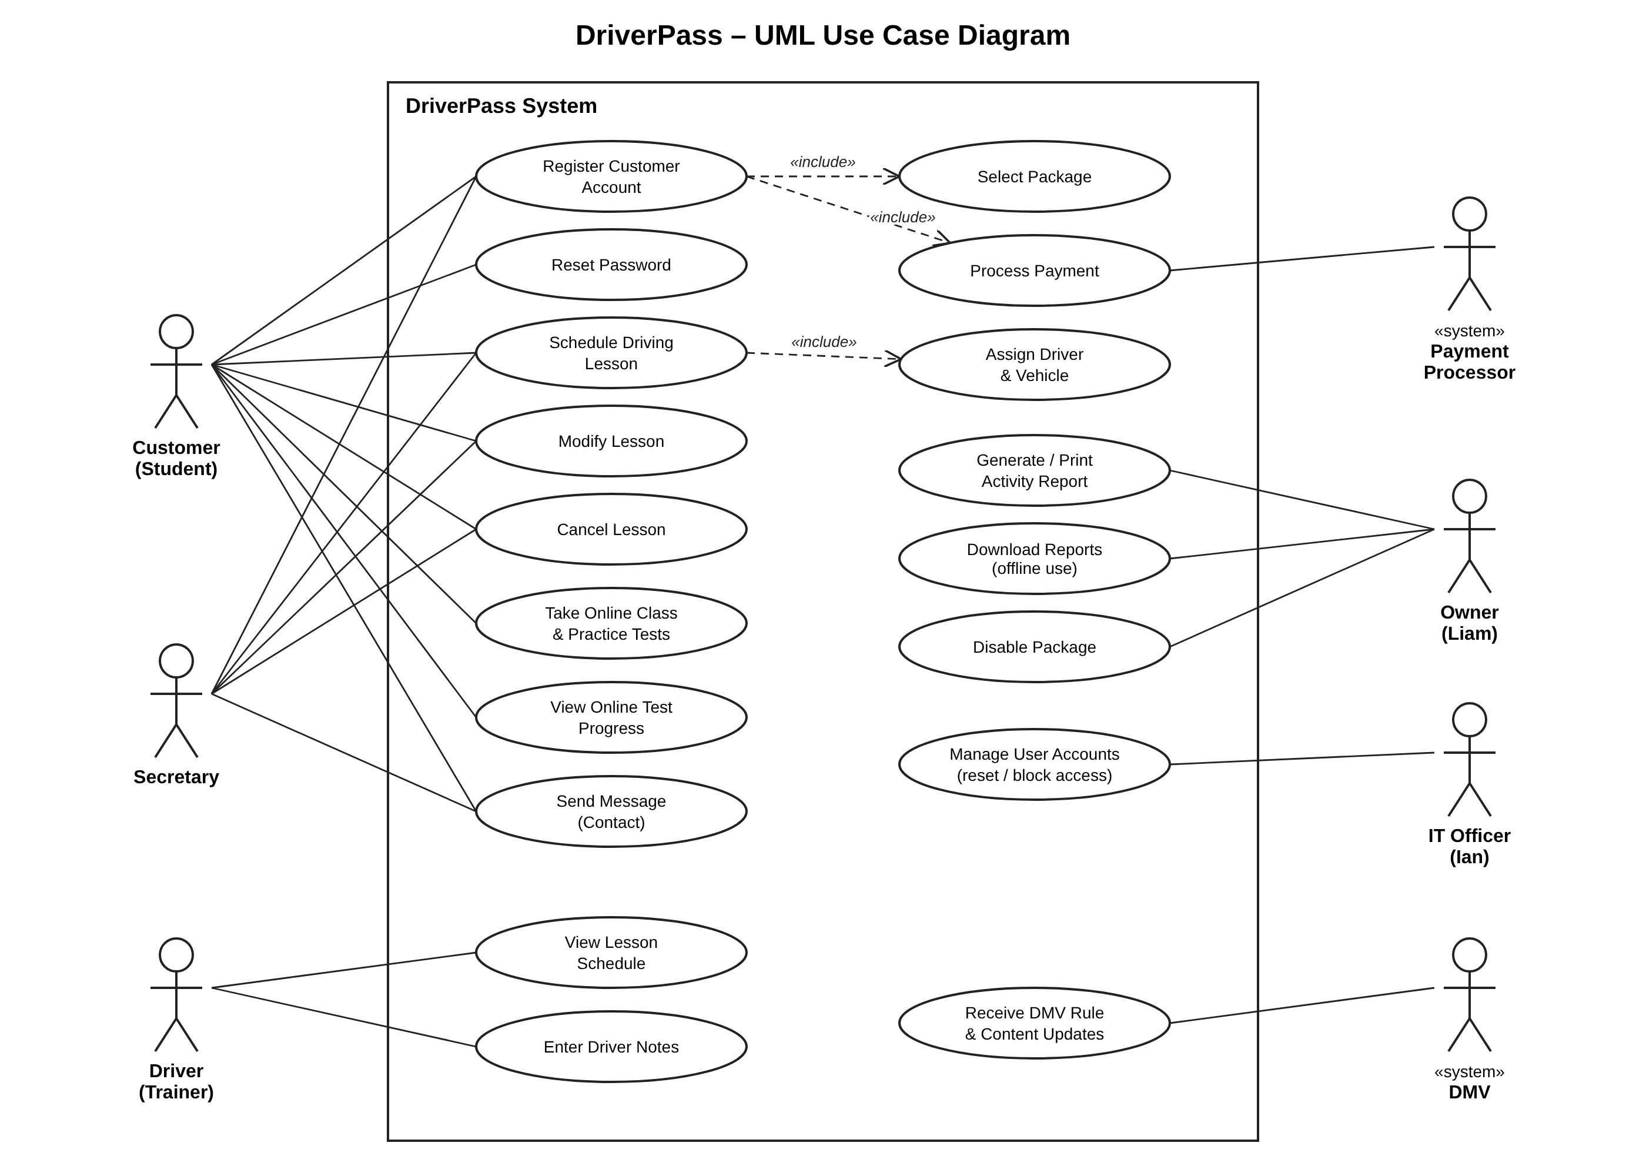
Figure 1. DriverPass UML use case diagram
The use case diagram shows seven actors. Customers and the secretary share the reservation use cases (register, schedule, modify, and cancel), so lessons can be booked online or over the phone. Registering a customer includes selecting a package and processing payment, and scheduling a lesson includes assigning a driver and vehicle. Drivers view their schedules and enter lesson notes. The owner prints activity reports, downloads reports for offline use, and disables packages. The IT officer manages user accounts. The DMV and the payment processor are external systems.

UML Activity Diagrams

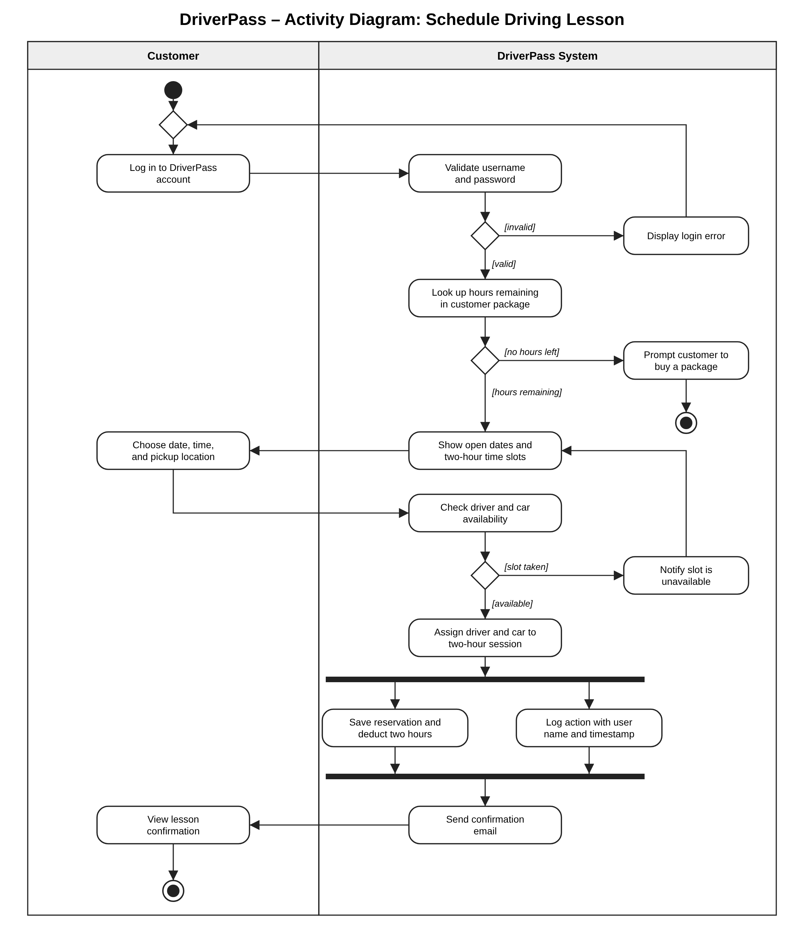
Figure 2. Activity diagram for the Schedule Driving Lesson use case
The first activity diagram follows a customer booking a lesson online. After the login is validated, the system checks that the customer has hours remaining, shows only open two-hour slots, and confirms that a driver and car are free. If the slot is taken, the flow loops back to the available times. Saving the reservation and logging who made it happen in parallel, which gives Liam the record of who made each reservation.
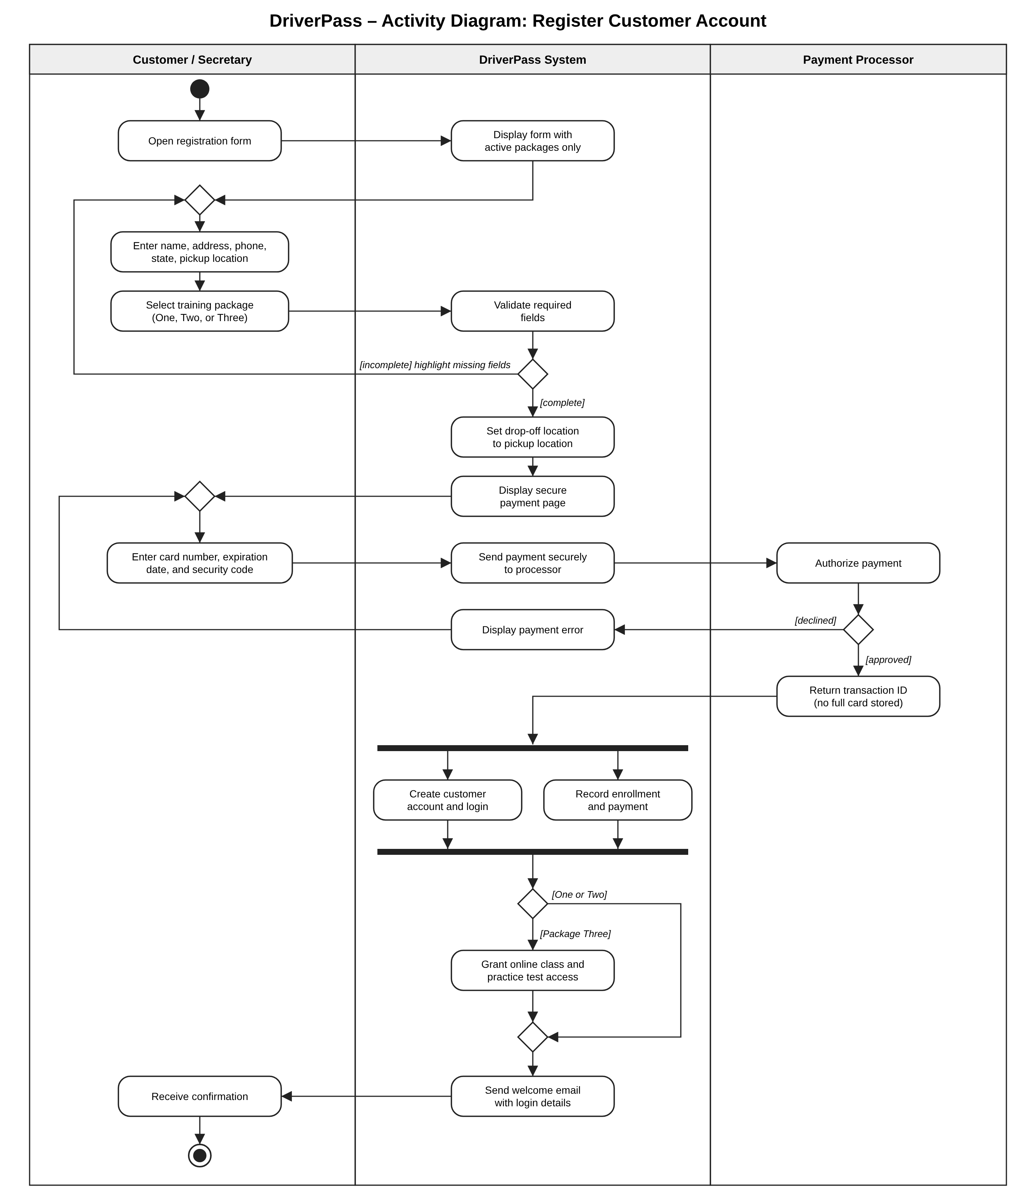
Figure 3. Activity diagram for the Register Customer Account use case
The second activity diagram covers registration by a customer online or by the secretary on the customer's behalf. Only active packages are offered, missing fields send the user back to the form, and the drop-off location is set to the pickup location. The payment processor authorizes the card so that DriverPass never stores the full card number. After approval, the account and enrollment are created in parallel, and Package Three customers are also given access to the online class and practice tests.

UML Sequence Diagram

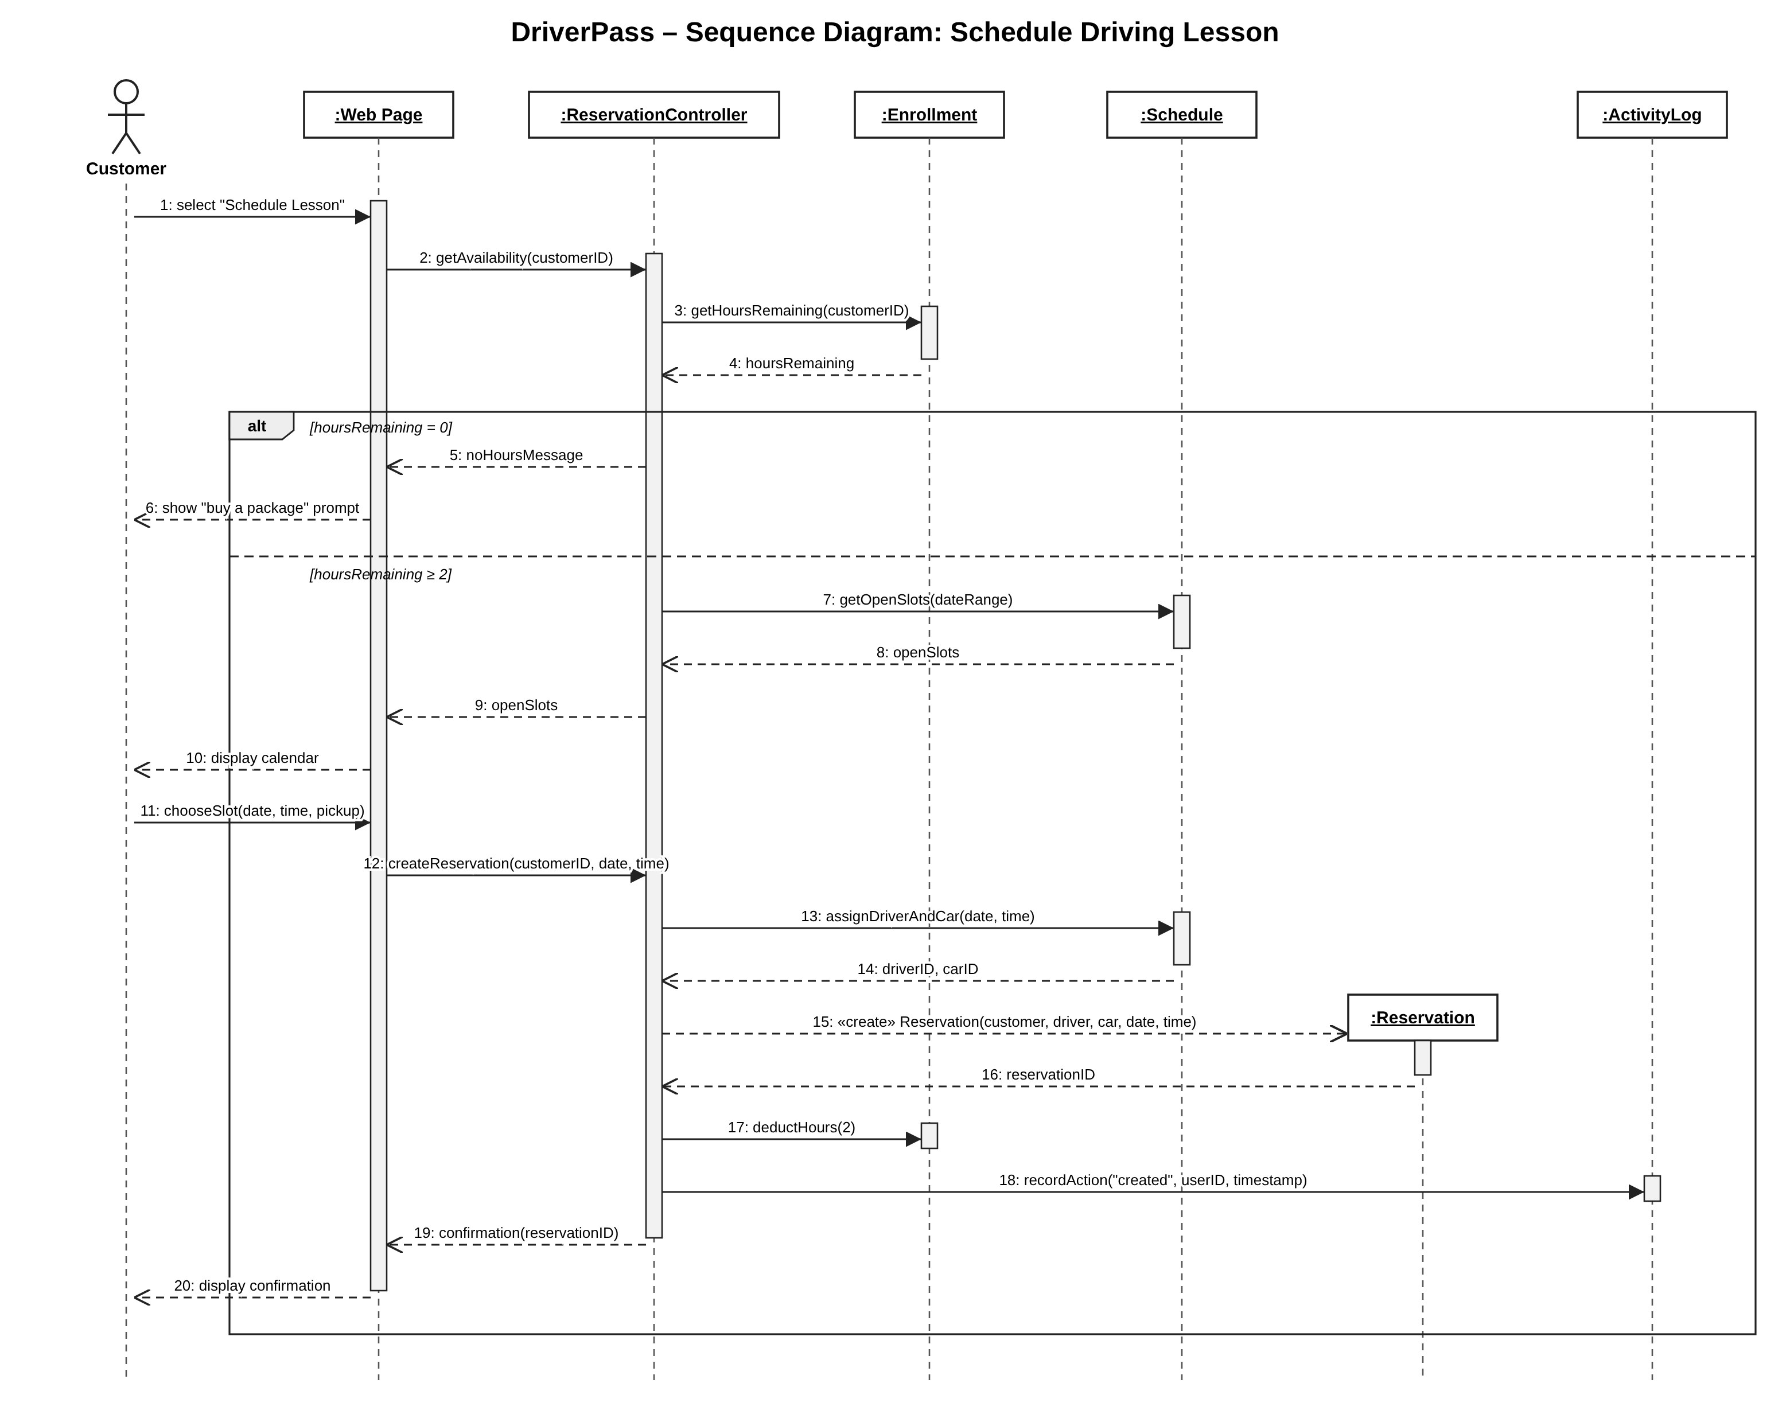
Figure 4. Sequence diagram for the Schedule Driving Lesson use case
This diagram shows the messages passed between objects when a customer books a lesson. The ReservationController first checks the customer's Enrollment for hours remaining. The alt fragment covers both outcomes: with no hours left the customer is prompted to buy a package, and otherwise the Schedule returns open slots. When the customer picks a slot, the controller has the Schedule assign a driver and car, creates the Reservation, deducts two hours from the Enrollment, and records the action in the ActivityLog before confirming the booking.

UML Class Diagram

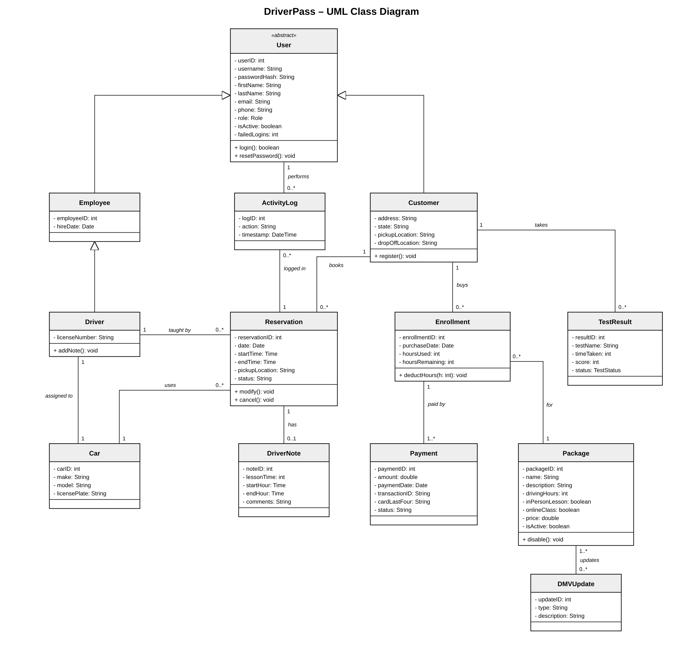
Figure 5. DriverPass UML class diagram
User is an abstract class that holds the login and contact attributes shared by everyone. Customer and Employee inherit from it, and Driver inherits from Employee. A Customer buys one or more Enrollments, each tied to one Package and paid for by one or more Payments. Hours used and hours remaining are tracked on the Enrollment, so a package can be split into two-hour Reservations. Each Reservation links one Customer to one Driver and one Car, can have one DriverNote, and generates ActivityLog entries that record who acted and when. TestResult stores online test progress for Package Three customers, the isActive attribute on Package lets the owner disable a package, and DMVUpdate records the DMV changes that apply to the packages.

Technical Requirements
DriverPass will be a web application hosted in the cloud. The diagrams above describe what it has to do. The requirements below cover the hardware, software, tools, and infrastructure needed to build and run it.

Hardware
Client devices: Users need only a desktop, laptop, tablet, or smartphone with a current web browser and an internet connection. Nothing is installed locally, which meets Liam's request that he and his staff be able to work from any location rather than only from the office.
Office equipment: The secretary needs a computer and a phone line to register customers and book lessons for people who call or walk in. A printer is needed so the owner can print activity reports.
Server hardware: DriverPass will not buy or maintain servers. All compute, storage, and networking hardware is supplied by the cloud provider, which follows Liam's decision to leave backups and server security to the provider.

Software
Front end: A responsive web interface built with HTML5, CSS, and JavaScript (for example, React). It must work in current versions of Chrome, Edge, Firefox, and Safari on Windows, macOS, iOS, and Android, and adapt its layout to phone, tablet, and desktop screens.
Back end: An application server (for example, Java with Spring Boot, or Node.js) that implements the classes in the class diagram: User, Customer, Employee, Driver, Reservation, Enrollment, Package, Payment, Car, DriverNote, TestResult, ActivityLog, and DMVUpdate. The ReservationController in the sequence diagram is part of this layer. It checks hours remaining, assigns drivers and cars, and writes to the activity log.
Database: A managed relational database (for example, PostgreSQL or MySQL) with a table for each class in the class diagram. Foreign keys and a unique constraint on driver, car, date, and start time keep a driver or car from being booked twice for the same slot.
Authentication and access control: Role-based access for the customer, secretary, driver, owner, and IT officer roles. Passwords are stored as salted hashes (for example, bcrypt). Accounts lock after five failed login attempts, and forgotten passwords are reset through an emailed link. The IT officer has an administration page for resetting, blocking, and changing accounts.
Integrations: A PCI DSS compliant payment processor (for example, Stripe or Square) authorizes card payments so that DriverPass stores only a transaction ID and the last four card digits. An email service sends confirmations and password resets. An interface to the DMV, such as a data feed or notification service, delivers rule, policy, and sample question updates, which are stored as DMVUpdate records.
Reporting: A reporting module that builds the owner's activity report from the ActivityLog table and exports reports as .xlsx or .csv files. Downloaded reports can be opened in Excel offline, while data can only be changed online.

Tools
Design and modeling: Lucidchart for the UML use case, activity, sequence, and class diagrams in this document.
Development: An IDE such as Visual Studio Code or IntelliJ IDEA, Git with a hosted repository (for example, GitHub) for version control, and a CI/CD pipeline that runs automated tests before each deployment.
Testing: Unit testing (for example, JUnit or Jest), browser testing on desktop and mobile, and load testing to confirm that pages respond within about three seconds.
Project management: A task tracker such as Jira or Trello to manage the schedule from requirements gathering to the May 10 sign-off.

Infrastructure
Cloud hosting: A public cloud platform such as AWS, Microsoft Azure, or Google Cloud, running the application server, managed database, and file storage for online class content. The provider handles automated daily backups, operating system patching, and physical security.
Availability and scaling: The system must be available 24 hours a day, so it should run in at least two availability zones behind a load balancer, with autoscaling to handle growth past the current 10 cars and drivers. Maintenance is scheduled for low-usage hours.
Network security: All traffic is encrypted with HTTPS (TLS 1.2 or later). A firewall or web application firewall protects the application, and the database is reachable only from the application servers.
Logging and monitoring: Every create, modify, and cancel action on a reservation is written to the activity log with the user and a timestamp. The cloud provider's monitoring tools alert the IT officer to outages, errors, and repeated failed logins.

