Final Capstone Full Report

James Wright
CIS480: Data Analytics & Programming Capstone
Dr. Kazuaki Kashihara
May 1, 2026

Final Capstone Full Report
Introduction and Rationale
One of the primary commodities in knit and crochet markets are patterns – i.e., instructions for making a knit or crochet item, similar to a recipe for cooking. Hosting over one million patterns and more than three million active users, Ravelry is a central hub for the fiber arts community, and for most independent pattern designers, it’s where they make the most sales (Eckman, 2021). But what pattern attributes help businesses and independent designers maximize sales revenue?
The well-organized categorization and tagging system that Ravelry offers and provides access to through their API makes them a great source for data which can help address this question. I intend to collect relevant data through the Ravelry API; clean, filter, transform, and engineer the features as necessary; and try multiple different regression models to determine which ones most accurately predict sales. A selection of best models will then go through hyperparameter tuning and further experimentation with different data preprocessing approaches. The result will be a useful predictive model that takes a set of pattern attributes, including price, and predicts sales (which, since I’m working with time-series data, will likely be approximate per week or per day expectations). By repeatedly sending the same pattern attributes through the trained model with a different price each time, we can get sales estimates for a pattern at different price points, ultimately providing the opportunity to estimate which price will maximize overall revenue. Additionally, exploring the relationships between different features and overall revenue can give a better picture of which kinds of patterns sell better in general. Issues of pricing optimization are near-ubiquitous in the business world, so while this project relates specifically to knit and crochet pattern pricing, the overall process relates broadly to a problem faced by most businesses.
The output of this project – a pricing optimization model along with observed relationships between pattern attributes and revenue – will be useful for pattern design planning for both independent designers and small-to-large businesses. However, the scope of this project does not include ongoing re-training to address model drift. Text mining processes (e.g., pulling keywords from the title or description of a pattern to use as features) are also beyond the scope of this project.

Feasibility and Next Steps
I already have a working script to pull data from Ravelry through their API, though I will need to alter it to get all the data I need for this project. The speed of downloading data through that method is a concern and may limit the number of records I want to retrieve. However, I expect that more recent data (from the past year or two) will be more relevant for my model than historical data. I am first going to tinker with the script to get the fields I need, then download 20,000 or so records to check that everything is working and see how much time it takes. Once I have confirmed the output is what I want and have estimated the number of records I can retrieve in a reasonable timespan, I will pull all of the records I want to use. Thankfully, Ravelry provides pretty open ready-only connection to their database, so data access for this project is not a concern.
One unfortunate limitation is that Ravelry does not publish the number of copies a pattern has sold, so I will be using the number of user-created projects associated with a pattern as a proxy for its sales. Many people purchase patterns and then don’t end up actually making anything – or do make a project, but don’t post it – and users may post multiple projects made using a pattern despite only having purchased it once. On the whole, posted projects generally represent only a small fraction of pattern copies actually sold. That being said, I have no reason to believe the ratio of copies sold to projects posted would be imbalanced across different pattern categories for any reason. One might guess that newly-published patterns would be affected, since customers may not have had time to finish and post a project. However, it is common practice on Ravelry to start a project page when starting a project, so incomplete and recently-started projects will also show up in my data collection. I do not expect inconsistencies in projects-to-sales ratios to be significant enough to disqualify this method of estimation. Ideally, I would have actual sales figures, but lacking that, I think this is a suitable and appropriate – if imperfect – proxy.
This project involves publicly published, publicly accessible data, none of which is sensitive. However, Ravelry is an all-ages website. In order to sell patterns directly on Ravelry, users must connect a PayPal account, which requires being at least 18 years old (“PayPal User Agreement,” 2026). But patterns listed on Ravelry may also link to an external site (such as Etsy, LoveCrafts, PayHip, or a personal website) for purchase, and external sites may not require age verification of any kind. Users who simply post their projects – and are not selling patterns – may be of any age. All of this means I will inevitably be collecting some data from users under the age of 13. However, user-posted project data will only be collected insofar as one user’s project affects the number of total projects associated with a pattern – no photos, usernames, notes, or any other data will be collected from project pages. User-posted pattern data will not be sensitive or personally identifiable. Additionally, this data is not being used to target advertising or other activities toward children: in fact, minors’ data is expected to make up a small minority of the total data collected, and this project as a whole is not oriented toward insights regarding children. No harm or risk to children or any other individuals is expected as a result of this project. These factors address many common concerns related to collection and use of childrens’ data and ultimately lead me to conclude that no special considerations need to be made regarding the collection and use of data – including data posted by children – in this project (Verhulst & Young, n.d.; “Principles,” n.d.; Facca, et al., 2020).
My main concern regarding the scope/feasibility of this project is the time-series nature of the data, which I am not experienced with for this kind of project. I’m likely going to need to do extra trial-and-error to figure out ideal data preprocessing and feature engineering. Right off the bat, I’m planning to divide estimated sales by days-since-publication to get an approximate sales rate. If I have multiple years of data to work with, I intend to try weighting the model to value more recent data more heavily and see how that affects its performance. While date data will naturally be an essentially continuous variable, I think it could be helpful to add a “season” variable (by which I mean, set of dummy variables) as well to better track seasonal differences.
For train/validate/test sets, I’m thinking I will split my training set into a training set + validation set with the validation set being 6 months of data just before the test set begins; use the validation set for evaluation and hyperparameter tuning; and then train the final model on the full training + validation set before evaluating on the test set.
Next steps for this project include hypothesis formation, literature review, and beginning the process of updating my API collection script as detailed above.

Hypothesis and Literature Review
Literature Review
Even very experienced and well-respected crochet or knit pattern designers find pricing their work to be a struggle, trying to balance the very real costs of pattern production and marketing with relatively low consumer price expectations (Teague-Long, 2019). Increasing prices might increase income, but it could just as easily decrease income due to lowered sales. Some crafters express a complete refusal to pay above a certain price for any pattern, regardless of its qualities, due to 1) their proclivity to buy a pattern and then not end up making the item; and/or 2) the amount of alterations they expect to make to a pattern – particularly in regards to garments, many people have figured out what fits them best and will inevitably be doing significant math to adjust the “default” fit of any pattern they purchase (“How Much Should Knitwear Designers Charge for Their Patterns?,” 2024). Part of the value of a pattern is that someone else has already figured out the math, so knowing you will need to re-do and adjust some of it makes high prices less worth it. To date, there do not seem to be any publicly available systematic approaches to help designers determine what price will likely maximize revenue for a given pattern. In endeavoring to bridge this gap, it’s worth reviewing current pricing recommendations and considerations that designers have developed based on their experiences.
Pattern pricing is generally based on a designer’s subjective assessment of their own brand strength, pattern complexity, pattern uniqueness, and any additional, non-standard elements such as a chart, accompanying video, or extensive photo tutorial (Grice, n.d.). Patterns that align with current aesthetic trends may also command a higher price (“Pricing Your Knitting Patterns,” 2025).
Of these elements, one of the most crucial is complexity, which can include colorwork, lace, or cabling elements; multiple sizes offered that require grading and testing; or unusual or innovative techniques. Easier patterns typically require less effort to create, are faster to make a sample for, and target less experienced or more casual crafters. They compete in a more crowded and oversaturated market with a target demographic that tends to be hesitant to invest a lot of money. On the other hand, complex patterns take more time and labor to design and create a sample, targeting a smaller audience that is more willing to pay for high-quality patterns (“How to Price Crochet Patterns,” 2025). According to the Craft Industry Alliance 2025 survey, knitters knit more frequently than crocheters and are more likely to report an “Intermediate,” “Advanced,” “Expert,” or “Professional” level of knitting ability. Crochet ability is more likely to be self-reported as “Beginner.” This could be bias in the survey’s relatively small sample; however, Ravelry project numbers indicate that 4x more knit projects are made than crochet projects, and a significantly higher percentage of knit projects are in the Clothing category, which is often considered a higher-commitment, higher-skill category (though of course this is not always true). If knitters generally consider themselves more committed and skilled, they may be more likely to pay for higher-priced patterns, especially since there is often a correlation between pattern complexity and price. If crocheters tend to be more casual or “beginner,” high-priced crochet patterns may be disproportionately less popular (Glassenberg, 2025).
Additionally, the cost of yarn used in a project is worth consideration, both as a cost of business that needs to be recouped and as a factor in relating to a given target audience. The cost of a pattern can be seen in context with the overall price of a project; for a small project that uses inexpensive yarn, a $5 pattern could cost more than the yarn itself, which is not a favorable ratio. On the other hand, for larger projects like sweaters or blankets, or patterns whose samples are made in a luxury fiber, the cost of yarn is higher, and therefore the cost of a pattern can be higher while remaining a small portion of the overall project cost. While any pattern can be made with any type of yarn, 1) different fibers have different qualities, and you can often get a better result by using a pattern that is designed for the type of yarn you want to use; 2) people sometimes like to replicate a pattern sample by using the same exact yarn and prefer to only use patterns which use yarn types they prefer; and 3) pattern samples look different in different fibers and can be more visually appealing/unappealing depending on whether someone enjoys the fiber. Pattern samples made in luxury fibers in particular may appeal more to a higher-spending audience and can justify higher prices if marketed correctly (“How to Price Crochet Patterns,” 2025). In 2024, the Craft Industry Alliance reported that the most-preferred fiber by knitters and crocheters was wool, with 41% of their more than 7,000 respondents indicating that it was their preferred fiber. Only 2% indicated that “Luxury” yarns are their preference (Glassenberg, 2024). There is some unclarity in the fact that wool and luxury yarns are not mutually exclusive, and many wool enthusiasts often use merino wool or other luxury-priced wool yarns. So, it will be interesting to see how fiber types affect a pattern’s sales volume in the regression analysis.
Altogether, it can be expected that a pattern’s price will increase based on how well-established a designer is, how complex the pattern is, and what fiber types are used in the pattern sample. Different designers target different consumer audiences (e.g., beginners looking for easy, inexpensive patterns vs. advanced crafters looking for complex, luxurious items that may be priced higher but are perceived as worth it), and there remains a question of which audience is more likely to be profitable to cater to. Additionally, I hope to explore the trade-offs between pricing higher to get more money from each sale vs. the possibility of a higher price scaring away some customers, ultimately reducing revenue.

Hypothesis Development
Research Question: Do high-priced knit patterns sell disproportionately better than high-priced crochet patterns? (One-tailed)
Null Hypothesis (H₀): High-priced knit patterns do not sell disproportionately better than high-priced crochet patterns. (E.g., if low-priced knit patterns sell 50% better than low-priced crochet patterns, high-priced knit patterns sell 50% better than high-priced crochet patterns as well.)
Alternative Hypothesis (H₁): High-priced knit patterns sell disproportionately better than high-priced crochet patterns. (E.g., if low-priced knit patterns sell 50% better than low-priced crochet patterns, high-priced knit patterns sell 80% better than high-priced crochet patterns.)
Model: Linear regression with sales as the dependent variable and an interaction term between price and knit-vs-crochet status included in the independent variables.
Rationale: Knitters tend to be more committed and consider themselves more skilled on average, so they may be more likely to pay for higher-priced patterns, especially since there is often a correlation between pattern complexity and price.

Research Question: Do patterns that use/recommend wool yarn sell better than those that don’t? (One-tailed)
Null Hypothesis (H₀): Patterns that use/recommend wool yarn do not sell differently than other patterns.
Alternative Hypothesis (H₁): Patterns that use/recommend wool yarn sell better than other patterns.
Model: Regression model with sales as the dependent variable and gender, pattern category (clothing, accessory, home, etc.), price, and other pattern features used as independent variables.
Rationale: The Craft Industry Alliance 2024 survey indicates that wool is the most preferred yarn type among survey respondents, and the type of yarn recommended or used in a pattern sample relates to different target audiences.

Data Collection and Modeling
Data Collection Strategy
All of the data for this project will come directly from Ravelry’s API (see “Ravelry API Documentation,” 2026). This is the foremost knitting & crochet website and a huge marketplace for pattern sales; additionally, it provides access to its data freely and in a structure amenable to this analysis. The tagging and categorization features lead to a dataset that describes relevant features such as yarn weight, fiber content, and design elements in consistent terms. Only non-discontinued knit or crochet patterns published since 2007 – the year Ravelry launched – will be included; discontinued or historical patterns shared to the site will be excluded. Discontinued patterns obviously provide skewed sales data, as they cannot generate new sales over time, and historical patterns tend to have very low project numbers regardless of how well they sold when published – that it to say, consumer behavior that occurred pre-Ravelry is not well documented on Ravelry.
The following features will be collected, in addition to the target (Number of projects posted by users who have used the pattern):
- Pattern ID
- Date published
- Number of favorites (similar to “likes” on other social media sites)
- Free/paid status (Boolean; free patterns will be used for feature engineering, then removed for modeling)
- UK vs US vs Unknown terminology (for crochet patterns, UK and US stitch notations are significantly different)
- Pattern language(s)
- Yarn fiber(s) recommended (e.g., wool, acrylic, cotton)
- Yarn weight recommended (from thread to jumbo, including “any” and “not specified” options)
- Pattern attributes (these range from fabric features like cables to structural design elements like collar or sleeve type, as relevant)
- Pattern author
- Pattern category (e.g., Clothing, Accessories, Home) and sub-categories (e.g., in Clothing: Sweater, Cardigan, Vest)
- Price
- Number of users who have added the pattern to their queue (generally used to keep track of patterns a user hasn’t started yet but intends to; may or may not have already purchased the pattern; can be a measure of popularity/interest)
- Number and average of ratings (rated by users, from one to five stars)
- Minimum yardage needed (amount of yarn required to make the project)
Two features that must be engineered are the number of total patterns a designer has previously published, and whether or not they have any free patterns available. Some consumers appreciate checking a designer’s writing style before purchasing a pattern, even if they aren’t interested in the free pattern itself, and total number of patterns published can be related to how well-established a designer is. For patterns that aren’t free but also don’t have pricing information available (which may be the case if they are only available for purchase from an external site), these will be treated as free patterns: counted in a designer’s total number of previously released patterns, but then the individual records for these patterns will be dropped before modeling.
Missing attributes are a relevant factor in whether or not a pattern shows up in user searches. For example, a pattern with lace detailing that is not tagged as such will not show up in user searches for lacey patterns, thereby failing to reach potential buyers. In that sense, the features a pattern is tagged with are almost as important as the actual features of the pattern. The lack of appropriate tags is itself relevant to the sales a pattern may garner. While Ravelry’s volunteer base does not consistently input missing feature tags for patterns uploaded without them, they do have methods for correcting wholly inaccurate feature tags; feature tags can be generally considered reliable and accurate, and no effort will be made to fill or alter records where this feature is missing.

Modeling Strategy
The target for this project (sales, using number of user projects posted for each pattern as a proxy) will be averaged relative to the date published feature and data collection date to get an average sales-per-day measure for each pattern, which will be used as the target feature. Independent features for this project will be number of favorites, number of queues, crochet terminology (UK, US, or Unknown; Null indicates a knit pattern), pattern language(s), yarn fiber recommended, yarn weight recommended, pattern attributes, price, minimum yardage needed, pattern subcategory, and the season of publication (derived from the publication date using Northern Hemisphere seasons). Additionally, three engineered features will be used: total number of patterns previously published by the designer (integer), whether or not any previously published patterns were free (Boolean), and a calculated weight to pass to models that values more recent records more strongly.
Pattern attributes, categories, languages, fiber types, yarn weights, and seasons will all need to be converted to dummy variables, so handling a large quantity of features is an important consideration for this regression project. Non-dummy values will be log-transformed as necessary and scaled. Elastic Net and Random Forest regressions will be done first to help pull out the most useful features, which will then be used to experiment with additional models.
Since the goal is ultimately to produce a practical model that has the greatest utility for real-world sales predictions, a variety of additional models – including Polynomial, SVR, Random Forest, and/or AdaBoost models – will be tested to see which perform the best. Then, the best performers will receive additional hyperparameter tuning to get the best performance possible. If the best-performing models do not support feature importance understanding, a simpler model like Elastic Net regression will be used for feature understanding and hypothesis testing while the best-performing model is used for actual sales predictions and price optimization.

Data Visualization and Analysis
In order to prepare the data for visualization, I rounded price to the nearest dollar to get bins with more patterns in them, trying to avoid random spikes from a single unusually-priced (e.g., $8.37) pattern. Additionally, the `days_since_previous_pattern` feature was rounded to the nearest 10 – e.g., 10 days ago, 20 days ago, and so on – to smooth out spikes and make sure there are enough patterns for reliability of each data point. For many of the Boolean columns, I added sort value columns to the model to ensure that “True” always appears on the left and “False” always appears on the right, rather than showing in descending order of median 2-yr revenue (“Custom Sort Orders in Power BI,” n.d.). The yarn weight feature also required a sort column to properly display from thinnest to thickest weight (“Custom Sort Orders in Power BI,” n.d.).
I primarily compared features based on their correlation with estimated 2-yr revenue, which has been calculated per pattern based the `projects_per_day` value and its price in USD. After all, revenue is ultimately more important to designers than pure sales numbers. The dashboard is designed to be easy to understand at a glance, and the red and green colors used are different enough in saturation that they are easy to tell apart for colorblind people (see Figure 1).

Figure 1
Main Dashboard Page
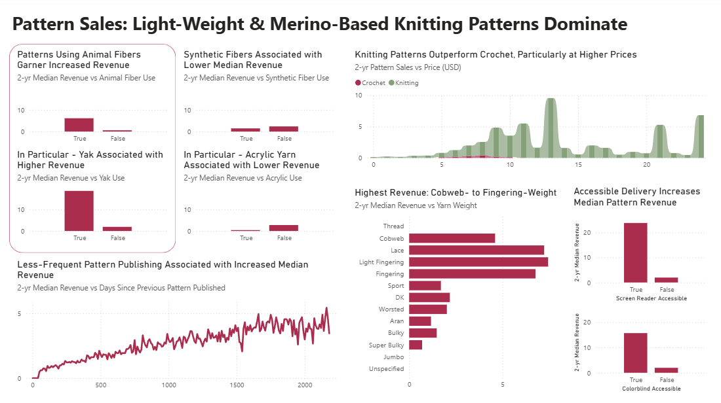

My dashboard creation began with the intent to answer one of my research questions – do patterns that use/recommend wool yarn sell better than those that don’t? My alternative hypothesis was that wool-based patterns would sell better than non-wool-based patterns (one-tailed). I found a small (coefficient = 0.07) but significant (p-value = 0.000) relationship indicating that yes, wool-based patterns have both higher median revenue and higher median sales than non-wool-based patterns. However, in my analysis, I also found that the use of yak fiber relates to higher median revenue and sales, and due to its higher impact, this is the animal fiber I chose to highlight in my dashboard (See Figure 2.).

Figure 2
Median 2-Year Revenue vs Fiber Content
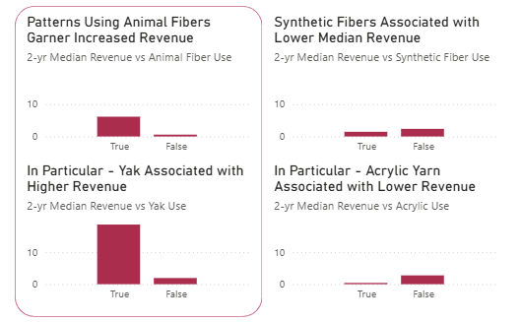

I used the curved red box shape to separate the animal- and synthetic-fiber charts, making it easier to understand the flow and storytelling between these four charts. Since a yarn can contain multiple fibers, these categories are not mutually exclusive and therefore can’t be condensed into a single column with different values. As with many of my features, yarn fiber types have been stored in a Boolean format, with a column for each fiber and a True/False value indicating whether or not that fiber is present in a given pattern. This makes column or bar charts the best visualization option. The X-axis variable for these column charts is the feature being examined (animal fiber, yak fiber, synthetic fiber, and acrylic fiber, respectively) and the Y-axis variable is the target value – estimated 2-yr revenue. I have made sure that the Y-axis is scaled the same across charts to ensure that comparison is easy and not misleading.
The next visual on my dashboard was chosen to address my other research question – do high-priced knit patterns sell disproportionately well compared to high-priced crochet patterns? My alternative hypothesis was that high-priced knit patterns would indeed sell better than high-priced crochet patterns (one-tailed). Since price is a relatively continuous value and I wanted to highlight the differences between two categories (crochet vs knitting), I used a ribbon chart (See Figure 3). The X-axis shows price, while the Y-axis shows median 2-yr sales (calculated based on `projects_per_day`). This makes it easy to see that crochet pattern median sales peak around $8, while knitting patterns more or less continue to increase in sales and peak around $13. The tooltip includes the count of pattern IDs as you mouse over each price, and the price has been capped at $24 for formatting and clarity reasons – expensive patterns are rare, and their median sales can be non-representative.

Figure 3
Median 2-Year Pattern Sales vs Price (USD)
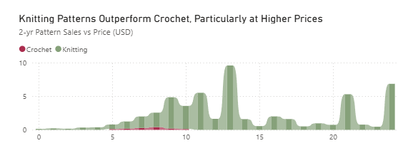

After addressing my two research questions, I decided to turn my attention to other attributes that influence pattern sales, starting with those identified by my modeling process as important. I combined an Ada Boost model, Random Forest model, Gradient Boost model, and K-Nearest Neighbors model via a Voting Regressor. While permutation importance was computationally prohibitive for the KNN model, I did do permutation importance for the other three models to see what features most influenced their predictions. Two features that all three models found relevant were 1) yarn weight and 2) days since a pattern’s author published their previous pattern. I displayed yarn weight relevance through a bar chart, which allows the relatively long labels to be legible and easily associated with their associated bar along the Y-axis (See Figure 4). The X-axis is median 2-yr revenue, though the result is much the same using median 2-yr sales instead.

Figure 4
Median 2-Year Revenue vs. Yarn Weight
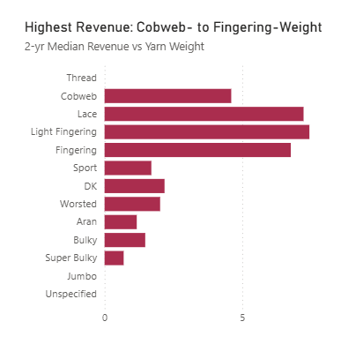

Since `days_since_previous_pattern` is a continuous time-based variable, I decided to display it using a line chart (See Figure 5). With that on the X-axis and 2-yr median revenue on the Y-axis, it’s easy to see how median revenue changes over time. A tooltip indicates the count of pattern IDs for each bin. It is unusual for designers to go extremely long between pattern releases, so this chart only includes patterns uploaded within 6 years of a designer’s previous pattern to avoid non-representative spikes and dips.

Figure 5
Median 2-Year Revenue vs. Days Since Previous Pattern Published
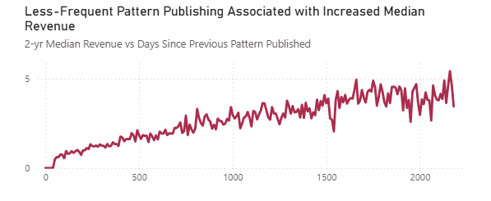

Finally, I noticed that all three models had indicated that the presence or absence of a video tutorial is predictive of a pattern’s sales. I found that the presence of a video tutorial was associated with higher median sales, but other aspects of a pattern’s instructions actually had a higher impact on median sales, namely screen reader and colorblind accessibility. Only one model identified screen-reader accessibility as influential, and none identified colorblind accessibility as influential. I would guess this may be due to the low variance present in these variables, as the vast majority of patterns display False for both of these features. The tooltip count of pattern IDs shows that only 407 patterns included are screen reader accessible and 837 are colorblind accessible. However, the impact for patterns that do have these features is significant.
I had considered that this relationship may be due to more successful designers adding accessibility as their approach became more professional, so I added a new table listing designers and calculating their performance percentile based on the average number of projects their designs receive (“Summarize,” n.d.). This allowed me to filter based on percentile and verify that even excluding the top 10% of designers, the relationship between screen reader or colorblind accessibility and median revenue holds true. In such a skewed market, this is significant and indicates a relationship that extends beyond full-time designers.
Being dummy variables, these were visualized via column chart with median estimated 2-yr revenue on the Y-Axis (See Figure 6).

Figure 6
Median 2-Year Revenue vs Pattern Instruction Accessibility
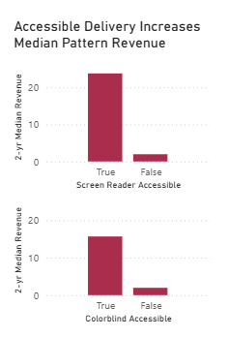

Throughout the rest of my report pages, I was able to use this percentile feature to evaluate the relationships I highlighted, trying to focus on high-impact features that are influential for both upper-tier and mid-tier designers. (The lowest-performing designers have median sales around 0 across the board, so identifying relationships there is difficult.) I also took into consideration the number of projects that a feature actually applies to; very rarely-used features can be more prone to being overinfluenced by relatively few successful patterns.
Drill-through pages have not been included in this project as I did not see any opportunities where they would truly be more useful in comparison to a typical report page. My main dashboard page does not include any slicers; however, other report pages have included slicers as I see fit. This main dashboard page is more intended as a singular overview of the market; even when using one of the visuals to filter the page content, I appreciate that the default values are still lightly visible. Slicers alter that comparative ability in a way that I don’t find desirable for this particular dashboard page.

Summary
Hypotheses and Results
One research question addressed by this project was: do high-priced knit patterns sell disproportionately better than high-priced crochet patterns (“disproportionate” referring to the fact that knit patterns already outsell crochet patterns across the price spectrum – the question is, does this gap increase as price increases)? The alternative hypothesis was that high-priced knit patterns do in fact sell disproportionately better than high-priced crochet patterns. This hypothesis was supported and not rejected. OLS regression revealed a small coefficient for this relationship (0.0713) with a p-value of 0.000. For OLS regression using only the most expensive 25% of patterns ($6+ USD), the coefficient is 0.1070 with a p-value of 0.000; as price increases, the gap between knit pattern sales and crochet pattern sales does indeed slightly increase.
The other research question was whether or not wool-based patterns sell better than non-wool-based patterns. The alternative hypothesis was that wool-based patterns do sell better than non-wool-based patterns, and this hypothesis was also not rejected. OLS regression shows a coefficient of 0.0702 with a p-value of 0.000. While the coefficient is small – indicating a small effect size –the low p-value indicates that the relationship is statistically significant.

Project Summary and Reflection
Several key findings from this project provide insight on knit and crochet market preferences. Luxury fibers, particularly yak, are associated with higher median revenue, while synthetic fibers, particularly acrylic, are associated with low median revenue. Knitting patterns, despite significantly outnumbering crochet patterns, see higher median sales than crochet patterns, with higher-priced knitting patterns (up to $14 USD) performing particularly well. This might indicate an overall consumer preference for high-quality patterns – particularly knit apparel – even if they come at higher prices. This is also reflected in the higher revenue seen for patterns featuring details like short rows, gussets, and steeks. The higher median sales for cobweb-to-fingering-weight patterns is interesting, as these projects tend to take longer than an equivalent project made with a thicker yarn weight.
At the same time, top-down and seamless patterns’ high median revenue is indicative of a preference for easy-to-fit garments. Both negative-ease and oversized apparel see increased median revenue, as do patterns catering to the specialty-fit demographics of tall, petite, male, and plus-size.
Challenges encountered in this project mostly related to the large scale of data being collected and used, and the associated time cost of re-doing steps due to mistakes or oversights. While 319 columns and 559,308 rows isn’t a huge final dataset by Big Data standards, it is the largest dataset I’ve ever worked with, and most of the scripts I created for preprocessing, exploratory data analysis (EDA), and predictive model development took several hours to execute on my 2-core CPU. An unfortunate result of this is that the category columns have data quality issues that were identified too late in the process to fix.
The hierarchical “category” feature split across multiple columns was challenging to adequately assess using standard methods, and due to the amount of time each EDA step was taking, I experimented less thoroughly than I usually would. When I looked at unique values in the top level of the hierarchy, I should have investigated rather than discarded suspicious values. In the future, I will also make sure to check hierarchical columns like this not only individually, but sequentially; filter the next level of the hierarchy by each top-level value to see that values are as expected, and so on down the chain. This would have identified the miscategorized values like Home > Vest much sooner; both “Home” and “Vest” are appropriate values for their level of the hierarchy, but “Vest” is not a valid home décor item in Ravelry’s schema. This data is clearly not correct. I had checked this in a basic way, looking at a few records to check that category had been split properly and made sense – and, in fact, it had worked in what seems to be a majority of cases – but this did not catch the significant minority of cases which had wildly corrupted data.
For most of my scripts, I started with a small slice of the dataset (~10%), developed the script, re-ran it with the full dataset once I felt it was complete, and then troubleshot problems that came up with the full dataset that hadn’t with the sample. The only script I had failed to do this for was my EDA script, which was a mistake. I learned a lot in this project about handling larger datasets and how to effectively conduct data quality analysis on more complicated features.

Real-World Implications
This project aims to fill information gaps that exist for knit and crochet pattern designers trying to get and maintain a foothold in the market. Identifying the market niche that a designer is best prepared to capitalize on can be challenging, and while there are well-selling patterns and top designers in all categories, there are some market areas that are more prepared than others to support newer or less-popular designers. For example, top-level amigurumi designers will see median revenue far outperforming mid-tier clothing designers – but the overall amigurumi market has extremely low median revenue, and even at the top level, non-amigurumi patterns outperform amigurumi patterns. Pattern design is a challenging and oversaturated market, so focusing design efforts in areas that are more likely to profit better is of critical importance. The key findings from this project can help pattern designers identify features that are associated with higher median revenue, and the predictive modeling element of this project, if further developed, could be used to improve guidance for the challenging act of price setting.
For both knit and crochet pattern designers, light-weight apparel sells best. Focusing on adult and teen apparel sizes will garner increased median revenue, while newborn- and toddler-sized apparel performs poorly. Consumers also show preference for easy-to-fit construction attributes like top-down, circular-yoke, and seamless, as well as fit-improving features such as short rows, gussets, and waist shaping. The best niche to target is high-quality, well-fitting apparel patterns at a higher price point. Using a luxury fiber, particularly yak or a yak blend, for the pattern sample is also recommended. Designers would do well to avoid certain synthetic fibers, such as acrylic, in their pattern samples. Rather than publishing directly to Ravelry or another website, ideally distribute patterns through a book, magazine, or webzine. Additionally, consumers are more likely to buy a pattern if the designer has at least one free pattern available.
Across levels of designer popularity, accessible pattern formatting makes a meaningful difference in median pattern revenue and should be done when possible – particularly colorblind, low-vision, and screen-reader accessibility. This may relate to a broader consumer shift toward rewarding inclusive design practices, but it also may simply be a result of colorblind, low-vision, and blind crafters purchasing patterns that are accessible for them. As of 2021, an estimated 1.1 billion people worldwide live with some level of visual impairment (Orbis, n.d.); approximately 300 million people globally have some form of color vision deficiency (“About Colour Blindness,” n.d.). While knit and crochet are often considered vision-heavy tasks, both are possible and can be quite enjoyable for people with impaired or no vision (McKie, 2022). Ensuring accessibility in pattern design expands participation in the craft community for people who are otherwise excluded from a significant portion of available patterns – and the market data used for this project strengthens the case for accessibility as both a social good and a sound business strategy.
This project also provides a skeleton for a sales prediction model to be developed. Due to computational and time constraints, very little model tuning was able to be done, and the current final model has an R² score of 0.10 – better than a null model, but there is certainly room for improvement. I believe this could be noticeably increased with more compute power and tuning, and the resulting sales prediction model could be used for price optimization. This could be configured so that the relevant features of a design are entered, and the model repeatedly predicts the sales for that pattern at different price points. By multiplying the price points and sales results, the price that maximizes overall revenue could be selected. This may not wholly replace designer judgement in setting a price, as there are qualitative aspects to pattern design and designer audience that the model doesn’t account for, but it would provide a useful starting point for newer designers and helpful context for experienced designers.
Beyond the immediate value to individual knit and crochet designers, product insight and pricing guidance are extremely common challenges across all business environments. The collection of market data through an API, EDA, OLS regression modeling, and iterative predictive model development is a framework transferable to a wide variety of data-driven decision-making tasks in other domains.
References
About colour blindness. (n.d.). Colour Blind Awareness. https://www.colourblindawareness.org/colour-blindness/
Custom sort orders in Power BI. (n.d.). Nova Silva. https://visuals.novasilva.com/sorting-data-in-power-bi/
Eckman, E. (2021, November 1). Beyond Ravelry: Pattern platforms for knitting and crochet designers. Craft Industry Alliance. https://craftindustryalliance.org/beyond-ravelry-pattern-platforms-for-knitting-and-crochet-designers/
Facca, D., Smith, M. J., Shelly, J., Lizotte, D., & Donelle, L. (2020, August 27). Exploring the ethical issues in research using digital data collection strategies with minors: A scoping review. PLOS. https://doi.org/10.1371/journal.pone.0237875
Glassenberg, A. (2024, May 14). The size of the yarn market: Yarn consumer survey results 2024. Craft Industry Alliance. https://craftindustryalliance.org/the-size-of-the-yarn-market-yarn-consumer-survey-results-2024/
Glassenberg, A. (2025, May 18). The size of the yarn market: Yarn consumer survey results 2025. Craft Industry Alliance. https://craftindustryalliance.org/the-size-of-the-yarn-market-yarn-consumer-survey-results-2025/
Grice, P. (n.d.). How to sell crochet patterns at the best price: A guide for designers. CrochetPreneur. https://crochetpreneur.com/crochet-pricing-formula-sell-patterns/
How much should knitwear designers charge for their patterns? (2024, August 5). Sierra & Pine. https://www.sierraandpine.com/blogs/articles/how-much-should-pattern-designers-charge-for-their-pattern
How to price crochet patterns. (2025, December 21). GoSadi. https://gosadi.com/blog/pricing-crochet-patterns/
McKie, A. (2022, October 23). Knitting and crochet with Deafblind Scotland. Knitting For All. https://www.knittingforall.com/blog/DeafblindScotland
Orbis. Global blindness was slowing prior to pandemic study reveals [sic]. (n.d.). https://www.orbis.org/en/news/2021/new-global-blindness-data
PayPal User Agreement. (2026, January 26). PayPal. https://www.paypal.com/us/legalhub/paypal/useragreement-full
Pricing your knitting patterns: Strategies & considerations. (2025, October 30). GoSadi. https://gosadi.com/blog/how-to-price-knitting-patterns/
Principles. (n.d.). Responsible Data for Children. https://rd4c.org/principles
Ravelry API Documentation. (2026, March 30). Ravelry. https://www.ravelry.com/api
Summarize. (n.d.). Microsoft. https://learn.microsoft.com/en-us/dax/summarize-function-dax
Teague-Long, Y. (2019, May 10). Pay what you can pattern pricing. Ysolda Ltd. https://ysolda.com/blogs/journal/pay-what-you-can-pattern-pricing
Verhulst, S. G., & Young, A. (n.d.). The responsible use of data for and about children: Treading carefully and ethically. Child Ethics. https://childethics.com/blog/data-and-children/

