# **What is Grunt**

Grunt is a cross platform task runner for your project, Similar to what NPM and Gulp can do, Grunt uses JavaScript and can be used easily by selecting the appropriate plugin and installing and configuring it. Grunt has a good community following, and there are many NPM plugins that have a grunt plugin available.

Grunt Tasks read/write to/from disk, keep this in mind as many tasks might require to read/write to disk, this can cause grunt to run slow. While with NPM, does it differently by using bash to pipe output into the next command.

Gulp relies heavily on streams, pipes and asynchronous code, which fits hand in hand with Node unlike NPM and grunt. Grunt seems to be the easiest method as most developers working on the client side and server side, will know and be using JavaScript. Also for big teams grunt also has the advantage of more of the team members knowing how to use it, rather than having to specialize in Node.

Grunt: <http://gruntjs.com/getting-started>

Gulp: <http://gulpjs.com/>

Comparing NPM, Grunt, Gulp: <https://ponyfoo.com/articles/choose-grunt-gulp-or-npm>

# **Getting Started**

Start of by installing the command line interface for grunt (grunt-cli) from NPM, this will install the grunt command line interface and will allow us to call grunt from anywhere in our project (use grunt globally with **“-g”**).

Command: **“npm install grunt-cli”**



Install these 3 modules to get up and running, we need grunt initially, but also install

**“grunt-contrib-jshint”,**

**“grunt-contrib-watch”**

as these will come in handy later on.

 

Once we have these dependacies installed and updated in our package.json we can create the gruntfile.js now.

This is a simple example of a grunt file using the dependacies mentioned above.

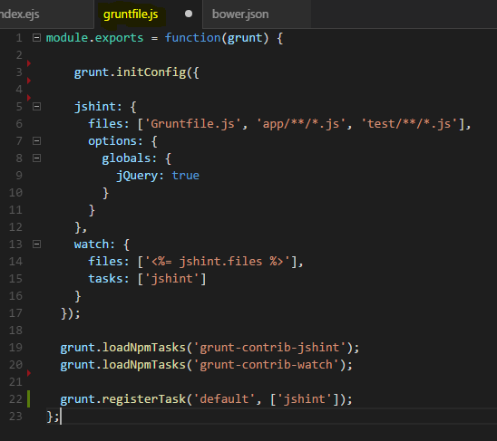

In this example we have 2 tasks currently, jshint and watch, since we installed these 2 dependacies also, if we want to use them we must load the task plugin by:

**“grunt.loadNpmTasks('grunt-contrib-watch');”**

You may create custom tasks inside this grunt file, some may require you to install more dependacies or load more npm tasks.