# **Jenkins**

<https://jenkins.io/>

“The leading open source automation server, Jenkins provides hundreds of plugins to support building, deploying and automating any project.”

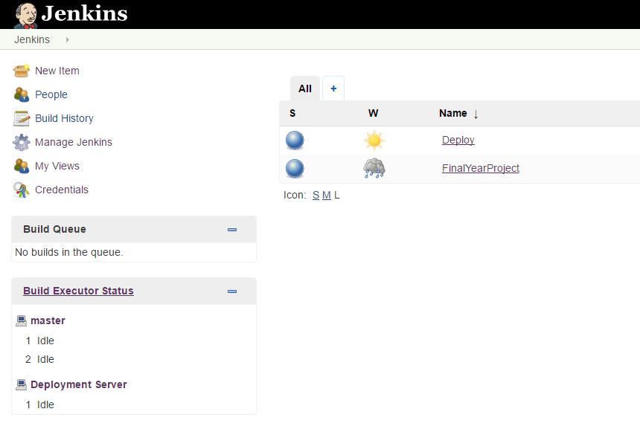

## **Install Jenkins:**

<https://wiki.jenkins-ci.org/display/JENKINS/Installing+Jenkins+on+Ubuntu>

## **Why Jenkins?**

When creating small, large or enterprise apps and projects, you will need a centralized build platform, that will take control of all the various builds, tests, and deployment.

Jenkins fits the bill here; it is a continuous integration/ continuous delivery server. Which is extensible with numerous plugins. And can be distributed if needed, Jenkins is easy to install and configure.

Here is an example of the various tasks/jobs Jenkins can preform

