# **What is MongoDB**

The latest in industries growing database. MongoDB is free and open source cross platform document-orientated database program. MongoDB uses JSON like documents and is considered to be a no-SQL database. This allows schemas to be changed on the fly and do not require downtime. This approach to document-orientated database allows you to spend less time prepping and organizing your data and makes it easy to store and combine data of any structure.

Main Points:

* Fast, Iterative Development
* Flexible Data Model
* Multi-Datacenter Scalability
* Integrated Feature Set
* Lower TCO
* Long-Term commitment

More @ <https://www.mongodb.com/mongodb-architecture>

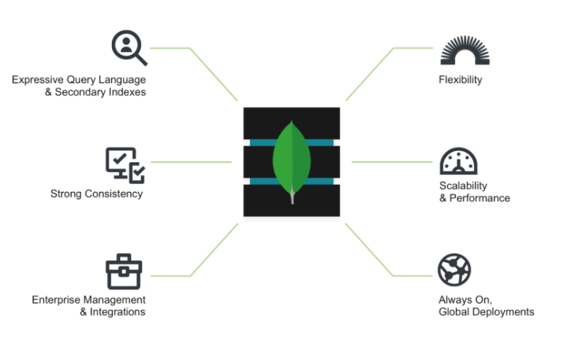

From: <https://www.mongodb.com/mongodb-architecture>

High level diagram view of MongoDB’s characteristics