# **Database Tool: Robomongo**

Robomongo is a tool that can be used to manage your MongoDB, it provides a UI and GUI to allow the user to interact with and manage their database.

More @ <https://robomongo.org/>

**How to connect Robomongo to your database**

Download Robomongo at <https://robomongo.org/download> , you will use robomongo locally to manage your database.

To Connect:

create a new connection, by clicking the top left “create” button

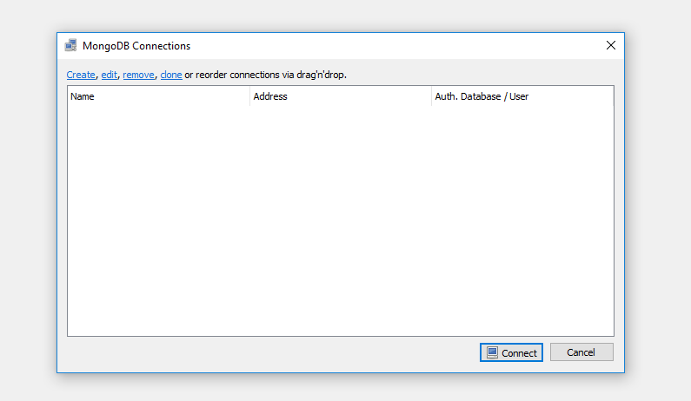

Input the name you would like to call this connection, and then supply it with the correct address and port number

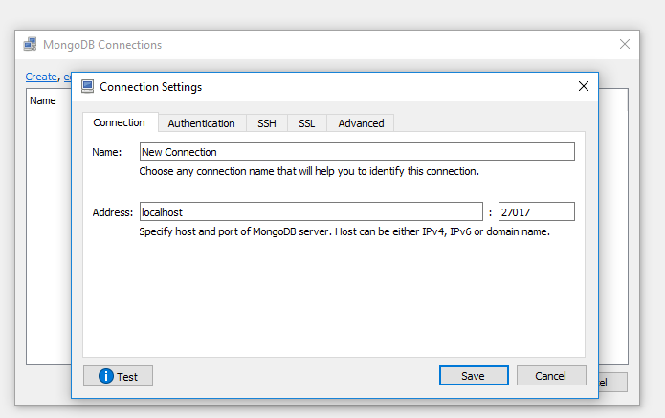

Next we need to add authentication

Enter the database name, username and password.

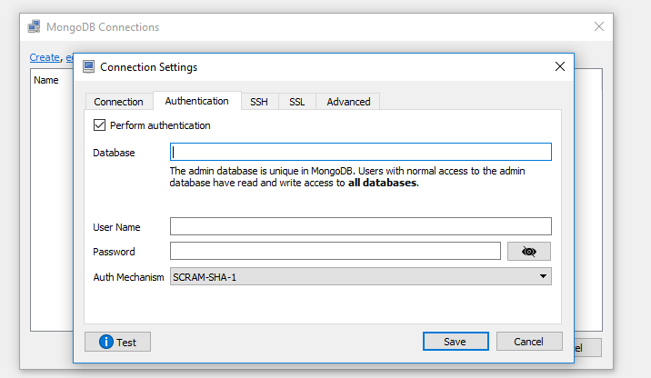

For me I changed the security to MONGODB-CR



Then finally you have robomongo setup to connect to your database.

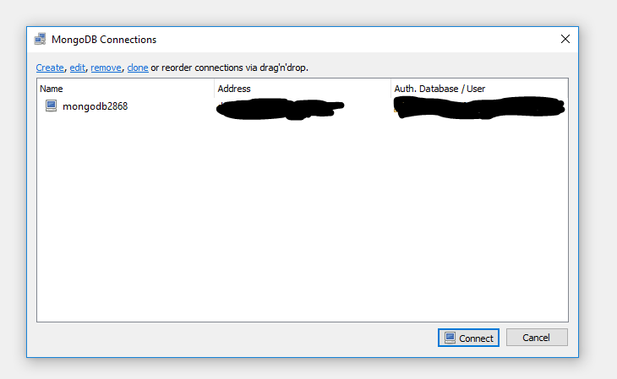

This is what you will see once you connect

