# **Creating a Repository**

Create a repository and it will instruct you to follow the steps shown below.

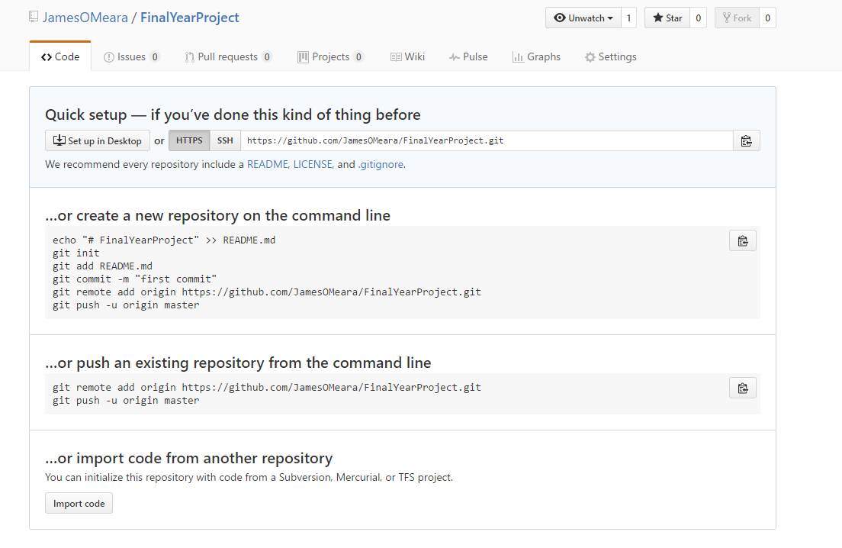

Once you download and install git on your local machine

CD into the directory you wish to save to source control, for this example I am inside the “FinalYearProject” directory and everything inside this will be saved to source control.



Using the command **“git status”** you can check to see what has been modified, has yet to be / or been committed.

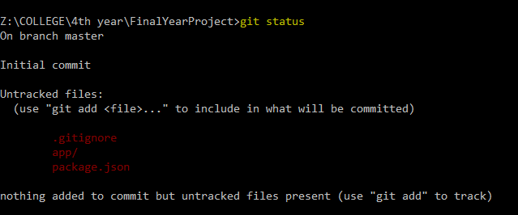

Now since we have seen what files have been changed and we want to commit and push these to source control we can add them to our local commit.

Use the command **“git add”** followed by the name of the file you would like

Or you can add all by: **“git add .”**

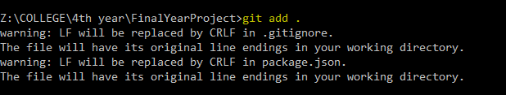

Call “git status” again and now you will see what files are added and ready to be committed, as you can see below they are showing up in green.

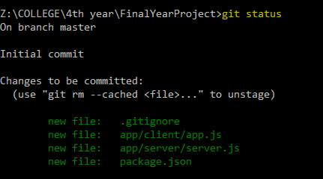

Finally, now since we are happy with the files we have added, we can now create a commit. To do this us the command **‘git commit -m “your message here”’.**

The -m stands for message to accompany the commit. It is good practice to do multiple commits for certain files and new features. Give the commits meaningful names, as this will help greatly in the future identify what changes were made.

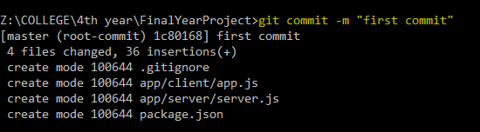

This next command is a one off command, since here we are first initializing the local repository, this command for your repo is shown in the browser when you create the repository, or in the first image in this doc.



Finally after we have all these steps complete, we can now push our local commits to our repository

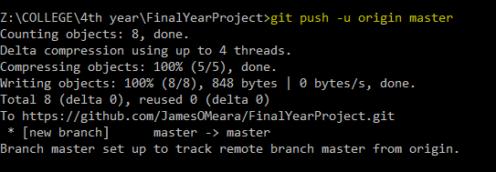

And here we can see the changes made in our browser.

