# **Setting up a Node Server**

Our app will require a server side, Node does this easily and can be set up very quickly.

We are going to use an express server, First off install express via Npm command:

**“npm install express –save”**

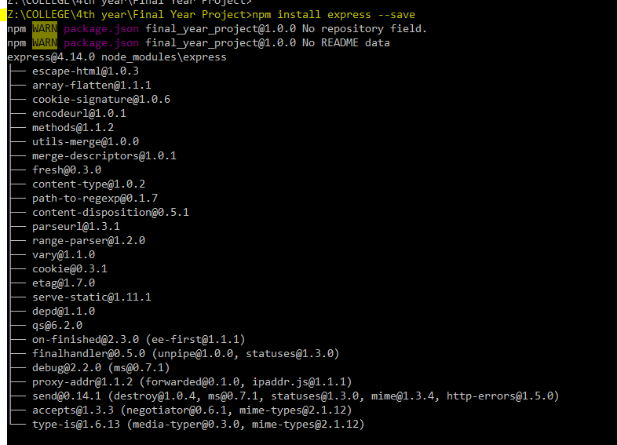

After installing the package your package.json should have updated to reflect the new dependency since you stated that you wanted to “—save” it.

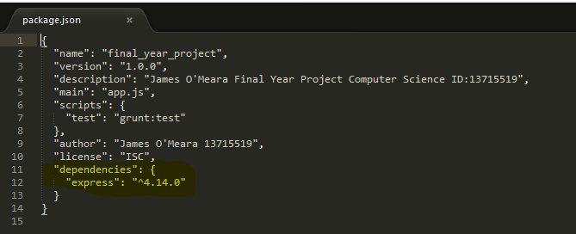

Once we have this done we can no create our app folder to store all our source code. Create a folder “app” inside the folder we previously created (this one is called “FinalYearProject”)

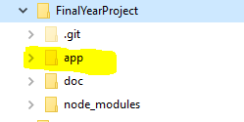

Then inside this create a folder named “server” any code here dealing with the server will be put in here.

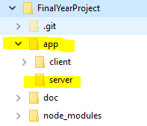

Create a file Server.js

We will run this file when we want to start our server, this will also deal with any routing of our app, and anything else that requires use of the server.

**var express = require('express');**

**var path = require('path');**

**var app = express();**

First off we must require any dependencies for our server, here we need express and path, Express to run an express server and path to tell our server what location to return files from.

**app.set('view engine', 'ejs');**

**app.set('views', __dirname + '/../client/src');**

Next we must set our view engine, in this app we are using “.ejs” files not html files (EJS is a client-side templating language). So we set our view engine to “.ejs” and tell it where it will find the files from.

**app.use(express.static(path.join(__dirname, '/../client/public')));**

Another way to tell our server where to find all the files located in joining our local folder to the express static location, this will ensure that it will look for files in the directory you specify here.

**app.get('/', function(req, res) {**

**res.render('index');**

**});**

Now we tell our server what file to render when we enter the particular URL into the browser. Here we are just specifying the home URL.

**app.listen(3333, function () {**

**console.log('Server listening on port 3333!');**

**});**

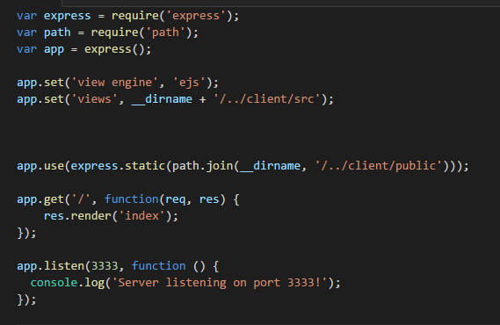

What our server.js should look like.

Then finally we want to start our server, specify the port in the app.listen function. Here we are just printing out a simple message to know that we are up and running.

Then run the server by

**“Node server.js”**



Creating index.ejs.

This file will be the go to page to load the app/site, i.e. the entry point.

First off install EJS with command: **“npm install ejs –save”**

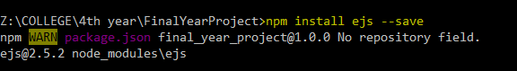

Create a file called index.ejs in app/client/ and create a simple webpage to display a hello world message. This will be the entry point for the app in which the server will render to the user.

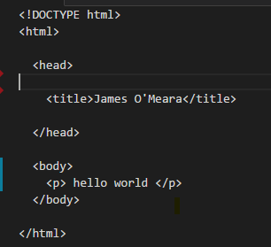

Look at the

* angular tutorial how to install angular and give this simple webpage more functionality.
* MongoDb tutorial provide interactions with a database.