* What is node
* Installing
* Getting started
* Installing adependacy

**What is Node**

“Node.js® is a JavaScript runtime built on [Chrome's V8 JavaScript engine](https://developers.google.com/v8/). Node.js uses an event-driven, non-blocking I/O model that makes it lightweight and efficient. Node.js' package ecosystem, [npm](https://www.npmjs.com/), is the largest ecosystem of open source libraries in the world.”

<https://nodejs.org/en/>

<http://www.hongkiat.com/blog/node-js-server-side-javascript/>

Node is an asynchronous event driven that uses JavaScript. Node is saleable and can handle many connections concurrently if there are no connections or no work to be done node will be in sleeping mode.

Node is fast, and uses JavaScript as its backend. Node runs on Googles V8 engine which compiles the JavaScript directly into machine code making it faster than most other backends.

Node has a massive NPM (Node Package Manager) which is a package manager that allows us to keep track of our project dependencies, their versions and easily install them. NPM is open source and continually growing. This offers many modules and tools to help add functionality. NPM module count is quickly growing and has a larger count than that of Maven, and even Ruby on Rails gems, among others.

NPM

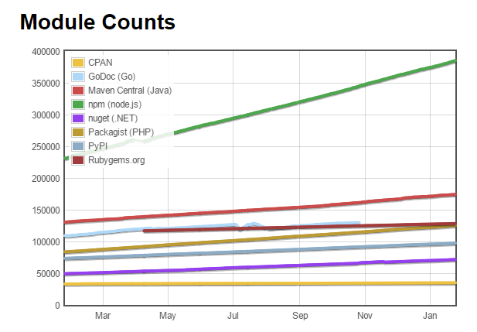

Taken from: <http://www.modulecounts.com/> (24-Jan-2017)

**To install**

First off install node.js. From this we can use NPM (Node Package Manager) and set up a server to run our app off.

Download link for Node can be easily found on the site: <https://nodejs.org/en/download/>

From here pick your Operating System and version.

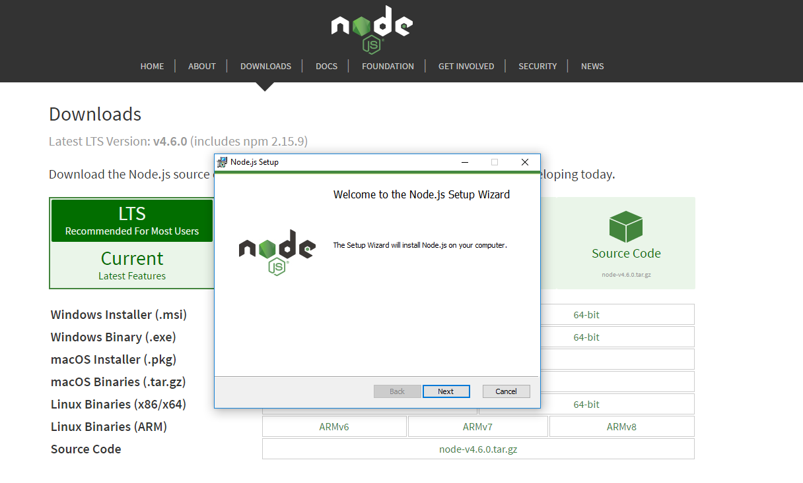

Check that node is installed

Command: Node -- version



**Getting started:**

Next we can create our App folder. Here I have called mine “FinalYearProject”. From here we can go through the steps of initializing a node project. This will result in node creating a “package.json” file which is used for node/project settings and list of dependencies.

1. Open a command window in this new folder you just created
2. Type “npm init”

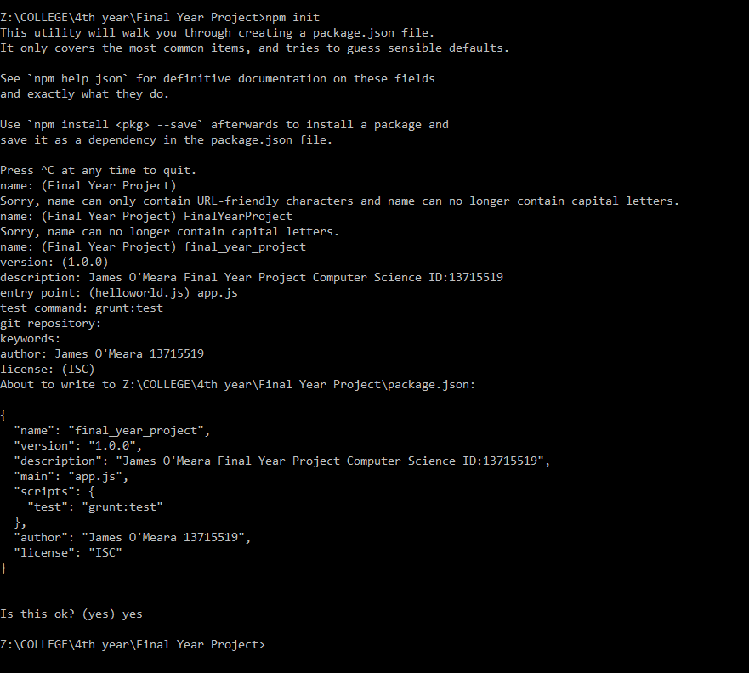

1. Next you will go through the setup, (leaving field blank will use default) you can copy the same input I have entered here if you wish.



1. When you have finished, you will be prompted with the output of the package.json



1. If happy with this, type “yes” and press enter. Remember that these can be changed at any time in the future.
2. Finally you will now have this “package.json” file in your folder.

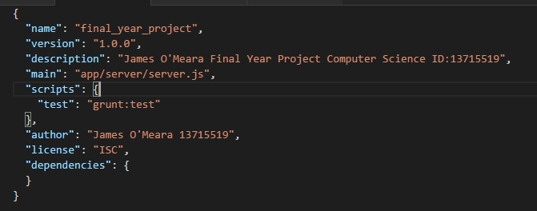

**Installing a dependency**

NPM (Node Package Manager) Hosts a very large range of open source libraries/degeneracies and they can be easily downloaded/installed into your project.

This can be done by:

1. Opening a command window inside your project, as I have one open below, (you will find the package.json at this level).
2. Then type the command “Npm install (followed by the package you wish)”

E.g.: “Npm install express”

1. If you wish to save this to your package.json as a dependency you can do so by adding “--save” to the end of it.

E.g.: **“Npm install express –save”**

1. One other option for installing dependencies is by adding **“—save-dev”** to the end of the command instead of **“—save”**, as save-dev will mean this dependency is only used for development. And will not be bundled into the release of the app.

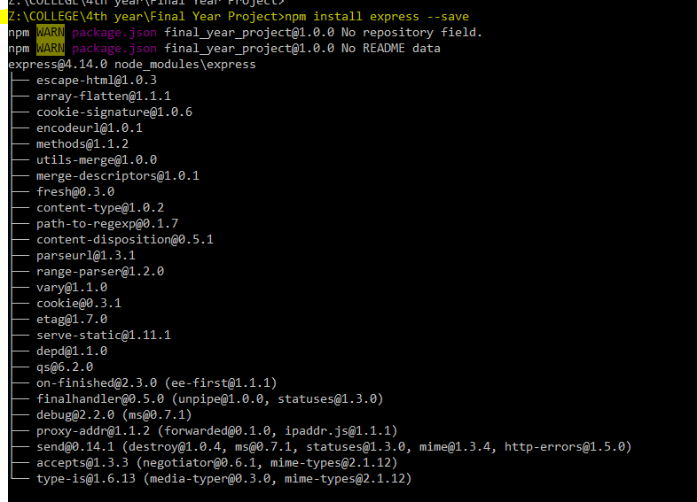

1. Finally you will see this dependency reflected in your package.json.

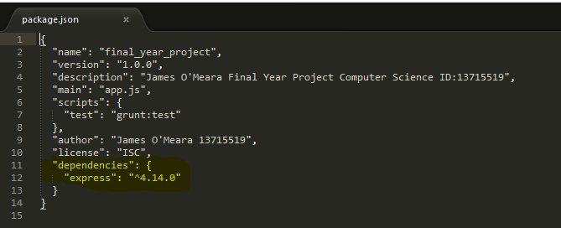

**Setting up a Node Server**

Our app will require a server side, Node does this easily and can be set up very quickly.

We are going to use an express server, First off install express via Npm command:

**“npm install express –save”**



After installing the package your package.json should have updated to reflect the new dependency since you stated that you wanted to “—save” it.



Once we have this done we can no create our app folder to store all our source code. Create a folder “app” inside the folder we previously created (this one is called “FinalYearProject”)

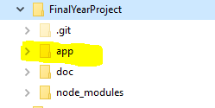

Then inside this create a folder named “server” any code here dealing with the server will be put in here.

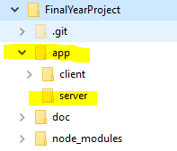

Create a file Server.js

We will run this file when we want to start our server, this will also deal with any routing of our app, and anything else that requires use of the server.

**var express = require('express');**

**var path = require('path');**

**var app = express();**

First off we must require any dependencies for our server, here we need express and path, Express to run an express server and path to tell our server what location to return files from.

**app.set('view engine', 'ejs');**

**app.set('views', __dirname + '/../client/src');**

Next we must set our view engine, in this app we are using “.ejs” files not html files (EJS is a client-side templating language). So we set our view engine to “.ejs” and tell it where it will find the files from.

**app.use(express.static(path.join(__dirname, '/../client/public')));**

Another way to tell our server where to find all the files located in joining our local folder to the express static location, this will ensure that it will look for files in the directory you specify here.

**app.get('/', function(req, res) {**

**res.render('index');**

**});**

Now we tell our server what file to render when we enter the particular URL into the browser. Here we are just specifying the home URL.

**app.listen(3333, function () {**

**console.log('Server listening on port 3333!');**

**});**

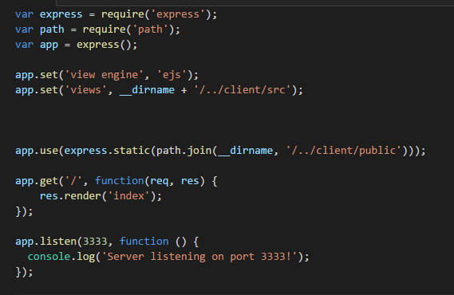

What our server.js should look like.

Then finally we want to start our server, specify the port in the app.listen function. Here we are just printing out a simple message to know that we are up and running.

Then run the server by

**“Node server.js”**



Creating index.ejs.

This file will be the go to page to load the app/site, i.e. the entry point.

First off install EJS with command: **“npm install ejs –save”**

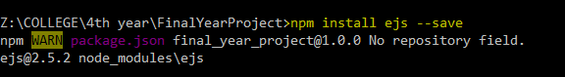

Create a file called index.ejs in app/client/ and create a simple webpage to display a hello world message. This will be the entry point for the app in which the server will render to the user.

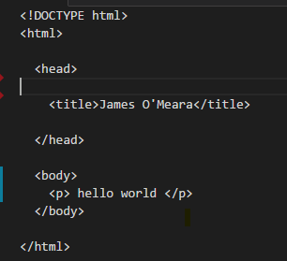

Look at the

* angular tutorial how to install angular and give this simple webpage more functionality.
* MongoDb tutorial provide interactions with a database.