# **Get started:**

To start out we must include angular in our app

We can do this by installing it through Npm. Although Npm is the package manager for node, there are additional package managers, we are going to use bower, bower is a package manager for client side dependencies. <https://github.com/bower/bower>

We can install this by “**npm install bower -g**”

We are installing this module globally so we can use command line with it.



Then we must initialize bower, using the “**bower init**” command, this will create a bower.json, similar to the way we initialized npm and it created the package.json file for us.



Again follow through with the setup, answering yes to them all will suffice. You will end up with something like so.

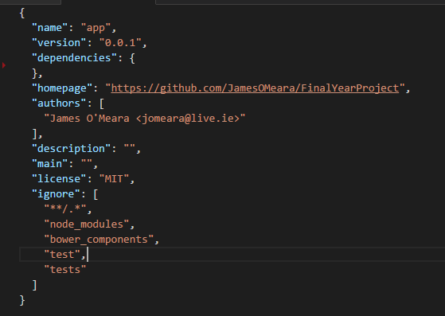

You may configure your bower with an additional file “.bowerrc”, here I am specifying what directory I wish for my dependencies to be installed into.

<https://bower.io/docs/config/>

I am installing my bower dependencies into my public folder in my app directory, as later we will use this folder to store all our files we wish to be made accessible in the browser.

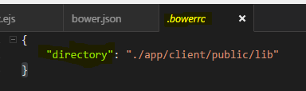

Now we are ready to start installing our client side dependencies.

Install Angular: “bower install angular –save”



This will result in adding angular to your bower.json, just like installing a dependacy with Npm (remember here NPM is for server side dependencies, while Bower is for Client side).

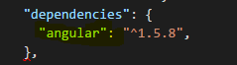

We must now add this angular.js file into index.egs, so when we launch our app it has angular loaded and we can use it then.

Open your index.ejs file and add this line of code. Insert this in the <head> section of our .egs file.



Now we are set up to do some angular work.