# **Creating a simple angular app and controller,**

Creating the angular app module is simple and easy and can be done in 2 lines, although it doesn’t do anything, it is the entry point of the app.

Create an “app.js” file within the “app/client/ folder”

We must require angular, when this page is loaded into the browser, we have already specified in our “index.ejs” that angular must be loaded with it, but in this JavaScript file we are telling it to look for the angular file.

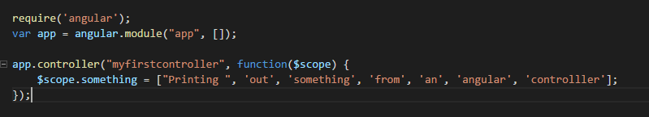

Next are going to create a simple controller, where we will hard code in some values and in the browser we will use angular to display this array.



Next go back to the “index.egs” file and now we can add this file to be loaded



Now we have an index.js file that loads our app file and angular file we can now start doing things with angular now in the “.ejs” file

First we must declare what app we want, we called our app module “app” earlier now we are telling our body tag that everything inside it will be able to access this module.



In another tag we can call on our angular controller and inside the “**{{ }}**” we can write angular expressions. This will iterate through the array that the angular controller has initialized and print them out in the browser.

