# **Browserify**

Using Grunt we can automate the bundling of the app into separate files.

With our app, we specify all js files in the browser, this includes all angular directives, controllers, factories, filters and even the dependacies. A good way to do this is to use a plugin like “Browserify” this will bundle all the apps files and dependacies into one or many files, which then can be used in the index.ejs page.

Info @ [**https://www.npmjs.com/package/grunt-browserify**](https://www.npmjs.com/package/grunt-browserify)

Browserify will collate all the files needed for loading into the browser into one file. Or mutiple if you wish.

For this app we are going to create 2 files, one for the app code, and another for all the dependacies.

To do this we must install browserify:



Once we have this done and the package.json updated we can start to edit the gruntfile.js

Add in this new line of code:

“grunt.loadNpmTasks('grunt-browserify');”

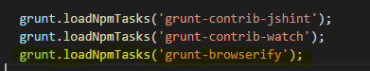

Now we can begin to add our browserify task and configure it.

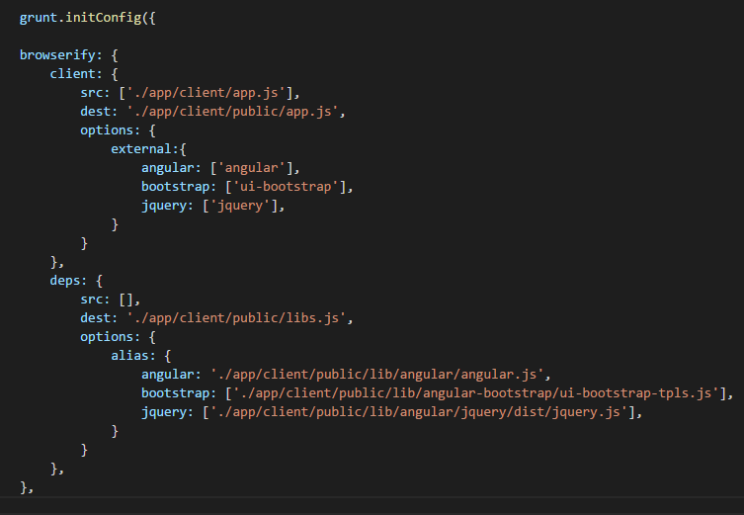

Start of by creating the task “Browserify” and we have here 2 tasks within it. This is a basic example to get browserify to create separate files (One for App source code, 2nd for dependencies).

More info can be found:@ <https://www.npmjs.com/package/grunt-browserify>

Inside the client task we are telling browserify what file is our entry-point to the app, here it is the app.js

**src: ['./app/client/app.js'],**

And then we specify the destination where we want to save the file. We must give this task a list of the external files also.

**dest: './app/client/public/app.js',**

**external:[**

**'angular',**

**'bootstrap',**

**"templates",**

**]**

*May ask why are we having separate file?

-To get correct coverage of our app for testing

-Faster build times for dev, as you only need to create one file when source code is changed

Inside the deps task we do not need to tell it of any source files, but we must give it the location of where the dependencies are kept for it to include them in the output file.