# **What is Node**

“Node.js® is a JavaScript runtime built on [Chrome's V8 JavaScript engine](https://developers.google.com/v8/). Node.js uses an event-driven, non-blocking I/O model that makes it lightweight and efficient. Node.js' package ecosystem, [npm](https://www.npmjs.com/), is the largest ecosystem of open source libraries in the world.”

<https://nodejs.org/en/>

<http://www.hongkiat.com/blog/node-js-server-side-javascript/>

Node is an asynchronous event driven that uses JavaScript. Node is saleable and can handle many connections concurrently if there are no connections or no work to be done node will be in sleeping mode.

Node is fast, and uses JavaScript as its backend. Node runs on Googles V8 engine which compiles the JavaScript directly into machine code making it faster than most other backends.

Node has a massive NPM (Node Package Manager) which is a package manager that allows us to keep track of our project dependencies, their versions and easily install them. NPM is open source and continually growing. This offers many modules and tools to help add functionality. NPM module count is quickly growing and has a larger count than that of Maven, and even Ruby on Rails gems, among others.

NPM

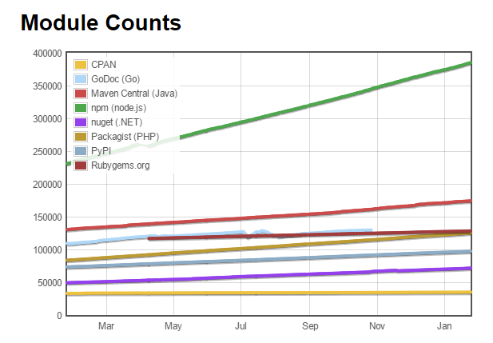

Taken from: <http://www.modulecounts.com/> (24-Jan-2017)