Laporan Pengembangan Game

Flappy Robot Bird



James Oktavian

A11.2019.11742

A11.4501

Daftar Isi

Halaman Judul ………………………………………………………………............................. i

Daftar Isi …………………………………………………………………………………………………… ii

Bab I Tentang Game …………………………………………………………………………………. iii

1. Deskripsi ……………………………………………………………………………………. iii
2. Screenshot ………………………………………………………………………………… iii

Bab II Detail Pembangunan Aplikasi …………………………………………………………. iv

1. Flow Chart …………………………………………………………………………………. iv
2. Class Diagram ……………………………………………………………………………. v
3. Screenshot Lengkap ………………………………………………………………….. vi

Referensi ………………………………………………………………………………………………….. x

Tentang Game

1. Deskripsi

Game ini adalah game Flappy Robot Bird isi dari game ini seperti Flappy Bird tetapi berbeda musuh dan character disini saya menggunakan musuh bird dan character robot bird. Game mudah digunakan tidak perlu belajar.

1. Hasil ScreenShot

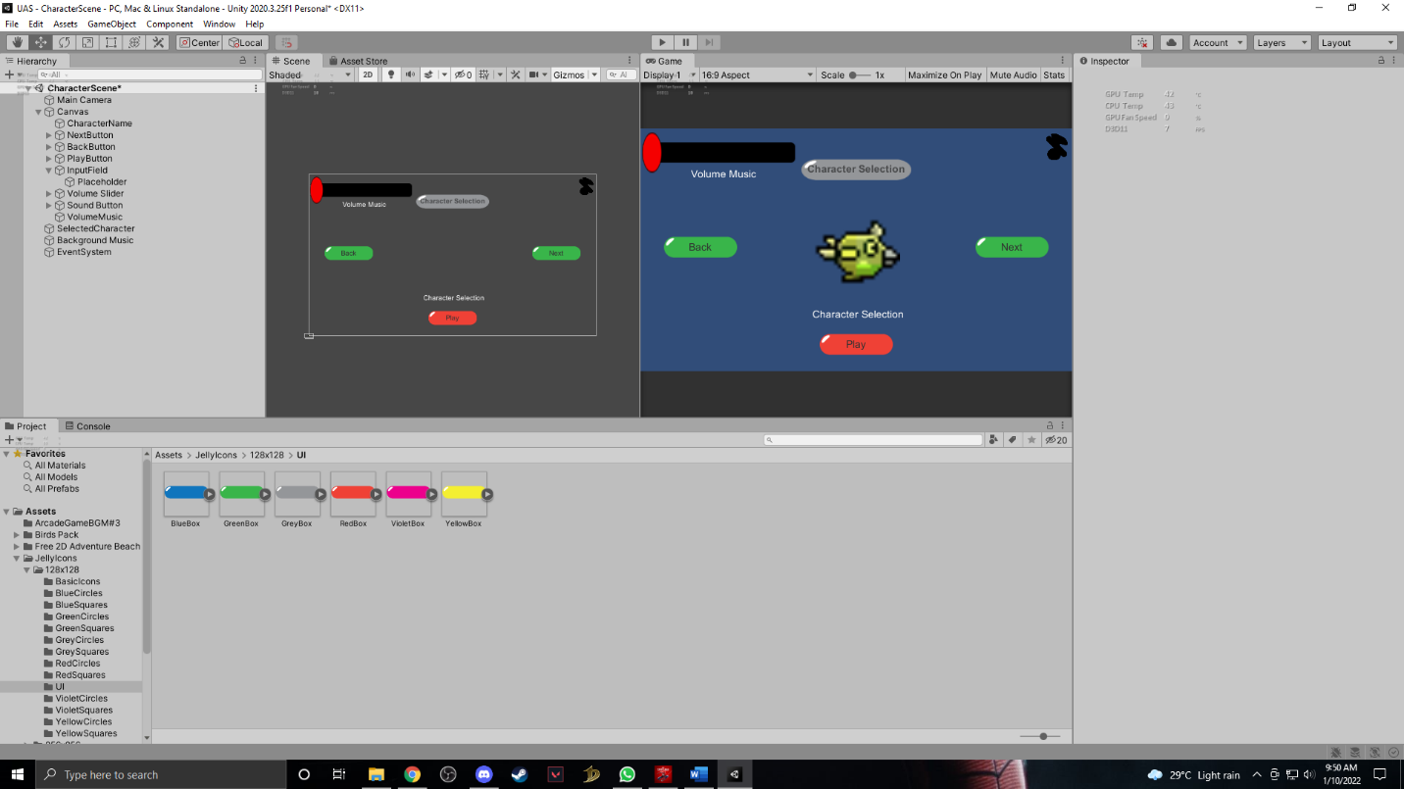

Detail Pengembangan Aplikasi

1. Flow Chart

Start

Character Selection

Input Select Character

Volume Slider

Music On/Off

Pause Menu

Start

In Game

Game Scene

Volume Slider

Music On/Off

Jika Mati Restart Game

1. Class Diagram

|  |
| --- |
| Character Manager |
| + selectedoption : Int  - artworkSprite : SpriteRenderer  - nameText : Text |
| - NextOption()  - BackOption()  - UpdateCharacter()  + Load()  + Save()  - ChangeScene() |

|  |
| --- |
| Camera |
| - camSpeed : Float |

|  |
| --- |
| Player |
| - speed : Float  + rb : RigidBody2D  + playerDirection : Vector2  - characterDB  - artworkSprite : SpriteRenderer  + selectedOption : Int |
| + UpdateCharacter()  + Load()  - FixedUpdate() |

|  |
| --- |
| Enemy |
| - obstacle : GameObject  - maxX : Float  - minx : Float  - maxY : Float  - minY : Float  - timeBetweenSpawn : Float  - spwanTime : Float |
| - Spwan() |

1. ScreenShoot

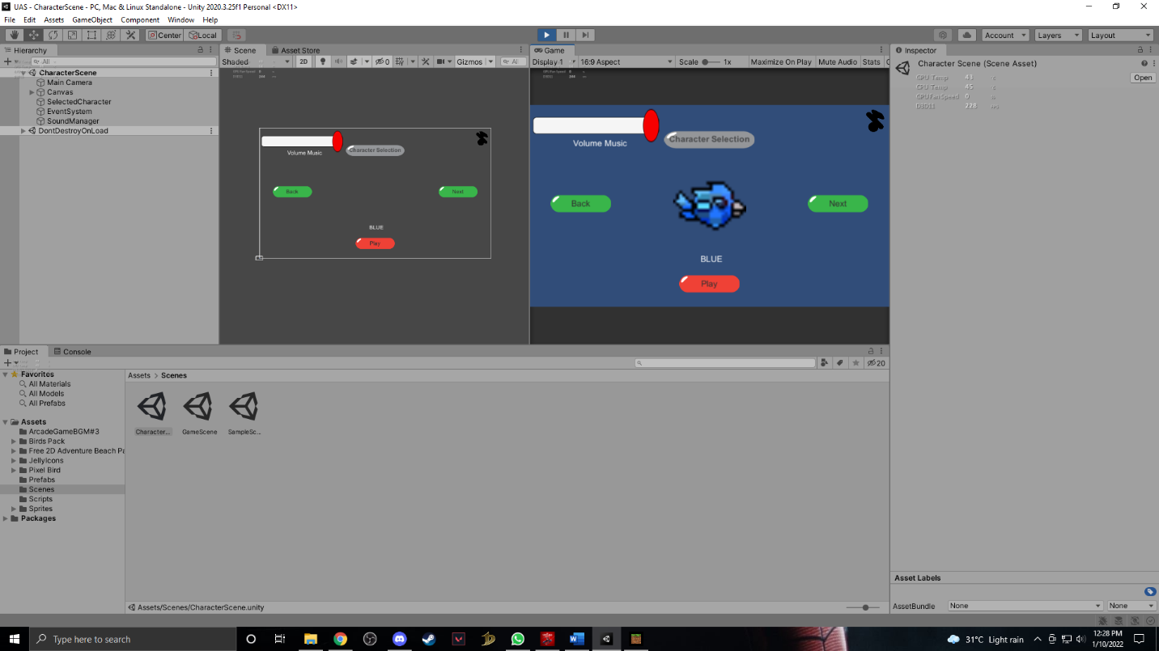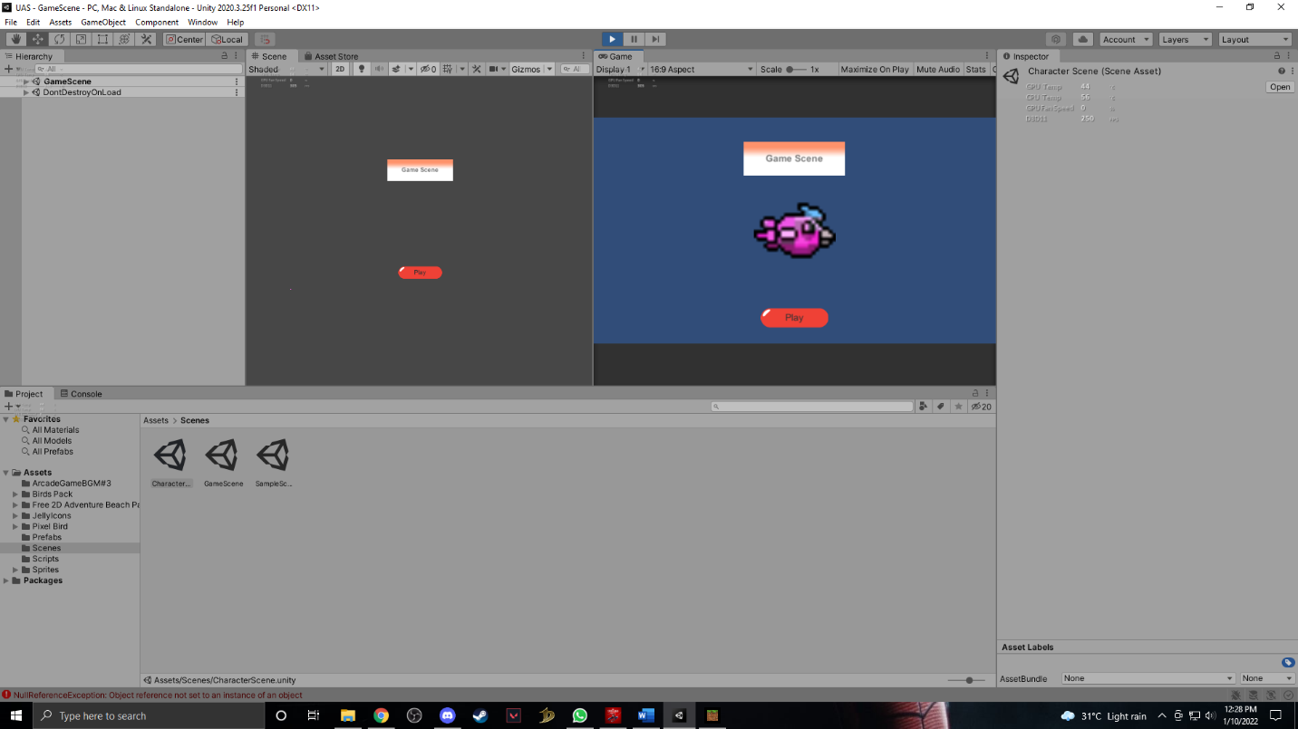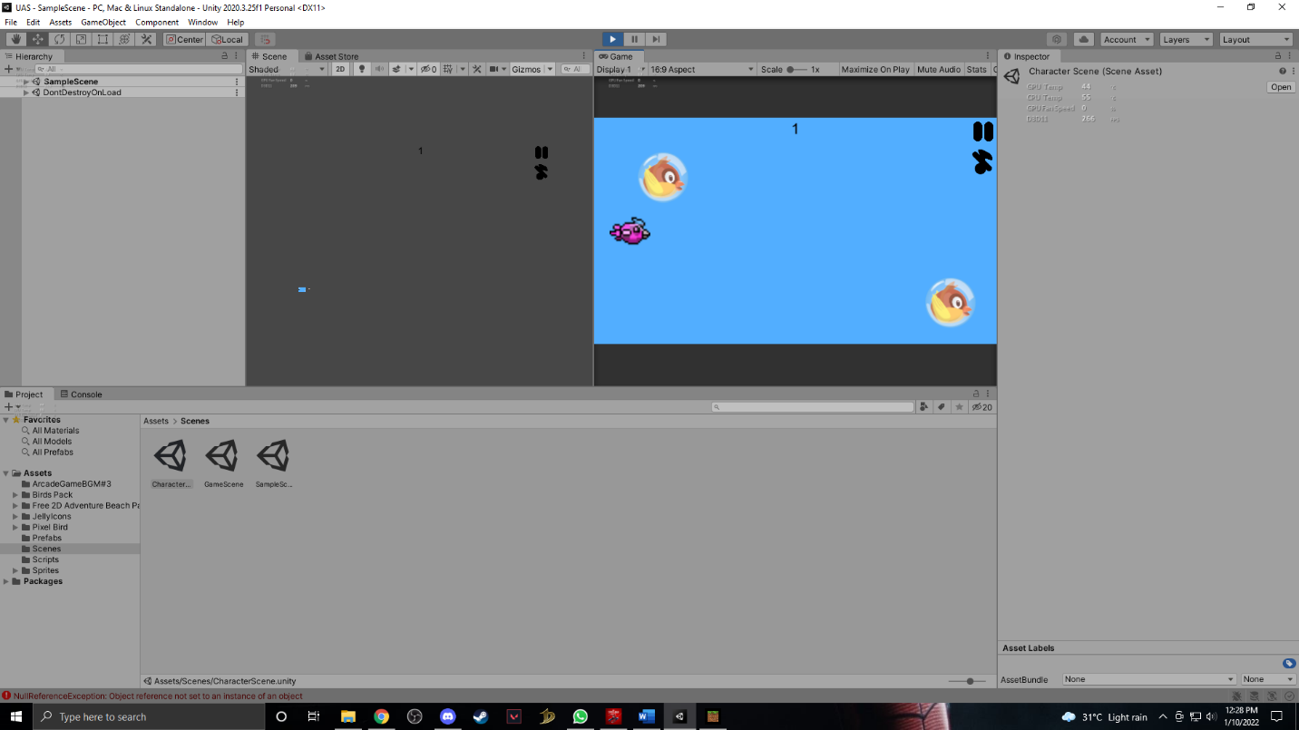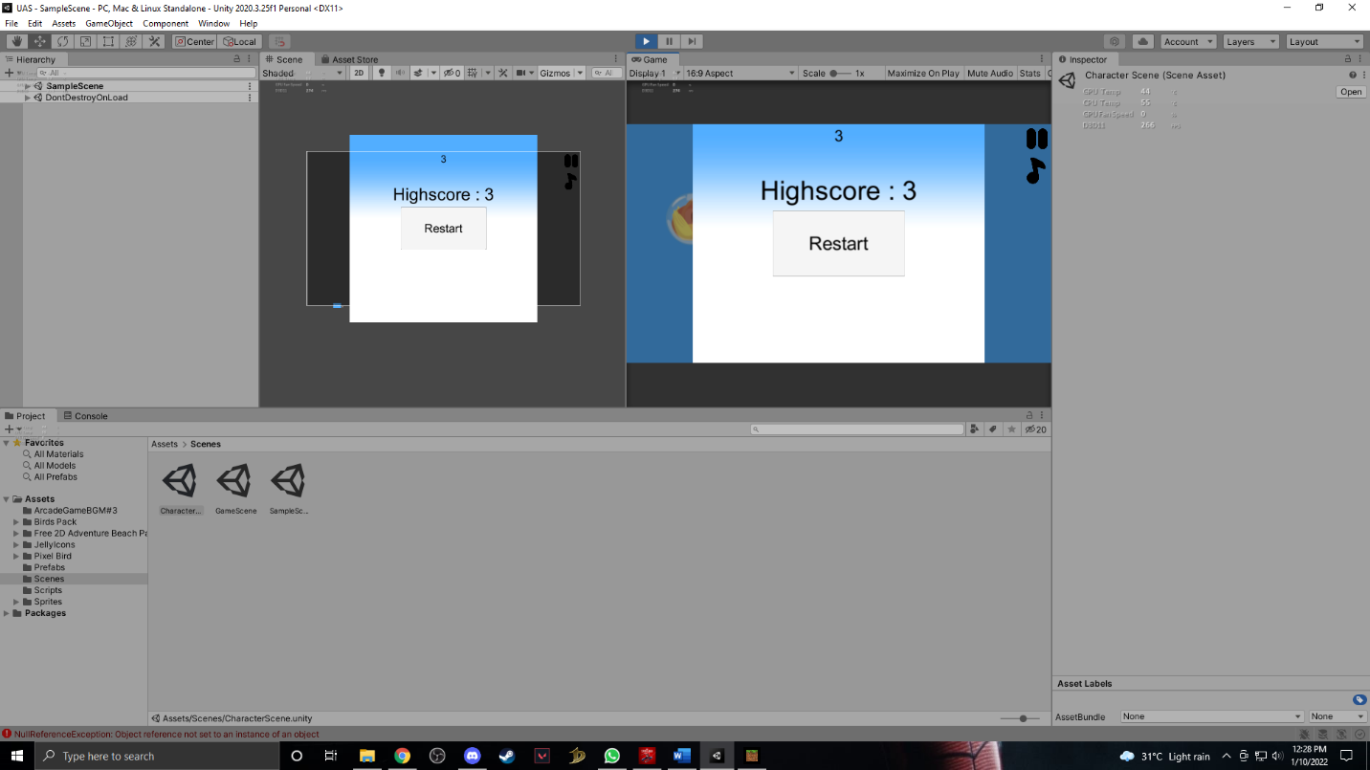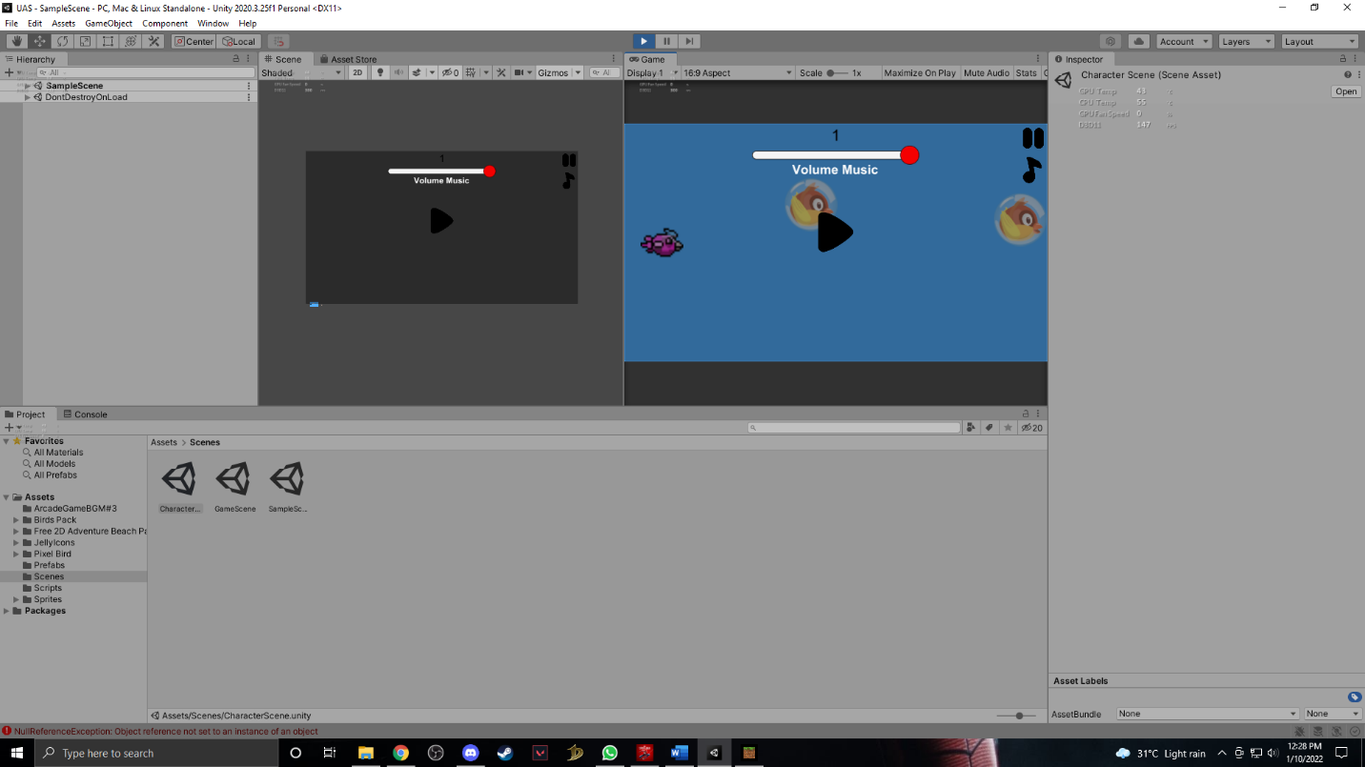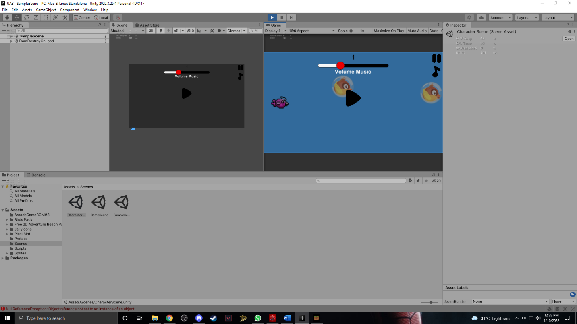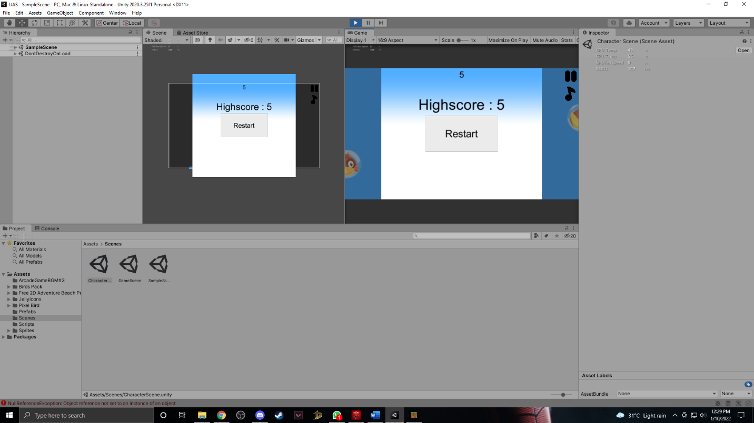

1. Referensi

Asset

<https://assetstore.unity.com/packages/2d/gui/icons/jelly-icons-99749>

<https://assetstore.unity.com/packages/2d/environments/free-2d-adventure-beach-background-82090>

<https://assetstore.unity.com/packages/2d/characters/birds-pack-4-in-1-27774>

<https://assetstore.unity.com/packages/2d/environments/landscape-tiles-birds-free-93903>

Youtube

<https://www.youtube.com/watch?v=2PKBChN10us&t=140s>

<https://www.youtube.com/watch?v=yWCHaTwVblk>

<https://www.youtube.com/watch?v=AFcHsKd_aMo&t=2s>

<https://www.youtube.com/watch?v=U3sT-T5bKX4&t=3s>

<https://www.youtube.com/watch?v=tfzwyNS1LUY&t=90s>