Summary of Current Operations for Big Sky Prints

The first section of this report focuses on current operations for Big Sky Prints and the first five figures below summarize those operations.

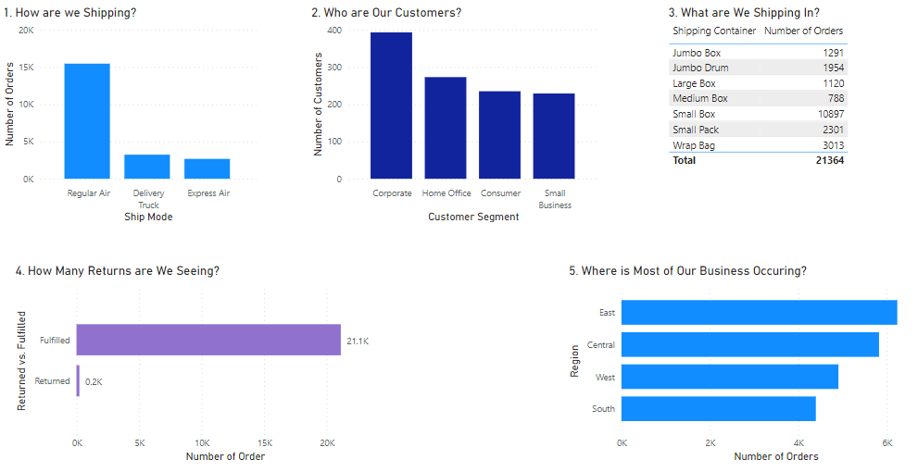

Graph one shows the three methods of shipping we use and compares them. We rely heavily on shipping methods involving aircraft. The second graph shows the customer segments we deal with, corporate customers being our largest segment. The third table in the lineup gives a breakdown of the shipping containers we use most often. The fourth graph shows the number of returns compared to total orders, giving you an idea of how satisfied customers are with our products. Finally, graph five shows which region most of our orders are coming from. As these graphics show, Big Sky Prints is in a good position to continue growing and there are areas of the business we can leverage in our favor.

Looking at the Bigger Picture

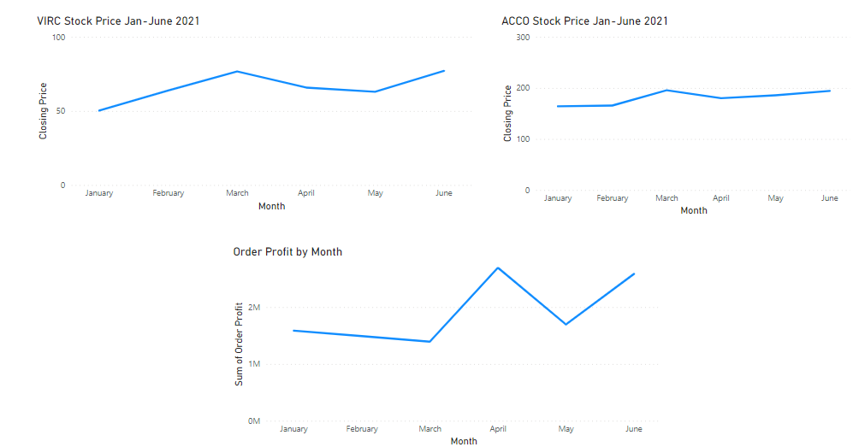

The top two graphs in this section show the stock prices of two of our competitors, Virco Mfg. Corporation (VIRC) and ACCO Brands Corporation (ACCO), for the first half of 2021 compared to our profits for the same time period. As you can see, our profits started to increase shortly after an increase in both of our competitor’s stock prices and continued to rise along with their stock prices into mid-year. This leads me to believe that Big Sky Prints has become well established in the retail space for office supplies and technologies. Though stock prices for both companies had slight upticks in May, Big Sky Prints saw a sharp rise in profits going into June. Overall, Big Sky Prints continues to position itself to gain market share.

Management Questions

The first question management asked to be addressed is the increasing need for manager level positions at the regional level. The following graph shows our total current sales split by region and by customer segment. This can give us a better idea of where to add manager positions within our organization.

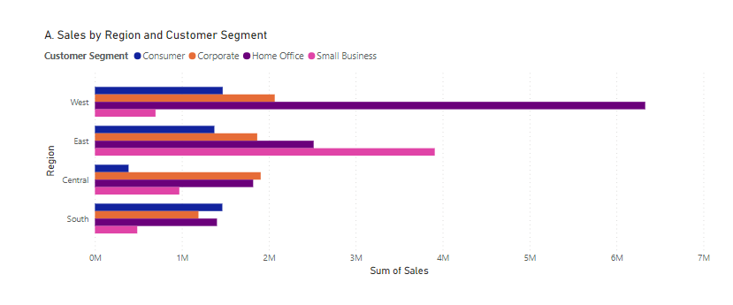

After looking over the figure, the areas that standout are the west and east regions of the company. Here is my proposal for the seven new manager positions being considered: I suggest giving at least one new manager position to each region, to maintain the operations we already have and to free up more senior managers in those areas to pursue growth opportunities. That leaves three possible manager positions to be brought on. I suggest one of these positions be hired for the south region, this new manager position could focus on expanding sales primarily in the small business and corporate segments of this region. Another manager position could be used in the central region to focus on the consumer and small business segments of that region. The final manager position could be hired in the west region to focus on the small business segment in that region, as it seems we are legging behind in that segment, especially considering our success in the home office segment in that region. This position could also travel to the east region from time to time to assist them with growing their consumer segment sales while also learning from them about their success in small business sales.

The next question management asked to be considered involves the cost quoted to us by each of three box suppliers. The following figure shows those what those costs would look like if put against our current shipping data.

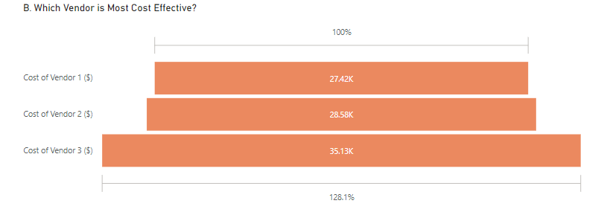

Vendor 1 is the most cost-efficient choice with our current shipping numbers. Even with the free shipping on small packages and wrap bags, Vendor 3 would have been 28.1% more expensive over the course of the last year than Vendor 1.

The final question management asked to be addressed is the order prioritization structure within the company. The tables below show what our current prioritization structure looks like and what the new structure being considered would look like with our order data from the last year.

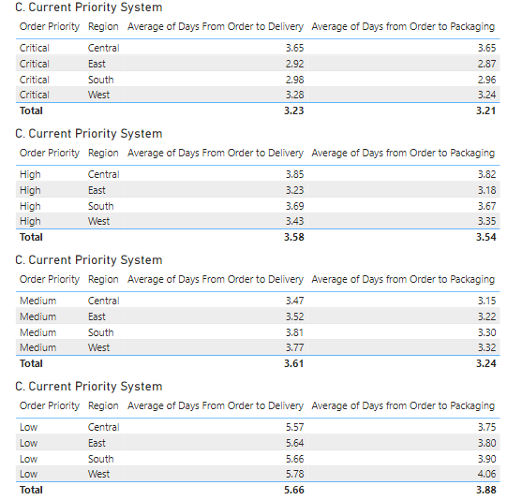

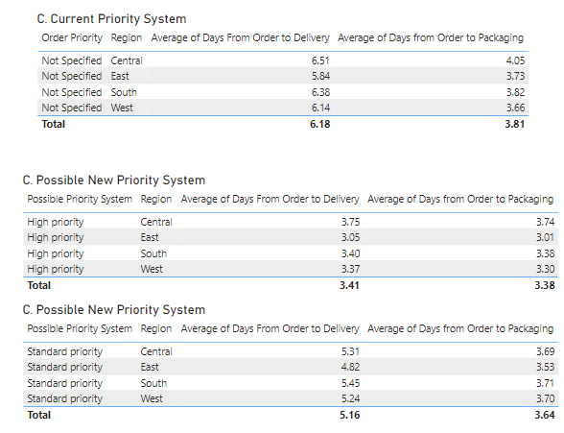

As you can see, by implementing the new prioritization system the process would become more streamlined, however, the average days from order to delivery would increase substantially for the medium priority items that would now be included in standard priority. There may be an increase in overall efficiency though, because of a simpler and easier to understand system. I believe this new system of prioritization should be trialed, possibly in only one region before adopting it companywide.

Overall, Big Sky Prints has been successful up to this point and will continue to be in the future. There are a few opportunities laid out in this report for continued growth and efficiency that should be considered as the business moves forward into a future filled with success and expansion.