The inspiration

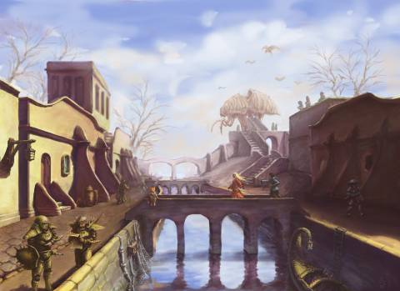

This image of the concept art for Balmora in Morrowind serves as my inspiration the environment I want to create. This would be more of a technical exercise given the fact that I plan to recreate this scene in detail in order to be able to render this scene (minus characters and adding a few more still objects).

Basic plan

To begin with I want to start by developing the overall terrain for the ground, which is the largest component for the scene. I want to work by modelling the largest models first and then model the smaller details for the scene.