Data Exploration

1. Data Set Overview

The table below lists each of the files available for analysis with a short description of what is found in each one.

|  |  |  |
| --- | --- | --- |
| **File Name** | **Description** | **Fields** |
| ad-clicks.csv | A line is added to this file when a player clicks on an advertisement in the Flamingo app. | **timestamp**: when the click occurred.  **txId**: a unique id (within ad-clicks.log) for the click  **userSessionid**: the id of the user session for the user who made the click  **teamid**: the current team id of the user who made the click  **userid**: the user id of the user who made the click  **adId**: the id of the ad clicked on  **adCategory**: the category/type of ad clicked on |
| buy-clicks.csv | A line is added to this file when a player makes an in-app purchase in the Flamingo app. | **timestamp**: when the purchase was made.  **txId**: a unique id (within buy-clicks.log) for the purchase  **userSessionId**: the id of the user session for the user who made the purchase  **team**: the current team id of the user who made the purchase  **userId**: the user id of the user who made the purchase  **buyId**: the id of the item purchased  **price**: the price of the item purchased |
| game-clicks.csv | A line is added to this file each time a user performs a click in the game. | **timestamp**: when the click occurred.  **clickId**: a unique id for the click.  **userId**: the id of the user performing the click.  **userSessionId**: the id of the session of the user when the click is performed.  **isHit**: denotes if the click was on a flamingo (value is 1) or missed the flamingo (value is 0)  **teamId**: the id of the team of the user  **teamLevel**: the current level of the team of the user |
| level-events.csv | A line is added to this file each time a team starts or finishes a level in the game. | **timestamp**: when the event occurred.  **eventId**: a unique id for the event  **teamId**: the id of the team  **teamLevel**: the level started or completed  **eventType**: the type of event, either start or end |
| team-assignments.csv | A line is added to this file each time a user joins a team. A user can be in at most a single team at a time. | **timestamp**: when the user joined the team.  **team**: the id of the team  **userId**: the id of the user  **assignmentId**: a unique id for this assignment |
| team.csv | This file contains a line for each team terminated in the game. | **teamId**: the id of the team  **name**: the name of the team  **teamCreationTime**: the timestamp when the team was created  **teamEndTime**: the timestamp when the last member left the team  **strength**: a measure of team strength, roughly corresponding to the success of a team  **currentLevel**: the current level of the team |
| user.session.csv | Each line in this file describes a user session, which denotes when a user starts and stops playing the game. Additionally, when a team goes to the next level in the game, the session is ended for each user in the team and a new one started. | **timestamp**: a timestamp denoting when the event occurred.  **userSessionId**: a unique id for the session.  **userId**: the current user's ID.  **teamId**: the current user's team.  **assignmentId**: the team assignment id for the user to the team.  **sessionType**: whether the event is the start or end of a session.  **teamLevel**: the level of the team during this session.  **platformType**: the type of platform of the user during this session. |
| users.csv | This file contains a line for each user playing the game. | **timestamp**: when user first played the game.  **userId**: the user id assigned to the user.  **nick**: the nickname chosen by the user.  **twitter**: the twitter handle of the user.  **dob**: the date of birth of the user.  **country**: the two-letter country code where the user lives. |

2. Aggregation

|  |  |
| --- | --- |
| Amount spent buying items | source=buy-clicks.csv host="Admins-MacBook-Air.local" sourcetype="csv" | **stats sum(price)**  Result = 21407.0 |
| Number of unique items available to be purchased | source=buy-clicks.csv host="Admins-MacBook-Air.local" sourcetype="csv" | **stats dc(buyId)**  Result = 6 |

A histogram showing how many times each item is purchased:

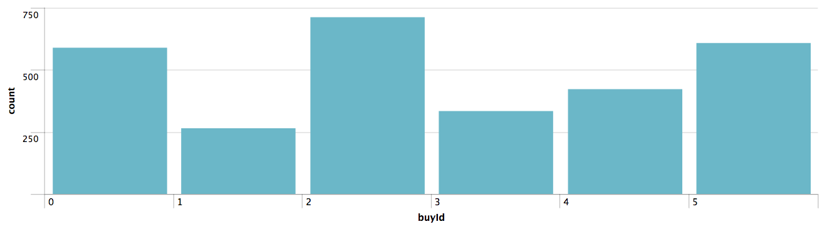

A histogram showing how much money was made from each item:

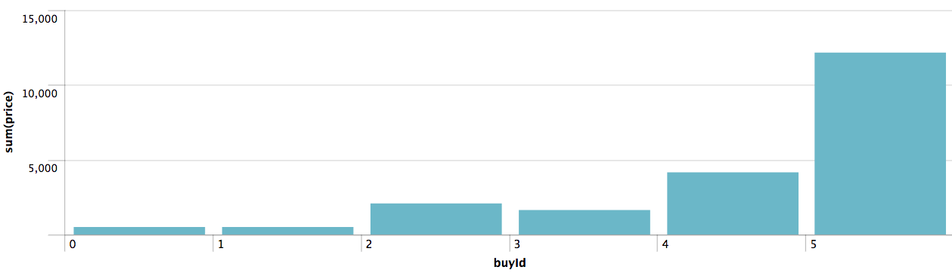

3. Filtering

A histogram showing total amount of money spent by the top ten users (ranked by how much money they spent).

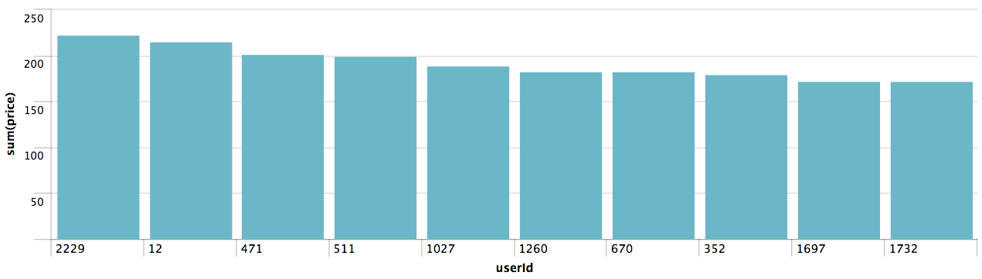

The following table shows the user id, platform, and hit-ratio percentage for the top three buying users:

|  |  |  |  |  |  |
| --- | --- | --- | --- | --- | --- |
| **Rank** | **User Id** | **Platform** | **Count** | **Hits** | **Hit-Ratio (%)** |
| 1 | 2229 | iphone | 526 | 61 | 11.60 |
| 2 | 12 | iphone | 100 | 92 | 92.00 |
| 3 | 471 | iphone | 524 | 76 | 14.50 |