**Data Visualization and Visual Analytics**

**HW9 Report**

311551096 錢承

The visualization system designed for the Spotify Tracks Dataset comprises three key components:

1. Scatter Plot: This plot illustrates the relationship between any two chosen attributes. The color coding of each point indicates the song's popularity, which is categorized into ten levels for simplicity (e.g., 0-10, 11-20, etc.).
2. Correlation Matrix: Functionally akin to the scatter plot, this matrix displays the correlation between any two attributes. A unique feature here is the ability for users to select specific artists for a more focused analysis.
3. Stacked Bar Charts: These charts display nine key attributes - popularity, duration (in minutes), danceability, energy, speechiness, acousticness, liveness, valence, and tempo - across various track genres. Users have the option to sort these charts based on any of the listed attributes. User can also see more detail when the mouse hover over the bar.

Each component of this system offers a distinct perspective on the data, facilitating a comprehensive understanding of the relationships and trends within the Spotify Tracks Dataset.

Following is an example of my system.

1. Frontpage

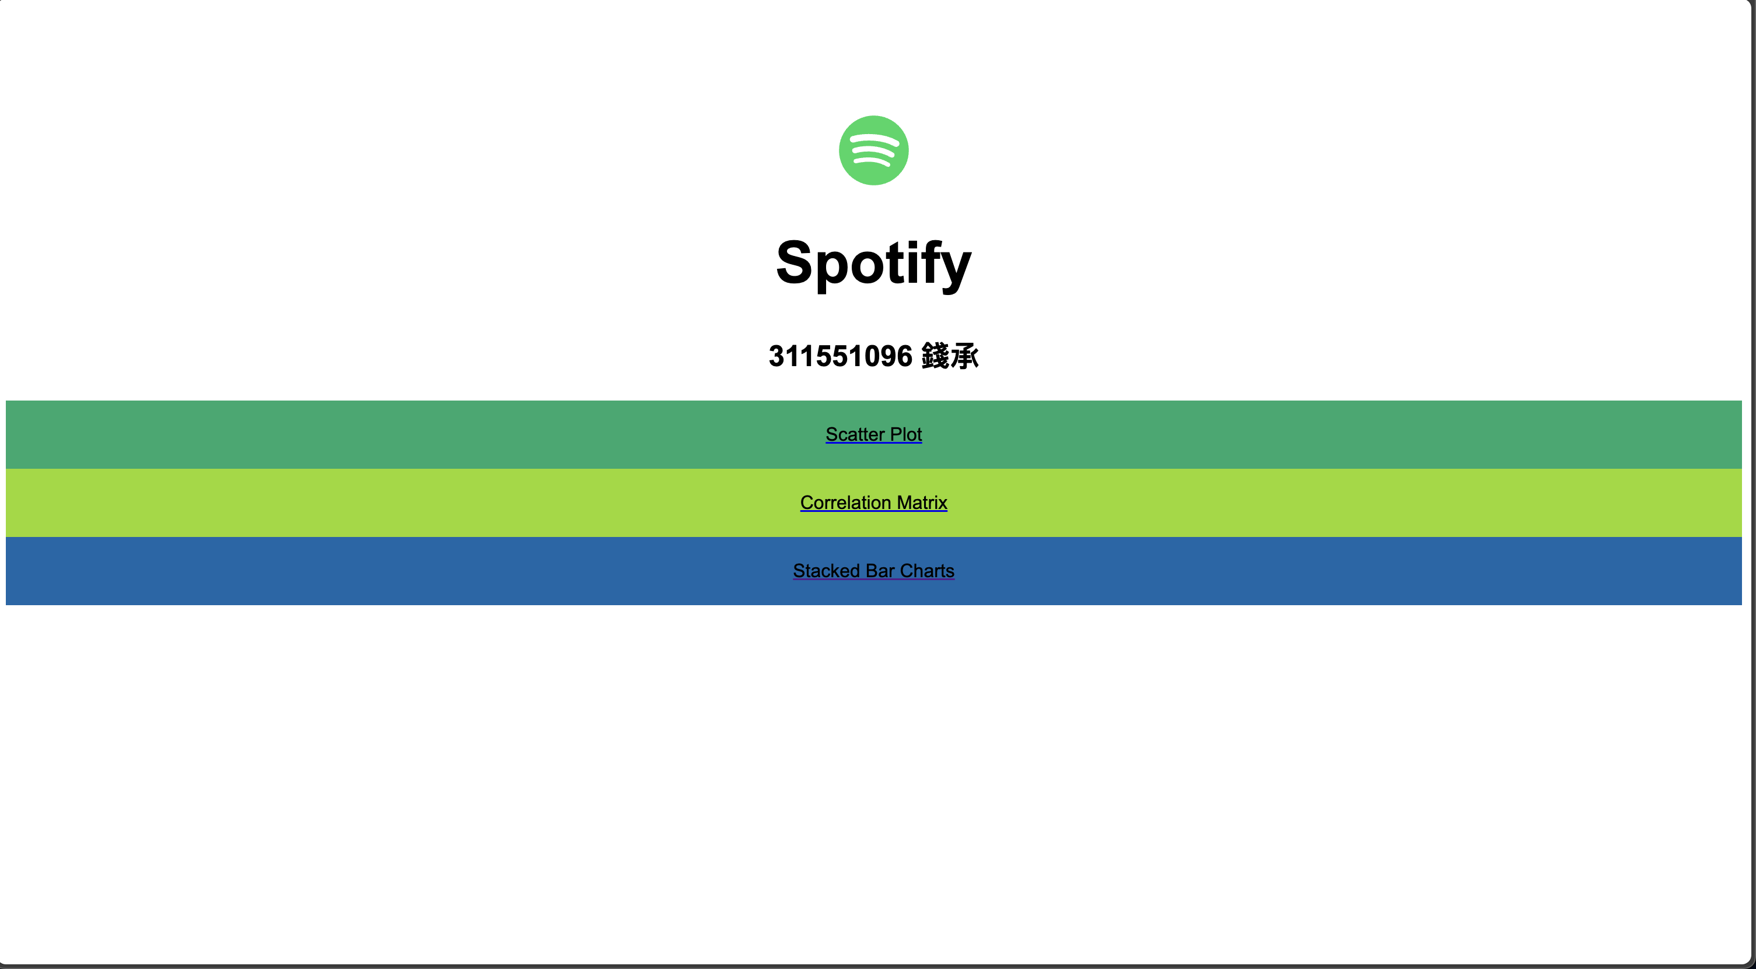

1. Scatter Plot

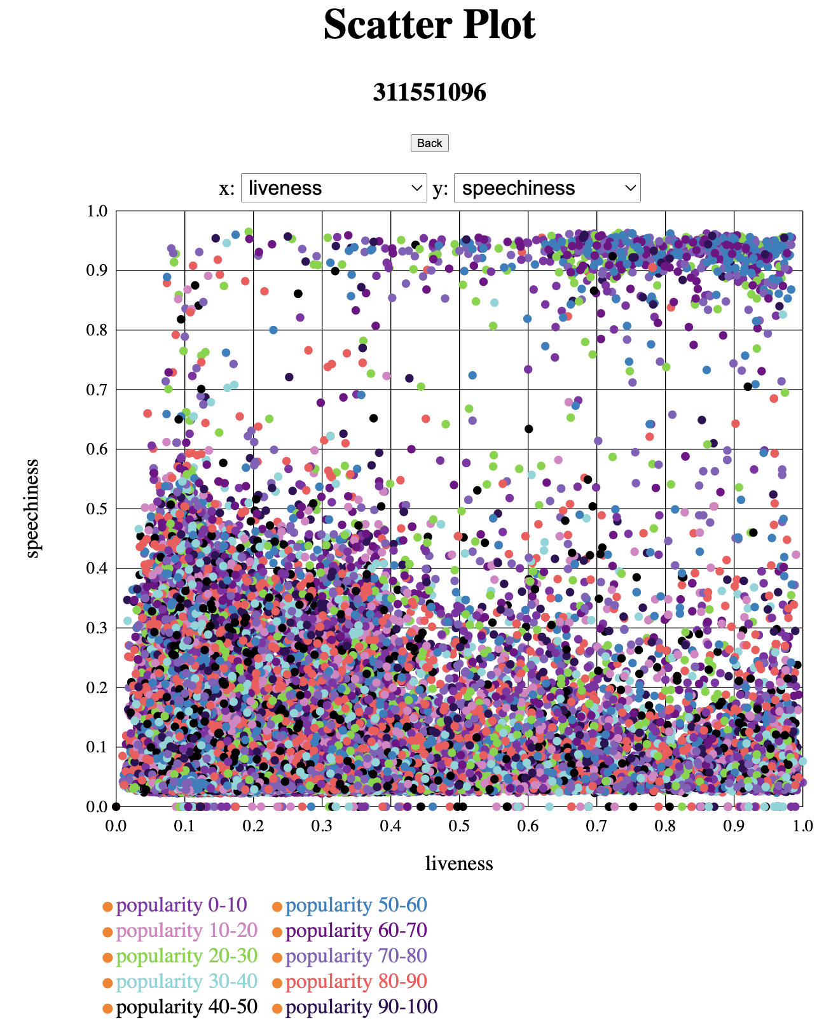

1. Correlation Metrix

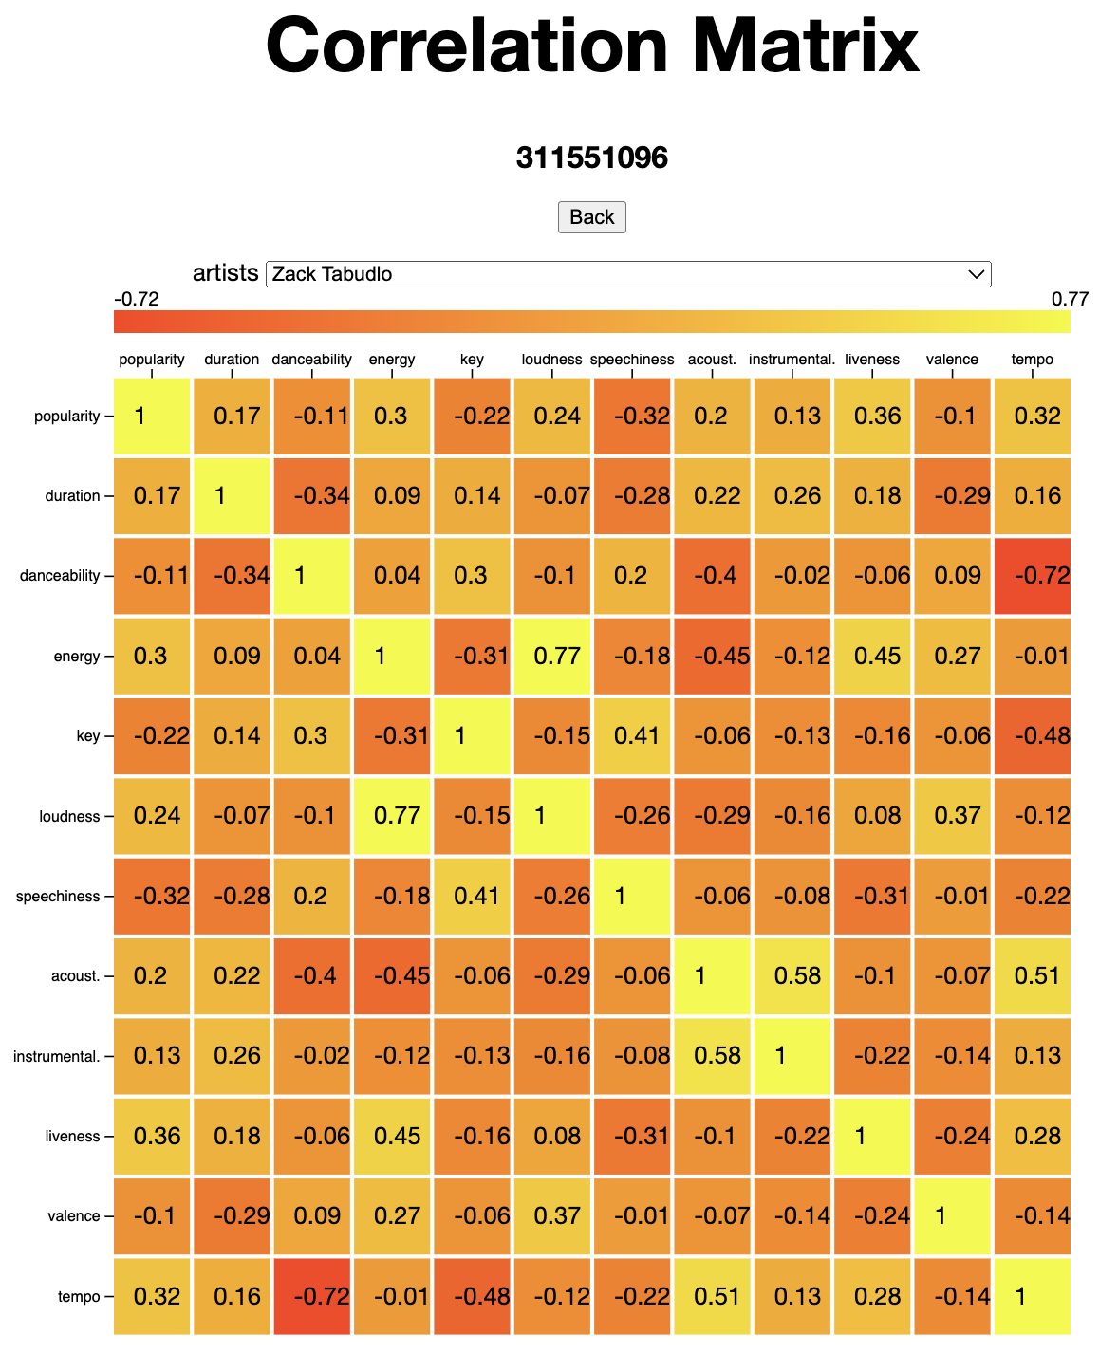

1. Stacked Bar Charts

