Video Compression - Homework 1

311551096 錢承

The RGB represent Red, Green and Blue respectively. The three colors are primary colors of light, by mixing them together can get most of the color in the word. And YUV include a luminance component and two chrominance components. The value range of RGB and YUV is normally between 0 and 255 or between 0 and 1. By different sample type, YUV can divide into YUV444, YUV422, YUV422, etc. Following are the visualized image of R, G, B, Y, U, V, Cb and Cr components.

Original Image:

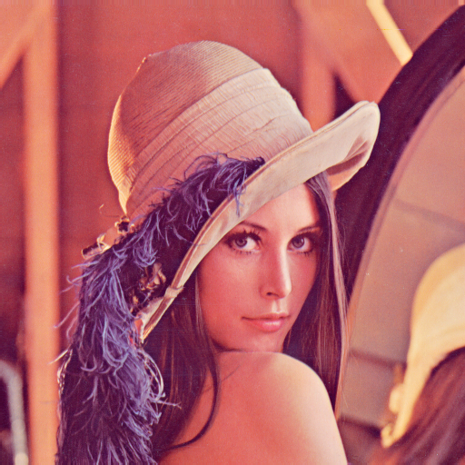

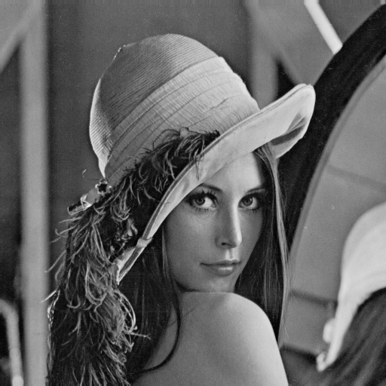R, G, B Gray Scale Images:



Y, U, V Gray Scale Images:

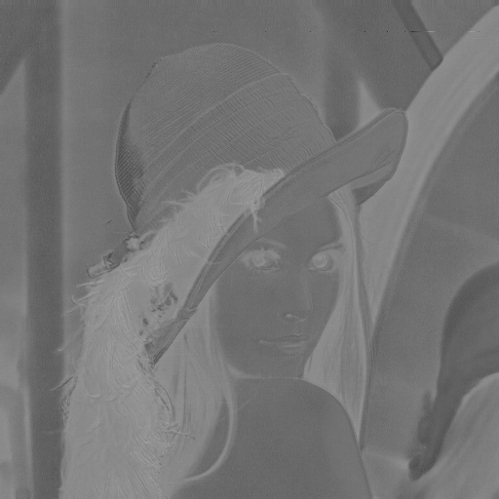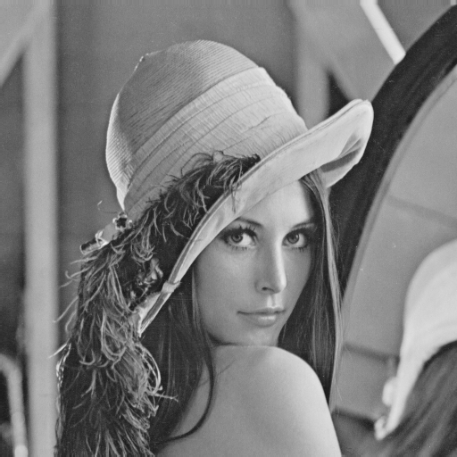

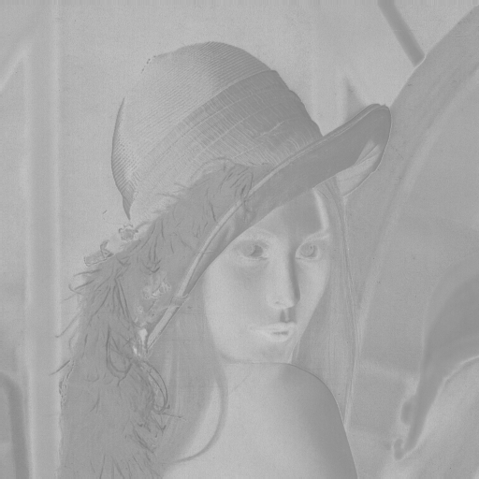

Y, Cb, Cr Gray Scale Images:

