Video Compression - Homework 3

311551096 錢承

Run length encoding and decoding are techniques used in digital image compression that reduce the transmitted data needed to represent an image. These techniques are widely used in image and video compression standards, such as JPEG, MPEG, and H.264. In this homework implementation, I will encode and decode "lena.png" by compressing and decompressing an 8x8 block-based DCT coefficient while quantizing the coefficients with 16-bit for DC and 8-bit for AC.

First, I used DCT to convert images into the frequency domain.

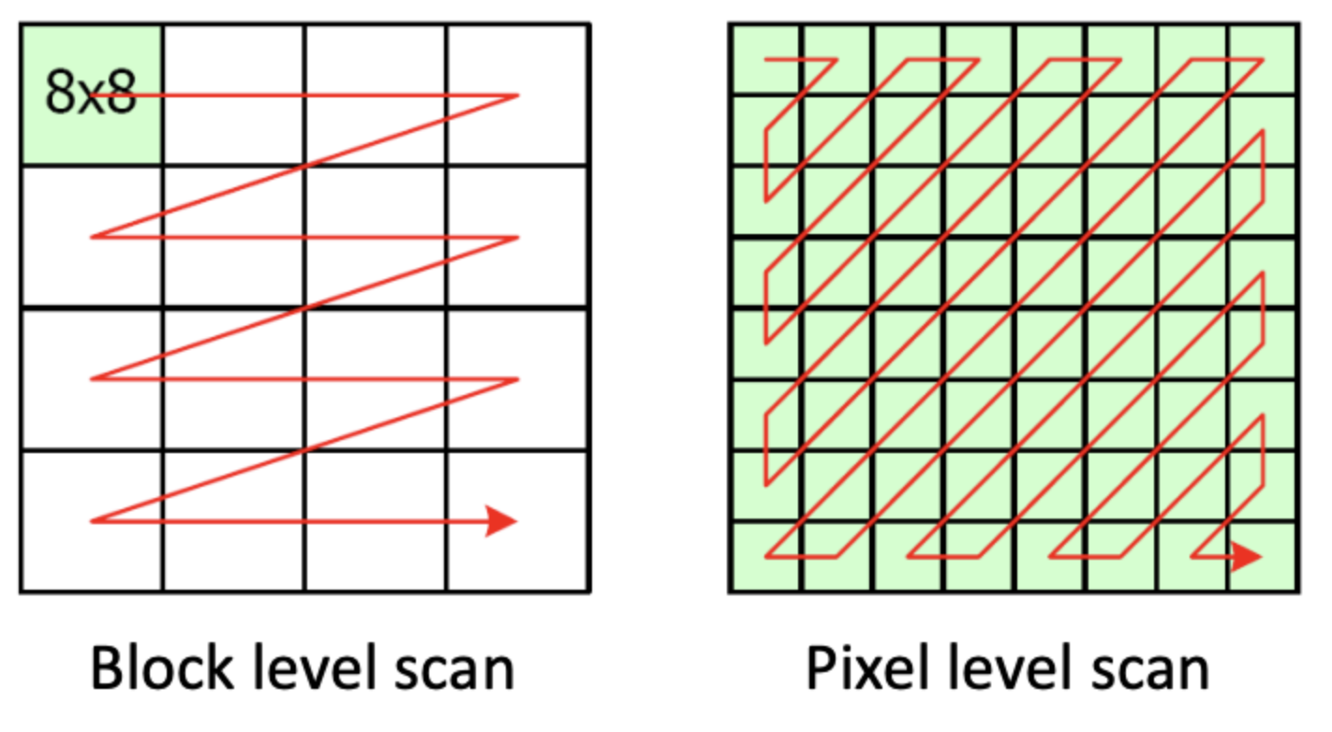Second, I implemented entropy coding: run-length encoding and run-length decoding. The implementation is two-part, block level and pixel level. For the block level, I will use a raster scan. But at the pixel level, I will use a zigzag scan. The visualization is as follows.

For the quantization, I will calculate the scalar first and use the scalar to quantize the images. The equation is as follows.

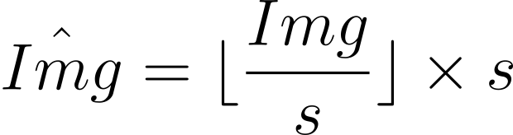

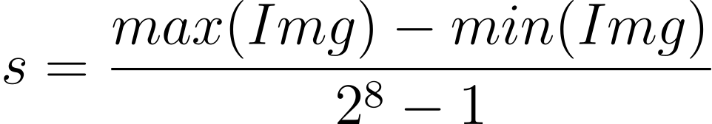

After finishing all above processes, the encoding is complete.

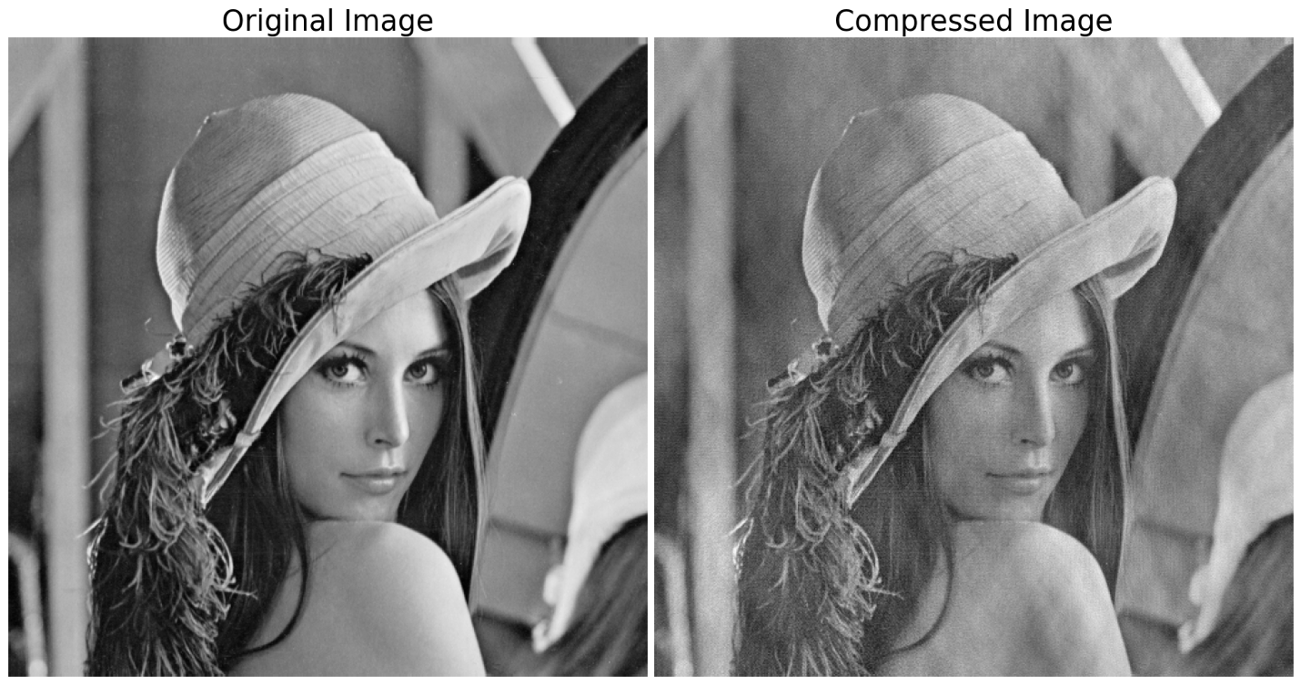When we need to decode the image, invert the above processes, and do IDCT. The image with loss is reconstructed. Following is the visualization between the original image and the compressed image.