Patient List Analysis Responsive Piece
This report explores the impact of recent attempts to reduce ghost patients in the GP patients registered dataset
Total GP List size has seen an increase over time until it’s peak in November 2025 at 63,947,100, after this total list size has seen a continued decrease and currently stands at 63,488,912 as of June 2026.
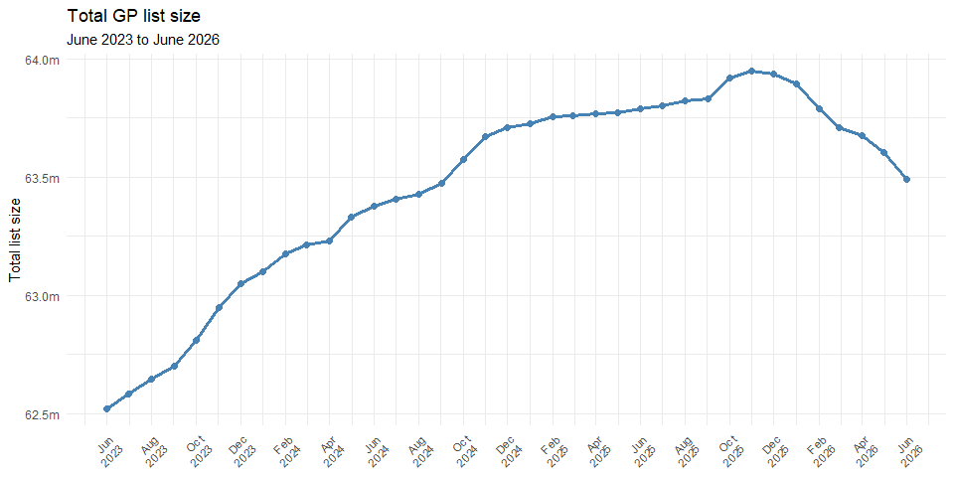
Focusing on the peak at November 2025 we can see that the list size has dropped 458,188 patients as of June 2026 a 0.72% decrease.
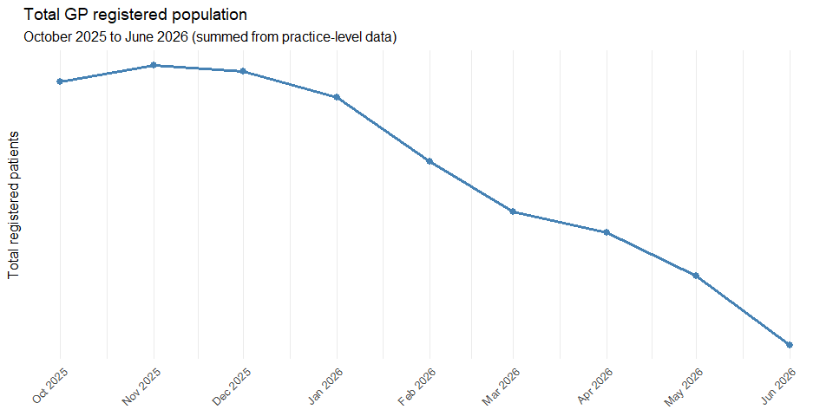
Trying to match similar work done by Helen Salisbury in the BMJ looking at the change between November 2025 and May 2026 we can match the 344,000 patients removed they were referencing, and a similar cost if using a global sum payment of £121.79.
Overall change in GP registered population and cost (Nov 2025 to May 2026)
Nov 2025 | May 2026 | Change | % change | Cost
63,947,100 | 63,602,865 | -344,235 | -0.54% | -£41,924,381
When grouping practices by their list size as of October 2025 we can see that smaller practices have seen a 1.5% decrease over the time period while practices with 20k+ patients have seen an increase of 0.4% in this time period.
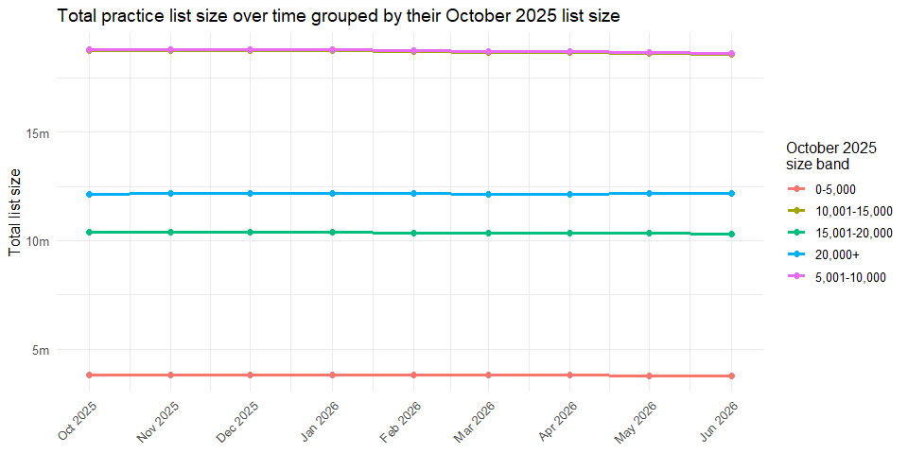
Change in registered patients by October 2025 practice size band (October 2025 to June 2026)
Size_Band | Oct 2025 | Jun 2026 | Number change | % change
0-5,000 | 3,824,485 | 3,765,704 | -58,781 | -1.5%
5,001-10,000 | 18,817,295 | 18,642,206 | -175,089 | -0.9%
10,001-15,000 | 18,766,691 | 18,598,195 | -168,496 | -0.9%
15,001-20,000 | 10,386,021 | 10,311,418 | -74,603 | -0.7%
20,000+ | 12,125,035 | 12,171,389 | 46,354 | 0.4%

When looking at list size by practice contract type we can see that practices with APMS contracts have seen the largest decrease losing 82,742 patients or 3.1% of their list size.
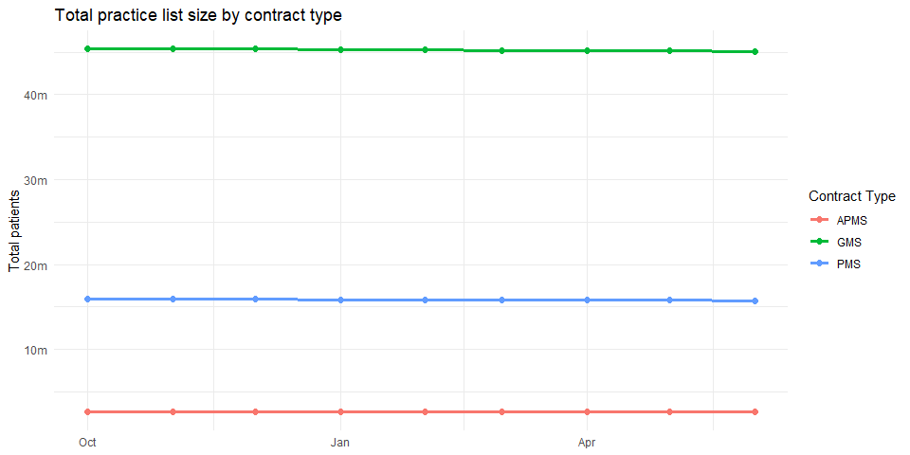
Change in registered patients by contract type (October 2025 to June 2026)
Contract_Type | Oct 2025 | Jun 2026 | Number change | % change
APMS | 2,677,965 | 2,595,223 | -82,742 | -3.1%
GMS | 45,349,132 | 45,124,944 | -224,188 | -0.5%
PMS | 15,880,098 | 15,758,290 | -121,808 | -0.8%

List size for non-dispensing practices saw the majority of the list size change. Losing 426,471 or 0.8% of their list size. While dispensing practices lost 0.02%. This means out of all the patients removed non-dispensing practices have seen 99.5% the removals.
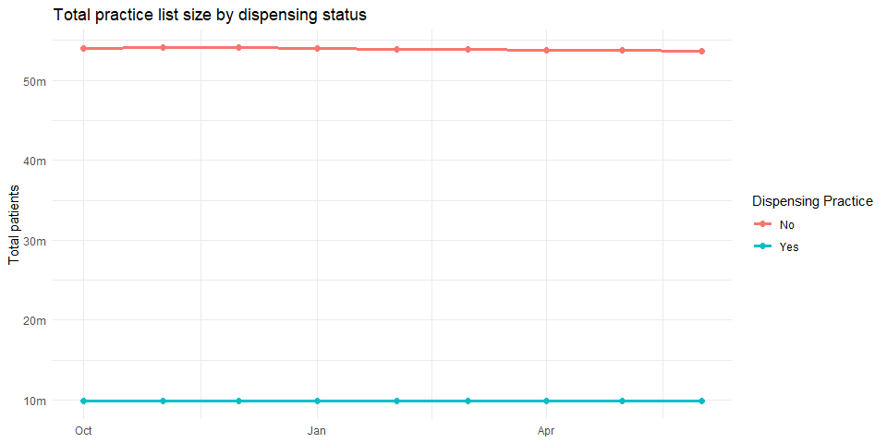
Change in registered patients by dispensing status (October 2025 to June 2026)
Dispensing_Practice | Oct 2025 | Jun 2026 | Number change | % change
No | 54,045,408 | 53,618,937 | -426,471 | -0.8%
Yes | 9,861,787 | 9,859,520 | -2,267 | 0.0%

List size for urban practices also saw the majority of the list size change. Losing 428,846 or 0.8% of their list size.
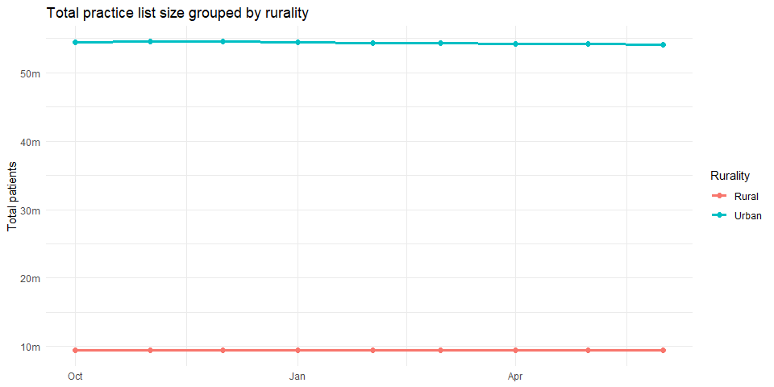
Change in registered patients by practice rurality (October 2025 to June 2026)
Practice_Rurality | Oct 2025 | Jun 2026 | Number change | % change
Rural | 9,410,304 | 9,410,412 | 108 | 0.0%
Urban | 54,496,891 | 54,068,045 | -428,846 | -0.8%

Using GP IMD deciles from fingertips which uses Patients Registered at a GP practice LSOA level data to map patient LSOA IMD to create a practice level. We can see that in general more deprived practices have been losing a higher % of their list size over this time period. (May need to check this again - do we expect practices in less depirved areas to have a higher list size?)
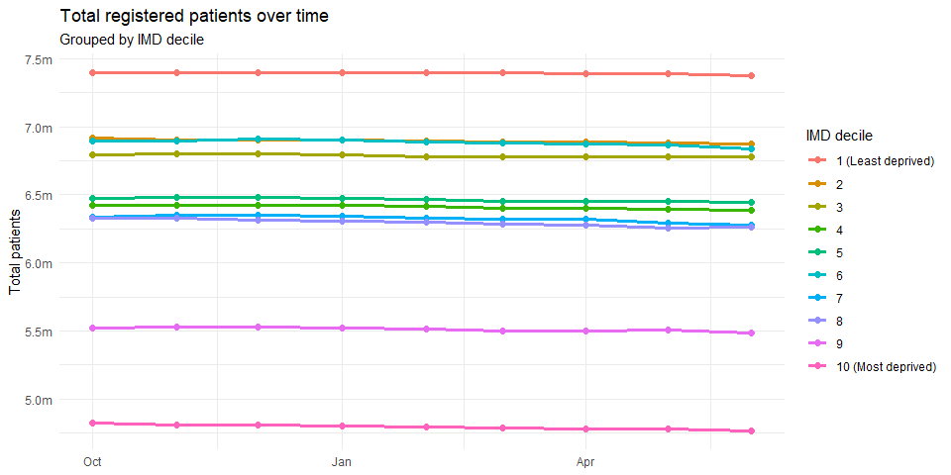
Change in registered patients by practice IMD decile (October 2025 to June 2026)
IMD_Decile | Oct 2025 | Jun 2026 | Number change | % change
1 | 7,395,130 | 7,374,494 | -20,636 | -0.3%
2 | 6,914,243 | 6,870,980 | -43,263 | -0.6%
3 | 6,790,989 | 6,777,147 | -13,842 | -0.2%
4 | 6,425,194 | 6,387,432 | -37,762 | -0.6%
5 | 6,472,957 | 6,442,553 | -30,404 | -0.5%
6 | 6,894,473 | 6,834,398 | -60,075 | -0.9%
7 | 6,339,410 | 6,277,254 | -62,156 | -1.0%
8 | 6,329,155 | 6,263,809 | -65,346 | -1.0%
9 | 5,519,781 | 5,486,037 | -33,744 | -0.6%
10 | 4,823,593 | 4,762,816 | -60,777 | -1.3%

The London region has lost a larger percentage of it’s list size (1.5%) in this time period compared to other regions.
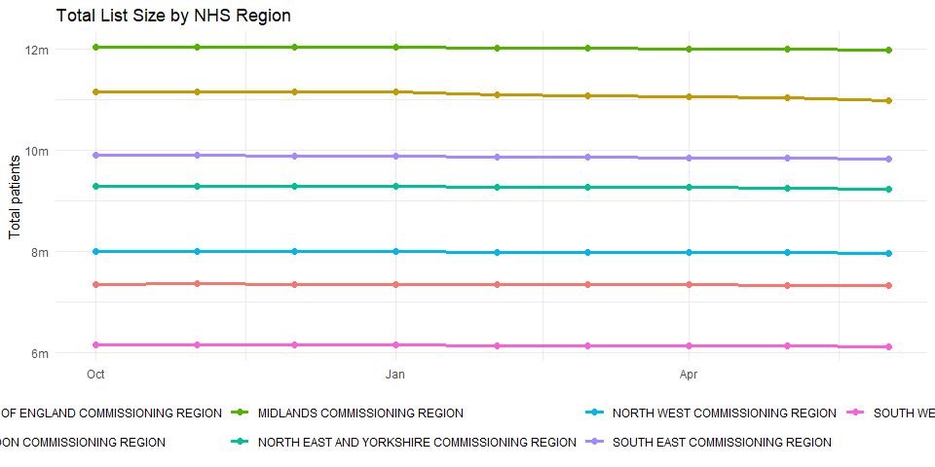
Change in registered patients by region (October 2025 to June 2026)
Region | Oct 2025 | Jun 2026 | Number change | % change
SOUTH WEST COMMISSIONING REGION | 6,157,041 | 6,131,379 | -25,662 | -0.4%
NORTH WEST COMMISSIONING REGION | 7,997,370 | 7,969,178 | -28,192 | -0.4%
EAST OF ENGLAND COMMISSIONING REGION | 7,362,631 | 7,328,959 | -33,672 | -0.5%
NORTH EAST AND YORKSHIRE COMMISSIONING REGION | 9,288,929 | 9,241,703 | -47,226 | -0.5%
SOUTH EAST COMMISSIONING REGION | 9,899,672 | 9,839,304 | -60,368 | -0.6%
MIDLANDS COMMISSIONING REGION | 12,046,991 | 11,981,259 | -65,732 | -0.5%
LONDON COMMISSIONING REGION | 11,154,561 | 10,986,675 | -167,886 | -1.5%

When looking at practices by Average Payment per registered patients from the Payments to General practice dataset 2024/25 we can see that practices that received less payments saw a larger reduction in their list size.
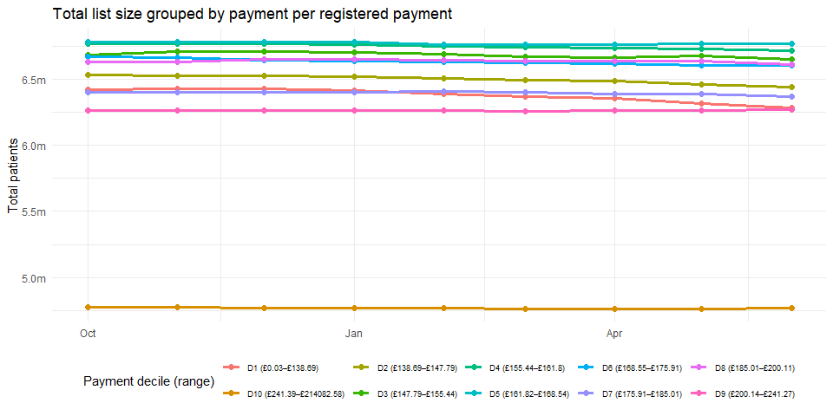
Change in registered patients by payment-per-patient decile (October 2025 to June 2026)
Decile_Label | Oct 2025 | Jun 2026 | Number change | % change
D1 (£0.03–£138.69) | 6,417,155 | 6,281,010 | -136,145 | -2.1%
D2 (£138.69–£147.79) | 6,529,651 | 6,439,875 | -89,776 | -1.4%
D3 (£147.79–£155.44) | 6,680,878 | 6,649,355 | -31,523 | -0.5%
D4 (£155.44–£161.8) | 6,765,359 | 6,715,206 | -50,153 | -0.7%
D5 (£161.82–£168.54) | 6,782,023 | 6,764,430 | -17,593 | -0.3%
D6 (£168.55–£175.91) | 6,666,088 | 6,604,781 | -61,307 | -0.9%
D7 (£175.91–£185.01) | 6,399,255 | 6,370,161 | -29,094 | -0.5%
D8 (£185.01–£200.11) | 6,631,368 | 6,611,916 | -19,452 | -0.3%
D9 (£200.14–£241.27) | 6,260,329 | 6,270,224 | 9,895 | 0.2%
D10 (£241.39–£214082.58) | 4,775,089 | 4,771,499 | -3,590 | -0.1%

When looking at the total list size by gender we can see that male patients have been the most impacted. Losing 1% of their numbers compared to 0.3% for women in the same time period.
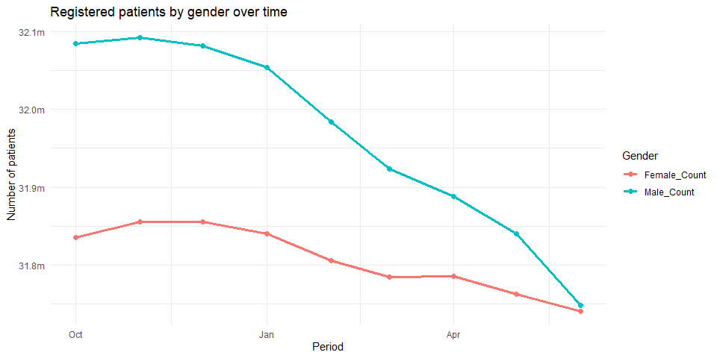
Change in registered patients by gender (October 2025 to June 2026)
Gender | Oct 2025 | Jun 2026 | Number change | % change
Male_Count | 32,084,312 | 31,747,999 | -336,313 | -1.0%
Female_Count | 31,835,215 | 31,740,913 | -94,302 | -0.3%

List size across age groups has also been variable. Notably the 80-89 and 90+ categories have increased by 1.9% and 1.3% receptively across this time period but with the number reductions being driven by the 0-9, the 30-39 and 50-59 age groups.
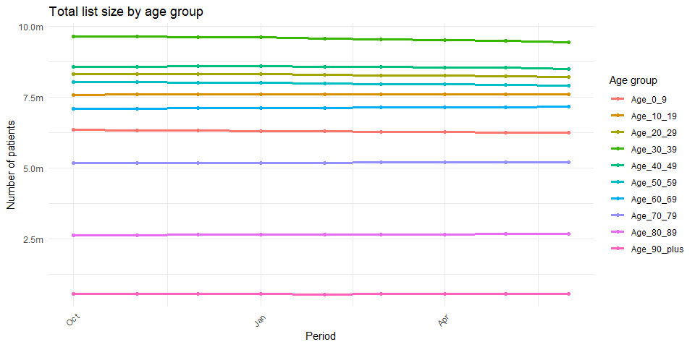
Change in registered patients by age group (October 2025 to June 2026)
Age_Group | Oct 2025 | Jun 2026 | Number change | % change
Age_0_9 | 6,346,029 | 6,238,948 | -107,081 | -1.7%
Age_10_19 | 7,574,852 | 7,591,409 | 16,557 | 0.2%
Age_20_29 | 8,302,266 | 8,212,376 | -89,890 | -1.1%
Age_30_39 | 9,633,695 | 9,424,621 | -209,074 | -2.2%
Age_40_49 | 8,563,642 | 8,498,526 | -65,116 | -0.8%
Age_50_59 | 8,031,583 | 7,906,071 | -125,512 | -1.6%
Age_60_69 | 7,080,793 | 7,156,581 | 75,788 | 1.1%
Age_70_79 | 5,183,760 | 5,200,324 | 16,564 | 0.3%
Age_80_89 | 2,642,395 | 2,692,196 | 49,801 | 1.9%
Age_90_plus | 560,512 | 567,860 | 7,348 | 1.3%

When looking at patients and grouping them into IMD categories for the LSOAs where they are registered we can see that the patinets in the least deprived deciles (1) have seen the largest % reduction.
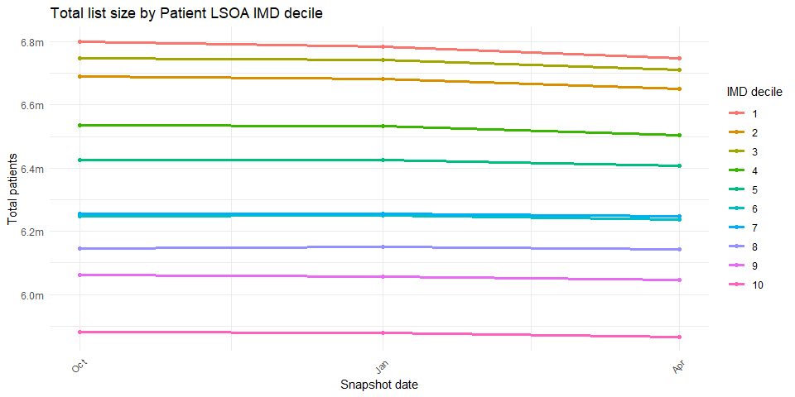
Change in registered patients by IMD decile (October 2025 to April 2026)
IMD_Decile | Oct 2025 | Apr 2026 | Number change | % change
1 | 6,800,269 | 6,748,377 | -51,892 | -0.76%
2 | 6,691,488 | 6,649,941 | -41,547 | -0.62%
3 | 6,747,065 | 6,711,506 | -35,559 | -0.53%
4 | 6,536,000 | 6,504,798 | -31,202 | -0.48%
5 | 6,426,448 | 6,406,447 | -20,001 | -0.31%
6 | 6,249,064 | 6,236,257 | -12,807 | -0.20%
7 | 6,254,910 | 6,248,290 | -6,620 | -0.11%
8 | 6,145,063 | 6,143,354 | -1,709 | -0.03%
9 | 6,060,742 | 6,045,739 | -15,003 | -0.25%
10 | 5,880,857 | 5,867,021 | -13,836 | -0.24%

