Ghost Patients Descriptive Analysis

Dataset Disparities
For 01 July 2024 data, the practice-level registered patients data contains 63,407,818 registered patients, compared with 63,365,094 in the LSOA-level registered patients’ data before any filtering or linkage. The LSOA source contains 42,724 fewer registrations than the practice-level total. NHS England reported processing issues in the July 2024 LSOA release which led to this difference.
The LSOA extract also includes 15,509 registered patients in Welsh LSOAs. Another 78,282 registrations have an unknown or other residence code and are also excluded from the IMD dataset, leaving 63,271,303 registrations in IMD chart.

National population over time
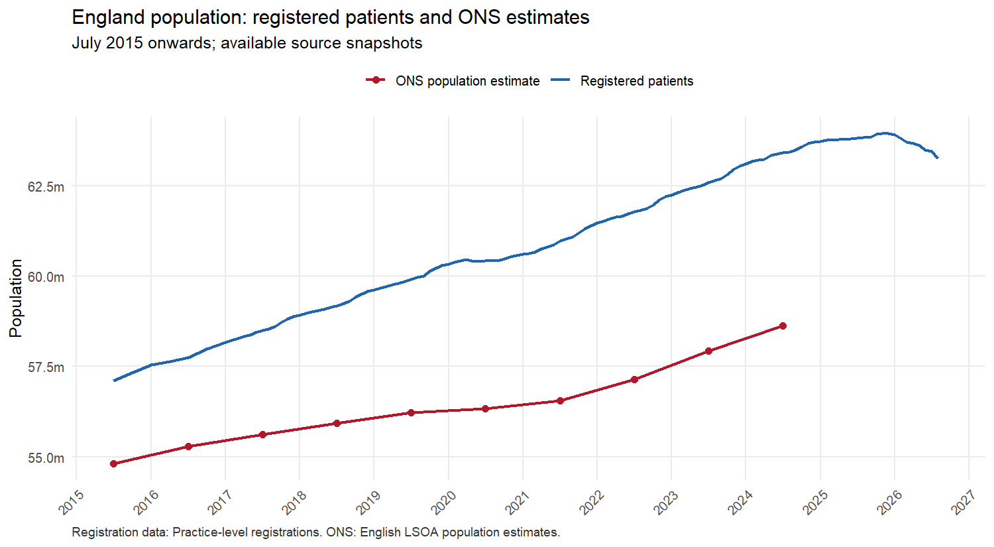

Age over time
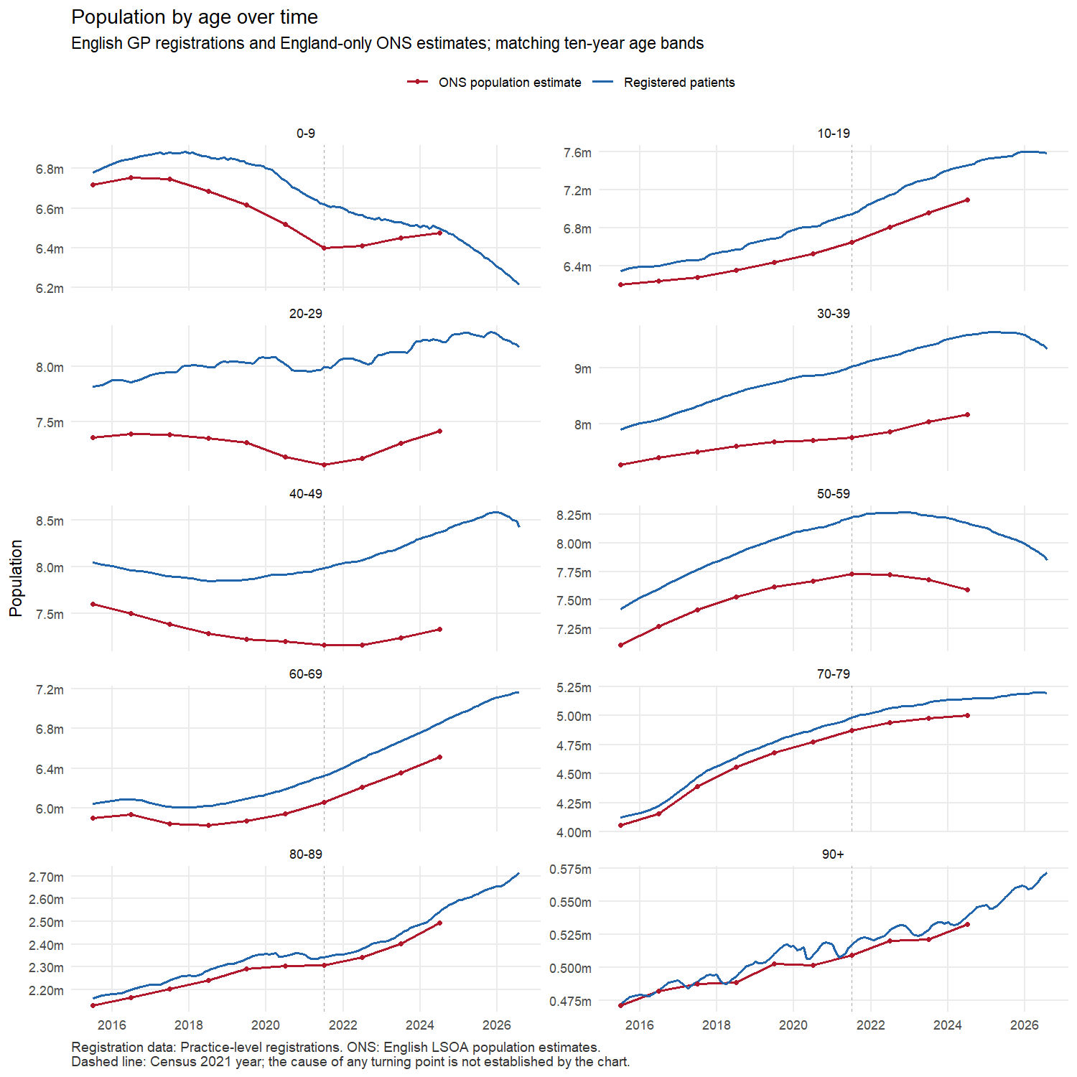

Sex over time
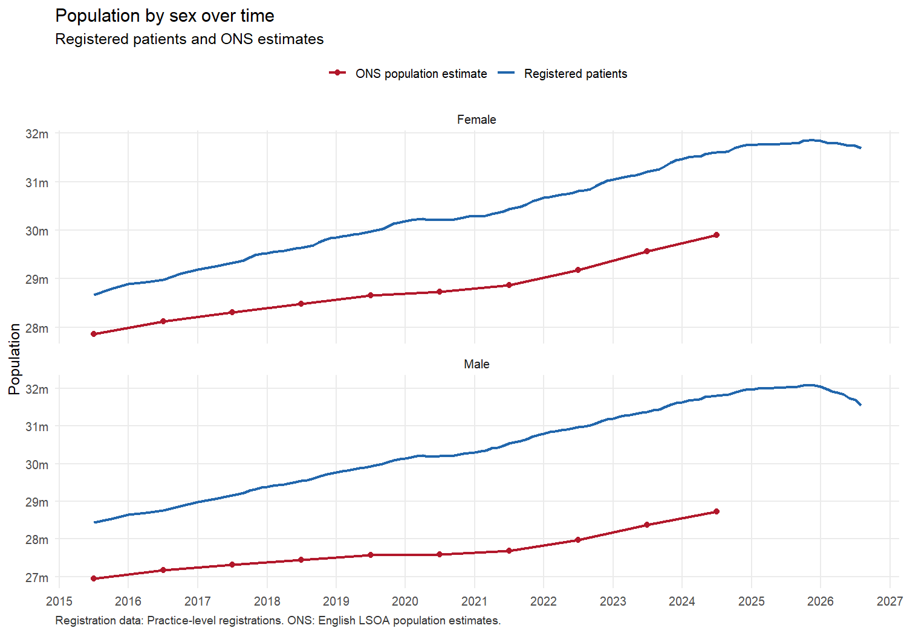

July 2024 Snapshots

National total
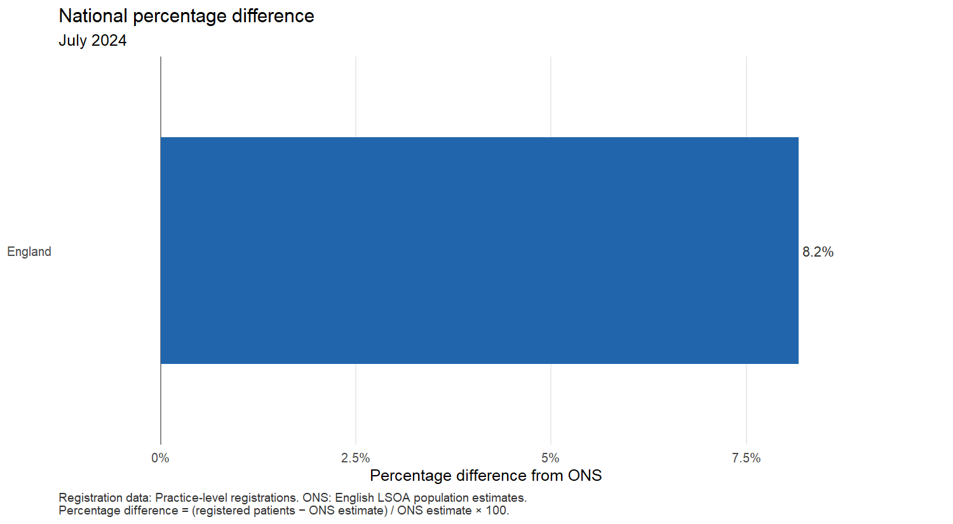
National population comparison (Practice-level registrations)
Geography | Registered patients | ONS population | Raw difference | Percentage difference
England | 63,407,818 | 58,620,101 | 4,787,717 | 8.2%

Age
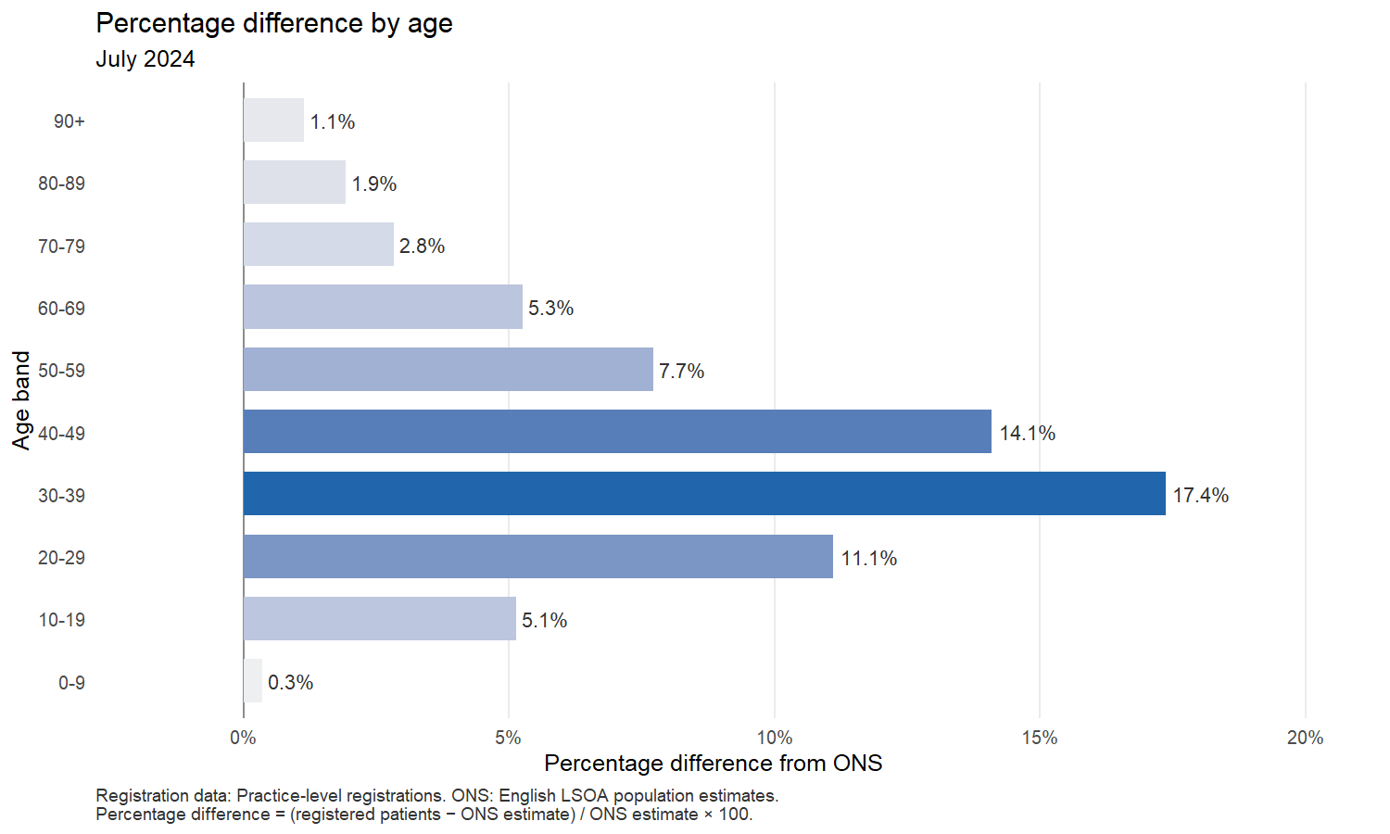
Population comparison by age (Practice-level registrations)
Age band | Registered patients | ONS population | Raw difference | Percentage difference
0-9 | 6,496,574 | 6,473,967 | 22,607 | 0.3%
10-19 | 7,454,828 | 7,090,887 | 363,941 | 5.1%
20-29 | 8,234,922 | 7,411,589 | 823,333 | 11.1%
30-39 | 9,594,407 | 8,174,602 | 1,419,805 | 17.4%
40-49 | 8,368,953 | 7,335,047 | 1,033,906 | 14.1%
50-59 | 8,175,621 | 7,590,138 | 585,483 | 7.7%
60-69 | 6,857,153 | 6,514,421 | 342,732 | 5.3%
70-79 | 5,144,130 | 5,002,303 | 141,827 | 2.8%
80-89 | 2,542,535 | 2,494,504 | 48,031 | 1.9%
90+ | 538,695 | 532,643 | 6,052 | 1.1%

Sex
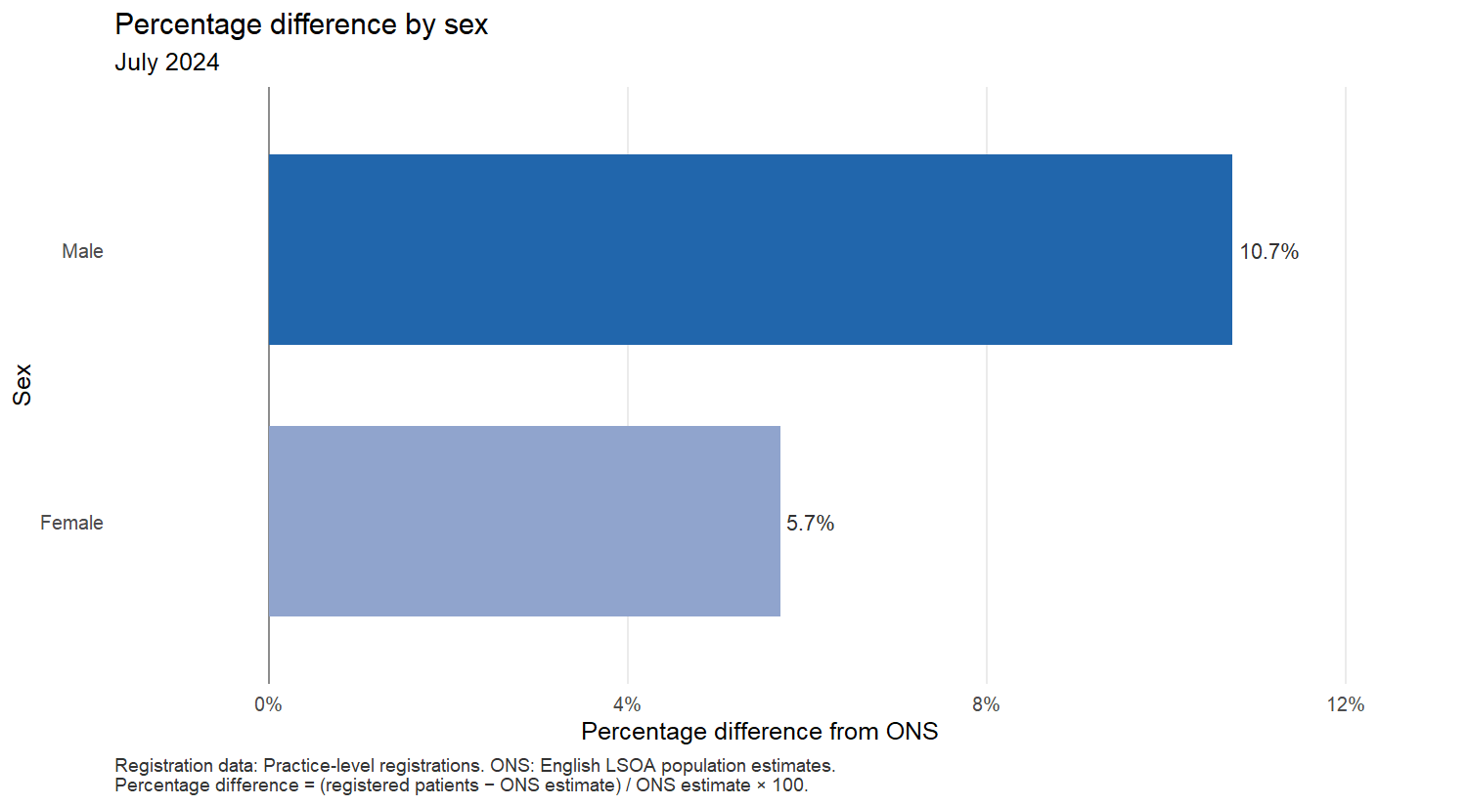
Population comparison by sex (Practice-level registrations)
Sex | Registered patients | ONS population | Raw difference | Percentage difference
Female | 31,600,037 | 29,895,762 | 1,704,275 | 5.7%
Male | 31,807,781 | 28,724,339 | 3,083,442 | 10.7%

Age and sex
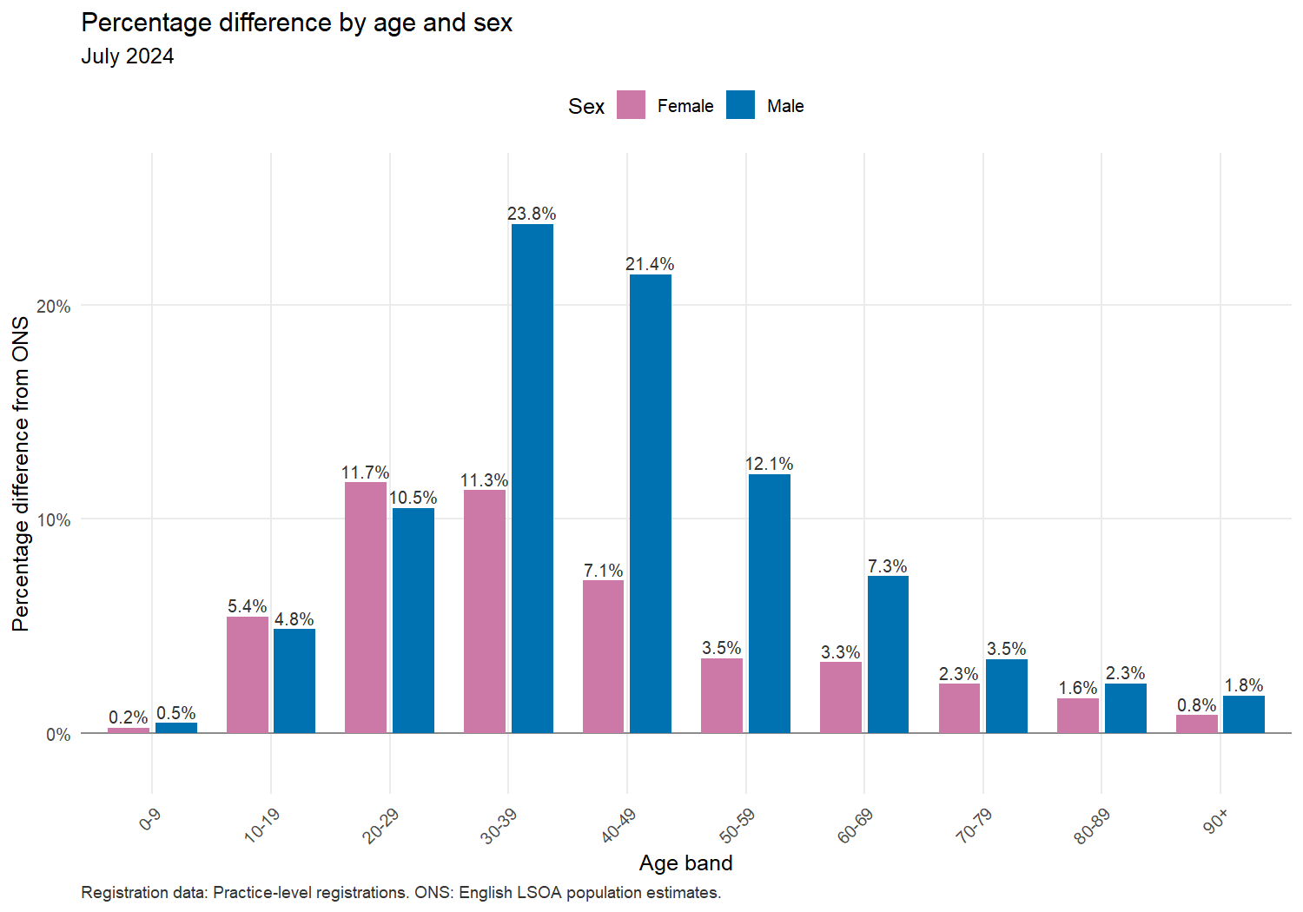
Population comparison by age and sex (Practice-level registrations)
Age band | Sex | Registered patients | ONS population | Raw difference | Percentage difference
0-9 | Female | 3,167,956 | 3,160,590 | 7,366 | 0.2%
0-9 | Male | 3,328,618 | 3,313,377 | 15,241 | 0.5%
10-19 | Female | 3,637,550 | 3,449,797 | 187,753 | 5.4%
10-19 | Male | 3,817,278 | 3,641,090 | 176,188 | 4.8%
20-29 | Female | 4,107,449 | 3,676,960 | 430,489 | 11.7%
20-29 | Male | 4,127,473 | 3,734,629 | 392,844 | 10.5%
30-39 | Female | 4,696,662 | 4,218,195 | 478,467 | 11.3%
30-39 | Male | 4,897,745 | 3,956,407 | 941,338 | 23.8%
40-49 | Female | 4,028,647 | 3,760,590 | 268,057 | 7.1%
40-49 | Male | 4,340,306 | 3,574,457 | 765,849 | 21.4%
50-59 | Female | 4,005,323 | 3,870,111 | 135,212 | 3.5%
50-59 | Male | 4,170,298 | 3,720,027 | 450,271 | 12.1%
60-69 | Female | 3,448,807 | 3,338,533 | 110,274 | 3.3%
60-69 | Male | 3,408,346 | 3,175,888 | 232,458 | 7.3%
70-79 | Female | 2,709,853 | 2,649,210 | 60,643 | 2.3%
70-79 | Male | 2,434,277 | 2,353,093 | 81,184 | 3.5%
80-89 | Female | 1,441,610 | 1,418,506 | 23,104 | 1.6%
80-89 | Male | 1,100,925 | 1,075,998 | 24,927 | 2.3%
90+ | Female | 356,180 | 353,270 | 2,910 | 0.8%
90+ | Male | 182,515 | 179,373 | 3,142 | 1.8%

IMD deciles using LSOA data
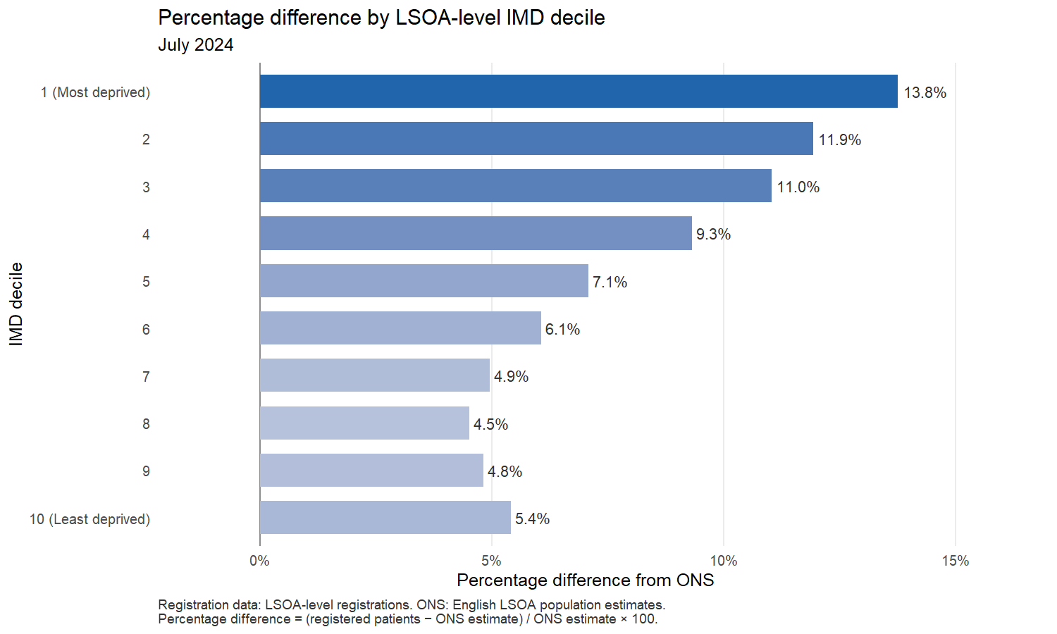
This excludes: 15,509 in Wales and 78,282 in “other LSOAs”. It also excludes 0 English registrations without a valid IMD decile.
Population comparison by IMD decile (LSOA-level registrations)
IMD decile | Registered patients | ONS population | Raw difference | Percentage difference
1 (Most deprived) | 6,767,857 | 5,948,978 | 818,879 | 13.8%
2 | 6,648,958 | 5,940,147 | 708,811 | 11.9%
3 | 6,685,963 | 6,021,480 | 664,483 | 11.0%
4 | 6,483,120 | 5,930,566 | 552,554 | 9.3%
5 | 6,363,401 | 5,942,293 | 421,108 | 7.1%
6 | 6,191,852 | 5,837,647 | 354,205 | 6.1%
7 | 6,187,954 | 5,896,163 | 291,791 | 4.9%
8 | 6,072,242 | 5,810,149 | 262,093 | 4.5%
9 | 6,018,463 | 5,741,718 | 276,745 | 4.8%
10 (Least deprived) | 5,851,493 | 5,550,960 | 300,533 | 5.4%

NHS England regions
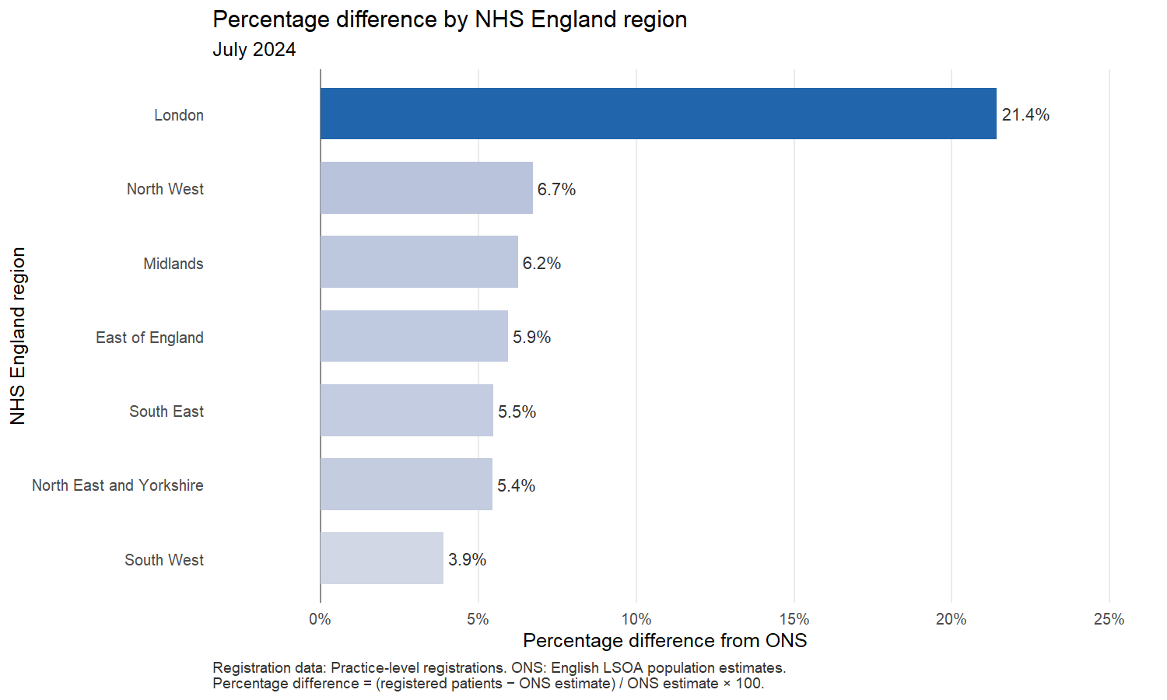
Population comparison by NHS England region (Practice-level registrations)
NHS England region | Registered patients | ONS population | Raw difference | Percentage difference
London | 11,036,366 | 9,089,736 | 1,946,630 | 21.4%
North West | 7,914,132 | 7,415,407 | 498,725 | 6.7%
Midlands | 11,952,920 | 11,250,368 | 702,552 | 6.2%
East of England | 7,299,121 | 6,889,610 | 409,511 | 5.9%
South East | 9,831,503 | 9,322,323 | 509,180 | 5.5%
North East and Yorkshire | 9,231,531 | 8,755,647 | 475,884 | 5.4%
South West | 6,125,759 | 5,897,010 | 228,749 | 3.9%

Integrated Care Boards
All ICB comparisons use the new April 2026 structure while using the July 2024 data. Practice registrations, workforce and payments use the practice-to-2026-ICB mapping, including the Frimley transfers. ONS populations are reassigned through the official ONS April 2026 LSOA lookup.
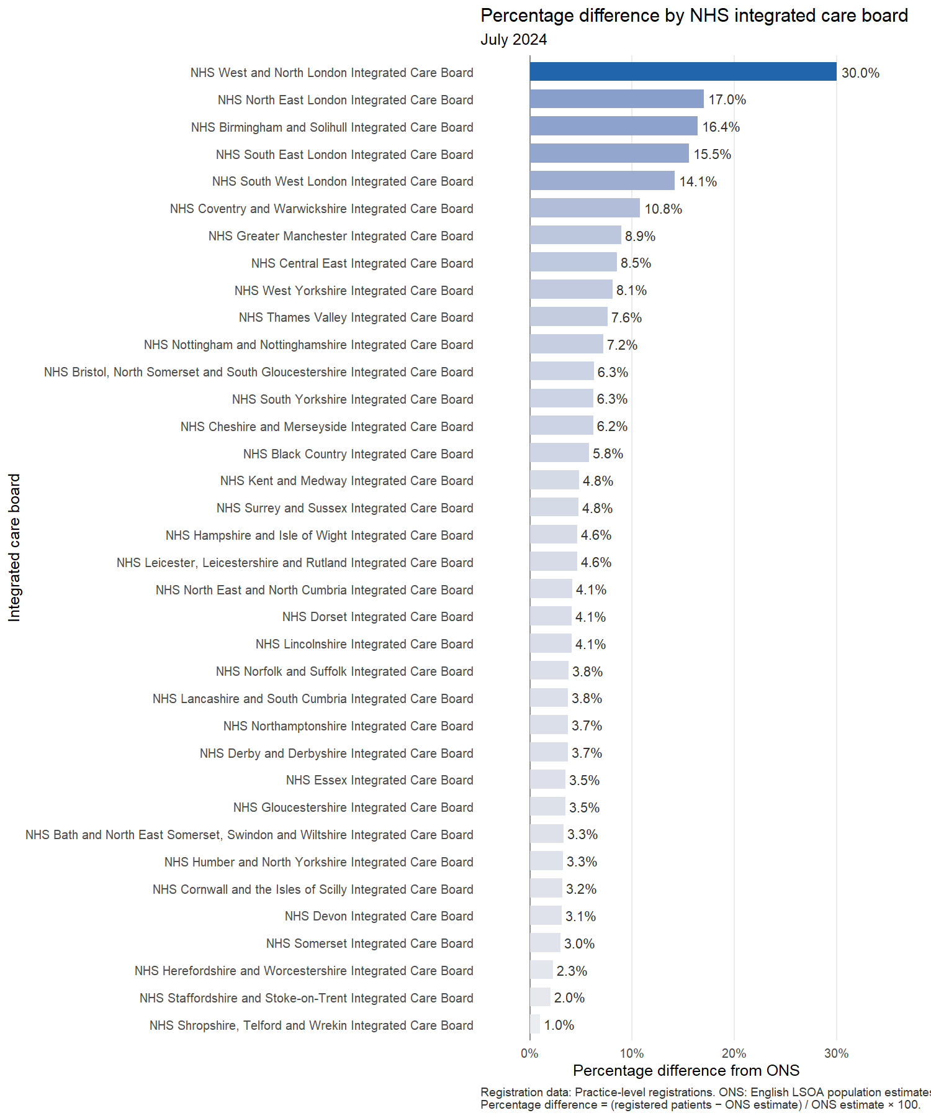
Population comparison by NHS integrated care board (Practice-level registrations)
ICB | Registered patients | ONS population | Raw difference | Percentage difference
NHS West and North London Integrated Care Board | 4,704,389 | 3,617,796 | 1,086,593 | 30.0%
NHS North East London Integrated Care Board | 2,455,444 | 2,098,267 | 357,177 | 17.0%
NHS Birmingham and Solihull Integrated Care Board | 1,635,193 | 1,404,860 | 230,333 | 16.4%
NHS South East London Integrated Care Board | 2,107,886 | 1,824,242 | 283,644 | 15.5%
NHS South West London Integrated Care Board | 1,768,647 | 1,549,431 | 219,216 | 14.1%
NHS Coventry and Warwickshire Integrated Care Board | 1,108,877 | 1,001,233 | 107,644 | 10.8%
NHS Greater Manchester Integrated Care Board | 3,278,318 | 3,009,664 | 268,654 | 8.9%
NHS Central East Integrated Care Board | 3,509,685 | 3,233,410 | 276,275 | 8.5%
NHS West Yorkshire Integrated Care Board | 2,688,809 | 2,487,154 | 201,655 | 8.1%
NHS Thames Valley Integrated Care Board | 2,496,567 | 2,319,582 | 176,985 | 7.6%
NHS Nottingham and Nottinghamshire Integrated Care Board | 1,273,621 | 1,188,090 | 85,531 | 7.2%
NHS Bristol, North Somerset and South Gloucestershire Integrated Care Board | 1,089,773 | 1,025,309 | 64,464 | 6.3%
NHS South Yorkshire Integrated Care Board | 1,520,057 | 1,430,623 | 89,434 | 6.3%
NHS Cheshire and Merseyside Integrated Care Board | 2,778,201 | 2,615,425 | 162,776 | 6.2%
NHS Black Country Integrated Care Board | 1,336,065 | 1,262,719 | 73,346 | 5.8%
NHS Kent and Medway Integrated Care Board | 2,024,587 | 1,931,684 | 92,903 | 4.8%
NHS Surrey and Sussex Integrated Care Board | 3,152,168 | 3,008,438 | 143,730 | 4.8%
NHS Hampshire and Isle of Wight Integrated Care Board | 2,158,181 | 2,062,619 | 95,562 | 4.6%
NHS Leicester, Leicestershire and Rutland Integrated Care Board | 1,229,749 | 1,175,364 | 54,385 | 4.6%
NHS North East and North Cumbria Integrated Care Board | 3,216,559 | 3,088,985 | 127,574 | 4.1%
NHS Dorset Integrated Care Board | 831,779 | 798,914 | 32,865 | 4.1%
NHS Lincolnshire Integrated Care Board | 821,891 | 789,502 | 32,389 | 4.1%
NHS Norfolk and Suffolk Integrated Care Board | 1,792,210 | 1,726,590 | 65,620 | 3.8%
NHS Lancashire and South Cumbria Integrated Care Board | 1,857,613 | 1,790,318 | 67,295 | 3.8%
NHS Northamptonshire Integrated Care Board | 844,159 | 813,682 | 30,477 | 3.7%
NHS Derby and Derbyshire Integrated Care Board | 1,137,283 | 1,096,526 | 40,757 | 3.7%
NHS Essex Integrated Care Board | 1,997,226 | 1,929,610 | 67,616 | 3.5%
NHS Gloucestershire Integrated Care Board | 692,664 | 669,380 | 23,284 | 3.5%
NHS Bath and North East Somerset, Swindon and Wiltshire Integrated Care Board | 1,007,100 | 974,918 | 32,182 | 3.3%
NHS Humber and North Yorkshire Integrated Care Board | 1,806,106 | 1,748,885 | 57,221 | 3.3%
NHS Cornwall and the Isles of Scilly Integrated Care Board | 604,377 | 585,655 | 18,722 | 3.2%
NHS Devon Integrated Care Board | 1,293,901 | 1,254,506 | 39,395 | 3.1%
NHS Somerset Integrated Care Board | 606,165 | 588,328 | 17,837 | 3.0%
NHS Herefordshire and Worcestershire Integrated Care Board | 831,106 | 812,407 | 18,699 | 2.3%
NHS Staffordshire and Stoke-on-Trent Integrated Care Board | 1,201,389 | 1,177,578 | 23,811 | 2.0%
NHS Shropshire, Telford and Wrekin Integrated Care Board | 533,587 | 528,407 | 5,180 | 1.0%

Patients per qualified GP FTE
Registrations and qualified GP FTE follow practice assignment to the April 2026 geography. ONS populations follow English residence LSOAs. Regional and ICB comparisons can therefore reflect cross-boundary registration. Unassigned practice registrations are excluded from the corresponding local comparisons: 16,486 without a region and 16,486 without an ICB.

July 2024 national comparison
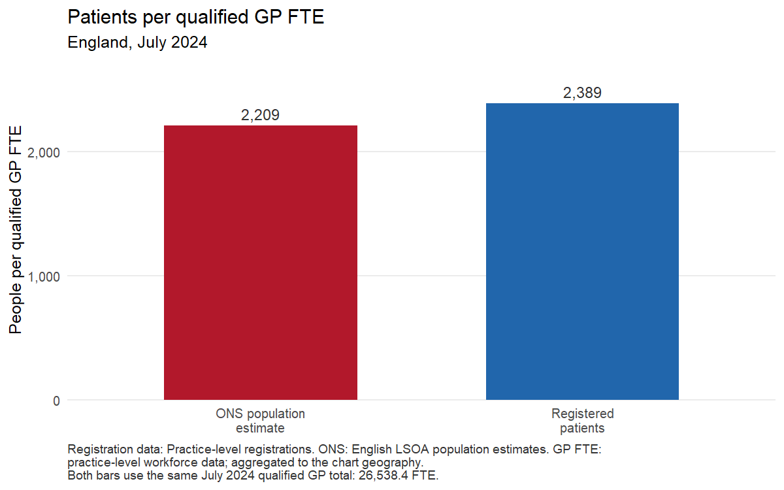

July time series
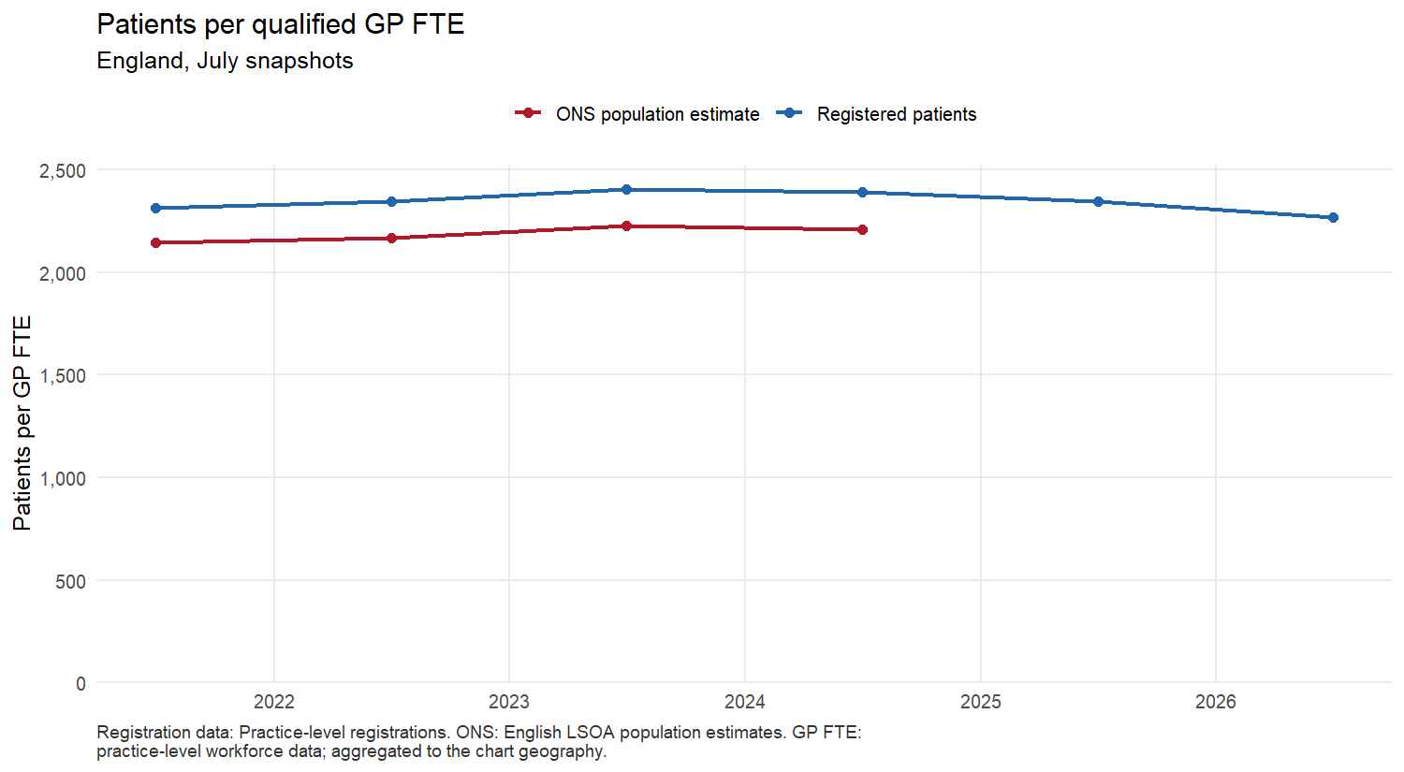
National patients per GP FTE comparison (Practice registrations; practice-level workforce)
Geography | Registered patients per GP FTE | ONS population per GP FTE
England | 2,389 | 2,209

NHS England regions
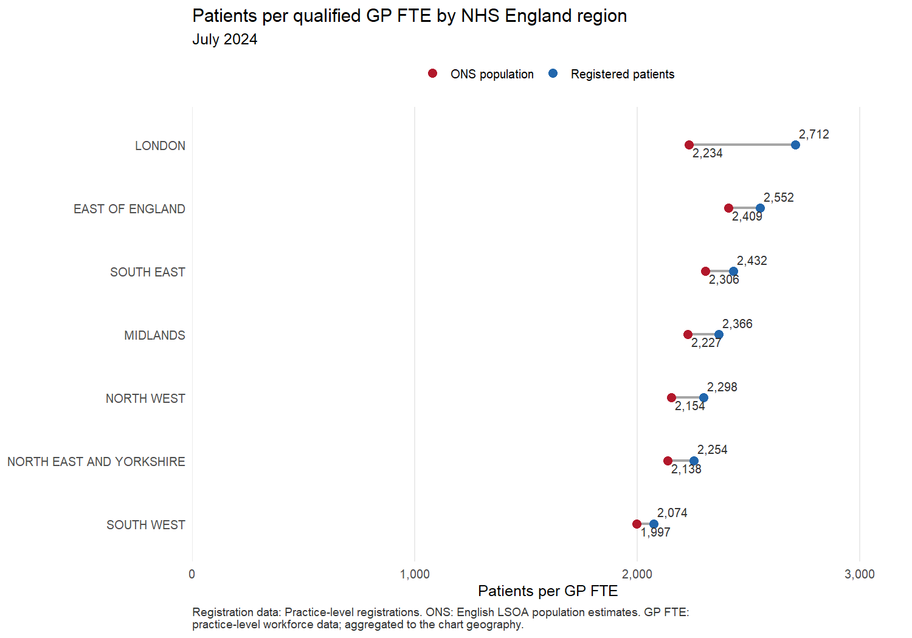
Regional patients per GP FTE comparison (Practice registrations; practice-level workforce)
NHS England region | Registered patients per GP FTE | ONS population per GP FTE
LONDON | 2,712 | 2,234
EAST OF ENGLAND | 2,552 | 2,409
SOUTH EAST | 2,432 | 2,306
MIDLANDS | 2,366 | 2,227
NORTH WEST | 2,298 | 2,154
NORTH EAST AND YORKSHIRE | 2,254 | 2,138
SOUTH WEST | 2,074 | 1,997

Integrated care boards
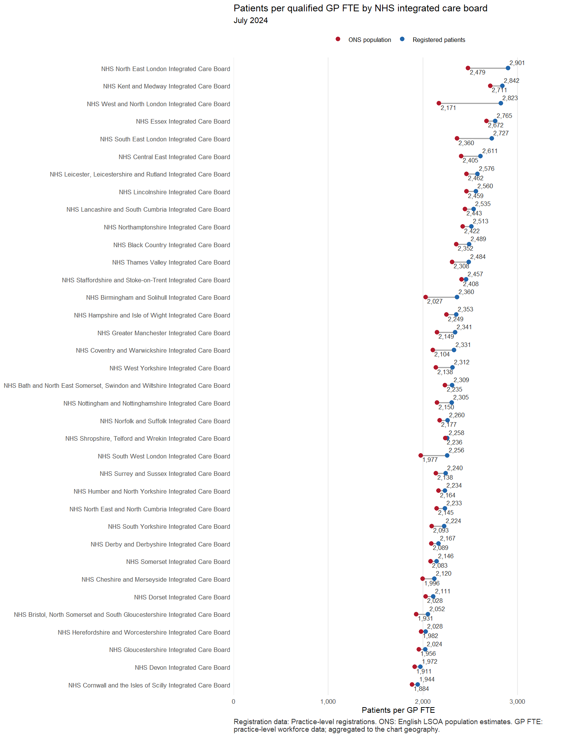
ICB patients per GP FTE comparison (Practice registrations; practice-level workforce)
ICB | Registered patients per GP FTE | ONS population per GP FTE
NHS North East London Integrated Care Board | 2,901 | 2,479
NHS Kent and Medway Integrated Care Board | 2,842 | 2,711
NHS West and North London Integrated Care Board | 2,823 | 2,171
NHS Essex Integrated Care Board | 2,765 | 2,672
NHS South East London Integrated Care Board | 2,727 | 2,360
NHS Central East Integrated Care Board | 2,611 | 2,405
NHS Leicester, Leicestershire and Rutland Integrated Care Board | 2,576 | 2,462
NHS Lincolnshire Integrated Care Board | 2,560 | 2,459
NHS Lancashire and South Cumbria Integrated Care Board | 2,535 | 2,443
NHS Northamptonshire Integrated Care Board | 2,513 | 2,422
NHS Black Country Integrated Care Board | 2,489 | 2,352
NHS Thames Valley Integrated Care Board | 2,484 | 2,308
NHS Staffordshire and Stoke-on-Trent Integrated Care Board | 2,457 | 2,408
NHS Birmingham and Solihull Integrated Care Board | 2,360 | 2,027
NHS Hampshire and Isle of Wight Integrated Care Board | 2,353 | 2,249
NHS Greater Manchester Integrated Care Board | 2,341 | 2,149
NHS Coventry and Warwickshire Integrated Care Board | 2,331 | 2,104
NHS West Yorkshire Integrated Care Board | 2,312 | 2,138
NHS Bath and North East Somerset, Swindon and Wiltshire Integrated Care Board | 2,309 | 2,235
NHS Nottingham and Nottinghamshire Integrated Care Board | 2,305 | 2,150
NHS Norfolk and Suffolk Integrated Care Board | 2,260 | 2,177
NHS Shropshire, Telford and Wrekin Integrated Care Board | 2,258 | 2,236
NHS South West London Integrated Care Board | 2,256 | 1,977
NHS Surrey and Sussex Integrated Care Board | 2,240 | 2,138
NHS Humber and North Yorkshire Integrated Care Board | 2,234 | 2,164
NHS North East and North Cumbria Integrated Care Board | 2,233 | 2,145
NHS South Yorkshire Integrated Care Board | 2,224 | 2,093
NHS Derby and Derbyshire Integrated Care Board | 2,167 | 2,089
NHS Somerset Integrated Care Board | 2,146 | 2,083
NHS Cheshire and Merseyside Integrated Care Board | 2,120 | 1,996
NHS Dorset Integrated Care Board | 2,111 | 2,028
NHS Bristol, North Somerset and South Gloucestershire Integrated Care Board | 2,052 | 1,931
NHS Herefordshire and Worcestershire Integrated Care Board | 2,028 | 1,982
NHS Gloucestershire Integrated Care Board | 2,024 | 1,956
NHS Devon Integrated Care Board | 1,972 | 1,911
NHS Cornwall and the Isles of Scilly Integrated Care Board | 1,944 | 1,884

If payment to general practice were to remain constant despite reduction in list size
This comparison keeps overall payments the same but changes the population denominator.
For each geography, the full annual payment total is divided separately by the practice-level registered count and the ONS population. Payments use Total NHS Payments to General Practice Minus Deductions, with the latest available payment snapshot (31 March 2025); populations refer to July 2024. Registrations and payments follow practice assignment, while the ONS denominator follows residence; cross-boundary registration can affect local comparisons. ICBs use April 2026 geography. Amounts without a region assignment are £0; amounts without an ICB assignment are £0 and are excluded from the respective local totals. A higher payment per resident is an average under a fixed budget, not extra income.
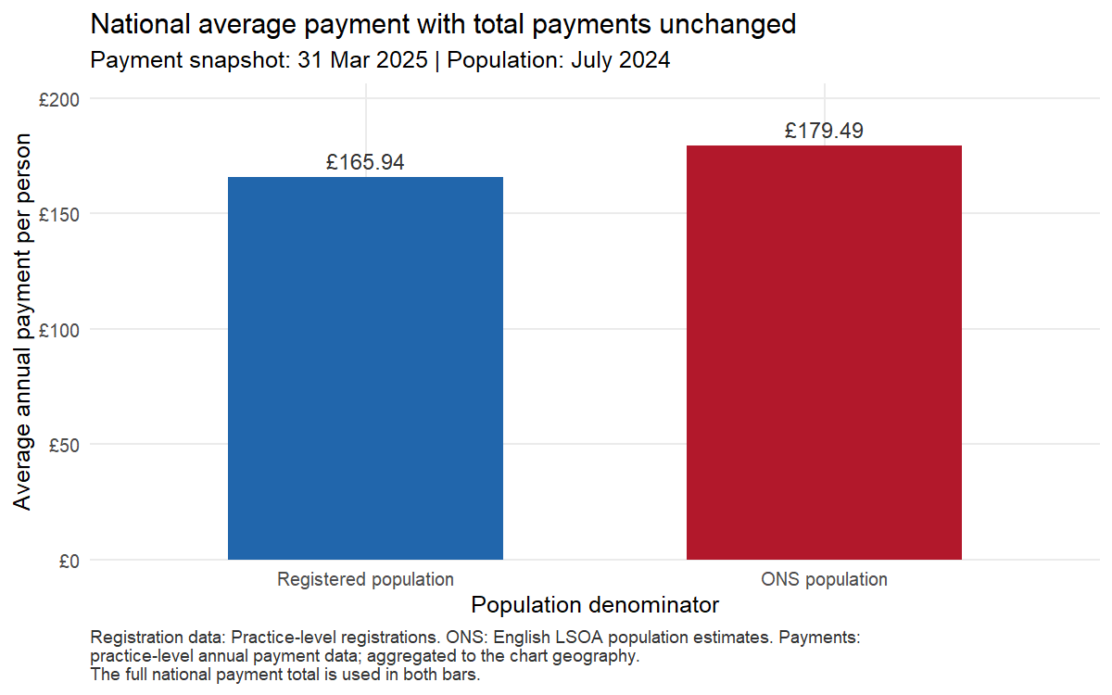
National average payments with the total held constant (Practice registrations; practice-level payments)
Geography | Total payments (£) | Registered, n | ONS, n | £/registered patient | £/ONS resident | Change (£/person) | Change (%)
England | 10,521,901,156 | 63,407,818 | 58,620,101 | 165.94 | 179.49 | 13.55 | 8.17%

Average payment by NHS England region
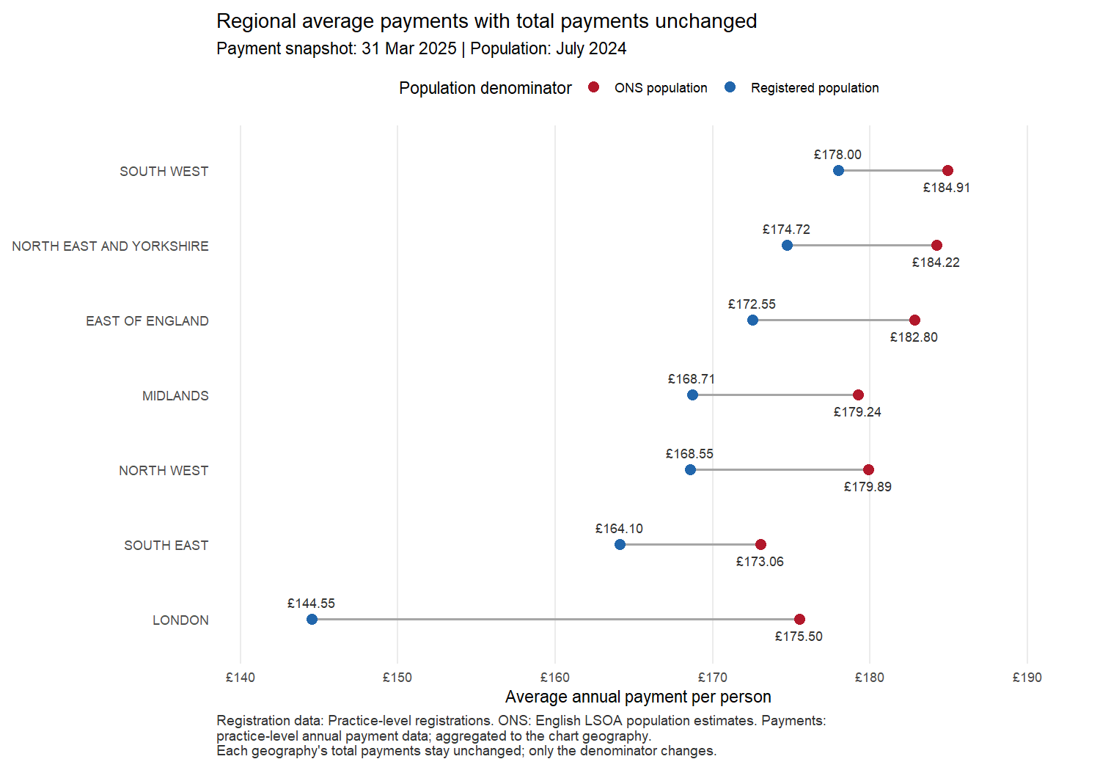
Regional average payments with each total held constant (Practice registrations; practice-level payments)
Geography | Total payments (£) | Registered, n | ONS, n | £/registered patient | £/ONS resident | Change (£/person) | Change (%)
SOUTH WEST | 1,090,394,585 | 6,125,759 | 5,897,010 | 178.00 | 184.91 | 6.90 | 3.88%
NORTH EAST AND YORKSHIRE | 1,612,974,585 | 9,231,531 | 8,755,647 | 174.72 | 184.22 | 9.50 | 5.44%
EAST OF ENGLAND | 1,259,450,400 | 7,299,121 | 6,889,610 | 172.55 | 182.80 | 10.26 | 5.94%
MIDLANDS | 2,016,531,246 | 11,952,920 | 11,250,368 | 168.71 | 179.24 | 10.54 | 6.24%
NORTH WEST | 1,333,941,544 | 7,914,132 | 7,415,407 | 168.55 | 179.89 | 11.34 | 6.73%
SOUTH EAST | 1,613,355,241 | 9,831,503 | 9,322,323 | 164.10 | 173.06 | 8.96 | 5.46%
LONDON | 1,595,253,555 | 11,036,366 | 9,089,736 | 144.55 | 175.50 | 30.96 | 21.42%

Average payment by integrated care board
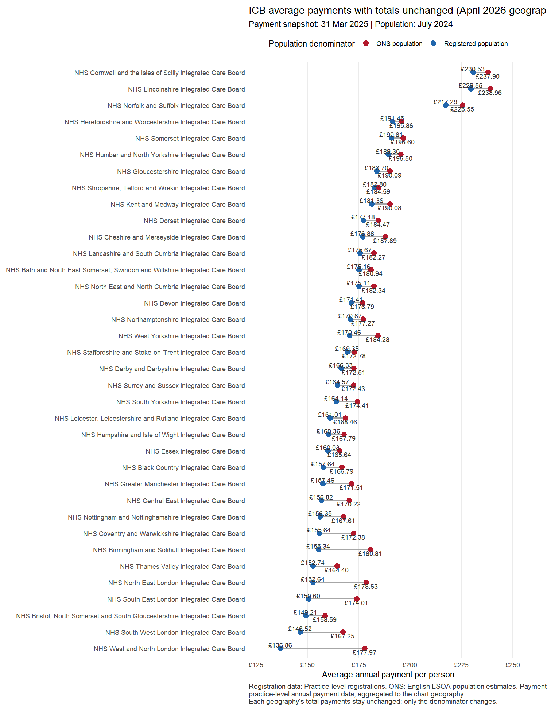
ICB average payments with each total held constant (Practice registrations; practice-level payments)
Geography | Total payments (£) | Registered, n | ONS, n | £/registered patient | £/ONS resident | Change (£/person) | Change (%)
NHS Cornwall and the Isles of Scilly Integrated Care Board | 139,326,473 | 604,377 | 585,655 | 230.53 | 237.90 | 7.37 | 3.20%
NHS Lincolnshire Integrated Care Board | 188,662,925 | 821,891 | 789,502 | 229.55 | 238.96 | 9.42 | 4.10%
NHS Norfolk and Suffolk Integrated Care Board | 389,429,183 | 1,792,210 | 1,726,590 | 217.29 | 225.55 | 8.26 | 3.80%
NHS Herefordshire and Worcestershire Integrated Care Board | 159,114,257 | 831,106 | 812,407 | 191.45 | 195.86 | 4.41 | 2.30%
NHS Somerset Integrated Care Board | 115,663,476 | 606,165 | 588,328 | 190.81 | 196.60 | 5.79 | 3.03%
NHS Humber and North Yorkshire Integrated Care Board | 341,903,311 | 1,806,106 | 1,748,885 | 189.30 | 195.50 | 6.19 | 3.27%
NHS Gloucestershire Integrated Care Board | 127,241,627 | 692,664 | 669,380 | 183.70 | 190.09 | 6.39 | 3.48%
NHS Shropshire, Telford and Wrekin Integrated Care Board | 97,540,674 | 533,587 | 528,407 | 182.80 | 184.59 | 1.79 | 0.98%
NHS Kent and Medway Integrated Care Board | 367,181,048 | 2,024,587 | 1,931,684 | 181.36 | 190.08 | 8.72 | 4.81%
NHS Dorset Integrated Care Board | 147,373,483 | 831,779 | 798,914 | 177.18 | 184.47 | 7.29 | 4.11%
NHS Cheshire and Merseyside Integrated Care Board | 491,418,071 | 2,778,201 | 2,615,425 | 176.88 | 187.89 | 11.01 | 6.22%
NHS Lancashire and South Cumbria Integrated Care Board | 326,329,441 | 1,857,613 | 1,790,318 | 175.67 | 182.27 | 6.60 | 3.76%
NHS Bath and North East Somerset, Swindon and Wiltshire Integrated Care Board | 176,404,546 | 1,007,100 | 974,918 | 175.16 | 180.94 | 5.78 | 3.30%
NHS North East and North Cumbria Integrated Care Board | 563,239,662 | 3,216,559 | 3,088,985 | 175.11 | 182.34 | 7.23 | 4.13%
NHS Devon Integrated Care Board | 221,784,340 | 1,293,901 | 1,254,506 | 171.41 | 176.79 | 5.38 | 3.14%
NHS Northamptonshire Integrated Care Board | 144,238,582 | 844,159 | 813,682 | 170.87 | 177.27 | 6.40 | 3.75%
NHS West Yorkshire Integrated Care Board | 458,323,706 | 2,688,809 | 2,487,154 | 170.46 | 184.28 | 13.82 | 8.11%
NHS Staffordshire and Stoke-on-Trent Integrated Care Board | 203,456,560 | 1,201,389 | 1,177,578 | 169.35 | 172.78 | 3.42 | 2.02%
NHS Derby and Derbyshire Integrated Care Board | 189,166,301 | 1,137,283 | 1,096,526 | 166.33 | 172.51 | 6.18 | 3.72%
NHS Surrey and Sussex Integrated Care Board | 518,752,682 | 3,152,168 | 3,008,438 | 164.57 | 172.43 | 7.86 | 4.78%
NHS South Yorkshire Integrated Care Board | 249,507,906 | 1,520,057 | 1,430,623 | 164.14 | 174.41 | 10.26 | 6.25%
NHS Leicester, Leicestershire and Rutland Integrated Care Board | 198,003,515 | 1,229,749 | 1,175,364 | 161.01 | 168.46 | 7.45 | 4.63%
NHS Hampshire and Isle of Wight Integrated Care Board | 346,085,172 | 2,158,181 | 2,062,619 | 160.36 | 167.79 | 7.43 | 4.63%
NHS Essex Integrated Care Board | 319,615,283 | 1,997,226 | 1,929,610 | 160.03 | 165.64 | 5.61 | 3.50%
NHS Black Country Integrated Care Board | 210,611,373 | 1,336,065 | 1,262,719 | 157.64 | 166.79 | 9.16 | 5.81%
NHS Greater Manchester Integrated Care Board | 516,194,032 | 3,278,318 | 3,009,664 | 157.46 | 171.51 | 14.06 | 8.93%
NHS Central East Integrated Care Board | 550,405,934 | 3,509,685 | 3,233,410 | 156.82 | 170.22 | 13.40 | 8.54%
NHS Nottingham and Nottinghamshire Integrated Care Board | 199,130,361 | 1,273,621 | 1,188,090 | 156.35 | 167.61 | 11.26 | 7.20%
NHS Coventry and Warwickshire Integrated Care Board | 172,590,386 | 1,108,877 | 1,001,233 | 155.64 | 172.38 | 16.73 | 10.75%
NHS Birmingham and Solihull Integrated Care Board | 254,016,312 | 1,635,193 | 1,404,860 | 155.34 | 180.81 | 25.47 | 16.40%
NHS Thames Valley Integrated Care Board | 381,336,338 | 2,496,567 | 2,319,582 | 152.74 | 164.40 | 11.65 | 7.63%
NHS North East London Integrated Care Board | 374,808,998 | 2,455,444 | 2,098,267 | 152.64 | 178.63 | 25.98 | 17.02%
NHS South East London Integrated Care Board | 317,437,749 | 2,107,886 | 1,824,242 | 150.60 | 174.01 | 23.42 | 15.55%
NHS Bristol, North Somerset and South Gloucestershire Integrated Care Board | 162,600,640 | 1,089,773 | 1,025,309 | 149.21 | 158.59 | 9.38 | 6.29%
NHS South West London Integrated Care Board | 259,148,969 | 1,768,647 | 1,549,431 | 146.52 | 167.25 | 20.73 | 14.15%
NHS West and North London Integrated Care Board | 643,857,838 | 4,704,389 | 3,617,796 | 136.86 | 177.97 | 41.11 | 30.03%

If payments decreased alongside reduction in list size
This section examines how much money could be removed from practices if registered lists were reduced to be in line with the ONS. It uses the calculated payment per capita before removal and multiplies it by the removed number of patients, using Total NHS Payments to General Practice Minus Deductions.
For each geography, the rate is total annual payments divided by practice-level registrations; the list reduction is the positive difference between those registrations and ONS residents. The loss is the rate multiplied by that reduction, and remaining payments are current payments minus the loss. For example, £165 per patient multiplied by 1,000 removed registrations gives a £165,000 loss. Where ONS residents equal or exceed registrations, the loss is zero. Each geography uses its own rate, so local losses need not sum to the national estimate. This is an illustrative proportional-payment scenario, not a prediction of contractual losses.
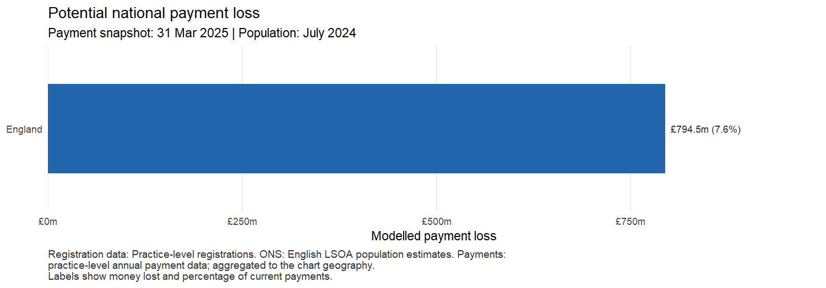
National payment loss scenario (Practice registrations; practice-level payments)
Geography | Current (£) | Rate (£/patient) | List reduction (n) | Loss (£) | Remaining (£)
England | 10,521,901,156 | 165.94 | 4,787,717 | 794,474,351 | 9,727,426,805

Loss by NHS England region
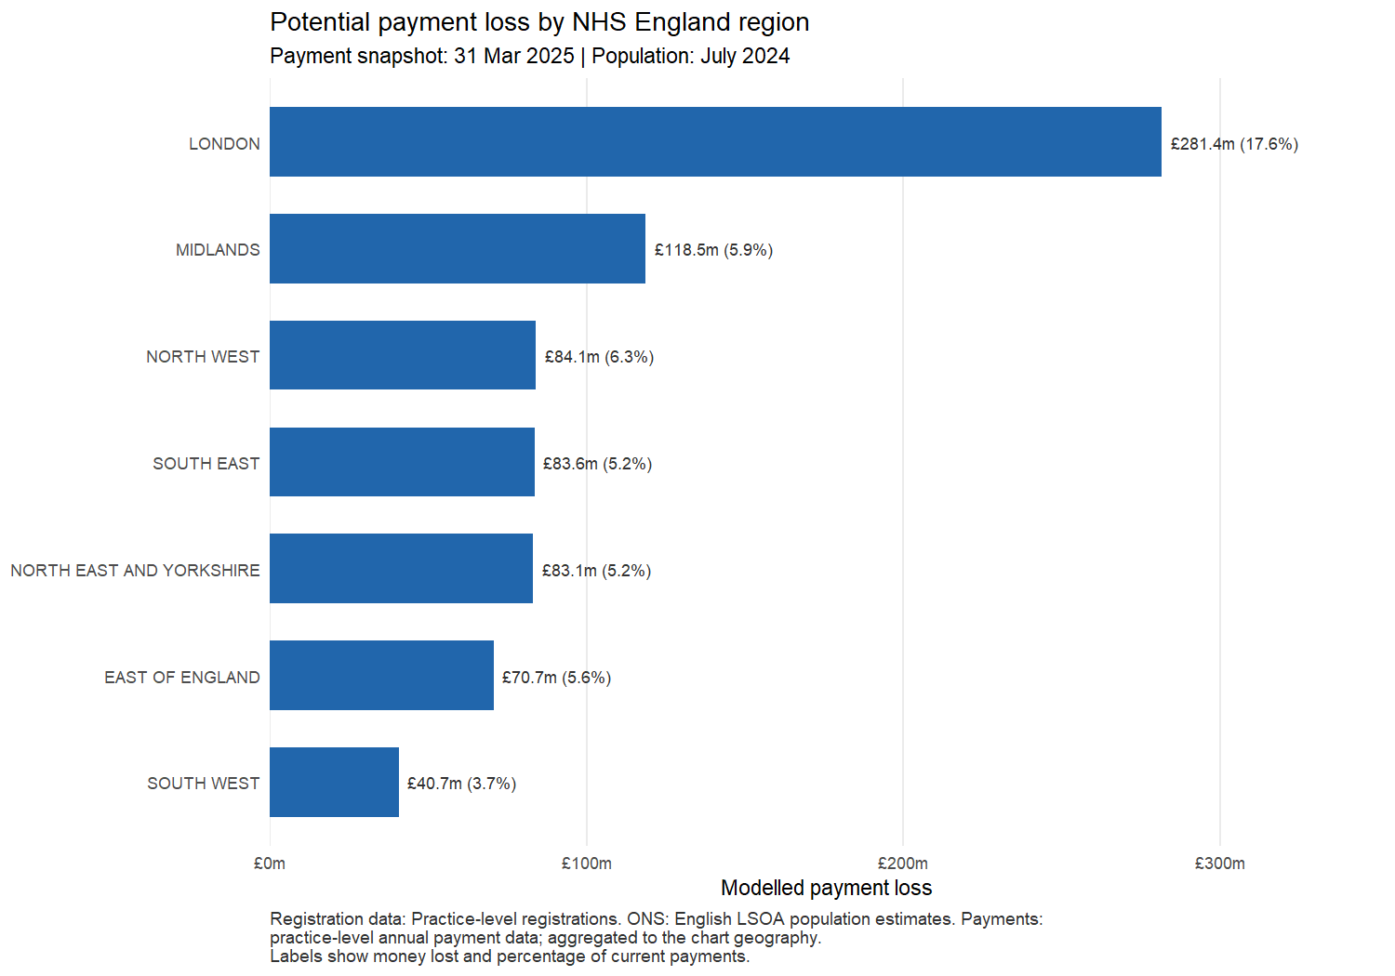
Regional payment loss scenarios (Practice registrations; practice-level payments)
Geography | Current (£) | Rate (£/patient) | List reduction (n) | Loss (£) | Remaining (£)
LONDON | 1,595,253,555 | 144.55 | 1,946,630 | 281,375,992 | 1,313,877,563
MIDLANDS | 2,016,531,246 | 168.71 | 702,552 | 118,524,851 | 1,898,006,395
NORTH WEST | 1,333,941,544 | 168.55 | 498,725 | 84,061,019 | 1,249,880,526
SOUTH EAST | 1,613,355,241 | 164.10 | 509,180 | 83,556,728 | 1,529,798,513
NORTH EAST AND YORKSHIRE | 1,612,974,585 | 174.72 | 475,884 | 83,148,591 | 1,529,825,994
EAST OF ENGLAND | 1,259,450,400 | 172.55 | 409,511 | 70,660,398 | 1,188,790,002
SOUTH WEST | 1,090,394,585 | 178.00 | 228,749 | 40,717,676 | 1,049,676,909

Loss by integrated care board
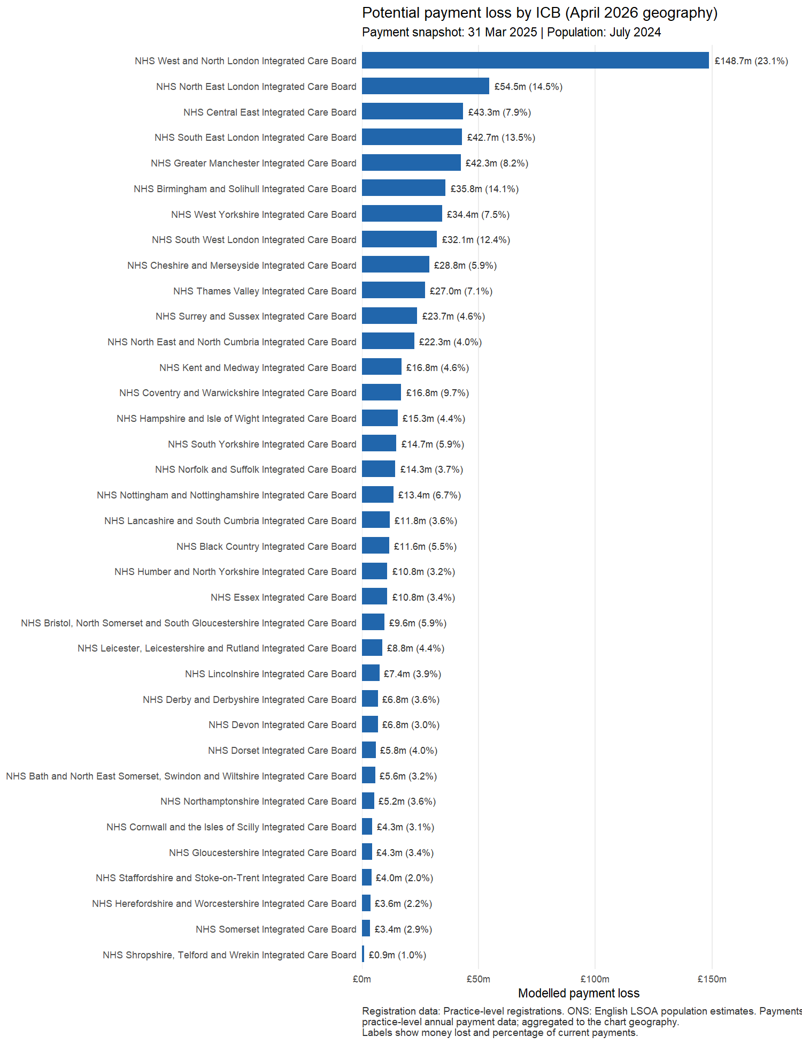
ICB payment loss scenarios (Practice registrations; practice-level payments)
Geography | Current (£) | Rate (£/patient) | List reduction (n) | Loss (£) | Remaining (£)
NHS West and North London Integrated Care Board | 643,857,838 | 136.86 | 1,086,593 | 148,714,620 | 495,143,219
NHS North East London Integrated Care Board | 374,808,998 | 152.64 | 357,177 | 54,520,956 | 320,288,042
NHS Central East Integrated Care Board | 550,405,934 | 156.82 | 276,275 | 43,326,794 | 507,079,140
NHS South East London Integrated Care Board | 317,437,749 | 150.60 | 283,644 | 42,715,457 | 274,722,293
NHS Greater Manchester Integrated Care Board | 516,194,032 | 157.46 | 268,654 | 42,301,446 | 473,892,587
NHS Birmingham and Solihull Integrated Care Board | 254,016,312 | 155.34 | 230,333 | 35,780,693 | 218,235,619
NHS West Yorkshire Integrated Care Board | 458,323,706 | 170.46 | 201,655 | 34,373,311 | 423,950,396
NHS South West London Integrated Care Board | 259,148,969 | 146.52 | 219,216 | 32,120,372 | 227,028,597
NHS Cheshire and Merseyside Integrated Care Board | 491,418,071 | 176.88 | 162,776 | 28,792,398 | 462,625,673
NHS Thames Valley Integrated Care Board | 381,336,338 | 152.74 | 176,985 | 27,033,447 | 354,302,891
NHS Surrey and Sussex Integrated Care Board | 518,752,682 | 164.57 | 143,730 | 23,653,664 | 495,099,018
NHS North East and North Cumbria Integrated Care Board | 563,239,662 | 175.11 | 127,574 | 22,339,008 | 540,900,654
NHS Kent and Medway Integrated Care Board | 367,181,048 | 181.36 | 92,903 | 16,848,978 | 350,332,071
NHS Coventry and Warwickshire Integrated Care Board | 172,590,386 | 155.64 | 107,644 | 16,754,175 | 155,836,211
NHS Hampshire and Isle of Wight Integrated Care Board | 346,085,172 | 160.36 | 95,562 | 15,324,290 | 330,760,882
NHS South Yorkshire Integrated Care Board | 249,507,906 | 164.14 | 89,434 | 14,680,035 | 234,827,870
NHS Norfolk and Suffolk Integrated Care Board | 389,429,183 | 217.29 | 65,620 | 14,258,565 | 375,170,618
NHS Nottingham and Nottinghamshire Integrated Care Board | 199,130,361 | 156.35 | 85,531 | 13,372,753 | 185,757,608
NHS Lancashire and South Cumbria Integrated Care Board | 326,329,441 | 175.67 | 67,295 | 11,821,806 | 314,507,635
NHS Black Country Integrated Care Board | 210,611,373 | 157.64 | 73,346 | 11,561,939 | 199,049,434
NHS Humber and North Yorkshire Integrated Care Board | 341,903,311 | 189.30 | 57,221 | 10,832,171 | 331,071,140
NHS Essex Integrated Care Board | 319,615,283 | 160.03 | 67,616 | 10,820,562 | 308,794,722
NHS Bristol, North Somerset and South Gloucestershire Integrated Care Board | 162,600,640 | 149.21 | 64,464 | 9,618,414 | 152,982,227
NHS Leicester, Leicestershire and Rutland Integrated Care Board | 198,003,515 | 161.01 | 54,385 | 8,756,601 | 189,246,914
NHS Lincolnshire Integrated Care Board | 188,662,925 | 229.55 | 32,389 | 7,434,810 | 181,228,115
NHS Derby and Derbyshire Integrated Care Board | 189,166,301 | 166.33 | 40,757 | 6,779,184 | 182,387,117
NHS Devon Integrated Care Board | 221,784,340 | 171.41 | 39,395 | 6,752,599 | 215,031,741
NHS Dorset Integrated Care Board | 147,373,483 | 177.18 | 32,865 | 5,822,976 | 141,550,507
NHS Bath and North East Somerset, Swindon and Wiltshire Integrated Care Board | 176,404,546 | 175.16 | 32,182 | 5,637,028 | 170,767,518
NHS Northamptonshire Integrated Care Board | 144,238,582 | 170.87 | 30,477 | 5,207,502 | 139,031,081
NHS Cornwall and the Isles of Scilly Integrated Care Board | 139,326,473 | 230.53 | 18,722 | 4,315,965 | 135,010,508
NHS Gloucestershire Integrated Care Board | 127,241,627 | 183.70 | 23,284 | 4,277,246 | 122,964,381
NHS Staffordshire and Stoke-on-Trent Integrated Care Board | 203,456,560 | 169.35 | 23,811 | 4,032,419 | 199,424,140
NHS Herefordshire and Worcestershire Integrated Care Board | 159,114,257 | 191.45 | 18,699 | 3,579,901 | 155,534,355
NHS Somerset Integrated Care Board | 115,663,476 | 190.81 | 17,837 | 3,403,511 | 112,259,965
NHS Shropshire, Telford and Wrekin Integrated Care Board | 97,540,674 | 182.80 | 5,180 | 946,913 | 96,593,761

