Ghost Patients Descriptive Analysis

Dataset Disparities
For 01 July 2024 data, the practice-level registered patients data contains 63,407,818 registered patients, compared with 63,365,094 in the LSOA-level registered patients’ data before any filtering or linkage. The LSOA source contains 42,724 fewer registrations than the practice-level total. NHS England reported processing issues in the July 2024 LSOA release and warned that its totals might differ from practice totals.
The LSOA extract includes 15,509 registered patients in Welsh LSOAs. Another 78,282 registrations have an unknown LSOA and are also excluded, leaving 63,271,303 registrations in English LSOAs dataset which is used for the IMD, regional and ICB population comparison.

National population over time
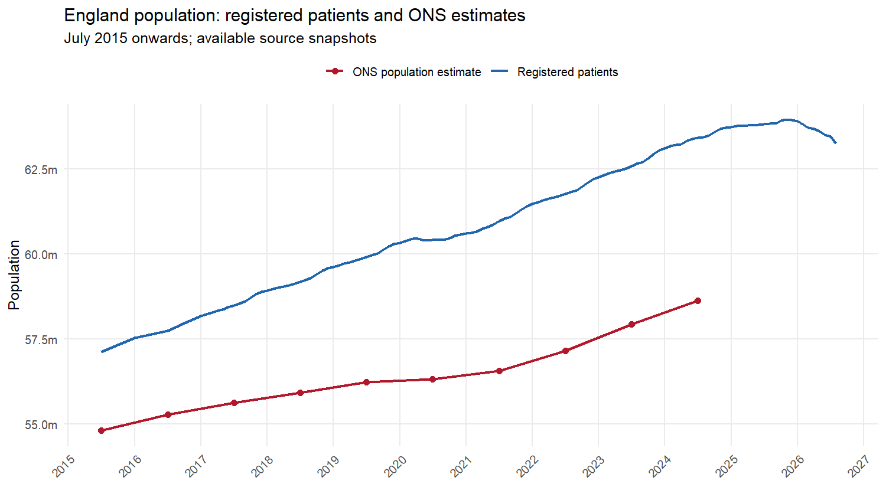

Age over time

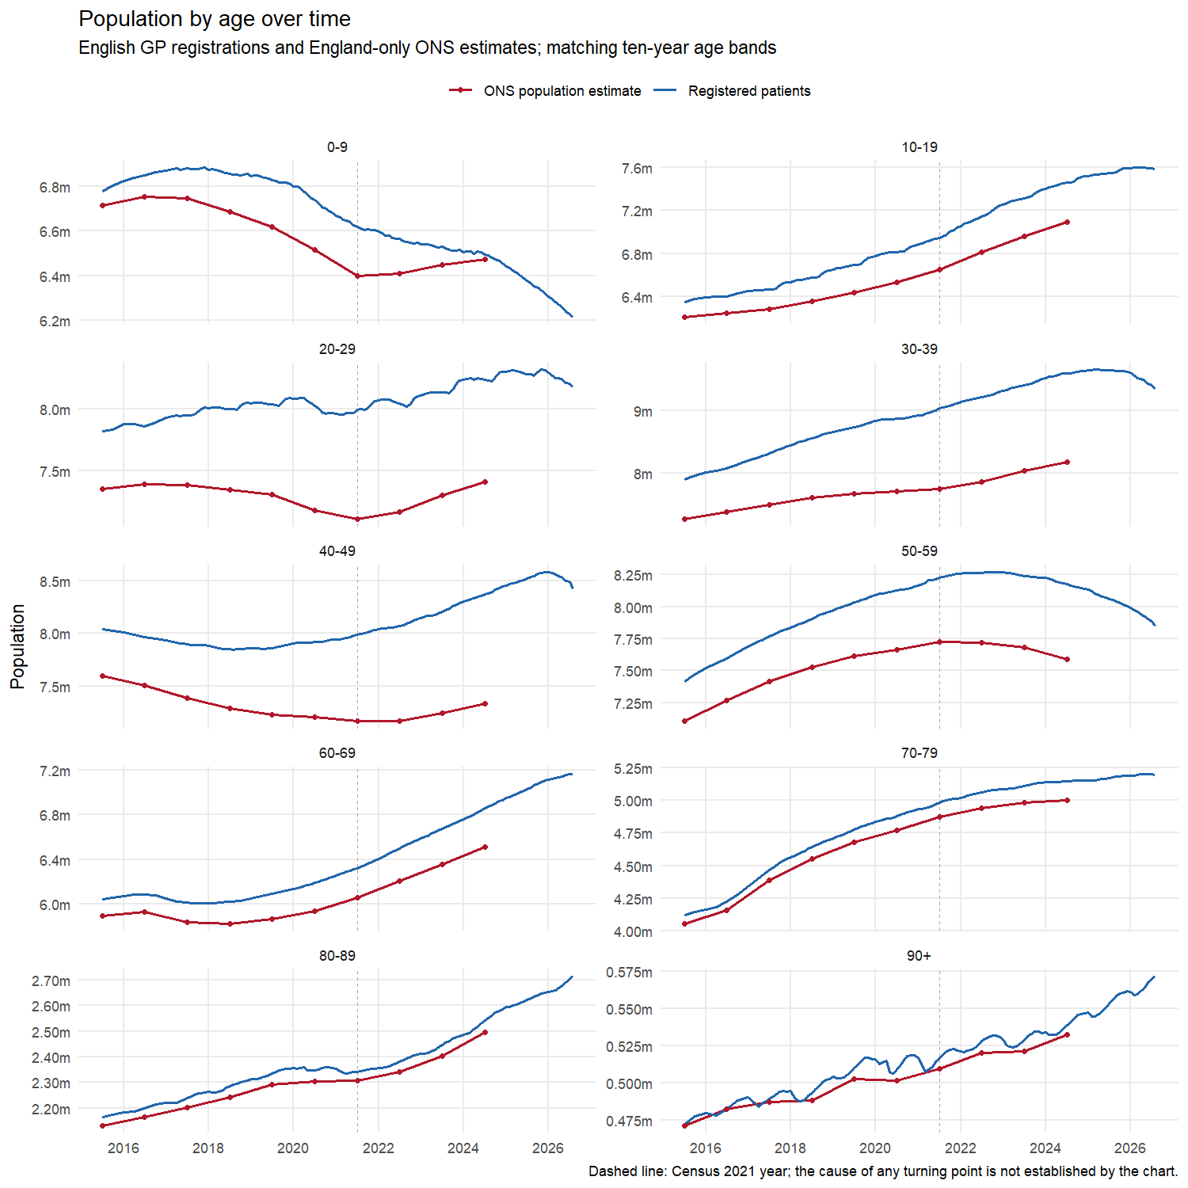

Sex over time
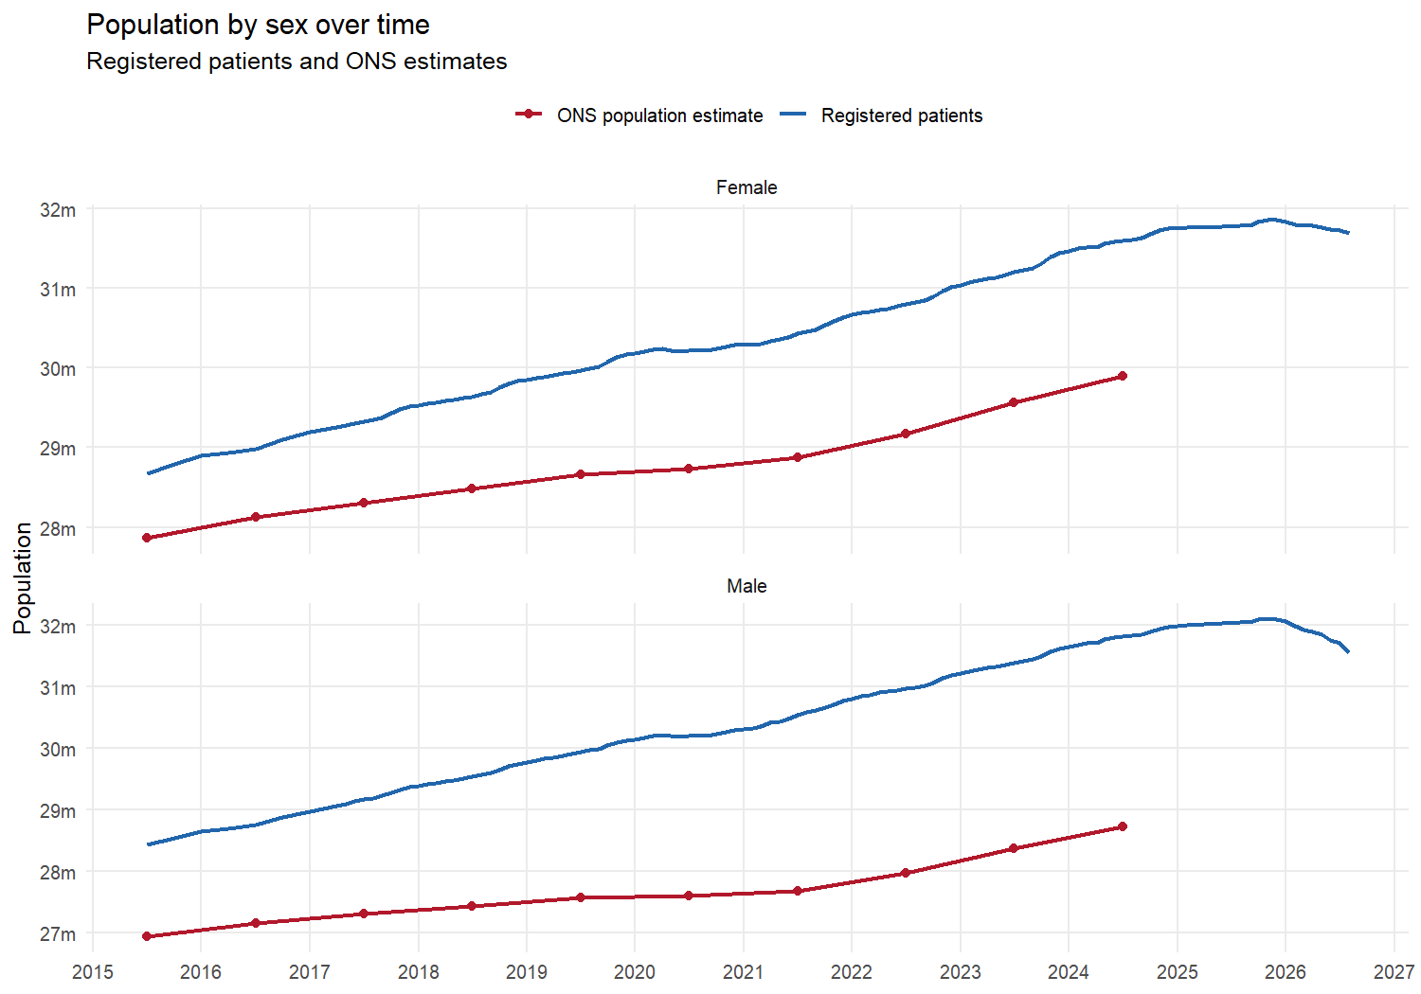

July 2024 Snapshots

National total

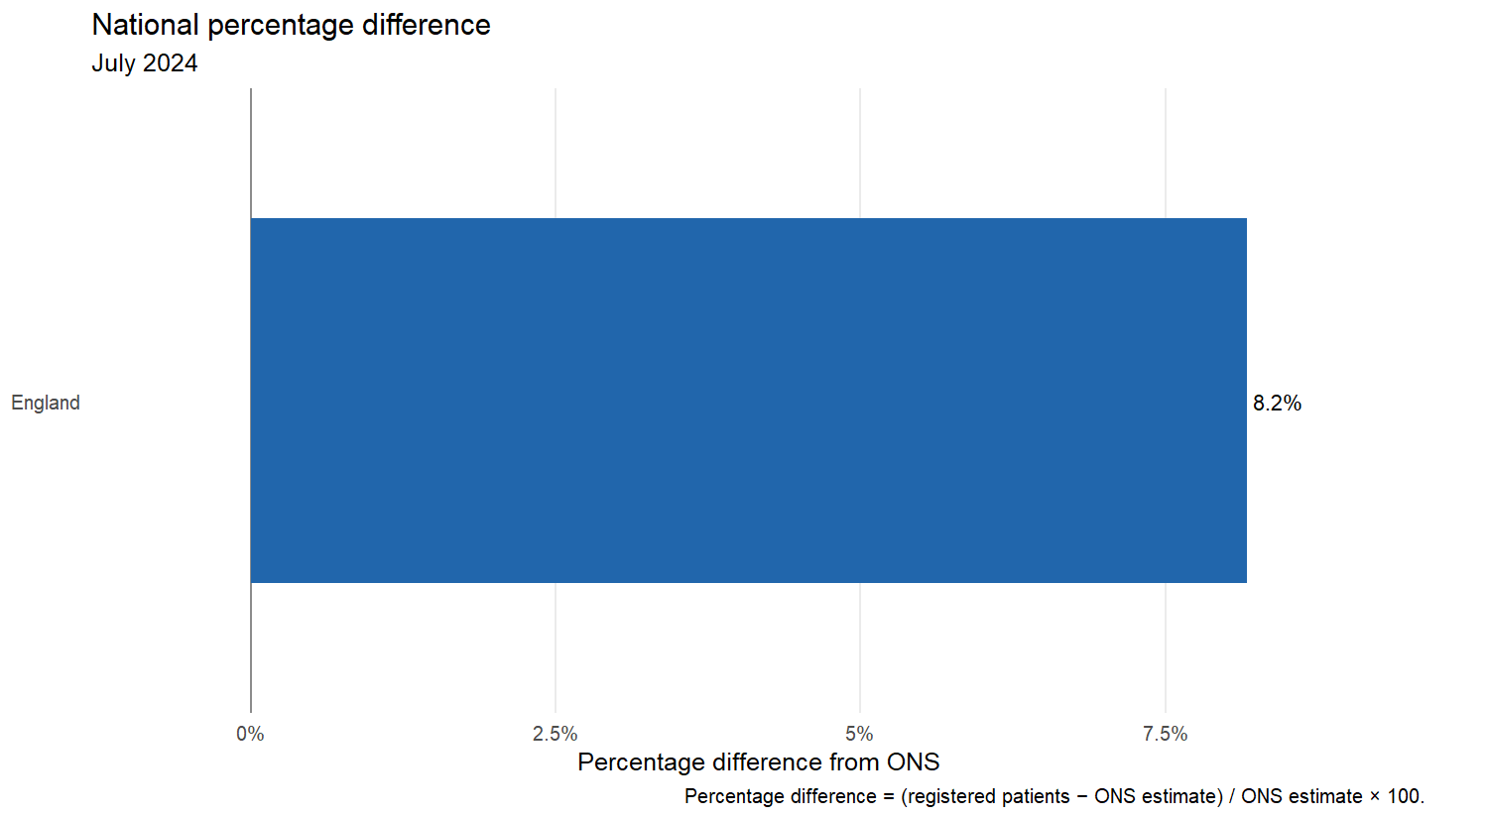
Geography | Registered patients | ONS population | Raw difference | Percentage difference
England | 63,407,818 | 58,620,101 | 4,787,717 | 8.2%

Age

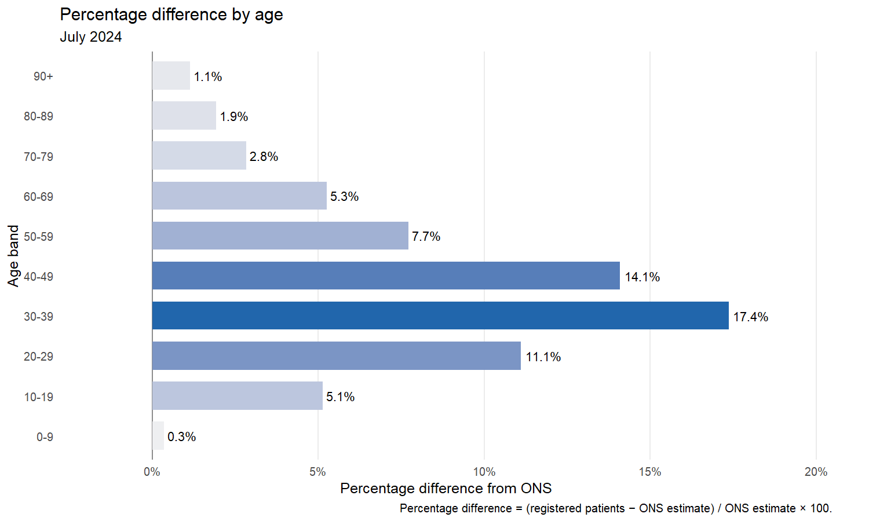

Age band | Registered patients | ONS population | Raw difference | Percentage difference
0-9 | 6,496,574 | 6,473,967 | 22,607 | 0.3%
10-19 | 7,454,828 | 7,090,887 | 363,941 | 5.1%
20-29 | 8,234,922 | 7,411,589 | 823,333 | 11.1%
30-39 | 9,594,407 | 8,174,602 | 1,419,805 | 17.4%
40-49 | 8,368,953 | 7,335,047 | 1,033,906 | 14.1%
50-59 | 8,175,621 | 7,590,138 | 585,483 | 7.7%
60-69 | 6,857,153 | 6,514,421 | 342,732 | 5.3%
70-79 | 5,144,130 | 5,002,303 | 141,827 | 2.8%
80-89 | 2,542,535 | 2,494,504 | 48,031 | 1.9%
90+ | 538,695 | 532,643 | 6,052 | 1.1%

Sex

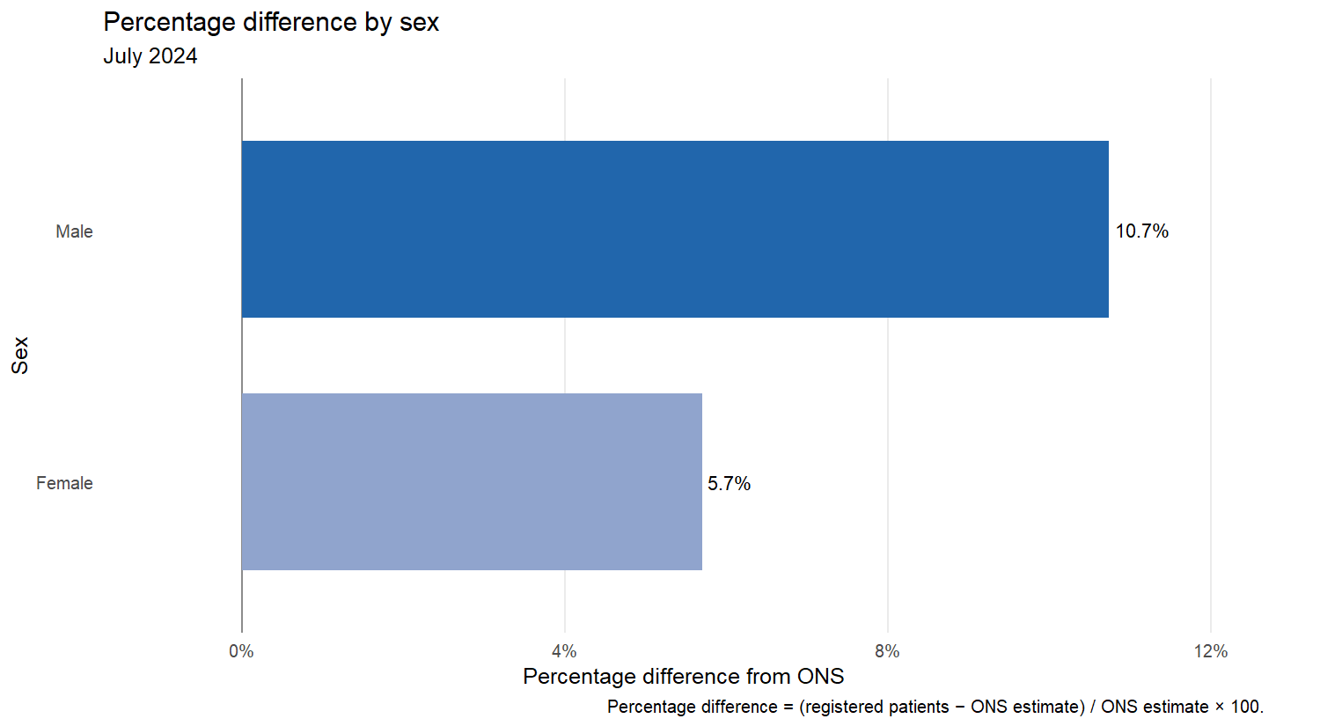
Sex | Registered patients | ONS population | Raw difference | Percentage difference
Female | 31,600,037 | 29,895,762 | 1,704,275 | 5.7%
Male | 31,807,781 | 28,724,339 | 3,083,442 | 10.7%

Age and sex
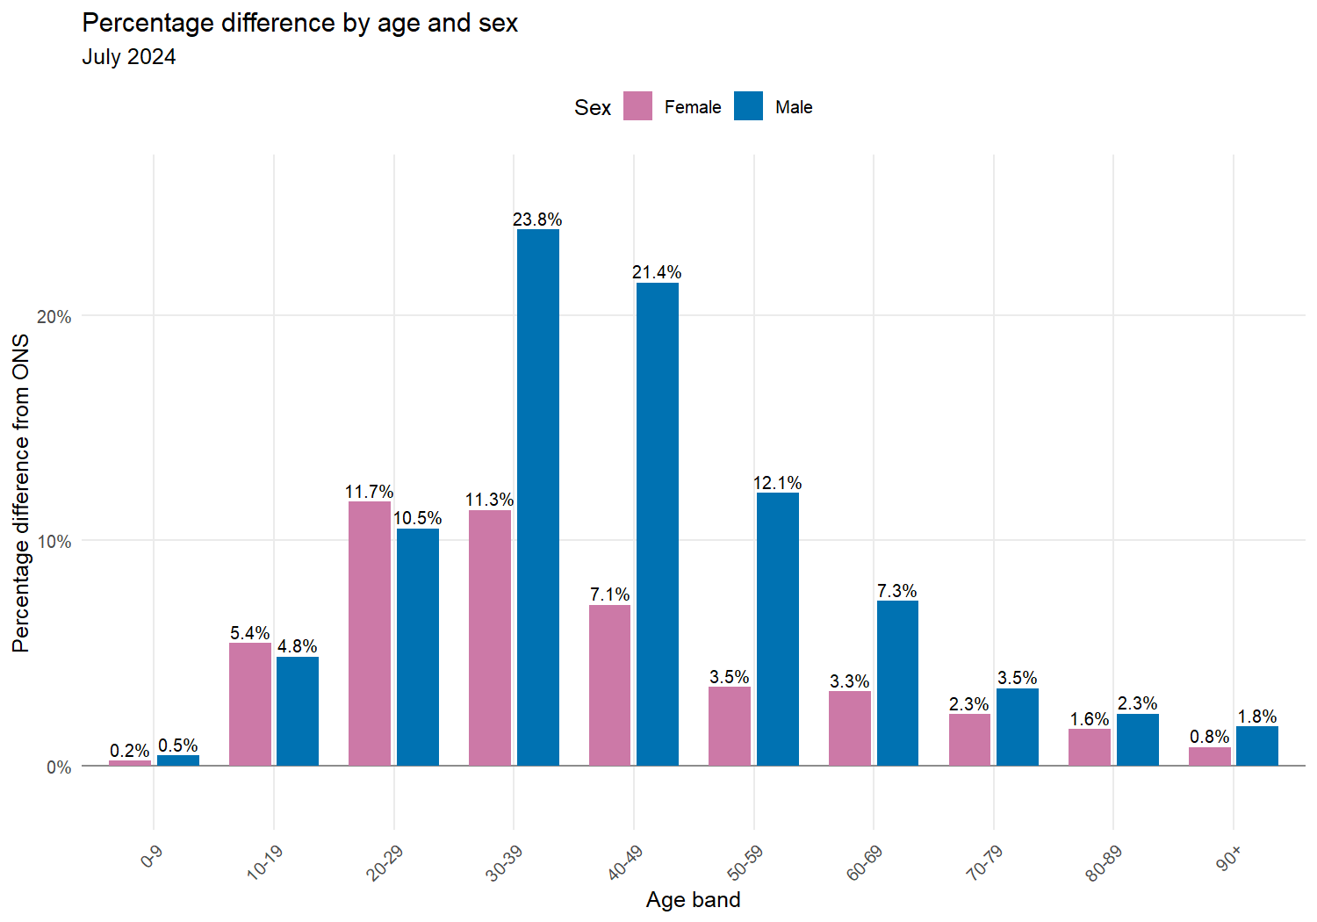
Age band | Sex | Registered patients | ONS population | Raw difference | Percentage difference
0-9 | Female | 3,167,956 | 3,160,590 | 7,366 | 0.2%
0-9 | Male | 3,328,618 | 3,313,377 | 15,241 | 0.5%
10-19 | Female | 3,637,550 | 3,449,797 | 187,753 | 5.4%
10-19 | Male | 3,817,278 | 3,641,090 | 176,188 | 4.8%
20-29 | Female | 4,107,449 | 3,676,960 | 430,489 | 11.7%
20-29 | Male | 4,127,473 | 3,734,629 | 392,844 | 10.5%
30-39 | Female | 4,696,662 | 4,218,195 | 478,467 | 11.3%
30-39 | Male | 4,897,745 | 3,956,407 | 941,338 | 23.8%
40-49 | Female | 4,028,647 | 3,760,590 | 268,057 | 7.1%
40-49 | Male | 4,340,306 | 3,574,457 | 765,849 | 21.4%
50-59 | Female | 4,005,323 | 3,870,111 | 135,212 | 3.5%
50-59 | Male | 4,170,298 | 3,720,027 | 450,271 | 12.1%
60-69 | Female | 3,448,807 | 3,338,533 | 110,274 | 3.3%
60-69 | Male | 3,408,346 | 3,175,888 | 232,458 | 7.3%
70-79 | Female | 2,709,853 | 2,649,210 | 60,643 | 2.3%
70-79 | Male | 2,434,277 | 2,353,093 | 81,184 | 3.5%
80-89 | Female | 1,441,610 | 1,418,506 | 23,104 | 1.6%
80-89 | Male | 1,100,925 | 1,075,998 | 24,927 | 2.3%
90+ | Female | 356,180 | 353,270 | 2,910 | 0.8%
90+ | Male | 182,515 | 179,373 | 3,142 | 1.8%

IMD deciles using LSOA data

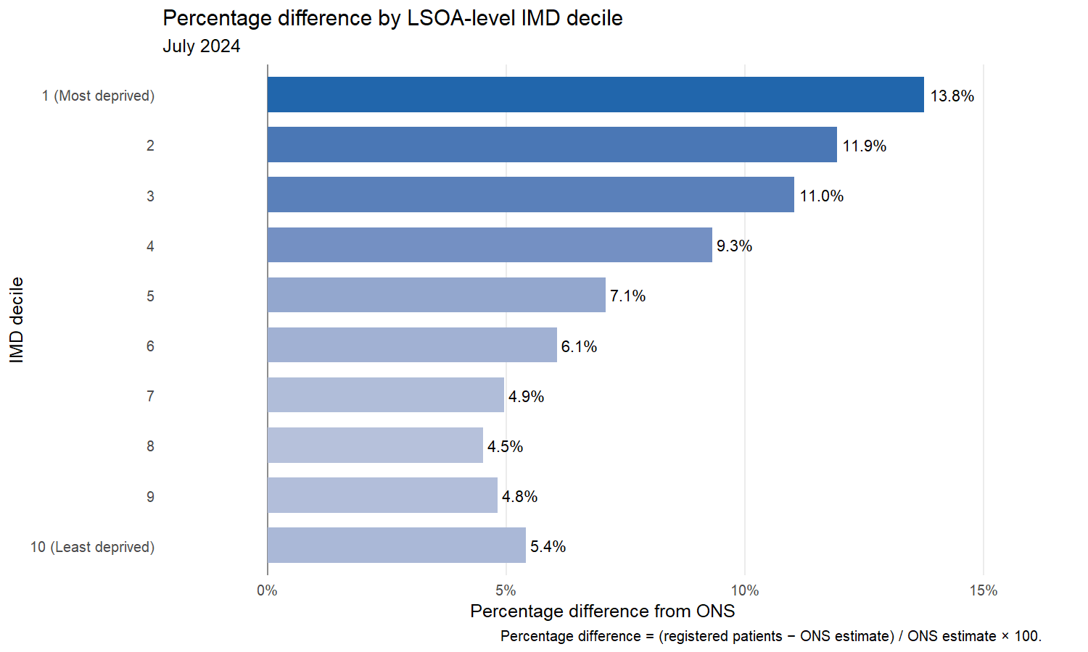
- This excludes: 15,509 in Wales and 78,282 in “other LSOAs”.
IMD decile | Registered patients | ONS population | Raw difference | Percentage difference
1 (Most deprived) | 6,767,857 | 5,948,978 | 818,879 | 13.8%
2 | 6,648,958 | 5,940,147 | 708,811 | 11.9%
3 | 6,685,963 | 6,021,480 | 664,483 | 11.0%
4 | 6,483,120 | 5,930,566 | 552,554 | 9.3%
5 | 6,363,401 | 5,942,293 | 421,108 | 7.1%
6 | 6,191,852 | 5,837,647 | 354,205 | 6.1%
7 | 6,187,954 | 5,896,163 | 291,791 | 4.9%
8 | 6,072,242 | 5,810,149 | 262,093 | 4.5%
9 | 6,018,463 | 5,741,718 | 276,745 | 4.8%
10 (Least deprived) | 5,851,493 | 5,550,960 | 300,533 | 5.4%

NHS England regions

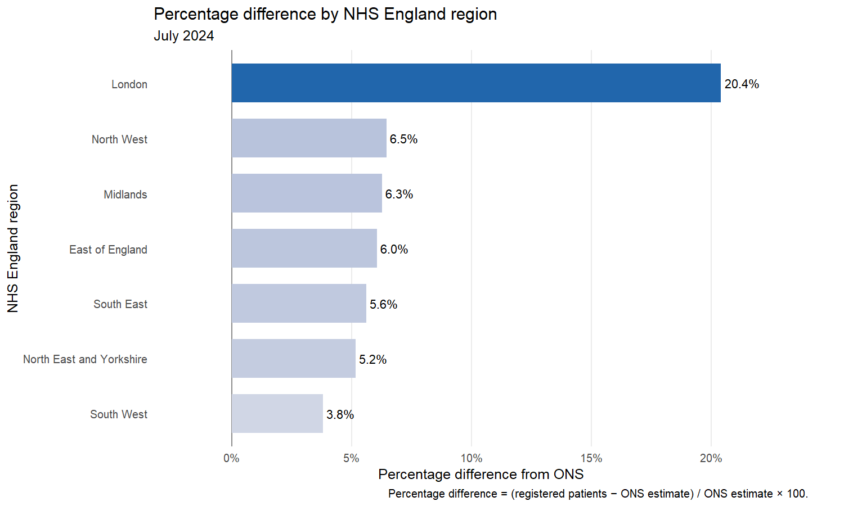
NHS England region | Registered patients | ONS population | Raw difference | Percentage difference
London | 10,943,219 | 9,089,736 | 1,853,483 | 20.4%
North West | 7,893,706 | 7,415,407 | 478,299 | 6.5%
Midlands | 11,954,944 | 11,250,368 | 704,576 | 6.3%
East of England | 7,306,097 | 6,889,610 | 416,487 | 6.0%
South East | 9,844,899 | 9,322,323 | 522,576 | 5.6%
North East and Yorkshire | 9,207,649 | 8,755,647 | 452,002 | 5.2%
South West | 6,120,789 | 5,897,010 | 223,779 | 3.8%

Integrated Care Boards
All ICB comparisons use the new April 2026 structure while using the July 2024 data. LSOA populations are reassigned through the official ONS April 2026 lookup, including the Frimley boundary changes.

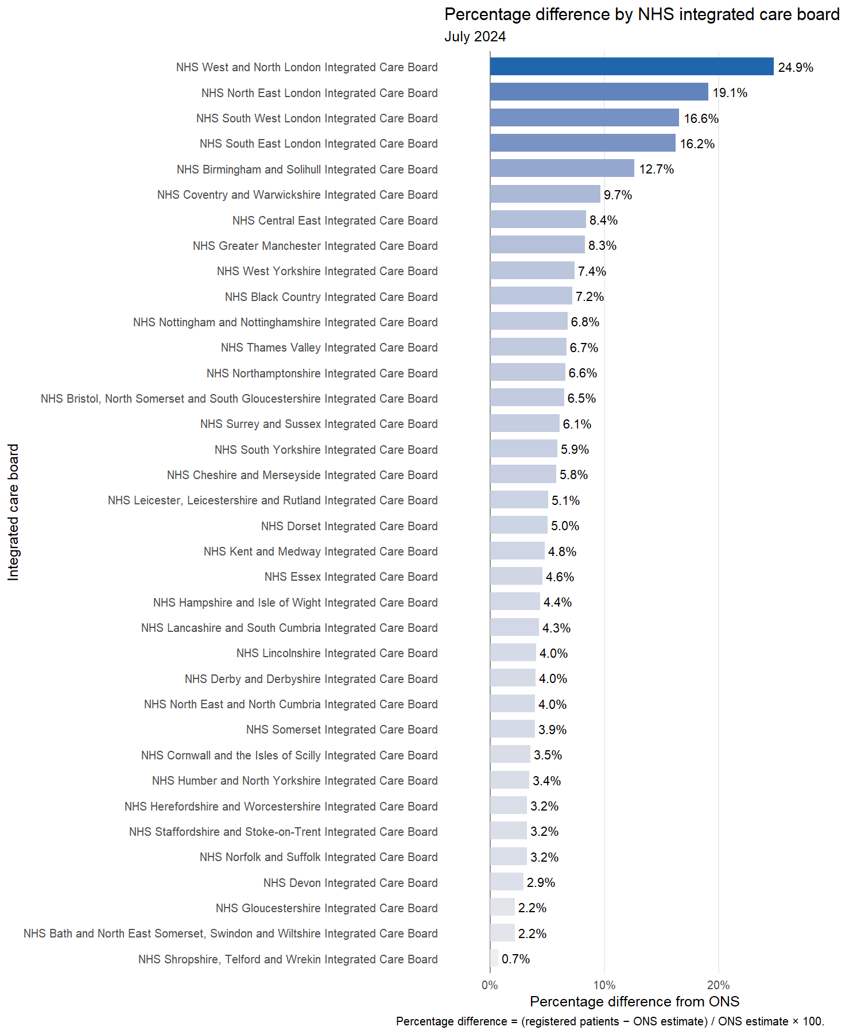
ICB | Registered patients | ONS population | Raw difference | Percentage difference
NHS West and North London Integrated Care Board | 4,517,022 | 3,617,796 | 899,226 | 24.9%
NHS North East London Integrated Care Board | 2,499,306 | 2,098,267 | 401,039 | 19.1%
NHS South West London Integrated Care Board | 1,806,261 | 1,549,431 | 256,830 | 16.6%
NHS South East London Integrated Care Board | 2,120,630 | 1,824,242 | 296,388 | 16.2%
NHS Birmingham and Solihull Integrated Care Board | 1,582,703 | 1,404,860 | 177,843 | 12.7%
NHS Coventry and Warwickshire Integrated Care Board | 1,098,077 | 1,001,233 | 96,844 | 9.7%
NHS Central East Integrated Care Board | 3,505,452 | 3,233,410 | 272,042 | 8.4%
NHS Greater Manchester Integrated Care Board | 3,259,621 | 3,009,664 | 249,957 | 8.3%
NHS West Yorkshire Integrated Care Board | 2,672,095 | 2,487,154 | 184,941 | 7.4%
NHS Black Country Integrated Care Board | 1,353,693 | 1,262,719 | 90,974 | 7.2%
NHS Nottingham and Nottinghamshire Integrated Care Board | 1,268,905 | 1,188,090 | 80,815 | 6.8%
NHS Thames Valley Integrated Care Board | 2,475,122 | 2,319,582 | 155,540 | 6.7%
NHS Northamptonshire Integrated Care Board | 867,446 | 813,682 | 53,764 | 6.6%
NHS Bristol, North Somerset and South Gloucestershire Integrated Care Board | 1,092,271 | 1,025,309 | 66,962 | 6.5%
NHS Surrey and Sussex Integrated Care Board | 3,192,313 | 3,008,438 | 183,875 | 6.1%
NHS South Yorkshire Integrated Care Board | 1,514,798 | 1,430,623 | 84,175 | 5.9%
NHS Cheshire and Merseyside Integrated Care Board | 2,766,584 | 2,615,425 | 151,159 | 5.8%
NHS Leicester, Leicestershire and Rutland Integrated Care Board | 1,235,463 | 1,175,364 | 60,099 | 5.1%
NHS Dorset Integrated Care Board | 839,235 | 798,914 | 40,321 | 5.0%
NHS Kent and Medway Integrated Care Board | 2,024,385 | 1,931,684 | 92,701 | 4.8%
NHS Essex Integrated Care Board | 2,018,303 | 1,929,610 | 88,693 | 4.6%
NHS Hampshire and Isle of Wight Integrated Care Board | 2,153,079 | 2,062,619 | 90,460 | 4.4%
NHS Lancashire and South Cumbria Integrated Care Board | 1,867,501 | 1,790,318 | 77,183 | 4.3%
NHS Lincolnshire Integrated Care Board | 821,273 | 789,502 | 31,771 | 4.0%
NHS Derby and Derbyshire Integrated Care Board | 1,140,583 | 1,096,526 | 44,057 | 4.0%
NHS North East and North Cumbria Integrated Care Board | 3,211,553 | 3,088,985 | 122,568 | 4.0%
NHS Somerset Integrated Care Board | 611,415 | 588,328 | 23,087 | 3.9%
NHS Cornwall and the Isles of Scilly Integrated Care Board | 606,369 | 585,655 | 20,714 | 3.5%
NHS Humber and North Yorkshire Integrated Care Board | 1,809,203 | 1,748,885 | 60,318 | 3.4%
NHS Herefordshire and Worcestershire Integrated Care Board | 838,775 | 812,407 | 26,368 | 3.2%
NHS Staffordshire and Stoke-on-Trent Integrated Care Board | 1,215,732 | 1,177,578 | 38,154 | 3.2%
NHS Norfolk and Suffolk Integrated Care Board | 1,782,342 | 1,726,590 | 55,752 | 3.2%
NHS Devon Integrated Care Board | 1,291,415 | 1,254,506 | 36,909 | 2.9%
NHS Gloucestershire Integrated Care Board | 683,978 | 669,380 | 14,598 | 2.2%
NHS Bath and North East Somerset, Swindon and Wiltshire Integrated Care Board | 996,106 | 974,918 | 21,188 | 2.2%
NHS Shropshire, Telford and Wrekin Integrated Care Board | 532,294 | 528,407 | 3,887 | 0.7%

Patients per qualified GP FTE

July 2024 national comparison

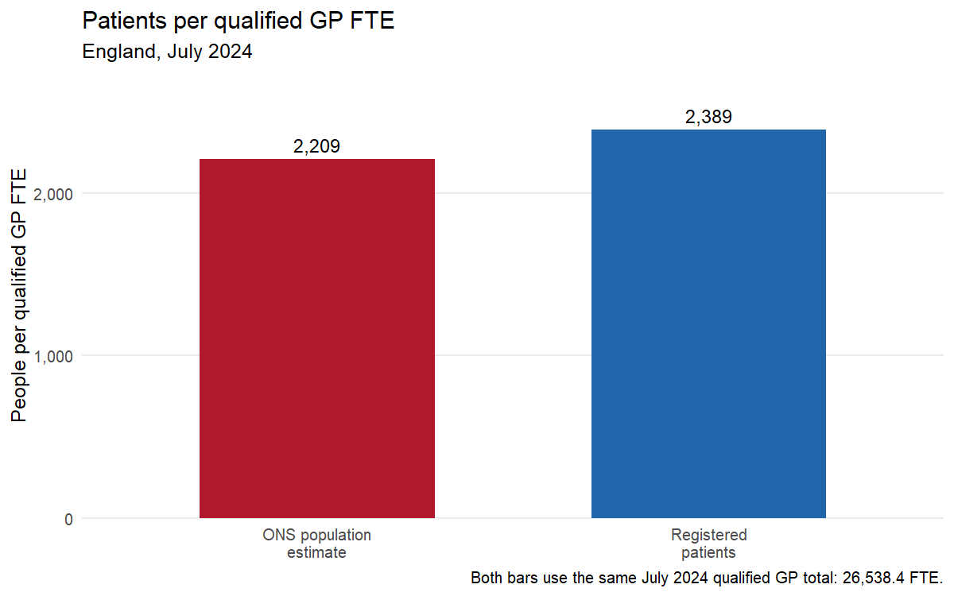

July 2024 time series
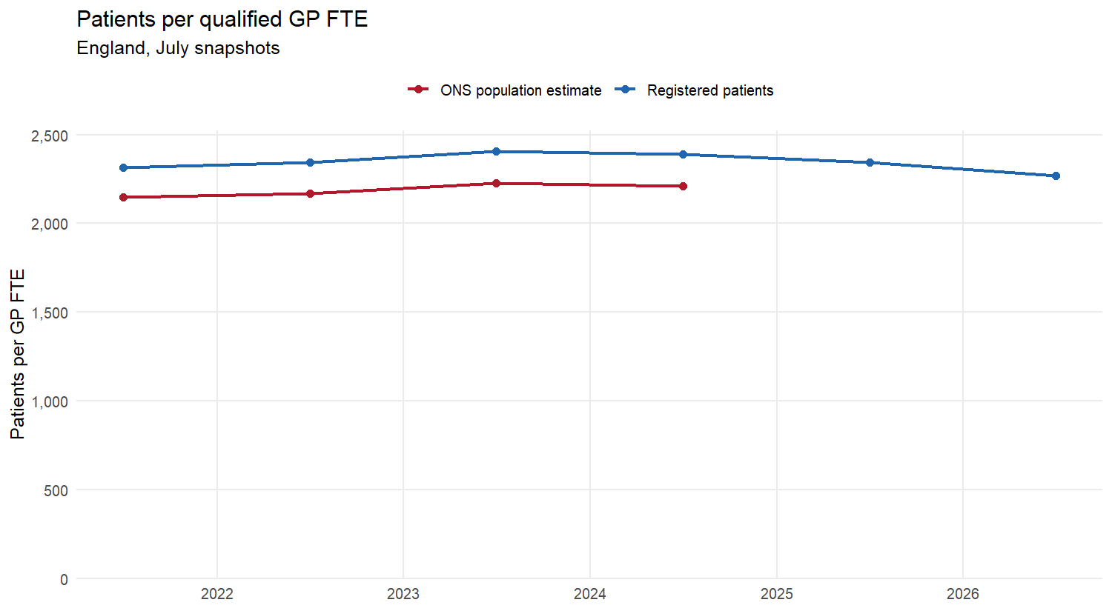
Geography | Registered patients per GP FTE | ONS population per GP FTE
England | 2,389 | 2,209

NHS England regions
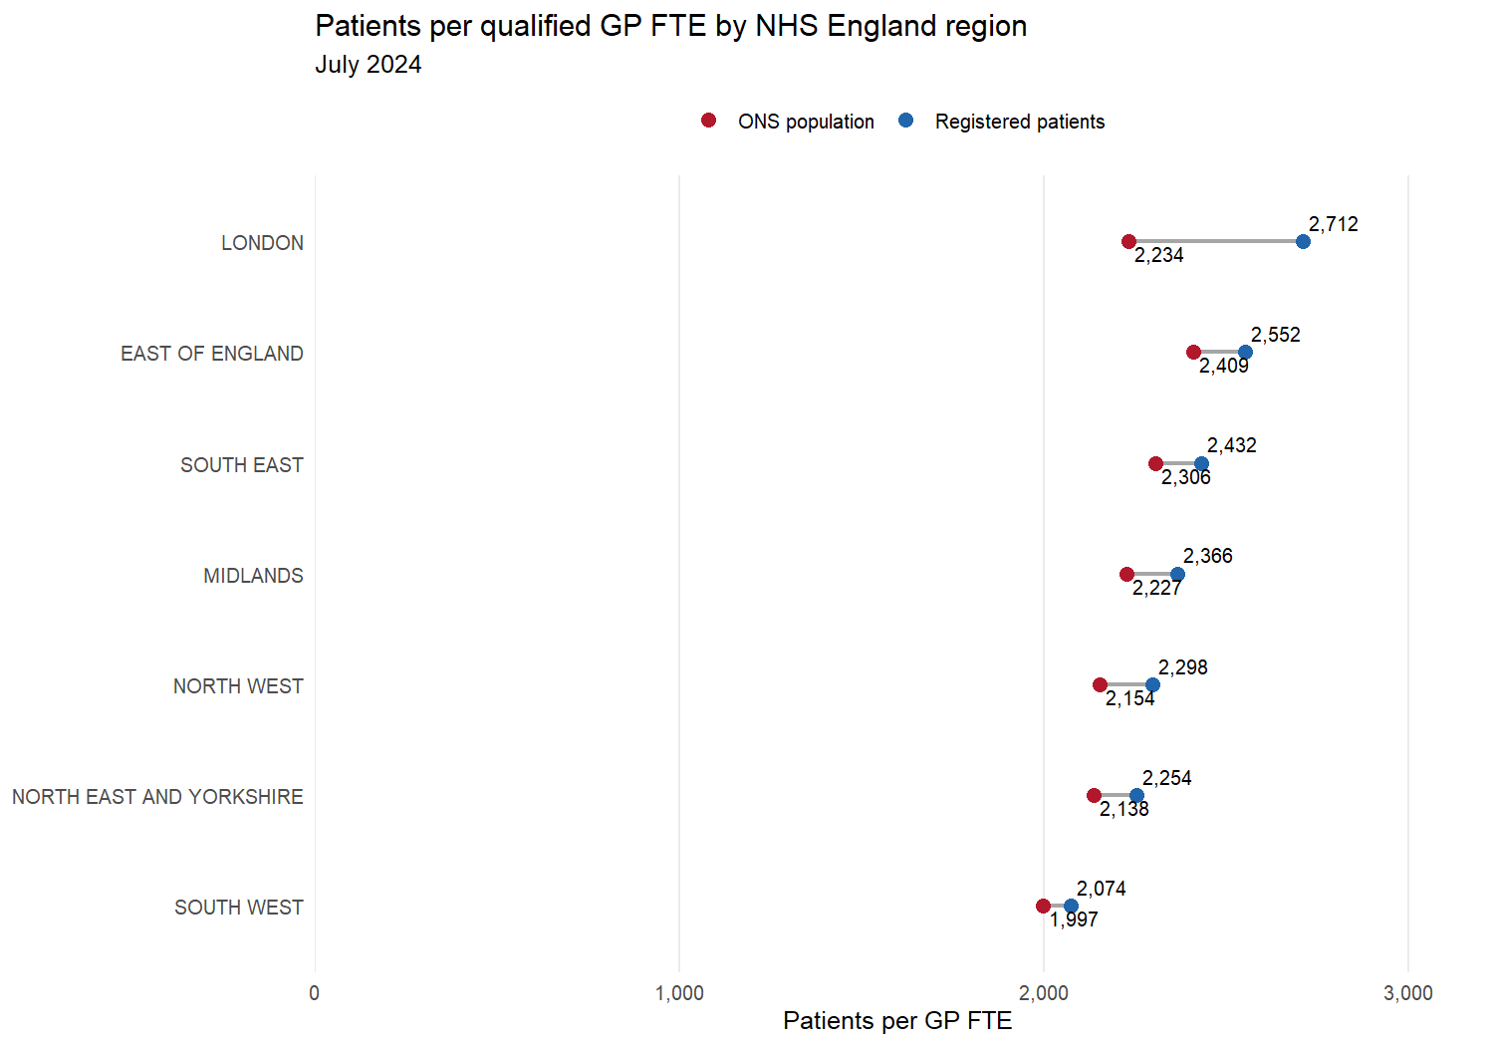

NHS England region | Registered patients per GP FTE | ONS population per GP FTE
LONDON | 2,712 | 2,234
EAST OF ENGLAND | 2,552 | 2,409
SOUTH EAST | 2,432 | 2,306
MIDLANDS | 2,366 | 2,227
NORTH WEST | 2,298 | 2,154
NORTH EAST AND YORKSHIRE | 2,254 | 2,138
SOUTH WEST | 2,074 | 1,997

Integrated care boards
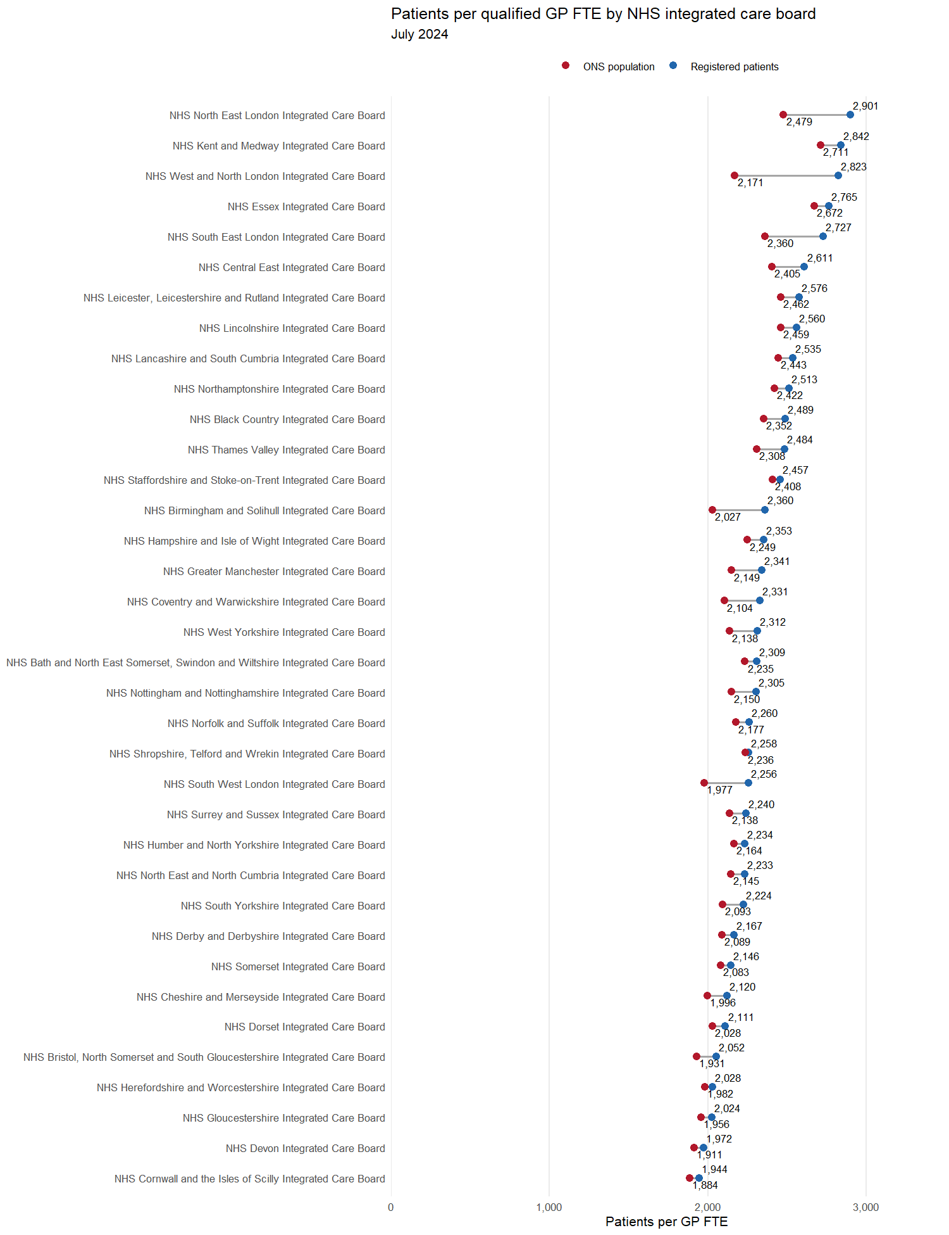

ICB | Registered patients per GP FTE | ONS population per GP FTE
NHS North East London Integrated Care Board | 2,901 | 2,479
NHS Kent and Medway Integrated Care Board | 2,842 | 2,711
NHS West and North London Integrated Care Board | 2,823 | 2,171
NHS Essex Integrated Care Board | 2,765 | 2,672
NHS South East London Integrated Care Board | 2,727 | 2,360
NHS Central East Integrated Care Board | 2,611 | 2,405
NHS Leicester, Leicestershire and Rutland Integrated Care Board | 2,576 | 2,462
NHS Lincolnshire Integrated Care Board | 2,560 | 2,459
NHS Lancashire and South Cumbria Integrated Care Board | 2,535 | 2,443
NHS Northamptonshire Integrated Care Board | 2,513 | 2,422
NHS Black Country Integrated Care Board | 2,489 | 2,352
NHS Thames Valley Integrated Care Board | 2,484 | 2,308
NHS Staffordshire and Stoke-on-Trent Integrated Care Board | 2,457 | 2,408
NHS Birmingham and Solihull Integrated Care Board | 2,360 | 2,027
NHS Hampshire and Isle of Wight Integrated Care Board | 2,353 | 2,249
NHS Greater Manchester Integrated Care Board | 2,341 | 2,149
NHS Coventry and Warwickshire Integrated Care Board | 2,331 | 2,104
NHS West Yorkshire Integrated Care Board | 2,312 | 2,138
NHS Bath and North East Somerset, Swindon and Wiltshire Integrated Care Board | 2,309 | 2,235
NHS Nottingham and Nottinghamshire Integrated Care Board | 2,305 | 2,150
NHS Norfolk and Suffolk Integrated Care Board | 2,260 | 2,177
NHS Shropshire, Telford and Wrekin Integrated Care Board | 2,258 | 2,236
NHS South West London Integrated Care Board | 2,256 | 1,977
NHS Surrey and Sussex Integrated Care Board | 2,240 | 2,138
NHS Humber and North Yorkshire Integrated Care Board | 2,234 | 2,164
NHS North East and North Cumbria Integrated Care Board | 2,233 | 2,145
NHS South Yorkshire Integrated Care Board | 2,224 | 2,093
NHS Derby and Derbyshire Integrated Care Board | 2,167 | 2,089
NHS Somerset Integrated Care Board | 2,146 | 2,083
NHS Cheshire and Merseyside Integrated Care Board | 2,120 | 1,996
NHS Dorset Integrated Care Board | 2,111 | 2,028
NHS Bristol, North Somerset and South Gloucestershire Integrated Care Board | 2,052 | 1,931
NHS Herefordshire and Worcestershire Integrated Care Board | 2,028 | 1,982
NHS Gloucestershire Integrated Care Board | 2,024 | 1,956
NHS Devon Integrated Care Board | 1,972 | 1,911
NHS Cornwall and the Isles of Scilly Integrated Care Board | 1,944 | 1,884

If payment to general practice were to remain constant despite reduction in list size
This comparison keeps overall payments the same but changes the population denominator.

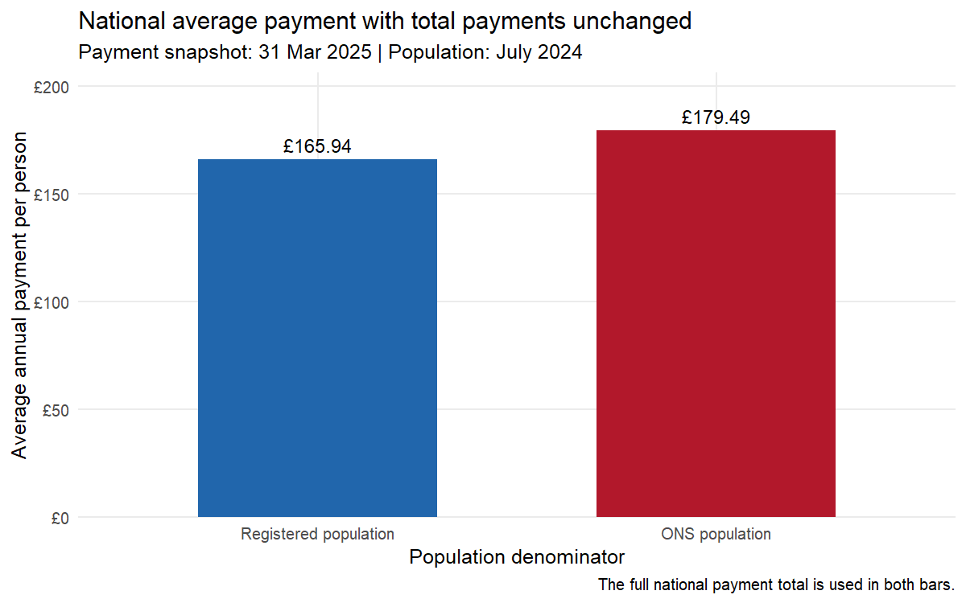
Geography | Total payments (£) | Registered, n | ONS, n | £/registered patient | £/ONS resident | Change (£/person) | Change (%)
England | 10,521,901,156 | 63,407,818 | 58,620,101 | 165.94 | 179.49 | 13.55 | 8.17%

Average payment by NHS England region

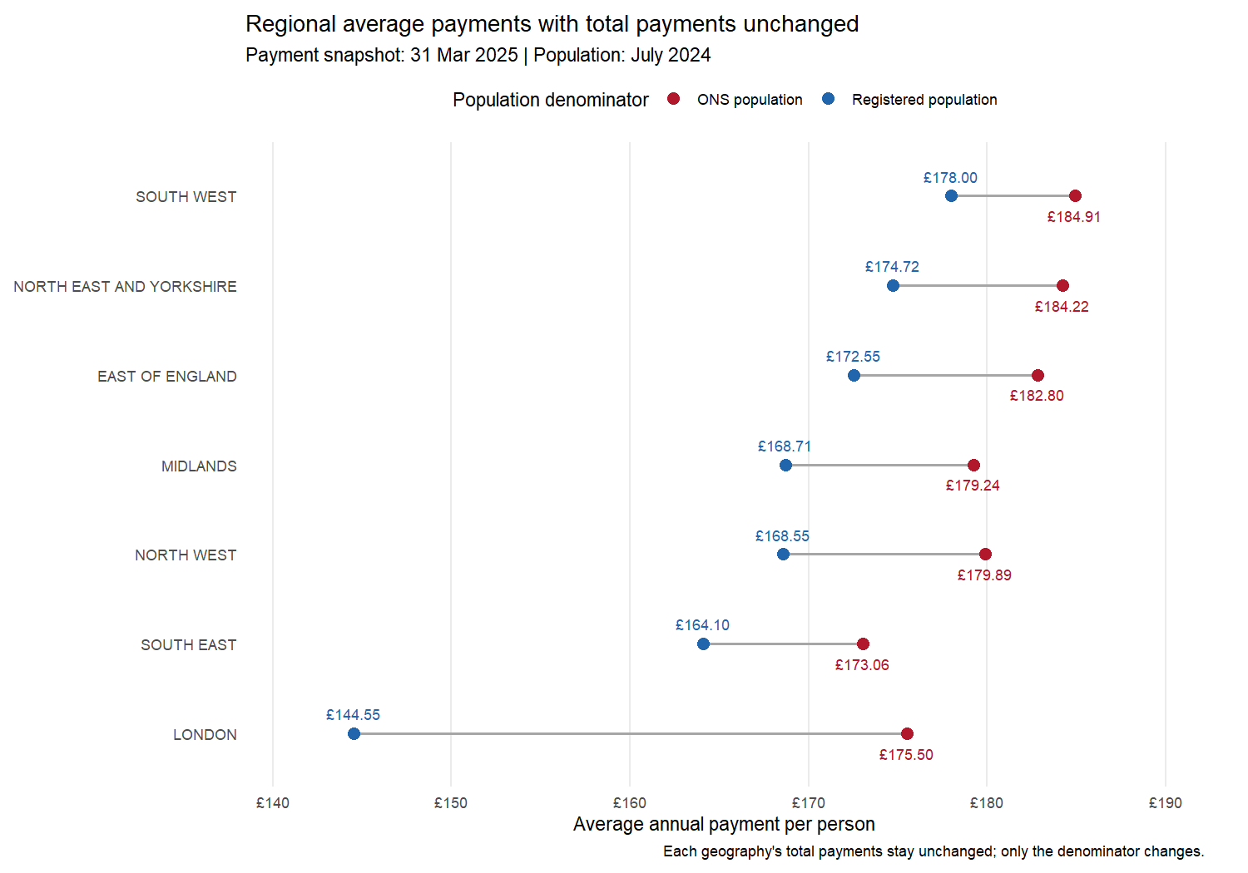
Geography | Total payments (£) | Registered, n | ONS, n | £/registered patient | £/ONS resident | Change (£/person) | Change (%)
SOUTH WEST | 1,090,394,585 | 6,125,759 | 5,897,010 | 178.00 | 184.91 | 6.90 | 3.88%
NORTH EAST AND YORKSHIRE | 1,612,974,585 | 9,231,531 | 8,755,647 | 174.72 | 184.22 | 9.50 | 5.44%
EAST OF ENGLAND | 1,259,450,400 | 7,299,121 | 6,889,610 | 172.55 | 182.80 | 10.26 | 5.94%
MIDLANDS | 2,016,531,246 | 11,952,920 | 11,250,368 | 168.71 | 179.24 | 10.54 | 6.24%
NORTH WEST | 1,333,941,544 | 7,914,132 | 7,415,407 | 168.55 | 179.89 | 11.34 | 6.73%
SOUTH EAST | 1,613,355,241 | 9,831,503 | 9,322,323 | 164.10 | 173.06 | 8.96 | 5.46%
LONDON | 1,595,253,555 | 11,036,366 | 9,089,736 | 144.55 | 175.50 | 30.96 | 21.42%

Average payment by integrated care board

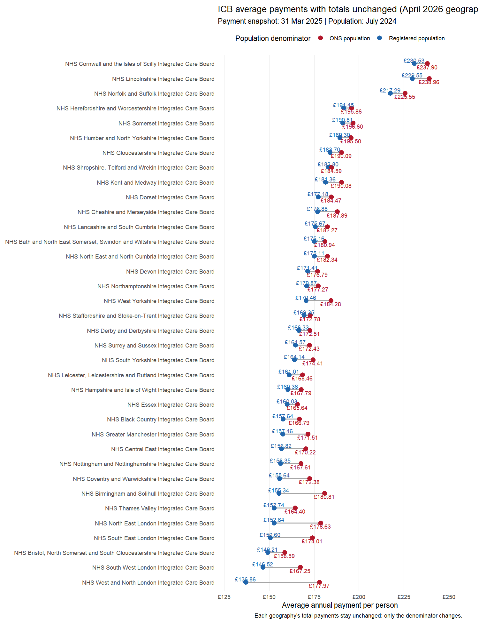

Geography | Total payments (£) | Registered, n | ONS, n | £/registered patient | £/ONS resident | Change (£/person) | Change (%)
NHS Cornwall and the Isles of Scilly Integrated Care Board | 139,326,473 | 604,377 | 585,655 | 230.53 | 237.90 | 7.37 | 3.20%
NHS Lincolnshire Integrated Care Board | 188,662,925 | 821,891 | 789,502 | 229.55 | 238.96 | 9.42 | 4.10%
NHS Norfolk and Suffolk Integrated Care Board | 389,429,183 | 1,792,210 | 1,726,590 | 217.29 | 225.55 | 8.26 | 3.80%
NHS Herefordshire and Worcestershire Integrated Care Board | 159,114,257 | 831,106 | 812,407 | 191.45 | 195.86 | 4.41 | 2.30%
NHS Somerset Integrated Care Board | 115,663,476 | 606,165 | 588,328 | 190.81 | 196.60 | 5.79 | 3.03%
NHS Humber and North Yorkshire Integrated Care Board | 341,903,311 | 1,806,106 | 1,748,885 | 189.30 | 195.50 | 6.19 | 3.27%
NHS Gloucestershire Integrated Care Board | 127,241,627 | 692,664 | 669,380 | 183.70 | 190.09 | 6.39 | 3.48%
NHS Shropshire, Telford and Wrekin Integrated Care Board | 97,540,674 | 533,587 | 528,407 | 182.80 | 184.59 | 1.79 | 0.98%
NHS Kent and Medway Integrated Care Board | 367,181,048 | 2,024,587 | 1,931,684 | 181.36 | 190.08 | 8.72 | 4.81%
NHS Dorset Integrated Care Board | 147,373,483 | 831,779 | 798,914 | 177.18 | 184.47 | 7.29 | 4.11%
NHS Cheshire and Merseyside Integrated Care Board | 491,418,071 | 2,778,201 | 2,615,425 | 176.88 | 187.89 | 11.01 | 6.22%
NHS Lancashire and South Cumbria Integrated Care Board | 326,329,441 | 1,857,613 | 1,790,318 | 175.67 | 182.27 | 6.60 | 3.76%
NHS Bath and North East Somerset, Swindon and Wiltshire Integrated Care Board | 176,404,546 | 1,007,100 | 974,918 | 175.16 | 180.94 | 5.78 | 3.30%
NHS North East and North Cumbria Integrated Care Board | 563,239,662 | 3,216,559 | 3,088,985 | 175.11 | 182.34 | 7.23 | 4.13%
NHS Devon Integrated Care Board | 221,784,340 | 1,293,901 | 1,254,506 | 171.41 | 176.79 | 5.38 | 3.14%
NHS Northamptonshire Integrated Care Board | 144,238,582 | 844,159 | 813,682 | 170.87 | 177.27 | 6.40 | 3.75%
NHS West Yorkshire Integrated Care Board | 458,323,706 | 2,688,809 | 2,487,154 | 170.46 | 184.28 | 13.82 | 8.11%
NHS Staffordshire and Stoke-on-Trent Integrated Care Board | 203,456,560 | 1,201,389 | 1,177,578 | 169.35 | 172.78 | 3.42 | 2.02%
NHS Derby and Derbyshire Integrated Care Board | 189,166,301 | 1,137,283 | 1,096,526 | 166.33 | 172.51 | 6.18 | 3.72%
NHS Surrey and Sussex Integrated Care Board | 518,752,682 | 3,152,168 | 3,008,438 | 164.57 | 172.43 | 7.86 | 4.78%
NHS South Yorkshire Integrated Care Board | 249,507,906 | 1,520,057 | 1,430,623 | 164.14 | 174.41 | 10.26 | 6.25%
NHS Leicester, Leicestershire and Rutland Integrated Care Board | 198,003,515 | 1,229,749 | 1,175,364 | 161.01 | 168.46 | 7.45 | 4.63%
NHS Hampshire and Isle of Wight Integrated Care Board | 346,085,172 | 2,158,181 | 2,062,619 | 160.36 | 167.79 | 7.43 | 4.63%
NHS Essex Integrated Care Board | 319,615,283 | 1,997,226 | 1,929,610 | 160.03 | 165.64 | 5.61 | 3.50%
NHS Black Country Integrated Care Board | 210,611,373 | 1,336,065 | 1,262,719 | 157.64 | 166.79 | 9.16 | 5.81%
NHS Greater Manchester Integrated Care Board | 516,194,032 | 3,278,318 | 3,009,664 | 157.46 | 171.51 | 14.06 | 8.93%
NHS Central East Integrated Care Board | 550,405,934 | 3,509,685 | 3,233,410 | 156.82 | 170.22 | 13.40 | 8.54%
NHS Nottingham and Nottinghamshire Integrated Care Board | 199,130,361 | 1,273,621 | 1,188,090 | 156.35 | 167.61 | 11.26 | 7.20%
NHS Coventry and Warwickshire Integrated Care Board | 172,590,386 | 1,108,877 | 1,001,233 | 155.64 | 172.38 | 16.73 | 10.75%
NHS Birmingham and Solihull Integrated Care Board | 254,016,312 | 1,635,193 | 1,404,860 | 155.34 | 180.81 | 25.47 | 16.40%
NHS Thames Valley Integrated Care Board | 381,336,338 | 2,496,567 | 2,319,582 | 152.74 | 164.40 | 11.65 | 7.63%
NHS North East London Integrated Care Board | 374,808,998 | 2,455,444 | 2,098,267 | 152.64 | 178.63 | 25.98 | 17.02%
NHS South East London Integrated Care Board | 317,437,749 | 2,107,886 | 1,824,242 | 150.60 | 174.01 | 23.42 | 15.55%
NHS Bristol, North Somerset and South Gloucestershire Integrated Care Board | 162,600,640 | 1,089,773 | 1,025,309 | 149.21 | 158.59 | 9.38 | 6.29%
NHS South West London Integrated Care Board | 259,148,969 | 1,768,647 | 1,549,431 | 146.52 | 167.25 | 20.73 | 14.15%
NHS West and North London Integrated Care Board | 643,857,838 | 4,704,389 | 3,617,796 | 136.86 | 177.97 | 41.11 | 30.03%

If payments decreased alongside reduction in list size
This section examines how much money could be removed removed from practices if registered lists were reduced to be in line with the ONS. At the moment this just uses the calculate payment per capita pre removal and multiplies by removed number of patients. Using the value for Total NHS Payments to General Practice minus deductions.
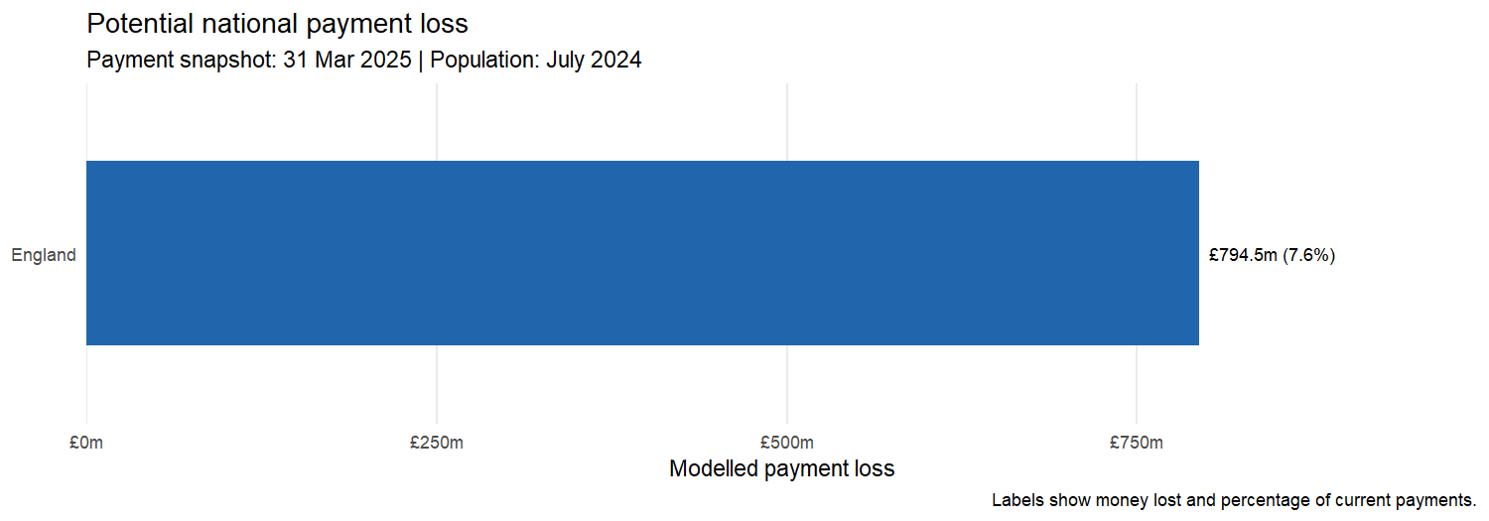
Geography | Current (£) | Rate (£/patient) | List reduction (n) | Loss (£) | Remaining (£)
England | 10,521,901,156 | 165.94 | 4,787,717 | 794,474,351 | 9,727,426,805

Loss by NHS England region
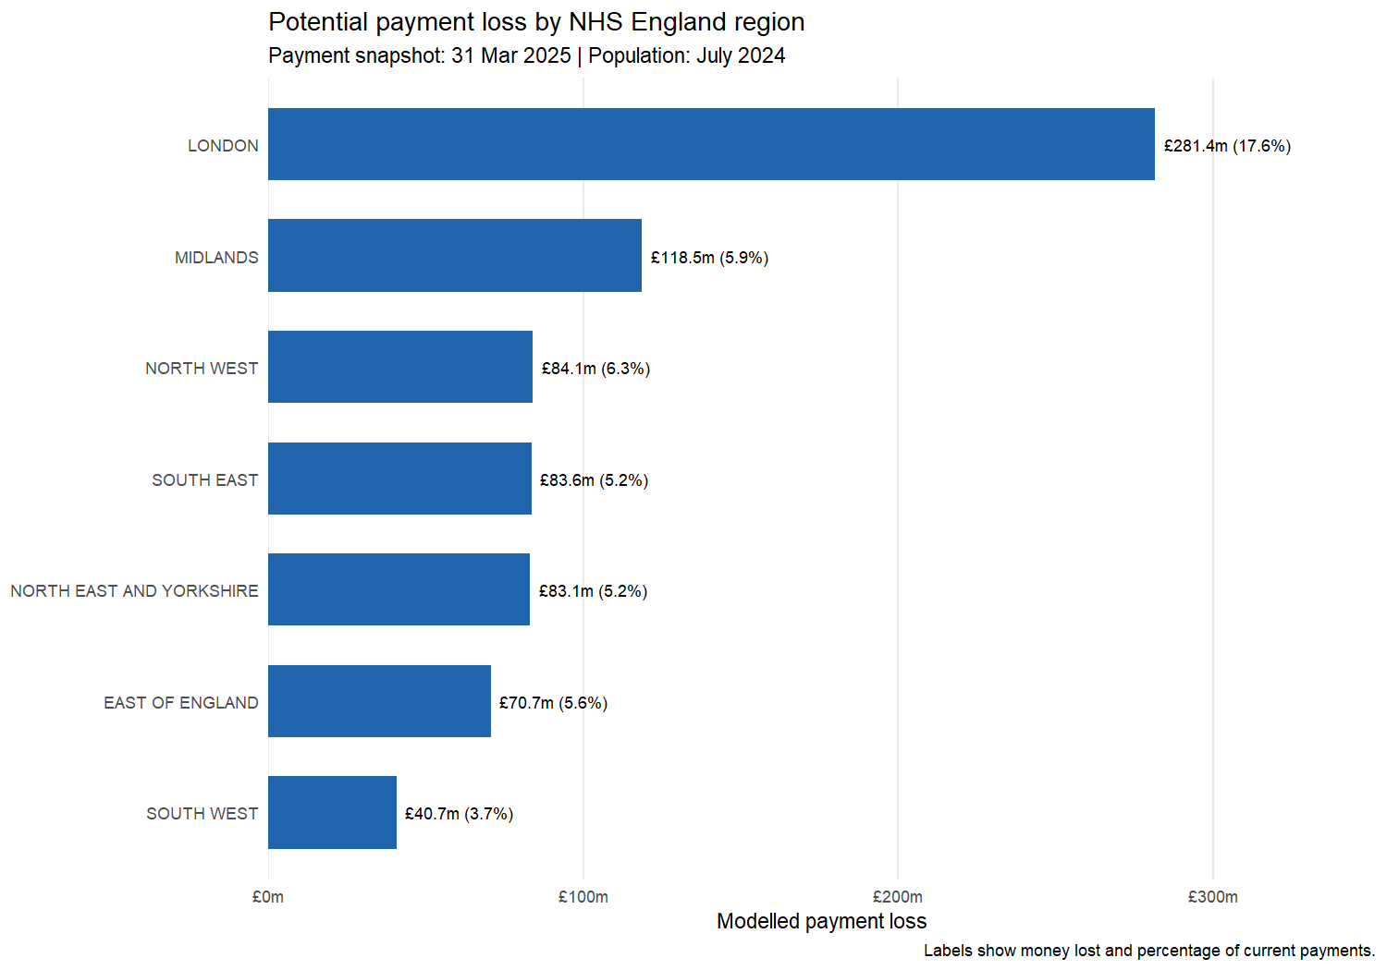
Geography | Current (£) | Rate (£/patient) | List reduction (n) | Loss (£) | Remaining (£)
LONDON | 1,595,253,555 | 144.55 | 1,946,630 | 281,375,992 | 1,313,877,563
MIDLANDS | 2,016,531,246 | 168.71 | 702,552 | 118,524,851 | 1,898,006,395
NORTH WEST | 1,333,941,544 | 168.55 | 498,725 | 84,061,019 | 1,249,880,526
SOUTH EAST | 1,613,355,241 | 164.10 | 509,180 | 83,556,728 | 1,529,798,513
NORTH EAST AND YORKSHIRE | 1,612,974,585 | 174.72 | 475,884 | 83,148,591 | 1,529,825,994
 | 1,259,450,400 | 172.55 | 409,511 | 70,660,398 | 1,188,790,002
SOUTH WEST | 1,090,394,585 | 178.00 | 228,749 | 40,717,676 | 1,049,676,909

Loss by integrated care board

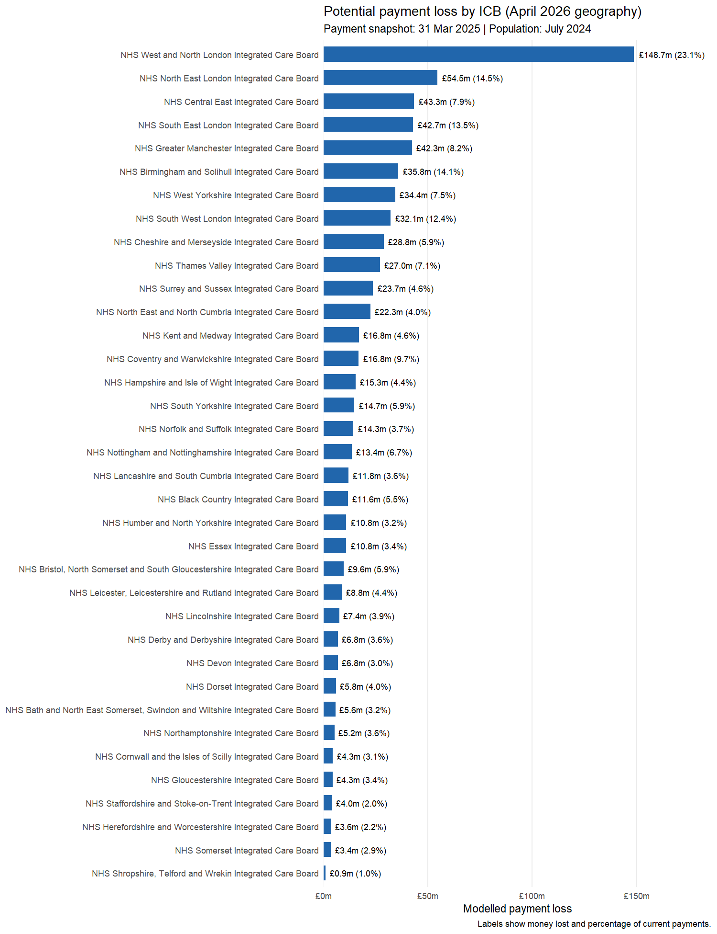
Geography | Current (£) | Rate (£/patient) | List reduction (n) | Loss (£) | Remaining (£)
NHS West and North London Integrated Care Board | 643,857,838 | 136.86 | 1,086,593 | 148,714,620 | 495,143,219
NHS North East London Integrated Care Board | 374,808,998 | 152.64 | 357,177 | 54,520,956 | 320,288,042
NHS Central East Integrated Care Board | 550,405,934 | 156.82 | 276,275 | 43,326,794 | 507,079,140
NHS South East London Integrated Care Board | 317,437,749 | 150.60 | 283,644 | 42,715,457 | 274,722,293
NHS Greater Manchester Integrated Care Board | 516,194,032 | 157.46 | 268,654 | 42,301,446 | 473,892,587
NHS Birmingham and Solihull Integrated Care Board | 254,016,312 | 155.34 | 230,333 | 35,780,693 | 218,235,619
NHS West Yorkshire Integrated Care Board | 458,323,706 | 170.46 | 201,655 | 34,373,311 | 423,950,396
NHS South West London Integrated Care Board | 259,148,969 | 146.52 | 219,216 | 32,120,372 | 227,028,597
NHS Cheshire and Merseyside Integrated Care Board | 491,418,071 | 176.88 | 162,776 | 28,792,398 | 462,625,673
NHS Thames Valley Integrated Care Board | 381,336,338 | 152.74 | 176,985 | 27,033,447 | 354,302,891
NHS Surrey and Sussex Integrated Care Board | 518,752,682 | 164.57 | 143,730 | 23,653,664 | 495,099,018
NHS North East and North Cumbria Integrated Care Board | 563,239,662 | 175.11 | 127,574 | 22,339,008 | 540,900,654
NHS Kent and Medway Integrated Care Board | 367,181,048 | 181.36 | 92,903 | 16,848,978 | 350,332,071
NHS Coventry and Warwickshire Integrated Care Board | 172,590,386 | 155.64 | 107,644 | 16,754,175 | 155,836,211
NHS Hampshire and Isle of Wight Integrated Care Board | 346,085,172 | 160.36 | 95,562 | 15,324,290 | 330,760,882
NHS South Yorkshire Integrated Care Board | 249,507,906 | 164.14 | 89,434 | 14,680,035 | 234,827,870
NHS Norfolk and Suffolk Integrated Care Board | 389,429,183 | 217.29 | 65,620 | 14,258,565 | 375,170,618
NHS Nottingham and Nottinghamshire Integrated Care Board | 199,130,361 | 156.35 | 85,531 | 13,372,753 | 185,757,608
NHS Lancashire and South Cumbria Integrated Care Board | 326,329,441 | 175.67 | 67,295 | 11,821,806 | 314,507,635
NHS Black Country Integrated Care Board | 210,611,373 | 157.64 | 73,346 | 11,561,939 | 199,049,434
NHS Humber and North Yorkshire Integrated Care Board | 341,903,311 | 189.30 | 57,221 | 10,832,171 | 331,071,140
NHS Essex Integrated Care Board | 319,615,283 | 160.03 | 67,616 | 10,820,562 | 308,794,722
NHS Bristol, North Somerset and South Gloucestershire Integrated Care Board | 162,600,640 | 149.21 | 64,464 | 9,618,414 | 152,982,227
NHS Leicester, Leicestershire and Rutland Integrated Care Board | 198,003,515 | 161.01 | 54,385 | 8,756,601 | 189,246,914
NHS Lincolnshire Integrated Care Board | 188,662,925 | 229.55 | 32,389 | 7,434,810 | 181,228,115
NHS Derby and Derbyshire Integrated Care Board | 189,166,301 | 166.33 | 40,757 | 6,779,184 | 182,387,117
NHS Devon Integrated Care Board | 221,784,340 | 171.41 | 39,395 | 6,752,599 | 215,031,741
NHS Dorset Integrated Care Board | 147,373,483 | 177.18 | 32,865 | 5,822,976 | 141,550,507
NHS Bath and North East Somerset, Swindon and Wiltshire Integrated Care Board | 176,404,546 | 175.16 | 32,182 | 5,637,028 | 170,767,518
NHS Northamptonshire Integrated Care Board | 144,238,582 | 170.87 | 30,477 | 5,207,502 | 139,031,081
NHS Cornwall and the Isles of Scilly Integrated Care Board | 139,326,473 | 230.53 | 18,722 | 4,315,965 | 135,010,508
NHS Gloucestershire Integrated Care Board | 127,241,627 | 183.70 | 23,284 | 4,277,246 | 122,964,381
NHS Staffordshire and Stoke-on-Trent Integrated Care Board | 203,456,560 | 169.35 | 23,811 | 4,032,419 | 199,424,140
NHS Herefordshire and Worcestershire Integrated Care Board | 159,114,257 | 191.45 | 18,699 | 3,579,901 | 155,534,355
NHS Somerset Integrated Care Board | 115,663,476 | 190.81 | 17,837 | 3,403,511 | 112,259,965
NHS Shropshire, Telford and Wrekin Integrated Care Board | 97,540,674 | 182.80 | 5,180 | 946,913 | 96,593,761

