GPpaymentGraphs
2025-10-15
library(tidyverse)
library(readxl)
#colnames(imd_raw)
imd <- imd_raw %>%
rename(
LSOA_CODE = LSOA.code..2011.,
IMD_SCORE = Index.of.Multiple.Deprivation..IMD..Score,
IMD_DECILE = Index.of.Multiple.Deprivation..IMD..Decile..where.1.is.most.deprived.10..of.LSOAs.,
IMD_HEALTH = Health.Deprivation.and.Disability.Score) %>%
mutate(
IMD_QUINTILE = case_when(IMD_DECILE %in% c(1:2) ~ 1,
IMD_DECILE %in% c(3:4) ~ 2,
IMD_DECILE %in% c(5:6) ~ 3,
IMD_DECILE %in% c(7:8) ~ 4,
IMD_DECILE %in% c(9:10) ~ 5),
LSOA_DATE = 2011) %>%
select(LSOA_CODE, IMD_SCORE, IMD_HEALTH, IMD_QUINTILE, LSOA_DATE)
mapping <- read_csv(file = "data/LSOA_2011_to_LSOA_2021_Lookup_E_W.csv", name_repair = make.names)
## Rows: 35796 Columns: 9
## ── Column specification ────────────────────────────────────────────────────────
## Delimiter: ","
## chr (8): LSOA11CD, LSOA11NM, LSOA21CD, LSOA21NM, CHGIND, LAD22CD, LAD22NM, L...
## dbl (1): ObjectId
##
## ℹ Use `spec()` to retrieve the full column specification for this data.
## ℹ Specify the column types or set `show_col_types = FALSE` to quiet this message.
# convert 2021 LSOA groups if the LSOA CHNGID M (merged in 2021) or X (unclear mapping)
weighted_mapping = mapping %>% left_join(
mapping %>% filter(CHGIND=="M" | CHGIND=="X") %>%
group_by(LSOA21CD) %>%
summarise(WEIGHT=1/n())) %>%
mutate(WEIGHT=if_else(CHGIND %in% c("S","U"),1,WEIGHT))
## Joining with `by = join_by(LSOA21CD)`
weighted_imd <- weighted_mapping %>%
left_join(select(imd, LSOA_CODE, IMD_HEALTH, IMD_SCORE), by=c("LSOA11CD" = "LSOA_CODE")) %>%
mutate(
weighted_imd = IMD_SCORE*WEIGHT,
weighted_imd_health = IMD_HEALTH*WEIGHT
) %>%
group_by(LSOA21CD) %>%
summarise(
IMD_SCORE = sum(weighted_imd),
IMD_HEALTH = sum(weighted_imd_health)
) %>%
mutate(IMD_QUINTILE = ntile(-IMD_SCORE,5)) %>%
mutate(LSOA_DATE = 2021) %>%
rename(LSOA_CODE = LSOA21CD)
imd_2011_2021 <- rbind(imd, weighted_imd)
year_list <- c(2017:2023)
load_ons_data <- function(year, sex) {
#print(year)
if(year == 2017) {
object_url = "data/population/SAPE20DT2-mid-2017-lsoa-syoa-estimates-unformatted.xls"
} else if(year == 2018) {
object_url = "data/population/SAPE21DT2-mid-2018-lsoa-syoa-estimates-unformatted.xlsx"
} else if(year == 2019) {
object_url = "data/population/SAPE22DT2-mid-2019-lsoa-syoa-estimates-unformatted.xlsx"
} else if(year == 2020) {
object_url = "data/population/sape23dt2mid2020lsoasyoaestimatesunformatted.xlsx"
} else if(year == 2021) {
object_url = "data/population/sapelsoasyoatablefinal.xlsx"
excel_sheet ="Mid-2021 LSOA 2021"
} else if(year %in% c(2022:2023)) {
object_url = "data/population/sapelsoasyoatablefinal.xlsx"
excel_sheet ="Mid-2022 LSOA 2021"
} # end setting the object url
print(object_url)
if(year == 2017) {
lsoa_date = 2011
data <- read_xls(
path = object_url,
sheet=paste0("Mid-",year," ",sex),
skip = 4,
trim_ws=TRUE,
.name_repair = "universal"
)
# data <- aws.s3::s3read_using(
# FUN = readxl::read_xls,
# object = object_url,
# bucket = s3_bucket,
# sheet=paste0("Mid-",year," ",sex),
# skip = 4,
# trim_ws=TRUE,
# .name_repair = "universal")
} else if(year %in% c(2018:2020)) {
lsoa_date = 2011
data <- read_xlsx(
path = object_url,
sheet = paste0("Mid-",year," ",sex),
skip = 4,
trim_ws=TRUE,
.name_repair = "universal"
)
# data <- aws.s3::s3read_using(
# FUN = readxl::read_xlsx,
# object = object_url,
# bucket = s3_bucket,
# sheet=paste0("Mid-",year," ",sex),
# skip = 4,
# trim_ws=TRUE,
# .name_repair = "universal")
} else if(year %in% c(2021:2023)) {
lsoa_date = 2021
data <- read_xlsx(
path = object_url,
sheet = excel_sheet,
skip = 3,
trim_ws=TRUE,
.name_repair = "universal"
)
# data <- aws.s3::s3read_using(
# FUN = readxl::read_xlsx,
# object = object_url,
# bucket = s3_bucket,
# sheet = "Mid-2021 LSOA 2021",
# skip = 3,
# trim_ws=TRUE,
# .name_repair = "universal")
} # end loading the data
if(year %in% c(2017:2018)) {
data1 <- data %>%
select(-All.Ages) %>%
pivot_longer(cols=!c('Area.Codes', 'Area.Names'), names_to='AGE', values_to='POP') %>%
mutate(AGE = as.numeric(str_remove_all(AGE, '[^[:alnum:]]')),
SEX = sex) %>%
rename(LSOA_CODE = Area.Codes)
} else if(year %in% c(2019:2020)) {
data1 <- data %>%
select(-contains('Boundaries'), -All.Ages) %>%
pivot_longer(cols=!c('LSOA.Code', 'LSOA.Name'), names_to='AGE', values_to='POP') %>%
mutate(AGE = as.numeric(str_remove_all(AGE, '[^[:alnum:]]')),
SEX = sex) %>%
rename(LSOA_CODE = LSOA.Code)
} else if (year %in% c(2021:2023)) {
data1 <- data %>%
select(-c(LAD.2021.Code, LAD.2021.Name, LSOA.2021.Name, Total)) %>%
pivot_longer(!LSOA.2021.Code, names_to="AGE", values_to="POP") %>%
separate(AGE, into = c("SEX", "AGE"), sep = "(?<=[A-Za-z])(?=[0-9])") %>%
mutate(SEX = case_when(SEX == "F" ~ "Females",SEX == "M" ~ "Males")
) %>%
filter(SEX == sex) %>%
rename(LSOA_CODE = LSOA.2021.Code)
} # end cleaning the data by year
# group into age groups once here
data2 <- data1 %>%
mutate(
AGE = as.numeric(AGE),
AGE = case_when(
AGE %in% c(0:4) ~ "0_4",
AGE %in% c(5:14) ~ "5_14",
AGE %in% c(15:44) ~ "15_44",
AGE %in% c(45:64) ~ "45_64",
AGE %in% c(65:74) ~ "65_74",
AGE %in% c(75:84) ~ "75_84",
AGE >85 ~ "85_PLUS")
) %>%
group_by(LSOA_CODE, AGE) %>%
summarise(Total_POP = sum(POP)) %>%
mutate(
YEAR = year,
SEX = sex,
LSOA_DATE = lsoa_date
)
}
#ons_data_M <- lapply(year_list, load_ons_data, sex="Males")
#ons_data_F <- lapply(year_list, load_ons_data, sex="Females")
#ons_both <- c(ons_data_M, ons_data_F)
ons_df <- read.csv("ons_population.csv", stringsAsFactors = FALSE)
#ons_df <- as.data.frame(do.call(rbind, ons_both))
## calculate weighted LSOA populations using Carr Hill formula values from 'Level or not?'
adj_pop_df <- ons_df %>%
mutate(
SEX = case_when(
SEX == "Males" ~ "MALE",
SEX == "Females" ~ "FEMALE"
),
YEAR = as.numeric(YEAR)
) %>%
pivot_wider(
names_from = c(SEX, AGE),
values_from = Total_POP
) %>%
filter(!str_detect(LSOA_CODE, 'W')) %>%
left_join(imd_2011_2021, by=c("LSOA_CODE"="LSOA_CODE", "LSOA_DATE"="LSOA_DATE")) %>%
group_by(YEAR, LSOA_CODE) %>%
mutate(TOTAL_POP = MALE_0_4 +
MALE_5_14 +
MALE_15_44 +
MALE_45_64 +
MALE_65_74 +
MALE_75_84 +
MALE_85_PLUS +
FEMALE_0_4 +
FEMALE_5_14 +
FEMALE_15_44 +
FEMALE_45_64 +
FEMALE_65_74 +
FEMALE_75_84 +
FEMALE_85_PLUS,
ADJUSTED_POP = (2.354*MALE_0_4 +
1*MALE_5_14 +
0.913*MALE_15_44 +
1.373*MALE_45_64 +
2.531*MALE_65_74 +
3.254*MALE_75_84 +
3.193*MALE_85_PLUS +
2.241*FEMALE_0_4 +
1.030*FEMALE_5_14 +
1.885*FEMALE_15_44 +
2.115*FEMALE_45_64 +
2.820*FEMALE_65_74 +
3.301*FEMALE_75_84 +
3.090*FEMALE_85_PLUS)* 1.054^IMD_HEALTH
)
# normalise the adjusted population
adj_pop_norm = adj_pop_df %>%
group_by(YEAR) %>%
summarise(TOTAL = sum(TOTAL_POP), ADJ=sum(ADJUSTED_POP)) %>%
mutate(AF=TOTAL/ADJ) %>%
select(YEAR,AF) %>%
inner_join(adj_pop_df) %>%
mutate(NORMALISED_ADJ_POP = ADJUSTED_POP*AF) %>%
select(YEAR,LSOA_CODE,NEED_ADJ_POP=NORMALISED_ADJ_POP,TOTAL_POP)
## Joining with `by = join_by(YEAR)`
### load the attribution datasets ###
temp = list.files(path = "data/attribution", pattern="\\.csv$", full.names = TRUE)
lsoa_attributions <- lapply(temp, read.csv)
#lsoa_attributions <- bulk_import_csv_files(iau_bucket, attribution_prefix)
for (i in seq_along(lsoa_attributions)) {
names(lsoa_attributions[[i]]) <- c("PUBLICATION","EXTRACT_DATE","PRACTICE_CODE","PRACTICE_NAME","LSOA_CODE","SEX","NUMBER_OF_PATIENTS")
}
lsoa_attributions_df <- as.data.frame(do.call(rbind, lsoa_attributions))
lsoa_prac_pc = lsoa_attributions_df %>%
mutate(YEAR = as.numeric(str_sub(EXTRACT_DATE, start = -4))) %>%
select(YEAR, PRACTICE_CODE, PRACTICE_NAME, LSOA_CODE, NUMBER_OF_PATIENTS) %>%
group_by(PRACTICE_CODE, YEAR) %>%
mutate(total_pat_in_practice = sum(NUMBER_OF_PATIENTS),
pc = NUMBER_OF_PATIENTS / total_pat_in_practice) %>%
select(-NUMBER_OF_PATIENTS, -total_pat_in_practice) %>%
ungroup() %>%
mutate(LSOA_DATE = case_when(YEAR<2021 ~ 2011,
YEAR>2020 ~2021))
## Warning: There was 1 warning in `mutate()`.
## ℹ In argument: `YEAR = as.numeric(str_sub(EXTRACT_DATE, start = -4))`.
## Caused by warning:
## ! NAs introduced by coercion
# assign IMD at the practice level using the attributions dataset
prac_imd = lsoa_prac_pc %>%
inner_join(imd_2011_2021, by=c("LSOA_CODE", "LSOA_DATE")) %>%
inner_join(adj_pop_norm, by=c("LSOA_CODE", "YEAR")) %>%
group_by(YEAR,PRACTICE_CODE) %>%
summarise(IMD_SCORE_PROP=sum(pc*TOTAL_POP*IMD_SCORE), TOTAL_POP=sum(pc*TOTAL_POP)) %>% #calculates number of people with each IMD score
mutate(IMD_SCORE=IMD_SCORE_PROP/TOTAL_POP) %>% #takes the average IMD score of all the people
ungroup() %>%
select(YEAR,PRACTICE_CODE,IMD_SCORE,TOTAL_POP)
## `summarise()` has grouped output by 'YEAR'. You can override using the
## `.groups` argument.
prac_imd = prac_imd %>%
group_by(YEAR) %>%
arrange(-IMD_SCORE) %>%
mutate(CUM_POP = cumsum(TOTAL_POP), PROP = CUM_POP/max(CUM_POP),
#IMD_DECILE=cut(PROP,10,labels=FALSE),
IMD_QUINTILE = ntile(PROP,5)) %>%
select(YEAR,PRACTICE_CODE,IMD_SCORE,IMD_QUINTILE)
lsoa_pc = lsoa_attributions_df %>%
mutate(YEAR = as.numeric(str_sub(EXTRACT_DATE, start = -4))) %>%
select(YEAR, LSOA_CODE) %>%
group_by(YEAR) %>%
ungroup() %>%
mutate(LSOA_DATE = case_when(YEAR<2021 ~ 2011,
YEAR>2020 ~2021))
## Warning: There was 1 warning in `mutate()`.
## ℹ In argument: `YEAR = as.numeric(str_sub(EXTRACT_DATE, start = -4))`.
## Caused by warning:
## ! NAs introduced by coercion
lsoa_imd = lsoa_pc %>%
inner_join(imd_2011_2021, by=c("LSOA_CODE", "LSOA_DATE")) %>%
inner_join(adj_pop_norm, by=c("LSOA_CODE", "YEAR")) %>%
group_by(YEAR,LSOA_CODE) %>%
ungroup() %>%
select(YEAR,LSOA_CODE,IMD_SCORE, IMD_QUINTILE, TOTAL_POP, NEED_ADJ_POP)
LSOA_imd_totals <- lsoa_imd %>%
group_by(YEAR, IMD_QUINTILE) %>%
summarise(
TOTAL_NEED_ADJ_POP = sum(NEED_ADJ_POP, na.rm = TRUE),
.groups = "drop"
)
### load workforce datasets
temp_workforce = list.files(path = "data/workforce", pattern="\\.csv$", full.names = TRUE)
september_records <- temp_workforce %>% str_subset(pattern = "September")
workforce_datasets <- lapply(
september_records, function(x) {
print(x)
split_path = strsplit(x, " ")
year = split_path[[1]][[6]]
workforce <- read.csv(x)
workkforce_relevant_cols <- workforce %>%
select(PRAC_CODE, PRAC_NAME, TOTAL_GP_FTE, TOTAL_GP_EXTGL_FTE, TOTAL_GP_EXL_FTE, TOTAL_GP_RET_FTE, GP_SOURCE) %>%
mutate(YEAR = as.numeric(year))
}
)
## [1] "data/workforce/1 General Practice – September 2023 Practice Level - Detailed.csv"
## [1] "data/workforce/1 General Practice – September 2024 Practice Level - Detailed.csv"
## [1] "data/workforce/3. General Practice – September 2017 Practice Level.csv"
## [1] "data/workforce/37. General Practice – September 2022 Practice Level.csv"
## [1] "data/workforce/4. General Practice – September 2018 Practice Level.csv"
## [1] "data/workforce/5. General Practice – September 2019 Practice Level.csv"
## [1] "data/workforce/6. General Practice – September 2020 Practice Level.csv"
## [1] "data/workforce/7. General Practice – September 2021 Practice Level.csv"
workforce_df <- as.data.frame(do.call(rbind, workforce_datasets))
attribute_gps_to_lsoa <- lsoa_prac_pc %>%
filter(!str_detect(LSOA_CODE, 'W|NO2011')) %>%
inner_join(workforce_df, by=c("PRACTICE_CODE" = "PRAC_CODE", "YEAR" = "YEAR")) %>%
mutate(
YEAR = as.numeric(YEAR),
TOTAL_GP_EXTGL_FTE = as.numeric(TOTAL_GP_EXTGL_FTE),
TOTAL_GP_RET_FTE = as.numeric(TOTAL_GP_RET_FTE),
pc_fte_gps = pc*(TOTAL_GP_EXTGL_FTE-TOTAL_GP_RET_FTE)
) %>%
group_by(LSOA_CODE, YEAR) %>%
summarise(gps_lsoa = sum(pc_fte_gps, na.rm=T)) %>%
left_join(adj_pop_norm, by=c("LSOA_CODE"="LSOA_CODE", "YEAR"="YEAR")) %>%
mutate(LSOA_DATE = case_when(YEAR %in% c(2017:2020) ~ 2011,
YEAR %in% c(2021:2023) ~ 2021)) %>%
left_join(imd_2011_2021, by=c("LSOA_CODE"="LSOA_CODE", "LSOA_DATE"= "LSOA_DATE"))
## Warning: There were 2 warnings in `mutate()`.
## The first warning was:
## ℹ In argument: `TOTAL_GP_EXTGL_FTE = as.numeric(TOTAL_GP_EXTGL_FTE)`.
## Caused by warning:
## ! NAs introduced by coercion
## ℹ Run `dplyr::last_dplyr_warnings()` to see the 1 remaining warning.
## `summarise()` has grouped output by 'LSOA_CODE'. You can override using the
## `.groups` argument.
workforce_imd <- attribute_gps_to_lsoa %>%
group_by(IMD_QUINTILE, YEAR) %>%
summarise(total_gps = sum(gps_lsoa, na.rm=T),
total_population = sum(NEED_ADJ_POP, na.rm=T)) %>%
mutate(gps_per_pop = 100000*total_gps/total_population) %>%
na.omit()
## `summarise()` has grouped output by 'IMD_QUINTILE'. You can override using the
## `.groups` argument.
write.csv(workforce_imd, "workforce.csv")
## finance datasets
#remove the 1 from the 19-20 dataset
temp_finance <- list.files(path = "data/payments", pattern="\\.csv$", full.names = TRUE)
finance_datasets <- lapply(temp_finance, function(x) {
message("Processing: ", x)
# Extract year from filename
year <- as.numeric(gsub(".*?([0-9]{2,4}).*", "\\1", x))
if (year < 100) year <- 2000 + year # Handle 2-digit years
# Read CSV
finances <- read.csv(x, stringsAsFactors = FALSE)
names_lower <- tolower(names(finances))
# Helper: safely extract column(s) if they exist
safe_extract <- function(pattern) {
idx <- grep(pattern, names_lower, ignore.case = TRUE)
if (length(idx) > 0) finances[, idx[1], drop = TRUE] else NA
}
# Helper: safely convert numeric columns
to_numeric <- function(x) as.numeric(gsub(",", "", x))
# Define all target columns with patterns
columns <- list(
PRACTICE_CODE = "practice.code",
CONTRACT_TYPE = "contract.type",
WEIGHTED_PATIENTS = "number.of.weighted.patients",
REGISTERED_PATIENTS = "number.of.registered.patients",
PAYMENTS = "total.nhs.payments.to.general.practice.minus.deductions",
PRESCRIBING_FEE = "prescribing.fee.payments",
DISPENSING_FEE = "dispensing.fee.payments",
REINBURSMENT_FEE = "reimbursement.of.drugs",
OTHER_PAYMENTS = "other.payments",
GLOBAL_SUM = "global.sum",
MPIG = "mpig.correction.factor",
IT = "information.management.and.technology",
PMS_BALANCE = "balance.of.pms.expenditure",
QOF_PAYMENT = "total.qof.payments",
CHILD_VACCINE = "childhood.vaccination.and.immunisation.scheme",
FLU_VACCINE = "influenza.and.pneumococcal.immunisations",
ROTAVIRUS_VACCINE = "rotavirus.and.shingles.immunisation",
PREMISES_PAYMENT = "premises.payments",
COVID_IMMUN = "covid.immunisation",
COVID_SUPPORT = "covid.support.and.expansion",
LONG_COVID = "long.covid",
ALCOHOL = "alcohol",
GP_EXTENDED = "gp.extended.hours.access",
FTDD = "facilitating.timely.diagnosis.and.support.for.people.with.dementia",
IPOA = "improving.patient.online.access",
LD = "learning.disabilities",
MS = "minor.surgery",
PP = "patient.participation",
RCM = "remote.care.monitoring",
RPCM = "risk.profiling.and.case.management",
SFVP = "services.for.violent.patients",
UA = "unplanned.admissions",
TNES = "total.national.enhanced.services",
TLES = "total.local.enhanced.services",
NDES = "non.des.item.pneumococcal.vaccine",
OOAIHUC = "out.of.area.in.hours.urgent.care",
Meningitis = "meningitis",
Pertussis = "pertussis",
TLIS = "total.local.incentive.schemes",
LIS = "local.incentive.schemes",
WMS = "weight.management.service",
MAR = "medical.assessment.reviews",
Seniority = "seniority",
DRSP = "doctors.retainer.scheme.payments",
TLA = "total.locum.allowances",
AC = "appraisal.costs",
PCO = "pco.admin.other",
GPFV = "general.practice.forward.view",
GPT = "general.practice.transformation",
WAF = "winter.access.fund",
PSL = "prolonged.study.leave",
AACIRL = "appraisal.*appraiser.costs.in.respect.of.locums",
PCNP = "pcn.participation",
PCNL = "pcn.leadership",
PCNS = "pcn.support",
PCNEHA = "pcn.extended.hours.access",
PCNW = "pcn.workforce",
PCNIIF = "pcn.investment.and.impact.fund",
PCNCHP = "pcn.care.home.premium",
PCNEA = "pcn.enhanced.access"
)
# Extract and combine into one data frame
extracted <- lapply(columns, safe_extract)
df <- as.data.frame(extracted, stringsAsFactors = FALSE)
# Add year
df$YEAR <- year
# Convert numeric-like fields
num_cols <- setdiff(names(df), c("PRACTICE_CODE", "CONTRACT_TYPE", "YEAR"))
df[num_cols] <- lapply(df[num_cols], function(x) suppressWarnings(to_numeric(x)))
return(df)
})
## Processing: data/payments/nhspaymentsgp-17-18-csv.csv
## Processing: data/payments/nhspaymentsgp-18-19-csv.csv
## Processing: data/payments/nhspaymentsgp-19-20-prac-csv.csv
## Processing: data/payments/nhspaymentsgp-20-21-prac-csv.csv
## Processing: data/payments/nhspaymentsgp-21-22-prac-csv-v2.csv
## Processing: data/payments/nhspaymentsgp-22-23-prac-csv.csv
## Processing: data/payments/nhspaymentsgp-23-24-prac-csv.csv
# Combine all years
finances_df <- bind_rows(finance_datasets)
finance_imd <- finances_df %>%
mutate(YEAR = as.numeric(YEAR),
WEIGHTED_PATIENTS = as.numeric(WEIGHTED_PATIENTS),
PAYMENTS = as.numeric(PAYMENTS)) %>%
left_join(prac_imd, by=c("YEAR", "PRACTICE_CODE")) %>%
mutate(IMD_QUINTILE = as.factor(IMD_QUINTILE)) %>%
group_by(IMD_QUINTILE, YEAR) %>%
summarise(TOTAL_PAYMENTS = sum(PAYMENTS, na.rm=T),
TOTAL_WEIGHTED = sum(WEIGHTED_PATIENTS, na.rm=T)) %>%
mutate(PAYMENT_PER_WEIGHTED_PATIENT = TOTAL_PAYMENTS/TOTAL_WEIGHTED) %>%
na.omit()
## `summarise()` has grouped output by 'IMD_QUINTILE'. You can override using the
## `.groups` argument.
finance_imd_registered <- finances_df %>%
mutate(YEAR = as.numeric(YEAR),
REGISTERED_PATIENTS = as.numeric(REGISTERED_PATIENTS),
PAYMENTS = as.numeric(PAYMENTS)) %>%
left_join(prac_imd, by=c("YEAR", "PRACTICE_CODE")) %>%
mutate(IMD_QUINTILE = as.factor(IMD_QUINTILE)) %>%
group_by(IMD_QUINTILE, YEAR) %>%
summarise(TOTAL_PAYMENTS = sum(PAYMENTS, na.rm=T),
TOTAL_REGISTERED = sum(REGISTERED_PATIENTS, na.rm=T)) %>%
mutate(PAYMENT_PER_REGISTERED_PATIENT = TOTAL_PAYMENTS/TOTAL_REGISTERED) %>%
na.omit()
## `summarise()` has grouped output by 'IMD_QUINTILE'. You can override using the
## `.groups` argument.
Total_Payments_GMS <- finances_df %>%
filter(CONTRACT_TYPE == "GMS")%>%
mutate(
YEAR = as.numeric(YEAR),
WEIGHTED_PATIENTS = as.numeric(WEIGHTED_PATIENTS),
REGISTERED_PATIENTS = as.numeric(REGISTERED_PATIENTS),
CHILD_VACCINE = as.numeric(CHILD_VACCINE),
FLU_VACCINE = as.numeric(FLU_VACCINE),
ROTAVIRUS_VACCINE = as.numeric(ROTAVIRUS_VACCINE),
PRESCRIBING_FEE = as.numeric(PRESCRIBING_FEE),
DISPENSING_FEE = as.numeric(DISPENSING_FEE),
REINBURSMENT_FEE = as.numeric(REINBURSMENT_FEE),
OTHER_PAYMENTS = as.numeric(OTHER_PAYMENTS),
QOF_PAYMENT = as.numeric(QOF_PAYMENT),
PREMISES_PAYMENT = as.numeric(PREMISES_PAYMENT),
PAYMENTS = as.numeric(PAYMENTS),
PRESCRIBING_FEE = as.numeric(PRESCRIBING_FEE),
DISPENSING_FEE = as.numeric(DISPENSING_FEE),
REINBURSMENT_FEE = as.numeric(REINBURSMENT_FEE),
OTHER_PAYMENTS = as.numeric(OTHER_PAYMENTS),
GLOBAL_SUM = as.numeric(GLOBAL_SUM),
MPIG = as.numeric(MPIG),
IT = as.numeric(IT),
PMS_BALANCE = as.numeric(PMS_BALANCE),
QOF_PAYMENT = as.numeric(QOF_PAYMENT),
CHILD_VACCINE = as.numeric(CHILD_VACCINE),
FLU_VACCINE = as.numeric(FLU_VACCINE),
ROTAVIRUS_VACCINE = as.numeric(ROTAVIRUS_VACCINE),
PREMISES_PAYMENT = as.numeric(PREMISES_PAYMENT),
COVID_IMMUN = as.numeric(COVID_IMMUN),
COVID_SUPPORT = as.numeric(COVID_SUPPORT),
LONG_COVID = as.numeric(LONG_COVID),
ALCOHOL = as.numeric(ALCOHOL),
GP_EXTENDED = as.numeric(GP_EXTENDED),
FTDD = as.numeric(FTDD),
IPOA = as.numeric(IPOA),
LD = as.numeric(LD),
MS = as.numeric(MS),
PP = as.numeric(PP),
RCM = as.numeric(RCM),
RPCM = as.numeric(RPCM),
SFVP = as.numeric(SFVP),
UA = as.numeric(UA),
TNES = as.numeric(TNES),
TLES = as.numeric(TLES),
NDES = as.numeric(NDES),
OOAIHUC = as.numeric(OOAIHUC),
Meningitis = as.numeric(Meningitis),
Pertussis = as.numeric(Pertussis),
TLIS = as.numeric(TLIS),
LIS = as.numeric(LIS),
WMS = as.numeric(WMS),
MAR = as.numeric(MAR),
Seniority = as.numeric(Seniority),
DRSP = as.numeric(DRSP),
TLA = as.numeric(TLA),
AC = as.numeric(AC),
PCO = as.numeric(PCO),
GPFV = as.numeric(GPFV),
GPT = as.numeric(GPT),
WAF = as.numeric(WAF),
PSL = as.numeric(PSL),
AACIRL = as.numeric(AACIRL),
PCNP = as.numeric(PCNP),
PCNL = as.numeric(PCNL),
PCNS = as.numeric(PCNS),
PCNEHA = as.numeric(PCNEHA),
PCNW = as.numeric(PCNW),
PCNIIF = as.numeric(PCNIIF),
PCNCHP = as.numeric(PCNCHP),
PCNEA = as.numeric(PCNEA),
GLOBAL_SUM_TOTAL = rowSums(across(c(GLOBAL_SUM, MPIG, PMS_BALANCE)), na.rm = TRUE),
ITPremises = rowSums(across(c(PREMISES_PAYMENT, IT)), na.rm = TRUE),
PCO = rowSums(across(c(Seniority, DRSP, TLA, AC, PCO, OTHER_PAYMENTS, GPFV, GPT, WAF, PSL, AACIRL,PCNP, PCNL, PCNS, PCNEHA, PCNW, PCNIIF, PCNCHP, PCNEA )), na.rm = TRUE),
contractedServices = rowSums(across(c(ALCOHOL, CHILD_VACCINE,GP_EXTENDED, FTDD, IPOA,FLU_VACCINE, LD, MS,PP, RCM, RPCM, ROTAVIRUS_VACCINE, SFVP, UA,TNES,TLES,NDES, OOAIHUC, Meningitis, Pertussis, TLIS, LIS, WMS, MAR)), na.rm = TRUE),
COVID = rowSums(across(c(COVID_IMMUN,COVID_SUPPORT,LONG_COVID)), na.rm = TRUE),
Prescribing = rowSums(across(c(PRESCRIBING_FEE, DISPENSING_FEE, REINBURSMENT_FEE)), na.rm = TRUE)
) %>%
left_join(prac_imd, by = c("YEAR", "PRACTICE_CODE")) %>%
mutate(IMD_QUINTILE = as.factor(IMD_QUINTILE)) %>%
group_by(IMD_QUINTILE, YEAR) %>%
summarise(
TOTAL_WEIGHTED = sum(WEIGHTED_PATIENTS, na.rm = TRUE),
TOTAL_REGISTERED = sum(REGISTERED_PATIENTS, na.rm = TRUE),
GLOBAL_SUM_TOTAL = sum(GLOBAL_SUM_TOTAL, na.rm = TRUE),
IT_TOTAL = sum(ITPremises, na.rm = TRUE),
QOF_PAYMENT_TOTAL = sum(QOF_PAYMENT, na.rm = TRUE),
PCO_TOTAL = sum(PCO, na.rm = TRUE),
contractedServices_TOTAL = sum(contractedServices, na.rm = TRUE),
COVID_TOTAL = sum(COVID, na.rm = TRUE),
Prescribing_TOTAL = sum(Prescribing, na.rm = TRUE),
.groups = "drop"
) %>%
pivot_longer(
cols = -c(YEAR, IMD_QUINTILE),
names_to = "Variable",
values_to = "Value"
)
Total_Payments <- finances_df %>%
mutate(
YEAR = as.numeric(YEAR),
WEIGHTED_PATIENTS = as.numeric(WEIGHTED_PATIENTS),
REGISTERED_PATIENTS = as.numeric(REGISTERED_PATIENTS),
CHILD_VACCINE = as.numeric(CHILD_VACCINE),
FLU_VACCINE = as.numeric(FLU_VACCINE),
ROTAVIRUS_VACCINE = as.numeric(ROTAVIRUS_VACCINE),
PRESCRIBING_FEE = as.numeric(PRESCRIBING_FEE),
DISPENSING_FEE = as.numeric(DISPENSING_FEE),
REINBURSMENT_FEE = as.numeric(REINBURSMENT_FEE),
OTHER_PAYMENTS = as.numeric(OTHER_PAYMENTS),
QOF_PAYMENT = as.numeric(QOF_PAYMENT),
PREMISES_PAYMENT = as.numeric(PREMISES_PAYMENT),
PAYMENTS = as.numeric(PAYMENTS),
PRESCRIBING_FEE = as.numeric(PRESCRIBING_FEE),
DISPENSING_FEE = as.numeric(DISPENSING_FEE),
REINBURSMENT_FEE = as.numeric(REINBURSMENT_FEE),
OTHER_PAYMENTS = as.numeric(OTHER_PAYMENTS),
GLOBAL_SUM = as.numeric(GLOBAL_SUM),
MPIG = as.numeric(MPIG),
IT = as.numeric(IT),
PMS_BALANCE = as.numeric(PMS_BALANCE),
QOF_PAYMENT = as.numeric(QOF_PAYMENT),
CHILD_VACCINE = as.numeric(CHILD_VACCINE),
FLU_VACCINE = as.numeric(FLU_VACCINE),
ROTAVIRUS_VACCINE = as.numeric(ROTAVIRUS_VACCINE),
PREMISES_PAYMENT = as.numeric(PREMISES_PAYMENT),
COVID_IMMUN = as.numeric(COVID_IMMUN),
COVID_SUPPORT = as.numeric(COVID_SUPPORT),
LONG_COVID = as.numeric(LONG_COVID),
ALCOHOL = as.numeric(ALCOHOL),
GP_EXTENDED = as.numeric(GP_EXTENDED),
FTDD = as.numeric(FTDD),
IPOA = as.numeric(IPOA),
LD = as.numeric(LD),
MS = as.numeric(MS),
PP = as.numeric(PP),
RCM = as.numeric(RCM),
RPCM = as.numeric(RPCM),
SFVP = as.numeric(SFVP),
UA = as.numeric(UA),
TNES = as.numeric(TNES),
TLES = as.numeric(TLES),
NDES = as.numeric(NDES),
OOAIHUC = as.numeric(OOAIHUC),
Meningitis = as.numeric(Meningitis),
Pertussis = as.numeric(Pertussis),
TLIS = as.numeric(TLIS),
LIS = as.numeric(LIS),
WMS = as.numeric(WMS),
MAR = as.numeric(MAR),
Seniority = as.numeric(Seniority),
DRSP = as.numeric(DRSP),
TLA = as.numeric(TLA),
AC = as.numeric(AC),
PCO = as.numeric(PCO),
GPFV = as.numeric(GPFV),
GPT = as.numeric(GPT),
WAF = as.numeric(WAF),
PSL = as.numeric(PSL),
AACIRL = as.numeric(AACIRL),
PCNP = as.numeric(PCNP),
PCNL = as.numeric(PCNL),
PCNS = as.numeric(PCNS),
PCNEHA = as.numeric(PCNEHA),
PCNW = as.numeric(PCNW),
PCNIIF = as.numeric(PCNIIF),
PCNCHP = as.numeric(PCNCHP),
PCNEA = as.numeric(PCNEA),
GLOBAL_SUM_TOTAL = rowSums(across(c(GLOBAL_SUM, MPIG, PMS_BALANCE)), na.rm = TRUE),
ITPremises = rowSums(across(c(PREMISES_PAYMENT, IT)), na.rm = TRUE),
PCO = rowSums(across(c(Seniority, DRSP, TLA, AC, PCO, OTHER_PAYMENTS, GPFV, GPT, WAF, PSL, AACIRL,PCNP, PCNL, PCNS, PCNEHA, PCNW, PCNIIF, PCNCHP, PCNEA )), na.rm = TRUE),
contractedServices = rowSums(across(c(ALCOHOL, CHILD_VACCINE,GP_EXTENDED, FTDD, IPOA,FLU_VACCINE, LD, MS,PP, RCM, RPCM, ROTAVIRUS_VACCINE, SFVP, UA,TNES,TLES,NDES, OOAIHUC, Meningitis, Pertussis, TLIS, LIS, WMS, MAR)), na.rm = TRUE),
COVID = rowSums(across(c(COVID_IMMUN,COVID_SUPPORT,LONG_COVID)), na.rm = TRUE),
Prescribing = rowSums(across(c(PRESCRIBING_FEE, DISPENSING_FEE, REINBURSMENT_FEE)), na.rm = TRUE)
) %>%
left_join(prac_imd, by = c("YEAR", "PRACTICE_CODE")) %>%
mutate(IMD_QUINTILE = as.factor(IMD_QUINTILE)) %>%
group_by(IMD_QUINTILE, YEAR) %>%
summarise(
TOTAL_WEIGHTED = sum(WEIGHTED_PATIENTS, na.rm = TRUE),
TOTAL_REGISTERED = sum(REGISTERED_PATIENTS, na.rm = TRUE),
GLOBAL_SUM_TOTAL = sum(GLOBAL_SUM_TOTAL, na.rm = TRUE),
IT_TOTAL = sum(ITPremises, na.rm = TRUE),
QOF_PAYMENT_TOTAL = sum(QOF_PAYMENT, na.rm = TRUE),
PCO_TOTAL = sum(PCO, na.rm = TRUE),
contractedServices_TOTAL = sum(contractedServices, na.rm = TRUE),
COVID_TOTAL = sum(COVID, na.rm = TRUE),
Prescribing_TOTAL = sum(Prescribing, na.rm = TRUE),
.groups = "drop"
) %>%
pivot_longer(
cols = -c(YEAR, IMD_QUINTILE),
names_to = "Variable",
values_to = "Value"
)
ADJ_pop <- attribute_gps_to_lsoa %>%
group_by(IMD_QUINTILE, YEAR) %>%
summarise(total_gps = sum(gps_lsoa, na.rm=T),
total_population = sum(NEED_ADJ_POP, na.rm=T)) %>%
na.omit()
## `summarise()` has grouped output by 'IMD_QUINTILE'. You can override using the
## `.groups` argument.
finance_ADJ <- finances_df %>%
mutate(YEAR = as.numeric(YEAR),
REGISTERED_PATIENTS = as.numeric(REGISTERED_PATIENTS),
PAYMENTS = as.numeric(PAYMENTS)) %>%
left_join(prac_imd, by=c("YEAR", "PRACTICE_CODE")) %>%
mutate(IMD_QUINTILE = as.factor(IMD_QUINTILE)) %>%
group_by(IMD_QUINTILE, YEAR) %>%
summarise(TOTAL_PAYMENTS = sum(PAYMENTS, na.rm=T)) %>%
na.omit()
## `summarise()` has grouped output by 'IMD_QUINTILE'. You can override using the
## `.groups` argument.
finance_ADJ <- finance_ADJ %>%
mutate(IMD_QUINTILE = as.character(IMD_QUINTILE)) %>%
left_join(
ADJ_pop %>%
mutate(IMD_QUINTILE = as.character(IMD_QUINTILE)),
by = c("YEAR", "IMD_QUINTILE")
) %>%
mutate(
PAYMENTS_PER_PERSON = TOTAL_PAYMENTS / total_population
)
finance_imd_PaymentType <- Total_Payments %>%
group_by(IMD_QUINTILE, YEAR) %>%
# summarise(TOTAL_PAYMENTS = sum(PAYMENTS, na.rm=T),
# TOTAL_WEIGHTED = sum(WEIGHTED_PATIENTS, na.rm=T)) %>%
# mutate(PAYMENT_PER_WEIGHTED_PATIENT = TOTAL_PAYMENTS/TOTAL_WEIGHTED) %>%
na.omit()
Payments_per_weighted_patient <- Total_Payments_GMS %>%
group_by(IMD_QUINTILE, YEAR) %>%
mutate(
TOTAL_WEIGHTED = Value[Variable == "TOTAL_WEIGHTED"]
) %>%
filter(Variable != "TOTAL_WEIGHTED", Variable != "TOTAL_REGISTERED") %>%
mutate(
PAYMENT_PER_WEIGHTED = Value / TOTAL_WEIGHTED
) %>%
ungroup() %>%
select(IMD_QUINTILE, YEAR, Variable, PAYMENT_PER_WEIGHTED)
Payments_per_registered_patient <- Total_Payments_GMS %>%
group_by(IMD_QUINTILE, YEAR) %>%
# Get the total weighted patients for each group
mutate(
TOTAL_REGISTERED = Value[Variable == "TOTAL_REGISTERED"]
) %>%
# Calculate payment per weighted patient for all other variables
filter(Variable != "TOTAL_WEIGHTED", Variable != "TOTAL_REGISTERED") %>%
mutate(
PAYMENT_PER_REGISTERED = Value / TOTAL_REGISTERED
) %>%
ungroup() %>%
select(IMD_QUINTILE, YEAR, Variable, PAYMENT_PER_REGISTERED)
#write.csv(final_df, "ADJpayments.csv")
#write.csv(Total_Payments, "TotalPayment.csv")
#write.csv(finance_imd, "finance.csv")
#write.csv(finance_imd_registered, "finance_registered.csv")
#write.csv(Payments_per_weighted_patient, "PaymentsPerWeightedPatient.csv")
#write.csv(Payments_per_registered_patient, "PaymentsPerRegisteredPatient.csv")
ggplot(finance_imd, aes(
x = YEAR,
y = PAYMENT_PER_WEIGHTED_PATIENT,
color = as.factor(IMD_QUINTILE),
group = IMD_QUINTILE
)) +
geom_line(linewidth = 1) +
geom_point(size = 2) +
scale_color_brewer(palette = "Set1", name = "IMD Quintile") +
labs(
title = "Payments per Weighted Patient by IMD Quintile",
x = "Year",
y = "Payment per Weighted Patient (£)"
) +
theme_minimal(base_size = 14) +
theme(
legend.position = "right",
panel.grid.minor = element_blank(),
strip.text = element_text(face = "bold")
)
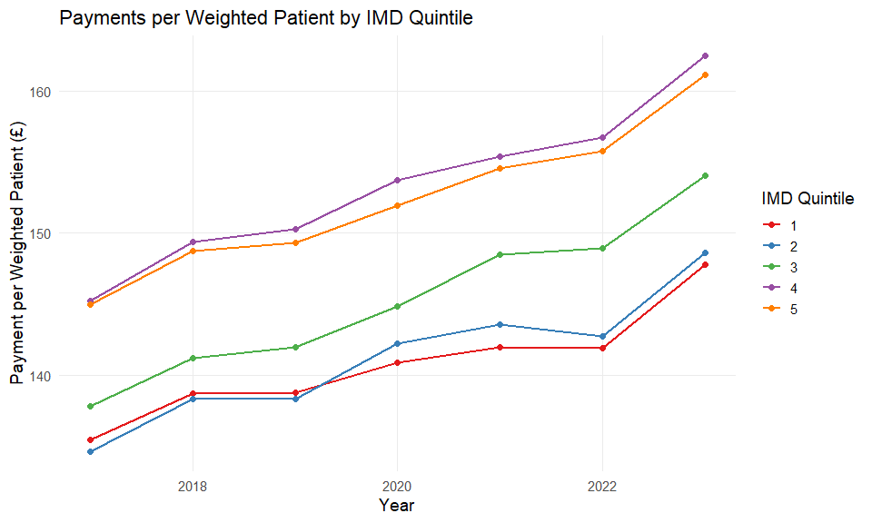
ggplot(finance_imd_registered, aes(
x = YEAR,
y = PAYMENT_PER_REGISTERED_PATIENT,
color = as.factor(IMD_QUINTILE),
group = IMD_QUINTILE
)) +
geom_line(linewidth = 1) +
geom_point(size = 2) +
scale_color_brewer(palette = "Set1", name = "IMD Quintile") +
labs(
title = "Payments per REGISTERED Patient by IMD Quintile",
x = "Year",
y = "Payment per REGISTERED Patient (£)"
) +
theme_minimal(base_size = 14) +
theme(
legend.position = "right",
panel.grid.minor = element_blank(),
strip.text = element_text(face = "bold")
)
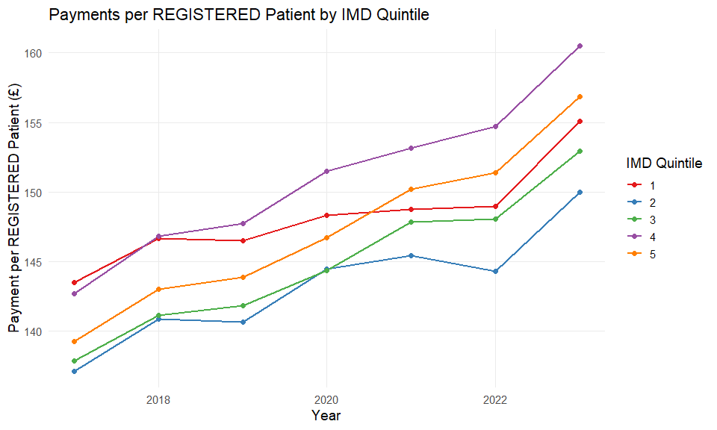
ggplot(finance_ADJ, aes(
x = YEAR,
y = PAYMENTS_PER_PERSON,
color = as.factor(IMD_QUINTILE),
group = IMD_QUINTILE
)) +
geom_line(linewidth = 1) +
geom_point(size = 2) +
scale_color_brewer(palette = "Set1", name = "IMD Quintile") +
labs(
title = "Payments per ADJ Patient by IMD Quintile",
x = "Year",
y = "Payment per ADJ Patient (£)"
) +
theme_minimal(base_size = 14) +
theme(
legend.position = "right",
panel.grid.minor = element_blank(),
strip.text = element_text(face = "bold")
)
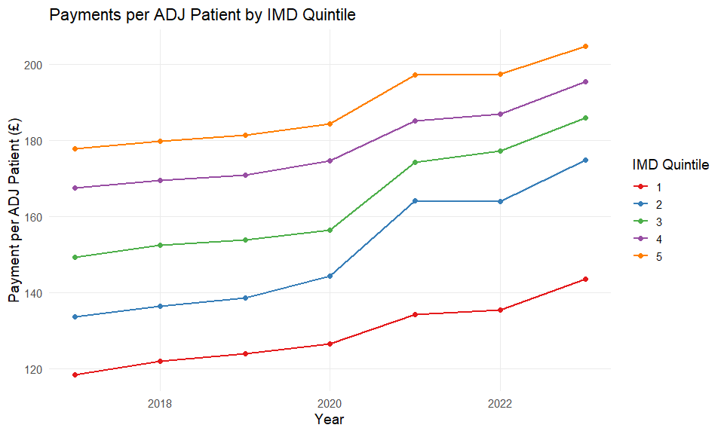
plot_data_2023 <- Total_Payments %>%
filter(
YEAR == 2023,
!is.na(IMD_QUINTILE),
!Variable %in% c("TOTAL_WEIGHTED", "TOTAL_REGISTERED")
)
ggplot(plot_data_2023, aes(
x = as.factor(IMD_QUINTILE),
y = Value,
fill = Variable
)) +
geom_bar(stat = "identity") +
scale_fill_brewer(palette = "Set3", name = "Payment Category") +
labs(
title = "Total NHS Payments by IMD Quintile (2023)",
x = "IMD Quintile (1 = Most Deprived, 5 = Least Deprived)",
y = "Total Payments (£)"
) +
theme_minimal(base_size = 14) +
theme(
legend.position = "right",
panel.grid.minor = element_blank(),
axis.text.x = element_text(face = "bold"),
plot.title = element_text(face = "bold", size = 16)
)
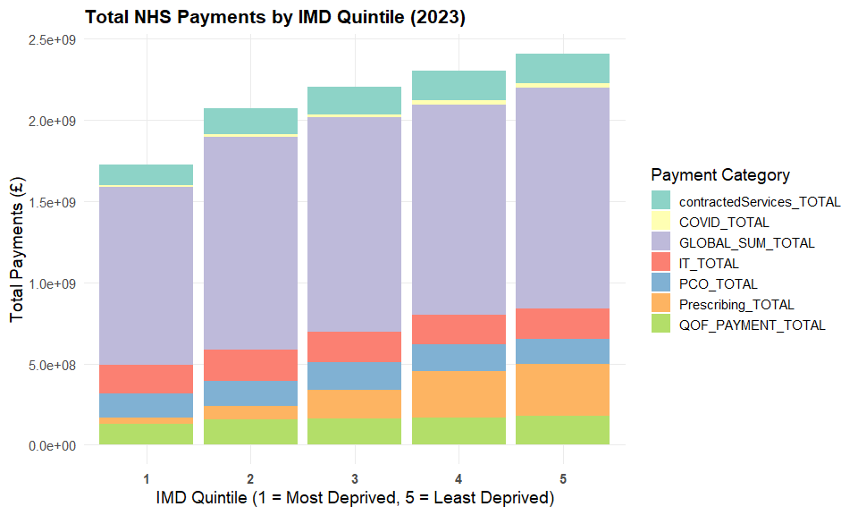
plot_data_2023_weighted <- Payments_per_weighted_patient %>%
filter(
YEAR == 2023,
!is.na(IMD_QUINTILE),
!Variable %in% c("TOTAL_WEIGHTED", "TOTAL_REGISTERED")
)
ggplot(plot_data_2023_weighted, aes(
x = as.factor(IMD_QUINTILE),
y = PAYMENT_PER_WEIGHTED,
fill = Variable
)) +
geom_bar(stat = "identity") +
scale_fill_brewer(palette = "Set3", name = "Payment Category") +
labs(
title = "Average GP Payments per Weighted patients by IMD Quintile (2023) GMS only",
x = "IMD Quintile (1 = Most Deprived, 5 = Least Deprived)",
y = "Total Payments (£)"
) +
theme_minimal(base_size = 14) +
theme(
legend.position = "right",
panel.grid.minor = element_blank(),
axis.text.x = element_text(face = "bold"),
plot.title = element_text(face = "bold", size = 16)
)
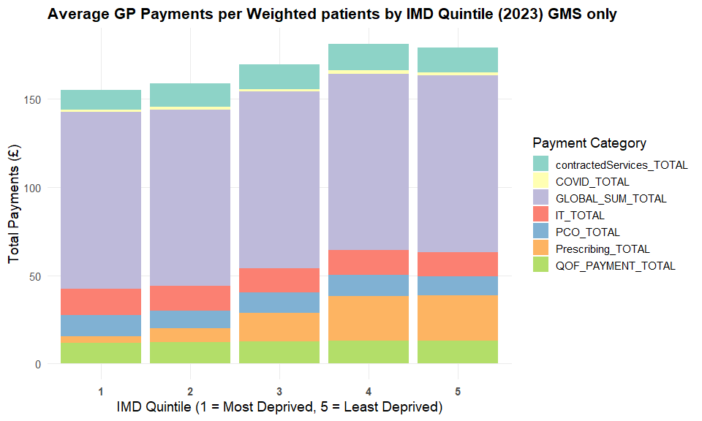
plot_data_2023_registered <- Payments_per_registered_patient %>%
filter(
YEAR == 2023,
!is.na(IMD_QUINTILE),
!Variable %in% c("TOTAL_WEIGHTED", "TOTAL_REGISTERED")
)
ggplot(plot_data_2023_registered, aes(
x = as.factor(IMD_QUINTILE),
y = PAYMENT_PER_REGISTERED,
fill = Variable
)) +
geom_bar(stat = "identity") +
scale_fill_brewer(palette = "Set3", name = "Payment Category") +
labs(
title = "Average GP Payments per Registered patients by IMD Quintile (2023) GMS only",
x = "IMD Quintile (1 = Most Deprived, 5 = Least Deprived)",
y = "Total Payments (£)"
) +
theme_minimal(base_size = 14) +
theme(
legend.position = "right",
panel.grid.minor = element_blank(),
axis.text.x = element_text(face = "bold"),
plot.title = element_text(face = "bold", size = 16)
)
