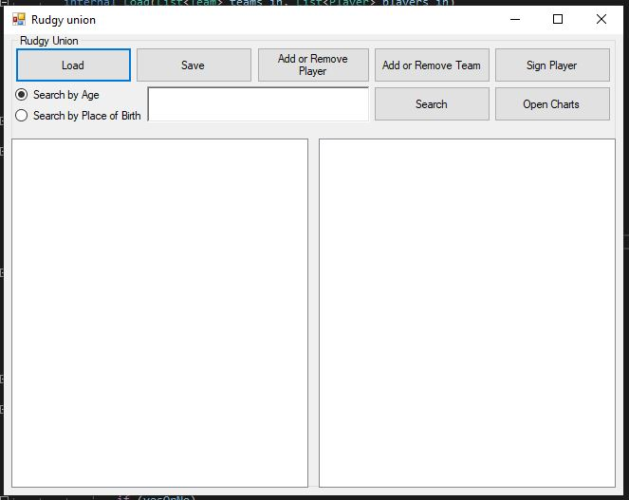

**Introduction**

This document will teach you how to use my Rugby Union program. As you can see below there is a screen show below. Each of the 5 top buttons and charts documentation will be on a separate page from 2-7 from left to right.

**Search function**

On the root form, or the main page below, is a “search by age” and “search by place of birth” radio button. You must select one of these, then enter a number or text respectively to your choice of radio button, to use the search button. Once done so, the program will return the output of your search parameters. The program will notify you if you enter anything incorrectly (number in text input, no number etc)

**List boxes**

At the bottom of the root form, or the main page, are two big white boxes which display players and teams respectively if data is entered. You can click on a player to get information about that player and on a team to get information about that team (Including what players are signed, and details about each of those players)

**Main page / root form**

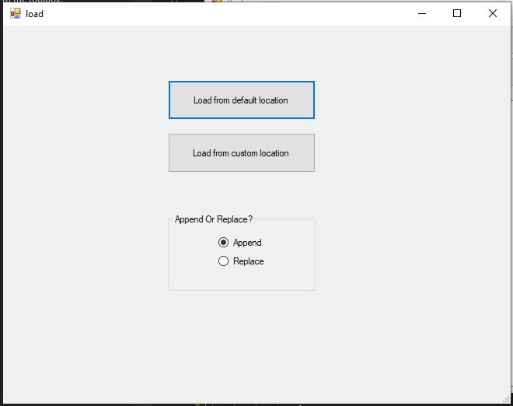

**Load Introduction**

This form will allow you to load data from two database text files containing players and teams. Data allowed is only in the format of the data we were given. All input files will be validated against data already in the program. This is to make sure no duplicate entries. Teams MUST have a different name, and players a different id.

**Load from default location**

You can choose to load from default location. This means that the program will load the data stored in the root directory / main folder to use. This is the data we were given from Stream. This is also the default save output.

**Load from custom location**

You can choose to load from a custom location. This means a dialog will open twice, once for the first database and once for the second. The program will tell you which order to input the files. These files need to be in the EXACT SAME FORMAT as the default inputs. Otherwise the program will not correctly read them and WILL ERROR.

**Append or Replace**

You can choose whether your loaded data will append to the previous data or if it will replace all the previous data. If chosen to replace DATA LOSS MAY OCCUR. This would be due to your previous data being OVERWRITTEN.

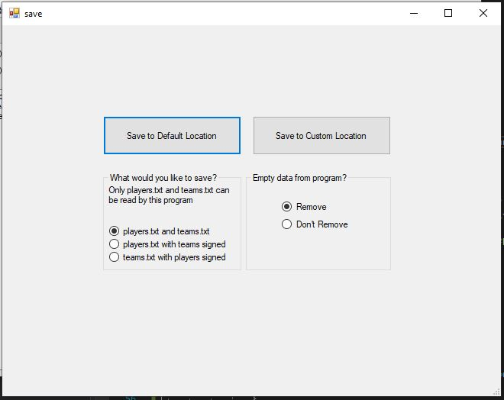

**Save Introduction**

This form will allow you to load save data into two database files, or a special output (As selected). You also have the choice to remove the data once you finish saving. This will result in DATA LOSS so use with caution.

**Save to default location**

You can choose to save to default location. This means that the program will save the data to the root directory / main folder to use. This is also the default load input.

**Save to custom location**

You can choose to save to a custom location. This means a folder finder dialog will open that asks you to find a location you wish to save the data to. This will either create two database files or whatever is selected in the below step.

**Save choice**

You can choose how to save your data. Please note ONLY the first option can be loaded by the program. You can choose to save as two files: players text file and teams text file. These can be reimported by custom load location finder. You can choose to save a single file: players text file with teams signed. This will add an extra piece of data to the end that includes the players team if they are signed to a team. Lastly you can choose to save a single file: teams text file with players signed. This will output each team as usual, however below each team it will output each player as would be in players text file in default save if the player is signed with the team in question.

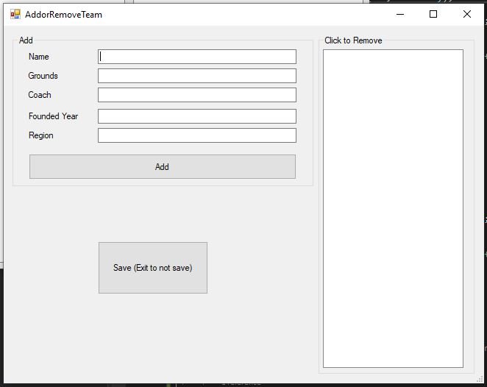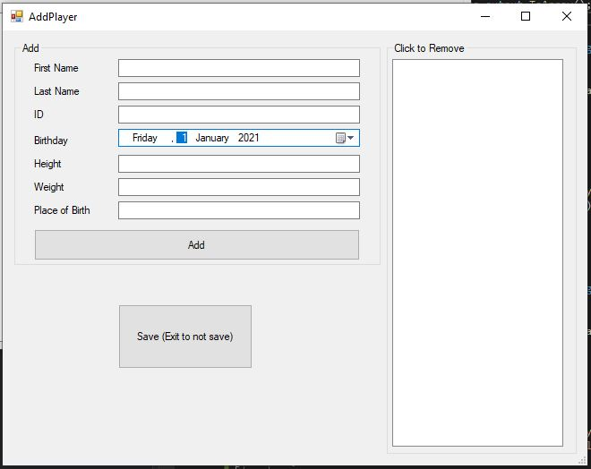

**Saving**

The changes will only be saved once you click SAVE. Please do not use exit unless you have changes you do not wish to save.

**Add Team**

To add a team, you need to fill every available data slot. The Name will need to be unique. Founded year needs to be a number otherwise the program will notify you there is an incorrect number input.

**Remove Team**

To remove a team simply click on the one you wish to remove on the right-hand list box.

**Add Player**

To add a player, you need to fill every available data slot. The ID will need to be unique and the birthdate needs to be valid. ID, Weight and Height need to be numbers otherwise the program will notify you there is an incorrect number input.

**Remove Player**

To remove a player simply click on the one you wish to remove on the right-hand list box.

**Add Introduction**

There are two forms that allow for adding of players and teams respectively. Each one will open on a different form depending on which button you have clicked. It asks for the inputs needed to create each data structure. You can also click on the right of each form to remove players or teams. TO SAVE CHANGES YOU MUST CLICK SAVE AND NOT JUST EXIT.

**Sign Introduction**

You can sign players to teams using the Sign form. There a two list boxes as seen in the image below. You must select one from each side. You can either sign or un-sign a player from a team. You can then use the Close and Save button. There will not be data lose if you exit without saving. Data will appear in each box once the use adds players and teams.

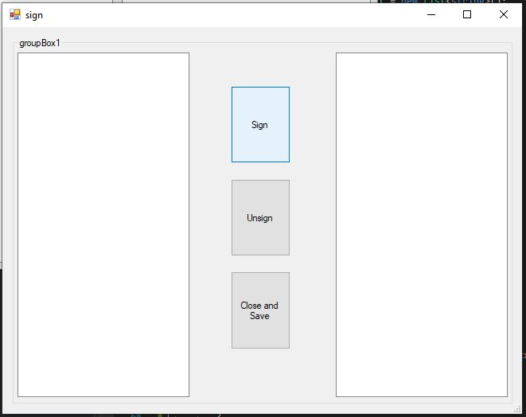

**Viewing Signed**

You can view signed players in the root form / main page via clicking on a player or a team. A player will display what team they are signed to. A team will display what players are signed to it.

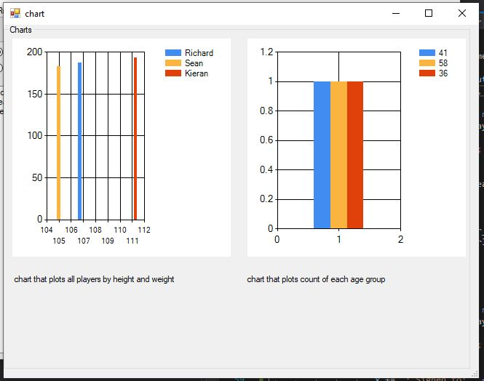

**Graph Introduction**

Below is a screenshot of the graphing page being used on a small set of players (3). These graphs show some simple data as labelled below.

**Graph Left**

This graph shows height in CM vs weight in KG. On the right of the graph is a key of colours which shows each player name. Below the graph is a label describing it

**Graph Right**

This graph shows the count of age groups. As you can see there is only one from each age group as this is a very small set of data. With 100’s of players you’ll very quickly understand the average/mean age of players. On the right of the graph is a key of colours which shows each player’s name. Below the graph is a label describing it.

Assignment 3 Documentation; By James Satherley, 19040618