Data Analytics Capstone
Retail Sentiment as a Volatility Early-Warning Signal:
A Machine-Learning Study of StockTwits and U.S. Equity Risk
Interim Report

James Savage
Walsh College
QM640: Data Analytics Capstone
Mr. Sharath Srivatsa
Group 12
[Current Term] Term
[Date]

GitHub repository (data and code): https://github.com/JamesSavages/Retail_Sentiment_and_Market_Volatility

Introduction

Background and Context
Financial markets are driven not only by fundamentals but by the collective mood of the people trading them, which is now broadcast in real time on social platforms and financial news. A substantial literature establishes that this visible sentiment carries information about market behaviour. Message-board and microblog activity has been linked to trading volume and volatility (Antweiler & Frank, 2004; Sprenger et al., 2014), and social-media mood has been related to index movements (Bollen et al., 2011). Importantly, the strongest and most consistent evidence is for volatility and trading volume rather than for returns, which are closer to efficient (Audrino et al., 2020).
For the businesses that serve retail investors, including brokerages, robo-advisors, and risk-management desks, the operationally valuable question is not what the crowd feels today but whether today's mood signals which stocks will be volatile tomorrow. Volatility surprises are where retail users are most exposed, and where hedging and liquidity-provision costs are incurred. An accurate early-warning signal for next-day volatility therefore has direct commercial value, informing user risk alerts, position sizing, and liquidity decisions.
Measuring sentiment accurately is itself a research problem. Traditional dictionary-based methods have systematically misclassified financial language (Loughran & McDonald, 2011), whereas transformer-based models such as FinBERT read text in context and have improved financial sentiment classification (Araci, 2019). More recently, large language models have shown an emerging capacity for financial reasoning. For example, Lopez-Lira and Tang (2023) found that GPT-4 can predict market reactions to news headlines without task specific training, although returns appear to decay as adoption spreads, further supporting a focus on volatility rather than returns. A further constraint of methodologies used in this field of study is endogeneity. Given that news causes sentiment and price to change at the same time, it is impossible to tell which one is driving the other. To avoid this, this study adopts a predictive design relating sentiment at day t to volatility on day t + 1, consistent with prior work (Antweiler & Frank, 2004; Audrino et al., 2020).

Problem Statement
The objective of this study is to predict next-day realized volatility (Y) for eight high-liquidity United States technology equities, with the ticker-day as the unit of analysis, using retail investor sentiment features (X = news sentiment score, message and article volume as an attention proxy) together with lagged market controls, over the period January 2023 to December 2024. Success is evaluated by out-of-sample forecast error (root mean squared error, RMSE, and the quasi-likelihood loss, QLIKE) and by the risk-adjusted return (Sharpe ratio) of a sentiment-informed trading strategy, net of transaction costs.

Purpose of the Study
The study is primarily predictive, forecasting a continuous risk measure, with an explanatory component that quantifies sentiment's marginal information beyond price history, a classification component that predicts next day return direction, and an inferential component that tests whether a sentiment informed strategy significantly improves risk-adjusted return. Its purpose is to establish whether freely available public sentiment provides an operationally useful, cost-aware early-warning signal for equity volatility.

Interim Project Status (Progress Snapshot)
The current status of the project is summarised below.
- Completed: Synopsis submitted; data pipeline designed, implemented, and validated end-to-end by a 27-check automated assertion harness; analysis panel assembled (3,840 ticker-days, eight tickers); data cleaning and exploratory data analysis completed; 24-ticker daily price panel collected (Tiingo); news-sentiment collection complete for all eight sentiment tickers; StockTwits labelled corpus accumulating; literature review completed.
- In progress: RQ1 sentiment modelling (FinBERT versus the lexicon baseline); specification of the RQ2 volatility models.
- Pending: FinBERT sentiment modelling (RQ1); volatility and direction models (RQ2, RQ3); strategy backtest (RQ4); preliminary results and interpretation.

Scope and Objectives
This study is organised around four research questions, each addressing a distinct aspect of the relationship between retail sentiment and equity risk and drawing on a different family of methods. Each is stated below with its null and alternative hypotheses and the test used to decide between them. All tests are evaluated at a 5% significance level.

Research Question 1 (RQ1): Sentiment Measurement
How accurately can a transformer model (FinBERT) classify StockTwits message sentiment, benchmarked against users' self-tagged labels and a lexicon baseline? The baseline combines VADER, a general social-media dictionary, with the Loughran-McDonald finance dictionary (Loughran & McDonald, 2011); the transformer is FinBERT (Araci, 2019). Because 82% of the labelled corpus is bullish, accuracy alone is uninformative, so the majority-class rate is reported as a floor alongside balanced accuracy, macro-averaged F1 and the area under the receiver operating characteristic curve. H0: FinBERT's accuracy is no greater than the lexicon's. H1: it is greater. Both classifiers score identical messages, so McNemar's test applies, with a paired bootstrap for the balanced metrics.

Research Question 2 (RQ2): Volatility Prediction
Does aggregated daily sentiment at day t predict next-day realized volatility at t + 1, controlling for lagged volatility and trading volume? A heterogeneous autoregressive (HAR) baseline using daily, weekly and monthly volatility components is compared with the same specification augmented by sentiment and attention features, with ticker fixed effects in both, for the reason established in Figure 4. H0: the sentiment coefficients are jointly zero. H1: at least one is non-zero. In-sample comparison uses an incremental F-test and the change in adjusted R-squared; out-of-sample forecast accuracy uses the Diebold-Mariano test (Diebold & Mariano, 1995) applied to QLIKE losses following Patton (2011).

Research Question 3 (RQ3): Direction Classification
Do sentiment features improve next-day return-direction prediction beyond a technicals-only baseline? Logistic regression and gradient boosting are each trained on market controls alone, then on the same controls plus sentiment. H0: the augmented classifier is no more accurate than the baseline. H1: it is more accurate. Both are evaluated on identical test observations, so McNemar's test applies. The base rate for daily direction is close to 50%, so a null result is an expected and reportable outcome.

Research Question 4 (RQ4): Strategy Evaluation
Does a sentiment-informed trading strategy produce a statistically significant improvement in risk-adjusted return over buy-and-hold, net of transaction costs? The volatility forecast is converted into a transparent exposure rule and back-tested with realistic costs. H0: the strategy's Sharpe ratio is no greater than buy-and-hold's. H1: it is greater. Significance uses the Ledoit-Wolf (2008) robust test, which assumes neither normality nor serial independence, implemented with a circular block bootstrap so volatility clustering is preserved.

Literature Survey

Literature Review Approach
Sources were identified through Google Scholar, Scopus, Web of Science, ScienceDirect, SSRN, and arXiv, using Boolean combinations of the study's concept clusters (for example, “investor sentiment” OR “StockTwits” AND “realized volatility” AND “FinBERT” OR “transformer”). Inclusion was limited to peer-reviewed empirical work linking textual sentiment to a measurable market outcome, with field-defining preprints retained where relevant, and priority given to highly cited papers in leading finance and forecasting journals balanced against recency to capture the large-language-model era. Table 1 summarises the most relevant studies.
Table 1
Literature Relevance Matrix
Study | Purpose / Context | Method | Key Findings | Relevance to This Study
Antweiler & Frank (2004) | Message-board sentiment and market activity | Computational-linguistics bullishness index | Messages predict volatility; disagreement predicts volume; return effect small | Anchors the volatility-over-returns focus and the article-count attention feature
Das & Chen (2007) | Extracting sentiment from web small talk | Multi-classifier voting | Sentiment tracks index moves; activity relates to volatility | Early evidence linking posting activity to volatility
Tetlock (2007) | Media tone and the stock market | Media-pessimism factor; VAR | Pessimism predicts price pressure then reversion; extremes predict volume | Frames the endogeneity/simultaneity concern
Bollen et al. (2011) | Social-media mood and the market | Mood dimensions + causality tests | Reported mood relates to index moves; noted as fragile | Motivates a reproducible, firm-level design
Loughran & McDonald (2011) | Sentiment in financial text | Finance-specific dictionaries | General dictionaries misclassify financial tone | Basis for the lexicon baseline in RQ1
Sprenger et al. (2014) | Microblog sentiment and trading | ML sentiment + regression | Sentiment relates to returns; disagreement to volatility | Supports microblog sentiment and attention features
Oliveira et al. (2017) | Microblog data for market prediction | Sentiment indicators + multiple ML | Improves volatility/volume forecasts; weaker for returns | Validates the feature family and volatility target
Renault (2017) | StockTwits investor sentiment | Custom lexicon vs. ML | Sentiment predicts intraday index returns; lexicon competitive | StockTwits-specific precedent and baseline
Behrendt & Schmidt (2018) | Twitter sentiment and intraday volatility | GARCH + intraday sentiment | Adds little to intraday volatility once controlled | Cautionary; motivates conservative effect sizes
Araci (2019) | Transformer sentiment for finance | FinBERT (fine-tuned BERT) | Improves financial sentiment classification | The deep-learning method used in RQ1
Audrino et al. (2020) | Sentiment/attention and volatility | Penalized regression on HAR | Attention and StockTwits volume improve realized-volatility forecasts | Closest precedent; frames the per-ticker, business-evaluated gap
Lopez-Lira & Tang (2023) | LLMs and return predictability | GPT-4 on news headlines | Predicts reactions; edges decay as adoption spreads | Frontier LLM evidence; reinforces volatility focus
Yu et al. (2023) | LLM trading agents | FinMem agent with layered memory | Autonomous agent enhances trading decisions | Grounds the optional agentic briefing extension

Three themes organise this literature and connect it directly to the present study. First, on outcome selection, the evidence consistently shows that sentiment and attention forecast volatility and trading volume more reliably than returns, which are closer to efficient (Antweiler & Frank, 2004; Oliveira et al., 2017; Audrino et al., 2020); this study therefore targets next-day volatility as its primary outcome. Second, on sentiment measurement, the field has evolved from finance-specific dictionaries (Loughran & McDonald, 2011) through transformer models (Araci, 2019) to general-purpose large language models (Lopez-Lira & Tang, 2023); RQ1 positions FinBERT against a lexicon baseline within this progression. Third, on the research gap, prior work concentrates at the market-index level, uses lexicon or classical methods, and reports statistical rather than economic value, with limited reproducibility; this study addresses that gap by operationalising transformer sentiment as a per-ticker, next-day volatility early-warning signal, validated through a cost-aware backtest and an open, reproducible pipeline.

Data Description

Data Source(s) and Access
The study draws on three free, publicly accessible sources. Daily split and dividend-adjusted price data are obtained from Tiingo (https://www.tiingo.com); historical per-ticker news sentiment from Alpha Vantage (https://www.alphavantage.co); and recent labelled messages from the StockTwits API (https://api.stocktwits.com). Prices supply the target and market controls, Alpha Vantage supplies the historical sentiment feature for RQ2 to RQ4, and StockTwits supplies the human-labelled corpus for RQ1. During development, an initial price source (Stooq) was found to block automated access and Alpha Vantage's full-history price endpoint was available at a premium price, so Tiingo was adopted after validating access. This deliberate evaluation of data sources strengthens reproducibility and is noted as a practical constraint in the limitations of the final report.

Dataset Overview
The assembled analysis panel is organised as a ticker-day table combining price-derived controls, the next-day realized-volatility target, and news-sentiment features.
- Number of records (rows): 3,840 usable ticker-days (eight sentiment tickers, 480 trading days each) drawn from a 24-ticker, 11,873-row price panel.
- Number of variables (columns): 15 principal variables (see Table 2).
- Time period: 3 January 2023 to 31 December 2024.
- Unit of analysis: the ticker-day.
- Target variable(s): next-day realized volatility (rv_next), estimated from daily open-high-low-close (OHLC) prices via the Parkinson estimator.

Data Dictionary (Mandatory)
Table 2
Data Dictionary (Principal Variables)
Variable Name | Source | Definition | Datatype | Allowed Values/Range | Missing Values Handling | Notes
symbol | All | Stock ticker symbol identifying the equity | string | 24 tickers (see config.TICKERS) | None permitted; row invalid without it | Key. Analysis sample restricted to the 8 tickers in NEWS_TICKERS
date | All | Trading date (US/Eastern) of the observation | date | 2023-01-03 to 2024-12-31, NYSE trading days | None permitted; row invalid without it | Key. Non-trading days absent by construction, not imputed
close | Tiingo | Split- and dividend-adjusted daily closing price | float | > 0 USD | None observed | Raw. Adjusted series, so corporate actions create no false volatility
log_return | Derived | Daily log return, ln(close_t / close_t-1) | float | approx. -0.5 to +0.5 log points | Null on each ticker's first day; row excluded | Control. Used lagged, never contemporaneously with the target
abs_return | Derived | Absolute daily log return | float | >= 0 log points | Null where log_return is null; row excluded | Control. Correlated with rv; monitored via VIF (Table 5)
log_volume | Derived | Log adjusted share volume, log(1 + volume) | float | > 0 ln(shares) | None observed | Control. log1p so a zero-volume day maps to 0, not minus infinity
rv | Derived | Realized volatility at t from the high-low range (Parkinson) | float | > 0 daily sigma | None observed | Control. Known at the close of t; daily HAR component
rv_lag1 | Derived | Realized volatility at t-1 | float | > 0 daily sigma | Null on each ticker's first day; row excluded | Control. Retained for continuity with the synopsis specification
rv_w | Derived | Weekly HAR component: mean rv over t-4 to t inclusive | float | > 0 daily sigma | Null for the first 4 days per ticker; rows excluded | Control. Window ends at t because rv_t is observable at that close
rv_m | Derived | Monthly HAR component: mean rv over t-21 to t inclusive | float | > 0 daily sigma | Null for the first 21 days per ticker; rows excluded | Control. Binding on sample size: costs 21 ticker-days per ticker
rv_next | Derived | Next-day realized volatility (t+1) | float | > 0 daily sigma | Null on each ticker's final day; row excluded | TARGET. The only column using information dated after t, by design
news_sent_wmean | Alpha Vantage | Relevance-weighted mean news sentiment on day t | float | -1 (bearish) to +1 (bullish) | Set to 0.0 (neutral) on queried tickers with no articles, flagged by news_missing; null for tickers never queried | Predictor. Weights are Alpha Vantage relevance scores
news_article_count | Alpha Vantage | Articles referencing the ticker on day t; attention proxy | int | >= 0 articles | Set to 0 on queried tickers with no articles (a genuine low-attention observation); null for tickers never queried | Predictor. Zero-article days retained; dropping them truncates attention at 1
news_missing | Derived | 1 if the ticker-day had no articles, 0 otherwise | int | {0, 1} | Null for tickers never queried for news | Flag. Separates neutral coverage from absent coverage
log_articles | Derived | Log attention proxy, log(1 + news_article_count) | float | >= 0 | Null where news_article_count is null | Predictor. Well defined only because zero-article days are retained

Note. The panel contains 15 variables. The StockTwits labelled corpus (id, created_at, symbol, body, sentiment_basic) is used separately for RQ1 sentiment-model validation and is not part of the historical RQ2–RQ4 panel; no user-identifying fields are retained. Generated by src/make_data_dictionary.py and versioned at data/data_dictionary.md.

GitHub Data Availability Statement
The raw and processed datasets and all code are openly available in the project repository:
- Raw data: data/raw/{prices, news, stocktwits}/
- Processed/clean data: data/processed/panel.csv
- Code/notebooks: src/ (collection, feature building, and dictionary scripts)

Screenshots / Evidence
[ Insert Figures: repository folder tree, and dataset preview screenshots of the raw folders and the assembled panel.csv, each labelled and referenced in the text (carried over from the synopsis figures). ]

Analysis

Data Cleaning
Cleaning is implemented in src/build_features.py and verified by an automated assertion harness, src/validate_panel.py, which recomputes every derived variable from the raw source files and fails if any value disagrees. It runs 27 checks spanning key uniqueness, definitional consistency, news integrity, corporate actions, and the point-in-time test described below. All 27 pass, and the script exits with an error status if any fails, so a corrupted panel cannot silently reach the modelling stage.
The collected price panel contains 11,873 ticker-days across 24 technology equities, 175 fewer than the 12,048 implied by 24 tickers over 502 trading days because Arm Holdings (ARM) listed in September 2023. Restricting to the eight tickers with news sentiment leaves 4,016 ticker-days; removing the final trading day of each series, where the target is undefined, and the first 21 days, where the monthly heterogeneous autoregressive (HAR) component has insufficient history, yields a balanced analysis sample of 3,840 ticker-days, exactly 480 per ticker. Table 3 records each step.
Table 3
Data Cleaning Log
Issue | Variables Affected | Detection Method | Treatment Applied | Records Affected | Rationale
Duplicate ticker-days | symbol, date | Key-uniqueness assertion in validate_panel.py | None found; no action required | 0 (0.00%) | Data quality
Tickers outside the sentiment universe | news_sent_wmean, news_article_count | Free-tier quota of 25 requests per day | Excluded from the analysis sample; retained in the price panel as market context | 7,857 (66.18%) | Quota constraint, not a data defect
Target undefined at series end | rv_next | Null check after the t to t+1 shift | Excluded, one ticker-day per ticker | 8 (0.07%) | Next-day volatility does not exist for the final observation
HAR burn-in window | rv_m | 22-day rolling mean requires 22 prior observations | Excluded, 21 ticker-days per ticker | 168 (1.42%) | Monthly HAR component undefined until the window fills
No news articles on a trading day | news_sent_wmean, news_article_count | Gap between the news files and the trading calendar | Retained as zero-attention observations: article count 0, sentiment 0 (neutral), indicator news_missing = 1 | 945 (7.96%) | A zero-article day is a genuine low-attention observation, not a missing measurement
Extreme one-day price moves | close, rv | Screen for absolute close-to-close moves above 30%, cross-checked against split ratios and the volatility path | Both flagged moves verified as post-earnings repricings and retained; no winsorising or trimming applied | 2 (0.02%) | Extreme volatility is the phenomenon under study, not noise to remove
User-identifying fields | user_id, user_followers | Privacy review of the StockTwits collector | Removed at collection and stripped from 23 existing files | 23 files | Ethics: no individual user is profiled or re-published
Note. Percentages are of the 11,873-row collected price panel. Exclusions are sequential, leaving an analysis sample of 3,840 ticker-days. Counts are produced by src/run_eda.py and written to docs/tables/eda_cleaning_log.csv.
Two treatment decisions warrant explanation. The first concerns the 945 ticker-days, 24.6% of the analysis sample, on which no article mentioned the ticker. An earlier version of the pipeline discarded these rows because the join produced no match. That was incorrect: a day with no coverage is a genuine low-attention observation, not a failed measurement, and discarding such days truncates the attention variable at one article, removing the low-attention contrast the study depends upon. The loss would also have fallen unevenly, with Palantir forfeiting 73% of its history against Microsoft's 4%. These days are retained with an article count of zero, a neutral sentiment score, and an indicator distinguishing neutral coverage from absent coverage. The correction raised the analysis sample from 3,026 to 3,840 ticker-days and balanced the panel at 480 days per ticker.
This treatment is applied only to the eight tickers actually queried. For the remaining sixteen no request was issued, so their news fields remain null; recording a zero would fabricate an observation from an absence of collection, and the validation harness asserts none exists.
The second decision concerns outliers. No trimming or winsorising was applied. A screen for absolute close-to-close moves above 30% flagged two observations: ARM on 8 February 2024 (+47.9%) and PLTR on 6 February 2024 (+30.8%). An unadjusted split produces a price ratio sitting on a simple fraction, and neither ratio, 1.479 and 1.308, does so; a split also leaves volatility unchanged, whereas both show volatility rising over several sessions, ARM from 0.030 to 0.179. Both are post-earnings repricings. Since the study forecasts exactly such episodes, removing them would remove the signal of interest.
Because the study makes a forecasting claim, cleaning must guarantee that no predictor contains information dated after day t. This is verified rather than asserted: for a random sample of ticker-days the harness rebuilds every predictor from raw records dated on or before t and requires an exact match, and across all 11,873 ticker-days the largest discrepancy is of the order of ten to the power of minus sixteen. Realized volatility at t is computed from that day's high and low, so it is known at the close and is admissible as a predictor of t + 1; the HAR windows accordingly end at t rather than being shifted back.

Exploratory Data Analysis
Table 4 summarises the analysis sample. The target and its lagged components share a common scale, so differences between them are informative: averaging volatility over longer windows progressively removes the right tail, with skewness falling from 1.81 for the daily series to 0.62 for the monthly average.
Table 4
Descriptive Statistics for the Analysis Sample
Variable | N | M | Mdn | SD | IQR | Min | Max | Skew | Kurtosis
rv_next (target) | 3,840 | 0.0184 | 0.0158 | 0.0107 | 0.0124 | 0.0032 | 0.1003 | 1.81 | 5.42
rv (daily HAR) | 3,840 | 0.0185 | 0.0158 | 0.0108 | 0.0124 | 0.0032 | 0.1003 | 1.81 | 5.35
rv_w (weekly HAR) | 3,840 | 0.0185 | 0.0170 | 0.0085 | 0.0117 | 0.0045 | 0.0583 | 1.07 | 1.43
rv_m (monthly HAR) | 3,840 | 0.0186 | 0.0178 | 0.0074 | 0.0115 | 0.0070 | 0.0467 | 0.62 | -0.11
news_sent_wmean | 3,840 | 0.1365 | 0.1320 | 0.1774 | 0.2677 | -0.6165 | 0.8746 | -0.12 | 0.57
news_article_count | 3,840 | 2.20 | 2.00 | 2.32 | 2.00 | 0 | 26 | 2.30 | 12.10
log_articles | 3,840 | 0.9354 | 1.0986 | 0.6770 | 0.6931 | 0.0000 | 3.2958 | 0.08 | -0.82
log_return | 3,840 | 0.0022 | 0.0013 | 0.0275 | 0.0252 | -0.1638 | 0.2685 | 1.08 | 10.54
log_volume | 3,840 | 17.85 | 17.74 | 0.99 | 1.17 | 15.37 | 21.16 | 0.63 | 0.10
Note. Realized volatility is expressed in daily sigma units. Sentiment is relevance-weighted and bounded at -1 and +1. Values are written to docs/tables/eda_descriptives.csv.
Figure 1 shows why the target is modelled on a logarithmic scale. Raw next-day realized volatility is strongly right-skewed (skewness 1.81, kurtosis 5.42): most days are quiet and a few extreme. Logging reduces these to 0.09 and -0.23, close to normal. Two decisions follow: the regression target is the logarithm of next-day volatility, so estimates are not dominated by a handful of earnings days, and accuracy is reported using QLIKE alongside RMSE, because squared-error loss on a fat-tailed target rewards fitting the extreme tail at the expense of the rest.
Figure 1
Distribution of Next-Day Realized Volatility, Raw and Log Scale
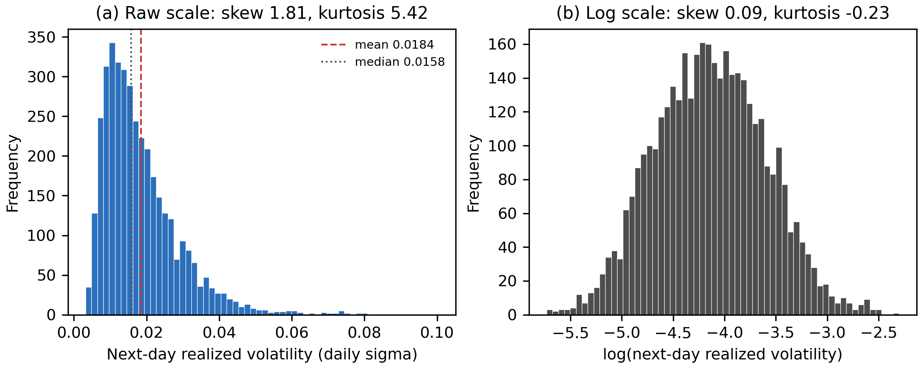
Note. Panel (a) shows the raw target and panel (b) its natural logarithm, each with 60 bins.
Figure 2 shows that news coverage is highly uneven. Microsoft is covered on 96% of trading days and Amazon on 94%, whereas Palantir is covered on only 27%. Coverage is therefore a characteristic that differs systematically between firms, which is the principal justification for retaining zero-attention days and including the news_missing indicator. It also anticipates the confounding problem identified in Figure 5.
Figure 2
News Coverage by Ticker Within the Analysis Sample
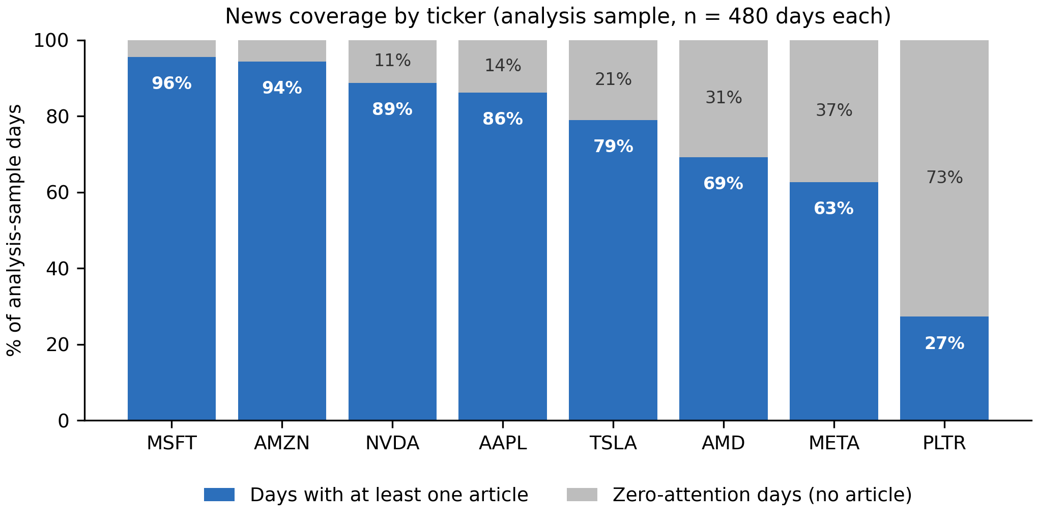
Note. Each ticker contributes exactly 480 ticker-days. Shaded portions are days on which no article mentioned the ticker.
Figure 3 reveals an asymmetry with direct consequences. Relevance-weighted sentiment averages +0.181 and is positive on 87% of days with news, so the measure carries far less negative than positive variation. This compresses the range over which any sentiment effect could be detected and is recorded as a limitation. Panel (b) shows attention is concentrated at low values, median two articles and maximum 26, which is why it enters the models in logarithmic form.
Figure 3
Distribution of News Sentiment and Attention
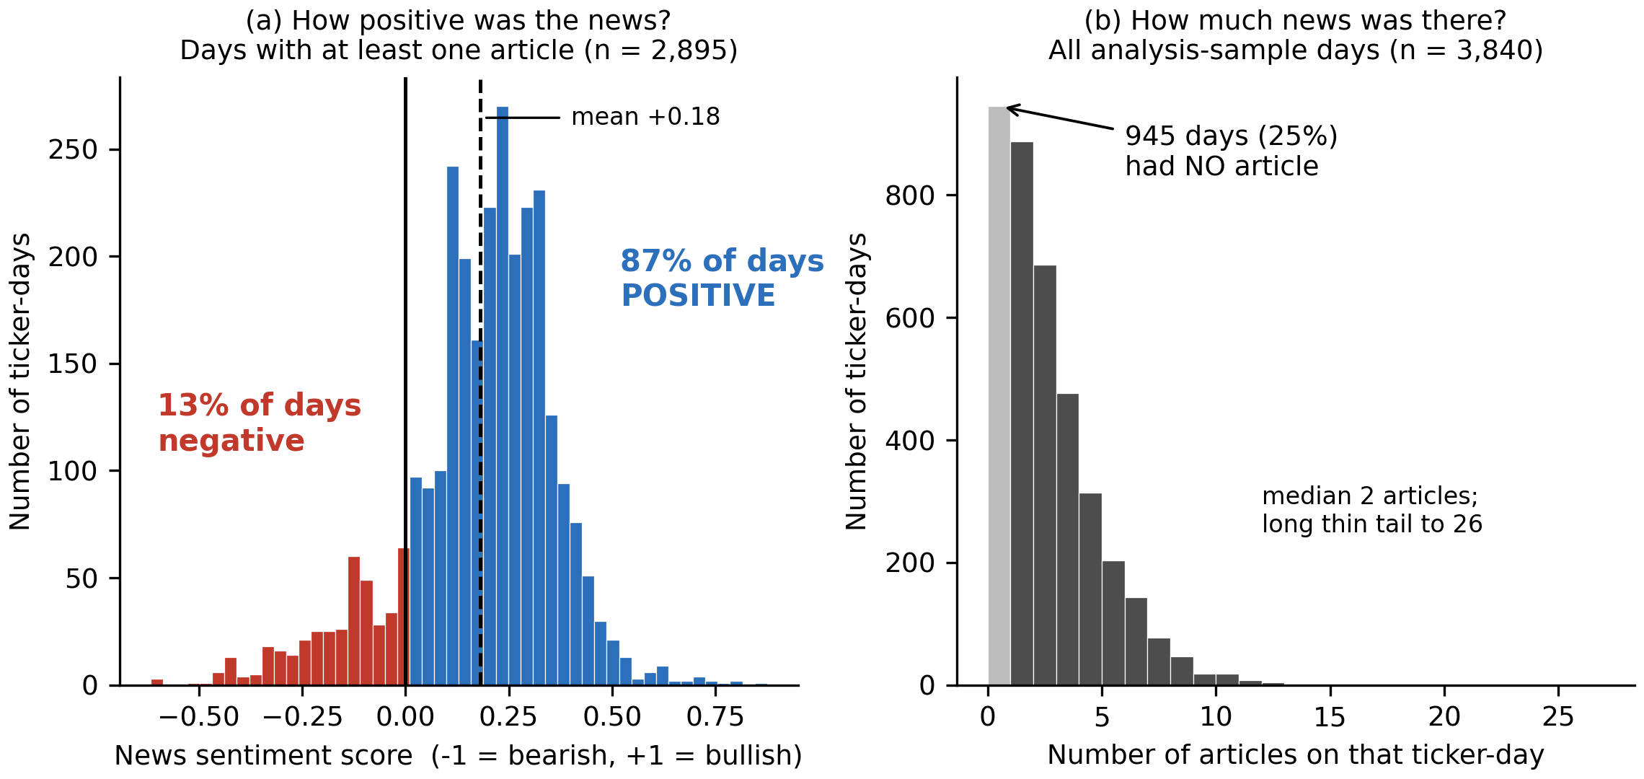
Note. Panel (a) is restricted to days with at least one article; panel (b) includes all analysis-sample days.
Figure 4 contains the most consequential finding of the exploratory analysis. Pooled across tickers, moving from the lowest to the highest attention band is associated with 28.7% lower next-day volatility, contradicting the established result that attention and volatility move together (Audrino et al., 2020). Comparing each ticker against its own mean reverses the sign: days with seven or more articles carry 9.3% higher next-day volatility than days with none, rising monotonically across all five bands. Sentiment shows no consistent pattern in either specification, at -2.7% pooled and -1.9% within ticker. The pooled estimate is an artefact, for the reason set out in Figure 5; the models addressing RQ2 must therefore include ticker fixed effects, and attention rather than tone emerges as the stronger candidate predictor.
Figure 4
Next-Day Volatility by Predictor Group, Pooled and Within Ticker
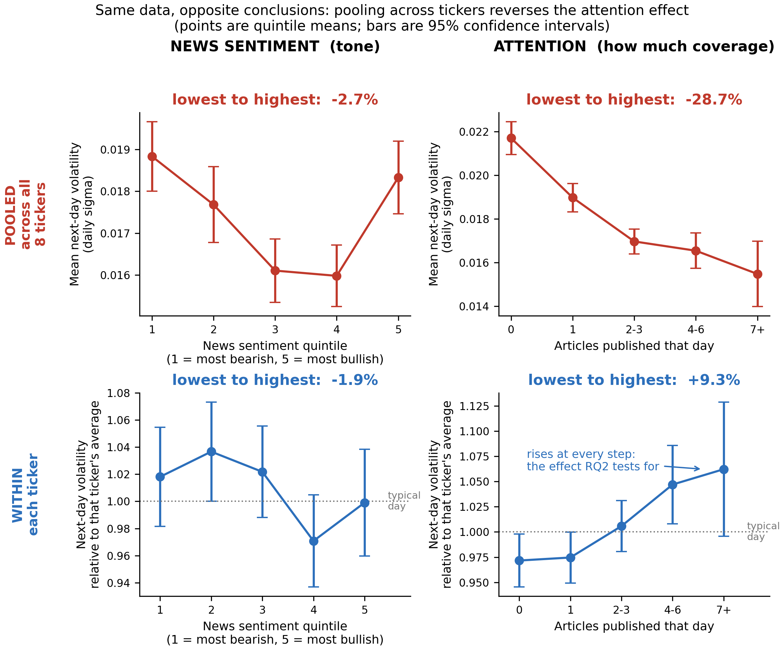
Note. Upper panels pool all tickers; lower panels express the target relative to each ticker's own mean, so 1.00 denotes a typical day for that stock. Sentiment is grouped into quintiles; attention is grouped by article count rather than quintiles, because a quarter of ticker-days have exactly zero articles and quantile boundaries would either collapse or split identical observations. Error bars are 95% confidence intervals.
Figure 5 explains the sign reversal. Across the eight tickers, the proportion of zero-attention days correlates 0.69 with average volatility: Palantir has the least coverage and the highest volatility, Microsoft the most coverage and among the lowest. In pooled data, low attention therefore functions largely as a label for which stock is being observed rather than as information about what is about to happen to it. This is a Simpson's paradox, in which a relationship holding within each group reverses when the groups are combined. Because RQ2 asks whether a change in a ticker's own attention predicts a change in its own volatility, only the within-ticker comparison is informative.
Figure 5
Cross-Sectional Confounding Between Coverage and Baseline Volatility
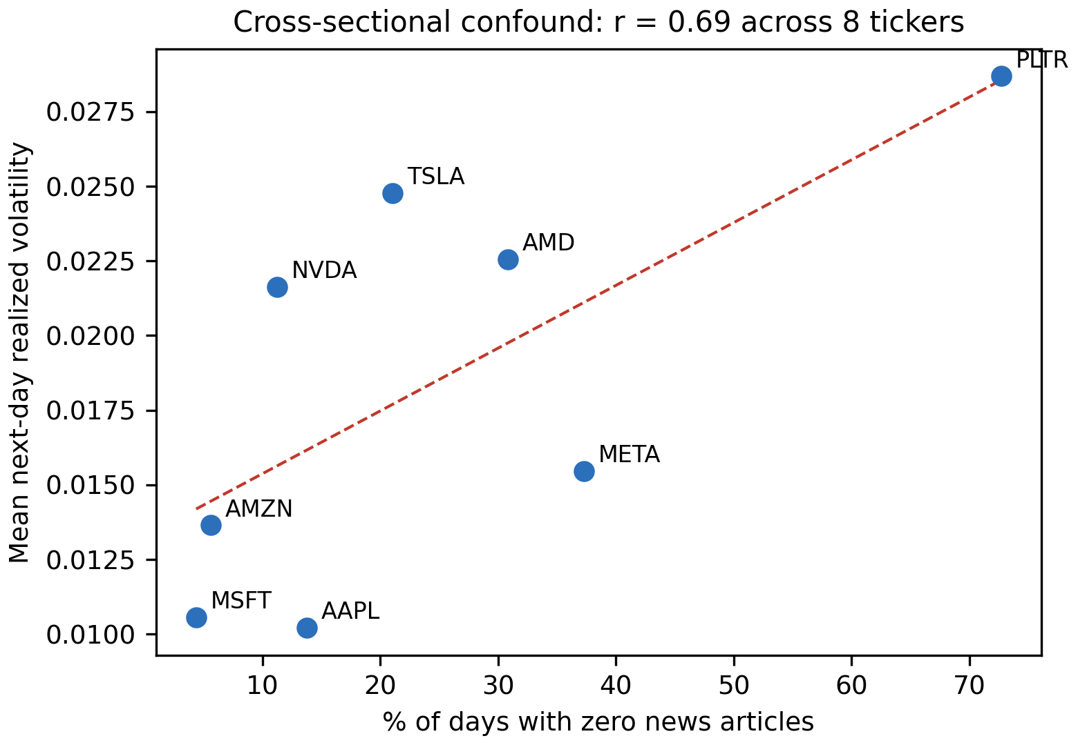
Note. Each point is one of the eight tickers in the analysis sample; the dashed line is an ordinary least squares fit.
Figure 6 confirms that lagged volatility dominates the predictor set: the weekly HAR component correlates 0.63 with the target, news sentiment only -0.11 and attention -0.15. This determines how RQ2 must be evaluated. Sentiment cannot be judged by its raw association with next-day volatility, which is small, but by whether it adds explanatory power once the HAR components are in the model. The hypothesis test for RQ2 is therefore an incremental one.
Figure 6
Correlation Matrix of Predictors and Target
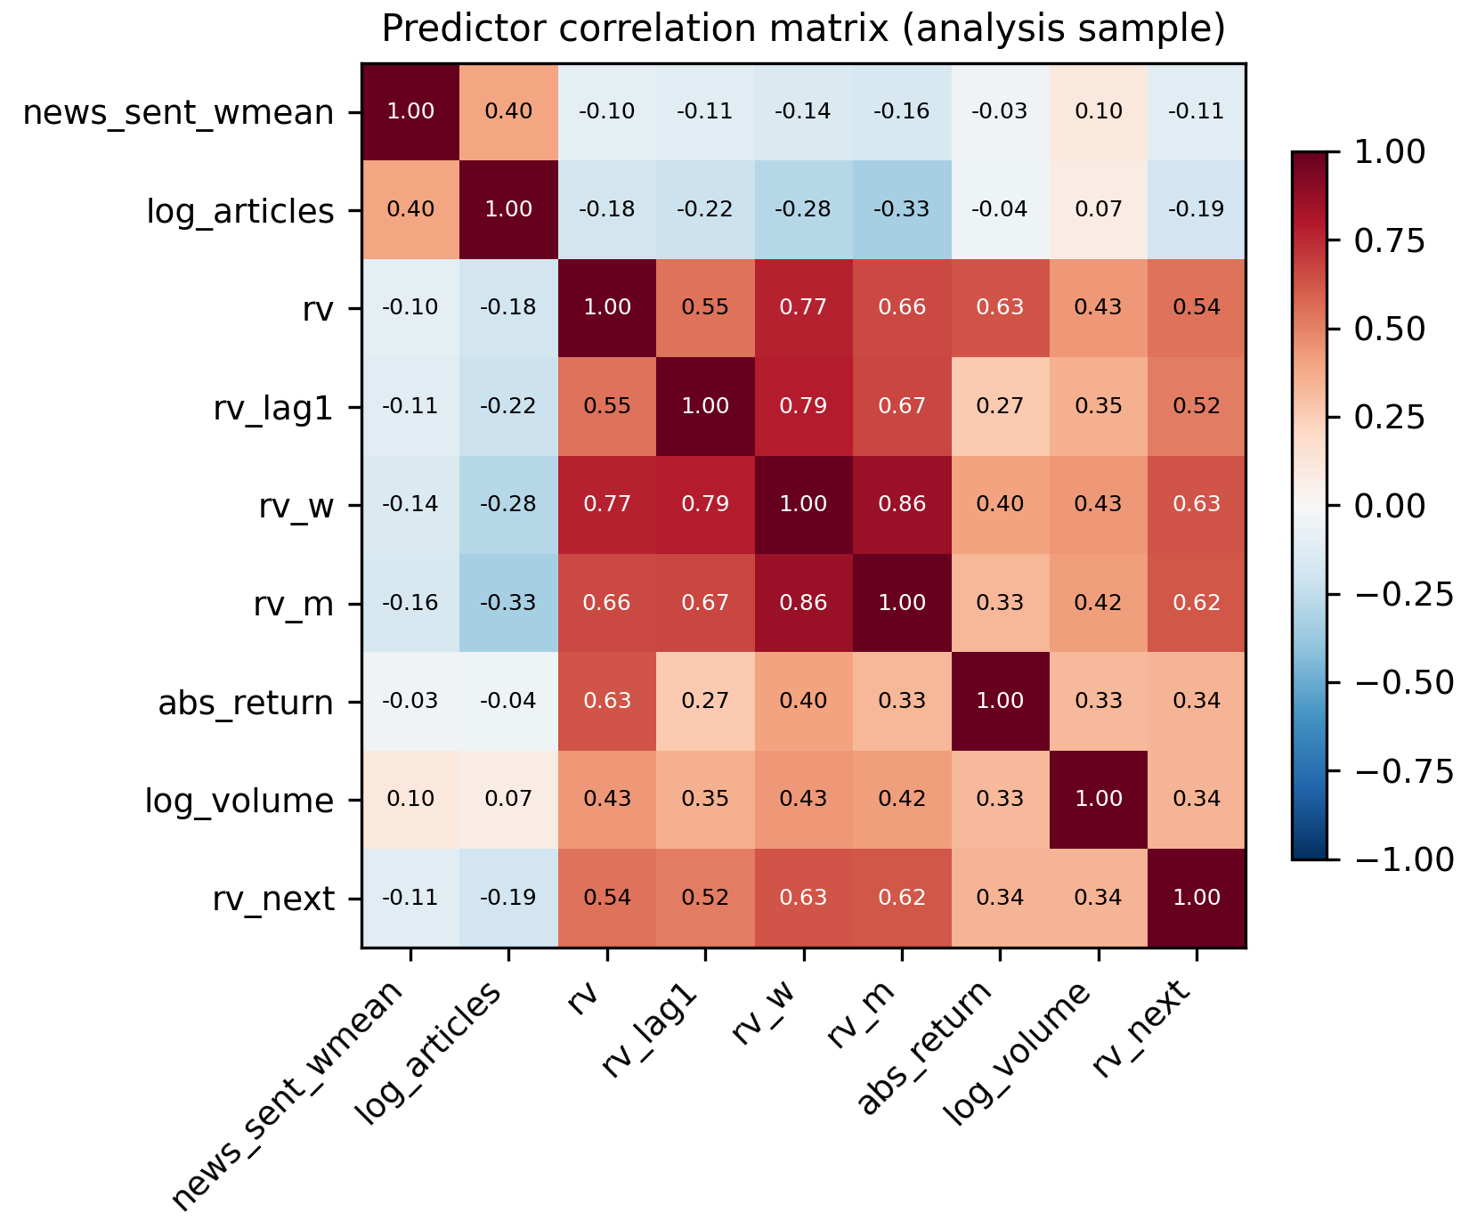
Note. Pearson correlations computed on the 3,840-observation analysis sample.
Multicollinearity was assessed using variance inflation factors (Table 5). Step 4 identifies a factor above 10 as severe; none approaches it. The weekly HAR component is highest at 7.91, expected since it is a moving average of the daily series. The two sentiment variables are close to orthogonal to the market controls, at 1.36 and 1.20, so whatever incremental contribution they make cannot be an artefact of overlap with lagged volatility. The full control set is retained unchanged.
Table 5
Variance Inflation Factors for the Full Predictor Set
Predictor | VIF | Assessment
rv_w (weekly HAR component) | 7.91 | Moderate (5-10)
rv_m (monthly HAR component) | 4.20 | Acceptable (below 5)
rv (daily HAR component) | 3.63 | Acceptable (below 5)
rv_lag1 | 2.71 | Acceptable (below 5)
abs_return | 1.74 | Acceptable (below 5)
log_volume | 1.40 | Acceptable (below 5)
log_articles | 1.36 | Acceptable (below 5)
news_sent_wmean | 1.20 | Acceptable (below 5)
Note. Computed on the analysis sample and written to docs/tables/eda_vif.csv. No predictor exceeds the severe threshold of 10.
Figure 7
Realized Volatility Over Time for NVDA and MSFT
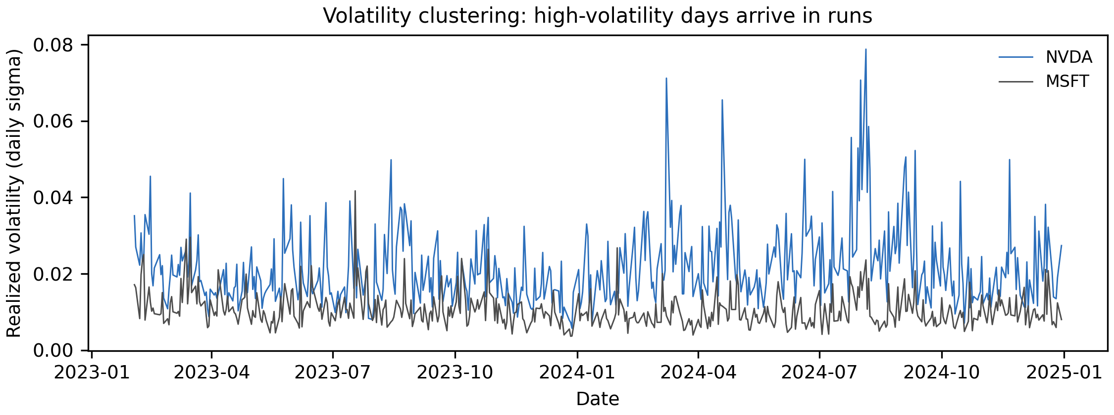
Note. Daily realized volatility across the 2023 to 2024 study window for two contrasting large-capitalisation tickers.
Volatility arrives in runs rather than independently from day to day: quiet periods persist and turbulent periods persist. This is why a forecasting model can achieve substantial accuracy from lagged volatility alone, and why the benchmark for RQ2 is a HAR baseline rather than a naive mean. It sets a demanding standard for the sentiment features, which must improve on a baseline that is already informative.
Table 6
Exploratory Data Analysis Insight Summary
Figure/Table Reference | What it Shows | Key Insight | Why it Matters (Link to RQ/Objective) | Decision/Next Step
Figure 1 | Distribution of the target, raw and logged | Right-skewed (1.81), fat-tailed; near-normal once logged | RQ2 estimates would be dominated by a few extreme days | Model the log target; report QLIKE alongside RMSE
Figure 2 | News coverage by ticker | Coverage ranges from 27% (PLTR) to 96% (MSFT) | Determines whether zero-attention days can be dropped | Retain zero-attention days; include news_missing
Figure 3 | Sentiment and attention distributions | Sentiment positive on 87% of days; attention concentrated at low counts | Limited negative variation caps the detectable sentiment effect | Use log attention; record the asymmetry as a limitation
Figure 4 | Group means, pooled versus within ticker | Attention effect reverses sign: -28.7% pooled, +9.3% within | A pooled model would report the wrong sign for RQ2 | Include ticker fixed effects in the RQ2 and RQ3 models
Figure 5 | Coverage against baseline volatility across tickers | Correlation of 0.69 produces a Simpson's paradox | Identifies the cause of the reversal in Figure 4 | Report within-ticker results as primary, pooled as contrast
Figure 6 | Predictor correlation matrix | rv_w correlates 0.63 with the target; sentiment only -0.11 | Sentiment cannot be assessed on raw correlation alone | Test sentiment by incremental contribution over HAR
Table 5 | Variance inflation factors | Maximum VIF 7.91; sentiment features at 1.36 and 1.20 | Confirms the coefficients will be interpretable | Retain the full control set unchanged
Figure 7 | Realized volatility over time | Pronounced volatility clustering | Justifies the HAR benchmark used for RQ2 | Benchmark against HAR rather than a naive mean
Note. Each row states the interpretation drawn from the exhibit and the design decision that follows from it.

Sample Size Computation
Each research question is sized by the method matching its statistical form: a confidence interval where a single quantity is estimated, power analysis where an effect is tested. Effect sizes are conservative, following the literature's finding that sentiment effects are real but economically small (Antweiler & Frank, 2004; Audrino et al., 2020). Table 7 states the method, parameters and substitution for each.
Table 7
Minimum Sample Size by Research Question
RQ | Method | Formula | Parameters | Substitution | Minimum N
RQ1 | Confidence interval for a proportion | n = Z^2 p(1-p) / e^2 | Z = 1.96 (95%); p = 0.50; e = 0.05 | (1.96)^2 (0.50)(0.50) / (0.05)^2 | 385 labelled messages
RQ2 | Power analysis, multiple regression (Cohen, 1988) | N = L / f^2 + u + 1 | alpha = .05; power = .80; f^2 = 0.02 (small); u = 3; L = 10.90 | 10.90 / 0.02 + 3 + 1 | 549 ticker-days
RQ3 | Power analysis, one-sample proportion | n = [Z(1-a) sqrt(p0 q0) + Z(1-b) sqrt(p1 q1)]^2 / (p1 - p0)^2 | Z(1-a) = 1.645; Z(1-b) = 0.8416; p0 = 0.52; p1 = 0.57 | [1.645 sqrt(.2496) + .8416 sqrt(.2451)]^2 / (.05)^2 | 614 ticker-days
RQ4 | Power analysis, one-sample t test on the Sharpe ratio | n = [Z(1-a) + Z(1-b)]^2 / d^2 | Z(1-a) = 1.645; Z(1-b) = 0.8416; d = 0.063 (annual Sharpe 1.0 / sqrt(252)) | (1.645 + 0.8416)^2 / (0.063)^2 | 1,558 trading days
Note. Effect sizes follow Cohen's (1988) benchmarks. For RQ2 the tested predictors are relevance-weighted sentiment, log attention and the zero-attention indicator, so u = 3 and the corresponding tabulated constant is L = 10.90.
Because all four analyses draw on the same data, the study adopts the largest of the four minima. Three are met comfortably: the labelled corpus contains 4,222 messages against the 385 required for RQ1, and the panel contains 3,840 ticker-days against the 549 and 614 required for RQ2 and RQ3. RQ4 is the binding and unmet constraint. Its requirement of 1,558 observations is expressed in trading days and the window contains only 500. Pooling the eight tickers does not resolve this, because their daily returns are strongly cross-correlated, so the effective number of independent observations is far below the row count. RQ4 is therefore under-powered by design, its test uses a block bootstrap to respect that dependence, and a null result must be read as inconclusive rather than as evidence of no effect.
Meeting a minimum sample size is necessary but not sufficient, because the ticker-days are not independent. Table 8 restates the available sample on three bases and reports the smallest effect RQ2 could detect on each. Even on the most conservative basis the design retains power to detect a small effect in Cohen's (1988) terms, the magnitude the literature leads the study to expect.
Table 8
Effective Sample Size and Minimum Detectable Effect for RQ2
Basis | N | Rationale | Detectable f² | Interpretation
Pooled ticker-days | 3,840 | Raw row count; assumes every observation is independent | 0.003 | Optimistic; overstates precision
Correlation-adjusted | 1,093 | 8 / (1 + 7 x 0.359) = 2.28 effective series x 480 dates | 0.010 | Primary basis reported in this study
Distinct trading dates | 480 | Treats each date as one cluster, ignoring cross-sectional information | 0.023 | Most conservative; still near the small-effect threshold
Note. Computed at alpha = .05 and power = .80 with u = 3 tested predictors and L = 10.90 (Cohen, 1988). Cohen's benchmarks are f² = 0.02 (small), 0.15 (medium) and 0.35 (large). Generated by src/run_eda.py.

Modelling
The overall research pipeline, from data collection through preprocessing, feature engineering, modelling, and evaluation, is shown in Figure 8.
Figure 8
End-to-End Research Pipeline
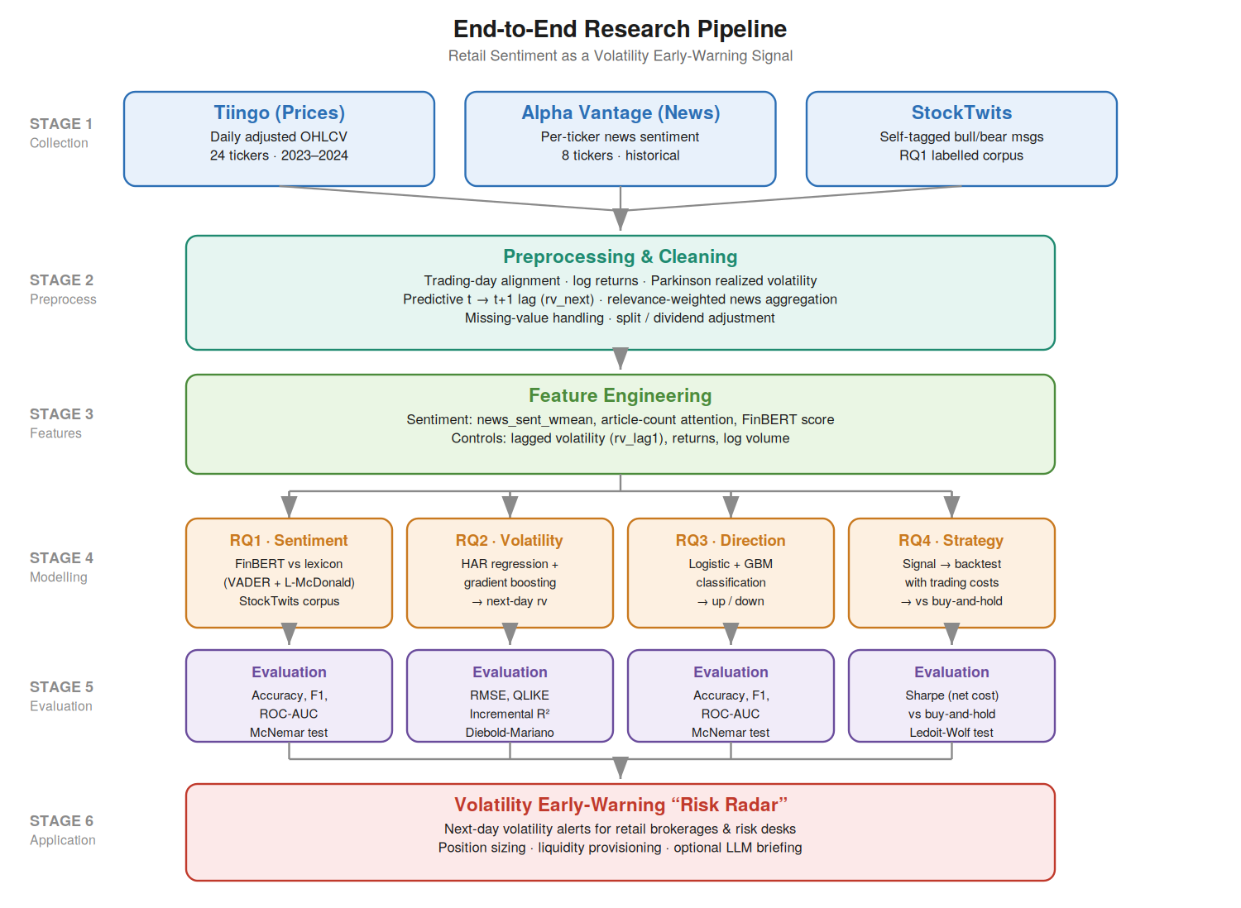
Note. The pipeline maps each of the four research questions to its model family and evaluation metrics, with StockTwits feeding RQ1 and Alpha Vantage news feeding RQ2–RQ4.

Data Preprocessing
Preprocessing is deterministic and executed in src/build_features.py, so the panel can be rebuilt from the raw files by one command. Articles are assigned to United States Eastern trading dates, with items published after the 16:00 close attributed to the following trading day, so post-close information informs t + 1. The predictive alignment is created by shifting realized volatility back one trading day within each ticker, defining the target while leaving every predictor dated on or before t.
Missing values are handled by category, because the causes differ. Structural gaps, namely the first 21 trading days of each series where the monthly HAR window is incomplete and the final day where the target is undefined, are removed rather than imputed, since imputing would invent history. Zero-article days are not treated as missing at all, for the reason given in the cleaning subsection. No imputation of prices or volumes was required, the adjusted Tiingo series being complete.
Transformation is dictated by the model. Trading volume and article counts are heavily right-skewed and enter in logarithmic form, and the regression target is log-transformed on the evidence of Figure 1. Predictors are standardised for logistic regression, where a coefficient's scale would otherwise depend on its variable's units; no scaling is applied for gradient boosting, because tree splits are invariant to monotonic rescaling. The only categorical variable is the ticker symbol, absorbed as a fixed effect rather than one-hot encoded, which is the appropriate treatment for a panel where each unit contributes many observations.

Experimental Design and Validation Strategy
Each research question is a controlled comparison. The control condition contains only market information; the experimental condition is the identical model, algorithm and hyperparameters with sentiment features added. Both are estimated on the same training windows and scored on the same test observations, making the comparison paired and isolating sentiment's contribution from any difference in model class. Reproducibility is supported by fixed random seeds, a public repository, and the validation harness described earlier.
Models are validated by walk-forward analysis rather than k-fold cross-validation. Although Step 4 proposes k-fold as the default safeguard against overfitting, random partitioning is not admissible here: assigning observations to folds at random would place future trading days in the training set, allowing the model to learn from information unavailable at the time of the forecast. Walk-forward validation trains on an initial contiguous block, tests on the block that follows, then advances both windows, so every prediction uses only prior data. Splits are formed on dates rather than rows, so all eight tickers move through the windows together.

Regression Diagnostics and Model Selection
The HAR specification is assessed against the assumptions of linear regression. Residuals are inspected for non-linearity and heteroscedasticity, the latter expected in volatility data and addressed by clustering standard errors by date, so that inference accounts for the cross-sectional correlation identified in Figure 5. Normality is examined on the log scale, where Figure 1 shows the target is close to symmetric. Multicollinearity is assessed in Table 5, where no variance inflation factor exceeds the threshold of 10. Nested specifications are compared using adjusted R-squared together with the Akaike and Bayesian information criteria, which penalise the additional parameters the sentiment features introduce.

Choice of Models with Justification
Each research question is framed as a baseline-versus-augmented comparison, so that any improvement is attributable to sentiment rather than to model class. Models were selected on the basis of the literature, the data type, interpretability, and the evaluation task.
Model 1 — FinBERT vs. lexicon (RQ1): a transformer classifier (FinBERT) benchmarked against a VADER + Loughran–McDonald lexicon baseline, graded on StockTwits self-tagged labels. Justified by FinBERT's demonstrated gains in financial sentiment classification (Araci, 2019) and the transparency of the lexicon baseline (Loughran & McDonald, 2011).
Model 2 — HAR regression + gradient boosting (RQ2): a heterogeneous-autoregressive baseline for realized volatility, extended with sentiment features and a gradient-boosting regressor to capture non-linearities. Justified by the HAR model's standing in volatility forecasting and prior sentiment-volatility evidence (Audrino et al., 2020).
Model 3 — Logistic regression + gradient boosting (RQ3): a technicals-only classifier of next-day return direction, compared with a sentiment-augmented version. Justified by interpretability (logistic) and predictive strength (gradient boosting) on tabular data.
Model 4 — Sentiment-informed strategy backtest (RQ4): a transparent trading rule derived from the volatility signal, back-tested with transaction costs against buy-and-hold. Justified by the need to demonstrate economic, cost-aware value rather than statistical significance alone.

Features Included and Feature Engineering
The feature set combines news-derived sentiment features with lagged market controls; the target is the next-day realized volatility. Table 9 summarises the feature set and its usage.
Table 9
Feature Set and Usage
Feature | Type | Engineering | Used in
news_sent_wmean | Sentiment | Relevance-weighted daily mean | RQ2, RQ3, RQ4
news_article_count | Attention | Daily article count (log) | RQ2, RQ3
FinBERT sentiment | Sentiment (DL) | RQ1 model applied to news text | RQ2, RQ3
rv_lag1 | Control | Prior-day realized volatility | RQ2
log_return, abs_return | Control | Daily returns | RQ2, RQ3
log_volume | Control | log(1 + volume) | RQ2, RQ3

Evaluation Metrics (Formulae and Calculations)
Metrics are matched to each question's form. Table 10 lists the metrics, their formulae, and the research question to which each applies; worked illustrative calculations are retained from the synopsis and will be recomputed on real results in the final report.
Table 10
Evaluation Metrics and Formulae
Metric | Formula | Applies to
Accuracy | (TP + TN) / (TP + FP + TN + FN) | RQ1, RQ3
Precision / Recall | TP/(TP+FP) ; TP/(TP+FN) | RQ1, RQ3
F1 | 2(Precision × Recall)/(Precision + Recall) | RQ1, RQ3
ROC-AUC | Area under TPR-vs-FPR curve | RQ1, RQ3
McNemar's χ² | (|b − c| − 1)² / (b + c) | RQ1, RQ3
RMSE | √[(1/n) Σ(pred − actual)²] | RQ2
QLIKE | (1/n) Σ[(a/p) − ln(a/p) − 1] | RQ2
Sharpe ratio | (mean − rf)/sd, annualised × √252 | RQ4

Preliminary Results
Modelling is complete for RQ1 and RQ2 and outstanding for RQ3 and RQ4. All figures below are out-of-sample; Table 11 compares each model against its baseline.

RQ1: Sentiment Measurement
After cleaning, the labelled corpus contains 3,152 messages, of which 81.6% are tagged bullish. The corpus was split 70/30 with stratification, and every value below is computed on the held-out 30%. Because both scorers emit a continuous value, the decision threshold was chosen on the training half alone to maximise balanced accuracy; evaluating at a threshold selected on the test data would flatter the models.
The result is more nuanced than the hypothesis anticipated. Measured on raw accuracy, FinBERT (0.670) is significantly less accurate than the VADER lexicon (0.739), and McNemar's test rejects equality in the lexicon's favour, with 237 messages correct for the lexicon alone against 102 for FinBERT alone (chi-square = 52.97, p < .001). Taken at face value this retains the null hypothesis. Accuracy is, however, the wrong criterion on a corpus that is 82% one class: answering bullish every time scores 0.816, higher than either model, while carrying no information. The lexicon's advantage has the same source, since its calibrated threshold predicts bullish on roughly four-fifths of messages.
On the criteria that account for the class imbalance, FinBERT is ahead. Its balanced accuracy is 0.660 against 0.611, and it identifies 64.4% of bearish messages against 40.8%. Its ranking ability is clearly superior, with an area under the receiver operating characteristic curve of 0.712 against 0.614. A paired bootstrap over 5,000 resamples, permitted by the research design as an alternative to McNemar's test, confirms the ranking advantage is significant (+0.098, 95% CI [+0.053, +0.143], p < .001) and that the balanced-accuracy advantage over the combined lexicon is also significant (+0.058, 95% CI [+0.013, +0.103], p = .012). The comparable difference against VADER alone is positive but not significant (+0.042, p = .071).

RQ2: Volatility Prediction
The RQ2 models were estimated on the full 3,840-observation panel with ticker fixed effects, using expanding-window walk-forward validation across six folds split on dates. The baseline is the heterogeneous autoregressive specification with trading volume; the augmented model adds the three sentiment and attention variables.
The sentiment block is jointly significant. An incremental F-test rejects the null that its coefficients are all zero (F = 3.61, p = .013), and the adjusted coefficient of determination rises from .5387 to .5401 while both the Akaike and Bayesian criteria fall, so the improvement survives the penalty for three additional parameters. Out-of-sample the augmented model lowers pooled QLIKE loss by 1.26% and is more accurate in five of the six folds; the Diebold-Mariano test rejects equal predictive accuracy decisively (DM = 4.82, p < .001).
The composition of that gain corroborates the exploratory analysis. With standard errors clustered by date, attention carries the effect (coefficient 0.055, t = 3.12, p = .002) while sentiment tone does not (-0.035, t = -0.86, p = .389) and the zero-attention indicator is not individually significant (p = .170). How much a stock is written about predicts its next-day volatility; whether that coverage reads positive or negative does not. This is the pattern Figure 4 showed before any model was fitted, and it is consistent with Audrino et al. (2020).
Gradient boosting was fitted on the identical feature set and did not improve on the linear specification (DM = -1.25, p = .211). With 3,840 observations and a volatility process close to linear in its lagged components, the additional flexibility captures noise rather than structure. The result is reported rather than discarded, since a null finding on model class is itself informative.
Table 11
Preliminary Model Performance
Research Question | Model | Feature Set | Validation Approach | Baseline | Augmented | Key Takeaway
RQ1 | FinBERT vs VADER lexicon | Message text | Stratified 70/30 split; threshold fitted on train | AUC .614 | AUC .712 | FinBERT ranks significantly better (+.098, p < .001) but is less accurate on a 82/18 corpus
RQ1 | FinBERT vs VADER lexicon | Message text | As above | Bal. acc .611 | Bal. acc .660 | Advantage significant against the combined lexicon (p = .012)
RQ2 | HAR + sentiment (OLS) | rv, rv_w, rv_m, log_volume, ticker FE, + 3 sentiment variables | Expanding-window walk-forward, 6 folds on dates | QLIKE .3715 | QLIKE .3668 | Sentiment block jointly significant (F = 3.61, p = .013); DM = 4.82, p < .001
RQ2 | Gradient boosting | As above | As above | QLIKE .3715 | QLIKE .3861 | No improvement over linear HAR (DM = -1.25, p = .211)
RQ3 | Logistic + gradient boosting | As RQ2, target = return direction | As RQ2 | pending | pending | Scheduled for the final report
RQ4 | Strategy vs buy-and-hold | RQ2 volatility forecast | Cost-aware backtest; block-bootstrap Ledoit-Wolf | pending | pending | Power-constrained; see limitations
Note. All metrics are out-of-sample. QLIKE is computed on the variance scale (Patton, 2011); lower is better. AUC denotes the area under the receiver operating characteristic curve. Generated by src/run_rq1.py and src/run_rq2.py.

Link to the Research Questions
RQ1 confirms the sentiment instrument is sound: FinBERT separates bullish from bearish messages better than a lexicon, though not more accurately in a raw sense. RQ2 answers the central question affirmatively, with the qualification that attention rather than tone supplies the predictive content, which narrows what the risk-radar signal should be built on. RQ3 reuses the RQ2 panel and validation scheme with a binary target; RQ4 converts the volatility forecast into an exposure rule, constrained by the power limitation already noted.

Interim Limitations and Risks
- Free-tier data quota (Alpha Vantage, 25 requests/day) constrains the sentiment universe to eight tickers and slows collection; mitigated by caching and resumable, per-ticker pulls.
- StockTwits serves only recent messages, so it supports RQ1 validation rather than the historical panel; mitigated by using Alpha Vantage news as the historical sentiment feature.
- Sentiment effects are expected to be economically small (per the literature); mitigated by conservative effect-size assumptions in the sample-size design.
- Rural hotspot connectivity causes intermittent collection timeouts; mitigated by retry/backoff and the option to collect from a stable cloud environment.
Statistical power for RQ4 is limited: the strategy test requires 1,558 trading days and the study window provides 500, so the backtest is under-powered and a null result there is inconclusive rather than negative; mitigated by a block-bootstrap implementation of the Ledoit-Wolf test and by explicit reporting of the shortfall.
Effective sample size is materially smaller than the row count. The eight tickers move together, with a mean pairwise correlation of 0.359 in realized volatility, so the 3,840 ticker-days correspond to roughly 2.3 independent series and an effective sample nearer 1,093 observations; mitigated by reporting standard errors clustered by date and by sizing claims against the adjusted figure rather than the raw row count.
The study window contains a single volatility regime. Quarterly cross-sectional mean volatility varies only 1.25-fold across 2023-2024, with no crisis or sustained stress episode, so the models are trained and validated under calm to moderate conditions only; mitigated by restricting all claims to comparable conditions and identifying regime generalisation as future work.
Attention is measured from news-media coverage rather than retail activity. The direct retail measure would be StockTwits message volume, which is unavailable historically because the API serves only recent messages; mitigated by treating article count as a proxy and stating the substitution explicitly.

Next Steps (for Final Report)
- Complete Alpha Vantage news collection for all eight sentiment tickers.
- Assemble the final analysis panel and run data cleaning and EDA with interpretation.
- Train and validate FinBERT against the lexicon baseline (RQ1).
- Fit and evaluate the volatility (RQ2) and direction (RQ3) models out-of-sample.
- Run the cost-aware strategy backtest and significance test (RQ4).
- Report preliminary and final results, and draft the implementation, recommendation, and limitations sections.

Bibliography
Antweiler, W., & Frank, M. Z. (2004). Is all that talk just noise? The information content of internet stock message boards. The Journal of Finance, 59(3), 1259–1294. https://doi.org/10.1111/j.1540-6261.2004.00662.x
Araci, D. (2019). FinBERT: Financial sentiment analysis with pre-trained language models [Preprint]. arXiv. https://arxiv.org/abs/1908.10063
Audrino, F., Sigrist, F., & Ballinari, D. (2020). The impact of sentiment and attention measures on stock market volatility. International Journal of Forecasting, 36(2), 334–357. https://doi.org/10.1016/j.ijforecast.2019.05.010
Behrendt, S., & Schmidt, A. (2018). The Twitter myth revisited: Intraday investor sentiment, Twitter activity and individual-level stock return volatility. Journal of Banking & Finance, 96, 355–367.
Bollen, J., Mao, H., & Zeng, X. (2011). Twitter mood predicts the stock market. Journal of Computational Science, 2(1), 1–8. https://doi.org/10.1016/j.jocs.2010.12.007
Cohen, J. (1988). Statistical power analysis for the behavioral sciences (2nd ed.). Lawrence Erlbaum.
Das, S. R., & Chen, M. Y. (2007). Yahoo! for Amazon: Sentiment extraction from small talk on the web. Management Science, 53(9), 1375–1388.
Diebold, F. X., & Mariano, R. S. (1995). Comparing predictive accuracy. Journal of Business & Economic Statistics, 13(3), 253–263.
Ledoit, O., & Wolf, M. (2008). Robust performance hypothesis testing with the Sharpe ratio. Journal of Empirical Finance, 15(5), 850–859. https://doi.org/10.1016/j.jempfin.2008.03.002
Lopez-Lira, A., & Tang, Y. (2023). Can ChatGPT forecast stock price movements? Return predictability and large language models [Preprint]. arXiv. https://arxiv.org/abs/2304.07619
Loughran, T., & McDonald, B. (2011). When is a liability not a liability? Textual analysis, dictionaries, and 10-Ks. The Journal of Finance, 66(1), 35–65. https://doi.org/10.1111/j.1540-6261.2010.01625.x
Oliveira, N., Cortez, P., & Areal, N. (2017). The impact of microblogging data for stock market prediction: Using Twitter to predict returns, volatility, trading volume and survey sentiment indices. Expert Systems with Applications, 73, 125–144. https://doi.org/10.1016/j.eswa.2016.12.036
Patton, A. J. (2011). Volatility forecast comparison using imperfect volatility proxies. Journal of Econometrics, 160(1), 246–256. https://doi.org/10.1016/j.jeconom.2010.03.034
Renault, T. (2017). Intraday online investor sentiment and return patterns in the U.S. stock market. Journal of Banking & Finance, 84, 25–40. https://doi.org/10.1016/j.jbankfin.2017.07.002
Sprenger, T. O., Tumasjan, A., Sandner, P. G., & Welpe, I. M. (2014). Tweets and trades: The information content of stock microblogs. European Financial Management, 20(5), 926–957. https://doi.org/10.1111/j.1468-036X.2013.12007.x
Tetlock, P. C. (2007). Giving content to investor sentiment: The role of media in the stock market. The Journal of Finance, 62(3), 1139–1168. https://doi.org/10.1111/j.1540-6261.2007.01232.x
Yu, Y., Li, H., Chen, Z., Jiang, Y., Li, Y., Zhang, D., Liu, R., Suchow, J. W., & Khashanah, K. (2023). FinMem: A performance-enhanced LLM trading agent with layered memory and character design [Preprint]. arXiv. https://arxiv.org/abs/2311.13743

Appendix
[ Optional. Include any code referenced in the text (e.g., feature-building or collection scripts), with each appendix titled and referenced from the body. ]

