Data Analytics Capstone
Retail Sentiment as a Volatility Early-Warning Signal:
A Machine-Learning Study of StockTwits and U.S. Equity Risk
Interim Report

James Savage
Walsh College
QM640: Data Analytics Capstone
Mr. Sharath Srivatsa
Group 12
[Current Term] Term
[Date]

GitHub repository (data and code): https://github.com/JamesSavages/Retail_Sentiment_and_Market_Volatility

Introduction

Background and Context
Financial markets are driven not only by fundamentals but by the collective mood of the people trading them, which is now broadcast in real time on social platforms and financial news. A substantial literature establishes that this visible sentiment carries information about market behaviour. Message-board and microblog activity has been linked to trading volume and volatility (Antweiler & Frank, 2004; Sprenger et al., 2014), and social-media mood has been related to index movements (Bollen et al., 2011). Importantly, the strongest and most consistent evidence is for volatility and trading volume rather than for returns, which are closer to efficient (Audrino et al., 2020).
For the businesses that serve retail investors, including brokerages, robo-advisors, and risk-management desks, the operationally valuable question is not what the crowd feels today but whether today's mood signals which stocks will be volatile tomorrow. Volatility surprises are where retail users are most exposed, and where hedging and liquidity-provision costs are incurred. An accurate early-warning signal for next-day volatility therefore has direct commercial value, informing user risk alerts, position sizing, and liquidity decisions.
Measuring sentiment accurately is itself a research problem. Traditional dictionary-based methods have systematically misclassified financial language (Loughran & McDonald, 2011), whereas transformer-based models such as FinBERT read text in context and have improved financial sentiment classification (Araci, 2019). More recently, large language models have shown an emerging capacity for financial reasoning. For example, Lopez-Lira and Tang (2023) found that GPT-4 can predict market reactions to news headlines without task specific training, although returns appear to decay as adoption spreads, further supporting a focus on volatility rather than returns. A further constraint of methodologies used in this field of study is endogeneity. Given that news causes sentiment and price to change at the same time, it is impossible to tell which one is driving the other. To avoid this, this study adopts a predictive design relating sentiment at day t to volatility on day t + 1, consistent with prior work (Antweiler & Frank, 2004; Audrino et al., 2020).

Problem Statement
The objective of this study is to predict next-day realized volatility (Y) for eight high-liquidity United States technology equities, with the ticker-day as the unit of analysis, using retail investor sentiment features (X = news sentiment score, message and article volume as an attention proxy) together with lagged market controls, over the period January 2023 to December 2024. Success is evaluated by out-of-sample forecast error (root mean squared error, RMSE, and the quasi-likelihood loss, QLIKE) and by the risk-adjusted return (Sharpe ratio) of a sentiment-informed trading strategy, net of transaction costs.

Purpose of the Study
The study is primarily predictive, forecasting a continuous risk measure, with an explanatory component that quantifies sentiment's marginal information beyond price history, a classification component that predicts next day return direction, and an inferential component that tests whether a sentiment informed strategy significantly improves risk-adjusted return. Its purpose is to establish whether freely available public sentiment provides an operationally useful, cost-aware early-warning signal for equity volatility.

Interim Project Status (Progress Snapshot)
The current status of the project is summarised below.
- Completed: Synopsis submitted; data pipeline designed, implemented, and validated end-to-end by a 27-check automated assertion harness; analysis panel assembled (3,840 ticker-days, eight tickers); data cleaning and exploratory data analysis completed; 24-ticker daily price panel collected (Tiingo); news-sentiment collection complete for all eight sentiment tickers; StockTwits labelled corpus accumulating; literature review completed.
- In progress: RQ1 sentiment modelling (FinBERT versus the lexicon baseline); specification of the RQ2 volatility models.
- Pending: FinBERT sentiment modelling (RQ1); volatility and direction models (RQ2, RQ3); strategy backtest (RQ4); preliminary results and interpretation.

Scope and Objectives
This study is organised around four research questions, each addressing a distinct aspect of the relationship between retail sentiment and equity risk and drawing on a different family of methods.
RQ1. How accurately can a transformer model (FinBERT) classify StockTwits message sentiment, benchmarked against users' self-tagged bullish/bearish labels and a lexicon baseline? (Supervised classification.)
RQ2. Does aggregated daily sentiment at day t predict next day realized volatility at t + 1, controlling for lagged volatility and trading volume? (Multiple regression and gradient boosting.)
RQ3. Do sentiment features improve next day return direction prediction beyond a technicals-only baseline? (Binary classification.)
RQ4. Does a sentiment informed trading strategy produce a statistically significant improvement in risk-adjusted return (Sharpe ratio) over buy-and-hold, net of transaction costs? (Inferential backtest.)

Literature Survey

Literature Review Approach
Sources were identified through Google Scholar, Scopus, Web of Science, ScienceDirect, SSRN, and arXiv, using Boolean combinations of the study's concept clusters (for example, “investor sentiment” OR “StockTwits” AND “realized volatility” AND “FinBERT” OR “transformer”). Inclusion was limited to peer-reviewed empirical work linking textual sentiment to a measurable market outcome, with field-defining preprints retained where relevant, and priority given to highly cited papers in leading finance and forecasting journals balanced against recency to capture the large-language-model era. Table 1 summarises the most relevant studies.
Table 1
Literature Relevance Matrix
Study | Purpose / Context | Method | Key Findings | Relevance to This Study
Antweiler & Frank (2004) | Message-board sentiment and market activity | Computational-linguistics bullishness index | Messages predict volatility; disagreement predicts volume; return effect small | Anchors the volatility-over-returns focus and the article-count attention feature
Das & Chen (2007) | Extracting sentiment from web small talk | Multi-classifier voting | Sentiment tracks index moves; activity relates to volatility | Early evidence linking posting activity to volatility
Tetlock (2007) | Media tone and the stock market | Media-pessimism factor; VAR | Pessimism predicts price pressure then reversion; extremes predict volume | Frames the endogeneity/simultaneity concern
Bollen et al. (2011) | Social-media mood and the market | Mood dimensions + causality tests | Reported mood relates to index moves; noted as fragile | Motivates a reproducible, firm-level design
Loughran & McDonald (2011) | Sentiment in financial text | Finance-specific dictionaries | General dictionaries misclassify financial tone | Basis for the lexicon baseline in RQ1
Sprenger et al. (2014) | Microblog sentiment and trading | ML sentiment + regression | Sentiment relates to returns; disagreement to volatility | Supports microblog sentiment and attention features
Oliveira et al. (2017) | Microblog data for market prediction | Sentiment indicators + multiple ML | Improves volatility/volume forecasts; weaker for returns | Validates the feature family and volatility target
Renault (2017) | StockTwits investor sentiment | Custom lexicon vs. ML | Sentiment predicts intraday index returns; lexicon competitive | StockTwits-specific precedent and baseline
Behrendt & Schmidt (2018) | Twitter sentiment and intraday volatility | GARCH + intraday sentiment | Adds little to intraday volatility once controlled | Cautionary; motivates conservative effect sizes
Araci (2019) | Transformer sentiment for finance | FinBERT (fine-tuned BERT) | Improves financial sentiment classification | The deep-learning method used in RQ1
Audrino et al. (2020) | Sentiment/attention and volatility | Penalized regression on HAR | Attention and StockTwits volume improve realized-volatility forecasts | Closest precedent; frames the per-ticker, business-evaluated gap
Lopez-Lira & Tang (2023) | LLMs and return predictability | GPT-4 on news headlines | Predicts reactions; edges decay as adoption spreads | Frontier LLM evidence; reinforces volatility focus
Yu et al. (2023) | LLM trading agents | FinMem agent with layered memory | Autonomous agent enhances trading decisions | Grounds the optional agentic briefing extension

Three themes organise this literature and connect it directly to the present study. First, on outcome selection, the evidence consistently shows that sentiment and attention forecast volatility and trading volume more reliably than returns, which are closer to efficient (Antweiler & Frank, 2004; Oliveira et al., 2017; Audrino et al., 2020); this study therefore targets next-day volatility as its primary outcome. Second, on sentiment measurement, the field has evolved from finance-specific dictionaries (Loughran & McDonald, 2011) through transformer models (Araci, 2019) to general-purpose large language models (Lopez-Lira & Tang, 2023); RQ1 positions FinBERT against a lexicon baseline within this progression. Third, on the research gap, prior work concentrates at the market-index level, uses lexicon or classical methods, and reports statistical rather than economic value, with limited reproducibility; this study addresses that gap by operationalising transformer sentiment as a per-ticker, next-day volatility early-warning signal, validated through a cost-aware backtest and an open, reproducible pipeline.

Data Description

Data Source(s) and Access
The study draws on three free, publicly accessible sources. Daily split and dividend-adjusted price data are obtained from Tiingo (https://www.tiingo.com); historical per-ticker news sentiment from Alpha Vantage (https://www.alphavantage.co); and recent labelled messages from the StockTwits API (https://api.stocktwits.com). Prices supply the target and market controls, Alpha Vantage supplies the historical sentiment feature for RQ2 to RQ4, and StockTwits supplies the human-labelled corpus for RQ1. During development, an initial price source (Stooq) was found to block automated access and Alpha Vantage's full-history price endpoint was available at a premium price, so Tiingo was adopted after validating access. This deliberate evaluation of data sources strengthens reproducibility and is noted as a practical constraint in the limitations of the final report.

Dataset Overview
The assembled analysis panel is organised as a ticker-day table combining price-derived controls, the next-day realized-volatility target, and news-sentiment features.
- Number of records (rows): 3,840 usable ticker-days (eight sentiment tickers, 480 trading days each) drawn from a 24-ticker, 11,873-row price panel.
- Number of variables (columns): 15 principal variables (see Table 2).
- Time period: 3 January 2023 to 31 December 2024.
- Unit of analysis: the ticker-day.
- Target variable(s): next-day realized volatility (rv_next), estimated from daily open-high-low-close (OHLC) prices via the Parkinson estimator.

Data Dictionary (Mandatory)
Table 2
Data Dictionary (Principal Variables)
Variable | Source | Type | Unit | Role | Description
symbol | All | string | - | key | Stock ticker symbol
date | All | date | YYYY-MM-DD | key | Trading date (US/Eastern)
close | Tiingo | float | USD | raw | Adjusted daily closing price
log_return | Derived | float | log points | control | ln(close_t / close_t-1)
abs_return | Derived | float | log points | control | Absolute daily log return
log_volume | Derived | float | ln(shares) | control | log(1 + daily share volume)
rv | Derived | float | daily sigma | control | Realized volatility at t (Parkinson)
rv_lag1 | Derived | float | daily sigma | control | Realized volatility at t-1
rv_next | Derived | float | daily sigma | TARGET | Next-day realized volatility (t+1)
news_sent_wmean | Alpha Vantage | float | -1 to +1 | predictor | Relevance-weighted mean news sentiment
news_article_count | Alpha Vantage | int | articles | predictor | News articles on the ticker-day

Note. The StockTwits labelled corpus (message-level bullish/bearish tags) is used separately for RQ1 sentiment-model validation and is not part of the historical RQ2–RQ4 panel.

GitHub Data Availability Statement
The raw and processed datasets and all code are openly available in the project repository:
- Raw data: data/raw/{prices, news, stocktwits}/
- Processed/clean data: data/processed/panel.csv
- Code/notebooks: src/ (collection, feature building, and dictionary scripts)

Screenshots / Evidence
[ Insert Figures: repository folder tree, and dataset preview screenshots of the raw folders and the assembled panel.csv, each labelled and referenced in the text (carried over from the synopsis figures). ]

Analysis
This section documents how the analysis sample was constructed from the collected data, then reports the exploratory analysis that informed the modelling decisions described in the following section. Every figure and table reported here is generated by src/run_eda.py in the project repository, so all values are reproducible from the committed data.

Data Cleaning
Cleaning is implemented in src/build_features.py and verified by an automated assertion harness, src/validate_panel.py. Rather than inspecting the output by eye, the harness recomputes every derived variable directly from the raw source files and fails if any value disagrees. It runs 27 checks spanning key uniqueness, definitional consistency, news integrity, corporate actions, and the point-in-time test described at the end of this subsection. All 27 pass on the current panel, and the script exits with an error status if any fails, so a corrupted panel cannot silently reach the modelling stage.
The collected price panel contains 11,873 ticker-days across 24 technology equities. This is 175 fewer than the 12,048 implied by 24 tickers over 502 trading days, because Arm Holdings (ARM) listed in September 2023 and has no earlier history. Restricting to the eight tickers for which news sentiment was collected leaves 4,016 ticker-days. Removing the final trading day of each series, where the next-day target is undefined, and the first 21 days, where the monthly heterogeneous autoregressive (HAR) component has insufficient history, yields a balanced analysis sample of 3,840 ticker-days, exactly 480 per ticker. Table 3 records each step with counts and percentages.
Table 3
Data Cleaning Log
Issue | Variables Affected | Detection Method | Treatment Applied | Records Affected | Rationale
Duplicate ticker-days | symbol, date | Key-uniqueness assertion in validate_panel.py | None found; no action required | 0 (0.00%) | Data quality
Tickers outside the sentiment universe | news_sent_wmean, news_article_count | Free-tier quota of 25 requests per day | Excluded from the analysis sample; retained in the price panel as market context | 7,857 (66.18%) | Quota constraint, not a data defect
Target undefined at series end | rv_next | Null check after the t to t+1 shift | Excluded, one ticker-day per ticker | 8 (0.07%) | Next-day volatility does not exist for the final observation
HAR burn-in window | rv_m | 22-day rolling mean requires 22 prior observations | Excluded, 21 ticker-days per ticker | 168 (1.42%) | Monthly HAR component undefined until the window fills
No news articles on a trading day | news_sent_wmean, news_article_count | Gap between the news files and the trading calendar | Retained as zero-attention observations: article count 0, sentiment 0 (neutral), indicator news_missing = 1 | 945 (7.96%) | A zero-article day is a genuine low-attention observation, not a missing measurement
Extreme one-day price moves | close, rv | Screen for absolute close-to-close moves above 30%, cross-checked against split ratios and the volatility path | Both flagged moves verified as post-earnings repricings and retained; no winsorising or trimming applied | 2 (0.02%) | Extreme volatility is the phenomenon under study, not noise to remove
User-identifying fields | user_id, user_followers | Privacy review of the StockTwits collector | Removed at collection and stripped from 23 existing files | 23 files | Ethics: no individual user is profiled or re-published
Note. Percentages are of the 11,873-row collected price panel. Exclusions are sequential, leaving an analysis sample of 3,840 ticker-days. Counts are produced by src/run_eda.py and written to docs/tables/eda_cleaning_log.csv.
Two treatment decisions warrant explanation. The first concerns the 945 ticker-days, 24.6% of the analysis sample, on which no news article mentioned the ticker. An earlier version of the pipeline discarded these rows, because joining the news files to the trading calendar produced no match. That treatment was incorrect. A day on which no article mentions a ticker is a genuine low-attention observation rather than a failed measurement, and discarding such days truncates the attention variable at a minimum of one article, removing exactly the low-attention contrast the study depends upon. The loss would also have fallen unevenly: Palantir (PLTR) would have forfeited 73% of its history while Microsoft (MSFT) forfeited 4%, leaving a severely unbalanced panel. These days are therefore retained with an article count of zero, a neutral sentiment score, and an indicator variable that allows the models to distinguish neutral coverage from absent coverage. The correction increased the analysis sample from 3,026 to 3,840 ticker-days and produced a balanced panel of 480 days per ticker.
This treatment is applied only to the eight tickers actually queried. For the remaining sixteen no request was ever issued, so their news fields remain null; recording a zero there would fabricate an observation from an absence of collection. The validation harness asserts that no such value exists.
The second decision concerns outliers. No trimming or winsorising was applied. A screen for absolute close-to-close moves above 30% flagged two observations: ARM on 8 February 2024 (+47.9%) and PLTR on 6 February 2024 (+30.8%). Each was tested in two ways. An unadjusted stock split produces a price ratio sitting almost exactly on a simple fraction, and neither ratio, 1.479 and 1.308, does so. A split also leaves the price discontinuous while realized volatility is unchanged, whereas both observations show volatility rising sharply over several sessions, ARM from 0.030 to 0.179. Both are therefore post-earnings repricings rather than data errors. Since the object of the study is to forecast exactly such episodes, removing them would remove the signal of interest.
Because the study makes a forecasting rather than an explanatory claim, cleaning must guarantee that no predictor contains information dated after day t. This is verified rather than asserted. For a random sample of ticker-days the harness rebuilds every predictor from raw records restricted to dates on or before t and requires an exact match with the stored value; across all 11,873 ticker-days the largest discrepancy is of the order of ten to the power of minus sixteen, that is, floating-point rounding. Realized volatility at t is computed from that day's high and low prices, so it is known at the close of day t and is admissible as a predictor of day t + 1. The HAR windows accordingly end at t rather than being shifted back, which is the standard specification and introduces no look-ahead bias.

Exploratory Data Analysis
Table 4 summarises the analysis sample. The target and its lagged components share a common scale, so the differences between them are informative: averaging volatility over longer windows progressively removes the right tail, with skewness falling from 1.81 for the daily series to 0.62 for the monthly average.
Table 4
Descriptive Statistics for the Analysis Sample
Variable | N | M | Mdn | SD | IQR | Min | Max | Skew | Kurtosis
rv_next (target) | 3,840 | 0.0184 | 0.0158 | 0.0107 | 0.0124 | 0.0032 | 0.1003 | 1.81 | 5.42
rv (daily HAR) | 3,840 | 0.0185 | 0.0158 | 0.0108 | 0.0124 | 0.0032 | 0.1003 | 1.81 | 5.35
rv_w (weekly HAR) | 3,840 | 0.0185 | 0.0170 | 0.0085 | 0.0117 | 0.0045 | 0.0583 | 1.07 | 1.43
rv_m (monthly HAR) | 3,840 | 0.0186 | 0.0178 | 0.0074 | 0.0115 | 0.0070 | 0.0467 | 0.62 | -0.11
news_sent_wmean | 3,840 | 0.1365 | 0.1320 | 0.1774 | 0.2677 | -0.6165 | 0.8746 | -0.12 | 0.57
news_article_count | 3,840 | 2.20 | 2.00 | 2.32 | 2.00 | 0 | 26 | 2.30 | 12.10
log_articles | 3,840 | 0.9354 | 1.0986 | 0.6770 | 0.6931 | 0.0000 | 3.2958 | 0.08 | -0.82
log_return | 3,840 | 0.0022 | 0.0013 | 0.0275 | 0.0252 | -0.1638 | 0.2685 | 1.08 | 10.54
log_volume | 3,840 | 17.85 | 17.74 | 0.99 | 1.17 | 15.37 | 21.16 | 0.63 | 0.10
Note. Realized volatility is expressed in daily sigma units. Sentiment is relevance-weighted and bounded at -1 and +1. Values are written to docs/tables/eda_descriptives.csv.
Figure 1 shows why the target is modelled on a logarithmic scale. On the raw scale next-day realized volatility is strongly right-skewed, with a skewness of 1.81 and a kurtosis of 5.42: most days are quiet and a small number are extreme. Taking logarithms reduces these to 0.09 and -0.23 respectively, which is close to normal. Two modelling decisions follow. The regression target is the logarithm of next-day realized volatility, so that estimates are not dominated by a handful of earnings days, and forecast accuracy is reported using QLIKE alongside RMSE, because squared-error loss on a fat-tailed target rewards a model that fits the extreme tail at the expense of the remaining observations.
Figure 1
Distribution of Next-Day Realized Volatility, Raw and Log Scale
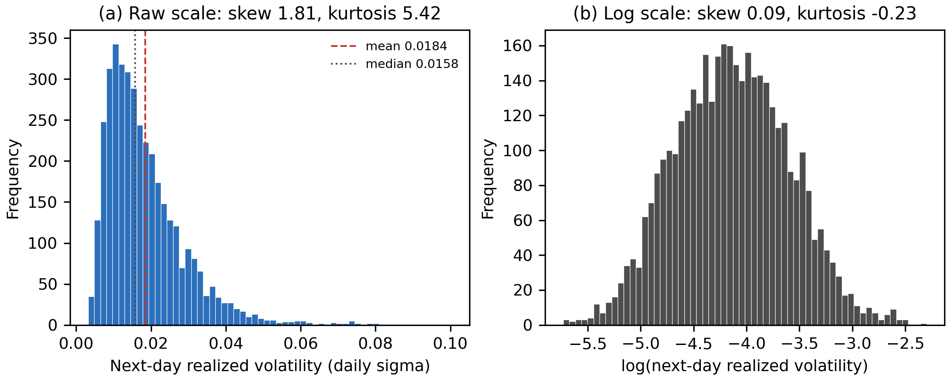
Note. Panel (a) shows the raw target and panel (b) its natural logarithm, each with 60 bins.
Figure 2 shows that news coverage is highly uneven across the sentiment universe. Microsoft is covered on 96% of trading days and Amazon on 94%, whereas Palantir is covered on only 27%. Coverage is therefore not an incidental property of the data but a characteristic that differs systematically between firms, which is the principal justification for retaining zero-attention days and including the news_missing indicator. It also anticipates the confounding problem identified in Figure 5.
Figure 2
News Coverage by Ticker Within the Analysis Sample
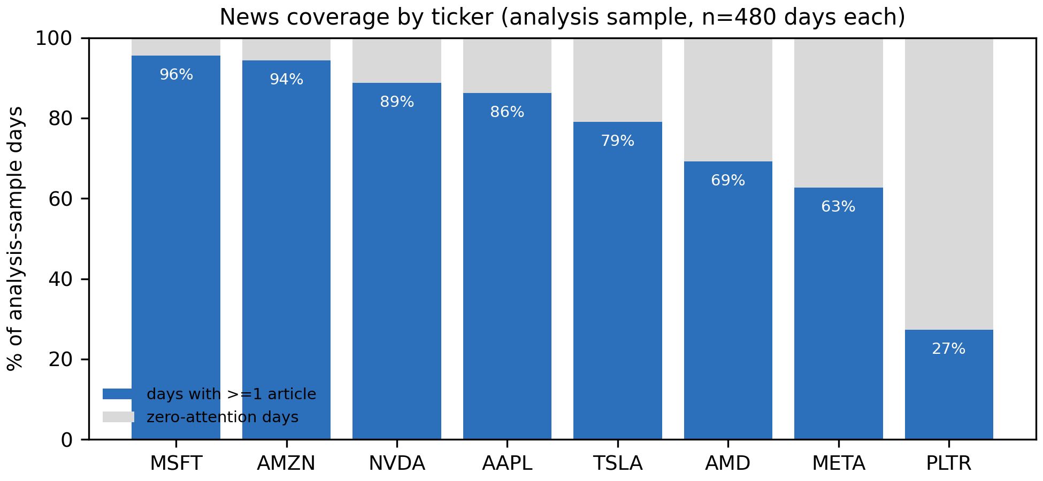
Note. Each ticker contributes exactly 480 ticker-days. Shaded portions are days on which no article mentioned the ticker.
Figure 3 reveals an asymmetry with direct consequences for the study. Relevance-weighted sentiment averages +0.181 and is positive on 87% of days with news, so the measure carries considerably less negative than positive variation. This compresses the range over which any sentiment effect could be detected and is recorded as a limitation. Panel (b) shows that attention is heavily concentrated at low values, with a median of two articles and a maximum of 26, which is why it enters the models in logarithmic form.
Figure 3
Distribution of News Sentiment and Attention
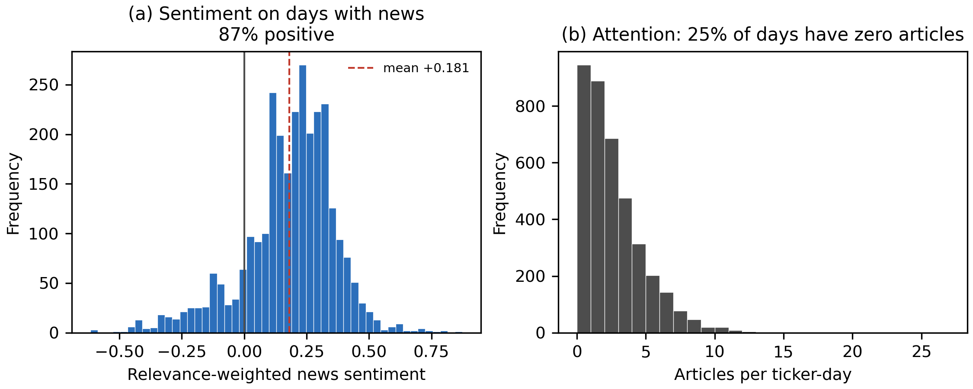
Note. Panel (a) is restricted to days with at least one article; panel (b) includes all analysis-sample days.
Figure 4 contains the most consequential finding of the exploratory analysis. Pooled across tickers, moving from the lowest to the highest attention quintile is associated with 21.6% lower next-day volatility, which contradicts the established result that attention and volatility move together (Audrino et al., 2020). Comparing each ticker against its own mean reverses the sign: within tickers, the highest attention quintile carries 9.9% higher next-day volatility than the lowest, and the relationship is monotonic across all five quintiles. Sentiment behaves differently, showing no consistent pattern in either specification, at -2.7% pooled and -2.2% within ticker. The pooled estimate is an artefact, for the reason set out in Figure 5, and the practical consequence is that the models addressing RQ2 must include ticker fixed effects. Attention, rather than sentiment tone, emerges as the stronger candidate predictor.
Figure 4
Next-Day Volatility by Predictor Quintile, Pooled and Within Ticker
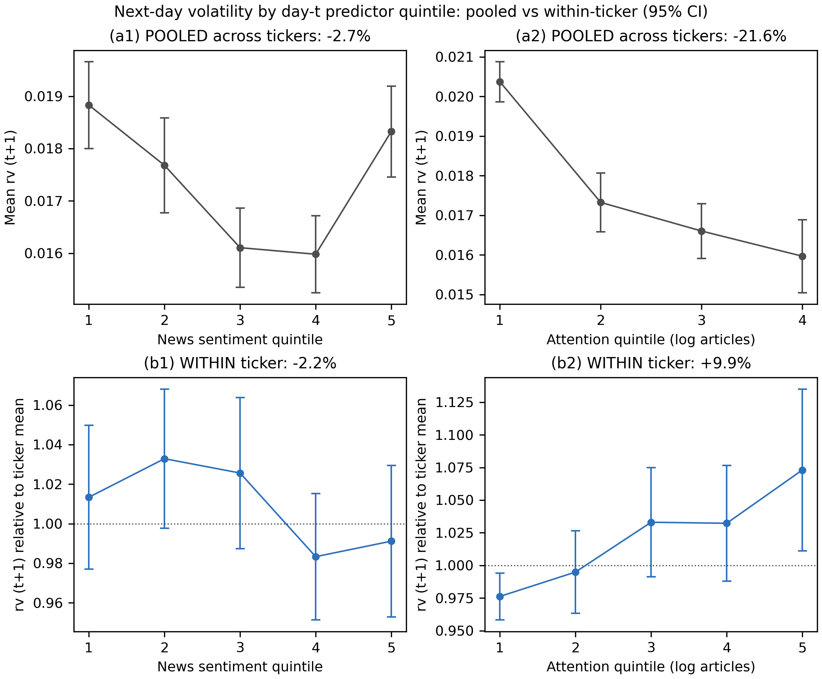
Note. Upper panels pool all tickers. Lower panels express the target relative to each ticker's own mean, so that 1.00 denotes a typical day for that stock. Error bars are 95% confidence intervals.
Figure 5 explains the sign reversal. Across the eight tickers, the proportion of zero-attention days correlates 0.69 with average volatility. Palantir has the least coverage, with no article on 73% of days, and the highest average volatility at 0.0287, while Microsoft has the most coverage, with no article on only 4% of days, and among the lowest volatility at 0.0106. In pooled data, low attention therefore functions largely as a label for which stock is being observed rather than as information about what is about to happen to it. This is a Simpson's paradox: a relationship that holds within each group reverses when the groups are combined. Because RQ2 asks whether a change in a ticker's own attention predicts a change in its own next-day volatility, only the within-ticker comparison is informative, and pooled results are reported solely as a cautionary contrast.
Figure 5
Cross-Sectional Confounding Between Coverage and Baseline Volatility
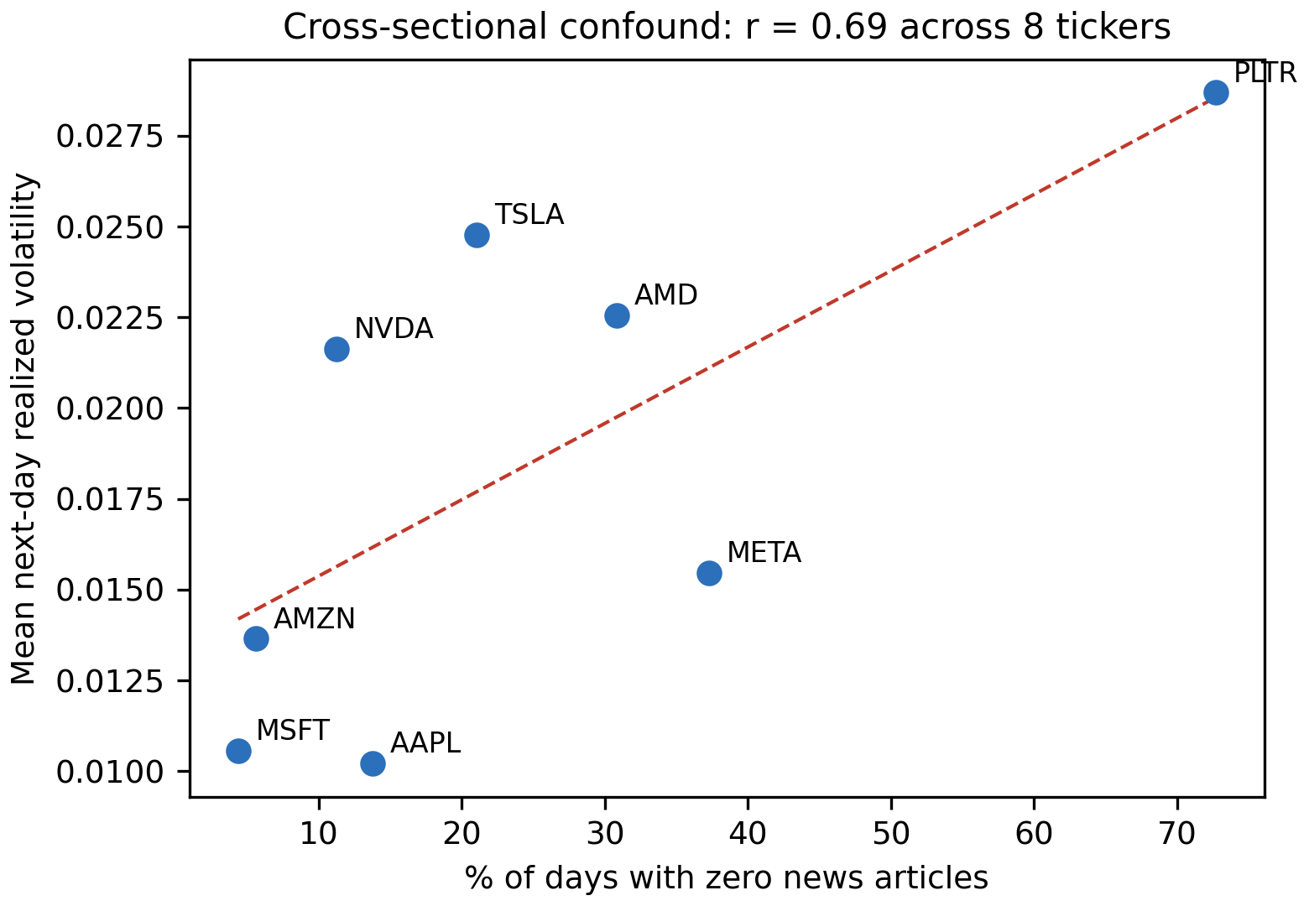
Note. Each point is one of the eight tickers in the analysis sample; the dashed line is an ordinary least squares fit.
Figure 6 confirms that lagged volatility dominates the predictor set. The weekly HAR component correlates 0.63 with the target, while news sentiment correlates only -0.11 and attention -0.15. This is the expected ordering and it determines how RQ2 must be evaluated. Sentiment cannot be judged by its raw association with next-day volatility, which is small, but by whether it adds explanatory power once the HAR components are already in the model. The hypothesis test for RQ2 is therefore an incremental one.
Figure 6
Correlation Matrix of Predictors and Target
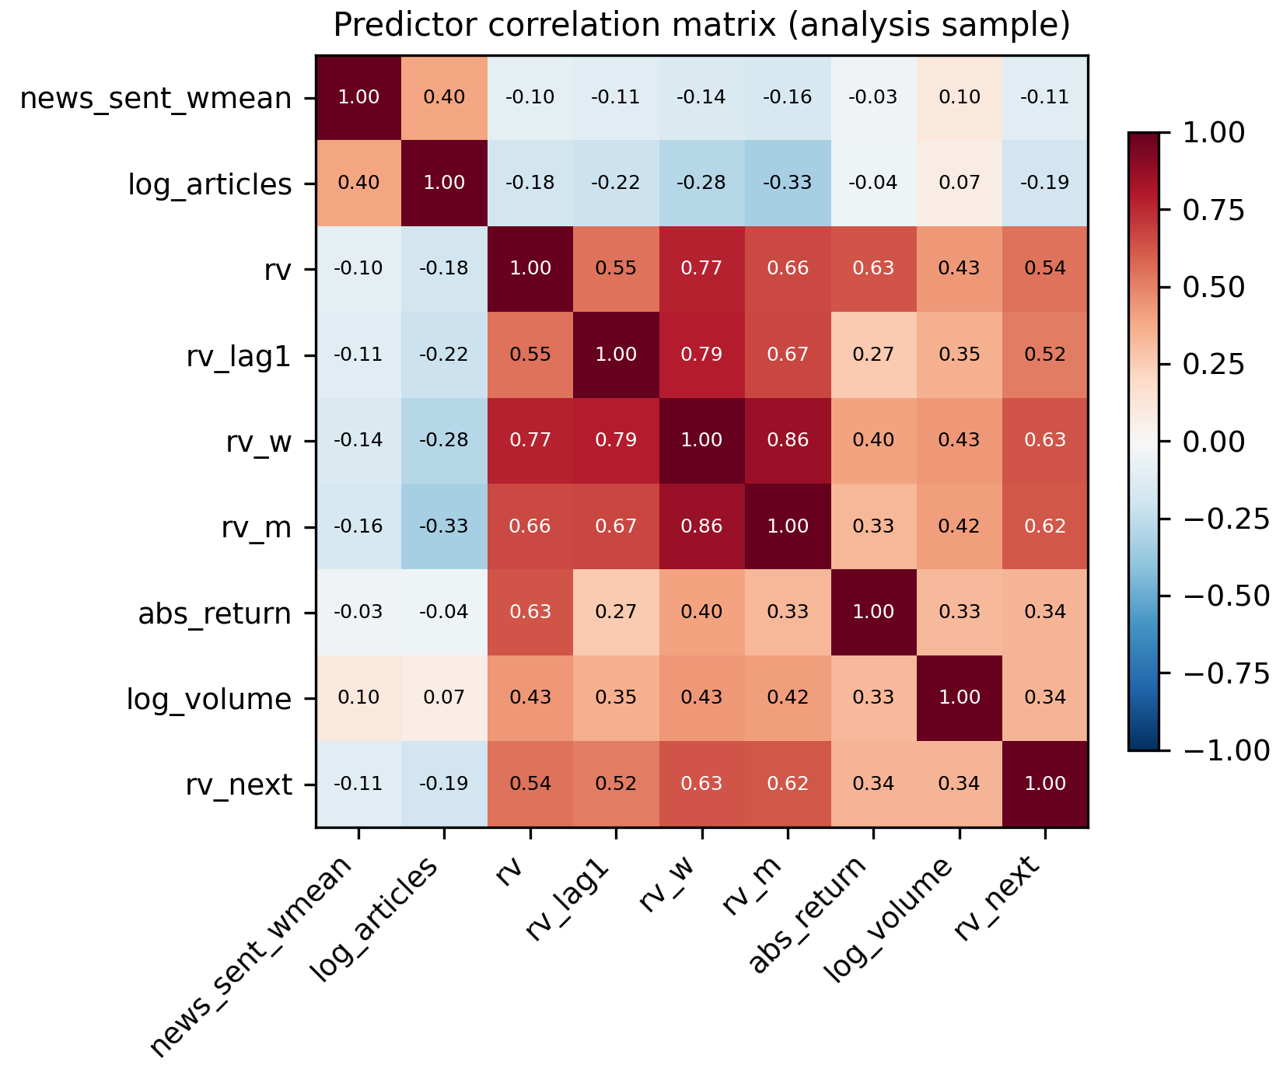
Note. Pearson correlations computed on the 3,840-observation analysis sample.
Because several controls measure closely related quantities, multicollinearity was assessed using variance inflation factors, reported in Table 5. Step 4 of the research design identifies a factor above 10 as indicating severe multicollinearity.
Table 5
Variance Inflation Factors for the Full Predictor Set
Predictor | VIF | Assessment
rv_w (weekly HAR component) | 7.91 | Moderate (5-10)
rv_m (monthly HAR component) | 4.20 | Acceptable (below 5)
rv (daily HAR component) | 3.63 | Acceptable (below 5)
rv_lag1 | 2.71 | Acceptable (below 5)
abs_return | 1.74 | Acceptable (below 5)
log_volume | 1.40 | Acceptable (below 5)
log_articles | 1.36 | Acceptable (below 5)
news_sent_wmean | 1.20 | Acceptable (below 5)
Note. Computed on the analysis sample and written to docs/tables/eda_vif.csv. No predictor exceeds the severe threshold of 10.
No predictor exceeds the severe threshold. The weekly HAR component is the most collinear at 7.91, which is expected because it is a moving average of the daily series, and it remains within the range normally considered tolerable. The two sentiment variables are close to orthogonal to the market controls, at 1.36 and 1.20, which is an encouraging result for RQ2: whatever incremental contribution they make will not be an artefact of overlap with lagged volatility. The full control set is therefore retained without modification.
Finally, Figure 7 illustrates the volatility clustering that motivates the HAR specification.
Figure 7
Realized Volatility Over Time for NVDA and MSFT
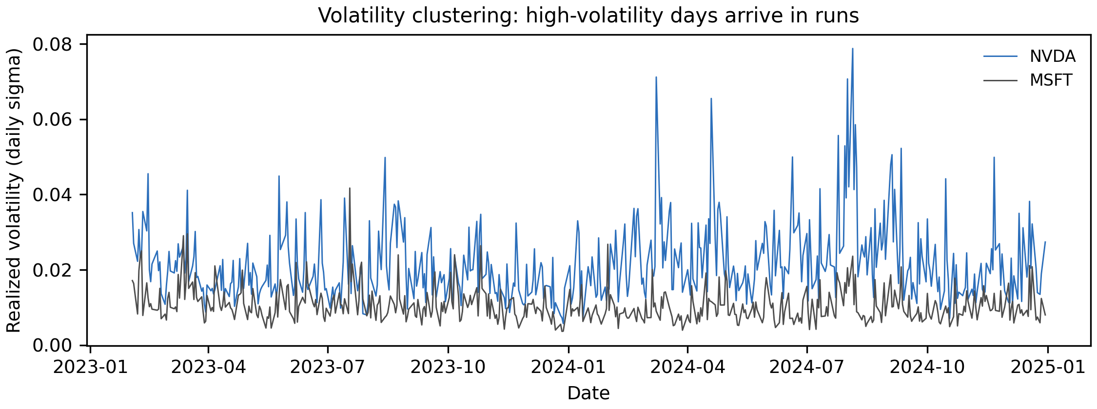
Note. Daily realized volatility across the 2023 to 2024 study window for two contrasting large-capitalisation tickers.
Volatility arrives in runs rather than independently from day to day: quiet periods persist and turbulent periods persist. This is why a forecasting model can achieve substantial accuracy from lagged volatility alone, and why the appropriate benchmark for RQ2 is a HAR baseline rather than a naive mean. It also sets a demanding standard for the sentiment features, which must improve upon a baseline that is already informative.
Table 6
Exploratory Data Analysis Insight Summary
Figure/Table Reference | What it Shows | Key Insight | Why it Matters (Link to RQ/Objective) | Decision/Next Step
Figure 1 | Distribution of the target, raw and logged | Right-skewed (1.81), fat-tailed; near-normal once logged | RQ2 estimates would be dominated by a few extreme days | Model the log target; report QLIKE alongside RMSE
Figure 2 | News coverage by ticker | Coverage ranges from 27% (PLTR) to 96% (MSFT) | Determines whether zero-attention days can be dropped | Retain zero-attention days; include news_missing
Figure 3 | Sentiment and attention distributions | Sentiment positive on 87% of days; attention concentrated at low counts | Limited negative variation caps the detectable sentiment effect | Use log attention; record the asymmetry as a limitation
Figure 4 | Quintile means, pooled versus within ticker | Attention effect reverses sign: -21.6% pooled, +9.9% within | A pooled model would report the wrong sign for RQ2 | Include ticker fixed effects in the RQ2 and RQ3 models
Figure 5 | Coverage against baseline volatility across tickers | Correlation of 0.69 produces a Simpson's paradox | Identifies the cause of the reversal in Figure 4 | Report within-ticker results as primary, pooled as contrast
Figure 6 | Predictor correlation matrix | rv_w correlates 0.63 with the target; sentiment only -0.11 | Sentiment cannot be assessed on raw correlation alone | Test sentiment by incremental contribution over HAR
Table 5 | Variance inflation factors | Maximum VIF 7.91; sentiment features at 1.36 and 1.20 | Confirms the coefficients will be interpretable | Retain the full control set unchanged
Figure 7 | Realized volatility over time | Pronounced volatility clustering | Justifies the HAR benchmark used for RQ2 | Benchmark against HAR rather than a naive mean
Note. Each row states the interpretation drawn from the exhibit and the design decision that follows from it.

Modelling
The overall research pipeline, from data collection through preprocessing, feature engineering, modelling, and evaluation, is shown in Figure 8.
Figure 8
End-to-End Research Pipeline
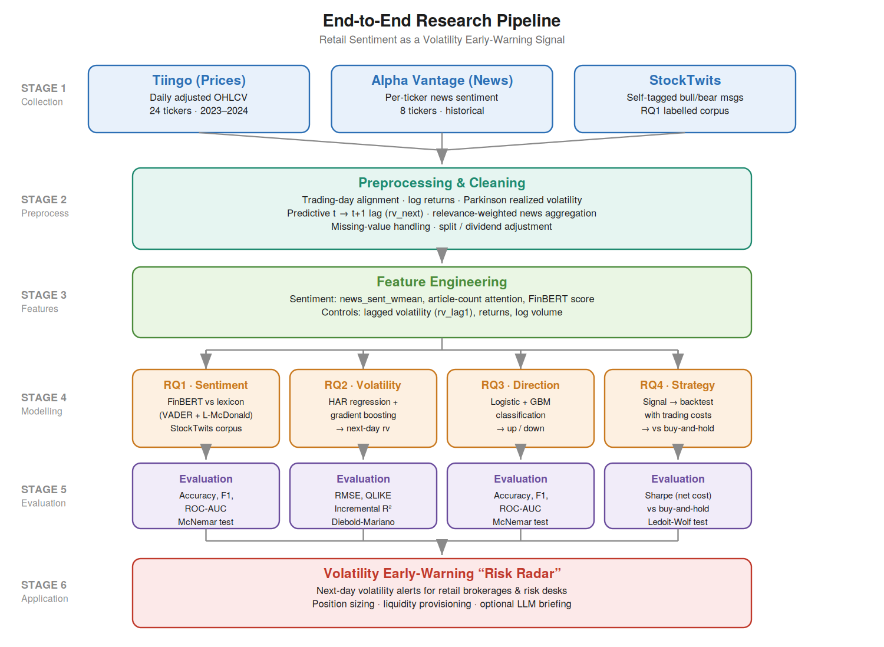
Note. The pipeline maps each of the four research questions to its model family and evaluation metrics, with StockTwits feeding RQ1 and Alpha Vantage news feeding RQ2–RQ4.

Choice of Models with Justification
Each research question is framed as a baseline-versus-augmented comparison, so that any improvement is attributable to sentiment rather than to model class. Models were selected on the basis of the literature, the data type, interpretability, and the evaluation task.
Model 1 — FinBERT vs. lexicon (RQ1): a transformer classifier (FinBERT) benchmarked against a VADER + Loughran–McDonald lexicon baseline, graded on StockTwits self-tagged labels. Justified by FinBERT's demonstrated gains in financial sentiment classification (Araci, 2019) and the transparency of the lexicon baseline (Loughran & McDonald, 2011).
Model 2 — HAR regression + gradient boosting (RQ2): a heterogeneous-autoregressive baseline for realized volatility, extended with sentiment features and a gradient-boosting regressor to capture non-linearities. Justified by the HAR model's standing in volatility forecasting and prior sentiment-volatility evidence (Audrino et al., 2020).
Model 3 — Logistic regression + gradient boosting (RQ3): a technicals-only classifier of next-day return direction, compared with a sentiment-augmented version. Justified by interpretability (logistic) and predictive strength (gradient boosting) on tabular data.
Model 4 — Sentiment-informed strategy backtest (RQ4): a transparent trading rule derived from the volatility signal, back-tested with transaction costs against buy-and-hold. Justified by the need to demonstrate economic, cost-aware value rather than statistical significance alone.

Features Included and Feature Engineering
The feature set combines news-derived sentiment features with lagged market controls; the target is the next-day realized volatility. Table 7 summarises the feature set and its usage.
Table 7
Feature Set and Usage
Feature | Type | Engineering | Used in
news_sent_wmean | Sentiment | Relevance-weighted daily mean | RQ2, RQ3, RQ4
news_article_count | Attention | Daily article count (log) | RQ2, RQ3
FinBERT sentiment | Sentiment (DL) | RQ1 model applied to news text | RQ2, RQ3
rv_lag1 | Control | Prior-day realized volatility | RQ2
log_return, abs_return | Control | Daily returns | RQ2, RQ3
log_volume | Control | log(1 + volume) | RQ2, RQ3

Evaluation Metrics (Formulae and Calculations)
Metrics are matched to each question's form. Table 8 lists the metrics, their formulae, and the research question to which each applies; worked illustrative calculations are retained from the synopsis and will be recomputed on real results in the final report.
Table 8
Evaluation Metrics and Formulae
Metric | Formula | Applies to
Accuracy | (TP + TN) / (TP + FP + TN + FN) | RQ1, RQ3
Precision / Recall | TP/(TP+FP) ; TP/(TP+FN) | RQ1, RQ3
F1 | 2(Precision × Recall)/(Precision + Recall) | RQ1, RQ3
ROC-AUC | Area under TPR-vs-FPR curve | RQ1, RQ3
McNemar's χ² | (|b − c| − 1)² / (b + c) | RQ1, RQ3
RMSE | √[(1/n) Σ(pred − actual)²] | RQ2
QLIKE | (1/n) Σ[(a/p) − ln(a/p) − 1] | RQ2
Sharpe ratio | (mean − rf)/sd, annualised × √252 | RQ4

Preliminary Results

Preliminary Findings (by Research Question)
[ Weeks 5–6 work. For each RQ, report what has been completed, what the preliminary outputs show (with references to Table/Figure numbers), and what remains. Begin with RQ1 (FinBERT vs. lexicon on the collected labelled corpus), which can be run first. ]

Preliminary Model Performance
Table 9
Preliminary Model Performance Comparison
RQ | Model | Baseline metric | Augmented metric | Change
RQ1 | FinBERT vs lexicon | [acc] | [acc] | [Δ]
RQ2 | HAR + sentiment | [RMSE/QLIKE] | [RMSE/QLIKE] | [Δ]
RQ3 | Technicals + sentiment | [acc/F1] | [acc/F1] | [Δ]
RQ4 | Strategy vs buy-and-hold | [Sharpe] | [Sharpe] | [Δ]

Interim Limitations and Risks
- Free-tier data quota (Alpha Vantage, 25 requests/day) constrains the sentiment universe to eight tickers and slows collection; mitigated by caching and resumable, per-ticker pulls.
- StockTwits serves only recent messages, so it supports RQ1 validation rather than the historical panel; mitigated by using Alpha Vantage news as the historical sentiment feature.
- Sentiment effects are expected to be economically small (per the literature); mitigated by conservative effect-size assumptions in the sample-size design.
- Rural hotspot connectivity causes intermittent collection timeouts; mitigated by retry/backoff and the option to collect from a stable cloud environment.

Next Steps (for Final Report)
- Complete Alpha Vantage news collection for all eight sentiment tickers.
- Assemble the final analysis panel and run data cleaning and EDA with interpretation.
- Train and validate FinBERT against the lexicon baseline (RQ1).
- Fit and evaluate the volatility (RQ2) and direction (RQ3) models out-of-sample.
- Run the cost-aware strategy backtest and significance test (RQ4).
- Report preliminary and final results, and draft the implementation, recommendation, and limitations sections.

Bibliography
Antweiler, W., & Frank, M. Z. (2004). Is all that talk just noise? The information content of internet stock message boards. The Journal of Finance, 59(3), 1259–1294. https://doi.org/10.1111/j.1540-6261.2004.00662.x
Araci, D. (2019). FinBERT: Financial sentiment analysis with pre-trained language models [Preprint]. arXiv. https://arxiv.org/abs/1908.10063
Audrino, F., Sigrist, F., & Ballinari, D. (2020). The impact of sentiment and attention measures on stock market volatility. International Journal of Forecasting, 36(2), 334–357. https://doi.org/10.1016/j.ijforecast.2019.05.010
Behrendt, S., & Schmidt, A. (2018). The Twitter myth revisited: Intraday investor sentiment, Twitter activity and individual-level stock return volatility. Journal of Banking & Finance, 96, 355–367.
Bollen, J., Mao, H., & Zeng, X. (2011). Twitter mood predicts the stock market. Journal of Computational Science, 2(1), 1–8. https://doi.org/10.1016/j.jocs.2010.12.007
Cohen, J. (1988). Statistical power analysis for the behavioral sciences (2nd ed.). Lawrence Erlbaum.
Das, S. R., & Chen, M. Y. (2007). Yahoo! for Amazon: Sentiment extraction from small talk on the web. Management Science, 53(9), 1375–1388.
Diebold, F. X., & Mariano, R. S. (1995). Comparing predictive accuracy. Journal of Business & Economic Statistics, 13(3), 253–263.
Ledoit, O., & Wolf, M. (2008). Robust performance hypothesis testing with the Sharpe ratio. Journal of Empirical Finance, 15(5), 850–859. https://doi.org/10.1016/j.jempfin.2008.03.002
Lopez-Lira, A., & Tang, Y. (2023). Can ChatGPT forecast stock price movements? Return predictability and large language models [Preprint]. arXiv. https://arxiv.org/abs/2304.07619
Loughran, T., & McDonald, B. (2011). When is a liability not a liability? Textual analysis, dictionaries, and 10-Ks. The Journal of Finance, 66(1), 35–65. https://doi.org/10.1111/j.1540-6261.2010.01625.x
Oliveira, N., Cortez, P., & Areal, N. (2017). The impact of microblogging data for stock market prediction: Using Twitter to predict returns, volatility, trading volume and survey sentiment indices. Expert Systems with Applications, 73, 125–144. https://doi.org/10.1016/j.eswa.2016.12.036
Patton, A. J. (2011). Volatility forecast comparison using imperfect volatility proxies. Journal of Econometrics, 160(1), 246–256. https://doi.org/10.1016/j.jeconom.2010.03.034
Renault, T. (2017). Intraday online investor sentiment and return patterns in the U.S. stock market. Journal of Banking & Finance, 84, 25–40. https://doi.org/10.1016/j.jbankfin.2017.07.002
Sprenger, T. O., Tumasjan, A., Sandner, P. G., & Welpe, I. M. (2014). Tweets and trades: The information content of stock microblogs. European Financial Management, 20(5), 926–957. https://doi.org/10.1111/j.1468-036X.2013.12007.x
Tetlock, P. C. (2007). Giving content to investor sentiment: The role of media in the stock market. The Journal of Finance, 62(3), 1139–1168. https://doi.org/10.1111/j.1540-6261.2007.01232.x
Yu, Y., Li, H., Chen, Z., Jiang, Y., Li, Y., Zhang, D., Liu, R., Suchow, J. W., & Khashanah, K. (2023). FinMem: A performance-enhanced LLM trading agent with layered memory and character design [Preprint]. arXiv. https://arxiv.org/abs/2311.13743

Appendix
[ Optional. Include any code referenced in the text (e.g., feature-building or collection scripts), with each appendix titled and referenced from the body. ]

