Data Analytics Capstone
Retail Sentiment as a Volatility Early-Warning Signal:
A Machine-Learning Study of StockTwits and U.S. Equity Risk
Interim Report

James Savage
Walsh College
QM640: Data Analytics Capstone
Mr. Sharath Srivatsa
Group 12
Term 3
August 4, 2026

Table of Contents
Introduction 5
Background and Context 5
Problem Statement 6
Purpose of the Study 6
Interim Project Status (Progress Snapshot) 6
Scope and Objectives 7
Research Question 1 (RQ1): Sentiment Measurement 8
Research Question 2 (RQ2): Volatility Prediction 8
Research Question 3 (RQ3): Direction Classification 9
Research Question 4 (RQ4): Strategy Evaluation 9
Literature Survey 9
Literature Review Approach 9
Data Description 11
Data Source(s) and Access 11
Dataset Overview 12
Data Dictionary (Mandatory) 12
GitHub Data Availability Statement 14
Screenshots / Evidence 14
Analysis 14
Data Cleaning 14
Exploratory Data Analysis 17
Sample Size Computation 24
Modelling 26
Data Preprocessing 27
Experimental Design and Validation Strategy 27
Regression Diagnostics and Model Selection 28
Choice of Models with Justification 28
Features Included and Feature Engineering 29
Evaluation Metrics (Formulae and Calculations) 30
Preliminary Results 30
RQ1: Sentiment Measurement 30
RQ2: Volatility Prediction 33
RQ3: Direction Classification 35
RQ4: Strategy Evaluation 36
Link to the Research Questions 39
Interim Limitations and Risks 39
Next Steps (for Final Report) 40
Bibliography 41
Appendix 44
Appendix A: Repository and Dataset Evidence 44

GitHub repository (data and code): https://github.com/JamesSavages/Retail_Sentiment_and_Market_Volatility

Introduction

Background and Context
Financial markets are driven not only by fundamentals but by the collective mood of those trading them, now broadcast in real time on social platforms and financial news. A substantial literature links this visible sentiment to market behavior, connecting message board and microblog activity to trading volume and volatility (Antweiler & Frank, 2004; Sprenger et al., 2014) and social media mood to index movements (Bollen et al., 2011). The evidence is strongest for volatility and volume rather than returns, which are closer to efficient (Audrino et al., 2020).
For brokerages, robo advisors and risk desks the valuable question is not what the crowd feels today but which stocks will be volatile tomorrow. An accurate early warning signal for next day volatility informs risk alerts, position sizing and liquidity decisions.
Measuring sentiment is itself a research problem. Dictionary methods misclassify financial language (Loughran & McDonald, 2011), whereas transformers such as FinBERT read text in context (Araci, 2019), and large language models show an emerging capacity for financial reasoning (Lopez-Lira & Tang, 2023). A further constraint is endogeneity, since a news event moves sentiment and price at once, so contemporaneous associations cannot identify the direction of influence. This study therefore adopts a predictive rather than causal design, relating sentiment at day t to volatility at t + 1.

Problem Statement
Retail investors generate a continuous public record of market sentiment, and the brokerages and robo advisors serving them already surface that stream back to users. What those firms cannot do is convert it into a forward looking risk measure. Sentiment is presented descriptively, as a mood gauge of what the crowd feels today, when the useful question is which stocks will move sharply tomorrow. Volatility surprises are where retail users are most exposed and where hedging costs fall, so the absence of an early warning signal is a commercial problem as well as an analytical one. Prior research has addressed the question at index level using lexicon measures, reporting statistical association rather than economic value. This study therefore predicts next day realized volatility (Y) for eight high liquidity United States technology equities, with the ticker day as the unit of analysis, from retail sentiment features (X = relevance weighted news sentiment and daily article volume as an attention proxy) with lagged market controls, over January 2023 to December 2024. Success is evaluated by out of sample forecast error (RMSE and QLIKE) and by the risk adjusted return of a sentiment informed strategy, net of transaction costs.

Purpose of the Study
The study is primarily predictive and combines four analytical modes. Measurement validates how sentiment is quantified. Explanation quantifies its marginal information beyond price history. Classification predicts next day return direction. Inference tests whether a sentiment informed strategy improves risk adjusted return net of costs.

Interim Project Status
- Completed: synopsis and literature review. Daily prices collected from Tiingo for all 24 tickers in the sampling frame, news sentiment from Alpha Vantage for the eight tickers forming the analysis sample, and a StockTwits corpus yielding 3,152 usable labelled messages. The pipeline was implemented and validated end to end by a script running 27 data quality and integrity checks. The panel is assembled, cleaned and explored, and all four research questions have been modelled and tested out of sample.
- In progress: verification of the literature relevance matrix against the source papers, and refinement of the results interpretation.
- Pending: RQ2 robustness to alternative specifications and a longer forecast horizon, extension of the window to a second volatility regime subject to quota constraints, re estimation of RQ4 across both regimes, a fine-tuned FinBERT trial against the RQ1 accuracy gap, and the implementation and recommendation sections.

Scope and Objectives
This study is organised around four research questions, each addressing a distinct aspect of the relationship between retail sentiment and equity risk. Table 1 states each as a measurable objective and binds it to the variables that answer it, using the names defined in the Data Dictionary (Table 3), together with the decision criterion fixed in advance of estimation and the outcome obtained so far. Each question is then set out below with its hypotheses, and all tests are evaluated at the 5% level.
Table 1
Research Questions, Objectives, Variables and Decision Criteria
RQ | Objective | Target variable | Predictor variables (Data Dictionary) | Method and test | Decision criterion and interim outcome
RQ1 | Validate the sentiment instrument before it is used as a feature. | sentiment_basic (self tagged label, message level) | Message text (body). No panel variables enter this question; the corpus is analysed at message level and is deliberately not merged into the RQ2-RQ4 panel. | FinBERT benchmarked against VADER + Loughran-McDonald. McNemar, with a paired bootstrap on balanced accuracy and AUC. | Criterion: FinBERT's balanced accuracy exceeds the lexicon's at the 5% level. Partially met: ranking ability is higher (AUC .712 against .614) but raw accuracy is lower.
RQ2 | Quantify the marginal information in sentiment beyond price history. | rv_next, modelled as log(rv_next) | Sentiment block: news_sent_wmean, log_articles, news_missing. Baseline controls: rv, rv_w, rv_m, log_volume. Ticker fixed effects in both specifications. | HAR baseline against the same specification augmented with the sentiment block. Incremental F-test in sample; Diebold-Mariano on QLIKE out of sample. | Criterion: the sentiment coefficients are jointly non zero at the 5% level and out of sample QLIKE falls. Met: F = 3.61, p = .013; DM = 4.82, p < .001.
RQ3 | Test whether the same features carry into return direction. | Sign of ret_next, derived from log_return | As RQ2, with log_return and abs_return added to the control block. | Logistic regression and gradient boosting, each fitted baseline and augmented on identical folds. McNemar. | Criterion: the accuracy gain is significant at the 5% level. Not met, as the design anticipated: +0.22 percentage points, p = .714.
RQ4 | Convert the volatility forecast into cost aware economic value. | Daily portfolio excess return | The RQ2 walk forward forecast of rv_next drives the exposure weight; realized log_return drives the payoff. Costs charged at 5 and 10 basis points on the change in weight. | Volatility target exposure rule back tested against equal-weight buy-and-hold. Ledoit-Wolf robust Sharpe test with a circular block bootstrap. | Criterion: the strategy's Sharpe ratio exceeds buy-and-hold at the 5% level net of costs. Not met: p = .090 at 10 bp, on 247 evaluated days against the 1,558 the power analysis requires.

Note. Variable names are defined in the Data Dictionary (Table 3) and correspond one to one with the columns of data/processed/panel.csv. Feature sets are reproduced in src/run_rq1.py through src/run_rq4.py. Outcomes are provisional and are reported in full, with the supporting figures, in the Preliminary Results section.

Research Question 1 (RQ1): Sentiment Measurement
How accurately can a transformer model (FinBERT) classify StockTwits message sentiment, benchmarked against users' self tagged labels and a lexicon baseline of VADER with the Loughran McDonald dictionary (Araci, 2019; Loughran & McDonald, 2011)?
- $H_{0}$: FinBERT's accuracy is no greater than the lexicon's.
- $H_{1}$: FinBERT's accuracy is greater than the lexicon's.
Both classifiers score on identical messages, so McNemar's test applies, with a paired bootstrap because 82% of the corpus is tagged as bullish.

Research Question 2 (RQ2): Volatility Prediction
Does aggregated daily sentiment at day t predict next day realized volatility at t + 1, controlling for lagged volatility and trading volume? A heterogeneous autoregressive (HAR) baseline is compared with the same specification augmented by sentiment and attention features, with ticker fixed effects in both, for the reason established in Figure 5.
- $H_{0}$: the sentiment coefficients are jointly zero.
- $H_{1}$: at least one is non zero.
Testing uses an incremental F-test in sample and the Diebold Mariano test on QLIKE losses out of sample (Diebold & Mariano, 1995; Patton, 2011).

Research Question 3 (RQ3): Direction Classification
Do sentiment features improve next day return direction prediction against a baseline? Logistic regression and gradient boosting are each trained on market controls alone, then with sentiment added.
- $H_{0}$: the augmented sentiment classifier is not more accurate.
- $H_{1}$: the augmented sentiment classifier is more accurate.
Both are evaluated on identical test observations, so McNemar's test applies. Daily direction is close to a coin flip, so a null result is an anticipated outcome.

Research Question 4 (RQ4): Strategy Evaluation
Does a sentiment informed trading strategy produce a statistically significant improvement in risk adjusted return over buy and hold, net of transaction costs? The volatility forecast is converted into a transparent exposure rule and back tested with realistic costs.
- $H_{0}$: the strategy's Sharpe ratio is no greater.
- $H_{1}$: the strategy's Sharpe ratio is greater.
Significance uses the Ledoit-Wolf (2008) robust test with a circular block bootstrap, so that neither normality nor serial independence is assumed.

Literature Survey

Literature Review Approach
Sources were identified through Google Scholar, Scopus, Web of Science, ScienceDirect, SSRN and arXiv, using Boolean combinations of the study's concept clusters. Inclusion was limited to peer reviewed empirical work linking textual sentiment to a measurable market outcome, with priority given to highly cited papers in leading finance and forecasting journals, balanced against recency. Table 2 summarises the most relevant studies.
Table 2
Literature Relevance Matrix
Author (Year) | Domain / Context | Dataset / Setting | Method(s) | Key Findings | How it supports RQ(s)
Antweiler & Frank (2004) | Message board sentiment and market activity | Internet message board posts, US large cap equities | Computational linguistics bullishness index | Messages predict volatility; disagreement predicts volume; return effect small | Anchors the volatility over returns focus and the article count attention feature
Das & Chen (2007) | Extracting sentiment from web small talk | Message board postings, US technology stocks | Multi classifier voting | Sentiment tracks index moves; activity relates to volatility | Early evidence linking posting activity to volatility
Tetlock (2007) | Media tone and the stock market | Daily financial press column, US market aggregate | Media pessimism factor; VAR | Pessimism predicts price pressure then reversion; extremes predict volume | Frames the endogeneity/simultaneity concern
Bollen et al. (2011) | Social media mood and the market | Public Twitter feed, US index level | Mood dimensions + causality tests | Reported mood relates to index moves; noted as fragile | Motivates a reproducible, firm level design
Loughran & McDonald (2011) | Sentiment in financial text | Corpus of US 10-K regulatory filings | Finance specific dictionaries | General dictionaries misclassify financial tone | Basis for the lexicon baseline in RQ1
Sprenger et al. (2014) | Microblog sentiment and trading | Cashtag microblog messages, US large cap equities | ML sentiment + regression | Sentiment relates to returns; disagreement to volatility | Supports microblog sentiment and attention features
Oliveira et al. (2017) | Microblog data for market prediction | Microblog data, US indices and portfolios | Sentiment indicators + multiple ML | Improves volatility/volume forecasts; weaker for returns | Validates the feature family and volatility target
Renault (2017) | StockTwits investor sentiment | StockTwits messages, US index ETF, intraday | Custom lexicon vs. ML | Sentiment predicts intraday index returns; lexicon competitive | StockTwits specific precedent and baseline
Behrendt & Schmidt (2018) | Twitter sentiment and intraday volatility | Twitter messages, index constituents, intraday | GARCH + intraday sentiment | Adds little to intraday volatility once controlled | Cautionary; motivates conservative effect sizes
Araci (2019) | Transformer sentiment for finance | Labelled financial sentiment benchmark corpora | FinBERT (fine tuned BERT) | Improves financial sentiment classification | The deep learning method used in RQ1
Audrino et al. (2020) | Sentiment/attention and volatility | StockTwits, search and news attention measures, US equities | Penalized regression on HAR | Attention and StockTwits volume improve realized volatility forecasts | Closest precedent; frames the per ticker, business evaluated gap
Lopez-Lira & Tang (2023) | LLMs and return predictability | News headlines scored by a large language model, US equities | GPT-4 on news headlines | Predicts reactions; edges decay as adoption spreads | Frontier LLM evidence; reinforces volatility focus
Yu et al. (2023) | LLM trading agents | Financial news and filings, small set of US equities | FinMem agent with layered memory | Autonomous agent enhances trading decisions | Grounds the optional agentic briefing extension

Three themes connect this literature to the present study. On outcome selection, sentiment and attention forecast volatility and volume more reliably than returns (Antweiler & Frank, 2004; Oliveira et al., 2017; Audrino et al., 2020), so this study targets volatility. On measurement, the field has moved from finance dictionaries (Loughran & McDonald, 2011) through transformers (Araci, 2019) and large language models (Lopez-Lira & Tang, 2023), which is why RQ1 positions FinBERT against a lexicon. On the research gap, prior work sits at index level and reports statistical rather than economic value. This study operationalises transformer sentiment as a per ticker early warning signal, validated through a cost aware backtest and an open pipeline.

Data Description

Data Source(s) and Access
The study draws on three free, publicly accessible sources. Daily split and dividend adjusted prices come from Tiingo (https://www.tiingo.com), historical per ticker news sentiment from Alpha Vantage (https://www.alphavantage.co), and recent labelled messages from the StockTwits API (https://api.stocktwits.com). Prices supply the target and market controls, Alpha Vantage the historical sentiment feature for RQ2 to RQ4, and StockTwits the human labelled corpus for RQ1. An initial price source (Stooq) blocked automated access and Alpha Vantage's full history endpoint proved premium gated, so Tiingo was adopted after validating access.

Dataset Overview
The analysis panel is a ticker day table combining price controls, the next day realized volatility target and news sentiment features.
- Number of records (rows): 3,840 usable ticker days (eight sentiment tickers, 480 trading days each) drawn from a 24-ticker, 11,873-row price panel.
- Number of variables (columns): 15 principal variables (see Table 3).
- Time period: 3 January 2023 to 31 December 2024.
- Unit of analysis: the ticker day.
- Target variable(s): next day realized volatility (rv_next), estimated from daily open high low close (OHLC) prices via the Parkinson estimator.

Data Dictionary
Table 3
Data Dictionary (Principal Variables)
Variable Name | Source | Definition | Datatype | Allowed Values/Range | Missing Values Handling | Notes
symbol | All | Stock ticker symbol identifying the equity | string | 24 tickers (see config.TICKERS) | None permitted; row invalid without it | Key. Analysis sample restricted to the 8 tickers in NEWS_TICKERS
date | All | Trading date (US/Eastern) of the observation | date | 2023-01-03 to 2024-12-31, NYSE trading days | None permitted; row invalid without it | Key. Non trading days absent by construction, not imputed
close | Tiingo | Split- and dividend adjusted daily closing price | float | > 0 USD | None observed | Raw. Adjusted series, so corporate actions create no false volatility
log_return | Derived | Daily log return, ln(close_t / close_t-1) | float | approx. -0.5 to +0.5 log points | Null on each ticker's first day; row excluded | Control. Used lagged, never contemporaneously with the target
abs_return | Derived | Absolute daily log return | float | >= 0 log points | Null where log_return is null; row excluded | Control. Correlated with rv; monitored via VIF (Table 6)
log_volume | Derived | Log adjusted share volume, log(1 + volume) | float | > 0 ln(shares) | None observed | Control. log1p so a zero volume day maps to 0, not minus infinity
rv | Derived | Realized volatility at t from the high low range (Parkinson) | float | > 0 daily sigma | None observed | Control. Known at the close of t; daily HAR component
rv_lag1 | Derived | Realized volatility at t-1 | float | > 0 daily sigma | Null on each ticker's first day; row excluded | Control. Retained for continuity with the synopsis specification
rv_w | Derived | Weekly HAR component: mean rv over t-4 to t inclusive | float | > 0 daily sigma | Null for the first 4 days per ticker; rows excluded | Control. Window ends at t because rv_t is observable at that close
rv_m | Derived | Monthly HAR component: mean rv over t-21 to t inclusive | float | > 0 daily sigma | Null for the first 21 days per ticker; rows excluded | Control. Binding on sample size: costs 21 ticker days per ticker
rv_next | Derived | Next day realized volatility (t+1) | float | > 0 daily sigma | Null on each ticker's final day; row excluded | TARGET. The only column using information dated after t, by design
news_sent_wmean | Alpha Vantage | Relevance weighted mean news sentiment on day t | float | -1 (bearish) to +1 (bullish) | Set to 0.0 (neutral) on queried tickers with no articles, flagged by news_missing; null for tickers never queried | Predictor. Weights are Alpha Vantage relevance scores
news_article_count | Alpha Vantage | Articles referencing the ticker on day t; attention proxy | int | >= 0 articles | Set to 0 on queried tickers with no articles (a genuine low attention observation); null for tickers never queried | Predictor. Zero article days retained; dropping them truncates attention at 1
news_missing | Derived | 1 if the ticker day had no articles, 0 otherwise | int | {0, 1} | Null for tickers never queried for news | Flag. Separates neutral coverage from absent coverage
log_articles | Derived | Log attention proxy, log(1 + news_article_count) | float | >= 0 | Null where news_article_count is null | Predictor. Well defined only because zero article days are retained

Note. The panel contains 15 variables. The StockTwits labelled corpus (id, created_at, symbol, body, sentiment_basic) is used separately for RQ1 sentiment model validation and is not part of the historical RQ2–RQ4 panel ensuring that no user identifying fields are retained. Generated by src/make_data_dictionary.py and versioned at data/data_dictionary.md.

GitHub Data Availability Statement
The raw and processed datasets and all code are openly available in the project repository (path provided at the beginning of report):
- Raw data: data/raw/{prices, news, stocktwits}/
- Processed/clean data: data/processed/panel.csv, with a 120-row GitHub sample available at data/processed/panel_preview.csv
- Code/notebooks: src/ (collection, feature building, validation, exploratory analysis and the four research question modelling scripts)

Screenshots / Evidence
Appendix A, Figures A1 to A5, evidences the repository structure, the raw price, news and StockTwits files, and a preview of the processed panel.

Analysis
This section documents how the analysis sample was constructed, then reports the exploratory analysis informing of the modelling decisions. Every figure and table here is generated by src/run_eda.py, so all values are reproducible.

Data Cleaning
Cleaning is implemented in src/build_features.py and verified by src/validate_panel.py, which recomputes every derived variable from the raw files and fails if any value disagrees. Its 27 checks span key uniqueness, news integrity, corporate actions and the point in time test below. All 27 pass, so a corrupted panel cannot reach the modelling stage.
The price panel contains 11,873 ticker days across 24 technology equities, 175 fewer than the 12,048 implied by 502 trading days. This is due to Arm Holdings listed in September 2023. Restricting to the eight tickers with news sentiment leaves 4,016. Removing each series' final day, where the target is undefined, and its first 21 days, where the monthly heterogeneous autoregressive (HAR) component lacks history, yields 3,840 ticker days, exactly 480 per ticker. Table 4 records each step.
Table 4
Data Cleaning Log
Issue | Variables Affected | Detection Method | Treatment Applied | Records Affected | Rationale
Duplicate ticker days | symbol, date | Key uniqueness assertion in validate_panel.py | None found; no action required | 0 (0.00%) | Data quality
Tickers outside the sentiment universe | news_sent_wmean, news_article_count | Free tier quota of 25 requests per day | Excluded from the analysis sample; retained in the repository as the pre specified sampling frame | 7,857 (66.18%) | Quota constraint, not a data defect; documents that the eight were fixed in advance rather than selected on results
Target undefined at series end | rv_next | Null check after the t to t+1 shift | Excluded, one ticker day per ticker | 8 (0.07%) | Next day volatility does not exist for the final observation
HAR burn in window | rv_m | 22 day rolling mean requires 22 prior observations | Excluded 21 ticker days per ticker | 168 (1.42%) | Monthly HAR component undefined until the window fills
No news articles on a trading day | news_sent_wmean, news_article_count | Gap between the news files and the trading calendar | Retained as zero attention observations: article count 0, sentiment 0 (neutral), indicator news_missing = 1 | 945 (7.96%) | A zero article day is a genuine low attention observation, not a missing measurement
Extreme one day price moves | close, rv | Screen for absolute close to close moves above 30%, cross checked against split ratios and the volatility path | Both flagged moves verified as post earnings repricing’s and retained; no winsorising or trimming applied | 2 (0.02%) | Extreme volatility is the phenomenon under study, not noise to remove
User identifying fields | user_id, user_followers | Privacy review of the StockTwits collector | Removed at collection and stripped from 23 existing files | 23 files | Ethics: no individual user is profiled or re published

Note. Percentages are of the 11,873-row collected price panel. Exclusions are sequential, leaving an analysis sample of 3,840 ticker days. Counts are produced by src/run_eda.py and written to docs/tables/eda_cleaning_log.csv.
Two treatment decisions warrant explanation. The first concerns the 945 ticker days, 24.6% of the sample, on which no article mentioned the ticker. An earlier pipeline discarded these rows because the join produced no match. That was wrong. A day without coverage is a genuine low attention observation, not a failed measurement, and discarding such days truncates the attention variable at one article and removes the contrast the study depends on. The loss would also have fallen unevenly, with Palantir forfeiting 73% of its history against Microsoft's 4%. These days are retained with a zero count, a neutral score and an indicator separating neutral from what was previously an absent coverage. This raises the sample from 3,026 to 3,840 and applies only to the eight tickers queried. For the remaining sixteen no request was made, so their news fields stay null. Recording a zero would fabricate an observation from an absence of collection.
The second decision concerns outliers, where no trimming or winsorising was applied. A check for absolute close to close moves above 30% flagged ARM on 8 February 2024 (+47.9%) and PLTR on 6 February 2024 (+30.8%). The only mechanical explanation that would justify removing them is an unadjusted stock split, which changes the quoted price without anything happening to the company. Two signs rule that out. A split moves the price by a simple fraction, whereas these ratios are 1.479 and 1.308, and a split leaves volatility unchanged, whereas both show volatility rising over several sessions, ARM from 0.030 to 0.179. Both are genuine post earnings repricing’s, and since the study forecasts such events, removing them would remove the signal of interest.
Because the study makes a forecasting claim, no predictor may contain information dated after day t, and this is verified rather than assumed. For a random sample of ticker days the script rebuilds every predictor from records dated on or before t and requires an exact match, the largest discrepancy being of the order of ten to the power of minus sixteen. Realized volatility at t uses that day's high and low, so it is known at the close and admissible as a predictor of t + 1.

Exploratory Data Analysis
Table 5 summarises the analysis sample. Averaging volatility over longer windows progressively removes the right tail, with skewness falling from 1.81 for the daily series to 0.62 for the monthly average.
Table 5
Descriptive Statistics for the Analysis Sample
Variable | N | M | Mdn | SD | IQR | Min | Max | Skew | Kurtosis
rv_next (target) | 3,840 | 0.0184 | 0.0158 | 0.0107 | 0.0124 | 0.0032 | 0.1003 | 1.81 | 5.42
rv (daily HAR) | 3,840 | 0.0185 | 0.0158 | 0.0108 | 0.0124 | 0.0032 | 0.1003 | 1.81 | 5.35
rv_w (weekly HAR) | 3,840 | 0.0185 | 0.0170 | 0.0085 | 0.0117 | 0.0045 | 0.0583 | 1.07 | 1.43
rv_m (monthly HAR) | 3,840 | 0.0186 | 0.0178 | 0.0074 | 0.0115 | 0.0070 | 0.0467 | 0.62 | -0.11
news_sent_wmean | 3,840 | 0.1365 | 0.1320 | 0.1774 | 0.2677 | -0.6165 | 0.8746 | -0.12 | 0.57
news_article_count | 3,840 | 2.20 | 2.00 | 2.32 | 2.00 | 0 | 26 | 2.30 | 12.10
log_articles | 3,840 | 0.9354 | 1.0986 | 0.6770 | 0.6931 | 0.0000 | 3.2958 | 0.08 | -0.82
log_return | 3,840 | 0.0022 | 0.0013 | 0.0275 | 0.0252 | -0.1638 | 0.2685 | 1.08 | 10.54
log_volume | 3,840 | 17.85 | 17.74 | 0.99 | 1.17 | 15.37 | 21.16 | 0.63 | 0.10

Note. Realized volatility is expressed in daily sigma units. Sentiment is relevance weighted and bounded at -1 and +1. Values are written to docs/tables/eda_descriptives.csv.
Figure 1 shows why the target is modelled on a logarithmic scale. Raw next day realized volatility is strongly right skewed (skewness 1.81, kurtosis 5.42), and logging reduces this to 0.09. Two decisions follow. The regression target is the logarithm of next day volatility, and accuracy is reported using QLIKE alongside RMSE. This is because squared error loss on a fat tailed target rewards fitting the extreme tail at the expense of the rest.
Figure 1
Distribution of Next Day Realized Volatility, Raw and Log Scale
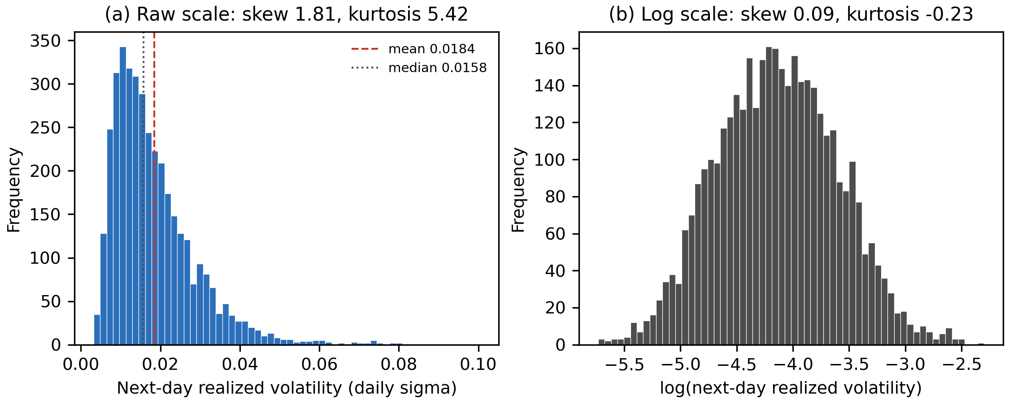
Note. Panel (a) shows the raw target and panel (b) its natural logarithm, each with 60 bins.
Figure 2 shows that coverage is highly uneven, from 96% of trading days for Microsoft to 27% for Palantir. Coverage is therefore a firm characteristic, which justifies retaining zero attention days and including the news_missing indicator, and it anticipates the confounding problem in Figure 5.
Figure 2
News Coverage by Ticker Within the Analysis Sample
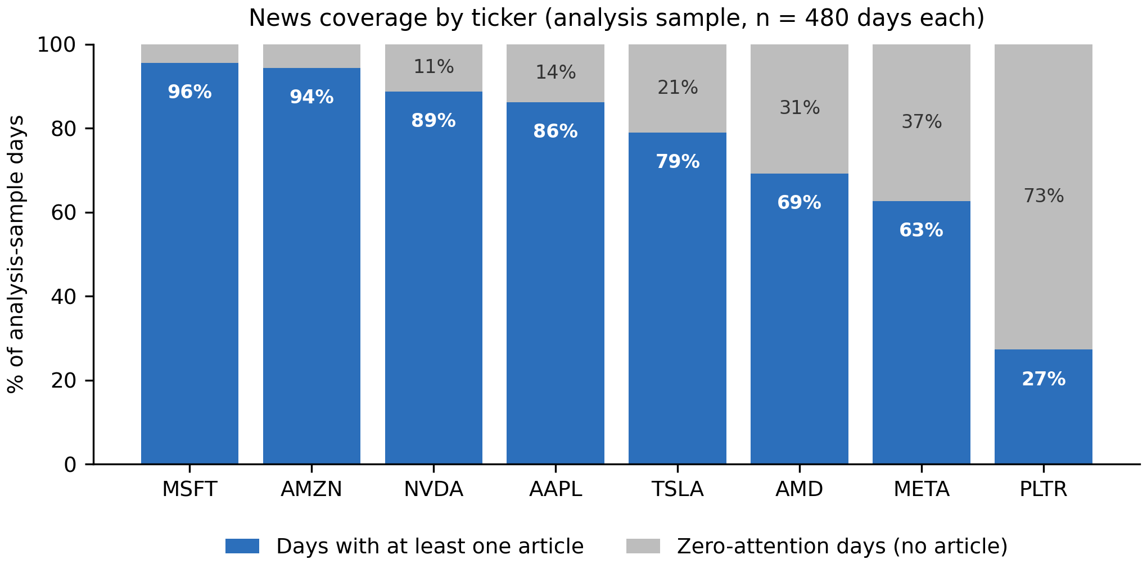
Note. Each ticker contributes exactly 480 ticker days.
Figure 3 reveals an asymmetry with direct consequences. Relevance weighted sentiment averages +0.181 and is positive on 87% of days with news, so the measure carries far less negative than positive variation, compressing the range over which an effect could be detected. Attention is concentrated at low values, a median of two articles against a maximum of 26, which is why it enters in logarithmic form.
Figure 3
Distribution of News Sentiment and Attention
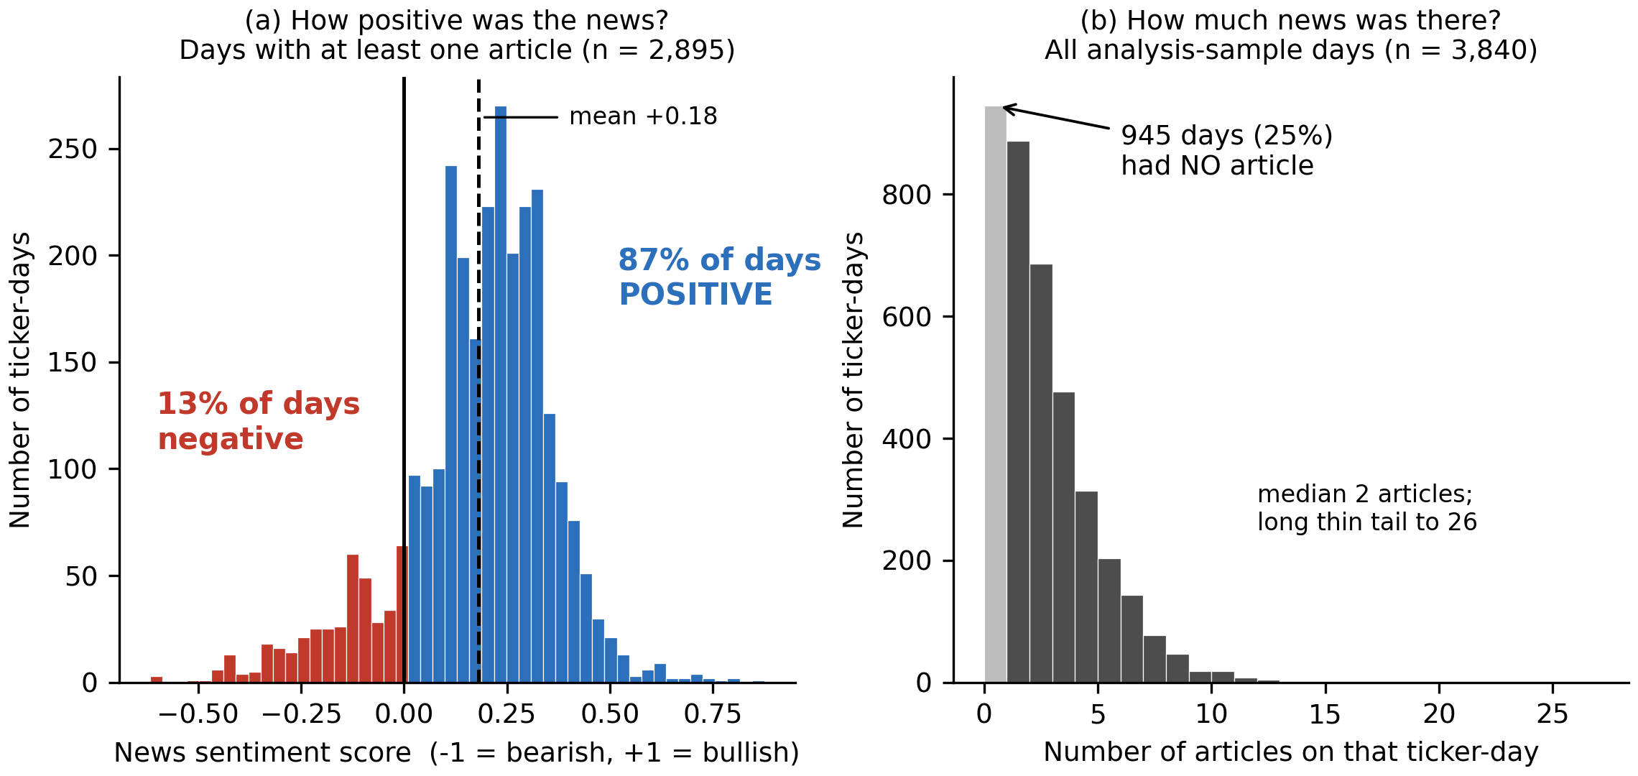
Note. Panel (a) is restricted to days with at least one article. Panel (b) includes all analysis sample days.
Figure 4 contains the most consequential finding of the exploratory analysis. By pooling the tickers together, moving from the lowest to the highest attention band is associated with -28.7% lower next day volatility, contradicting the established result that attention and volatility move together (Audrino et al., 2020). Comparing each ticker against its own mean reverses the sign, with days of seven or more articles carrying 9.3% higher volatility than days with none. Sentiment shows no consistent pattern either way. The pooled estimate is an artefact, for the reason set out in Figure 5, so the RQ2 models must include ticker fixed effects.
Figure 4
Next Day Volatility by Predictor Group, Pooled and Within Ticker
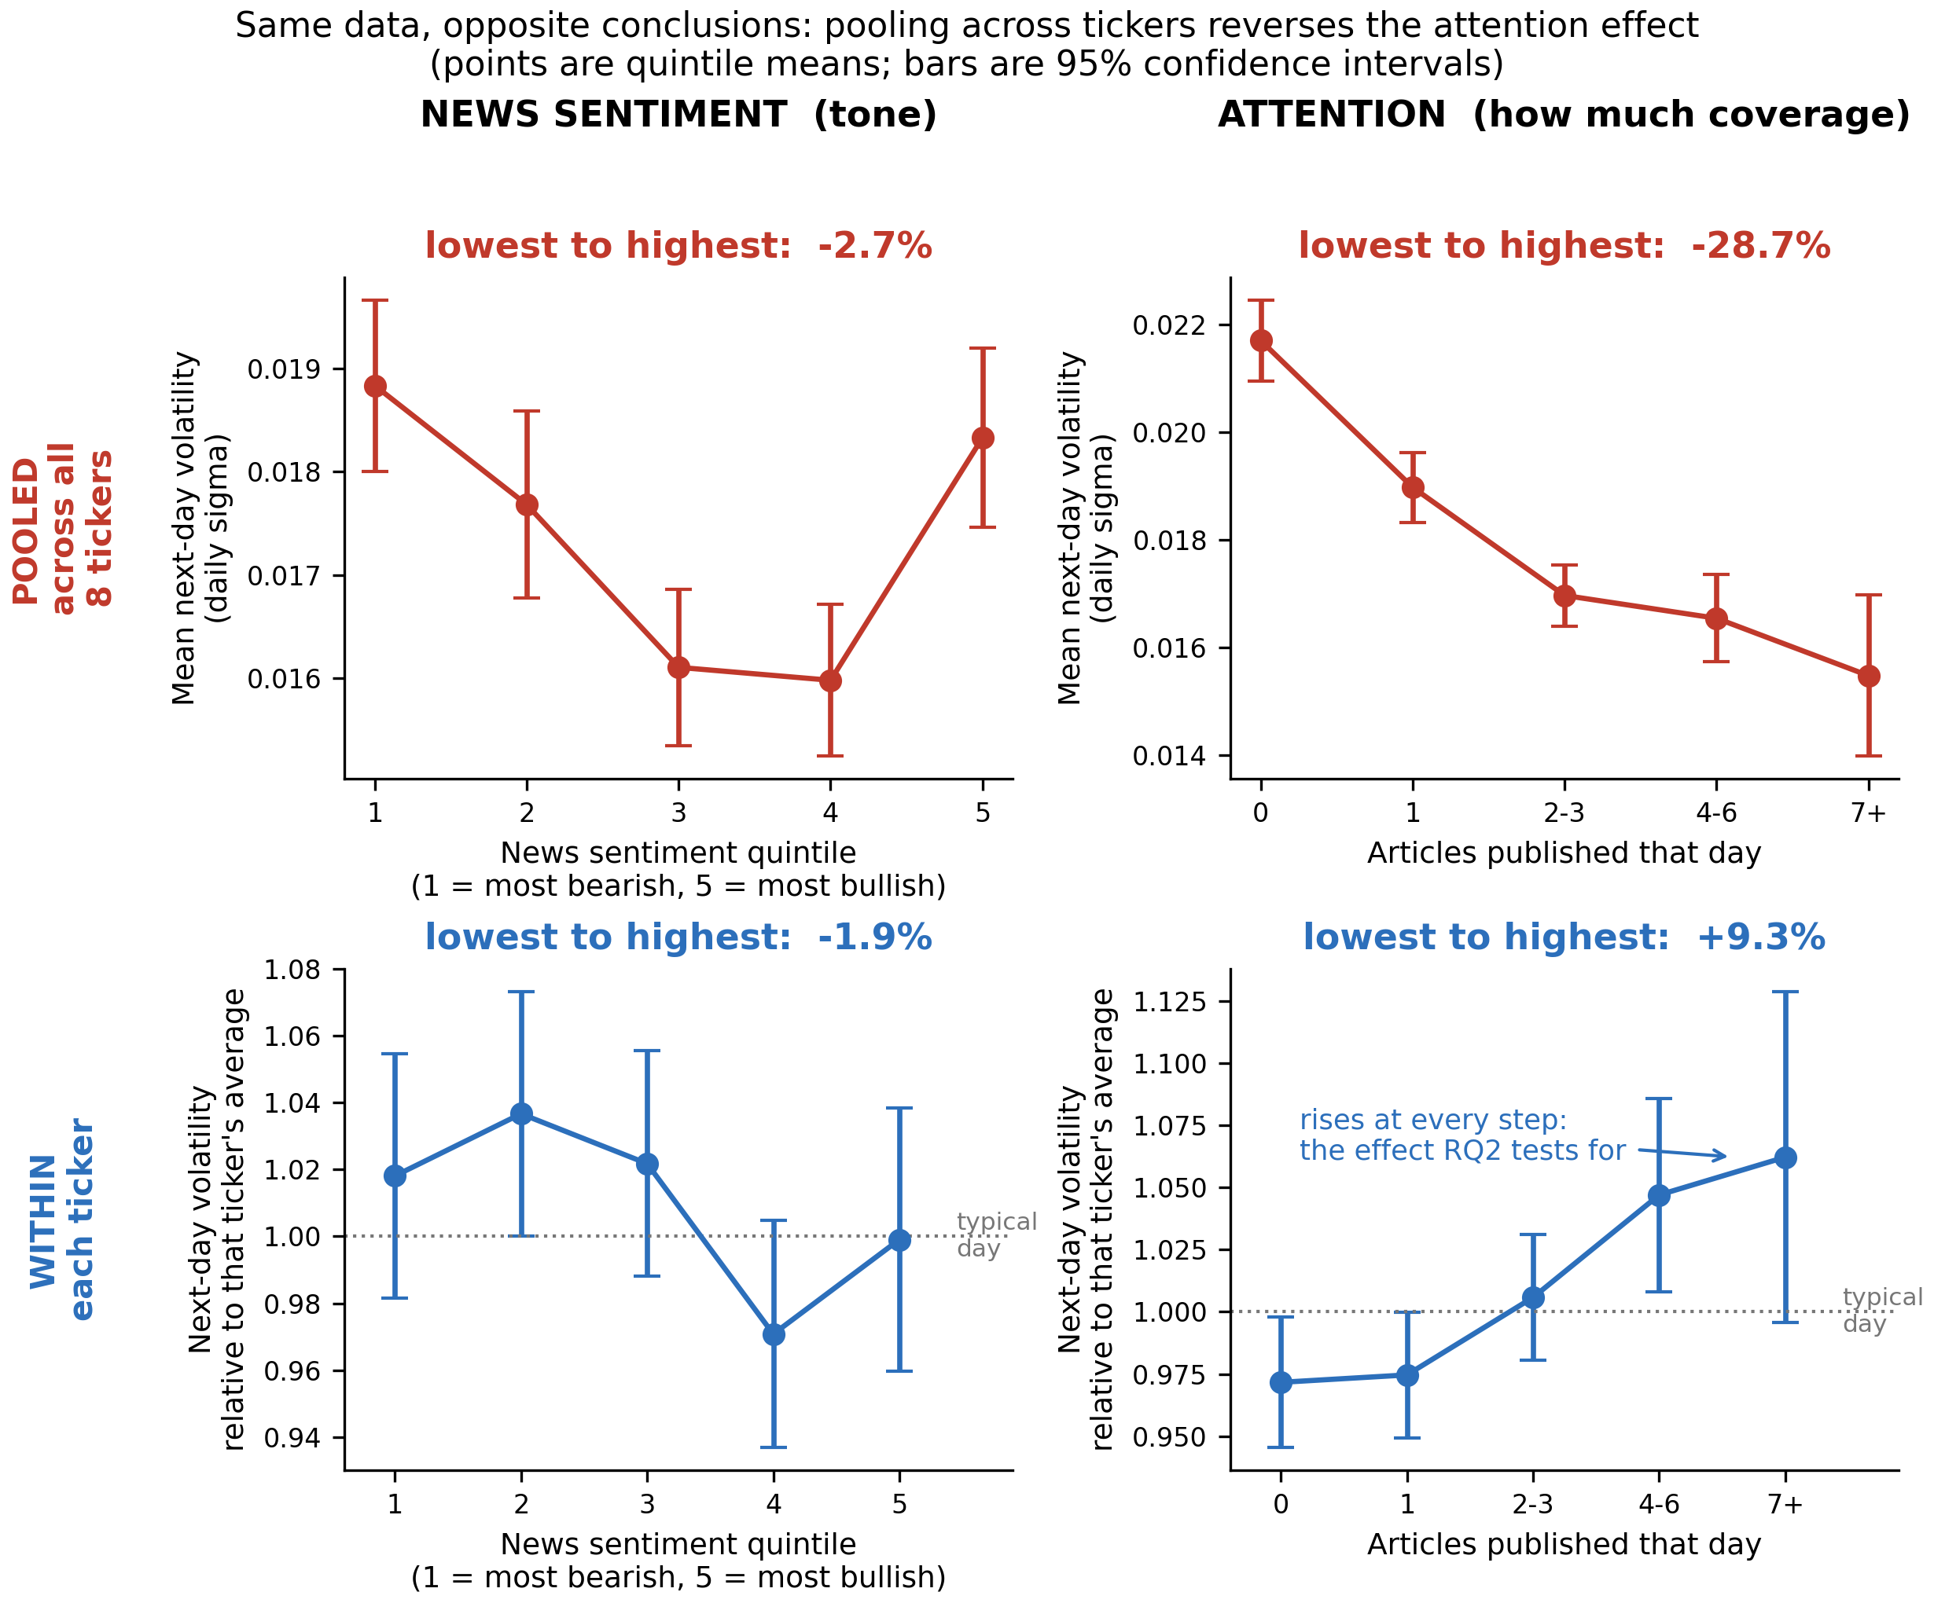
Note. Upper panels pool all tickers. Lower panels express the target relative to each ticker's own mean, so 1.00 denotes a typical day for that stock. Sentiment is grouped into quintiles, whereas attention is grouped by article count rather than quintiles, because a quarter of ticker days have exactly zero articles and quantile boundaries would either collapse or split identical observations. Error bars are 95% confidence intervals.
Figure 5 explains the sign reversal. Across the eight tickers the proportion of zero attention days correlates 0.69 with average volatility, Palantir having the least coverage and the highest volatility and Microsoft the reverse. In pooled data, low attention therefore acts largely as a label for which stock is being observed rather than as information about what will happen to it. This is a Simpson's paradox, in which a relationship holding within each group reverses when the groups are combined. Only the within ticker comparison is informative.
Figure 5
Cross Sectional Confounding Between Coverage and Baseline Volatility
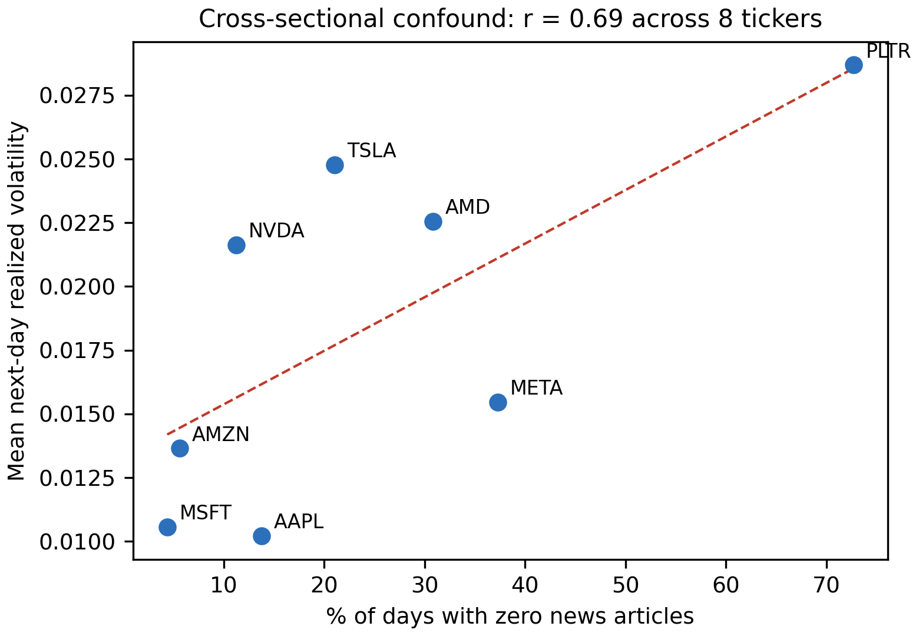
Note. Each point is one of the eight tickers in the analysis sample. The dashed line is an ordinary least squares fit.
Figure 6 confirms that lagged volatility dominates the predictor set. The weekly HAR component correlates 0.63 with the target, news sentiment only -0.11 and attention -0.19. Sentiment therefore cannot be judged by its raw association with next day volatility, but by whether it adds explanatory power once the HAR components are in the model. The test for RQ2 is accordingly an incremental one.
Figure 6
Correlation Matrix of Predictors and Target
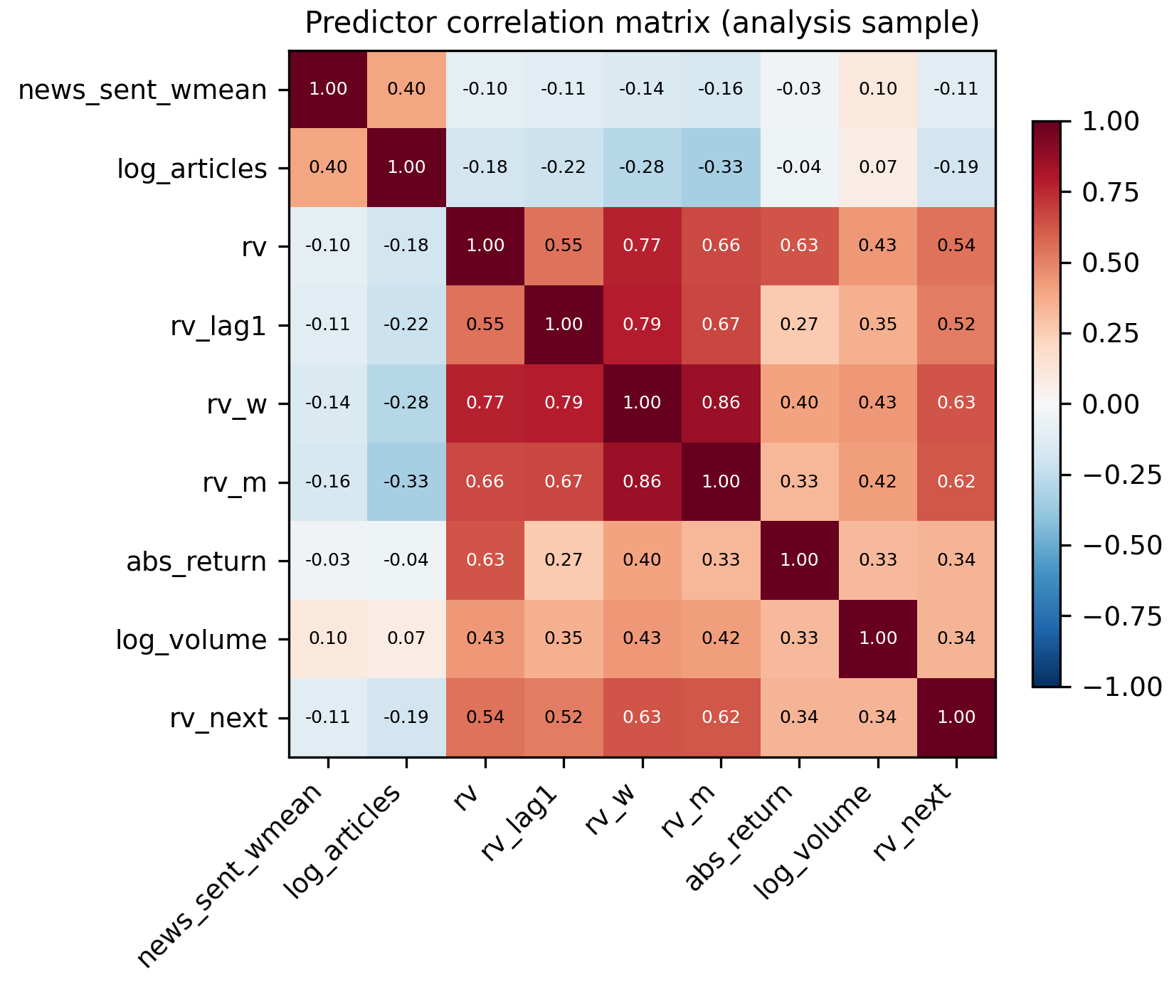
Note. Pearson correlations computed on the 3,840-observation analysis sample.
Multicollinearity was assessed using variance inflation factors (Table 6). A factor above 10 indicates severe multicollinearity (as instructed in Step 4) with none approaching this level. The weekly HAR component is highest at 7.91, expected since it is a moving average of the daily series. The two sentiment variables are close to orthogonal to the market controls, at 1.36 and 1.20, so any incremental contribution cannot be an artefact of overlap with lagged volatility.
Table 6
Variance Inflation Factors for the Full Predictor Set
Predictor | VIF | Assessment
rv_w (weekly HAR component) | 7.91 | Moderate (5-10)
rv_m (monthly HAR component) | 4.20 | Acceptable (below 5)
rv (daily HAR component) | 3.63 | Acceptable (below 5)
rv_lag1 | 2.71 | Acceptable (below 5)
abs_return | 1.74 | Acceptable (below 5)
log_volume | 1.40 | Acceptable (below 5)
log_articles | 1.36 | Acceptable (below 5)
news_sent_wmean | 1.20 | Acceptable (below 5)

Note. Computed on the analysis sample and written to docs/tables/eda_vif.csv. No predictor exceeds the severe threshold of 10.
Figure 7
Realized Volatility Over Time for NVDA and MSFT
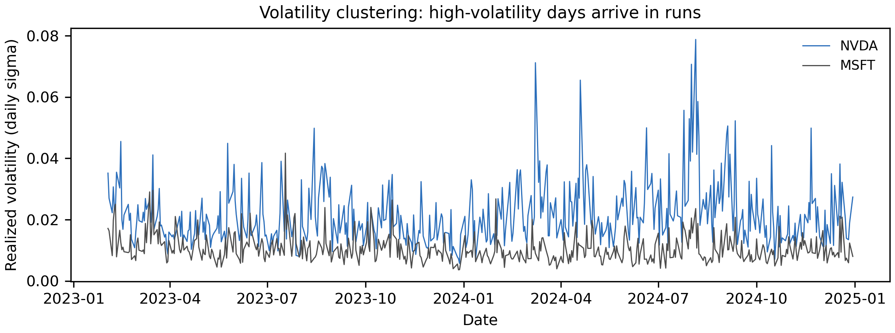Note. Daily realized volatility across the 2023 to 2024 study window for two contrasting large capitalization tickers.
Table 7 collects the exploratory findings and the design decision each one produced. Figure 7 shows volatility arriving in runs rather than independently, which is why the RQ2 benchmark is a HAR baseline rather than a naive mean, and why the sentiment features face a demanding standard.
Table 7
Exploratory Data Analysis Insight Summary
Figure/Table Reference | What it Shows | Key Insight | Why it Matters (Link to RQ/Objective) | Decision/Next Step
Figure 1 | Distribution of the target, raw and logged | Right skewed (1.81), fat tailed; near normal once logged | RQ2 estimates would be dominated by a few extreme days | Model the log target; report QLIKE alongside RMSE
Figure 2 | News coverage by ticker | Coverage ranges from 27% (PLTR) to 96% (MSFT) | Determines whether zero attention days can be dropped | Retain zero attention days; include news_missing
Figure 3 | Sentiment and attention distributions | Sentiment positive on 87% of days; attention concentrated at low counts | Limited negative variation caps the detectable sentiment effect | Use log attention; record the asymmetry as a limitation
Figure 4 | Group means, pooled versus within ticker | Attention effect reverses sign: -28.7% pooled, +9.3% within | A pooled model would report the wrong sign for RQ2 | Include ticker fixed effects in the RQ2 and RQ3 models
Figure 5 | Coverage against baseline volatility across tickers | Correlation of 0.69 produces a Simpson's paradox | Identifies the cause of the reversal in Figure 4 | Report within ticker results as primary, pooled as contrast
Figure 6 | Predictor correlation matrix | rv_w correlates 0.63 with the target; sentiment only -0.11 | Sentiment cannot be assessed on raw correlation alone | Test sentiment by incremental contribution over HAR
Table 6 | Variance inflation factors | Maximum VIF 7.91; sentiment features at 1.36 and 1.20 | Confirms the coefficients will be interpretable | Retain the full control set unchanged
Figure 7 | Realized volatility over time | Pronounced volatility clustering | Justifies the HAR benchmark used for RQ2 | Benchmark against HAR rather than a naive mean

Note. Each row states the interpretation drawn from the exhibit and the design decision that follows from it.

Sample Size Computation
Each research question is sized by the method matching its statistical form, using a confidence interval where a quantity is estimated and power analysis where an effect is tested. Effect sizes are set conservatively, because the literature reports that sentiment effects are statistically real but economically small (Antweiler & Frank, 2004; Audrino et al., 2020). Table 8 states the method, parameters and substitution for each question.
Table 8
Minimum Sample Size by Research Question
RQ | Method | Formula | Parameters | Substitution | Minimum N
RQ1 | Confidence interval for a proportion | $$n = Z^{2}×\frac{p\left(1 - p\right)}{e^{2}}$$ | Z = 1.96 (95%); p = 0.50; e = 0.05 | $$(1.96)²\frac{(0.5)(0.5) }{(0.05)²}$$ | 385 labelled messages
RQ2 | Power analysis, multiple regression (Cohen, 1988) | N = $L/f² + u + 1$ | alpha = .05; power = .80; f^2 = 0.02 (small); u = 3; L = 10.90 | 10.90 / 0.02 + 3 + 1 | 549 ticker days
RQ3 | Power analysis, one sample proportion | n = $[ Z₁₋α · \sqrt{(p₀(1 - p₀)}) + Z₁₋β · \sqrt{(p₁(1 - p₁))} ]² / (p₁ - p₀)²$ | Z(1-a) = 1.645; Z(1-b) = 0.8416; p0 = 0.52; p1 = 0.57 | $$[1.645\sqrt{(0.2496}) + 0.8416\sqrt{(0.2451)}]² / (0.05)²$$ | 614 ticker days
RQ4 | Power analysis, one sample t test on the Sharpe ratio | $$n = ( Z₁₋α + Z₁₋β )² / d²$$ | Z(1-a) = 1.645; Z(1-b) = 0.8416; d = 0.063 (annual Sharpe 1.0 / sqrt(252)) | $$(1.645 + 0.8416)² / (0.063)²$$ | 1,558 trading days

Note. Effect sizes follow Cohen's (1988) benchmarks. For RQ2 the tested predictors are relevance weighted sentiment, log attention and the zero attention indicator, so u = 3 and the corresponding tabulated constant is L = 10.90.
Because all four analyses draw on the same data, the study adopts the largest of the four minima. Three are met comfortably, with 3,152 messages against the 385 required for RQ1 and 3,840 ticker days against the 549 and 614 required for RQ2 and RQ3. RQ4 is the binding and unmet constraint, requiring 1,558 trading days where the window contains 500. Pooling the eight tickers does not resolve this, because their returns are strongly cross correlated. RQ4 is therefore under powered by design, and a null result must be read as inconclusive rather than as evidence of no effect.
Meeting a minimum is necessary but not sufficient, because ticker days are not independent. Table 9 restates the sample on three bases and reports the smallest effect RQ2 could detect on each. Even on the most conservative basis the design retains power to detect a small effect in Cohen's (1988) terms.
Table 9
Effective Sample Size and Minimum Detectable Effect for RQ2
Basis | N | What it assumes | Detectable f² | Interpretation
Pooled ticker days | 3,840 | Every observation is independent | 0.003 | Optimistic; overstates precision
Correlation adjusted | 1,093 | The 8 tickers behave as 2.28 independent series | 0.010 | Primary basis. Detects effects half the size of Cohen's small
Distinct trading dates | 480 | Each date is one observation, cross section discarded | 0.023 | Most conservative. Still detects effects at the small threshold
Note. f² is the effect size for a block of predictors added to a regression, calculated as the gain in explained variance divided by the variance still unexplained. A smaller value means the design can detect a weaker effect. Cohen's (1988) benchmarks are 0.02 small, 0.15 medium and 0.35 large, so on every basis shown the study can detect an effect at or below the small threshold. Computed at alpha = .05 and power = .80 with u = 3 tested predictors and L = 10.90. The correlation adjusted row uses 8 / (1 + 7 x 0.359) = 2.28 effective series, multiplied by 480 dates. Generated by src/run_eda.py.

Modelling
The overall research pipeline, from data collection through preprocessing, feature engineering, modelling, and evaluation, is shown in Figure 8.
Figure 8
End to End Research Pipeline
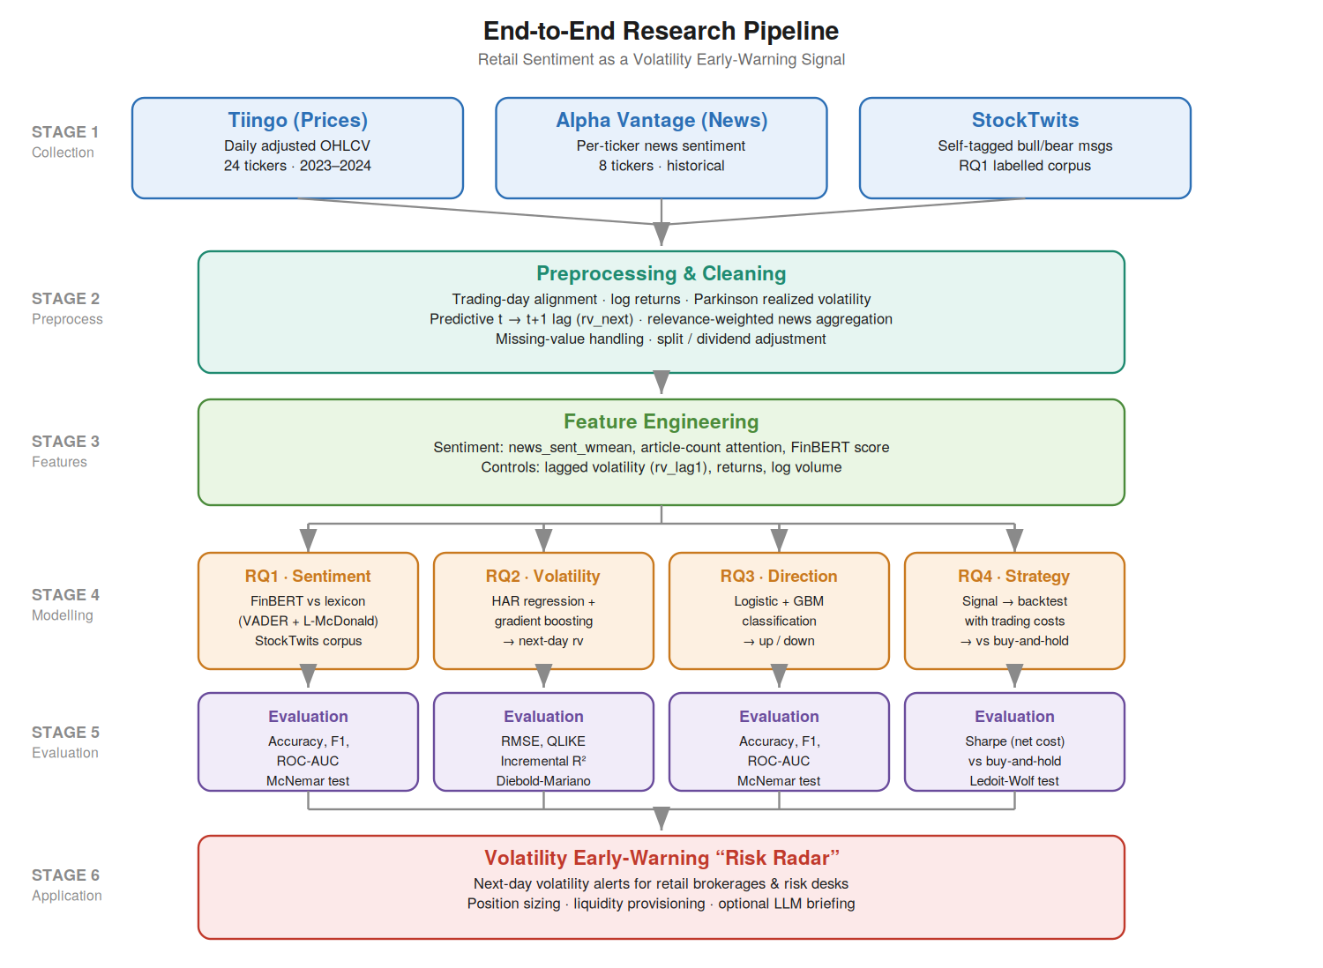
Note. The pipeline maps each of the four research questions to its model family and evaluation metrics, with StockTwits feeding RQ1 and Alpha Vantage news feeding RQ2–RQ4.

Data Preprocessing
Preprocessing is deterministic and executed in src/build_features.py, so the panel can be rebuilt from the raw files by one command. Articles are assigned to United States Eastern trading dates, with items published after the 16:00 close attributed to the following day. Realized volatility is shifted back one trading day within each ticker to create the target, leaving every predictor dated on or before t.
Missing values are handled by category. Structural gaps, namely the first 21 trading days of each series and the final day where the target is undefined, are removed rather than imputed. Zero article days are not treated as missing, for the reason given above. No imputation of prices or volumes was required.
Two kinds of transformation are applied. The first follows from the data. Trading volume and article counts are heavily right skewed, so both enter in logarithmic form, and Figure 1 shows the target should be modelled on the log scale for the same reason. The second follows from the model. Predictors are standardized for logistic regression, because its penalty term would otherwise shrink each coefficient according to the units that variable happens to be measured in. Gradient boosting is left unscaled, because a tree only asks whether a value falls above or below a threshold, and rescaling moves the threshold without moving the rows either side of it. The ticker symbol enters as a set of dummy variables with one ticker omitted, absorbing the persistent differences between firms so that estimation is within ticker rather than across the cross section, which Figure 5 showed is essential.

Experimental Design and Validation Strategy
Each research question is a controlled comparison. The control condition contains only market information. The experimental condition is the identical model, algorithm and hyperparameters with sentiment features added, estimated on the same training windows and scored on the same test observations, so the comparison is paired.
Models are validated by walk forward analysis rather than k-fold cross validation. Although Step 4 proposes k-fold as the default safeguard against overfitting, random partitioning could place future trading days in the training set. Walk forward validation trains on an initial data set, tests on the data block that follows, then advances both windows. Splits are formed on dates rather than rows, so all eight tickers move through the windows together.

Regression Diagnostics and Model Selection
The HAR specification is assessed against the assumptions of linear regression. Residuals are inspected for non linearity and heteroscedasticity, the latter expected in volatility data and addressed by clustering standard errors by date, so that inference accounts for the cross sectional correlation identified in Figure 5. Normality is examined on the log scale, where Figure 1 shows the target is close to symmetric. Multicollinearity is assessed in Table 6. Nested specifications are compared using adjusted R-squared with the Akaike and Bayesian information criteria.

Choice of Models with Justification
Each question is framed as a baseline against an augmented model, so any improvement is attributable to sentiment rather than model class. Selection reflected the literature, the data type, interpretability and the evaluation task, and Table 1 records the method used for each question.
Model 1 (RQ1) benchmarks FinBERT against a VADER and Loughran-McDonald lexicon, justified by FinBERT's demonstrated gains in financial sentiment classification (Araci, 2019) and the transparency of the lexicon.
Model 2 (RQ2) is a HAR baseline for realized volatility extended with sentiment features, plus a gradient boosting regressor for non linearities, justified by HAR's standing in volatility forecasting (Audrino et al., 2020).
Model 3 (RQ3) applies logistic regression and gradient boosting to return direction, justified by interpretability and predictive strength on tabular data.
Model 4 (RQ4) is a transparent trading rule back tested with costs against buy and hold, justified by the need to demonstrate economic operational value rather than only statistical value.

Features Included and Feature Engineering
The feature set combines news derived sentiment with lagged market controls, the target being next day realized volatility. FinBERT is validated in RQ1 on the StockTwits corpus and is not carried into the historical panel, which uses Alpha Vantage's own relevance weighted score, because applying FinBERT to the historical window would require full article text the free tier does not supply. Table 10 summarises the feature set and its usage.
Table 10
Feature Set and Usage
Variable | Role | Engineering | Used in
rv_next | Target | Next day, realized volatility from the Parkinson high low range; modelled on the log scale. | RQ2, and as the forecast input to RQ4
ret_next (sign) | Target | Sign of the next day's log return, coded 1 for an up day. | RQ3
news_sent_wmean | Sentiment | Relevance weighted daily mean of article sentiment; set to 0.0 on queried ticker days with no articles. | RQ2, RQ3, RQ4
log_articles | Attention | log(1 + news_article_count). Well defined only because zero article days are retained rather than dropped. | RQ2, RQ3, RQ4
news_missing | Flag | 1 where the ticker day carried no articles, 0 otherwise; separates genuinely neutral coverage from absent coverage. | RQ2, RQ3, RQ4
rv | Control | Daily HAR component: realized volatility at t, observable at that day's close. | RQ2, RQ3, RQ4
rv_w | Control | Weekly HAR component: mean realized volatility over t-4 to t inclusive. | RQ2, RQ3, RQ4
rv_m | Control | Monthly HAR component: mean realized volatility over t-21 to t inclusive. | RQ2, RQ3, RQ4
log_volume | Control | log(1 + adjusted daily share volume). | RQ2, RQ3, RQ4
log_return, abs_return | Control | Daily log return and its absolute value, entering only the direction model. | RQ3
Ticker fixed effects | Control | One dummy per ticker with the first omitted, so that estimation is within ticker rather than across the cross section. | RQ2, RQ3, RQ4
rv_lag1 | Not used | Realized volatility at t-1. Retained in the panel for continuity with the synopsis specification, but superseded by the HAR components and excluded from every fitted model. | None

Note. Variable names match the Data Dictionary (Table 3) and the columns of data/processed/panel.csv. The feature lists reproduced here are those declared at the head of src/run_rq2.py, src/run_rq3.py and src/run_rq4.py. RQ1 is estimated on the message level StockTwits corpus and draws on none of these variables.

Evaluation Metrics (Formulae and Calculations)
Metrics are matched to each question's form. Table 11 lists the metrics, their formulae, and the research question to which each applies. Each is computed on the study's own out of sample results in the preliminary results section below.
Table 11
Evaluation Metrics and Formulae
Metric | Formula | Applies to
Accuracy | (TP + TN) / (TP + FP + TN + FN) | RQ1, RQ3
Precision / Recall | TP/(TP+FP) ; TP/(TP+FN) | RQ1, RQ3
F1 | 2(Precision × Recall)/(Precision + Recall) | RQ1, RQ3
ROC AUC | Area under TPR vs FPR curve | RQ1, RQ3
McNemar's χ² | (|b − c| − 1)² / (b + c) | RQ1, RQ3
RMSE | √[(1/n) Σ(pred − actual)²] | RQ2
QLIKE | (1/n) Σ[(a/p) − ln(a/p) − 1] | RQ2
Sharpe ratio | (mean − rf)/sd, annualised × √252 | RQ4

Preliminary Results
Modelling is complete for all four research questions. Table 13 compares each model against its baseline. Hypothesis tests are reported per question below, and all figures are out of sample.

RQ1: Sentiment Measurement
The corpus contains 3,152 messages after cleaning, 81.6% tagged bullish, split 70/30 with stratification. Every figure below comes from the held out 30% (n = 946). Both scorers produce a continuous value rather than a label, so a threshold is required, and it was chosen on the training half alone.
The two models rank differently depending on which measure of accuracy is used, and that disagreement is the finding. On raw accuracy the lexicon wins. On every measure accounting for the class imbalance FinBERT wins.
On raw accuracy FinBERT scores 0.670 against the lexicon's 0.739, and McNemar's test confirms the gap is real (chi-square = 52.97, p < .001), which taken at face value retains the null hypothesis. But raw accuracy is not a safe measure on a corpus that is 82% one class. A rule replying bullish to every message, without reading any of them, scores 0.816 and beats both models. The lexicon calls bullish on 77% of messages against FinBERT's 62%, putting it closer to that uninformative rule.
Incorporating balanced accuracy corrects for this by scoring each class separately and averaging, so the bullish majority cannot dominate. On that measure FinBERT leads, 0.660 against 0.611, and the gap is widest on the class that matters most for an early warning signal, with FinBERT identifying 64.4% of bearish messages against 40.8%. It also ranks messages better, with an area under the receiver operating characteristic curve (AUC) of 0.712 against 0.614, as Figures 9 and 10 show.
A paired bootstrap over 5,000 resamples confirms both advantages. The ranking gap is +0.098, 95% CI [+0.053, +0.143], p < .001, and the balanced accuracy gap over the combined lexicon is +0.058, p = .012. Against VADER alone the difference points the same way but falls short of significance (+0.042, p = .071). The design specifies this bootstrap in advance, so it is a planned comparison.
Stated formally in terms of balanced accuracy the null hypothesis is rejected. The conclusion is that FinBERT is nonetheless the better instrument for this study, because it detects the bearish messages an early warning signal depends on.

Figure 9
RQ1 Classification Errors by Model
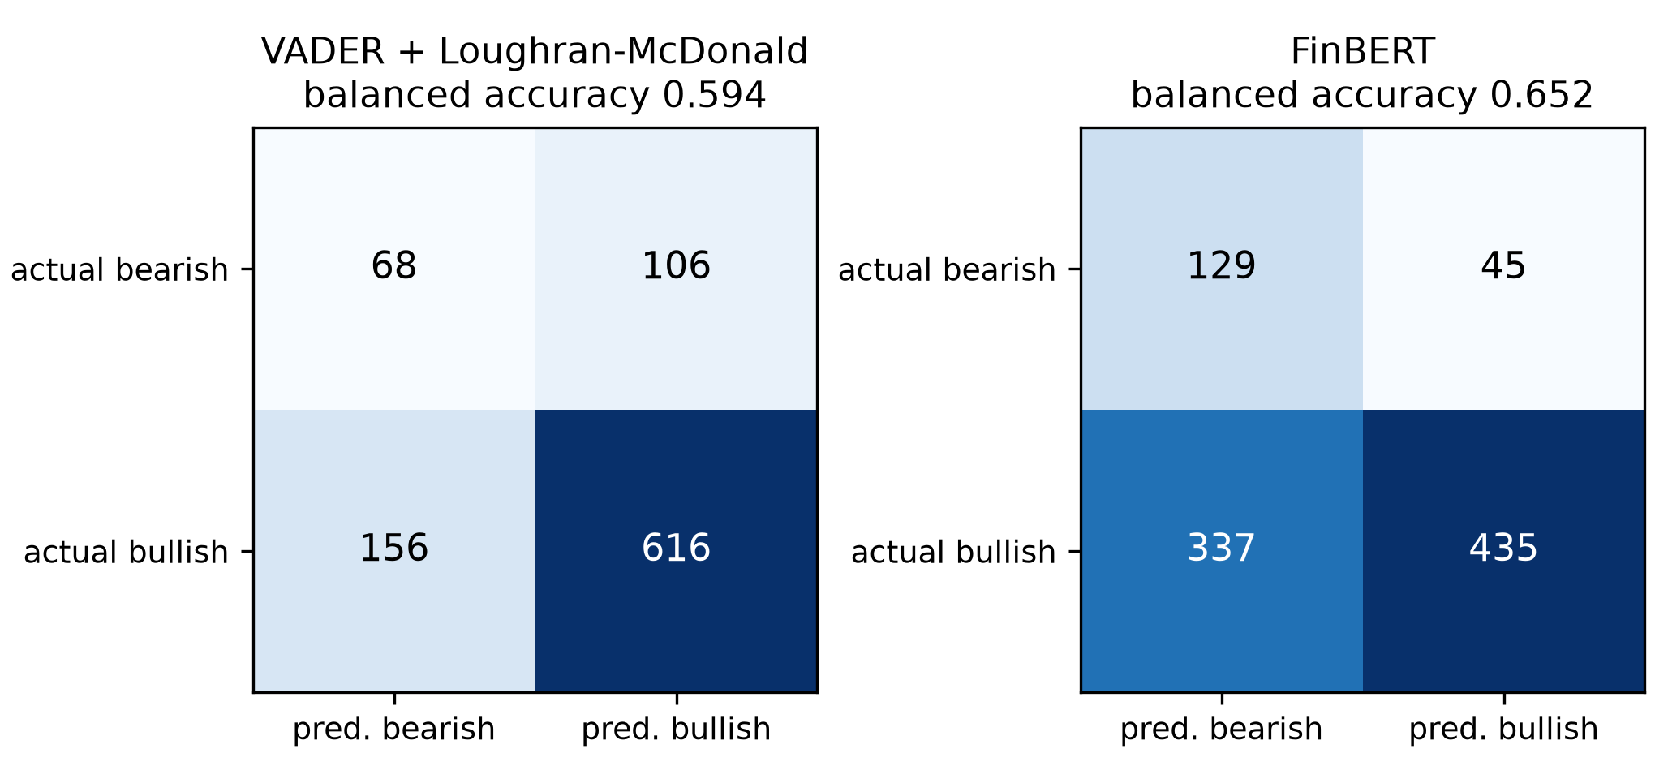
Note. Counts are test set messages (n = 946). FinBERT recovers 64.4% of bearish messages against the lexicon's 40.8%. The lexicon's higher raw accuracy comes from predicting the bullish majority more often.

Figure 10
RQ1 Ranking Ability (ROC)
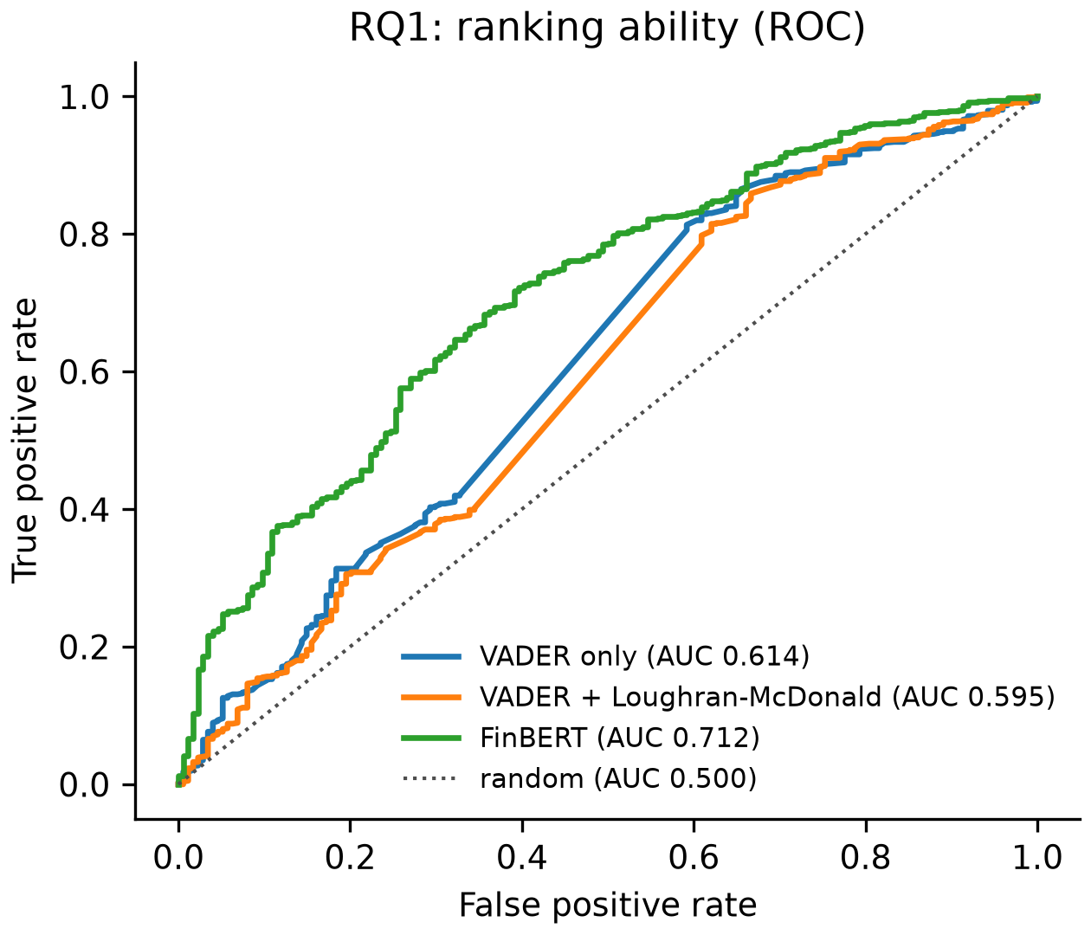
Note. Threshold free comparison. FinBERT's area under the curve of 0.712 exceeds the lexicon's 0.614. The paired bootstrap difference is +0.098, 95% CI [+0.053, +0.143].

RQ2: Volatility Prediction
The RQ2 models were estimated on the full 3,840 observation panel with ticker fixed effects, using expanding window walk forward validation across six folds split on dates. The baseline is the HAR specification with trading volume, and the augmented model adds the three sentiment and attention variables.
The sentiment block is jointly significant. An incremental F-test rejects the null that its coefficients are all zero (F = 3.61, p = .013), and adjusted R-squared rises from .5387 to .5401 while both information criteria fall. Out of sample the augmented model lowers pooled QLIKE by 1.26% and is more accurate in five of six folds, with Diebold-Mariano rejecting equal predictive accuracy decisively (DM = 4.82, p < .001).
The composition of that gain verifies the exploratory analysis. With standard errors clustered by date, attention carries the effect (0.055, t = 3.12, p = .002) while tone does not (-0.035, p = .389). How much a stock is written about predicts its next day volatility. Whether that coverage reads positive or negative does not. This is the pattern Figure 4 showed before any model was fitted.
Gradient boosting was fitted on the identical feature set and did not improve on the linear specification (DM = -1.25, p = .211). With a volatility process close to linear in its lagged components, the additional flexibility captures noise rather than structure. A null finding on model class is itself informative.
Figure 11
RQ2 Out of Sample Forecast Loss by Walk Forward Fold
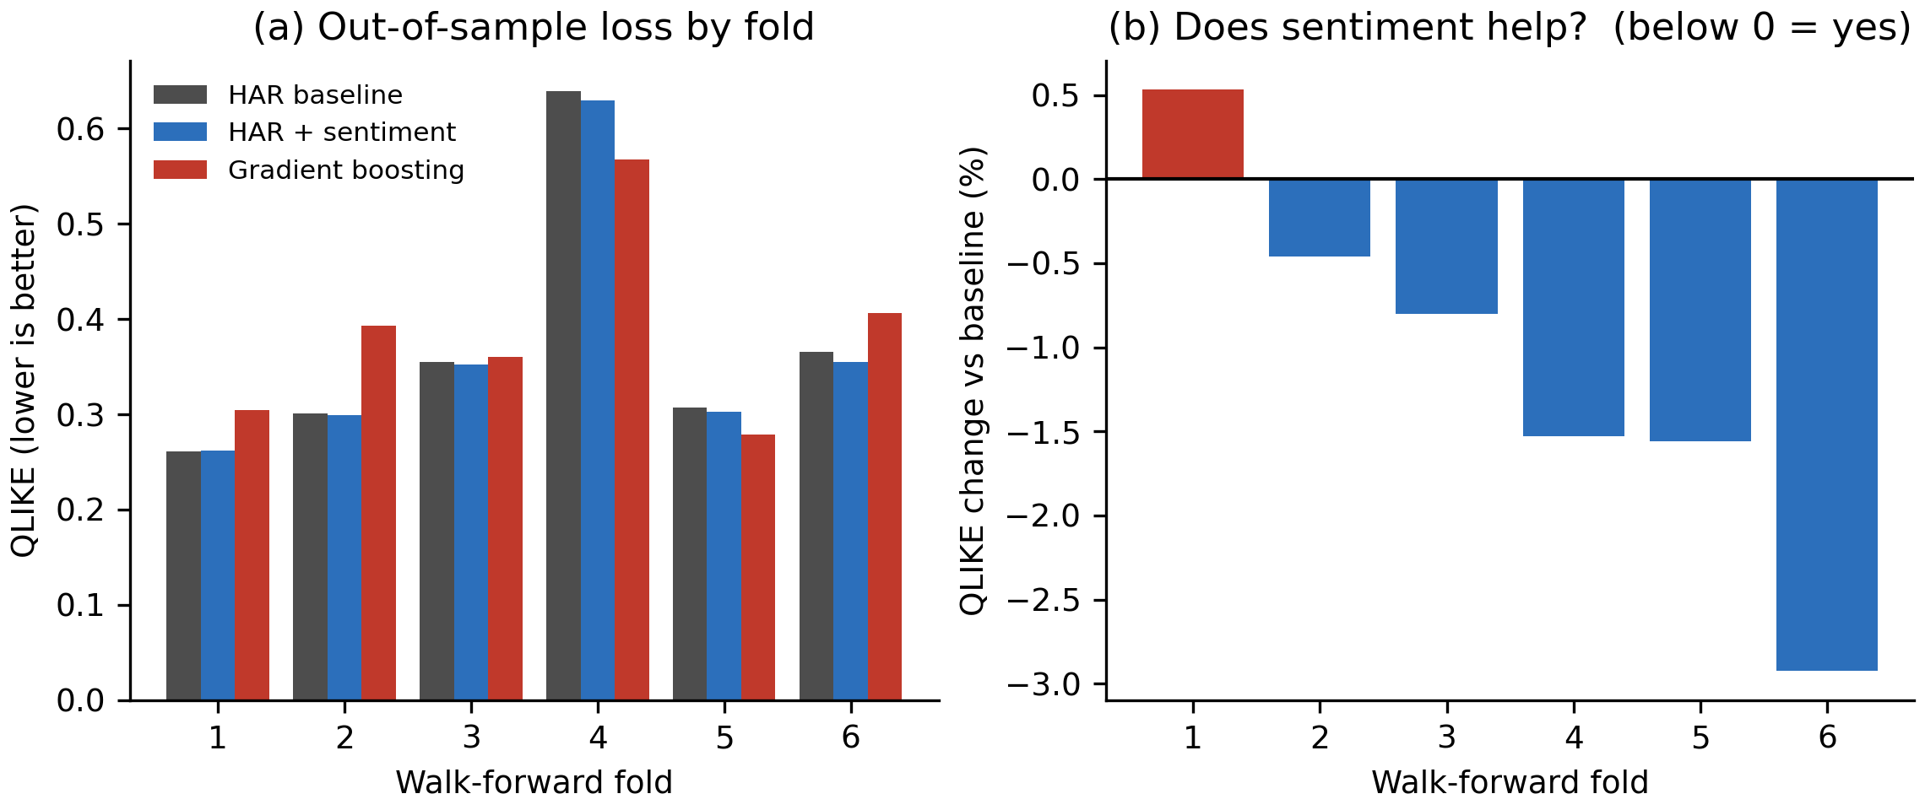
Note. QLIKE is computed on the variance scale (Patton, 2011), where lower is better. Panel (b) expresses the augmented model's loss relative to the baseline, so bars below zero indicate that sentiment helped.

RQ3: Direction Classification
RQ3 reuses the RQ2 panel, fixed effects and folds, changing only the target, which becomes the sign of the next day's return, and the model class.
Sentiment does not improve direction prediction. Pooled out of sample accuracy rises from .5282 to .5304, an increase of 0.22 percentage points that McNemar's test cannot distinguish from chance (chi-square = 0.13, p = .714), and the gradient boosting pair behaves the same way. The null hypothesis is retained. A constant rule predicting an up day every time scores .5295, and the area under the curve of .519 is close to the .500 of a coin toss, as Figure 12 shows.
This is the outcome the design anticipated, reported as a finding rather than a shortcoming. Read alongside RQ2 the two form a coherent pair, with the same features improving volatility forecasts while carrying no usable information about direction. That asymmetry justifies framing the application as a volatility early warning signal rather than a return prediction tool (Antweiler & Frank, 2004; Audrino et al., 2020).
Figure 12
RQ3 Direction Prediction Accuracy and Ranking Ability
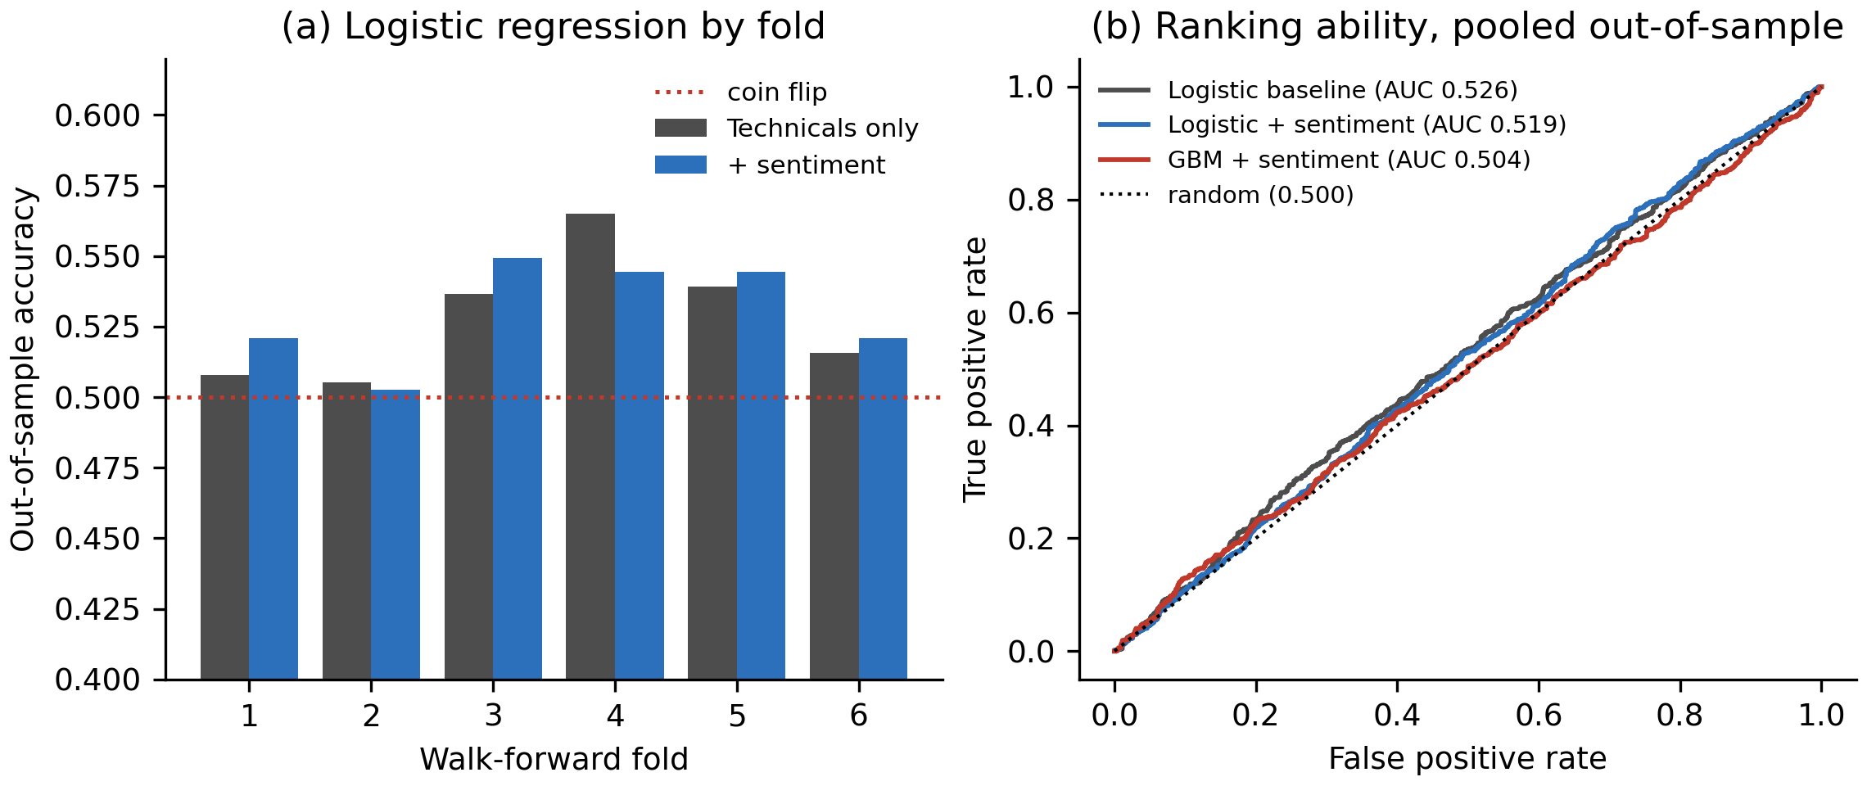
Note. Panel (a) shows out of sample accuracy by fold against the coin flip line. Panel (b) shows pooled receiver operating characteristic curves. All models sit close to random.

RQ4: Strategy Evaluation
The RQ2 volatility forecast is converted into a position size by two exposure rules, both specified in advance. The primary rule, on which the hypothesis is tested, is volatility targeting. Each ticker has a usual forecast level, defined as the expanding median of its own prior forecasts, so that only past data sets it. The weight is that usual level divided by tomorrow's forecast, capped at full investment, so the position shrinks whenever tomorrow looks more volatile than the ticker's own history. The second rule, threshold de-risking, serves as a robustness check and halves the weight whenever the forecast exceeds the expanding 80th percentile of that ticker's history. Capital not held in equities is assumed to earn the 5% annual risk-free rate.
Both rules, and both cost levels, were fixed before any performance figure was computed. That is what makes this a test rather than a search, since trying several rules and reporting the best would invalidate the p-value.
The strategy does not beat buy and hold. Over the 247 day out of sample window the benchmark earned a Sharpe ratio of 2.291, against 2.181 for volatility targeting and 1.986 for threshold de-risking, both net of 10 basis points. The Ledoit-Wolf test, implemented with a circular block bootstrap, fails to reject the null in every comparison, and for the primary rule the Sharpe difference is −0.110, 95% CI [−0.237, +0.017], p = .090. Halving the assumed cost to five basis points leaves the conclusion unchanged.
Table 12 and Figure 13 show why. On the risk side volatility targeting did what it was designed to do, cutting annualised volatility from 27.1% to 25.3% and maximum drawdown from −18.6% to −17.4%. It simply surrendered more return than risk. The benchmark earned 62% a year in excess terms, and any rule that reduces exposure forfeits part of that, which is especially costly in a sustained advance because the most volatile days are also among the most positive.
Two qualifications govern how this should be read. The first is length: 247 trading days against the 1,558 the power analysis requires, so the study cannot detect a modest effect. The second is coverage: the window lies entirely within a single rising regime, whereas a volatility scaling rule is built for more turbulent conditions, which this period never provides. The result should therefore not be read as evidence that the strategy destroys value, only that this window cannot support the claim that it creates it
Table 12
RQ4 Strategy Performance Against Buy-and-Hold
Strategy | Cost (bp) | Ann. excess return | Ann. volatility | Sharpe | Max drawdown | Turnover per year
Buy-and-hold (benchmark) | 5 | 62.2% | 27.1% | 2.291 | -18.6% | -
Volatility targeting (primary) | 5 | 55.5% | 25.3% | 2.199 | -17.4% | 8.4x
Threshold de risk 50% (robustness) | 5 | 47.0% | 23.2% | 2.026 | -15.5% | 18.2x
Buy-and-hold (benchmark) | 10 | 62.2% | 27.1% | 2.291 | -18.6% | -
Volatility targeting (primary) | 10 | 55.1% | 25.3% | 2.181 | -17.4% | 8.4x
Threshold de risk 50% (robustness) | 10 | 46.1% | 23.2% | 1.986 | -15.5% | 18.2x

Note. All series are evaluated on an identical 247 day window. The expanding window burn in costs the strategies the first 40 days, so the benchmark is restricted to the same period for comparability. Returns are excess of a 5% annual risk free rate. Generated by src/run_rq4.py.
Figure 13
RQ4 Cumulative Excess Return and Equity Exposure
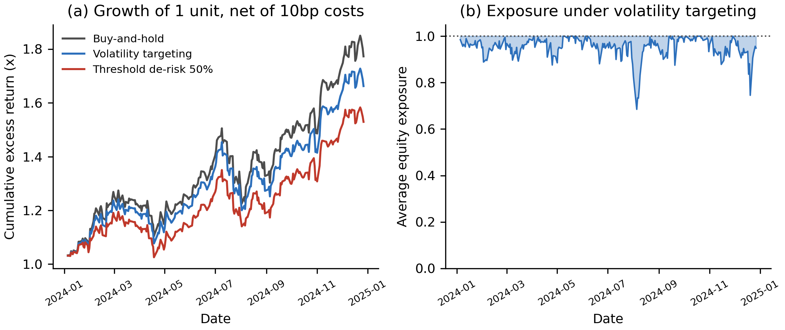
Note. Panel (a) shows the growth of one unit net of 10 basis point costs. Panel (b) shows average equity exposure under the volatility targeting rule, where 1.00 denotes full investment.
Table 13
Preliminary Model Performance
Research Question | Model | Feature Set | Validation Approach | Baseline | Augmented | Key Takeaway
RQ1 | FinBERT vs VADER lexicon | Message text | Stratified 70/30 split; threshold fitted on train | AUC .614 | AUC .712 | FinBERT ranks significantly better (+.098, p < .001) but is less accurate on a 82/18 corpus
RQ1 | FinBERT vs VADER lexicon | Message text | As above | Bal. acc .611 | Bal. acc .660 | Advantage significant against the combined lexicon (p = .012)
RQ2 | HAR + sentiment (OLS) | rv, rv_w, rv_m, log_volume, ticker FE, + 3 sentiment variables | Expanding window walk forward, 6 folds on dates | QLIKE .3715 | QLIKE .3668 | Sentiment block jointly significant (F = 3.61, p = .013); DM = 4.82, p < .001
RQ2 | Gradient boosting | As above | As above | QLIKE .3715 | QLIKE .3861 | No improvement over linear HAR (DM = -1.25, p = .211)
RQ3 | Logistic + gradient boosting | As RQ2; target = next day return direction | As RQ2 | Acc .5282 | Acc .5304 | No improvement; McNemar chi-square = 0.13, p = .714. Direction is near random, as anticipated
RQ4 | Strategy vs buy-and-hold | RQ2 volatility forecast | Cost aware backtest; block bootstrap Ledoit-Wolf | Sharpe 2.291 | Sharpe 2.181 | Does not beat buy-and-hold; Ledoit-Wolf p = .090, retain H0. Window is 247 days against 1,558 required

Note. All metrics are out of sample. QLIKE is computed on the variance scale (Patton, 2011), where lower is better. AUC denotes the area under the receiver operating characteristic curve. Generated by src/run_rq1.py, src/run_rq2.py, src/run_rq3.py and src/run_rq4.py.

Link to the Research Questions
Taken together, RQ1 confirms the instrument is sound, RQ2 answers the central question affirmatively with attention rather than tone supplying the predictive content, and RQ3 returns a null that supports rather than undermines that finding. RQ4 also returns a null, but on 247 evaluated days in a single rising regime it is inconclusive rather than negative.

Interim Limitations and Risks
- The Alpha Vantage free tier quota of 25 requests per day constrained the sentiment universe to eight tickers, bounding the cross section and limiting how far the window can be extended. Mitigated by caching and resumable per ticker pulls.
- StockTwits serves only recent messages, so it supports RQ1 validation rather than the historical panel. Attention is therefore measured from news coverage rather than retail message volume, which would be the direct measure. Mitigated by stating the substitution explicitly.
- Sentiment effects are expected to be economically small, and the measure is positive on 87% of days with news, compressing the range over which an effect could be detected. Mitigated by conservative effect size assumptions in the sample size design.
- Collection ran over an intermittent connection, causing occasional timeouts. Mitigated by retry and backoff logic and resolved without data loss.
- Statistical power for RQ4 is limited, as set out in the Sample Size Computation and RQ4 sections. Mitigated by a block bootstrap implementation of the Ledoit-Wolf test.
- Effective sample size is smaller than the row count. The eight tickers move together, with a mean pairwise correlation of 0.359, so 3,840 ticker days correspond to roughly 2.3 independent series. Mitigated by clustering standard errors by date and sizing claims against the adjusted figure.
- The window contains a single volatility regime, with quarterly mean volatility varying only 1.25 fold across 2023 and 2024. Mitigated by restricting claims to comparable conditions and identifying regime generalisation as future work.

Next Steps (for Final Report)
The work remaining is scheduled against the course timetable in Table 14, so each outstanding objective has a week, a deliverable and a form of evidence attached.
Table 14
Milestone Plan to Final Submission
Week | Milestone | Evidence on completion
8 | Interim report submitted. Alternative specifications for the RQ2 robustness check are pre registered in the repository before any of them is estimated. | This report; a dated specification note committed to the repository.
9 | Interim findings presented. Study window extended backwards towards 2022 to capture a second volatility regime, subject to the Alpha Vantage quota of 25 requests per day. | Presentation deck; the extended panel re validated by src/validate_panel.py with all 27 checks passing.
10 | RQ2 re estimated on the extended window and tested against alternative volatility estimators and a longer forecast horizon. RQ4 re tested across both regimes. A lightly fine tuned FinBERT trialled against the RQ1 gap. | Refreshed outputs in docs/tables and docs/figures; final report draft.
11 | Implementation and recommendation sections written, specifying how the signal would be delivered to a retail brokerage or risk desk. An optional large language model briefing layer that turns each alert into a short explanation is scoped as a stretch item. Final report submitted. | Final report, with the full analysis reproducible end to end from the repository.

Note. Week numbers follow the course timetable. Items scheduled for Week 9 depend on the Alpha Vantage free tier quota. If the extended window cannot be collected in full, the Week 10 regime comparison is reported on whatever additional history is obtained and the shortfall is stated explicitly.

Bibliography
Antweiler, W., & Frank, M. Z. (2004). Is all that talk just noise? The information content of internet stock message boards. The Journal of Finance, 59(3), 1259–1294. https://doi.org/10.1111/j.1540-6261.2004.00662.x
Araci, D. (2019). FinBERT: Financial sentiment analysis with pre-trained language models [Preprint]. arXiv. https://arxiv.org/abs/1908.10063
Audrino, F., Sigrist, F., & Ballinari, D. (2020). The impact of sentiment and attention measures on stock market volatility. International Journal of Forecasting, 36(2), 334–357. https://doi.org/10.1016/j.ijforecast.2019.05.010
Behrendt, S., & Schmidt, A. (2018). The Twitter myth revisited: Intraday investor sentiment, Twitter activity and individual-level stock return volatility. Journal of Banking & Finance, 96, 355–367.
Bollen, J., Mao, H., & Zeng, X. (2011). Twitter mood predicts the stock market. Journal of Computational Science, 2(1), 1–8. https://doi.org/10.1016/j.jocs.2010.12.007
Cohen, J. (1988). Statistical power analysis for the behavioral sciences (2nd ed.). Lawrence Erlbaum.
Das, S. R., & Chen, M. Y. (2007). Yahoo! for Amazon: Sentiment extraction from small talk on the web. Management Science, 53(9), 1375–1388.
Diebold, F. X., & Mariano, R. S. (1995). Comparing predictive accuracy. Journal of Business & Economic Statistics, 13(3), 253–263.
Ledoit, O., & Wolf, M. (2008). Robust performance hypothesis testing with the Sharpe ratio. Journal of Empirical Finance, 15(5), 850–859. https://doi.org/10.1016/j.jempfin.2008.03.002
Lopez-Lira, A., & Tang, Y. (2023). Can ChatGPT forecast stock price movements? Return predictability and large language models [Preprint]. arXiv. https://arxiv.org/abs/2304.07619
Loughran, T., & McDonald, B. (2011). When is a liability not a liability? Textual analysis, dictionaries, and 10-Ks. The Journal of Finance, 66(1), 35–65. https://doi.org/10.1111/j.1540-6261.2010.01625.x
Oliveira, N., Cortez, P., & Areal, N. (2017). The impact of microblogging data for stock market prediction: Using Twitter to predict returns, volatility, trading volume and survey sentiment indices. Expert Systems with Applications, 73, 125–144. https://doi.org/10.1016/j.eswa.2016.12.036
Patton, A. J. (2011). Volatility forecast comparison using imperfect volatility proxies. Journal of Econometrics, 160(1), 246–256. https://doi.org/10.1016/j.jeconom.2010.03.034
Renault, T. (2017). Intraday online investor sentiment and return patterns in the U.S. stock market. Journal of Banking & Finance, 84, 25–40. https://doi.org/10.1016/j.jbankfin.2017.07.002
Sprenger, T. O., Tumasjan, A., Sandner, P. G., & Welpe, I. M. (2014). Tweets and trades: The information content of stock microblogs. European Financial Management, 20(5), 926–957. https://doi.org/10.1111/j.1468-036X.2013.12007.x
Tetlock, P. C. (2007). Giving content to investor sentiment: The role of media in the stock market. The Journal of Finance, 62(3), 1139–1168. https://doi.org/10.1111/j.1540-6261.2007.01232.x
Yu, Y., Li, H., Chen, Z., Jiang, Y., Li, Y., Zhang, D., Liu, R., Suchow, J. W., & Khashanah, K. (2023). FinMem: A performance-enhanced LLM trading agent with layered memory and character design [Preprint]. arXiv. https://arxiv.org/abs/2311.13743

Appendix

Appendix A: Repository and Dataset Evidence
The figures below evidence the collection pipeline and the assembled panel. All are reproducible from the public repository.
Figure A1
Repository Folder Structure
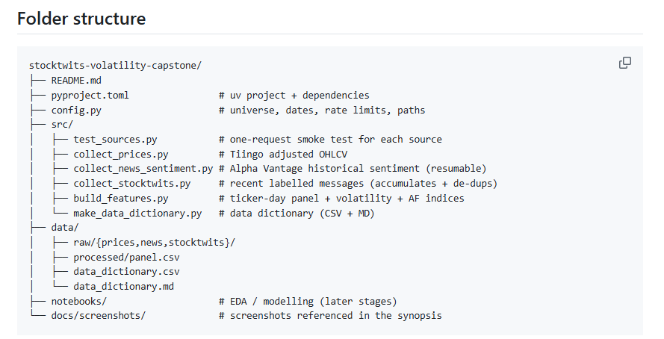
Note. The public GitHub repository, showing the src/ collection and modelling code, the data/ directories and configuration files.
Figure A2
Raw Price Data Files (Tiingo)
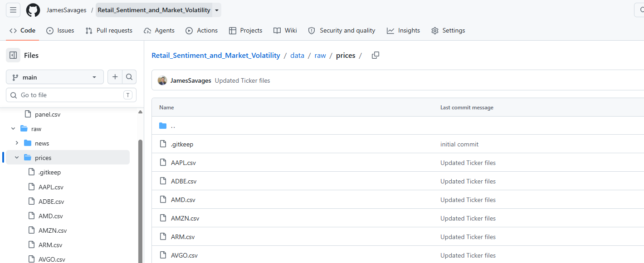
Note. Daily adjusted price files collected via Tiingo, one per ticker across the 24 stock sampling frame.
Figure A3
Raw News Sentiment Files (Alpha Vantage)
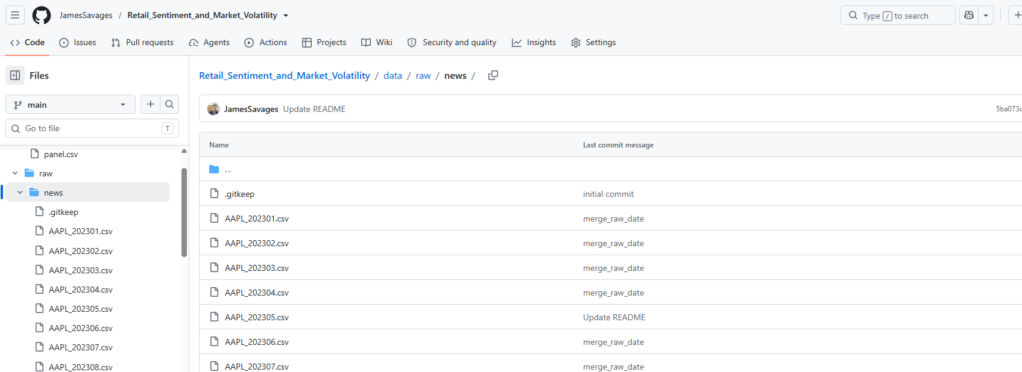
Note. Monthly news sentiment files retrieved via the Alpha Vantage API for the eight sentiment tickers, constrained by the free-tier limit of 25 requests per day.
Figure A4
Raw StockTwits Message Files
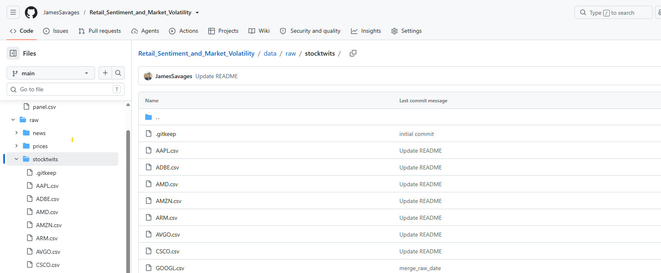
Note. Message files collected via the StockTwits API for the RQ1 validation corpus. StockTwits serves only recent messages, so these support model validation rather than the historical panel.
Figure A5
Assembled Analysis Panel (data/processed/panel_preview.csv)
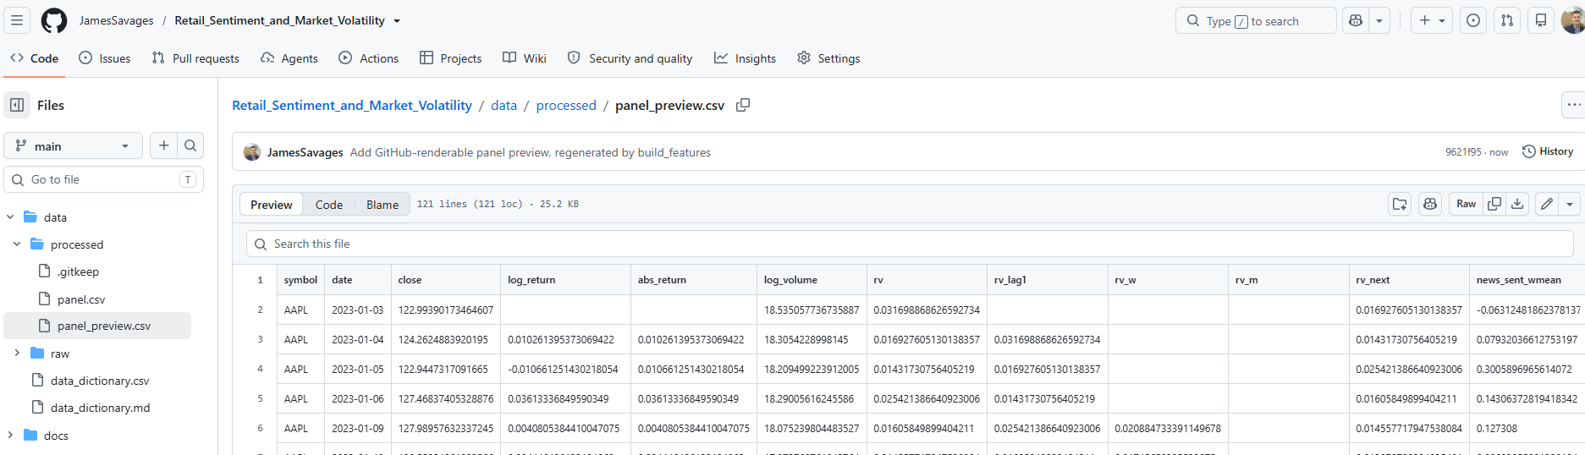
Note. A 120-row preview of the processed panel, comprising Apple and Palantir (screenshot just shows APPL ticker). GitHub does not render the full 2.36 MB panel file, so a preview is committed alongside it and regenerated automatically by src/build_features.py, which prevents the two from drifting apart. The two tickers were chosen as the best and least covered in the sample: rows with news_missing = 1 illustrate the zero-attention convention described in the data cleaning subsection, where a day with no articles is recorded as a genuine low attention observation rather than a missing value.

