

IT342-[Section]
System Integration and Architecture

System Design Document (SDD)

Project Title: QuickContacts
Prepared By: Legaspino, James Stefan Catayas

Version: 0.1
Date: February 27, 2026
Status: Draft

REVISION HISTORY TABLE
Version | Date | Author | Changes Made | Status
0.1 | February 20, 2026 | James Stefan C. Legaspino | Initial draft | Draft
0.2 | February 27, 2026 | James Stefan C. Legaspino | Added API specifications | Review
0.3 | March 10, 2026 | James Stefan C. Legaspino | Migrated Tech Stack to Supabase (BaaS). Updated Database Schema to include Groups and Favorites. | Review
0.4 | March 12, 2026 | James Stefan C. Legaspino | Refined API Contract to match Supabase SDK methods and RLS security protocols. | Review
0.5 | March 14, 2026 | James Stefan C. Legaspino | Updated Non-Functional Requirements | Revised
0.6 | [Date] | [Your Name] | Final review and corrections | Final
1 | [Date] | [Your Name] | Baseline version for development | Approved

TABLE OF CONTENTS
Contents
EXECUTIVE SUMMARY 4
1.0 INTRODUCTION 5
2.0 FUNCTIONAL REQUIREMENTS SPECIFICATION 5
3.0 NON-FUNCTIONAL REQUIREMENTS 8
4.0 SYSTEM ARCHITECTURE 9
5.0 API CONTRACT & COMMUNICATION 10
Authentication Endpoints 11
User Registration 11
User Login 11
6.0 DATABASE DESIGN 13
7.0 UI/UX DESIGN 14
8.0 PLAN 17

EXECUTIVE SUMMARY
1.1 Project Overview
QuickContacts is a simple app for storing and managing personal contact information. It provides a straightforward platform for users to keep track of their contacts, categorize them into groups, and access them easily through a secure web interface.
Objectives
- Full CRUD Implementation: Enable users to Create, Read, Update, and Delete contacts using a PostgreSQL database via Supabase.
- Advanced Organization: Implement a dynamic Grouping and Favorites system for better directory management.
- Secure Authentication: Utilize Supabase Auth for user registration and session management.
- Cloud Storage Integration: Enable Profile Picture Uploads using Supabase Storage Buckets.
1.3 Scope
Included Features:
- User Authentication: Secure user registration and login powered by Supabase Auth, including persistent session management and secure logout functionality.
- Centralized Contact Dashboard: A fully searchable and responsive interface for viewing and managing all stored contacts.
- Contact CRUD Operations: Full capability to add, view, edit, and delete contacts with fields for Name, Phone Number, and Email.
- Dynamic Contact Grouping: Ability for users to create custom categories (Groups) and assign contacts to them for better organization.
- Favorites System: A priority flagging feature that allows users to mark specific contacts as "Favorites" for quick filtering and access.
- Cloud Media Integration: Support for uploading and displaying contact profile pictures stored via Supabase Storage.
- User Profile Management: A dedicated section for users to manage their own account details and personal identifiers.
Excluded Features:
- Real-time Communication: The system does not support direct messaging, voice calls, or video conferencing within the application.
- Social Media Integration: Importing contacts from external social platforms like Facebook, LinkedIn, or Instagram is not supported.
- Third-Party Syncing: Legacy Google People API synchronization and Outlook integrations are excluded in favor of a centralized internal database.
- AI-Powered Automation: The system does not include AI-based contact sorting or automated data entry.

1.0 INTRODUCTION

1.1 Purpose
This document serves as the comprehensive design specification for the QuickContacts system. It provides detailed requirements, architectural decisions, and data flow specifications to ensure that contact management, grouping logic, and profile media handling work seamlessly across the React frontend and the Supabase cloud backend.

2.0 FUNCTIONAL REQUIREMENTS SPECIFICATION

2.1 Project Overview
Project Name: QuickContacts
Domain: Personal Information Management (PIM)
Primary Users:
- Students

Problem Statement: Users struggle to maintain an organized, accessible, and visually identifiable contact list that is securely stored in the cloud.
Solution: A centralized web application that allows users to manage contacts with advanced categorization (Groups), priority flagging (Favorites), and profile picture integration in one real-time dashboard.

2.2 Core User Journeys

Journey 1: Account Creation and Secure Login
- User registers for a QuickContacts account via the registration page.
- User logs in securely; Supabase Auth validates credentials and establishes a session.
- User arrives at the personalized dashboard.
Journey 2: Contact Organization and Media Management
- User adds a new contact and assigns them to a specific Group (e.g., "Family" or "Work").
- User flags important contacts as Favorites for instant access.
- User uploads a profile picture for a contact, which is stored in the cloud and displayed on the dashboard.

2.3 Feature List (MoSCoW)

MUST HAVE
- User registration and secure login (Supabase Auth).
- Full Contact CRUD (Create, Read, Update, Delete).
- Real-time Dashboard view.
- Contact Grouping and Favorites logic.

SHOULD HAVE
- Search and Filter functionality.
- User profile management.
- Profile picture uploads (Supabase Storage).

COULD HAVE
- Dark Mode UI.
- Export contact list to CSV.

WON'T HAVE
- Direct integration with Google People API (Legacy).
- In-app messaging or video calling.

2.4 Detailed Feature Specifications Feature: User Authentication
- Screens: Login, Registration, Home, Dashboard.
- Process: Supabase Auth manages registration and login.
- Security: Row Level Security (RLS) ensures users only see their own data.

Feature: Contact Management (Transactional)
- Fields: Full Name, Phone Number, Email, Group, IsFavorite, AvatarURL.
- Logic: Data is stored in PostgreSQL; UI updates automatically via state management.

Feature: Media Storage
- Function: Profile pictures are uploaded to a Supabase Storage Bucket and linked to contact records via public URLs.

2.5 Acceptance Criteria AC-1: Successful User Registration
- Given a new user enters a valid email and password.
- When they click "Create Account," the system creates a record in Supabase Auth.
- Then the user is redirected to the dashboard with an active session.

AC-2: Contact Organization (Groups & Favorites)
- Given a logged-in user with contacts.
- When the user marks a contact as a favorite or assigns a group.
- Then the change is persisted in the database and reflected immediately in the UI filters.

AC-3: Persistent Media Upload
- Given a user selects an image file for a contact.
- When the user saves the contact, the image is uploaded to cloud storage.
- Then the contact’s profile picture remains visible even after a page refresh.

3.0 NON-FUNCTIONAL REQUIREMENTS

3.1 Performance Requirements
- Database Efficiency: Queries for contact retrieval should complete within 500ms using PostgreSQL indexing.
- Media Delivery: Profile pictures should load within 1 second using CDN-backed storage.

3.2 Security Requirements
- Data Isolation: Implement Row Level Security (RLS) to prevent unauthorized data access between users.
- Encryption: Use HTTPS for all transmissions; Supabase handles password hashing and encrypted token storage.

3.3 Compatibility Requirements
- Web Browsers: Optimized for the latest two versions of Google Chrome, Mozilla Firefox, Apple Safari, and Microsoft Edge.
- Mobile Browsers: Fully responsive and functional on mobile browsers, specifically Chrome for Android and Safari for iOS, to ensure students can access contacts on the go.
- Screen Resolution: Responsive layout optimized for Mobile (360px+), Tablet (768px+), and Desktop (1024px+) to support various student devices (smartphones, tablets, and laptops).
- Operating Systems: Compatible with modern desktop environments including Windows 10/11, macOS, and Linux.

3.4 Usability Requirements
- Task Completion: A first-time student user should be able to add a new contact and assign it to a group within 60 seconds of logging in.
- Accessibility: Adherence to WCAG 2.1 Level AA standards to ensure the web interface is accessible to students with disabilities.
- Navigation: Consistent use of sidebars and headers across all dashboard views to provide an intuitive user experience.
- Error Feedback: Provide clear, human-readable error messages for common student interactions (e.g., "Invalid phone number format" or "Image file size too large").
- Interactivity: Minimum touch target size of 44x44px to ensure the dashboard is easy to navigate on touch-screen mobile devices.

4.0 SYSTEM ARCHITECTURE

4.1 Component Diagram
Note: This should be a component diagram
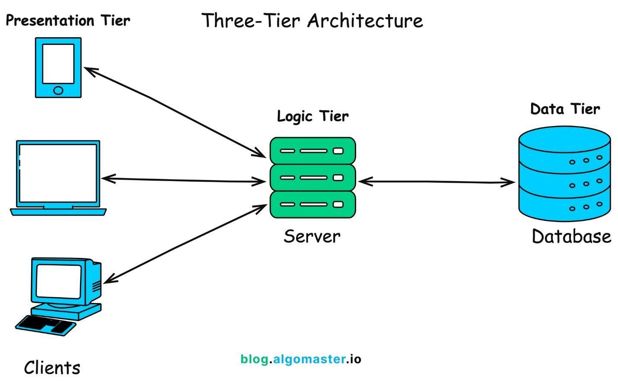
Technology Stack:
● Backend: Java 17, Spring Boot 3.x, Spring Security, Spring Data JPA, Spring Security

● Database: PostgreSQL: The primary relational database engine provided by Supabase.
- Web Frontend: React 18, Supabase Client SDK, Tailwind CSS, Axios
- Mobile: Kotlin, Jetpack Compose, Retrofit, Room
- Build Tools: Maven (Backend), npm/yarn (Web), Gradle (Android)
- Deployment: Railway/Heroku (Backend), Vercel/Netlify (Web), APK (Mobile)

5.0 API CONTRACT & COMMUNICATION

5.1 API Standards
Base URL | https://exeydhrvqpqcgbwoawpj.supabase.co
Format | JSON for all requests/responses
Authentication | JWT (JSON Web Token) managed via Supabase Auth
Response Structure | {
"success": boolean,
"data": object|null,
"error": {
"code": string,
"message": string,
"details": object|null
},
"timestamp": string
}

-
5.2 Endpoint Specifications

Authentication Endpoints

User Registration
Description | Creates a new student account and initializes a secure session in the cloud.
API URL | supabase.auth.signUp()
HTTP Request Method | POST (Handled via SDK auth.signUp())
Format | JSON for all requests/responses
Authentication | None (Initial account creation)
Request Payload | {  "email": <email>,  "password": <password>,  "options": {  "data": {  "full_name": <name>  }  }  }
Response Structure | {  "success": true,  "data": {  "user": {  "id": <uuid>,  "email": <email>  },  "session": <session_data>  },  "error": null,  "timestamp": <string>  }

User Login
Description | User Login
API URL | supabase.auth.signInWithPassword()
HTTP Method | POST (Handled via SDK auth.signInWithPassword()
Format | JSON for all requests/responses
Authentication | None
Request Payload | {  “email”: <email>,  “password”: <password>,  }
Response Structure | {  "success": true,  "data": {  "user": {  "id": <uuid>,  "email": <email>,  "full_name": <name>  },  "session": <session_data>  },  "error": null,  "timestamp": <string>  }

5.3 Error Handling HTTP Status Codes
- 200 OK - Successful request (e.g., fetching the contact list).
- 201 Created – Resource successfully created (e.g., new student registration or new contact added).
- 400 Bad Request - Invalid input, such as a missing phone number or improperly formatted email.
- 401 Unauthorized - Authentication required or the user's session has expired.
- 403 Forbidden - Triggered by Row Level Security (RLS); occurs if a student attempts to access or modify data belonging to another user.
- 404 Not Found – The requested contact or group does not exist in the database.
- 409 Conflict - Duplicate entry error (e.g., the student is trying to register an email that is already in use).
- 500 Internal Server Error – Issues with the cloud service or database connectivity.
Error Code Examples

Example 1: Authentication Error | {  "success": false,  "data": null,  "error": {  "code": "AUTH-001",  "message": "Invalid credentials",  "details": "Email or password is incorrect"  },  "timestamp": "2024-03-20T10:30:00Z"  }
Example 2: Validation Error | {  "success": false,  "data": null,  "error": {  "code": "VAL-001",  "message": "Validation failed",  "details": {  "full_name": "Full name is required",  "phone_number": "Invalid phone number format"  }  },  "timestamp": "2024-03-20T10:35:00Z"  }
Example 3: Conflict Error (Duplicate Entry) | {  "success": false,  "data": null,  "error": {  "code": "DB-002",  "message": "Conflict detected",  "details": "The email address is already registered."  },  "timestamp": "2024-03-20T10:40:00Z"  }

Common Error Codes
- AUTH-001: Invalid credentials
- AUTH-002: Session Expired
- AUTH-003: Insufficient permissions
- VALID-001: Validation failed (e.g., Invalid phone number format)
- DB-001: Resource not found (e.g., Contact ID does not exist)
- DB-002: Duplicate entry (e.g., Email already registered)
- STOR-001: Media Upload Error
- SYSTEM-001: Internal server error

6.0 DATABASE DESIGN

6.1 Entity Relationship Diagram
Note: This should be an ERD (Database Schema) Detailed
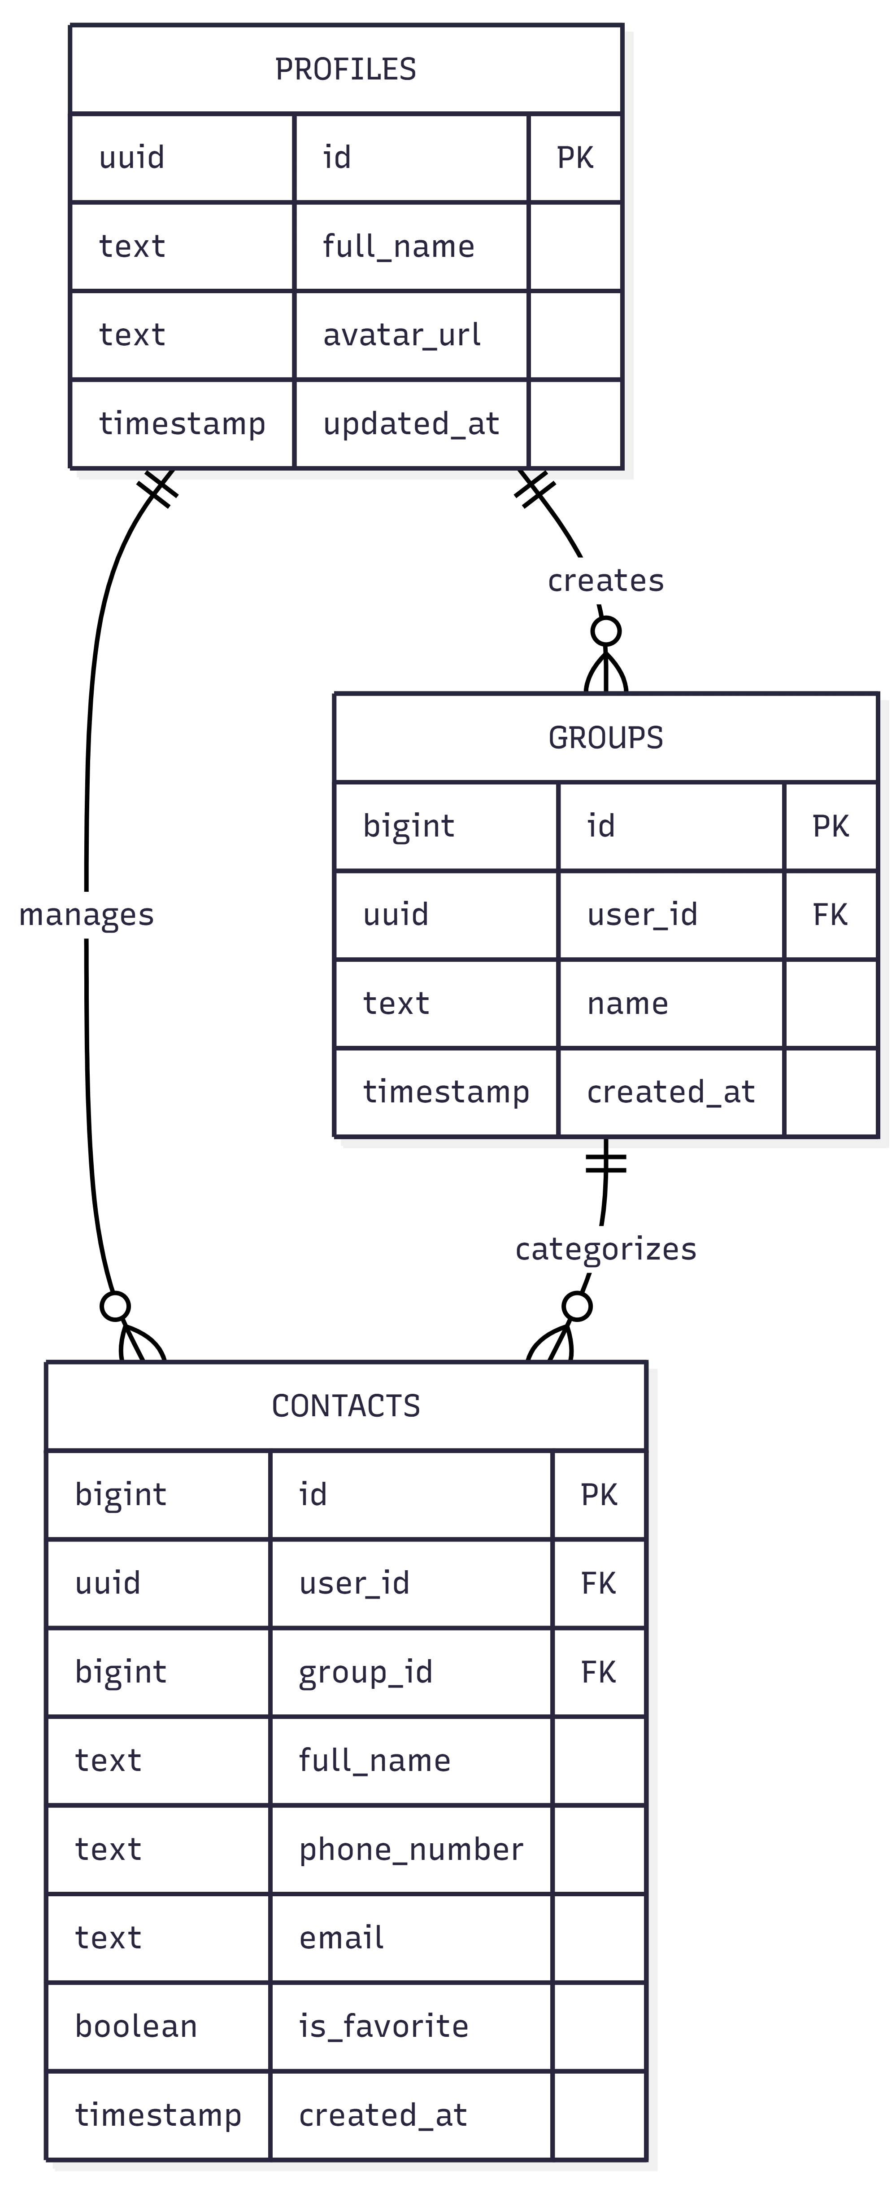
Relationships:
- One-to-One: auth.users ↔ profiles *Every authenticated student has a corresponding profile record for extended metadata (e.g., display name, avatar URL).
- One-to-Many: profiles → groups * A student can create multiple categories or groups (e.g., "Research Team," "Classmates") to organize their contacts.
- One-to-Many: profiles → contacts * A student can own and manage multiple contact entries.
- Many-to-One: contacts → groups * Each contact can optionally be assigned to one specific group for better organization.

Key Tables:
- profiles – Stores extended student user information, including display names and links to profile pictures stored in the cloud.
- groups – Manages custom categories created by students (e.g., "Thesis Group," "Classmates") to organize their contact list.
- contacts – The central repository for all contact data, featuring categorization via groups and priority flagging for favorite contacts.
Table Structure Summary:
- profiles: id (UUID), full_name, avatar_url, updated_at
- groups – id (BigInt), user_id (UUID), name, created_at
- contacts – id (BigInt), user_id (UUID), group_id (FK), full_name, phone_number, email, is_favorite (Boolean), created_at

7.0 UI/UX DESIGN

7.1 Web Application Wireframes
Note: This should be wireframes from Figma
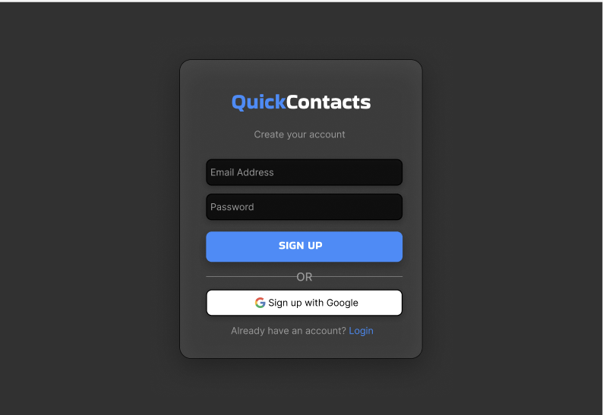
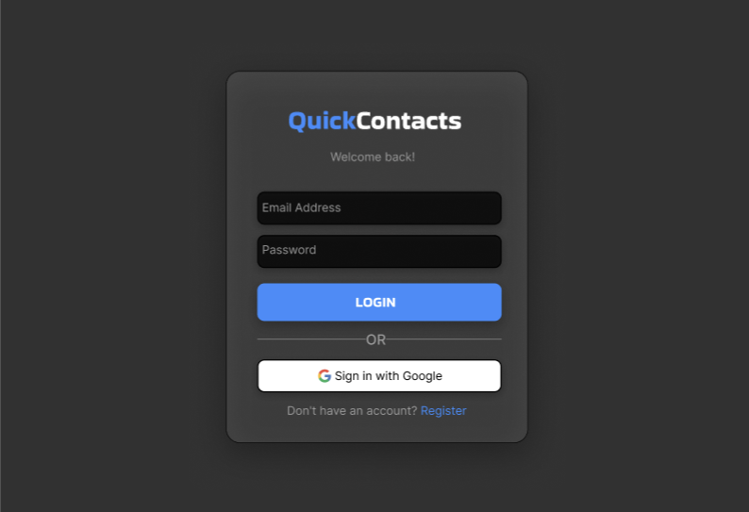

Homepage (Product Listing)
Header: [Logo] [Search Bar] [Cart Icon] [User Menu]
Content: Product Grid (3 columns desktop)
Each Product Card: Image, Name, Price, "Add to Cart" button
Footer: Links, Copyright

Product Detail Page
Back Button
Product Image (large)
Product Name and Price Description
Quantity Selector (1-10)
"Add to Cart" and "Buy Now" buttons
Product Specifications

Shopping Cart Page
Cart Title
List of Cart Items (Image, Name, Quantity, Price, Remove)
Order Summary: Subtotal, Shipping, Tax, Total
"Continue Shopping" and "Proceed to Checkout" buttons

Checkout Page
Shipping Address Form
Order Review (Items, Prices, Totals)
"Place Order" button
Terms and Conditions note

Admin Dashboard
Sidebar Navigation: Dashboard, Products, Orders, Users
Product Management: Add New button, Product list with Edit/Delete
Order Management: Order list with status filters

7.2 Mobile Application Wireframes
Note: This should be wireframes from Figma
Bottom Navigation
[🏠 Home] [🔍 Search] [🛒 Cart] [👤 Profile]

Home Screen
Search Bar
Product Grid (2 columns)
Swipe gestures for quick actions
Pull to refresh

Product Detail Screen
Back arrow
Product image (swipeable gallery)
Product info
Quantity selector
"Add to Cart" fixed bottom button

Cart Screen
Edit mode for quantity updates
Swipe to remove items
Order summary sticky bottom
Checkout button

Checkout Flow
Step indicator: Cart → Shipping → Payment → Confirm
Address form (auto-complete)
Order summary Place order button
Mobile-Specific Features:
- Touch-optimized buttons (min 44x44px)
- Gesture support (swipe, pull-to-refresh)
- Offline caching for product images
- Bottom navigation for main actions
- Simplified forms for mobile input
Design System:
- Colors: Primary (#2563EB), Secondary (#7C3AED), Success (#10B981), Error (#EF4444)
- Typography: Inter font family, responsive sizing
- Spacing: 8px grid system
- Components: Consistent buttons, inputs, cards, modals
- Responsive: Mobile-first approach, breakpoints at 640px, 768px, 1024px

8.0 PLAN

8.1 Project Timeline Phase 1: Planning & Design (Week 1-2)
Week 1: Requirements & Architecture
Day 1-2: Project setup and documentation
Day 3-4: Complete FRS and NFR
Day 5-7: System architecture design

Week 2: Detailed Design
Day 1-2: API specification
Day 3-4: Database design
Day 5-6: UI/UX wireframes
Day 7: Implementation plan finalization

Phase 2: Backend Development (Week 3-4)
Week 3: Foundation
Day 1: Spring Boot setup with dependencies
Day 2: Database configuration and entities
Day 3: JWT authentication implementation
Day 4: User management endpoints
Day 5: Product CRUD operations

Week 4: Core Features
Day 1: Cart functionality
Day 2: Order management
Day 3: Search and filtering
Day 4: Error handling and validation
Day 5: API documentation and testing

Phase 3: Web Application (Week 5-6)
Week 5: Frontend Foundation
Day 1: React setup with TypeScript
Day 2: Authentication pages (login, register)
Day 3: Product listing page
Day 4: Product detail page
Day 5: Shopping cart implementation

Week 6: Complete Web Features
Day 1: Checkout flow
Day 2: Order history and confirmation
Day 3: Admin dashboard
Day 4: Responsive design polish
Day 5: API integration and testing

Phase 4: Mobile Application (Week 7-8)
Week 7: Android Foundation
Day 1: Android Studio setup and project structure
Day 2: Authentication screens
Day 3: Product browsing
Day 4: Shopping cart
Day 5: API service layer

Week 8: Complete Mobile App
Day 1: Checkout flow
Day 2: Order management
Day 3: UI polish and animations
Day 4: Testing on emulator/device
Day 5: APK generation and documentation

Phase 5: Integration & Deployment (Week 9-10)
Week 9: Integration Testing
Day 1: End-to-end testing across platforms
Day 2: Bug fixes and optimization
Day 3: Security review
Day 4: Performance testing
Day 5: Documentation updates

Week 10: Deployment
Day 1: Backend deployment (Railway/Heroku)
Day 2: Web app deployment (Vercel/Netlify)
Day 3: Mobile APK distribution
Day 4: Final testing
Day 5: Project submission
Milestones:
- M1 (End Week 2): All design documents complete
- M2 (End Week 4): Backend API fully functional
- M3 (End Week 6): Web application complete
- M4 (End Week 8): Mobile application complete
- M5 (End Week 10): Full system deployed and integrated Critical Path:
- Authentication system (Week 3)
- Product catalog API (Week 3-4)
- Shopping cart functionality (Week 4)
- Checkout process (Week 6)
- Cross-platform testing (Week 9) Risk Mitigation:
- Start with simplest working version of each feature
- Test integration points early and often
- Keep backup of working versions
- Focus on core functionality before enhancements

