Data Visualization: 5th lesson – Distributions

In this tutorial, you’ll learn all about histograms and density plots.

***Set up the notebook***

As always, we begin by setting up the coding environment (this code is hidden, but you can un-hide it by clicking on the "Code" button immediately below this text, on the right).

import pandas as pd

pd.plotting.register_matplotlib_converters()

import matplotlib.pyplot as plt

%matplotlib inline

import seaborn as sns

print("Setup Complete")

Setup Complete

***Select a dataset***

We'll work with a dataset of 150 different flowers, or 50 each from three different species of iris: bristle-pointed iris (*Iris setosa*), blue flag (*Iris versicolor*), and Virginia iris (*Iris virginica*).

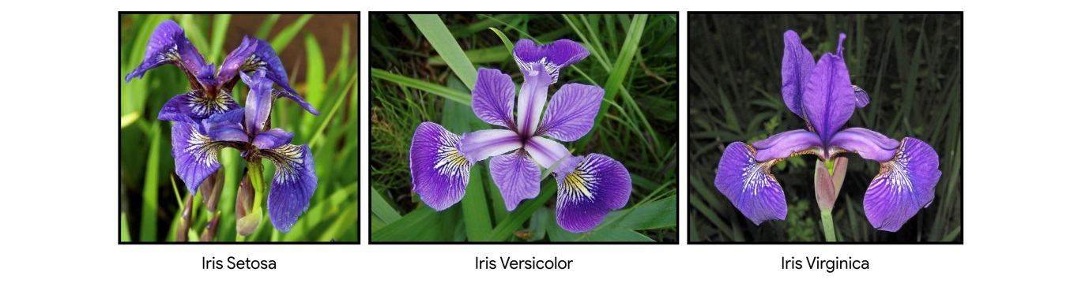

***Load and examine the data***

Each row in the dataset corresponds to a different flower. There are four measurements: the sepal length and width, along with the petal length and width. We also keep track of the corresponding species.

*# Path of the file to read*

iris_filepath = "../input/iris.csv"

*# Read the file into a variable iris_data*

iris_data = pd.read_csv(iris_filepath, index_col="Id")

*# Print the first 5 rows of the data*

iris_data.head()

Sepal Length (cm) Sepal Width (cm) Petal Length (cm) Petal Width (cm) Species

Id

1 5.1 3.5 1.4 0.2 Iris-setosa

2 4.9 3.0 1.4 0.2 Iris-setosa

3 4.7 3.2 1.3 0.2 Iris-setosa

4 4.6 3.1 1.5 0.2 Iris-setosa

5 5.0 3.6 1.4 0.2 Iris-setosa

***Histograms***

Say we would like to create a *histogram* to see how petal length varies in iris flowers. We can do this with the sns.histplot command.

*# Histogram*

sns.histplot(iris_data['Petal Length (cm)'])

<AxesSubplot:xlabel='Petal Length (cm)', ylabel='Count'>

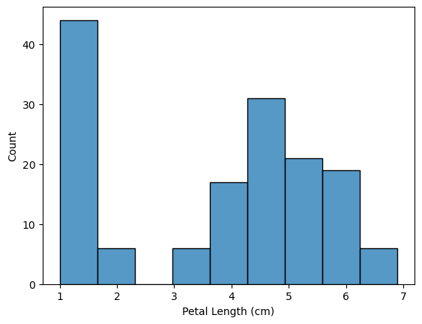

In the code cell above, we had to supply the command with the column we'd like to plot (in this case, we chose 'Petal Length (cm)').

***Density plots***

The next type of plot is a kernel density estimate (KDE) plot. In case you're not familiar with KDE plots, you can think of it as a smoothed histogram. To make a KDE plot, we use the sns.kdeplot command. Setting shade=True colors the area below the curve, and data= chooses the column we would like to plot.

*# KDE plot*

sns.kdeplot(data=iris_data['Petal Length (cm)'], shade=True)

<AxesSubplot:xlabel='Petal Length (cm)', ylabel='Density'>

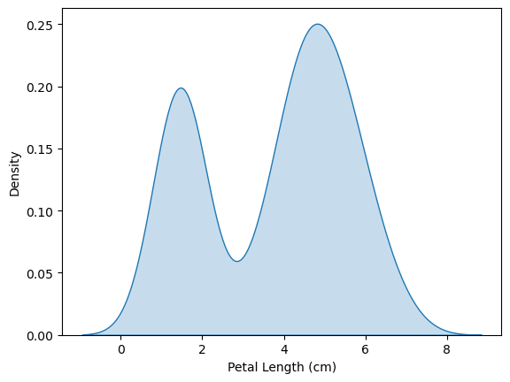

***Two-dimensional KDE plots***

We're not restricted to a single column when creating a KDE plot. We can create a two-dimensional (2D) KDE plot with the sns.jointplot command. In the plot below, the color-coding shows us how likely we are to see different combinations of sepal width and petal length, where darker parts of the figure are more likely.

*# 2D KDE plot*

sns.jointplot(x=iris_data['Petal Length (cm)'], y=iris_data['Sepal Width (cm)'], kind="kde")

<seaborn.axisgrid.JointGrid at 0x786187a48f50>

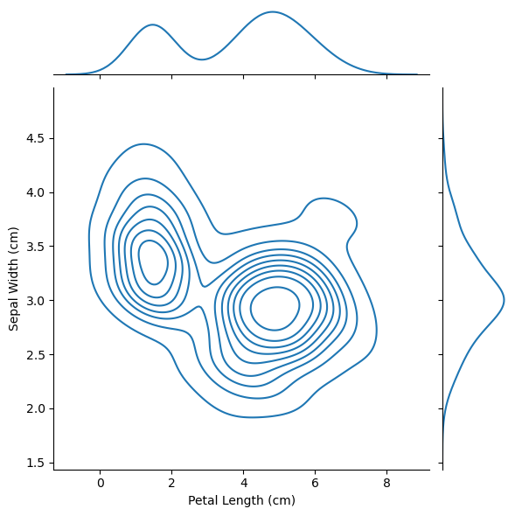

Note that in addition to the 2D KDE plot in the center:

* The curve at the top of the figure is a KDE plot for the data on the x-axis (in this case, iris_data['Petal Length (cm)']).
* The curve on the right of the figure is a KDE plot for the data on the y-axis (in this case, iris_data['Sepal Width (cm)']).

***Color-coded plots***

For the next part of the tutorial, we'll create plots to understand differences between the species. We can create three different histograms (one for each species) of petal length by using the sns.histplot command (as above):

* data= provides the name of the variable that we used to read in the data.
* x= sets the name of column with the data we want to plot.
* hue= sets the column we’ll use to split the data into different histograms.

*# Histograms for each species*

sns.histplot(data=iris_data, x='Petal Length (cm)', hue='Species')

*# Add title*

plt.title("Histogram of Petal Lengths, by Species")

Text(0.5, 1.0, 'Histogram of Petal Lengths, by Species')

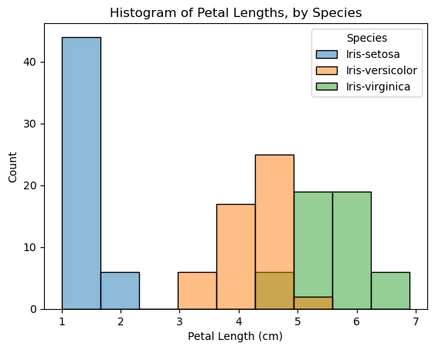

We can also create a KDE plot for each species by using sns.kdeplot (as above). The functionality for data, x, and hue are identical to when we used sns.histplot above. Additionally, we set shade=True to color the area below each curve.

*# KDE plots for each species*

sns.kdeplot(data=iris_data, x='Petal Length (cm)', hue='Species', shade=True)

*# Add title*

plt.title("Distribution of Petal Lengths, by Species")

Text(0.5, 1.0, 'Distribution of Petal Lengths, by Species')

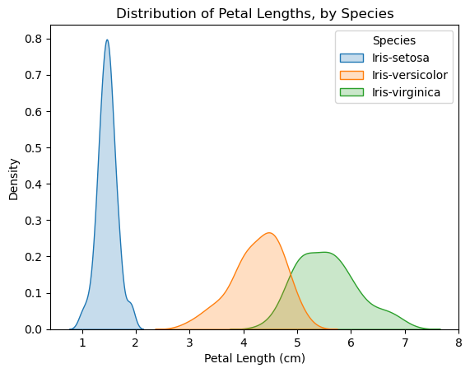

One interesting pattern that can be seen in plots is that the plants seem to belong to one of two groups, where *Iris versicolor* and *Iris virginica* seem to have similar values for petal length, while *Iris setosa* belongs in a category all by itself.

In fact, according to this dataset, we might even be able to classify any iris plant as *Iris setosa* (as opposed to *Iris versicolor* or *Iris virginica*) just by looking at the petal length: if the petal length of an iris flower is less than 2 cm, it's most likely to be *Iris setosa*!