James Swyter and Hollis Barnett

**Honors Pledge[1]:  
  
*As a student of the Dr. Robert B. Pamplin Jr. School of Business I have read and strive to uphold the University’s Code of Academic Integrity and promote ethical behavior. In doing so, I pledge on my honor that I have not given, received, or used any unauthorized materials or assistance on this examination or assignment. I further pledge that I have not engaged in cheating, forgery, or plagiarism and I have cited all appropriate sources.***

Student Signature: James Swyter, Hollis Barnett

|  |  |
| --- | --- |
| File | Description |
| BaseQueue | Code for BaseQueue |
| MMcQueue | Code for MMcQueue |
| MMcPriorityQueue | Code for MMcPriorityQueue |
| MD1Queue | Code for MD1Queue |
| MG1Queue | Code for MG1 Queue |
| MM1Queue | Code for MM1 Queue |
| TestCode | Testing code to check all the classes and make sure they work |

All files above should be in the folder ‘Python Class Files and Testing Code’.

|  |  |
| --- | --- |
| Team Member | Contribution to Submission |
| James Swyter | Wrote all code for BaseQueue, MMcQueue, MMcPriorityQueue, MG1Queue and the Testing code. Made all the flowcharts.  Also helped out with writing MD1Queue and MM1Queue. |
| Hollis Barnett | Helped with writing MD1Queue and MM1Queue |

Below are the flowcharts for the more complex methods that we implemented.

**BaseQueue**

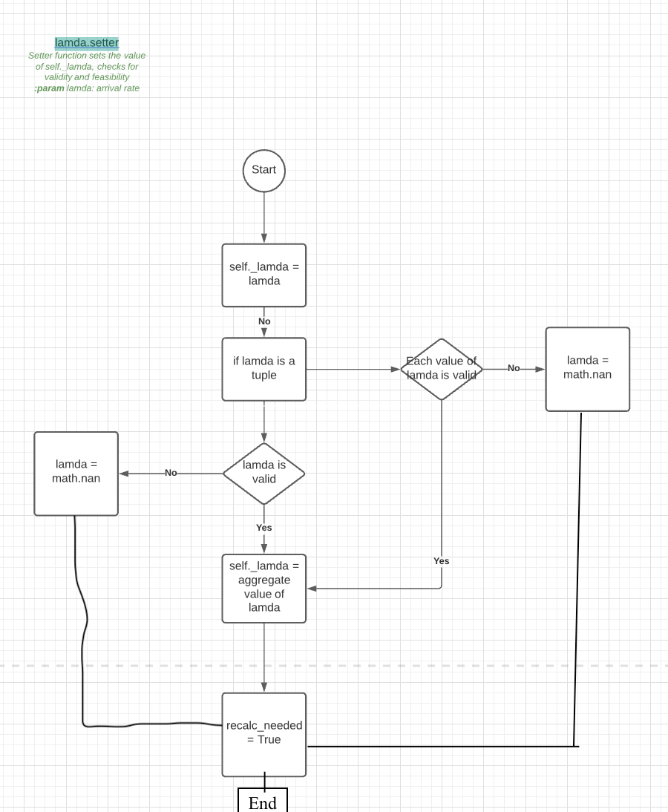

**MMcQueue**

The calc_metrics method inside MMcQueue used nearly identical code to functions already designed in Projects 3 and 4. No major modifications were made to those flowcharts except for different variable names, and a recalc_needed variable.

**MMcPriorityQueue**

Functions for calculating Bk, Wq,k and Lq,k were similar enough to functions from Project 4 that almost all of the code and logic was reused. The only changes were variable names.

**MM1Queue**

**MD1Queue**

**MG1Queue**

1.