James Torok Exam 1

PROBLEM 1

A B W

----------------------

0.0 1.000 0.000

0.2 1.447 0.098

0.4 1.632 0.864

0.6 1.775 2.945

0.8 1.894 6.799

1.0 2.000 12.704

1.2 2.095 20.803

1.4 2.183 31.149

1.6 2.265 43.733

1.8 2.342 58.510

2.0 2.414 75.412

>> 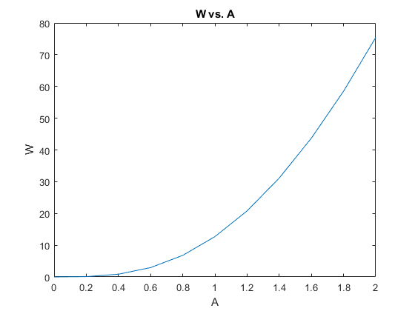

PROBLEM 2

Please enter a percent grade of Exam 1: 75

Please enter a percent grade of Exam 2: 90.5

Please enter a percent grade of Exam Homework: 95

The final score is 85.2

The letter grade is B

Please enter a percent grade of Exam 1: 45

Please enter a percent grade of Exam 2: 70

Please enter a percent grade of Exam Homework: 80

The final score is 62.0

The letter grade is D