Server-Side Development Final Assessment

James Downing – t00192739

# Database

The name of my database is veterinary.

The name of my sql file is veterinary.sql.

# Explanation

My System models a basic website for a veterinary clinic. It enables the user to log in, view the booked appointments, view their registered pets (if any), update their details, add a pet along with booking an appointment and deleting a pet once they have at least one pet registered.

This is achieved through sql queries, user interaction with forms and sessions to keep track of the logged in users ClientID which is used in various places e.g. displaying the appropriate pets for the user on the Make Appointment and delete pet forms

My process/transaction is making an appointment. This is achieved in stages:

1. Check if user has pets added to the system
2. If so, Display form
3. Check if there is already an appointment booked at the user’s entered date and time
4. If not, insert record into appointments table

**Notes:** Due to time constraints the content under the form is the same for each page and the time values in the Make Appointment form were hardcoded in. In a real system they would be replaced with an AppTimes table values and the Procedures table values along with allowing for an admin-level user to log in and add/remove appointment times and procedures via additional forms.

In addition, the simple select (view the date and time of booked appointments) doesn’t make logical sense to be visible to the user but I couldn’t think of what else to put in there.

Also due to time constraints, any pet who has an appointment booked in past or future can’t be removed due to referential integrity. In a real system, instead of fully deleting them there would be an additional column in the pets table for registration status, but I needed an example of deleting so I left it as it is.

Each Link on the navbar corresponds to one of the requested pages – Simple Select, Complex Select, Make Appointment (process), Add pet(insert), delete pet (delete) and Update Your Details (update).

Sample User Login

1. Username: JamesTD1949

Password: admin1?

Pets1-3(peach, toby, Oscar) can’t be deleted but pet 4 (bird) can until you give it an appointment

1. Username: nameTD1949

Password: Name1?

Has no pets so delete and make appointment forms will show an error message until you add one.

# References

Code in general is based off of examples In class.

Code for setting min/max on datepicker and selecting into listbox was provided by Anne.

Code for equivalent of isLetter()/isDigit() 🡪 https://www.php.net/manual/en/function.ctype-alpha.php

HTML and CSS for forms 🡪 <https://colorlib.com/wp/template/colorlib-contact-form/>

HTML and CSS for general structure 🡪 <https://www.w3schools.com/bootstrap/bootstrap_theme_me.asp>

# Data in Tables

**Appointments Table**

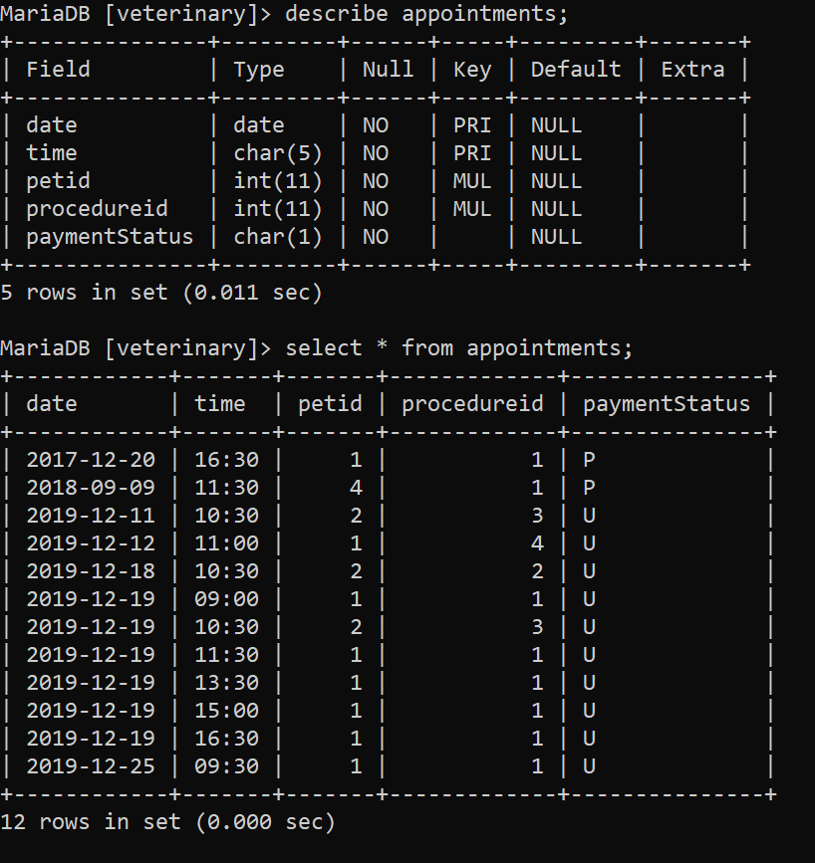

**Owners Table**

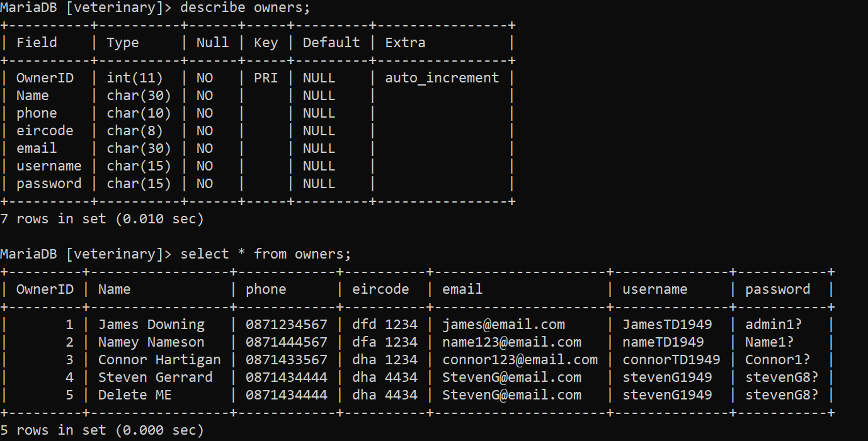

**Pets Table**

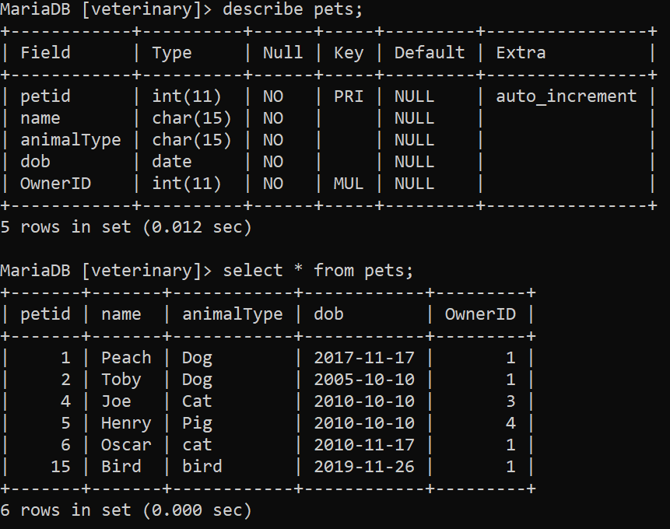

**Procedures Table**

