# **Types of Cloud Computing services**

# Infrastructure as a Service (IaaS)

AWS,

# Platform as a Service (PaaS)

Windows Azure, Redhat openShift online, GitHub, GitLab, Kubernates,Docker

# Software as a Service (SaaS)

Outlook, Google Apps, SalesForce(Create account and add needed services or software)

* Function as a Service(FaaS)

<https://www.linkedin.com/pulse/types-cloud-service-architectures-anees-kagzi>

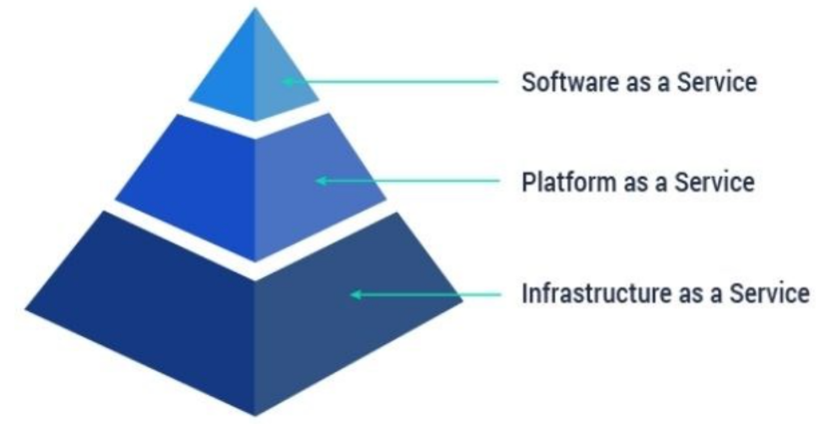

# Micro services

Scaling of Monolithic Apps causes all the modules to be scaled instead of on demand modules.

Communication between services :

1. Through HTTP request.
2. Through message queues, like AMQ
3. Service Mesh, this is new.

Disadvantages:

1. Configuring the service and setting communication between them.
2. Hard to find which service is down.