## Assignment 2: Show off

## Introduction

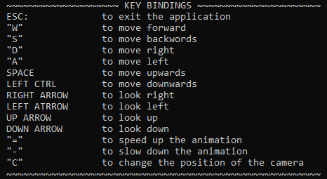 My assignment consists of a textured terrain in form of a field, a textured sphere in form of a sun, a custom object loaded from an obj file with a texture in form of a paper airplane flying around in a circle and a skybox around all these objects. For this assignment I have used the Sphere class and the tiny object loader texture class, the terrain class and a few of my custom classes for elements such as camera, shaders, texture and skybox as my advanced feature. I have also used the glfw wrapper however I have modified it to use my own shader class.

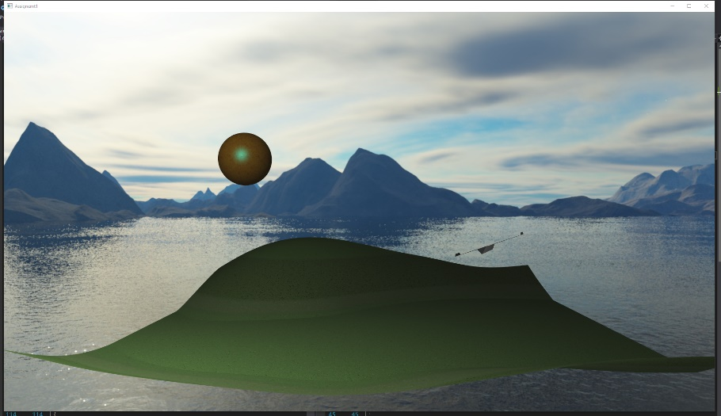First, I created a camera class, which is basically just a collection of camera related variables with functions to help with calculations and functions to handle camera movement from input. Here I have used Euler’s angles (I hope that counts as an advanced feature) to get first person shooter type movements, meaning that the WASD movements are relative to the angle of the camera. Here I also passed in time-based variables for smoother camera movement. Otherwise, it would depend on the frame rate.

I then continued onto making my shader class by modifying the glfw wrapper class and creating a separate ShaderProgram class, this allowed me to manage and wrap all the shader functions specific functions and variables a bit better. For example, I have a few overloaded functions which find the uniform in the shader by a string and pass in a specific type of a value.

Adding the central objects of terrain, plane and sun were not too much of a challenge. There was just a bit of troubleshooting with the terrain. And another small problem which I did not have time to debug was the plane texture, it should have a crumpled paper look to it but it only seems to load as white, I was just too short on time here.

My main and biggest challenge in this project was the skybox. Primarily I was following the learnopengl.com example based on the recommendation of some colleagues. However, it was not working. I must have re-written the skybox class about 4, 5 times in total at this point. And as you can see, I have managed to get it working by the end, however, it still baffles me as to what the problem was. Using glGetError() I managed to figure out that the problem was with the shader, and I think it was to do with some of the gl calls I was making right after initializing the skybox shader.

When it comes to my shaders, there is largely nothing special to them. In my main shaders (for the main overall program) I have implemented Phong shading with textures being passed through and used. The cubemap shaders just take care of the texture for the skybox faces.

## 

# References

* https://learnopengl.com