James Tran

R Assignment A2

This picture displays my profile dashboard. Specifically highlighting the two completed projects that were assigned.

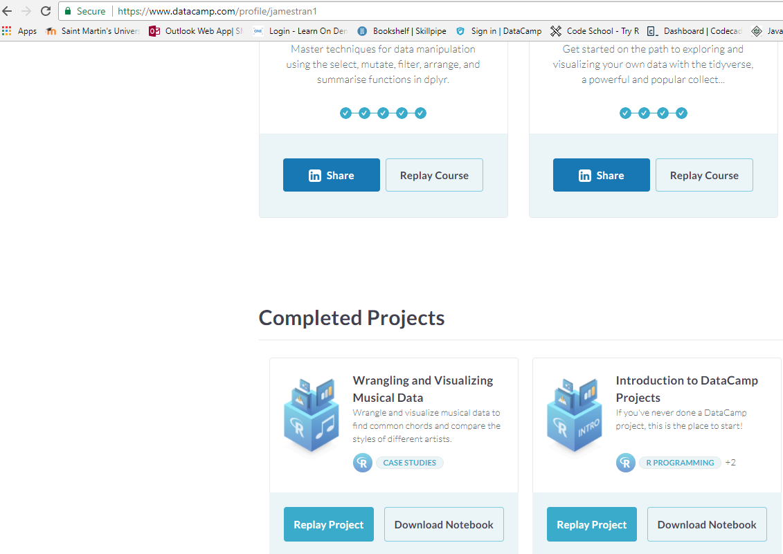

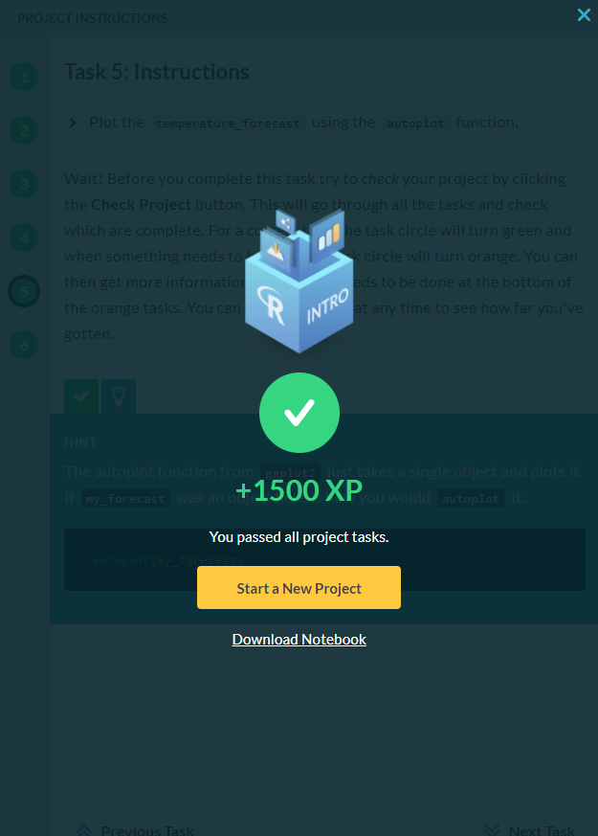

This picture is of the “Introduction to DataCamp Projects” that I completed.

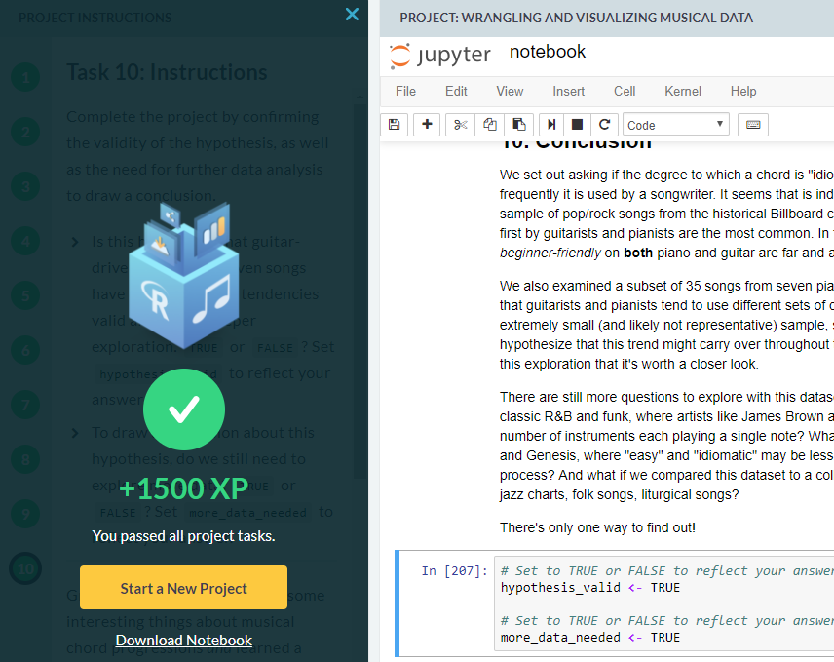

This picture is of the “Wrangling and Visualizing Musical Data” project that we were assigned.