☁️ AWS Cloud Engineering Portfolio
Custom VPC Build: Single-AZ Architecture
with WordPress Application Deployment
Prepared by: James Victor
AWS Networking Project
July 2026

📋 Executive Summary
This project delivers a custom-built Amazon VPC and deploys a WordPress application into it, moving away from AWS's default VPC toward purpose-built, documented network infrastructure. The build demonstrates core AWS networking competencies expected of a cloud engineer: CIDR planning, public/private subnet segmentation, route table design, security group and NACL configuration, and hands-on application deployment via SSH.
The completed environment includes one custom VPC (10.0.0.0/16), a public and private subnet pair in a single Availability Zone, dedicated route tables per subnet, and a running EC2 instance serving a self-hosted WordPress site. The architecture is scoped as a single-AZ build for this first phase, with a multi-AZ, production-hardened iteration planned as the next phase.

🏗️ Architecture Overview
The diagram below outlines the network topology: a single custom VPC spanning one Availability Zone, with a public subnet hosting the WordPress EC2 instance and a private subnet reserved for the database and internal application tier planned for the next phase.
Internet
│
Internet Gateway
│
VPC: james-project-vpc-vpc (10.0.0.0/16) in us-east-1a
├── Public Subnet 10.0.0.0/20 → rtb-public → EC2 (WordPress, public IP)
└── Private Subnet 10.0.128.0/20 → rtb-private1 → (reserved: future EC2/RDS)
Network ACL: acl-0570548284ae047a1, a shared baseline ACL across both subnets at this stage of the build.
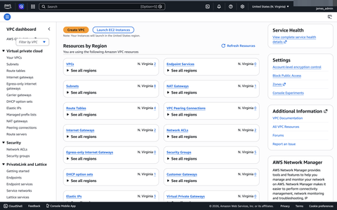
Figure 1: VPC Dashboard: Resources by Region confirming 2 VPCs, 8 subnets, 4 route tables, 2 Internet Gateways, and 1 NAT Gateway across the whole account, including resources outside this project's VPC.

🌐 CIDR & Subnet Design Decisions
The VPC and its two subnets were deliberately sized above the originally planned /24 blocks to build in scalability headroom without needing to re-architect the network later.
Resource | CIDR Block | Available IPs | Design Rationale
VPC | 10.0.0.0/16 | 65,536 | Standard private range; ample room for future subnets across additional AZs
Public Subnet | 10.0.0.0/20 | 4,096 | Sized above the original /24 plan for scalability; hosts internet-facing resources
Private Subnet | 10.0.128.0/20 | 4,096 | Non-overlapping block; isolated from direct internet exposure
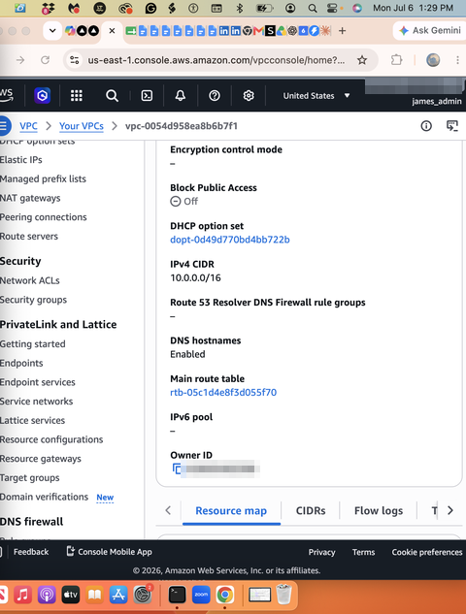
Figure 2: VPC details confirming IPv4 CIDR 10.0.0.0/16, DNS resolution enabled, and main route table association.
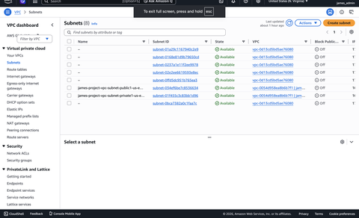
Figure 3: Subnets view showing 8 total subnets in the account; only 2 (public1 and private1, tagged james-project-vpc) belong to this custom VPC; the remaining 6 are AWS default-VPC subnets.
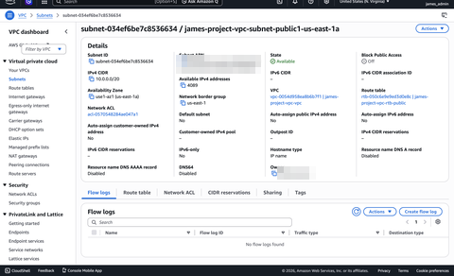
Figure 4: Public subnet detail: 10.0.0.0/20 in us-east-1a, associated with the public route table.
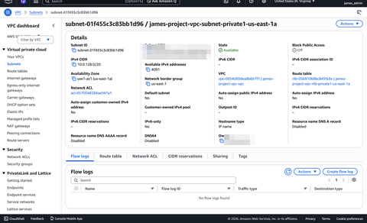
Figure 5: Private subnet detail: 10.0.128.0/20 in us-east-1a, associated with its own dedicated private route table.

🛣️ Route Table Logic
Each subnet is associated with its own dedicated route table rather than sharing a single table across the VPC. This is the correct pattern for enforcing different traffic rules per network tier.
Route Table | Subnet | Key Route | Purpose
james-project-vpc-rtb-public | Public (10.0.0.0/20) | 0.0.0.0/0 → IGW | Two-way internet access for public-facing resources
james-project-vpc-rtb-private1-us-east-1a | Private (10.0.128.0/20) | Local route only (NAT Gateway planned) | Outbound-only internet access, no inbound exposure

🔒 Security Posture
- Network ACL scope: Single Network ACL (acl-0570548284ae047a1) currently shared across both subnets; a production build would separate these per tier.
- Security Groups: 5 security groups configured account-wide, enforcing stateful, instance-level access control.
- Public IP exposure: Auto-assign public IPv4 is currently set to No on the public subnet, so the running instance received its public IP through an Elastic IP rather than automatically at launch. Flagged for correction.
- Database credentials: wp-config.php was set up with DB_USER: root and a blank password during initial testing. This is a hardening item for any environment beyond local development. A dedicated least-privilege MySQL user and managed secret storage (e.g., AWS Secrets Manager) should replace this before the site handles real traffic.
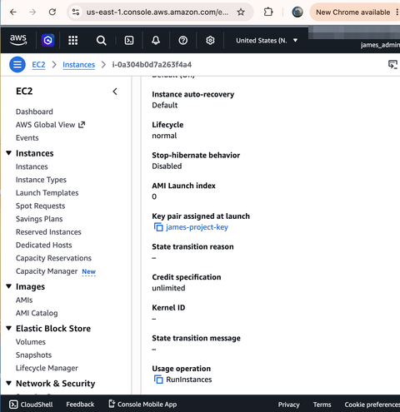
Figure 6: EC2 instance detail confirming the key pair (james-project-key) assigned at launch, used for SSH authentication.

🚀 Deployment Walkthrough

1. VPC & Subnet Creation
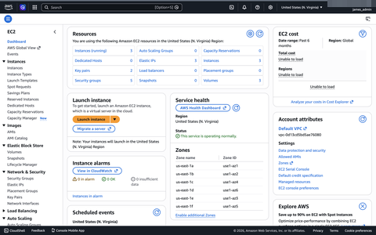
Figure 7: EC2 dashboard confirming 3 running instances, 5 security groups, and 2 key pairs prior to detailed VPC verification.
The VPC (10.0.0.0/16), public subnet (10.0.0.0/20), private subnet (10.0.128.0/20), Internet Gateway, and route tables were created via the AWS Console under the VPC service.

2. EC2 Instance Launch
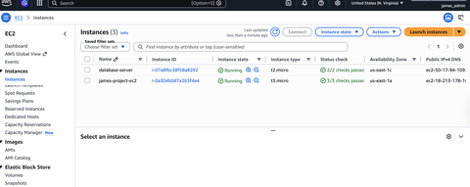
Figure 8: Instances list showing james-project-ec2 (t3.micro) running in us-east-1a.
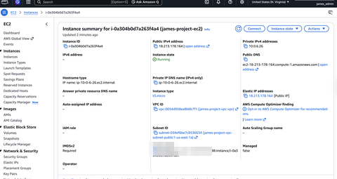
Figure 9: Instance summary confirming james-project-ec2 is correctly attached to vpc-0054d958ea8b6b7f1 and subnet-034ef6be7c8536634 (the public subnet).

3. WordPress Installation via SSH
cd /var/www/html
sudo wget https://wordpress.org/latest.tar.gz
sudo tar -xzf latest.tar.gz
sudo mv wordpress/* .
sudo chown -R www-data:www-data /var/www/html
sudo chmod -R 755 /var/www/html
sudo cp wp-config-sample.php wp-config.php
sudo nano wp-config.php
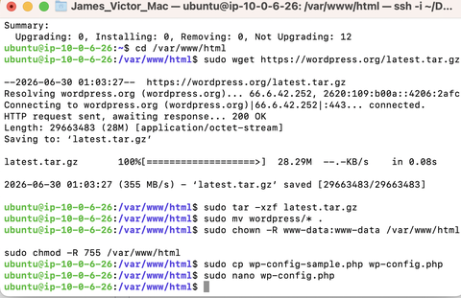
Figure 10: Terminal output of the WordPress download, extraction, and file permission commands.
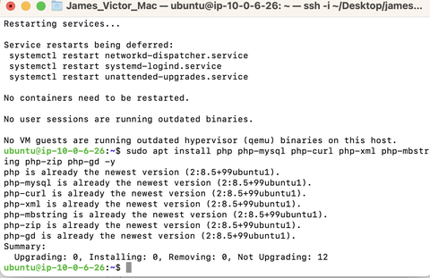
Figure 11: LAMP stack dependency installation (php, php-mysql, php-curl, php-xml, php-mbstring, php-zip, php-gd).
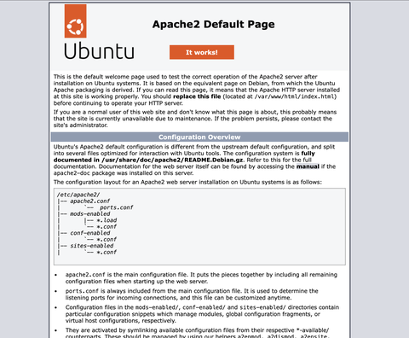
Figure 12: Apache2 Ubuntu default page confirming the web server was operational prior to the WordPress files taking over the document root.

💰 Cost Mitigation Strategy
Resource | Type | Est. Monthly Cost
EC2 Instance | t3.micro | ~$7.50 (or $0 under Free Tier)
EBS Volume | 8 GiB gp3 | ~$0.64
Elastic IP | 1 attached | ~$3.60 (AWS bills all public IPv4 since Feb 2024)
VPC / Subnets / Route Tables / IGW | N/A | $0 (no charge for these resources)
NAT Gateway (planned) | N/A | ~$32.40/mo + data processing; primary cost driver
The largest cost consideration going forward is the NAT Gateway, billed hourly regardless of traffic volume. For a low-traffic development environment, a self-managed NAT instance is a lower-cost alternative, traded off against reduced availability and manual patching responsibility.

🧯 Incident Response & Lessons Learned

Issue: SSH Connection Failures
Initial SSH attempts failed with "command not found" and "Permission denied (publickey)" errors.
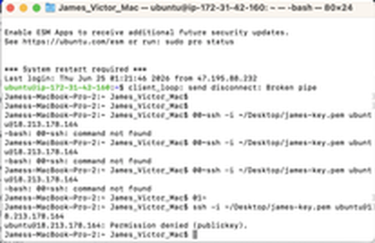
Figure 13: Terminal showing stray '00~' and '01~' characters injected into the SSH command, causing repeated connection failures.
- Root cause: Pasting the SSH command from a source that appended terminal control sequences, inserting stray characters (00~, 01~) at the start of the command.
- Resolution: Re-typed the SSH command manually rather than pasting, confirming the terminal prompt showed ubuntu@ip-10-0-6-26 (on the server) rather than the local Mac prompt before proceeding.
- Takeaway: Always verify the exact command before executing, especially after copy/paste, and confirm which machine's shell prompt is actually active before running further commands.

Issue: Pending Kernel & Package Updates
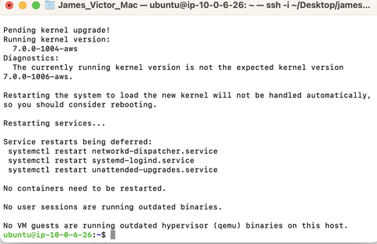
Figure 14: System flagged a pending kernel upgrade (running 7.0.0-1004-aws vs. expected 7.0.0-1006-aws) and 12 available package updates.
Freshly launched EC2 instances are not automatically patched to the latest kernel and package versions. A full sudo apt update && sudo apt upgrade pass, followed by a reboot when a kernel upgrade is pending, should be treated as a standard first step after instance launch, before installing application dependencies.

🎯 Key Concepts & Interview Talking Points
- Why build a custom VPC instead of using the default? Full control over CIDR planning, subnet segmentation, and routing. The default VPC is flat and public-facing by design, which isn't appropriate for anything beyond a quick test.
- Security Groups vs. NACLs: Security Groups are stateful and apply at the instance (ENI) level; NACLs are stateless and apply at the subnet level. A NACL deny rule cannot be overridden by a permissive Security Group, so proper defense in depth requires configuring both correctly.
- What actually makes a subnet 'public'? The subnet label alone doesn't make a resource internet-reachable. It takes an Internet Gateway route in the route table AND a public IP on the instance. This project surfaced that distinction directly when auto-assign public IP was found disabled on the 'public' subnet.
- NAT Gateway vs. Internet Gateway: An Internet Gateway allows two-way traffic for public subnet resources. A NAT Gateway allows one-way outbound-only access for private subnet resources, which is essential for patching a private database server without exposing it to inbound connections.
- Single-AZ limitation, addressed head-on: This build is intentionally single-AZ for this first phase. The production-minded answer: extend to two Availability Zones with duplicated public/private subnet pairs and Multi-AZ RDS or a load balancer, removing the single point of failure.

✅ Conclusion & Production Recommendations
This project successfully established a working custom VPC and deployed a WordPress application into it, validating core networking and deployment skills. The following steps are recommended as the next iteration of this project:
- Multi-AZ redundancy: Duplicate the public/private subnet pair into a second Availability Zone (e.g., us-east-1b) for high availability.
- Fix public IP assignment: Enable auto-assign public IPv4 on the public subnet so future instances receive public IPs automatically at launch.
- Harden WordPress credentials: Replace the root MySQL user and blank password in wp-config.php with a dedicated least-privilege user and managed secret storage.
- Deploy NAT Gateway: Deploy a NAT Gateway (or a cost-conscious NAT instance for dev environments) to support the private subnet's planned RDS and private EC2 workloads planned for the next phase.
- Segment NACLs per tier: Separate the shared Network ACL into per-tier ACLs, with the private subnet locked down more aggressively than the public subnet.
These items form a clear, documented roadmap from a working single-AZ proof of concept to a production-grade, resilient architecture, demonstrating not just what was built, but the engineering judgment behind what comes next.

