Hussam Hashem

James Clark

Dr. Yugyung Lee

CS 551

March 12, 2013

Increment Report #1

Deployment

Link to project home page - <http://vhost0165.site1.compute.ihost.com/>

Link to web service - <http://vhost0165.site1.compute.ihost.com/Assets/WebServices/DataHandler.asmx>

Agilefant - <http://vhost0009.site1.compute.ihost.com:8080/agilefant/login.jsp>

Github - <https://github.com/JamesWClark/Strikethrough>

Implementation & Report

Application Begin:

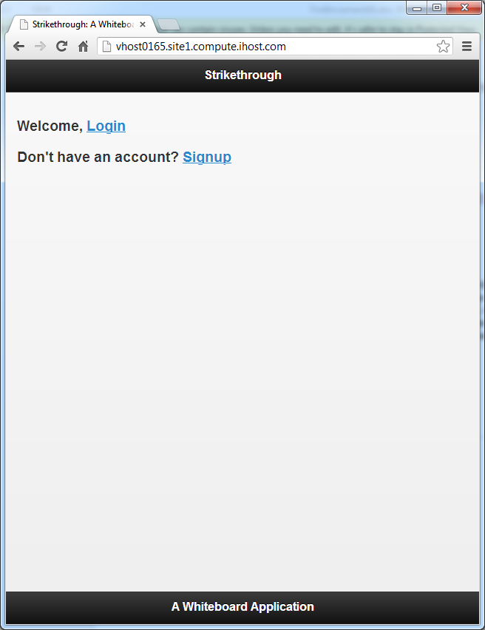

Click Signup:

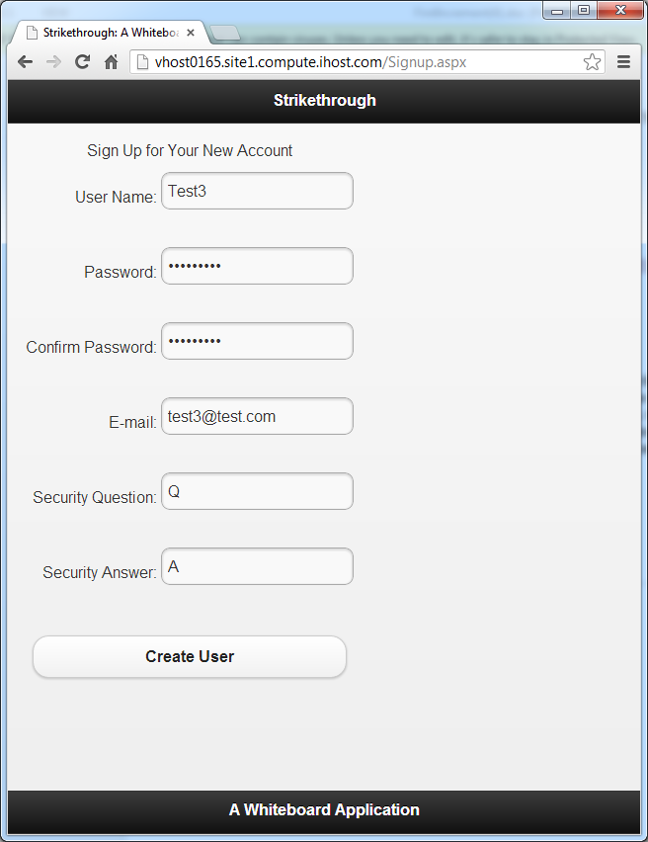

Click Create User (assuming successful creation)

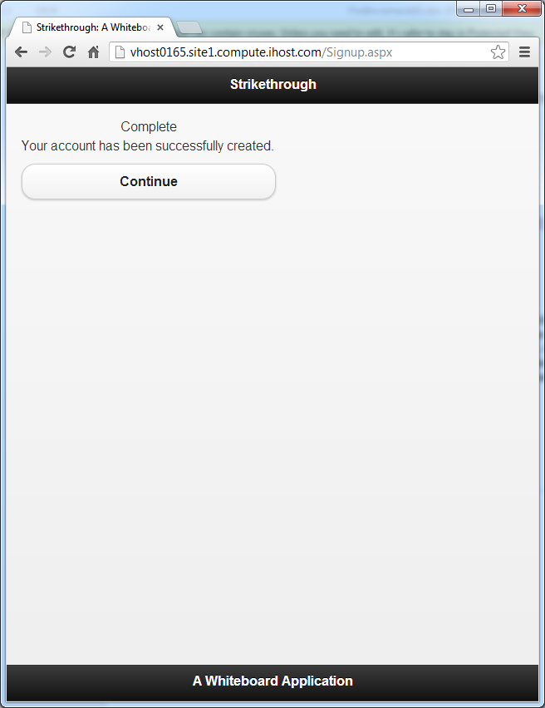

Click Create New Whiteboard

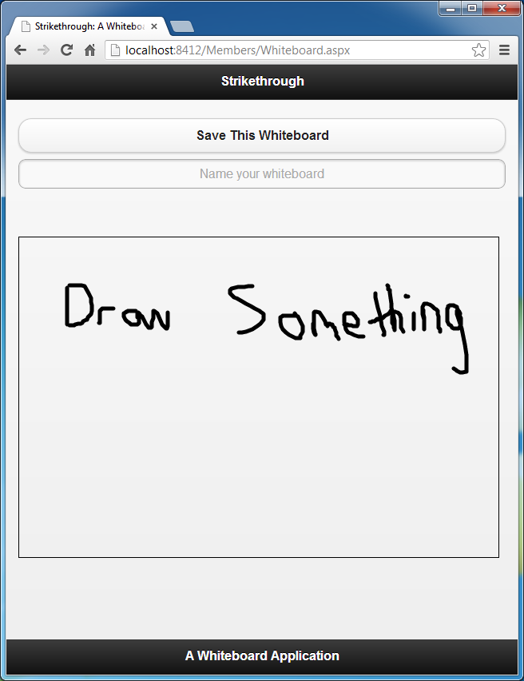

Detailed Design of Services

See WSDL service description at end of report.

Sequence Diagram



Class Diagram



Testing

NUnit

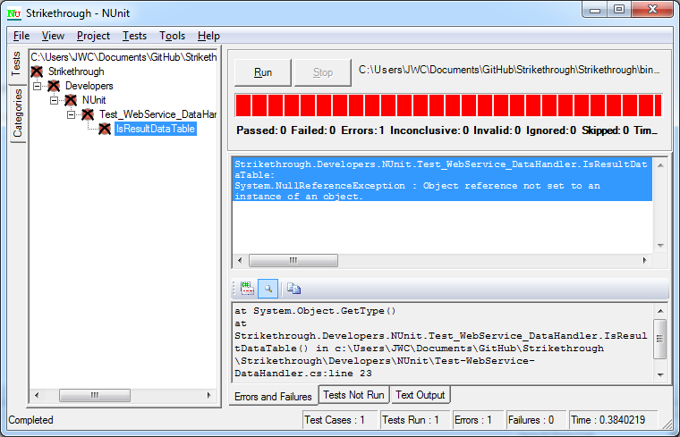

Project Management

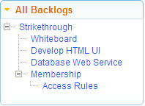

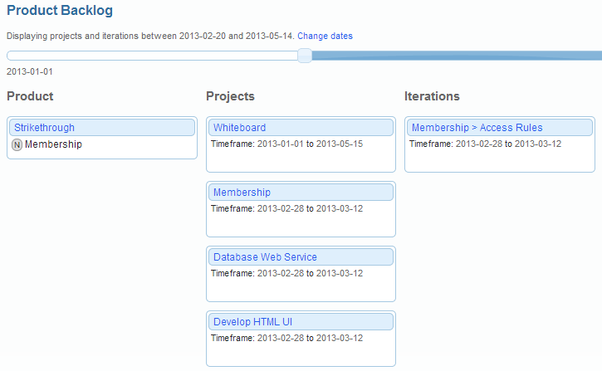

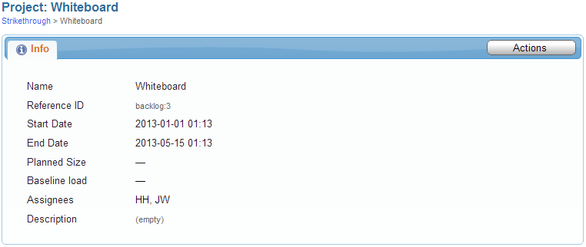

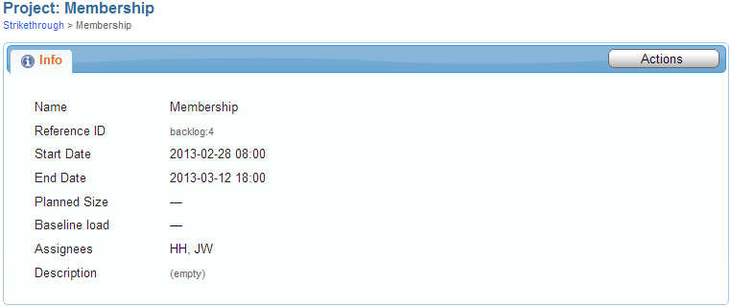

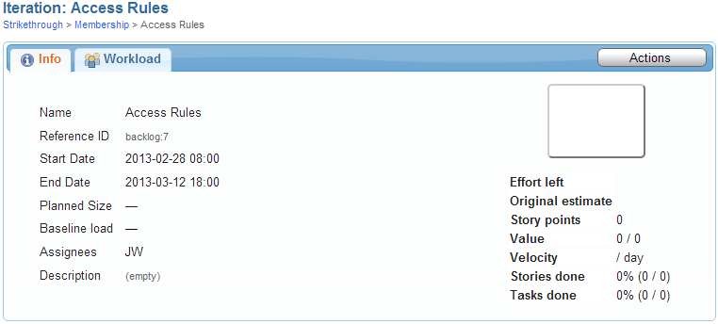

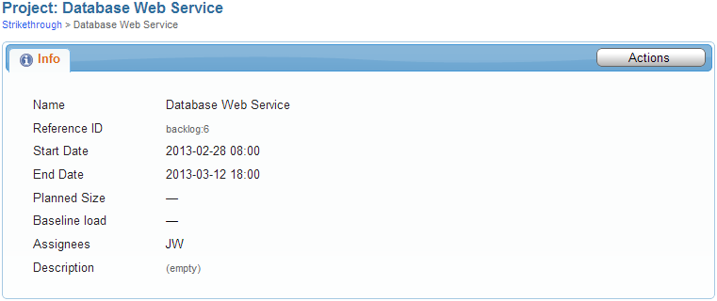

WSDL

<wsdl:definitions xmlns:tm="http://microsoft.com/wsdl/mime/textMatching/" xmlns:soapenc="http://schemas.xmlsoap.org/soap/encoding/"xmlns:mime="http://schemas.xmlsoap.org/wsdl/mime/" xmlns:tns="vhost0165.site1.compute.ihost.com" xmlns:soap="http://schemas.xmlsoap.org/wsdl/soap/"xmlns:s="http://www.w3.org/2001/XMLSchema" xmlns:soap12="http://schemas.xmlsoap.org/wsdl/soap12/" xmlns:http="http://schemas.xmlsoap.org/wsdl/http/"xmlns:wsdl="http://schemas.xmlsoap.org/wsdl/" targetNamespace="vhost0165.site1.compute.ihost.com">

<wsdl:types>

<s:schema elementFormDefault="qualified" targetNamespace="vhost0165.site1.compute.ihost.com">

<s:element name="ExecuteNonQuery">

<s:complexType>

<s:sequence>

<s:element minOccurs="0" maxOccurs="1" name="query" type="s:string"/>

</s:sequence>

</s:complexType>

</s:element>

<s:element name="ExecuteNonQueryResponse">

<s:complexType/>

</s:element>

<s:element name="ExecuteScalar">

<s:complexType>

<s:sequence>

<s:element minOccurs="0" maxOccurs="1" name="query" type="s:string"/>

</s:sequence>

</s:complexType>

</s:element>

<s:element name="ExecuteScalarResponse">

<s:complexType>

<s:sequence>

<s:element minOccurs="0" maxOccurs="1" name="ExecuteScalarResult" type="s:string"/>

</s:sequence>

</s:complexType>

</s:element>

<s:element name="GetDataTable">

<s:complexType>

<s:sequence>

<s:element minOccurs="0" maxOccurs="1" name="query" type="s:string"/>

</s:sequence>

</s:complexType>

</s:element>

<s:element name="GetDataTableResponse">

<s:complexType>

<s:sequence>

<s:element minOccurs="0" maxOccurs="1" name="GetDataTableResult">

<s:complexType>

<s:sequence>

<s:any minOccurs="0" maxOccurs="unbounded" namespace="http://www.w3.org/2001/XMLSchema" processContents="lax"/>

<s:any minOccurs="1" namespace="urn:schemas-microsoft-com:xml-diffgram-v1" processContents="lax"/>

</s:sequence>

</s:complexType>

</s:element>

</s:sequence>

</s:complexType>

</s:element>

</s:schema>

</wsdl:types>

<wsdl:message name="ExecuteNonQuerySoapIn">

<wsdl:part name="parameters" element="tns:ExecuteNonQuery"/>

</wsdl:message>

<wsdl:message name="ExecuteNonQuerySoapOut">

<wsdl:part name="parameters" element="tns:ExecuteNonQueryResponse"/>

</wsdl:message>

<wsdl:message name="ExecuteScalarSoapIn">

<wsdl:part name="parameters" element="tns:ExecuteScalar"/>

</wsdl:message>

<wsdl:message name="ExecuteScalarSoapOut">

<wsdl:part name="parameters" element="tns:ExecuteScalarResponse"/>

</wsdl:message>

<wsdl:message name="GetDataTableSoapIn">

<wsdl:part name="parameters" element="tns:GetDataTable"/>

</wsdl:message>

<wsdl:message name="GetDataTableSoapOut">

<wsdl:part name="parameters" element="tns:GetDataTableResponse"/>

</wsdl:message>

<wsdl:portType name="DataHandlerSoap">

<wsdl:operation name="ExecuteNonQuery">

<wsdl:input message="tns:ExecuteNonQuerySoapIn"/>

<wsdl:output message="tns:ExecuteNonQuerySoapOut"/>

</wsdl:operation>

<wsdl:operation name="ExecuteScalar">

<wsdl:input message="tns:ExecuteScalarSoapIn"/>

<wsdl:output message="tns:ExecuteScalarSoapOut"/>

</wsdl:operation>

<wsdl:operation name="GetDataTable">

<wsdl:input message="tns:GetDataTableSoapIn"/>

<wsdl:output message="tns:GetDataTableSoapOut"/>

</wsdl:operation>

</wsdl:portType>

<wsdl:binding name="DataHandlerSoap" type="tns:DataHandlerSoap">

<soap:binding transport="http://schemas.xmlsoap.org/soap/http"/>

<wsdl:operation name="ExecuteNonQuery">

<soap:operation soapAction="vhost0165.site1.compute.ihost.com/ExecuteNonQuery" style="document"/>

<wsdl:input>

<soap:body use="literal"/>

</wsdl:input>

<wsdl:output>

<soap:body use="literal"/>

</wsdl:output>

</wsdl:operation>

<wsdl:operation name="ExecuteScalar">

<soap:operation soapAction="vhost0165.site1.compute.ihost.com/ExecuteScalar" style="document"/>

<wsdl:input>

<soap:body use="literal"/>

</wsdl:input>

<wsdl:output>

<soap:body use="literal"/>

</wsdl:output>

</wsdl:operation>

<wsdl:operation name="GetDataTable">

<soap:operation soapAction="vhost0165.site1.compute.ihost.com/GetDataTable" style="document"/>

<wsdl:input>

<soap:body use="literal"/>

</wsdl:input>

<wsdl:output>

<soap:body use="literal"/>

</wsdl:output>

</wsdl:operation>

</wsdl:binding>

<wsdl:binding name="DataHandlerSoap12" type="tns:DataHandlerSoap">

<soap12:binding transport="http://schemas.xmlsoap.org/soap/http"/>

<wsdl:operation name="ExecuteNonQuery">

<soap12:operation soapAction="vhost0165.site1.compute.ihost.com/ExecuteNonQuery" style="document"/>

<wsdl:input>

<soap12:body use="literal"/>

</wsdl:input>

<wsdl:output>

<soap12:body use="literal"/>

</wsdl:output>

</wsdl:operation>

<wsdl:operation name="ExecuteScalar">

<soap12:operation soapAction="vhost0165.site1.compute.ihost.com/ExecuteScalar" style="document"/>

<wsdl:input>

<soap12:body use="literal"/>

</wsdl:input>

<wsdl:output>

<soap12:body use="literal"/>

</wsdl:output>

</wsdl:operation>

<wsdl:operation name="GetDataTable">

<soap12:operation soapAction="vhost0165.site1.compute.ihost.com/GetDataTable" style="document"/>

<wsdl:input>

<soap12:body use="literal"/>

</wsdl:input>

<wsdl:output>

<soap12:body use="literal"/>

</wsdl:output>

</wsdl:operation>

</wsdl:binding>

<wsdl:service name="DataHandler">

<wsdl:port name="DataHandlerSoap" binding="tns:DataHandlerSoap">

<soap:address location="http://localhost:8412/Assets/WebServices/DataHandler.asmx"/>

</wsdl:port>

<wsdl:port name="DataHandlerSoap12" binding="tns:DataHandlerSoap12">

<soap12:address location="http://localhost:8412/Assets/WebServices/DataHandler.asmx"/>

</wsdl:port>

</wsdl:service>

</wsdl:definitions>