James Clark

Hussam Hashem

Dr. Yugyung Lee

CS 551

March 27, 2014

Increment Report #2

# Detail Design of Services

We introduce a new web service for IP address geolocation. Our web service makes HTTP requests to <http://freegeoip.net/>. Our detailed WSDL is located at the end of this document.

**Sequence Diagram**

This is the canvas drawing sequence diagram originally proposed. Much progress was made toward actualizing this. The Line object is likely to be removed, but layering the canvas and stacking to one image before saving has been implemented successfully. This adds powerful ‘edit’ capability to the application.



**Class Diagram**

This is really quite simple, as is our web service. The majority of work for this iteration went into correcting and improving issues with our JavaScript HTML5 canvas.



**NUnit**

The NUnit test is comparably simple as it takes known values and compares them against the GeoIP class and GetGeoIP() method in the SystemNetService web service. Initial tests show only one failure against the zip code parameter.

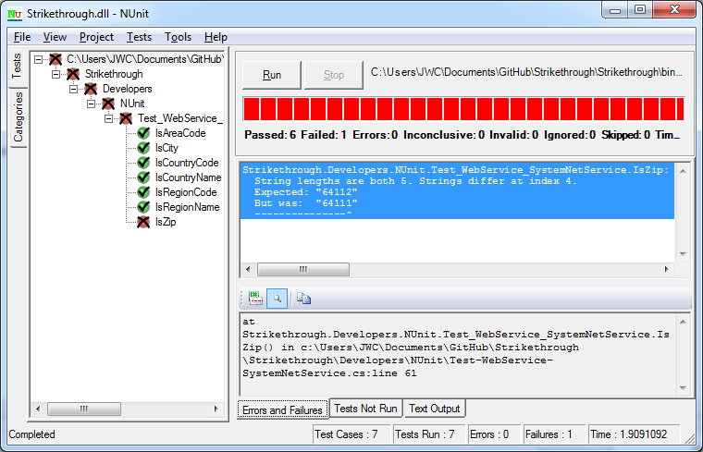

It should be noted that the service returns 64111 and is not equal to the assertion that the known value is 64112. However, the known value 64112 actually applies to a physical location. IP gelocation lookups are not an exact science, and the returned value of 64111 is acceptably close (literally a neighboring city district). Adjusting the zip code to 64111 satisfies tests for this service.

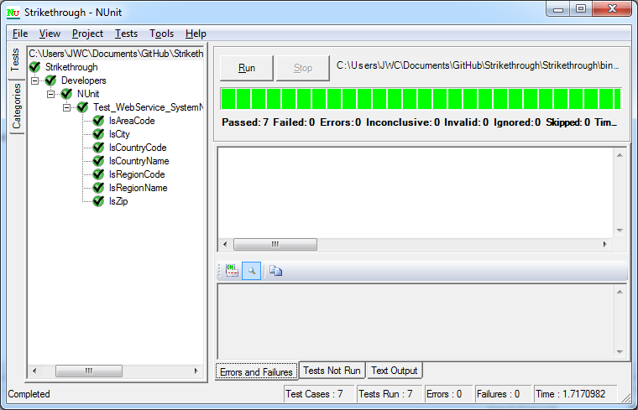

**NUnit Test Code**

using System;

using System.Collections.Generic;

using System.Linq;

using System.Web;

using NUnit.Framework;

namespace Strikethrough.Developers.NUnit

{

[TestFixture]

public class Test_WebService_SystemNetService

{

//known values

private static string ip = "69.76.186.116";

private static string country_code = "US";

private static string country_name = "United States";

private static string region_code = "MO";

private static string region_name = "Missouri";

private static string city = "Kansas City";

private static string zipcode = "64111";

//private static string latitude = "?";

//private static string longitude = "?";

//private static string metro_code = "?";

private static string areacode = "816";

private Assets.WebServices.SystemNetService sns = new Assets.WebServices.SystemNetService();

private Assets.Code.GeoIP geo = new Assets.Code.GeoIP();

[SetUp]

public void Init()

{

geo = sns.GetGeoIP(ip);

}

[Test]

public void IsCountryCode()

{

Assert.AreEqual(country_code, geo.country_code);

}

[Test]

public void IsCountryName()

{

Assert.AreEqual(country_name, geo.country_name);

}

[Test]

public void IsRegionCode()

{

Assert.AreEqual(region_code, geo.region_code);

}

[Test]

public void IsRegionName()

{

Assert.AreEqual(region_name, geo.region_name);

}

[Test]

public void IsCity()

{

Assert.AreEqual(city, geo.city);

}

[Test]

public void IsZip()

{

Assert.AreEqual(zipcode, geo.zipcode);

}

[Test]

public void IsAreaCode()

{

Assert.AreEqual(areacode, geo.areacode);

}

}

}

# Implementation

The greatest change is the ability to open a stored canvas image, draw on top of it, then save it with a new name.

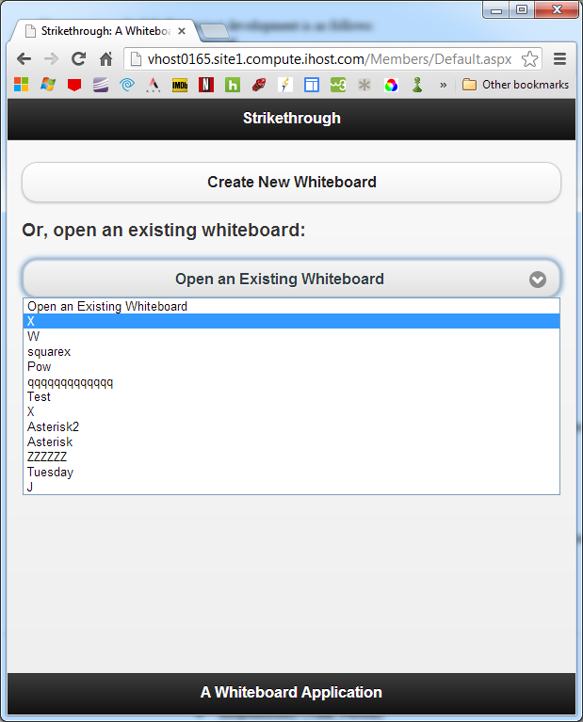

Canvas loaded…

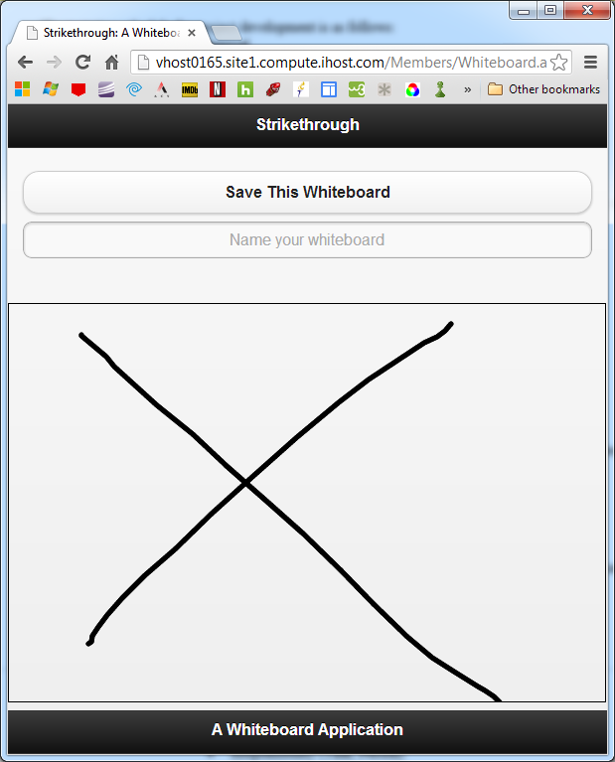

Draw on the old canvas, rename it, and save…

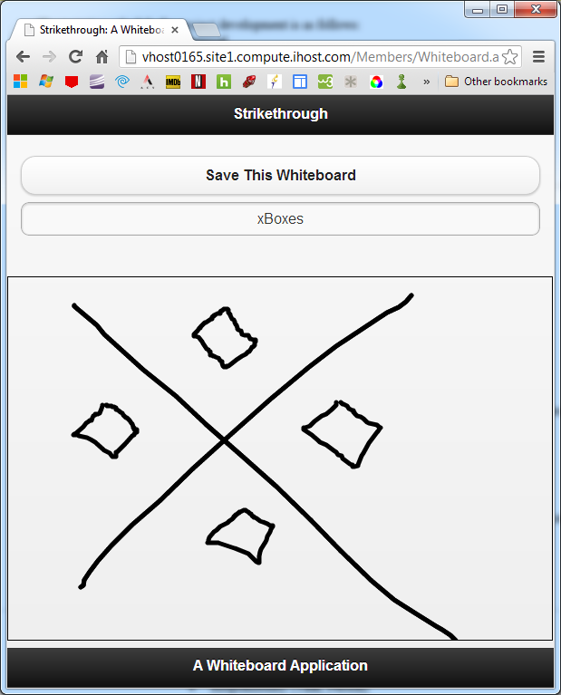

It is available to be opened with the new name…

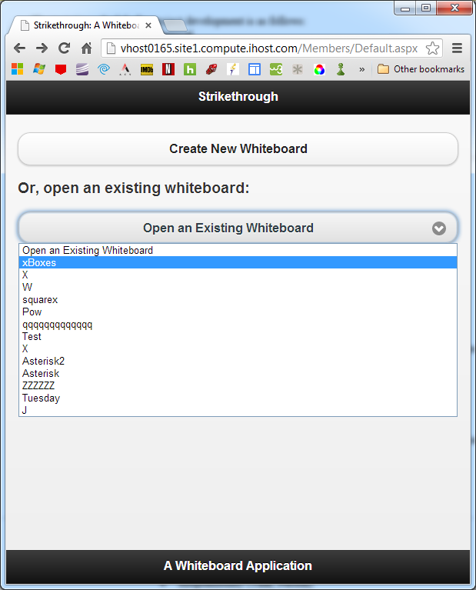

And you can see the change is saved…

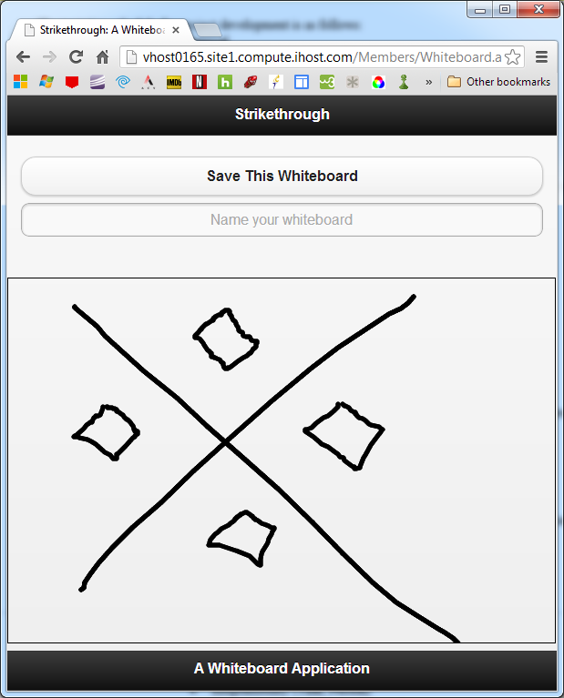

This cycle can continue. More drawing controls need to be added, and the navigation systems needs a rework.

# Deployment

Our new geolocation service is located at <http://vhost0165.site1.compute.ihost.com/assets/webservices/systemnetservice.asmx?WSDL>

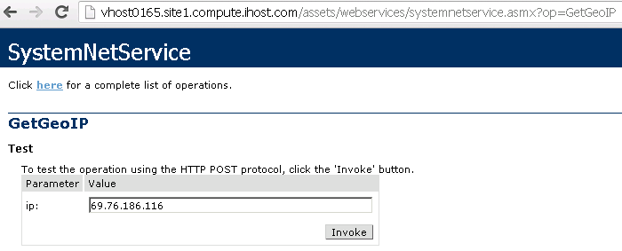

Invoking the service yields a GeoIP object, planned for implementing an administrative control panel for project iteration 3, as well as storing site usage statistics.

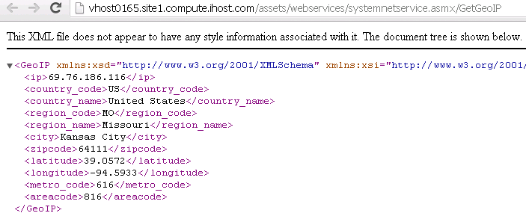

The site is still located at

<http://vhost0165.site1.compute.ihost.com/>

The two existing web services are

<http://vhost0165.site1.compute.ihost.com/assets/webservices/datahandler.asmx>

<http://vhost0165.site1.compute.ihost.com/assets/webservices/systemnetservice.asmx>

One public web service we are now using is

<http://freegeoip.net/>

Agilefant is still located at

<http://vhost0009.site1.compute.ihost.com:8080/agilefant/login.jsp>

Project Management

We are under-utilizing Agilefant for tracking progress. In a team of two, it has been sufficient to email, track changes over Github, and meet via Skype and Join.me desktop sharing sessions.

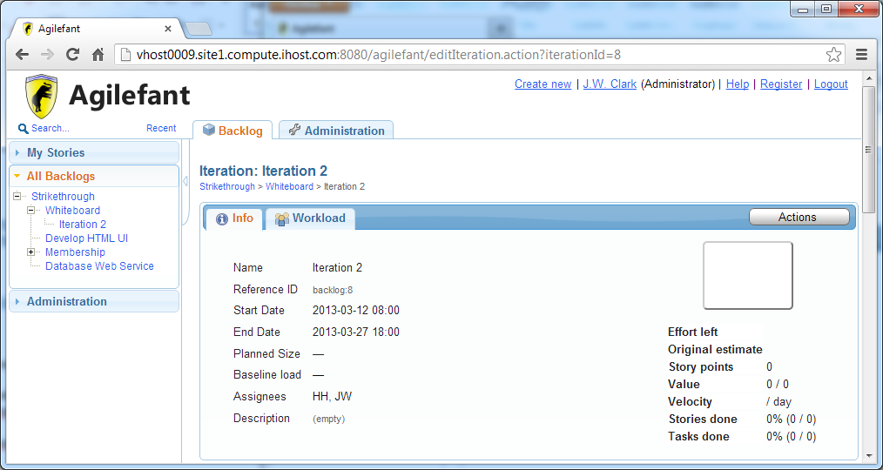

**WSDL**

This XML file does not appear to have any style information associated with it. The document tree is shown below.

<wsdl:definitions xmlns:s="http://www.w3.org/2001/XMLSchema" xmlns:soap12="http://schemas.xmlsoap.org/wsdl/soap12/" xmlns:mime="http://schemas.xmlsoap.org/wsdl/mime/" xmlns:tns="vhost0165.site1.compute.ihost.com" xmlns:soap="http://schemas.xmlsoap.org/wsdl/soap/" xmlns:tm="http://microsoft.com/wsdl/mime/textMatching/" xmlns:http="http://schemas.xmlsoap.org/wsdl/http/" xmlns:soapenc="http://schemas.xmlsoap.org/soap/encoding/" xmlns:wsdl="http://schemas.xmlsoap.org/wsdl/" targetNamespace="vhost0165.site1.compute.ihost.com">

<wsdl:types>

<s:schema elementFormDefault="qualified" targetNamespace="vhost0165.site1.compute.ihost.com">

<s:element name="GetGeoIP">

<s:complexType>

<s:sequence>

<s:element minOccurs="0" maxOccurs="1" name="ip" type="s:string"/>

</s:sequence>

</s:complexType>

</s:element>

<s:element name="GetGeoIPResponse">

<s:complexType>

<s:sequence>

<s:element minOccurs="0" maxOccurs="1" name="GetGeoIPResult" type="tns:GeoIP"/>

</s:sequence>

</s:complexType>

</s:element>

<s:complexType name="GeoIP">

<s:sequence>

<s:element minOccurs="0" maxOccurs="1" name="ip" type="s:string"/>

<s:element minOccurs="0" maxOccurs="1" name="country_code" type="s:string"/>

<s:element minOccurs="0" maxOccurs="1" name="country_name" type="s:string"/>

<s:element minOccurs="0" maxOccurs="1" name="region_code" type="s:string"/>

<s:element minOccurs="0" maxOccurs="1" name="region_name" type="s:string"/>

<s:element minOccurs="0" maxOccurs="1" name="city" type="s:string"/>

<s:element minOccurs="0" maxOccurs="1" name="zipcode" type="s:string"/>

<s:element minOccurs="0" maxOccurs="1" name="latitude" type="s:string"/>

<s:element minOccurs="0" maxOccurs="1" name="longitude" type="s:string"/>

<s:element minOccurs="0" maxOccurs="1" name="metro_code" type="s:string"/>

<s:element minOccurs="0" maxOccurs="1" name="areacode" type="s:string"/>

</s:sequence>

</s:complexType>

</s:schema>

</wsdl:types>

<wsdl:message name="GetGeoIPSoapIn">

<wsdl:part name="parameters" element="tns:GetGeoIP"/>

</wsdl:message>

<wsdl:message name="GetGeoIPSoapOut">

<wsdl:part name="parameters" element="tns:GetGeoIPResponse"/>

</wsdl:message>

<wsdl:portType name="SystemNetServiceSoap">

<wsdl:operation name="GetGeoIP">

<wsdl:input message="tns:GetGeoIPSoapIn"/>

<wsdl:output message="tns:GetGeoIPSoapOut"/>

</wsdl:operation>

</wsdl:portType>

<wsdl:binding name="SystemNetServiceSoap" type="tns:SystemNetServiceSoap">

<soap:binding transport="http://schemas.xmlsoap.org/soap/http"/>

<wsdl:operation name="GetGeoIP">

<soap:operation soapAction="vhost0165.site1.compute.ihost.com/GetGeoIP" style="document"/>

<wsdl:input>

<soap:body use="literal"/>

</wsdl:input>

<wsdl:output>

<soap:body use="literal"/>

</wsdl:output>

</wsdl:operation>

</wsdl:binding>

<wsdl:binding name="SystemNetServiceSoap12" type="tns:SystemNetServiceSoap">

<soap12:binding transport="http://schemas.xmlsoap.org/soap/http"/>

<wsdl:operation name="GetGeoIP">

<soap12:operation soapAction="vhost0165.site1.compute.ihost.com/GetGeoIP" style="document"/>

<wsdl:input>

<soap12:body use="literal"/>

</wsdl:input>

<wsdl:output>

<soap12:body use="literal"/>

</wsdl:output>

</wsdl:operation>

</wsdl:binding>

<wsdl:service name="SystemNetService">

<wsdl:port name="SystemNetServiceSoap" binding="tns:SystemNetServiceSoap">

<soap:address location="http://vhost0165.site1.compute.ihost.com/assets/webservices/systemnetservice.asmx"/>

</wsdl:port>

<wsdl:port name="SystemNetServiceSoap12" binding="tns:SystemNetServiceSoap12">

<soap12:address location="http://vhost0165.site1.compute.ihost.com/assets/webservices/systemnetservice.asmx"/>

</wsdl:port>

</wsdl:service>

</wsdl:definitions>