Hussam Hashem

James Clark

Dr. Yugyung Lee

CS 551

April 12, 2013

**Third Increment Report**

# Detail Design of Services

**Sequence Diagram**

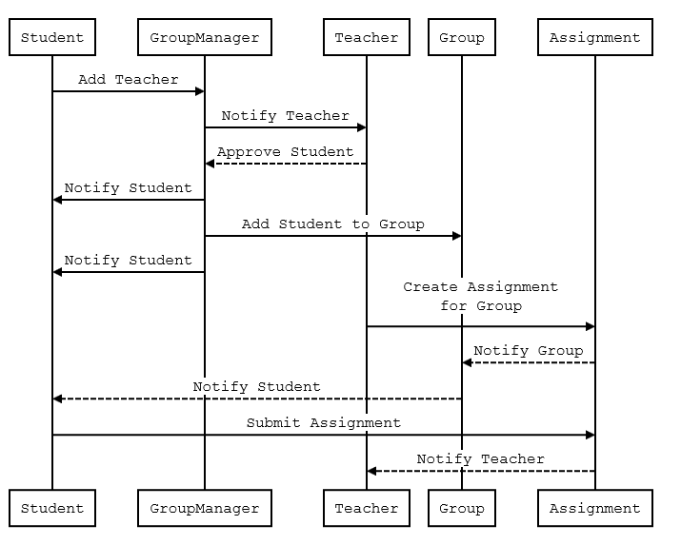

**Entity Relationship Diagram**



# Testing

Testing has proven fruitless as NullPointExceptions throw when testing web services that access the database. Great skill; huge waste of time. [SetUp] fixture fails to initialize variables.

A basic test is coded as follows:

private string test_userId = "";

private int test_numGroups = 0;

DataHandler test_handler = new DataHandler();

[SetUp]

public void Test_Init()

{

//this is the NUnit test account for database operations

test_userId = "2E7D538B-4C62-45B5-AF40-62EE3598E926";

test_numGroups = 0;

}

[Test]

public void Test_CreateGroup()

{

string selectNumGroups = "SELECT COUNT(TeacherId) FROM user_Groups WHERE TeacherId = '" + test_userId + "'";

//should be zero

test_numGroups = int.Parse(test_handler.ExecuteScalar(selectNumGroups));

Assert.AreEqual(0, test_numGroups);

//now do an insert

CreateGroup(Guid.NewGuid().ToString(), "Test Group", test_userId);

//should be 1

test_numGroups = int.Parse(test_handler.ExecuteScalar(selectNumGroups));

Assert.AreEqual(1, test_numGroups);

}

[TearDown]

public void Test_TearDown()

{

string delete = "DELETE FROM user_Groups WHERE UserId = '" + test_userId + "'";

test_handler.ExecuteNonQuery(delete);

}

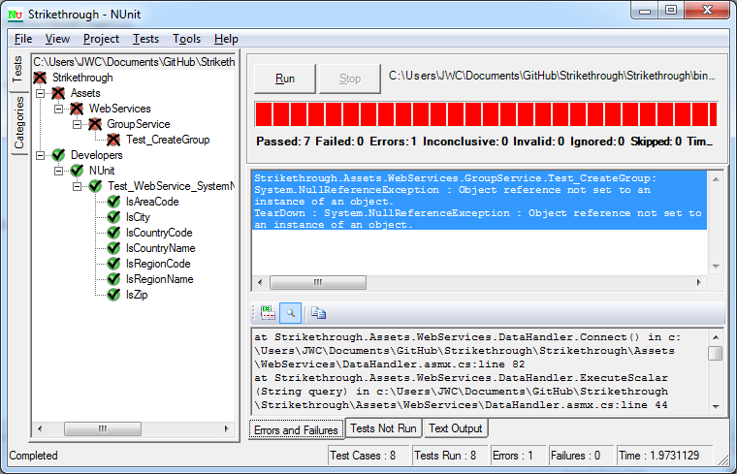

# Mobile Interface

The mobile interface in increments one and two is now located under ~/Mobile/

This week we removed the mobile interface in order to focus on satisfying all the functional requirements of our original proposal. Having completed all functional requirements, we will return to applying style sheets and mobile web development technologies. For now, the basic work flow is as follows:

Create an account:

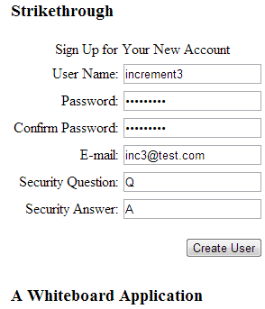

Home Page:

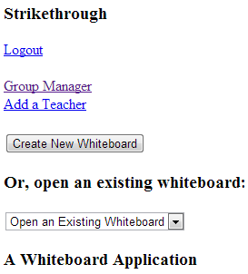

Group Manager:

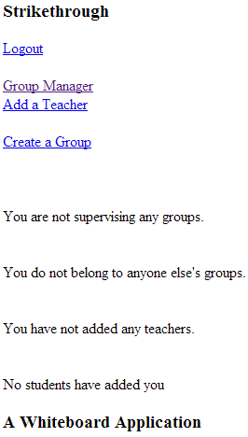

Create Group:

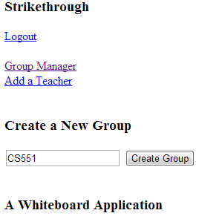

Login to another account, then add this account as a teacher

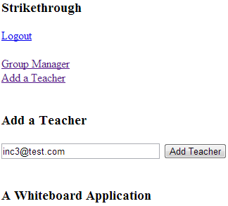

You can see it here.

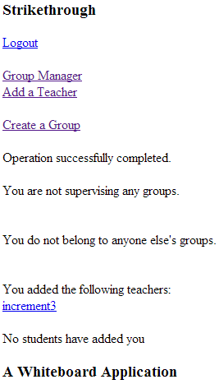

Logout and log back in to the account you added as teacher. You can see more info about people adding you. Click that link.

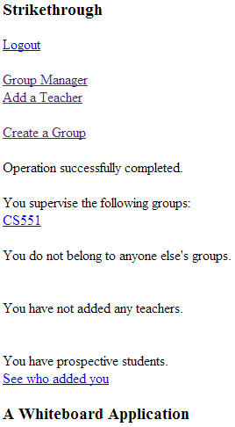

You can see this person, plus the option to add them to one of your groups.

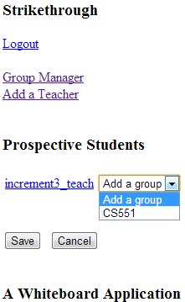

The Group Manager is in constant state of update.

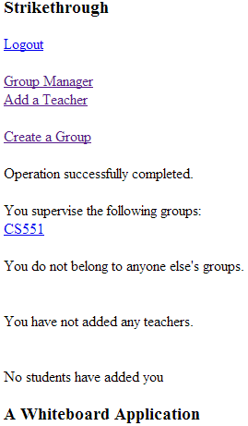

This is the Group page. You can see people in your group, as well as assign a canvas to the group.

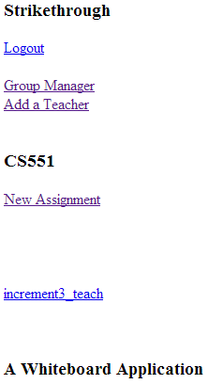

Finally, it’s possible to assign the canvas to a group. This is where development ceases and work needs to pick up for iteration 4.

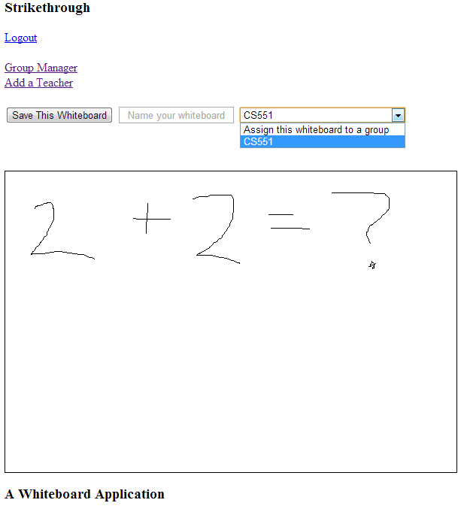

# Web Services

The new web service for this iteration is called GroupService, and is located at <http://vhost0165.site1.compute.ihost.com/assets/webservices/groupservice.asmx>

# GitHub

<https://github.com/JamesWClark/Strikethrough>

# WSDL

<http://vhost0165.site1.compute.ihost.com/assets/webservices/groupservice.asmx?wsdl>

This XML file does not appear to have any style information associated with it. The document tree is shown below.

<wsdl:definitions xmlns:s="http://www.w3.org/2001/XMLSchema" xmlns:soap12="http://schemas.xmlsoap.org/wsdl/soap12/" xmlns:mime="http://schemas.xmlsoap.org/wsdl/mime/" xmlns:tns="vhost0165.site1.compute.ihost.com"xmlns:soap="http://schemas.xmlsoap.org/wsdl/soap/" xmlns:tm="http://microsoft.com/wsdl/mime/textMatching/" xmlns:http="http://schemas.xmlsoap.org/wsdl/http/" xmlns:soapenc="http://schemas.xmlsoap.org/soap/encoding/"xmlns:wsdl="http://schemas.xmlsoap.org/wsdl/" targetNamespace="vhost0165.site1.compute.ihost.com">

<wsdl:types>

<s:schema elementFormDefault="qualified" targetNamespace="vhost0165.site1.compute.ihost.com">

<s:element name="CreateGroup">

<s:complexType>

<s:sequence>

<s:element minOccurs="0" maxOccurs="1" name="GroupId" type="s:string"/>

<s:element minOccurs="0" maxOccurs="1" name="GroupName" type="s:string"/>

<s:element minOccurs="0" maxOccurs="1" name="UserId" type="s:string"/>

</s:sequence>

</s:complexType>

</s:element>

<s:element name="CreateGroupResponse">

<s:complexType/>

</s:element>

<s:element name="GetSupervisorOfData">

<s:complexType>

<s:sequence>

<s:element minOccurs="0" maxOccurs="1" name="UserId" type="s:string"/>

</s:sequence>

</s:complexType>

</s:element>

<s:element name="GetSupervisorOfDataResponse">

<s:complexType>

<s:sequence>

<s:element minOccurs="0" maxOccurs="1" name="GetSupervisorOfDataResult">

<s:complexType>

<s:sequence>

<s:any minOccurs="0" maxOccurs="unbounded" namespace="http://www.w3.org/2001/XMLSchema" processContents="lax"/>

<s:any minOccurs="1" namespace="urn:schemas-microsoft-com:xml-diffgram-v1" processContents="lax"/>

</s:sequence>

</s:complexType>

</s:element>

</s:sequence>

</s:complexType>

</s:element>

<s:element name="GetMemberOfData">

<s:complexType>

<s:sequence>

<s:element minOccurs="0" maxOccurs="1" name="UserId" type="s:string"/>

</s:sequence>

</s:complexType>

</s:element>

<s:element name="GetMemberOfDataResponse">

<s:complexType>

<s:sequence>

<s:element minOccurs="0" maxOccurs="1" name="GetMemberOfDataResult">

<s:complexType>

<s:sequence>

<s:any minOccurs="0" maxOccurs="unbounded" namespace="http://www.w3.org/2001/XMLSchema" processContents="lax"/>

<s:any minOccurs="1" namespace="urn:schemas-microsoft-com:xml-diffgram-v1" processContents="lax"/>

</s:sequence>

</s:complexType>

</s:element>

</s:sequence>

</s:complexType>

</s:element>

<s:element name="GetHasTeachersData">

<s:complexType>

<s:sequence>

<s:element minOccurs="0" maxOccurs="1" name="UserId" type="s:string"/>

</s:sequence>

</s:complexType>

</s:element>

<s:element name="GetHasTeachersDataResponse">

<s:complexType>

<s:sequence>

<s:element minOccurs="0" maxOccurs="1" name="GetHasTeachersDataResult">

<s:complexType>

<s:sequence>

<s:any minOccurs="0" maxOccurs="unbounded" namespace="http://www.w3.org/2001/XMLSchema" processContents="lax"/>

<s:any minOccurs="1" namespace="urn:schemas-microsoft-com:xml-diffgram-v1" processContents="lax"/>

</s:sequence>

</s:complexType>

</s:element>

</s:sequence>

</s:complexType>

</s:element>

<s:element name="GetProspectiveStudentCount">

<s:complexType>

<s:sequence>

<s:element minOccurs="0" maxOccurs="1" name="UserId" type="s:string"/>

</s:sequence>

</s:complexType>

</s:element>

<s:element name="GetProspectiveStudentCountResponse">

<s:complexType>

<s:sequence>

<s:element minOccurs="1" maxOccurs="1" name="GetProspectiveStudentCountResult" type="s:int"/>

</s:sequence>

</s:complexType>

</s:element>

<s:element name="GetProspectiveStudentsData">

<s:complexType>

<s:sequence>

<s:element minOccurs="0" maxOccurs="1" name="UserId" type="s:string"/>

</s:sequence>

</s:complexType>

</s:element>

<s:element name="GetProspectiveStudentsDataResponse">

<s:complexType>

<s:sequence>

<s:element minOccurs="0" maxOccurs="1" name="GetProspectiveStudentsDataResult">

<s:complexType>

<s:sequence>

<s:any minOccurs="0" maxOccurs="unbounded" namespace="http://www.w3.org/2001/XMLSchema" processContents="lax"/>

<s:any minOccurs="1" namespace="urn:schemas-microsoft-com:xml-diffgram-v1" processContents="lax"/>

</s:sequence>

</s:complexType>

</s:element>

</s:sequence>

</s:complexType>

</s:element>

<s:element name="AddStudentToGroup">

<s:complexType>

<s:sequence>

<s:element minOccurs="0" maxOccurs="1" name="userId" type="s:string"/>

<s:element minOccurs="0" maxOccurs="1" name="groupId" type="s:string"/>

</s:sequence>

</s:complexType>

</s:element>

<s:element name="AddStudentToGroupResponse">

<s:complexType/>

</s:element>

<s:element name="GetUsersInGroup">

<s:complexType>

<s:sequence>

<s:element minOccurs="0" maxOccurs="1" name="groupId" type="s:string"/>

</s:sequence>

</s:complexType>

</s:element>

<s:element name="GetUsersInGroupResponse">

<s:complexType>

<s:sequence>

<s:element minOccurs="0" maxOccurs="1" name="GetUsersInGroupResult">

<s:complexType>

<s:sequence>

<s:any minOccurs="0" maxOccurs="unbounded" namespace="http://www.w3.org/2001/XMLSchema" processContents="lax"/>

<s:any minOccurs="1" namespace="urn:schemas-microsoft-com:xml-diffgram-v1" processContents="lax"/>

</s:sequence>

</s:complexType>

</s:element>

</s:sequence>

</s:complexType>

</s:element>

</s:schema>

</wsdl:types>

<wsdl:message name="CreateGroupSoapIn">

<wsdl:part name="parameters" element="tns:CreateGroup"/>

</wsdl:message>

<wsdl:message name="CreateGroupSoapOut">

<wsdl:part name="parameters" element="tns:CreateGroupResponse"/>

</wsdl:message>

<wsdl:message name="GetSupervisorOfDataSoapIn">

<wsdl:part name="parameters" element="tns:GetSupervisorOfData"/>

</wsdl:message>

<wsdl:message name="GetSupervisorOfDataSoapOut">

<wsdl:part name="parameters" element="tns:GetSupervisorOfDataResponse"/>

</wsdl:message>

<wsdl:message name="GetMemberOfDataSoapIn">

<wsdl:part name="parameters" element="tns:GetMemberOfData"/>

</wsdl:message>

<wsdl:message name="GetMemberOfDataSoapOut">

<wsdl:part name="parameters" element="tns:GetMemberOfDataResponse"/>

</wsdl:message>

<wsdl:message name="GetHasTeachersDataSoapIn">

<wsdl:part name="parameters" element="tns:GetHasTeachersData"/>

</wsdl:message>

<wsdl:message name="GetHasTeachersDataSoapOut">

<wsdl:part name="parameters" element="tns:GetHasTeachersDataResponse"/>

</wsdl:message>

<wsdl:message name="GetProspectiveStudentCountSoapIn">

<wsdl:part name="parameters" element="tns:GetProspectiveStudentCount"/>

</wsdl:message>

<wsdl:message name="GetProspectiveStudentCountSoapOut">

<wsdl:part name="parameters" element="tns:GetProspectiveStudentCountResponse"/>

</wsdl:message>

<wsdl:message name="GetProspectiveStudentsDataSoapIn">

<wsdl:part name="parameters" element="tns:GetProspectiveStudentsData"/>

</wsdl:message>

<wsdl:message name="GetProspectiveStudentsDataSoapOut">

<wsdl:part name="parameters" element="tns:GetProspectiveStudentsDataResponse"/>

</wsdl:message>

<wsdl:message name="AddStudentToGroupSoapIn">

<wsdl:part name="parameters" element="tns:AddStudentToGroup"/>

</wsdl:message>

<wsdl:message name="AddStudentToGroupSoapOut">

<wsdl:part name="parameters" element="tns:AddStudentToGroupResponse"/>

</wsdl:message>

<wsdl:message name="GetUsersInGroupSoapIn">

<wsdl:part name="parameters" element="tns:GetUsersInGroup"/>

</wsdl:message>

<wsdl:message name="GetUsersInGroupSoapOut">

<wsdl:part name="parameters" element="tns:GetUsersInGroupResponse"/>

</wsdl:message>

<wsdl:portType name="GroupServiceSoap">

<wsdl:operation name="CreateGroup">

<wsdl:input message="tns:CreateGroupSoapIn"/>

<wsdl:output message="tns:CreateGroupSoapOut"/>

</wsdl:operation>

<wsdl:operation name="GetSupervisorOfData">

<wsdl:input message="tns:GetSupervisorOfDataSoapIn"/>

<wsdl:output message="tns:GetSupervisorOfDataSoapOut"/>

</wsdl:operation>

<wsdl:operation name="GetMemberOfData">

<wsdl:input message="tns:GetMemberOfDataSoapIn"/>

<wsdl:output message="tns:GetMemberOfDataSoapOut"/>

</wsdl:operation>

<wsdl:operation name="GetHasTeachersData">

<wsdl:input message="tns:GetHasTeachersDataSoapIn"/>

<wsdl:output message="tns:GetHasTeachersDataSoapOut"/>

</wsdl:operation>

<wsdl:operation name="GetProspectiveStudentCount">

<wsdl:input message="tns:GetProspectiveStudentCountSoapIn"/>

<wsdl:output message="tns:GetProspectiveStudentCountSoapOut"/>

</wsdl:operation>

<wsdl:operation name="GetProspectiveStudentsData">

<wsdl:input message="tns:GetProspectiveStudentsDataSoapIn"/>

<wsdl:output message="tns:GetProspectiveStudentsDataSoapOut"/>

</wsdl:operation>

<wsdl:operation name="AddStudentToGroup">

<wsdl:input message="tns:AddStudentToGroupSoapIn"/>

<wsdl:output message="tns:AddStudentToGroupSoapOut"/>

</wsdl:operation>

<wsdl:operation name="GetUsersInGroup">

<wsdl:input message="tns:GetUsersInGroupSoapIn"/>

<wsdl:output message="tns:GetUsersInGroupSoapOut"/>

</wsdl:operation>

</wsdl:portType>

<wsdl:binding name="GroupServiceSoap" type="tns:GroupServiceSoap">

<soap:binding transport="http://schemas.xmlsoap.org/soap/http"/>

<wsdl:operation name="CreateGroup">

<soap:operation soapAction="vhost0165.site1.compute.ihost.com/CreateGroup" style="document"/>

<wsdl:input>

<soap:body use="literal"/>

</wsdl:input>

<wsdl:output>

<soap:body use="literal"/>

</wsdl:output>

</wsdl:operation>

<wsdl:operation name="GetSupervisorOfData">

<soap:operation soapAction="vhost0165.site1.compute.ihost.com/GetSupervisorOfData" style="document"/>

<wsdl:input>

<soap:body use="literal"/>

</wsdl:input>

<wsdl:output>

<soap:body use="literal"/>

</wsdl:output>

</wsdl:operation>

<wsdl:operation name="GetMemberOfData">

<soap:operation soapAction="vhost0165.site1.compute.ihost.com/GetMemberOfData" style="document"/>

<wsdl:input>

<soap:body use="literal"/>

</wsdl:input>

<wsdl:output>

<soap:body use="literal"/>

</wsdl:output>

</wsdl:operation>

<wsdl:operation name="GetHasTeachersData">

<soap:operation soapAction="vhost0165.site1.compute.ihost.com/GetHasTeachersData" style="document"/>

<wsdl:input>

<soap:body use="literal"/>

</wsdl:input>

<wsdl:output>

<soap:body use="literal"/>

</wsdl:output>

</wsdl:operation>

<wsdl:operation name="GetProspectiveStudentCount">

<soap:operation soapAction="vhost0165.site1.compute.ihost.com/GetProspectiveStudentCount" style="document"/>

<wsdl:input>

<soap:body use="literal"/>

</wsdl:input>

<wsdl:output>

<soap:body use="literal"/>

</wsdl:output>

</wsdl:operation>

<wsdl:operation name="GetProspectiveStudentsData">

<soap:operation soapAction="vhost0165.site1.compute.ihost.com/GetProspectiveStudentsData" style="document"/>

<wsdl:input>

<soap:body use="literal"/>

</wsdl:input>

<wsdl:output>

<soap:body use="literal"/>

</wsdl:output>

</wsdl:operation>

<wsdl:operation name="AddStudentToGroup">

<soap:operation soapAction="vhost0165.site1.compute.ihost.com/AddStudentToGroup" style="document"/>

<wsdl:input>

<soap:body use="literal"/>

</wsdl:input>

<wsdl:output>

<soap:body use="literal"/>

</wsdl:output>

</wsdl:operation>

<wsdl:operation name="GetUsersInGroup">

<soap:operation soapAction="vhost0165.site1.compute.ihost.com/GetUsersInGroup" style="document"/>

<wsdl:input>

<soap:body use="literal"/>

</wsdl:input>

<wsdl:output>

<soap:body use="literal"/>

</wsdl:output>

</wsdl:operation>

</wsdl:binding>

<wsdl:binding name="GroupServiceSoap12" type="tns:GroupServiceSoap">

<soap12:binding transport="http://schemas.xmlsoap.org/soap/http"/>

<wsdl:operation name="CreateGroup">

<soap12:operation soapAction="vhost0165.site1.compute.ihost.com/CreateGroup" style="document"/>

<wsdl:input>

<soap12:body use="literal"/>

</wsdl:input>

<wsdl:output>

<soap12:body use="literal"/>

</wsdl:output>

</wsdl:operation>

<wsdl:operation name="GetSupervisorOfData">

<soap12:operation soapAction="vhost0165.site1.compute.ihost.com/GetSupervisorOfData" style="document"/>

<wsdl:input>

<soap12:body use="literal"/>

</wsdl:input>

<wsdl:output>

<soap12:body use="literal"/>

</wsdl:output>

</wsdl:operation>

<wsdl:operation name="GetMemberOfData">

<soap12:operation soapAction="vhost0165.site1.compute.ihost.com/GetMemberOfData" style="document"/>

<wsdl:input>

<soap12:body use="literal"/>

</wsdl:input>

<wsdl:output>

<soap12:body use="literal"/>

</wsdl:output>

</wsdl:operation>

<wsdl:operation name="GetHasTeachersData">

<soap12:operation soapAction="vhost0165.site1.compute.ihost.com/GetHasTeachersData" style="document"/>

<wsdl:input>

<soap12:body use="literal"/>

</wsdl:input>

<wsdl:output>

<soap12:body use="literal"/>

</wsdl:output>

</wsdl:operation>

<wsdl:operation name="GetProspectiveStudentCount">

<soap12:operation soapAction="vhost0165.site1.compute.ihost.com/GetProspectiveStudentCount" style="document"/>

<wsdl:input>

<soap12:body use="literal"/>

</wsdl:input>

<wsdl:output>

<soap12:body use="literal"/>

</wsdl:output>

</wsdl:operation>

<wsdl:operation name="GetProspectiveStudentsData">

<soap12:operation soapAction="vhost0165.site1.compute.ihost.com/GetProspectiveStudentsData" style="document"/>

<wsdl:input>

<soap12:body use="literal"/>

</wsdl:input>

<wsdl:output>

<soap12:body use="literal"/>

</wsdl:output>

</wsdl:operation>

<wsdl:operation name="AddStudentToGroup">

<soap12:operation soapAction="vhost0165.site1.compute.ihost.com/AddStudentToGroup" style="document"/>

<wsdl:input>

<soap12:body use="literal"/>

</wsdl:input>

<wsdl:output>

<soap12:body use="literal"/>

</wsdl:output>

</wsdl:operation>

<wsdl:operation name="GetUsersInGroup">

<soap12:operation soapAction="vhost0165.site1.compute.ihost.com/GetUsersInGroup" style="document"/>

<wsdl:input>

<soap12:body use="literal"/>

</wsdl:input>

<wsdl:output>

<soap12:body use="literal"/>

</wsdl:output>

</wsdl:operation>

</wsdl:binding>

<wsdl:service name="GroupService">

<wsdl:port name="GroupServiceSoap" binding="tns:GroupServiceSoap">

<soap:address location="http://vhost0165.site1.compute.ihost.com/assets/webservices/groupservice.asmx"/>

</wsdl:port>

<wsdl:port name="GroupServiceSoap12" binding="tns:GroupServiceSoap12">

<soap12:address location="http://vhost0165.site1.compute.ihost.com/assets/webservices/groupservice.asmx"/>

</wsdl:port>

</wsdl:service>

</wsdl:definitions>